Numerical analysis of debonding identification in GFRP-steel marine structures using a curvature-wavelet based framework

D Yona¹*, B Zima², P Krata²
¹ Gdansk University of Technology, Poland
² Gdansk University of Technology, Institute of Naval Architecture, Poland

*E-mail: dawit.yona@pg.edu.pg

Abstract. Structural health monitoring is considered as an essential technique for assessing the condition of composite-steel structures in marine environments. This study proposes a framework that uses the application of continuous wavelet transform on curvature-derived debonding information, and introduces a multi-scale multi-mode debonding index (MMMDI). Three levels of debonding (4%, 6%, and 9%) from the bonded area, were considered at two different positions and propagating to the length of the structure. A finite element dynamic implicit model was used to simulate the real experimental vibration based modal analysis to compute the frequency response function (FRF). Based on the results, an individual mode and wavelet scale produce a misleading patterns when trying to determine the location of the debonded region. In contrast, the wavelet coefficients across multiple scales and modes provides a better indication of structural irregularities. Furthermore, the suggested MMMDI effectively localize when the debonding is centrally positioned than at the edge. This is because the closeness of debonding to the structural boundary can significantly be amplified, resulting in the debonding-induced singularity overlapping with the boundary response. Overall, the combined wavelet-curvature based diagnostic approach enhances sensitivity in detecting debonding, which are challenging to identify with conventional global methods. The suggested framework is an effective method with good sensitivity and resolution for detecting and localizing debonding in composite-steel marine structures.
1. Introduction
Vibration-based structural health monitoring (SHM) is considered as an effective approach for assessing the integrity of composite structures in marine systems, where durability, corrosion resistance, and weight efficiency are essential design considerations [1,2] . In particular, GFRP-reinforced steel members have received increasing attention because they combine the favorable mechanical properties with steel as the protective and strengthening benefits[3,4]. However, the structural performance of such hybrid systems is highly dependent on the integrity of the interface between the GFRP layer and the steel substrate. Interfacial debonding is therefore a critical defect, since it degrades load transfer capability, alters local stiffness, and may compromise integrity particularly in harsh marine environments subjected to repeated dynamic loading [5–9].
Global vibration-based methods, particularly those relying on changes in natural frequencies, have been widely used for assessing structural defects due to their simplicity and ease of implementation. Damage such as debonding introduces a localized reduction in stiffness, which in turn changes the global dynamic properties and leads to shifts in natural frequencies. While natural frequency based detection approach is effective in detecting the presence of debonding, it lacks the capability to identify smaller size defects and their spatial location. The findings from the research [10,11] indicates that, small-scale debonding may not produce measurable changes in global modal parameters, limiting the sensitivity of frequency-based methods of debonding identifications. To address the limited sensitivity of natural frequencies to small-scale debonding, most researchers considered mode shapes as an alternative diagnostic parameter than the natural frequencies, since it contains spatial information about the structural response.
Despite their advantages, mode shapes exhibit several limitations due to their noise resistance incapability [12]. Mostly damages may not affect mode shapes of the lower modes, and the extracted mode shapes may be influenced by the environmental noise or by sensor placement in regions with low sensitivity to the debonding. Furthermore, measurements at numerous locations are necessary to accurately capture displacement mode shapes for precise detection and localization. Accordingly, attention has shifted towards mode shape derivatives, which amplifies local structural changes [12,13] or a combination of mode shapes with some other techniques, such as the wavelets transform [14]. The combination of mode shape data with supplementary methods has significantly enhances the detection accuracy, while wavelet-based approaches are regarded as the best candidates for mitigating noise and thereby addressing the limitations inherent in mode shape curvatures [15–17]. The wavelet-based detection is conducted by applying the wavelet transform to the structural response, which amplifies the smaller changes in the structures at the location of defects. Despite all the developments of defect detection and localization, there remains a lack of deterministic methods that effectively integrate global and local indicators for debonding detection and localization at the interface between GFRP-steel structures using vibration based methods. This study proposed a deterministic framework that applies the application of continuous wavelet transforms to curvature-derived debonding information by integrating contributions from all modes and scales for localization.
2. Materials and methods
2.1 Test model
Layered specimens composed of steel-coated glass fiber reinforced polymer material were considered for the numerical analysis. Their material model, layer arrangements and measurement points are shown in Figure 1. Simulations and modeling were performed with Abaqus software, known for its ability to manage complex material behaviors and interaction conditions. The plates were designed with a constant dimension of 0.5 m* 0.1 m in two distinct thickness of 0.006 m and 0.002 m for steel and glass fiber composites where five layers are considered respectively with the detailed material properties shown in Tables 1 and 2. The properties of the GFRP composite were determined using the micromechanical analysis based on the given laminate data. The structural system represents typical rectangular configurations used in marine environments with an intact and debonded condition. The pattern of the debonding configurations has numerically modelled with three levels of severity in terms of percentage areas (4%, 6%, and 9%) at two different positions as shown in Figure 2. The debonding of the two layers was numerically modelled by simply applying a general contact in the interaction setting without constrain to prevent the materials from interacting with each other and a tie constraint considered for the bonding surfaces. The single instance of impact loading was applied at two different places for each unit of time away from the debonding regions to mitigate the influence of interference noise. The load position was varied with the debonding location: it was applied at the plate center when the debonding was 0.125 m from the left end and at 0.35 m from the left end when the debonding was at the plate center. If a load is introduced to or near the debonded region, it may excite the debonding instead of the overall structure, resulting in nonlinear frequency response. The load is characterized by a short pulse duration determined by the specifications of the experimental modal hammer equipped with a harder metal tip, thus facilitating broad-spectrum excitation of the structure to effectively capture dynamic responses up to 2000 Hz of frequencies, encompassing the designated frequency range of interest. The modal hammer load was modelled using a kinematic coupling constraint through a reference point, ensuring that the adjacent nodes in the loading region moved consistently with the control point. This modelling method facilitated a uniform distribution of the load across the coupled surface. The simply supported boundary were considered on both bottom sides of the lower edges, being constrained to prevent a rigid body motion during the impact load. To achieve this constraint, the vertical displacement was limited, while all rotational degrees of freedom (UR1, UR2, and UR3) were left unrestricted, allowing free rotational motion. The structural responses were quantified along the length of the plates utilizing finely meshed grids of 0.002 m element size with a uniformly distributed nodal point at equal spacing. This distribution facilitates a smoother signal to the subsequent estimation of mode shape curvature that necessitates a high spatial resolution of measurement locations with a uniform spacing. The placement of the series of measurement grids was placed away from the load application area and the boundary regions in order to reduce noise interference that could results in extra spikes and masking the defect signature in the second derivative of the mode shape.
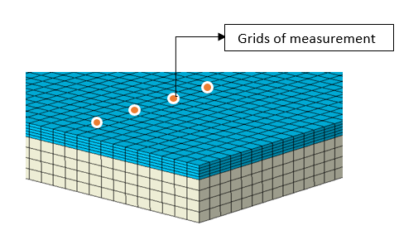
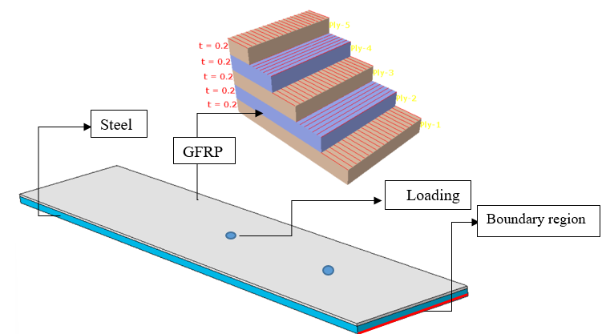
(a)
(b)

Figure 1. Numerical representation of (a) the model (b) meshing and measurement grids
However, these measurement grids are specifically designed to capture responses in the out-of-plane direction, which exhibits stronger sensitivity to flexural bending in longer plates. Consequently, given the substantial computational expense associated with the dynamic direct integration scheme, a one-dimensional analysis along the longitudinal direction is employed to calculate the bending stiffness.



(a)
(b)
(c)

Figure 2. Representation of (a) intact model and artificially induced debonding at (b) the center (c) 0.125 m from the left edge.

Table1. Material and geometric specification [10].
Property | GFRP | Steel
Density (kg/m³) | 1770 | 7850
Elastic Modulus (GPa) | 72 | 210
Poisson’s Ratio (-) | 0.30 | 0.30
Thickness (m) | 0.002 | 0.006
L X W (m) | 0.5 x 0.1 | 0.5 x 0.1
Table 2. Properties of laminates [13].
Density (kg/m3) | Elastic modulus, E1 (GPas) | Elastic modulus, E2=E3 (GPas) | Shear modulus, G12 =G13=G23 (GPas) | Poisons ration, v12=v13 | Poisons ration, v23
2000 | 26.3 | 4.8 | 2.3 | 0.28 | 0.3

2.2 Method of analysis
Unlike the conventional direct modal analysis employed by the majority of researchers, that fails to accurately represent the real impact testing, this study adopted a dynamic implicit integration scheme in Abaqus to replicate the ideal experimental impact and measurement strategy. The raw acceleration responses from the finite element numerical simulations were processed in order to prepare them for mode shape extraction and subsequent wavelet-based analysis. The frequency response functions (FRFs) were estimated in MATLAB by analyzing the excitation inputs alongside the acceleration data recorded at the monitoring locations. These FRFs were subsequently utilized to assess the modal characteristics of the structure, in accordance with the equation of motion presented in equation (1).
$$Mx¨\left(t\right)+Cx˙\left(t\right)+Kx\left(t\right)=f\left(t\right) \left(1\right)$$
In the dynamic system, M, C, and K describe the mass, damping, and stiffness matrices, respectively, while $x\left(t\right)$ is the displacement vector at time $t.$ At the $nth$natural frequency, $ωn,$ the response is dominated by a single mode, and in this case, the imaginary portion of the frequency response function can be used to estimate the mode shape vectors$ϕ_{n}$, due to its effectiveness in highlighting resonant behavior. The calculated amplitude vectors describe the structural mode shapes at the specified natural frequencies. The mode shape curvature is then calculated using the central difference approximation of the normalized mode shape vector, which can be the second spatial derivative of the modal displacement and given by equation (2). However, since the mode shape curvature data is vulnerable to measurement noise, a Savitzky-Golay filter was used to smooth the extracted curvatures while retaining important features such as peak amplitudes and widths. The data were processed using a second-order Savitzky–Golay filter with a nine-point window in MATLAB. The nine-point window was selected by visually inspecting the filtered curve and choosing a setting that reduced small fluctuations while retaining the prominent debonding-related feature. This filtering is particularly important before computing continuous wavelet analysis as the effects of noise are considerably magnified.
$$ϕ″_{i,n}=\frac{ϕ_{i-1,n}-2ϕ_{i,n}+ϕ_{i+1,n}}{{\left(Δx\right)}^{2}} \left(2\right)$$
Here, $ϕ″_{i,n}$ is the mode shape curvature at spatial point $i$ for mode $n$; $ϕ_{i,n}$ is the mode shape amplitude at that location; $ϕ_{i-1,n}$ and $ϕ_{i+1,n}$ are the amplitudes at neighboring places; and $Δx$ is the uniform distance between spatial points. However, to determine the debonding position, an index based on the curvature information was utilized, which is defined as the normalized cumulative absolute difference between the modal curvatures of the intact and debonded structures. The obtained Curvature index (CI) given by equation (3) is then used in wavelet analysis to establish the final index that provide more precise and reliable localization of the affected regions.
$$CI\left(i\right)=\frac{\sum_{k=1}^{N_{m}}{\left|K_{k}^{d}\left(i\right)-K_{k}^{h}\left(i\right)\right|}}{\max_{j}\left\{\sum_{k=1}^{N_{m}}{\left|K_{k}^{d}\left(j\right)-K_{k}^{h}\left(j\right)\right|}\right\}+ε} \left(3\right)$$
Where, $CI\left(i\right)$ is the curvature index at spatial point $i$; $K_{k}^{d}\left(i\right)$ and $K_{k}^{h}\left(i\right)$ are curvatures for mode $k$ in the debonded and healthy states, respectively; $N_{m}$ is the number of modes; $j$ ranges over all spatial points in the maximum; and $ε$ is a small positive constant introduced to prevent division by zero during the normalization process. As the mode shape curvature increases noise and unwanted signals caused by load application or measurement errors, it can be addressed by combining curvature data with the Continuous Wavelet Transform (CWT) that overcomes this limitation by allowing simultaneous spatial and scale-based analysis. The CWT is a highly advanced signal-processing framework that allows simultaneous spatial and scale-based analysis. The Mexican-hat wavelet type is utilized which is more suitable for small-localized defects and change in curvature.
Nonetheless, applying CWT directly to the raw curvature index can cause a localized disturbance near the loading and boundary edges, potentially leading to incorrect identification of the debonding location. To reduce these artifacts, the curvature signals were interpolated using a cubic spline interpolation. This method reduces the irregularity while maintaining the curvature singularity related to the local stiffness reduction. Signals identified within the affected regions were considered as missing value, and the local trend within this region was reconstructed by applying the interpolation to the surrounding unaffected signals. This processing step resulted in a signal with a reduced load effects, maintaining the overall shape of the debonding curve. The method was performed in OriginPro using 200 output points and a not-a-knot boundary condition setting. The output density was selected to provide a smooth visual representation of the spatial response and to make local variations around the debonding region easier to examine. The final indicator which is multi-scale multi-mode debonding index ($MMMDI$) is then derived using the curvature index wavelet coefficient distribution that combines multiple scales and modes together which can be represented by equation (4).
$$MMMDI\left(x\right)=\frac{1}{N}\sum_{i=1}^{N}{\sum_{s=1}^{N_{s}}{\frac{\left|W_{i}\left(x,s\right)\right|}{max\left|W_{i}\left(x,s\right)\right|}}} \left(4\right)$$
Where, $MMMDI\left(x\right)$ is the multi-scale multi-mode debonding index at position $x$ and $W_{i}\left(x,s\right)$is the wavelet coefficients of the curvature signal for mode $i$ at scale s and spatial position x; $N$ and $N_{s}$ are the numbers of modes and scales, respectively.

3. Results and Discussions
Figures 3–7, illustrate the results derived from processing numerical data in MATLAB, following the methods and specific cases outlined in Section 2.2. The normalized curvatures index shown in Figures 4-7 were summed across modes, and the continuous wavelet transform (CWT) of the resulting spatial signal was evaluated across the selected scales. The wavelet contributions were summed over the scales to obtain a single multi-scale multi-mode debonding index (MMMDI) value at each longitudinal position. Based on the test results, all the debonding cases are compared with the reference state and any curvature difference between these two can create a discontinuity in the curvature profile. Figure 3, represents the modal displacement and its second derivatives for the healthy model. As it has seen from the curvature profile, there is a discontinuity at the start and end of the plate, which is, attribute to the impact of boundary conditions.
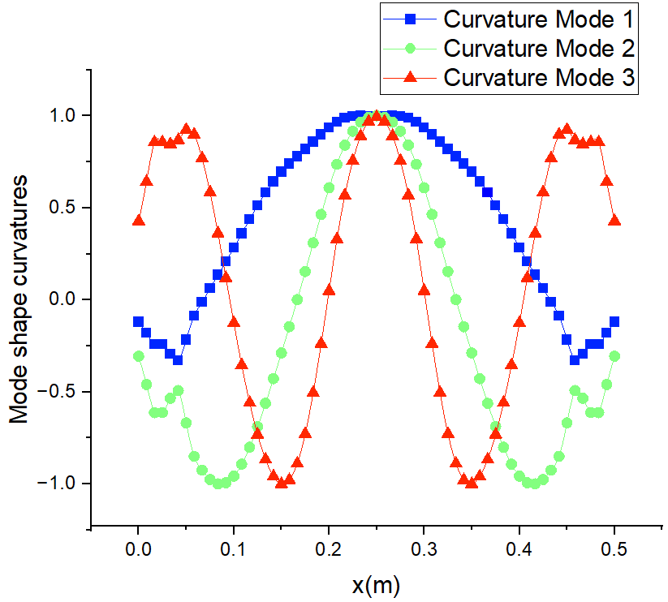
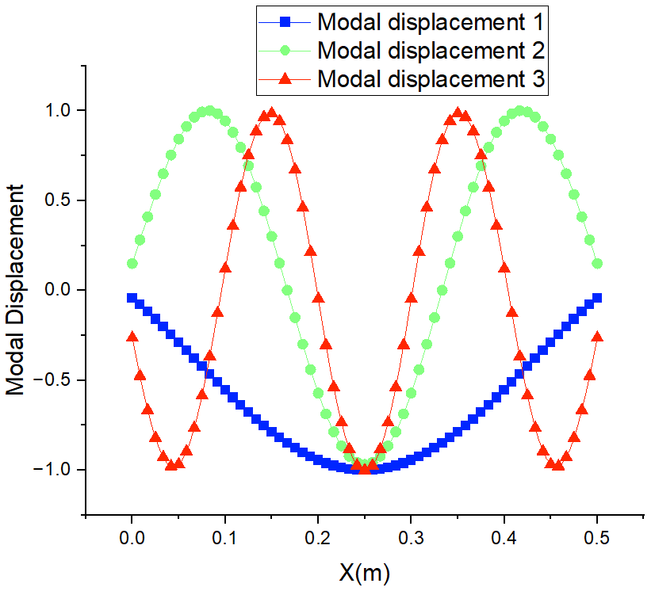
(a)
(b)

Figure 3. The (a) modal displacement and (b) mode shape curvature for an intact model.
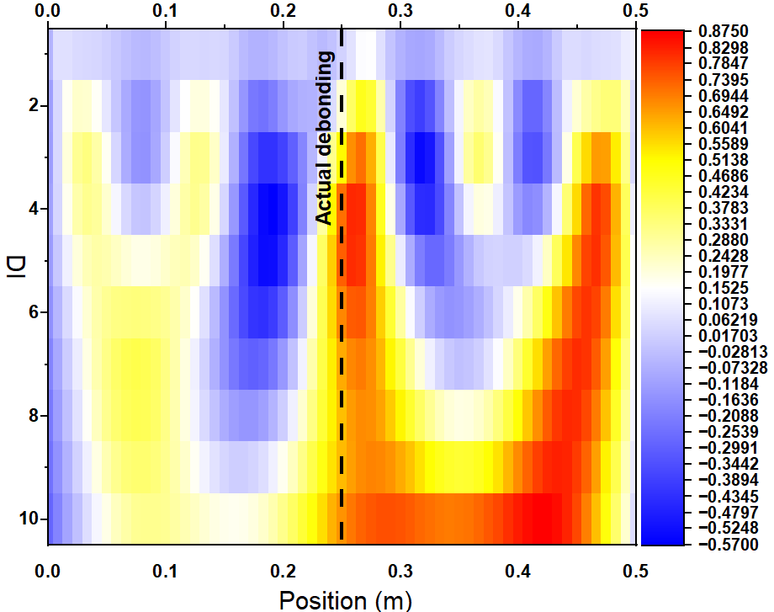
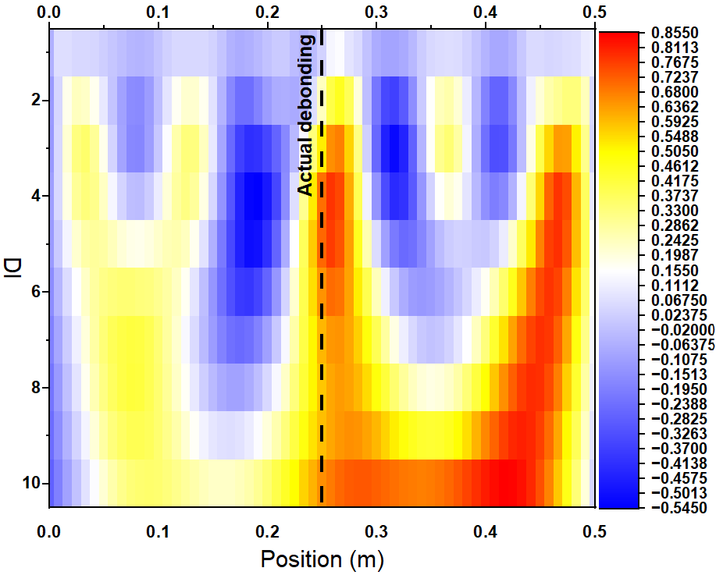
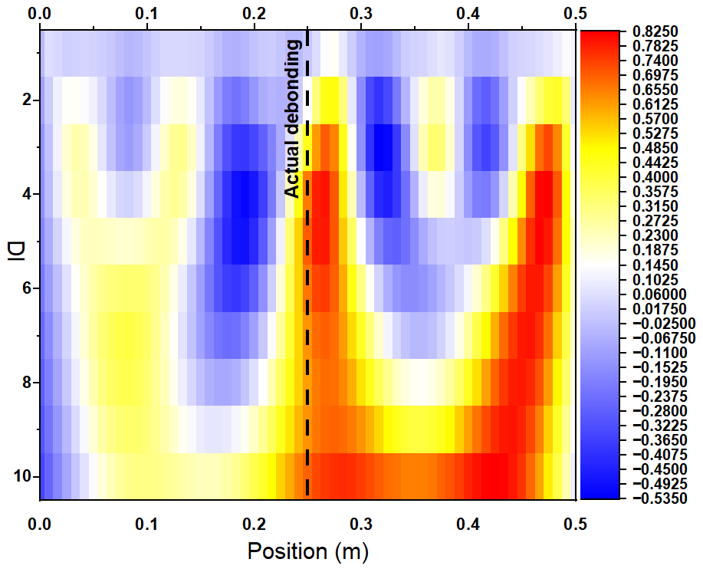
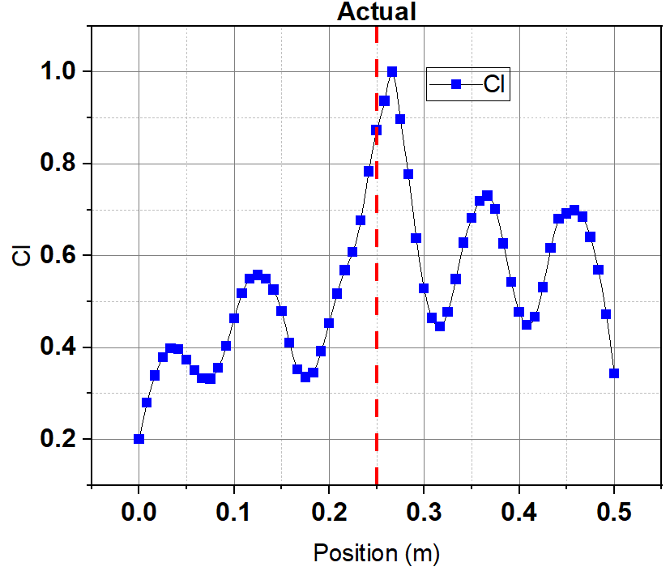
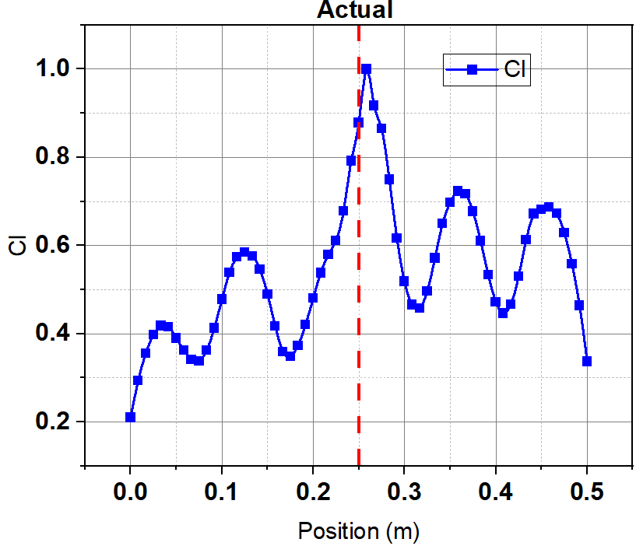
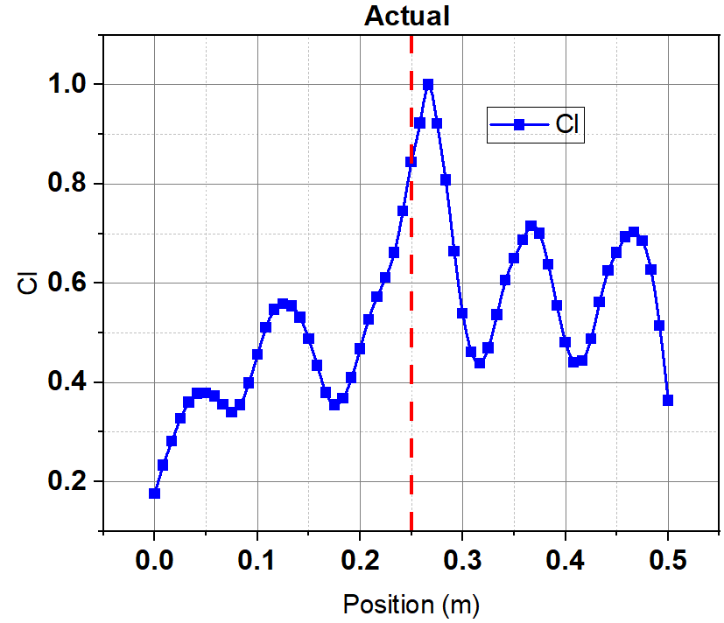
The results shown in Figure 4a–c illustrate the normalized curvature index for transverse debonding at the center of the GFRP–steel interface, with debonding areas of 4%, 6%, and 9%, from the total plate area. In each scenario, there is a noticeable indication of debonding near the actual site indicated in red dashed lines, which verifies that the local decrease in interfacial stiffness causes sharp spikes in the modal curvature field. Whereas, the CWT coefficient maps shown in Figure 4d–f presents a more detailed observation of these disturbances by examining the curvature signal across various scales. The result demonstrates that the damage signature consistently appears across multiple wavelet scales, creating continuous high-energy regions indicated in red colors centered on the plate, aligning with the actual debonding site. Conversely, the responses were also detected near the plate ends across scales and the impact points, indicating they are artefacts related to boundary effects and load-induced curvature concentrations. This detection problem can be addressed by utilizing the MMMDI with the contributions from all scales, where real structural anomalies remain more localized after applying the cubic spline interpolation techniques within the ranges of those impact and boundary regions to suppress random fluctuations and numerical noise. Consequently, the debonding maps shown in Figure 5a–c reveal a single, prominent ridge clearly defined at the center across all three debonding sizes. This enhancement illustrates that combining data from various scales and vibration modes strengthens the consistent debonding-related characteristics, while smoothing out numerical fluctuations and boundary condition effects.
(a)
(b)
(c)
(d)
(e)
(f)
Figure 4. The curvature indices for transverse debonding areas of (a) 4% (b) 6% (c) 9% and the corresponding CWT coefficient maps across scales for (d) 4%, (e) 6% and (f) 9% when the debonding is located at the center of the plate.
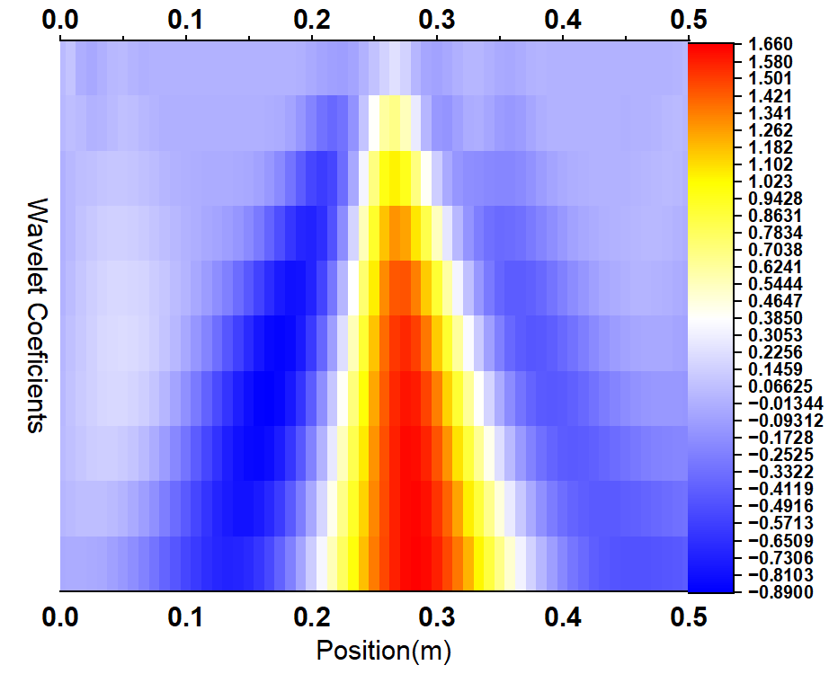
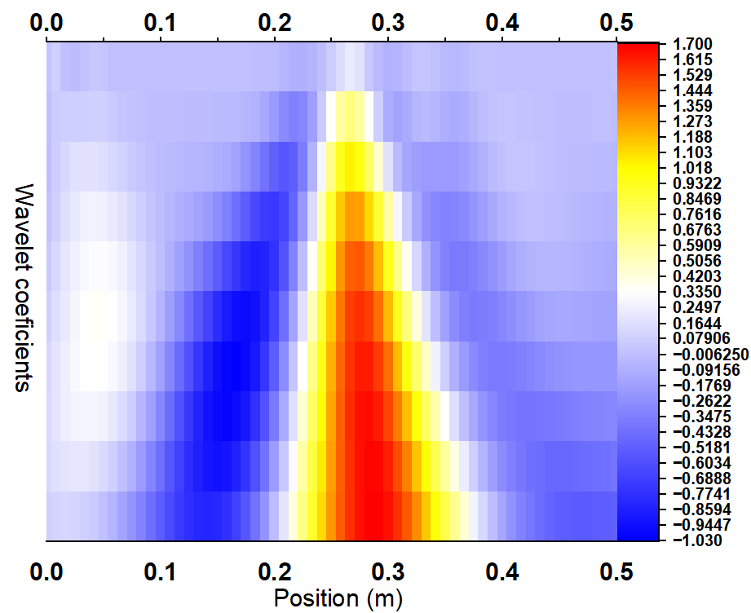
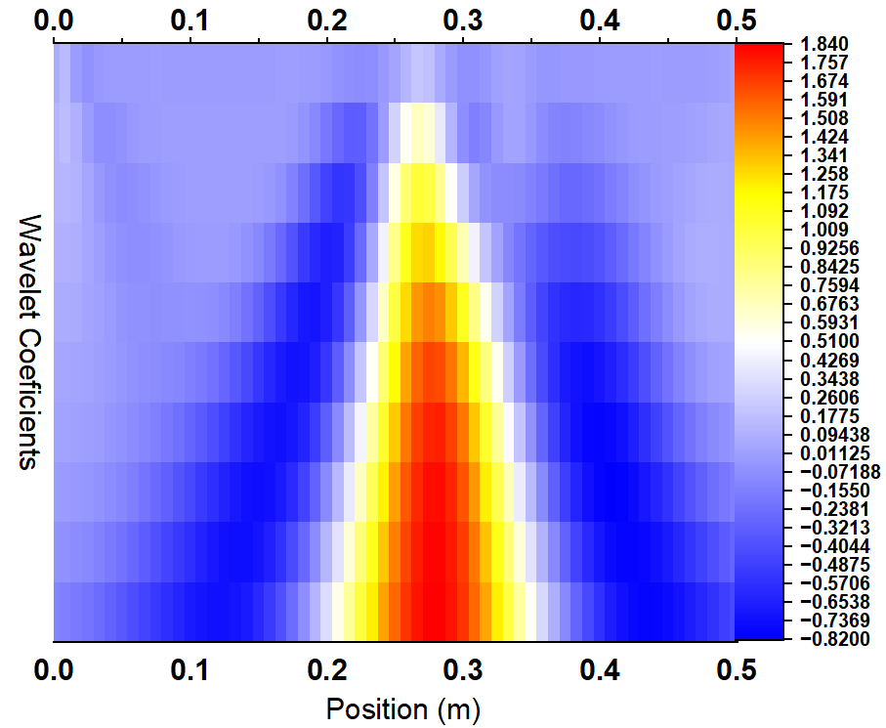
(a)
(b)
(c)
Figure 5. MMMDI maps for transverse debonding at (a) 4%, (b) 6% and (c) 9% debonded areas when the debonding is at the center of the plate.
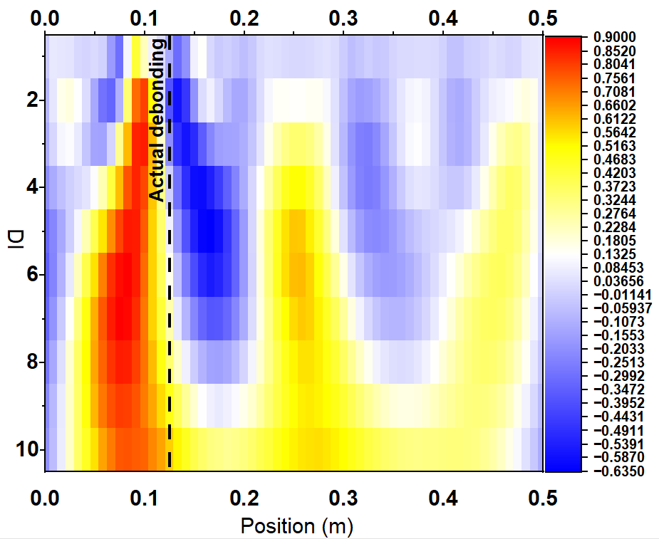
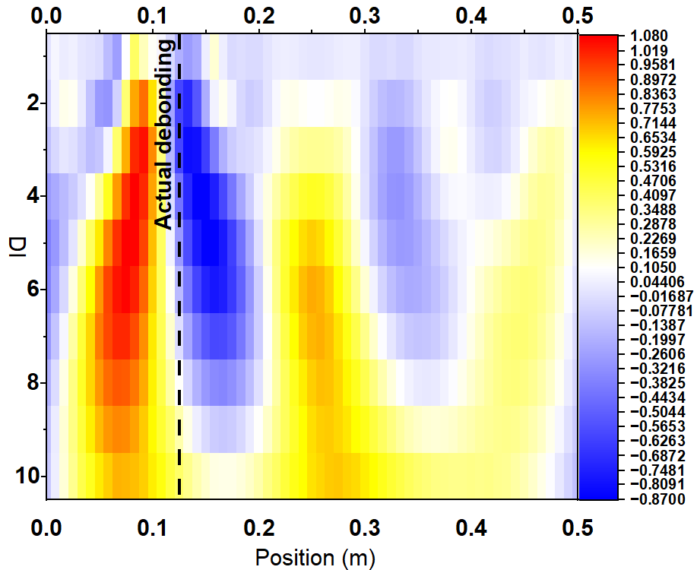
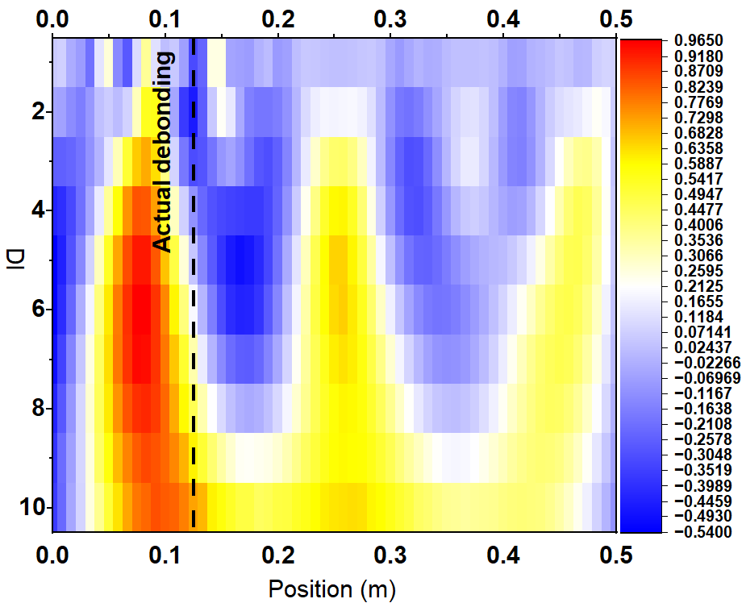
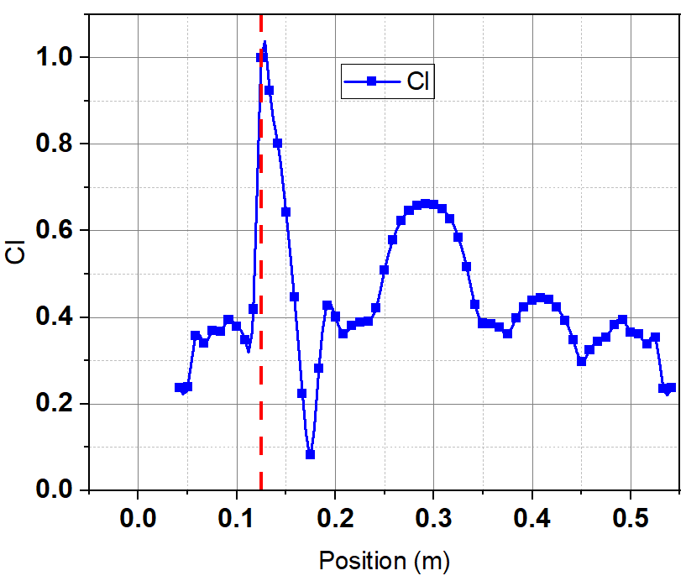
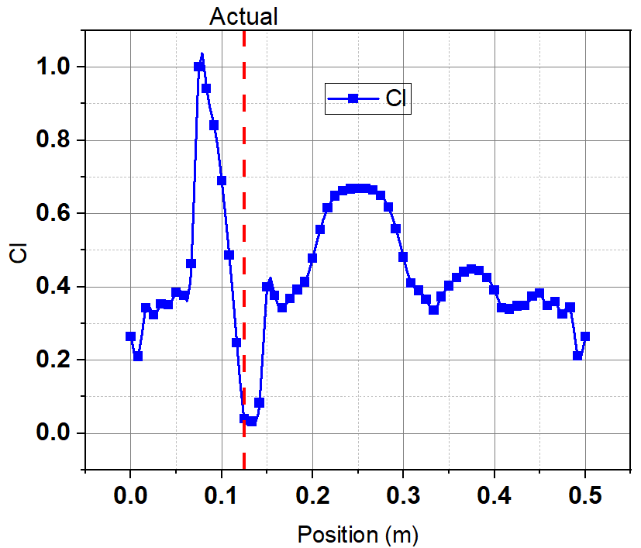
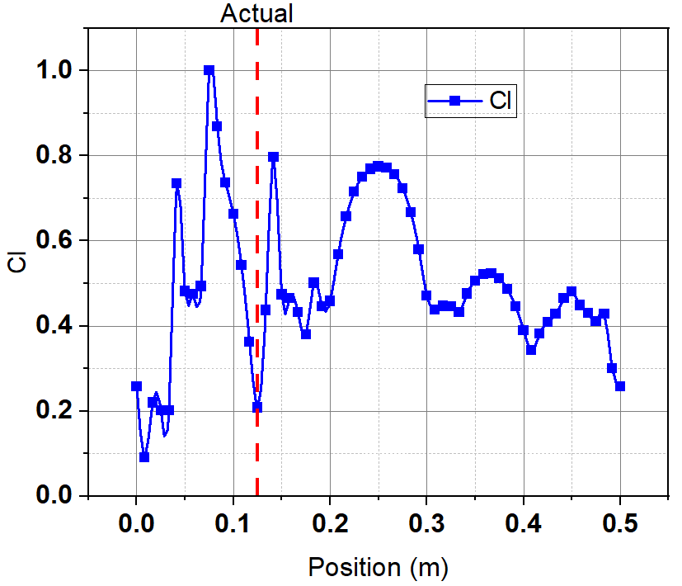
On the other hand, when the transverse debonding is located at its actual position, 0.125 m from the left end, as indicated by the red dashed line in Figure 6a–c, a different response pattern is observed. The curvature index still shows the debonded regions, but the main peaks are not precisely aligned with the actual debonding location. Instead, the highest responses are slightly shifted from its actual position. This decrease in accuracy is due to the debonding closeness to the structural boundary, where the modal curvature is heavily influenced by the support conditions. The CWT coefficient maps in Figure 6d–f also reveals a similar pattern. While high wavelet coefficients are produced near the area of debonding, the coefficient distribution spans a larger spatial area and does not always align with the precise debonding location. Additionally, several concentrated coefficients are found at the boundary and impact points where their impacts are less than when the debonding is position at the center.
(a)
(b)
(c)
(d)
(e)
(f)
Figure 6. The curvature indices for transverse debonding areas of (a) 4% (b) 6% (c) 9% and the corresponding CWT coefficient maps across scales for (d) 4%, (e) 6% and (f) 9% when the debonding is at 0.125 m far from left end.
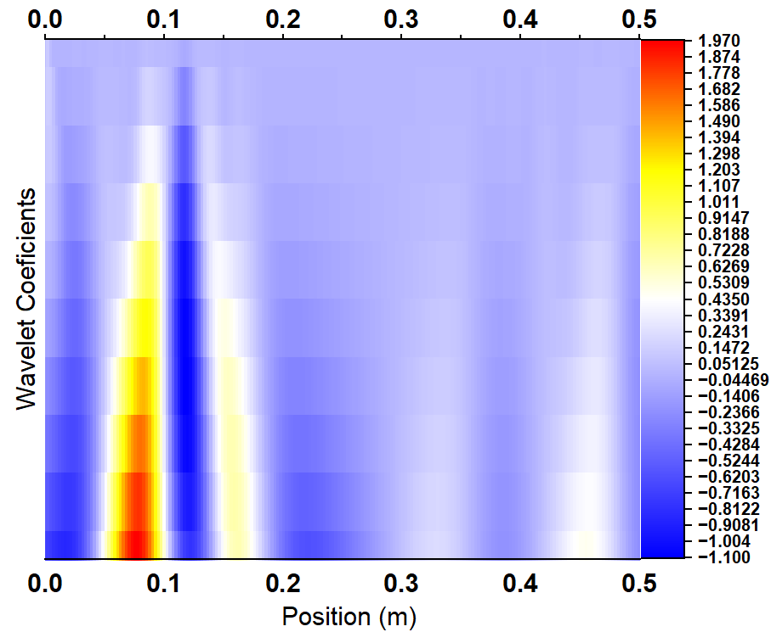
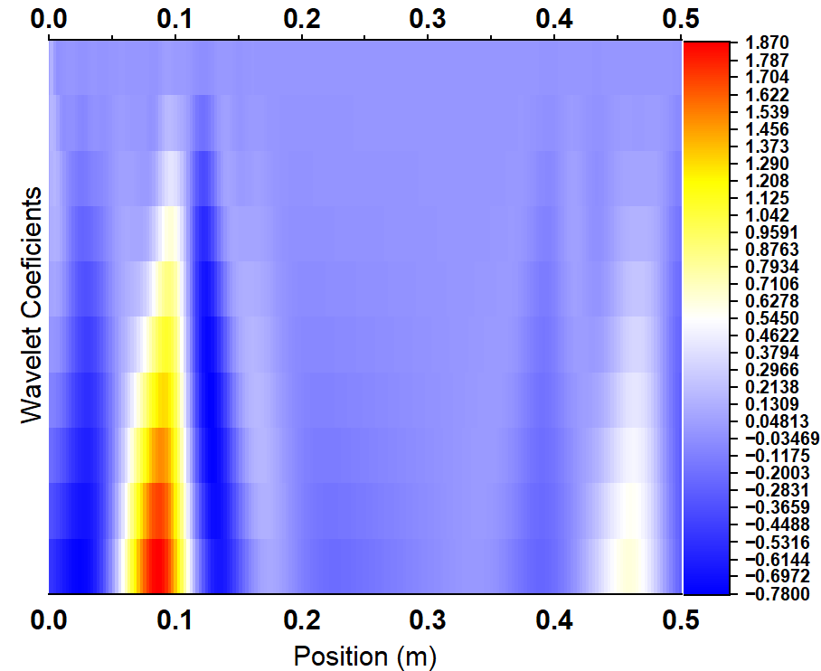
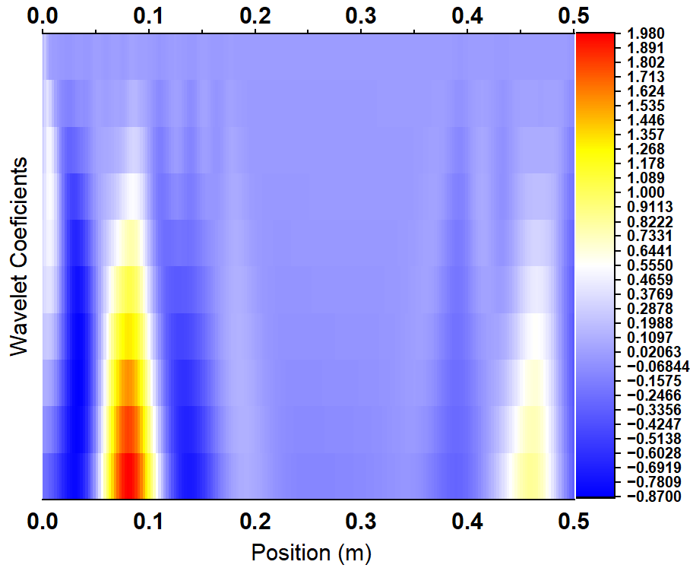
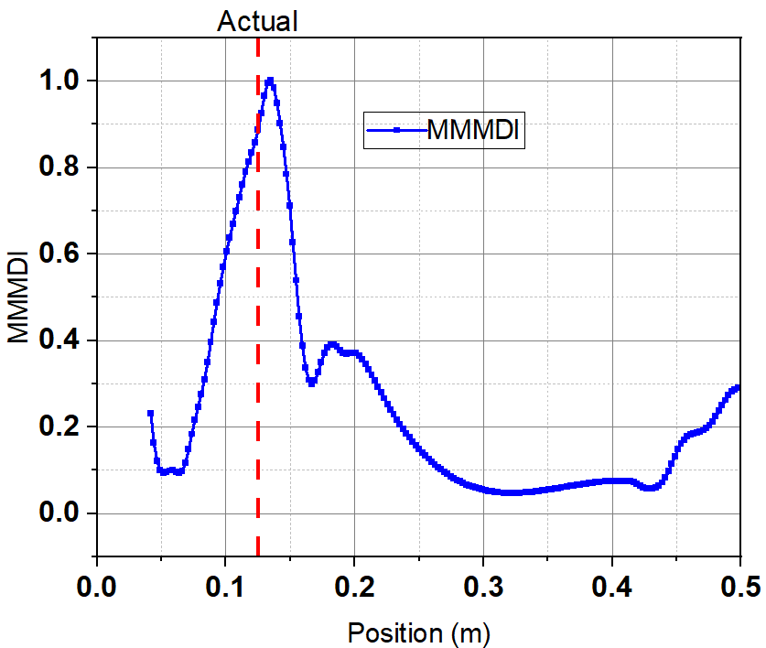
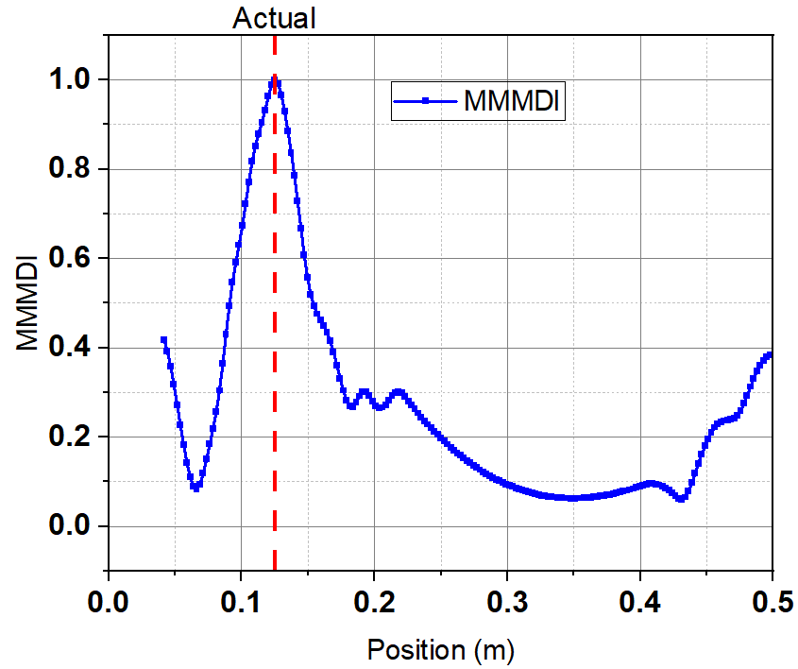
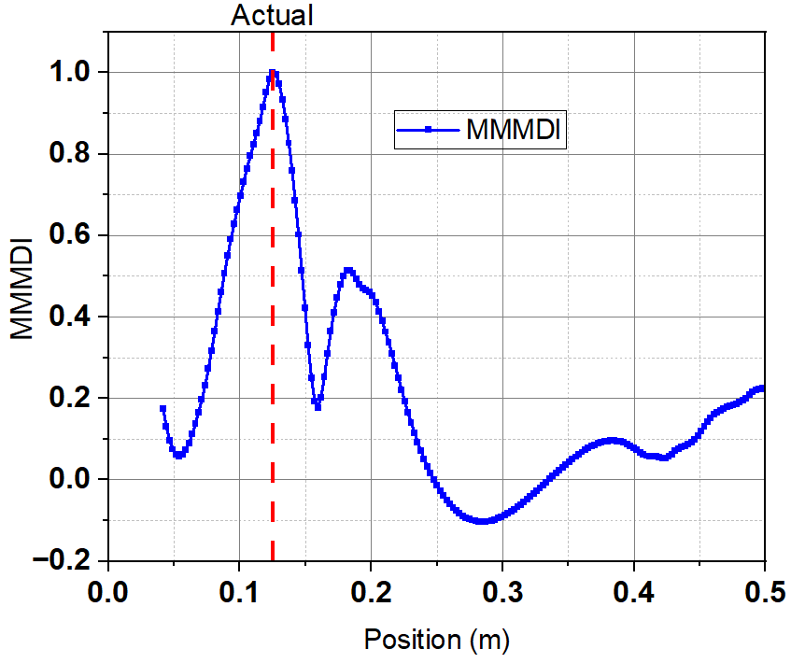
This result highlights that central debonding is identified with more precise positioning since its features are far from boundary influences and disturbances caused by loading. The proposed multi-scale multi-mode integration's effectiveness is shown in Figure 7a–f. By employing cubic spline smoothing and combining wavelet coefficients from all scales, the local fluctuations observed in Figure 6d–f, are significantly reduced.
(a)
(b)
(c)
(d)
(e)
(f)
Figure 7. MMMDI maps for transverse debonding at (a) 4%, (b) 6% and (c) 9% and the corresponding MMMD coefficient maps for (d) 4%, (e) 6% and (f) 9% when the debonding is at 0.125 m far from left end.
This signal processing provides the MMMDI with a narrow, well-defined region, with its peak much nearer to the actual debonding position, indicating its potential for localization in the case studied.
It is important to recognize the limitations of this study and their potential impact on the robustness of the findings and broader implications. The numerical analysis focused on assessing the curvature index and multi-modal multi-scale debonding index for debonding areas of only 4%, 6%, and 9% at two locations. While the analysis provides valuable insights into the effect of debonding identification and localization on multi-layered structures, the method does not provide the severity analysis for each cases. However, the CI and the proposed MMMDI effectively highlights the position of these debonding ranges in a good visible manner for the numerical case studied. Additionally, the method's response may differ based on location where a debonding near a modal node or structural boundary might be less distinctly identified than one in an area where the selected modes are more responsive to local stiffness changes. Consequently, the current results illustrate the method's performance for the studied cases but do not determine a minimum detectable debonding area or consistent performance across all locations. Further evaluation involving smaller deboning’s, additional locations, and different debonding patterns supported by experiments is necessary to define these limits. Moreover, the research evaluated debonding by examining out-of-plane responses recorded along the length of the plate. This monitoring setup, being one-dimensional, might restrict the identification of debonding at different directions. Future research will expand this method to incorporate a two-dimensional measurement grid and assess its effectiveness in detecting debonding at various positions.
4. Conclusion
The research employed a numerical vibration-based approach to detect and pinpoint the debonding location on a GFRP-coated steel structure at two locations and for areas of 4%, 6%, and 9%, utilizing continuous wavelet transform applied to curvature-derived debonding signal. The analysis results indicate that the proposed multi-scale multi-mode debonding-index offer a better localization than both the raw curvature- index and individual CWT coefficient maps. Furthermore, the wavelet signature and peaks associated with centrally located debonding are identified with a better visibility, as boundary effects do not affect this scenario or concentrated loading areas. In contrast, off-center debonding interacts more strongly with the structural boundary, introducing the risk of localization errors in the raw curvature index and individual CWT maps. Nonetheless, for the numerical cases investigated, the proposed MMMDI identified debonding at the two considered locations for the given ranges of debonding sizes. Further sensitivity analysis and experimental testing are required to evaluate its effectiveness for smaller debonding, various locations, different debonding patterns, and measurement noise. Moreover, the one-dimensional monitoring arrangement may limit sensitivity to debonding across different direction. Future work will evaluate the method using a two-dimensional measurement grid.

References
[1] Yang Y, Zhang Y and Tan X 2021 Review on Vibration-Based Structural Health Monitoring Techniques and Technical Codes, Symmetry (Basel). 13(11), 1998.
[2] Sun X, Ilanko S, Mochida Y and Tighe R C 2023 A Review on Vibration-Based Damage Detection Methods for Civil Structures, Vibration. 6(4), 843–875.
[3] Mahmoud A A, Sedeek M S, Salama M A and Khater A N M 2025 Repairing and Strengthening of Box-Section RC Beams Reinforced by GFRP Bars Using Epoxy Injection and GFRP Strips, Int. J. Concr. Struct. Mater. 19(1), 30.
[4] Elbawab Y, Elbawab Y, El Zoughby Z, ElKadi O, AbouZeid M and Sayed-Ahmed E 2025 Flexural Testing of Steel-, GFRP-, BFRP-, and Hybrid Reinforced Beams, Polymers (Basel). 17(15), 2027.
[5] Mitsopoulou N and Kattis M 2025 Mechanics of Interfacial Debonding in FRP Strengthening Systems: Energy Limits and Characteristic Bond Lengths J. Compos. Sci. 9(8), 412.
[6] Liu J, Wei Y, Zhao Q, Zhang Y and Zheng K 2024 Fatigue-induced fracture assessment for FRP-steel bonding joints after seawater exposure, Structures. 68, 107209.
[7] Tian T, Yang H, Yang Z, Xu H, Wu Z and Yang L 2025 Damage identification of adhesive bonded structures based on ultrasonic guided waves and neural network, Nondestruct. Test. Eval. 41(5), 2928-2952.
[8] Ke L, Li Y, Li C, Cheng Z, Ma K and Zeng J 2024 Bond behavior of CFRP-strengthened steel structures and its environmental influence factors : a critical review, Sustain. Struct. 4(1), 1-26.
[9] Pant U, Banerjee S and Kundu T 2025 Imaging of debonds in a FRP strengthened concrete beam using linear and nonlinear features of surface guided waves generated by a wedge transducer Ultrasonics. 150, 107600.
[10] Yona D, Zima B and Krata P 2025 A Feasibility Study of Debonding Detection in Multi-Layered Marine Thin-Wall Structures Using a Non-Destructive Vibration-Based Approach Polish Marit. Res. 32(1), 137–146.
[11] Yona D, Krata P and Zima B 2026 Vibration-based analysis of debonding defects in multilayered thin GFRP-reinforced steel structure, Arch. Civ. Mech. Eng. 26, 1–27.
[12] Huang M, Xu Z, Cai C, Chen D, Yin W and He X 2025 Vibration-based damage detection in laminated composite plates: a novel approach using superposition of higher-order derivatives of mode shapes, Struct. Health Monit. 25(5), 3396–3414.
[13] Govindasamy M, Kamalakannan G, Kesavan C and Meenashisundaram G K 2020 Damage Detection in Glass/Epoxy Laminated Composite Plates Using Modal Curvature for Structural Health Monitoring Applications, J. Compos. Sci. 4(4), 185.
[14] Knak M, Wojtczak E, Rucka M 2021 Non-Destructive Diagnostics of Concrete Beams Strengthened with Steel Plates Using Modal Analysis and Wavelet Transform, Materials. 14(11), 3014.
[15] Sokhangou F, Sorelli L, Chouinard L, Dey P and Conciatori D 2024 Detecting Multiple Damages in UHPFRC Beams through Modal Curvature Analysis, Sensors. 24(3), 971.
[16] Xu W, Cao M S, Radzieński M and Ostachowicz W M 2015 Multiple damage detection in beams in noisy conditions using complex-wavelet modal curvature by laser measurement, Vibroengineering PROCEDIA 5, 157–62.
[17] Liu L, Jiang L, Qiu Y, Wang P, Zhang G, Liu K and Xu Z 2026 Damage detection in composite laminated beams based on multi-scale enhancement of mode shape curvature using stationary wavelet transform Nondestruct. Test. Eval. 1–19 (published online), doi: 10.1080/10589759.2026.2626014.

