Effect of Post-Cooling Time on the Residual Bond Strength of GFRP Bars in Reinforced Concrete After Elevated-Temperature Exposure
H E K Bertheussen, S S Kakay and S C Siriwardane
Department of Mechanical and Structural Engineering and Material Science, Faculty of Science and Technology, University of Stavanger, Stavanger, Norway

* Contact Author: hansekbertheussen@gmail.com
Abstract. This paper investigated whether residual bond strength between GFRP reinforcement and concrete stabilizes immediately after cooling from elevated temperatures or continues to evolve over time. Pull-out tests were conducted on sand-coated vinyl ester bars embedded in concrete cubes exposed to 100, 200 and 300°C. Specimens were tested 24 hours, 7 days and 14 days after cooling to assess elapsed time effects. Results showed elapsed time effects depended on temperature. At 100°C, no immediate reduction was observed: 9.91 MPa (control) and 9.90 MPa after 24 hours, increasing to 11.04 MPa after 7 days. At 200°C, strength dropped from 9.91 to 7.81 MPa, then recovered to 8.87 MPa (7 days) and 9.64 MPa (14 days), approximately 87% recovery of initial loss. At 300°C, values remained stable between 7.77-7.98 MPa over 14 days. These findings indicate residual bond strength depends on both maximum temperature and time after cooling. They do not contradict existing literature on detrimental effects of elevated temperature on GFRP-concrete bond performance but suggest reported residual strength may represent a transient post-cooling stage rather than a fully stabilized condition. Accordingly, timing of post-fire bond assessment is critical.

Introduction
Glass fibre-reinforced polymer (GFRP) bars are increasingly considered as an alternative to steel reinforcement in concrete structures where corrosion resistance, low weight and electromagnetic neutrality are important. Their use is nevertheless constrained by the thermal sensitivity of the polymer matrix. As the temperature approaches and exceeds the glass-transition range of the resin, matrix softening and degradation can reduce adhesion, friction and mechanical interlock at the GFRP-concrete interface [1-4]. Bond degradation is particularly important because the transfer of force from a GFRP bar to the surrounding concrete depends directly on the integrity of this interface.
Previous pull-out and structural studies have established that elevated temperature can reduce GFRP-concrete bond capacity, especially at temperatures above the resin glass-transition range [2-4]. However, most residual-property studies assess specimens at a single post-cooling age, often approximately 24 hours after exposure, and therefore implicitly treat the cooled state as time invariant. The possibility that bond strength continues to evolve after the specimen has returned to ambient temperature has received little attention. Related research on thermosetting vinyl ester systems shows that additional post-curing can alter resin properties [8,9], while cementitious materials may exhibit continued hydration and partial autogenous healing of microcracks under favourable conditions [10]. These mechanisms provide a plausible basis for post-cooling changes, although their role in a thermally damaged GFRP-concrete interface has not been established.
The objective of the present study was therefore to determine whether residual bond strength stabilizes immediately after cooling or changes during the subsequent days. Sand-coated vinyl ester GFRP bars embedded in concrete cubes were exposed to 100, 200 and 300°C and tested after 24 hours, 7 days and 14 days. The study was deliberately time-resolved: maximum temperature and elapsed time after cooling were treated as separate experimental variables. The resulting trends are discussed in relation to existing elevated-temperature bond research, possible recovery mechanisms and the implications for post-fire assessment.

Experimental programme

2.1 Materials, specimen matrix and bond geometry
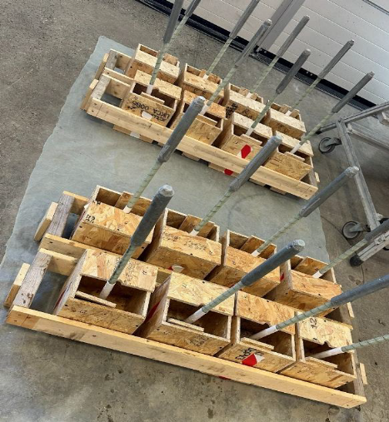
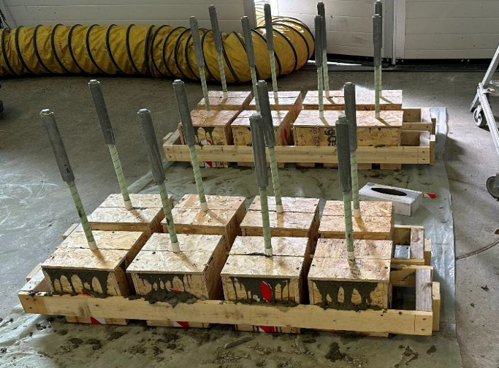
The reinforcement consisted of GLASSPREE® TS round sand-coated GFRP bars manufactured with E-CR glass fibres in a vinyl ester matrix. The nominal bar diameter was 20 mm; the effective diameter determined by the displacement method specified in ASTM D792 was 20.08 mm. Manufacturer data reported a tensile modulus of 46 GPa, guaranteed ultimate tensile strength of 780 MPa, density of 1.95 g/cm³ and fibre content exceeding 65%. Pull-out specimen geometry was based on ASTM D7913/D7913M [7]. The bonded length was five times the effective bar diameter, approximately 100.4 mm. Electrical tape was used as a bond breaker outside the intended bonded region so that force transfer was concentrated within the prescribed embedment length. The sample specimens after casting are shown in Figure 1.
Figure 1. Test specimens: (a) before concrete casting, and (b) after concrete casting
(a)
(b)
(b)
The main test matrix comprised three unheated control specimens and five specimens for each combination of exposure temperature (100, 200 and 300°C) and post-cooling test time (24 hours, 7 days and 14 days), giving 48 principal pull-out tests (refer to Table 1). Concrete was produced over three casting days. Similar compression cylinders were tested to verify that differences between casting groups did not dominate the bond results. The average cylinder strengths were 27.61, 31.33 and 28.82 MPa for the specimen groups associated with the 24-hour, 7-day and 14-day pull-out tests, respectively; all were within the target range of 30 ± 3 MPa.

Table 1. Principal pull-out test matrix.
Exposure | Control | 24 h | 7 d | 14 d
Unheated | 3 | - | - | -
100°C | - | 5 | 5 | 5
200°C | - | 5 | 5 | 5
300°C | - | 5 | 5 | 5

2.2 Thermal exposure and cooling
A dedicated dummy concrete specimen containing an embedded temperature sensor was used to establish the thermal controlling procedure. Preliminary trials showed that an oven fan setting of approximately 40% gave the most consistent performance. For the 100 and 200°C groups, the oven was initially set above the target temperature to reduce heating time. Once the target internal temperature range was reached, the oven set-point was reduced to the exposure temperature, and a 30-minute soak was applied. Although this procedure did not produce a perfectly stabilized internal temperature, it limited temperature increases during the soaking period and maintained the specimen temperature within ±5% of the desired target temperature. The 300°C group was heated directly at 300°C because the oven could not be set higher. The resulting procedures are summarized in Table 2.
Table 2. Heating procedure used for the three exposure temperatures.
Target temperature range | Oven temperature when heating | Time to reach target temperature | Soak setting/Oven temp. when Soak | Soak time
95-105°C | 200°C | 60 min | 100°C | 30 min
190-210°C | 250°C | 1 h 55 min | 200°C | 30 min
285-315°C | 300°C | 4 h 45 min | 300°C | 30 min

After heating, specimens were removed from the oven and cooled in ambient laboratory conditions. Temperature logging of the dummy specimen indicated that the concrete returned to within ±10% of room temperature within 24 hours. Consequently, 24 hours after removal from the oven was adopted as the reference point for the earliest residual test. The 7-day and 14-day intervals were measured from the same cooling event. Prior to testing the actual specimens, an additional verification experiment was conducted to assess whether the exposed section of GFRP reinforcement and the attached steel tube anchor would deform under elevated temperatures. A sacrificial GFRP specimen with a steel tube anchor was subjected to the developed heating procedure without being embedded in concrete. The test indicated negligible bending of the GFRP reinforcement up to approximately 270°C. The test was terminated at this temperature because the timber support blocks began to char and produce smoke. Although no significant deformation was observed, the test did not conclusively demonstrate the behavior of the exposed reinforcement at 300°C. As a precautionary measure, during heating, the exposed portion of the GFRP bar and the steel-tube anchor were wrapped with a 25 mm ceramic insulation blanket so that thermal exposure was concentrated within the concrete specimen.

2.3 Pull-out test arrangement and data reduction
Pull-out tests were performed in an INSTRON 5985 universal testing machine with a 250 kN load cell. The custom steel fixture clamped the concrete cube while the loaded end of the GFRP bar was transferred to the upper wedge grips through a grouted steel-tube anchor as shown in Figure 2 (a). A loaded-end LVDT measured displacement relative to the fixture, and an extensometer on the exposed GFRP bar measured axial strain as shown in Figure 2 (b). Because the modified fixture did not permit direct free-end slip measurement, free-end slip was estimated by correcting the loaded-end displacement for elastic elongation of the exposed bar. The crosshead displacement rate was 1 mm/min in accordance with ASTM D7913/D7913M [7]. Testing continued until either a sudden load reduction greater than 40% of the current peak occurred or approximately 18 mm estimated slip was reached.
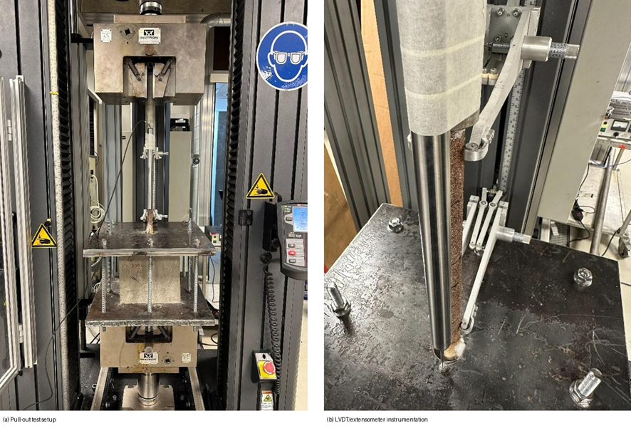
(a)
(b)

Figure 2. Pull-out test arrangement: (a) INSTRON test setup and custom fixture; (b) LVDT and extensometer used for displacement and strain measurements.

The average bond stress was calculated from the measured pull-out force using the nominal cylindrical bond surface. For a peak pull-out force P, effective bar diameter d and bonded length l, the peak average bond stress τ was calculated as shown in Eq. (1).
$$τ=P/{πdl}$$ | (1)
In addition to peak bond stress, the complete load-slip response and visible failure behaviour were recorded. The present paper focuses on the peak residual bond strength because it provides the clearest measure for comparing the post-cooling time series.

Results

3.1 Concrete strength control
Seventeen concrete cylinders were tested. Mean compressive strengths of 27.61, 31.33 and 28.82 MPa were obtained for the three casting groups. The variation between each group was consistent with normal batch-to-batch variation and the companion-cylinder results did not indicate a systematic concrete-strength trend that could explain the observed post-cooling bond-strength patterns. The pull-out comparisons were therefore interpreted primarily in terms of exposure temperature and elapsed time after cooling.

3.2 Peak residual bond strength
The bond stress versus slip response of the three unheated samples are shown in Figure 3. The peak values are marked by circles in the figure. In accordance with ASTM D7913, an additional marker is shown at a slip value of 2.5 mm beyond the peak to indicate the minimum termination criterion specified by the standard. However, the specimens were allowed to continue until approximately 18 mm slip in order to capture the post-peak bond behaviour. The unheated control specimens had an average peak bond strength of 9.91 MPa with a standard deviation of 1.03 MPa. The response after heating was strongly dependent on both exposure temperature and the time between cooling and testing.
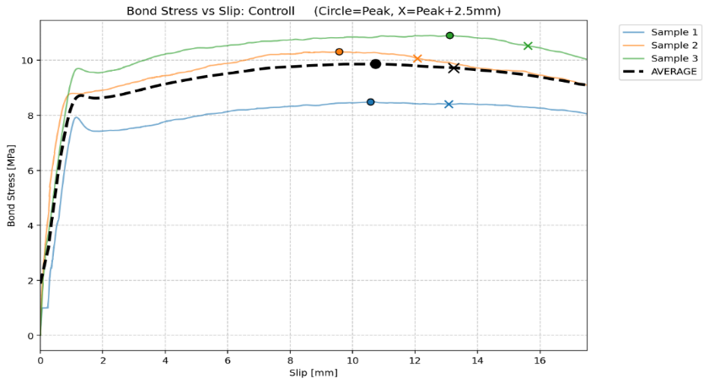
Figure 3. Bond stress versus slip response for control samples (i.e. unheated samples)

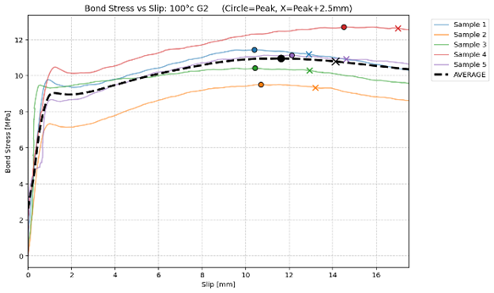
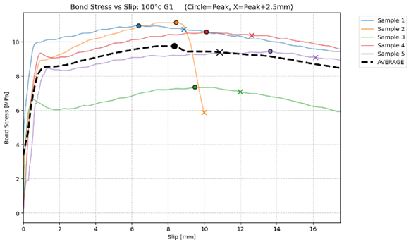
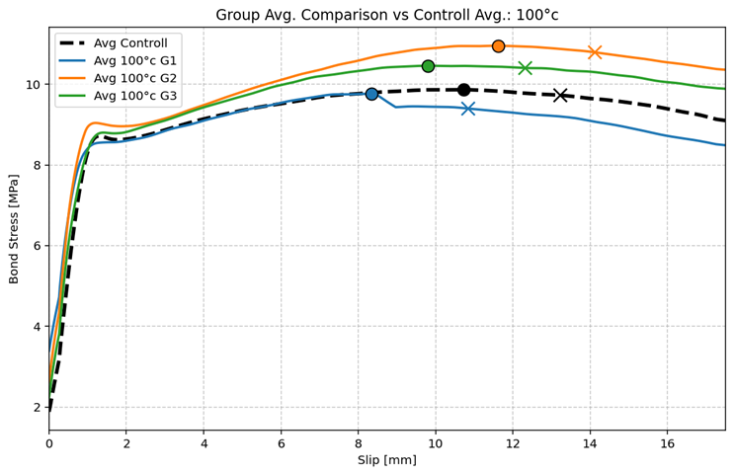
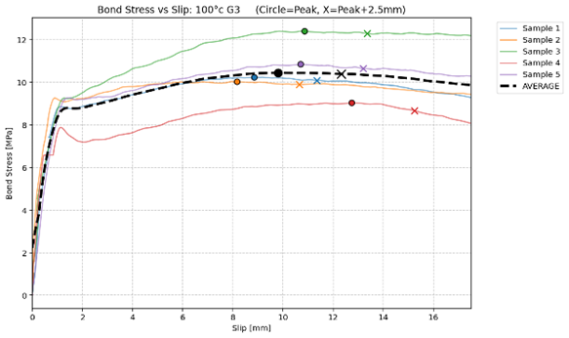
(c)
(b)
(a)
Figure 4. Bond stress versus slip response of the specimens exposed to 100°C: (a) tested after 24 hrs; (b) tested after 7 days; (c) tested after 14 days, and (d) comparison of average peaks of tested samples 24hrs, 7 days and 14days
(d)
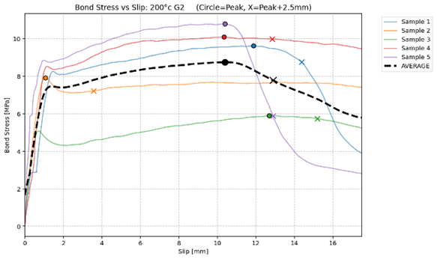
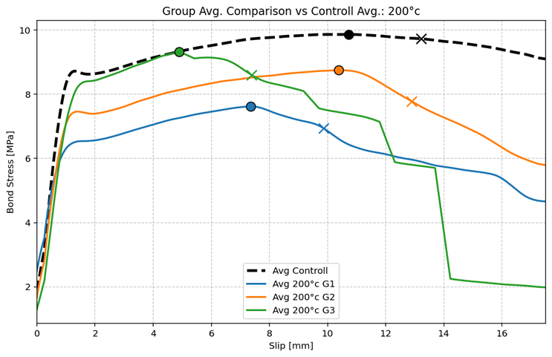
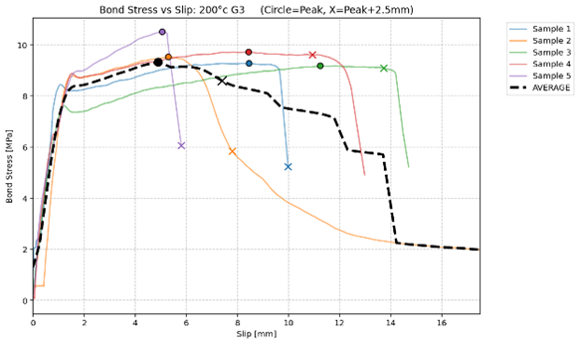
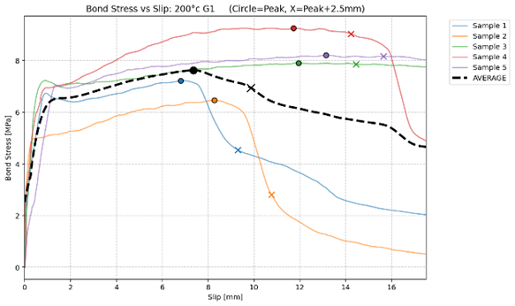
Figure 4 presents the bond stress versus slip response of the specimens exposed to 100°C and tested after 24 hours, 7 days and 14 days after cooling. In general, all specimens exhibited a response similar to that observed for the control specimens, consisting of an initial rapid increase in load, a local peak, a gradual increase towards the global peak and a subsequent reduction in load with increasing slip. Figure 4 (d) compares the average bond stress-slip responses of the three post-cooling intervals with the control specimens. The 24-hour specimens closely follow the control response throughout the test, indicating little immediate change in bond behavior following exposure to 100°C. At 100°C, the 24-hour average was 9.90 MPa, effectively identical to the control value. The average then increased to 11.04 MPa at 7 days and decreased slightly to 10.52 MPa at 14 days. Thus, this temperature series showed no immediate loss and the highest mean strength was measured one week after cooling.
(c)
(b)
(a)
Figure 5. Bond stress versus slip response of the specimens exposed to 200°C : (a) tested after 24 hrs; (b) tested after 7 days; (c) tested after 14 days, and (d) comparison of average peaks of tested samples 24hrs, 7 days and 14days
(d)

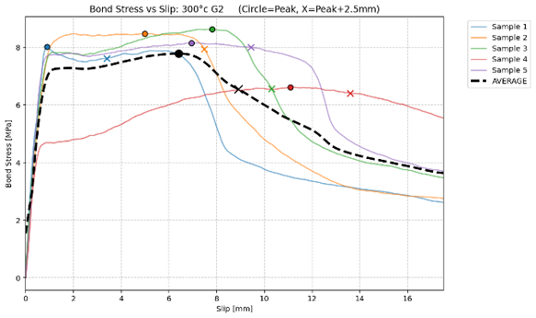
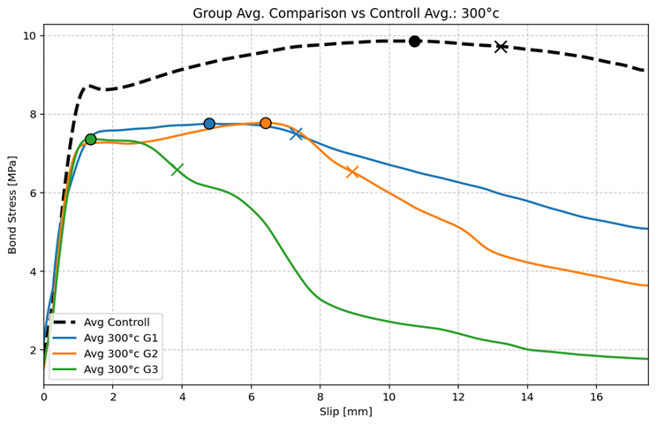
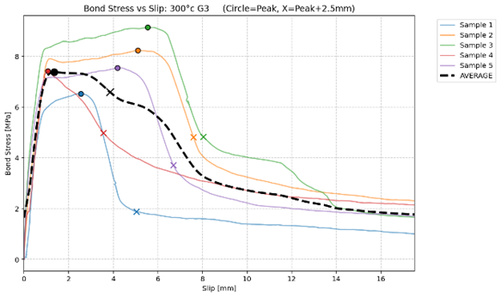
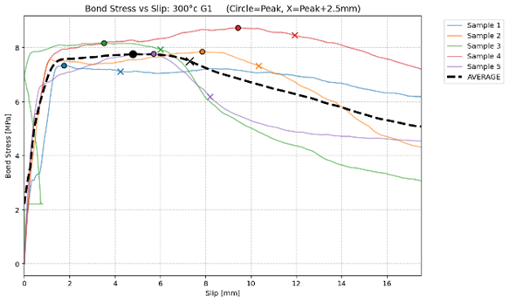
Figure 5 presents the bond stress versus slip response of the specimens exposed to 200°C and tested after 24 hours, 7 days and 14 days after cooling. Compared to the 100°C series, the specimens exposed to 200°C exhibited greater variability in both load-slip response and failure behaviour. The specimens tested 24 hours after cooling generally followed the same overall load-slip pattern as the control specimens. The specimens tested after 7 days exhibited a similar response. Specimens tested after 14 days exhibited the greatest degree of damage accumulation. Four of the five specimens experienced the failure mode classified as Break, resulting in abrupt reductions in load and a stepped descending load path in the average response. Figure 5 (d) compares the average bond stress-slip responses of the three post-cooling intervals with the control specimens. All three groups follow a similar response during the initial loading stage, although pronounced reductions in load occur after approximately 5 mm slip. The 24-hour specimen exhibits the lowest average response, while the 7-day and 14-day curves approach the control response for much of the loading path. At 200°C, the mean bond strength fell to 7.81 MPa after 24 hours, a reduction of approximately 21% relative to unheated control. It subsequently increased to 8.87 MPa at 7 days and 9.64 MPa at 14 days. The 14-day value was only 0.27 MPa below the control mean. Expressed relative to the initial loss from 9.91 to 7.81 MPa, the increase from 7.81 to 9.64 MPa represents approximately 87% recovery of that loss.
(c)
(b)
(a)
Figure 6. Bond stress versus slip response of the specimens exposed to 300°C: (a) tested after 24 hrs; (b) tested after 7 days; (c) tested after 14 days, and (d) comparison of average peaks of tested samples 24hrs, 7 days and 14days
(d)
Figure 6 presents the bond stress versus slip response of the specimens exposed to 300°C and tested after 24 hours, 7 days and 14 days after cooling. Compared to both the control specimens and the lower temperature series, the load-slip response of the 300°C specimens exhibited a noticeably different shape. The local peak remained visible, but was less pronounced, and the global peak was generally reached at lower slip values. Following the peak, a more rapid reduction in load was observed than for the control and 100°C series. The specimens tested 24 hours after cooling exhibited relatively consistent behaviour, with all specimens following a similar overall response. The specimens tested after 7 days exhibited behaviour similar to the 24-hour specimens. The specimens tested after 14 days displayed the most consistent response within the 300°C series. All specimens reached their peak load shortly after the local peak and subsequently exhibited a reduction in load without triggering the automatic break criterion. Fine cracking was observed in all specimens, extending from the reinforcement on the bottom surface of the concrete cube up the sides. Figure 6 (d) compares the average bond stress-slip responses of the three post-cooling intervals with the control specimens. All three sets exposed to 300°C exhibited substantially lower bond strengths than the control specimens. In contrast to the 200°C series, the average curves for the 24-hour, 7-day and 14-day specimen remain relatively close to one another throughout the test, indicating only minor differences in bond behaviour between the post-cooling intervals. Distinct reductions in load are visible in all three sets, particularly for the specimens tested after 14 days. The 300°C specimens behaved differently. Average strengths were 7.97, 7.98 and 7.77 MPa at 24 hours, 7 days and 14 days, respectively. These values remained well below the control strength but changed very little over the observation period. The mean response therefore suggests that, at this exposure level, the residual bond condition was largely established within the first 24 hours.
Table 3 summarizes the mean and standard deviation of the experimentally observed bond strengths for the unheated specimens and for specimens exposed to 100°C, 200°C and 300°C, and tested 24 hours, 7 days and 14 days after cooling.

Table 3. Mean peak bond strength and within-group standard deviation
Exposure | Control | 24 h | 7 d | 14 d
Unheated | 9.91 ± 1.03 | - | - | -
100°C | 9.91 ± 1.03 | 9.90 ± 1.40 | 11.04 ± 1.06 | 10.52 ± 1.11
200°C | 9.91 ± 1.03 | 7.81 ± 0.94 | 8.87 ± 1.76 | 9.64 ± 0.48
300°C | 9.91 ± 1.03 | 7.97 ± 0.46 | 7.98 ± 0.72 | 7.77 ± 0.87

3.3 Residual bond strength over time
Figure 7 shows the evolution of the average peak bond strength following exposure to elevated temperatures. The results are grouped according to exposure temperature (100°C, 200°C and 300°C) and the elapsed time between cooling and testing (24 hours, 7 days and 14 days). The trends are more informative than any single post-fire value: the 100 and 200°C series changed after the 24-hour measurement, whereas the 300°C series remained essentially flat. The confidence-interval plots showed substantial overlap between several groups, especially at 100°C and within the 300°C series. Consequently, the results should be interpreted as evidence of a systematic trend that requires larger replicate numbers for formal confirmation rather than as proof of statistically distinct populations.
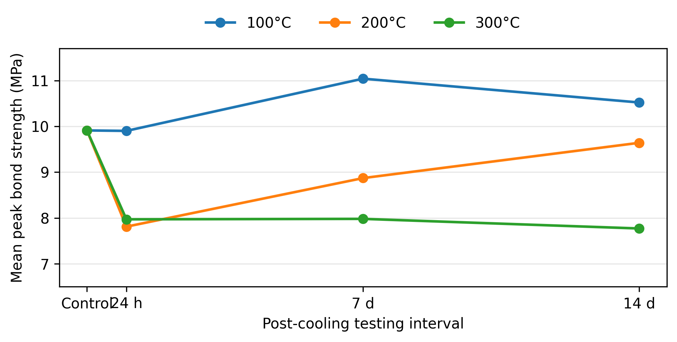
Figure 7. Evolution of mean peak bond strength after cooling (note: the same unheated control mean is shown as the initial reference for each temperature series).

3.4 Load-slip response and observed damage
The control specimens exhibited a consistent load-slip response and no visible cracking or splitting as shown in Figure 8. The 100°C series generally retained a response similar to the control specimens, although individual abrupt load reductions occurred. At 200°C, the load-slip curves became more irregular and visible cracking was more common; in the 14-day group, four of five specimens satisfied the abrupt 'break' criterion and one specimen split completely. At 300°C, the global peak was generally reached at lower slip than in the lower-temperature series and the post-peak responses contained repeated load drops. These observations indicate that the similar peak strengths recorded at different post-cooling ages do not necessarily imply identical damage states or post-peak bond behaviour.

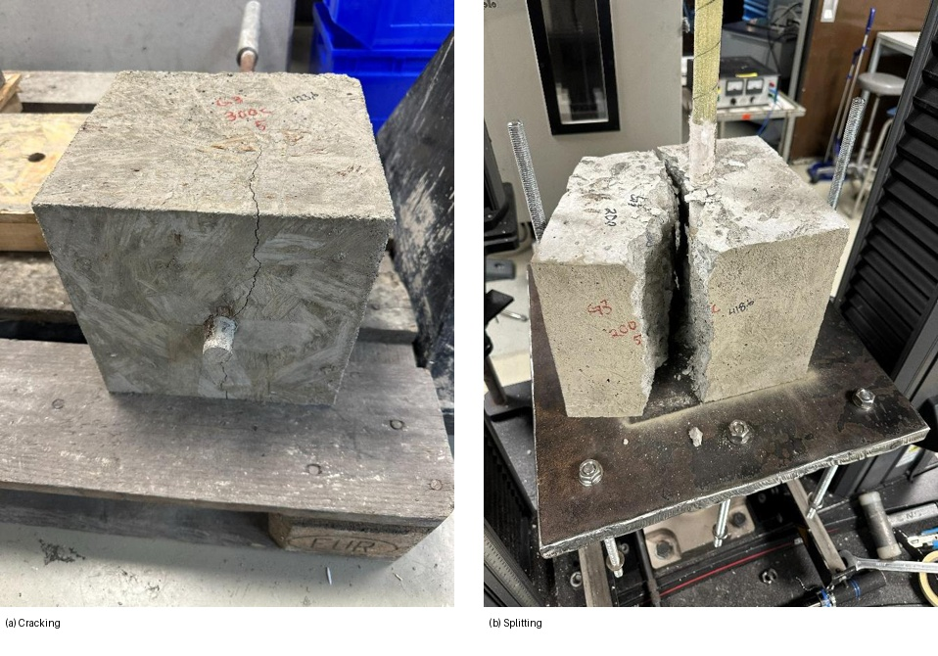
Figure 8. Representative post-test damage observed during the pull-out programme: (a) cracking radiating from the GFRP bar; (b) complete splitting of the concrete cube.

Comparison and Discussion

4.1 Post-cooling time as an independent assessment variable
The central finding is that residual bond strength cannot automatically be treated as a single, time-independent value immediately after the specimen has cooled. The 200°C series provides the clearest example. If only the 24-hour result had been measured, the residual strength would have been reported as 7.81 MPa, approximately 21% below the control. Two weeks later the corresponding average was 9.64 MPa, only about 3% below the control. Thus, an assessment based on a single early post-cooling measurement would have characterized the same thermal exposure substantially differently.
The 100°C series also suggests ongoing evolution, although the interpretation is less definitive because the changes are smaller and the confidence intervals overlap. The absence of an immediate reduction followed by a higher 7-day mean is consistent with the possibility that moderate heating altered the interface in a way that continued to develop after cooling. By contrast, the near-constant values at 300°C suggest that severe thermal damage may suppress mechanisms that could otherwise change bond performance with time.

4.2 Possible mechanisms
The experiments were designed to identify whether a time effect existed, not to isolate the underlying mechanism. Accordingly, mechanistic interpretations remain hypotheses. One possibility is continued post-curing of the vinyl ester matrix. Thermosetting vinyl ester systems can undergo additional cross-linking during thermal treatment, and previous studies have reported changes in glass-transition temperature, adhesion and thermomechanical performance with degree of cure [8,9]. The rise observed in the 100°C group is compatible with such behaviour, because 100°C lies within or near reported glass-transition ranges for many vinyl ester formulations [8,13].
A second possibility is recovery within the concrete adjacent to the bar. Thermal exposure can generate microcracking and redistribute moisture. Continued hydration, moisture redistribution and partial autogenous healing can improve the local cementitious matrix over time [10]. Since the bond of a sand-coated GFRP bar depends on adhesion and friction as well as the condition of the surrounding concrete, even limited changes in the interfacial concrete could affect measured pull-out strength. The progressive recovery at 200°C may therefore reflect a combination of polymer, concrete and interface processes rather than a single mechanism.
At 300°C, more extensive resin degradation, loss of surface integrity and concrete damage are likely to dominate. The sacrificial heating trial showed progressive discoloration and charring of exposed GFRP as temperature increased, and previous studies have documented strong deterioration in GFRP-concrete bond at high temperatures [2-4]. The absence of measurable recovery over 14 days is consistent with a transition from partly recoverable changes to predominantly irreversible thermal damage, although the present temperature spacing is too coarse to define a threshold.

4.3 Relation to previous research and engineering implications
The present findings do not challenge the established conclusion that elevated temperature is detrimental to GFRP-concrete bond. The immediate reductions measured after 200 and 300°C agree with earlier pull-out studies that reported decreasing residual capacity with increasing thermal exposure [2,3]. The additional contribution is temporal: the residual value measured at a given temperature may depend on when the test is performed. Most previous programmes used one post-cooling conditioning interval, which is sufficient to describe the state at that time but cannot establish whether the value had stabilized.
For post-fire evaluation, this distinction can be important. Decisions on repair, strengthening, continued use or demolition may rely on residual material properties measured shortly after an event. The present results suggest that, for moderate thermal exposure, early testing may be conservative relative to measurements made days later. This does not justify delaying safety decisions or assuming recovery in real structures; rather, it indicates that elapsed time after cooling should be reported explicitly and considered as a potential conditioning variable in experimental studies and post-fire assessment protocols.

4.4 Limitations
Several limitations restrict the generality of the results. Each heated condition contained only five pull-out specimens, and the overlap of confidence intervals confirms that specimen-to-specimen variability remains important. Only one 20 mm sand-coated vinyl ester GFRP product and one concrete strength level of approximately 30 MPa were investigated. Ribbed or helically wrapped bars, different resin systems, different bar diameters and other concrete strengths may exhibit different post-cooling behaviour. The thermal programme included only 100, 200 and 300°C, so a critical temperature at which recovery ceases cannot be identified. The observation period ended at 14 days and therefore does not establish long-term stability. Finally, degree of resin cure, glass-transition temperature, moisture content, concrete microcracking and hydration were not measured directly. The proposed recovery mechanisms should therefore be tested with complementary microstructural and material characterization.

Conclusions
This experimental study investigated the effect of elapsed time after cooling on the residual bond strength of sand-coated vinyl ester GFRP bars in concrete after exposure to 100, 200 and 300°C. The results demonstrate that maximum exposure temperature alone is insufficient to describe the measured residual bond response.
At 100°C, the mean peak bond strength was essentially unchanged after 24 hours (9.90 MPa compared with 9.91 MPa for the control) and increased to 11.04 MPa after 7 days before decreasing slightly to 10.52 MPa after 14 days. At 200°C, an initial reduction to 7.81 MPa was followed by recovery to 8.87 MPa after 7 days and 9.64 MPa after 14 days. This 14-day increase corresponds to approximately 87% recovery of the initial loss relative to the control. At 300°C, the average bond strength remained between 7.77 and 7.98 MPa throughout the observation period, indicating little post-cooling evolution.
The principal implication is that residual GFRP-concrete bond strength measured shortly after cooling may represent a transient stage rather than a fully stabilized condition, particularly after low to intermediate thermal exposure. The timing of residual bond assessment should therefore be documented and investigated as an independent variable. Future work should use larger sample sets, additional temperatures and longer monitoring periods and should combine pull-out testing with resin, moisture and microstructural characterization to identify the mechanisms responsible for the observed changes.

Acknowledgements
The authors would like to express their sincere gratitude to the Mehmet Inal for their technical support throughout the entire process of this study. This paper is based on the results of the first author's thesis submitted in 2026, and we acknowledge ChatGPT for assistance with English proofreading of the shortened version of the original his thesis.
References
- ACI Committee 440 2015 Guide for the Design and Construction of Structural Concrete Reinforced with FRP Bars (ACI 440.1R-15) (Farmington Hills, MI: American Concrete Institute).
- Ellis D S, Tabatabai H and Nabizadeh A 2018 Residual tensile strength and bond properties of GFRP bars after exposure to elevated temperatures, Materials 11, 346.
- Rosa I C, Firmo J P, Correia J R and Mazzuca P 2021 Influence of elevated temperatures on the bond behaviour of ribbed GFRP bars in concrete, Cem. Concr. Compos. 122, 104119.
- Rosa I C, Firmo J P, Correia J R and Bisby L A 2023 Fire behavior of GFRP-reinforced concrete structural members: a state-of-the-art review, J. Compos. Constr. 27, 03122003.
- Achillides Z and Pilakoutas K 2004 Bond behavior of fiber reinforced polymer bars under direct pullout conditions, J. Compos. Constr. 8, 173-181.
- Tighiouart B, Benmokrane B and Gao D 1999 Investigation of bond in concrete member with fibre reinforced polymer (FRP) bars, Constr. Build. Mater. 12, 453-462.
- ASTM International 2025 Standard Test Method for Bond Strength of Fiber-Reinforced Polymer Matrix Composite Bars to Concrete by Pullout Testing (ASTM D7913/D7913M-25) (West Conshohocken, PA: ASTM International).
- Scott T F, Cook W D and Forsythe J S 2002 Kinetics and network structure of thermally cured vinyl ester resins, Eur. Polym. J. 38, 705–716.
- Alia C, Jofre-Reche J A, Suárez J C, Arenas J M and Martín-Martínez J M 2015 Influence of post-curing temperature on the structure, properties, and adhesion of vinyl ester adhesive, J. Adhes. Sci. Technol. 29, 518–531.
- Suleiman A R and Nehdi M L 2021 Effect of autogenous crack self-healing on mechanical strength recovery of cement mortar under various environmental exposure, Sci. Rep. 11, 7245.
- Hajiloo H and Green M F 2018 Post-fire residual properties of GFRP reinforced concrete slabs: a holistic investigation, Compos. Struct. 201, 398–413.
- Abbasi A and Hogg P J 2006 Fire testing of concrete beams with fibre reinforced polymer rebar, Compos. Part A Appl. Sci. Manuf. 37, 1142–1150.
- Bank L C 2006 Composites for Construction: Structural Design with FRP Materials (Hoboken, NJ: Wiley).
- Baena M, Torres L, Turon A and Barris C 2009 Experimental study of bond behaviour between concrete and FRP bars using a pull-out test, Compos. Part B Eng. 40, 784–797.

