Machining operation optimization in turning of Al6061 using response surface methodology and desirability function analysis
J B Chali^{1,}*, H G Lemu² and M Gopal¹
¹Department of Mechanical Engineering, Wallaga University, Nekemte, Ethiopia
² Department of Mechanical and Structural Engineering and Materials Science, University of Stavanger, Stavanger, Norway

Corresponding Author: jaobirhanu@gmail.com

Abstract. In computer numerical control (CNC) metal-cutting operations such as turning, surface quality is a critical factor and is influenced by many parameters. In this study, the aluminum alloy Al6061 was used as the workpiece material, and response surface methodology with a central composite design was optimized using a desirability function analysis in Design-Expert software. Cutting speed (Vc), feed rate (f), and depth of cut (d) were also treated as process parameters, while material removal rate (MRR) and surface quality were selected as output responses. The experiments were conducted in a dry machining environment. The optimum surface roughness and MRR were obtained at Vc = 200 m/min, f = 0.1 mm/rev, and d = 0.598 mm. The ideal MRR and surface roughness achieved in this study are and 48.7 mm³/s and 0.67386 µm, respectively. The study's outcomes include reduced surface roughness, improving product quality and performance.
Keywords: Desirability function analysis, Response surface methodology, Surface roughness, Machining optimization, Computer numerical control
1. Introduction

Because of its superior strength-to-weight ratio, good machinability, and strong corrosion resistance, aluminum alloy 6061 (Al6061) is a key material in high-performance applications such as automotive, aerospace and marine engineering [1]. The surface finish achieved during machining significantly impacts the functional performance of Al6061 components, including fatigue life, wear resistance, and tribological characteristics [2]. A key measure of this quality is surface roughness (Ra), which is largely dictated by the machining settings used in operations such as turning [3]. The intricate, often nonlinear, and interactive effects of cutting speed (Vc), feed rate (f), and depth of cut (d) on process outputs make choosing the ideal turning parameters challenging [4]. Despite their historical use, operator experience and trial-and-error techniques often lead to less-than-ideal performance, higher production costs, and uneven product quality [5]. Statistical and empirical modeling techniques have become essential tools in contemporary manufacturing to overcome these limitations. A systematic framework for planning experiments, examining the effects of various parameters, and streamlining procedures with the fewest possible experimental runs is offered by the Response Surface Method (RSM) [6]. Compared with single-factor analyses, RSM provides deeper insights by creating mathematical models that predict process responses and show the combined effects of parameters through 3D surface plots [7], [8]. Numerous researchers have optimized Al6061 turning using statistical techniques [9], [10], although most have focused on a single response variable. However, in an industrial setting, productivity (i.e high MRR) and surface quality (low Ra) are inherently traded off against each other.
The novelty of this work is that it uses Response Surface Methodology (RSM), the Central Composite Design (CCD) technique, and a desirability function to optimize material removal rate (MRR) and surface roughness simultaneously in the dry CNC turning of aluminum alloy Al6061. This research paper identified a single optimum set of values for cutting speed, feed rate, and depth of cut that provides a better trade-off between efficiency and surface quality, unlike conventional optimization techniques that optimize machining responses independently. With a material removal rate (MRR) of 48.7 mm³/s and surface roughness of 0.67386 µm, the optimum cutting speed of 200 m/min, feed rate of 0.1 mm/rev, and depth of cut of 0.598 mm indicate the efficacy of the proposed approach.
2. Materials and methods

2.1. Experimental setup and materials
A central composite design with three equally spaced levels allows robust estimation of nonlinear curvature and quadratic effects in the response surface regression equations. The turning experiments were performed on a FANUC Oi-TC (LEADWELL) CNC lathe. The workpiece material was prepared from cylindrical Al6061 (diameter = 25 mm and length = 85 mm). A carbide insert (DCMT070204HQ VP15TF) with a 55° blade angle was used. All experiments were conducted under dry conditions to isolate the effects of lubrication differences during machining.

After each turning operation, the surface roughness was measured using a VOGEL contact-type surface roughness tester [11]. The average roughness value of the three measurements was used in further calculations. The MRR (mm³/s) per cutting revolution was calculated as a product of the cutting speed (mm/s), the feed rate (mm/rev) and the depth of cut (mm).

2.2. Design of experiments
An RSM-based Central Composite Design (CCD) [13] was used to plan the experiments using Design-Expert software. The three machining parameters, cutting speed, feed rate, and depth of cut, were selected as independent variables, each varied across three levels (Table 1).
The input parameters are based on the reference [14, 15]

Table 1. Machining parameters and their levels.
Parameter | Unit | Level
Parameter | Unit | 1 | 2 | 3
Cutting speed | m/min | 100 | 150 | 200
Feed rate | mm/rev | 0.1 | 0.25 | 0.5
Depth of cut | mm | 0.5 | 1 | 1.5
The results were analyzed to determine the optimal parameter combination to minimize surface roughness and MRR. Table 2 presents the experimental runs and the resulting responses. The design consisted of 27 experimental runs. We analyzed the collected data using Design-Expert software [16] [17].
Table 2. Experimental run
 | Factors |  |  | Responses
Run | Cutting speed [m/min] | Feed rate [mm/rev] | Depth of cut [mm] | Ra [μm] | MRR [mm³/s]
1 | 196.5 | 0.3 | 1 | 0.77 | 58.9
2 | 262 | 0.5 | 0.5 | 0.63 | 78.6
3 | 262 | 0.3 | 1 | 0.9 | 78.5
4 | 262 | 0.1 | 1.5 | 0.88 | 39.3
5 | 131 | 0.1 | 0.5 | 1.11 | 6.55
6 | 131 | 0.3 | 1 | 1.13 | 39.3
7 | 196.5 | 0.3 | 1 | 0.84 | 58.875
8 | 196.5 | 0.3 | 0.5 | 0.75 | 29.4
9 | 196.5 | 0.1 | 1 | 1.04 | 19.625
10 | 131 | 0.3 | 1 | 1.13 | 39.3
11 | 196.5 | 0.3 | 1 | 0.96 | 58.87
12 | 196.5 | 0.3 | 1 | 0.89 | 58.875
13 | 196.5 | 0.3 | 0.5 | 0.74 | 29.4375
14 | 196.5 | 0.5 | 1 | 0.7 | 98.125
15 | 262 | 0.1 | 0.5 | 0.78 | 13.08
16 | 262 | 0.5 | 1.5 | 0.62 | 196.25
17 | 196.5 | 0.3 | 1 | 0.93 | 58.88
18 | 196.5 | 0.1 | 1 | 1.04 | 19.63
19 | 262 | 0.3 | 1 | 0.89 | 78.501
20 | 196.5 | 0.5 | 1 | 0.71 | 98.125
21 | 131 | 0.5 | 0.5 | 0.71 | 32.71
22 | 196.5 | 0.3 | 1 | 0.9 | 88.3125
23 | 196.5 | 0.3 | 1.5 | 0.81 | 88.32
24 | 196.5 | 0.3 | 1 | 0.89 | 58.875
25 | 131 | 0.5 | 1.5 | 0.75 | 98.125
26 | 196.5 | 0.3 | 1.5 | 0.88 | 88.32
27 | 131 | 0.1 | 1.5 | 1.2 | 19.632
3. Results and discussion
Based on the experimental results, second-order quadratic regression models were developed to describe and predict the effects of the selected machining parameters on surface roughness (Ra) and material removal rate (MRR). The models incorporated the linear, quadratic, and interaction effects of cutting speed, feed rate, and depth of cut. Including these terms enabled the models to account not only for the individual influence of each machining parameter but also for their combined and nonlinear effects on the responses. The developed regression equations were then evaluated using analysis of variance (ANOVA) to determine the significance of the model and individual terms, and their adequacy was assessed using appropriate goodness-of-fit statistics. These validated models were then used to investigate the relationship between the machining parameters and responses and to identify the parameter combination that provides the desired balance between surface quality and material removal rate.

3.1. ANOVA of surface roughness

The ANOVA results for surface roughness (Table 3, where A = cutting speed, B = feed rate, and C = depth of cut) showed that the model is highly significant (F-value = 6.51, p < 0.001). The significant model terms are depth of cut and the quadratic terms for cutting speed (A²) and depth of cut (C²), indicating nonlinear relationships. The final regression equation for surface roughness in terms of Uncoded factors is given by Equation (1):
Ra (µm) = -1.11 + 0.0277 A + 2.70 B + 0.01 C - 0.000076 A² - 2.52 B² + 0.516 C² (1)

Table 3. ANOVA summary for the surface roughness (Ra) [18].
Source | Sum of Squares | df | Mean Square | F-value | p-value
Model | 0.6102 | 9 | 0.0678 | 35.55 | < 0.0001 | significant
A | 0.1474 | 1 | 0.1474 | 77.29 | < 0.0001
B | 0.3104 | 1 | 0.3104 | 162.76 | < 0.0001
C | 0.0147 | 1 | 0.0147 | 7.71 | 0.0129
AB | 0.0242 | 1 | 0.0242 | 12.69 | 0.0024
AC | 0.0002 | 1 | 0.0002 | 0.1049 | 0.75
BC | 0.0032 | 1 | 0.0032 | 1.68 | 0.2125
A² | 0.0517 | 1 | 0.0517 | 27.12 | < 0.0001
B² | 0.0081 | 1 | 0.0081 | 4.25 | 0.0548
C² | 0.0707 | 1 | 0.0707 | 37.05 | < 0.0001
Residual | 0.0324 | 17 | 0.0019
Lack of Fit | 0.0067 | 5 | 0.0013 | 0.6227 | 0.6857 | not significant
Pure Error | 0.0257 | 12 | 0.0021
Cor Total | 0.6426 | 26
Note: A = Cutting speed, B = Feed rate and C = Depth of cut

3.2. ANOVA of material removal rate
The MRR model was also found statistically significant (F(1, 9) = 4.87, p = 0.0025). The significant model terms are feed rate (B), depth of cut (C), and the quadratic term for cutting speed (A²), confirming that MRR is primarily driven by feed and depth, with a curvilinear relationship to speed.
This output provides the predicted material removal rate for a new set of machining parameters using established Uncoded regression equations.
MRR(mm³/s) = -98 + 1.79 A - 300 B + 12 C - 0.00412 A² + 539 B²  - 51 C² - 1.06 AB + 0.275 AC + 188 BC | (2)
Table 4 is an ANOVA table testing the statistical significance of the factors and their interactions on the response variable, i.e., MRR.
Table 4. ANOVA summary for the MRR
Source | Sum of squares | df | Mean square | F-value | p-value
Model | 39185.57 | 9 | 4353.95 | 72.18 | < 0.0001 | significant
A | 5150.74 | 1 | 5150.74 | 85.39 | < 0.0001
B | 19530.85 | 1 | 19530.9 | 323.77 | < 0.0001
C | 9642.94 | 1 | 9642.94 | 159.86 | < 0.0001
AB | 1735.11 | 1 | 1735.11 | 28.76 | < 0.0001
AC | 534.2 | 1 | 534.2 | 8.86 | 0.0085
BC | 2583.48 | 1 | 2583.48 | 42.83 | < 0.0001
A² | 1.09 | 1 | 1.09 | 0.0181 | 0.8946
B² | 1.21 | 1 | 1.21 | 0.02 | 0.8892
C² | 1.24 | 1 | 1.24 | 0.0206 | 0.8876
Residual | 1025.49 | 17 | 60.32
Lack of Fit | 282.92 | 5 | 56.58 | 0.9144 | 0.5038 | not significant
Pure Error | 742.56 | 12 | 61.88
Cor Total | 40211.06 | 26 | Cor Total

The ANOVA results strongly support the visual conclusions from the 3D surface plots: the overall model is highly significant (p < 0.0001), and the lack of fit is not significant (p = 0.5038). This means the predictive equation is reliable.
All the three main factors, i.e. feed rate, depth of cut, and cutting speed, are highly significant (p < 0.0001). Feed rate is the most dominant factor (F=323.77) in determining the surface roughness, followed by depth of cut and then cutting speed. All three two-way interactions (BC, AB and AC) are statistically significant, confirming that the factors cannot be optimized independently; the effect of one factor depends on the setting of the others. Overall, the statistical analysis confirms that the proposed model is excellent and accurately identifies the machining factors that must be precisely controlled to achieve optimal MRR.

3.3. Interaction effect of machining parameters
3.3.1. Interaction effect of surface roughness: The 3D surface plots shown in Figure 2 visualizes the relationships between the parameters and responses. The images display 3D surface plots (Figure 2 (a)) used in Response Surface Methodology (RSM). The purpose is to show the combined effect of two independent variables on a single response variable along the feed rate axis (Y-axis). As shown, the surface generally rises in this direction. This confirms the well-known machining principle: Increasing the feed rate leads to a significantly higher (worse) surface roughness, and along the cutting speed axis (X-axis), the surface drops and then rises slightly [19]. This suggests that increasing cutting speed generally reduces surface roughness.

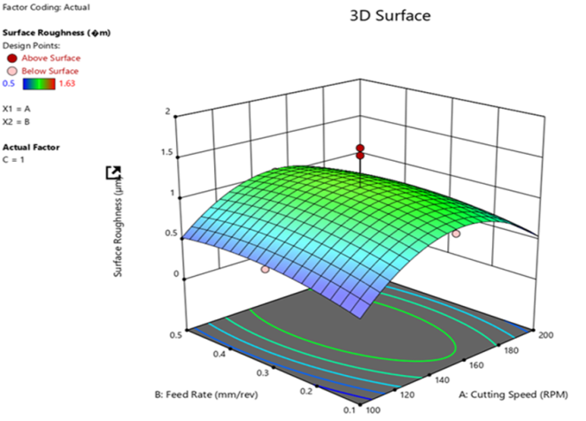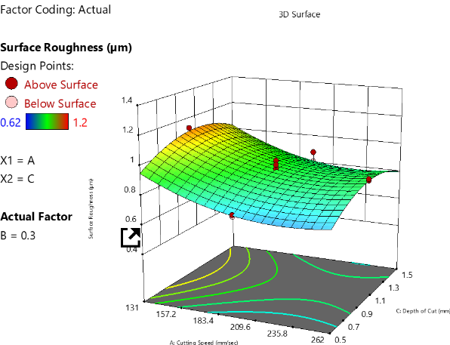
(b)
(a)
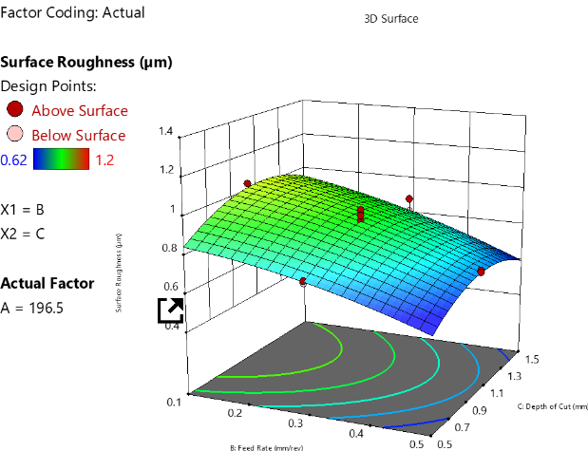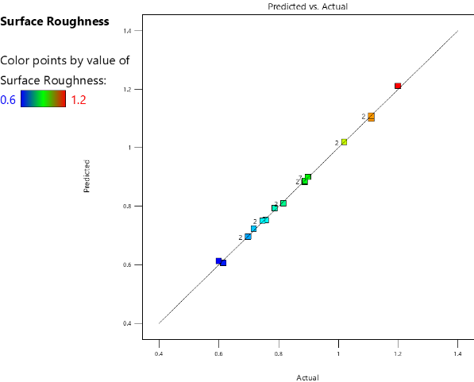
(d)
(c)
Figure 2. Surface plot of surface roughness

The curve shows a clear interaction between the two variables. The lowest roughness values (the optimum region, colored blue/green) occur at low feed rates. Figure 2(b) shows a surface plot of surface roughness as a function of cutting speed and depth of cut, while the plot in Figure 2 (c) shows the interaction between cutting speed and depth of cut, with feed rate held constant at 0.3 mm/rev. As the depth of cut increases from 0.5 to 1.5 mm, surface roughness generally increases; i.e., the surface shows a valley at the higher range of cutting speed. The blue/green region (lowest roughness ≈ 0.62 μm) is achieved by combining a low depth of cut with a high cutting speed. The plot in Figure 2(c) also shows the combined influence (interaction) of feed rate and depth of cut on the resulting surface roughness. As the feed rate increases from 0.1 mm/rev to 0.5 mm/rev, the surface roughness rises dramatically from the blue/green region to the yellow/red region.
The feed rate is also the most significant factor. Increasing it drastically increases (worsens) the surface roughness. This aligns with the theoretical geometric model of machining, in which the feed rate largely determines the height of the tool marks. As we move from the front of the plot (low depth of cut, 0.5 mm) toward the back (high depth of cut, 1.5 mm), the surface shows a slight upward trend (rising from dark blue/green to light blue/green). The depth of cut also increases surface roughness, but its effect is much less pronounced than the feed rate, especially in the optimal (low feed rate) region. This alignment between the diagnostic plot (validation) and the interaction plots (optimization) confirms that the process is well modeled and that the optimal settings have been successfully identified.
Figure 2 (d) is a predicted vs. actual plot used in statistical modeling to assess the accuracy and quality of a model. It shows a gradient from blue (0.6), representing the lowest measured roughness, through green and yellow, to red (1.2), representing the highest measured roughness. The color helps visualize whether the model performs equally well across the entire response range. Here, the low-roughness points (blue/green) and high-roughness points (orange/red) align well, confirming the model's robustness across the operating range.

3.3.2. Interaction effect of material removal rate: The primary objective of increasing MRR is to maximize productivity. The data show that MRR increases with both feed rate and depth of cut.
This 3D response surface plot in Figure 3 visualizes the relationship between cutting speed and depth of cut and the dependent variable, MRR. The scale ranges from 6.55 (blue/low) to 196.25 (red/high). The first independent variable is cutting speed. The axis shows values ranging from approximately 131 to 262 mm/s. The axis for the second independent variable, the depth of cut, shows values ranging from approximately 0.5 to 1.5 mm. The plot is shown at a fixed level of actual factor B = 0.3. This indicates that a third factor, 'B' (likely feed rate from the previous context, though not explicitly labeled), is held constant at 0.3 mm/rev to isolate the combined effect of cutting speed and depth of cut.
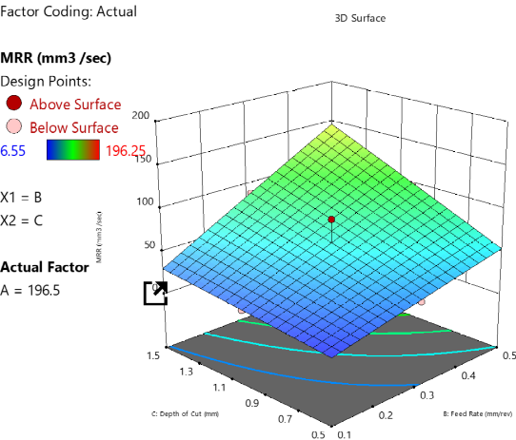
(a)
(b)
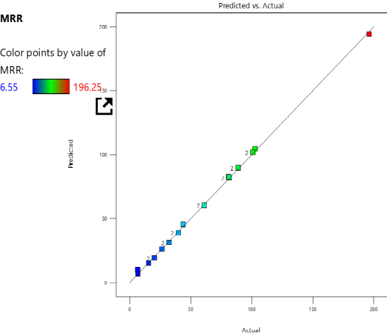
(d)
(c)
Figure 3. Surface plot of MRR
The plot is shown at a fixed level of actual factor B = 0.3. This indicates that a third factor, 'B' (likely feed rate from the previous context, though not explicitly labeled), is held constant at 0.3 mm/rev to isolate the combined effect of Acutting speed and depth of cut. The primary goal of this analysis is likely to determine the process parameters that maximize productivity, as measured by MRR. The experimental data clearly show that MRR is maximized by simultaneously setting of both independent variables, cutting speed and depth of cut, to their highest tested levels, while keeping factor B (feed rate) constant at 0.3 mm/rev. This suggests that, within the tested range and at the fixed level of Factor B, increasing these two parameters provides a very effective way to boost material removal performance.
This analysis focuses on the final 3D surface plot (Figure 3(a)), which illustrates the combined effect of cutting speed and feed rate on the MRR. The 3D surface is a clearly defined planar slope rising toward the corner where both factors are maximized. As cutting speed increases (from 131 to 262 mm/s), MRR increases consistently. This is a strong positive linear relationship. As the feed rate increases (moving from 0.1 to 0.5), the MRR also increases consistently. This relationship also appears strongly positive and nearly linear. The surface slopes upward along both axes and peaks at the maximum cutting speed and feed rate settings. This indicates a synergistic relationship, meaning that increasing both parameters simultaneously leads to the highest MRR. This strong positive correlation suggests that maximizing the two process inputs is key to maximizing productivity, within the constraints of the experimental design. Figure 3(d) shows a Predicted vs. Actual Plot for the MRR response, a standard diagnostic tool used to assess the quality of a statistical model, typically derived from a Design of Experiments (DoE) analysis. This plot is a crucial validation step in DoE. The model developed to predict the MRR is also highly accurate, robust, and reliable. The strong linear alignment of all experimental data points along the ideal line (where Predicted equals Actual) confirms that the statistical relationships used to build the model capture MRR behavior across the tested range of process parameters. This plot provides strong confidence in using the underlying statistical model (which generated the 3D surface plots in the previous analyses) for optimization and prediction within the experimental domain.
Figure 4 depicts plots of the numerical optimization demonstrating the effect of cutting speed and feed rate on (a) Surface roughness (Ra), and (b) Material removal rate (MRR). Such results can be used as a recommended machine setup to achieve the best balance between productivity and quality. Accordingly, a cutting speed of 180.82 RPM (Figure 4(a)) is relatively high but can be optimal for surface roughness. The plots also show that the recommended optimal feed rate is 0.1 mm/rev (Figure 4(b)), where the feed rate is set to its lowest value. Because feed rate significantly improves MRR while not affecting surface roughness, the software was forced to choose this low value.

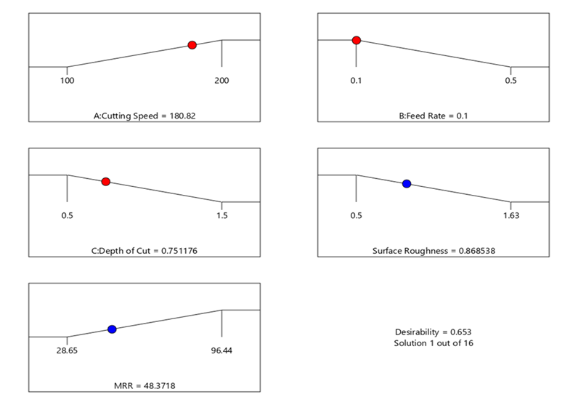
(c)
(e)
(b)
(a)
(d)
Figure 4. Numerical optimization of surface roughness and MRR using RSM optimizer
Overall attractiveness seems marginally enhanced at these settings by reducing the feed rate, most likely because a small increase in surface roughness compensated for the slight fall in MRR. The plot in Figure 4(c) shows that a depth of cut of 0.751 mm is a recommended optimal value, which falls in the medium-low range. This is an obvious compromise. On the response side, the ideal MRR was 1.5 mm, and the ideal surface roughness was approximately 0.9 mm. Again, this shows that the algorithm chose a surface roughness value closer to the optimum, as quality was prioritized.

3.4. Multi-objective optimization
The results plotted in the above figures reveal a clear conflict: the low feed rate required for a smooth surface (low Ra) results in a low material removal rate, whereas the high feed rate needed for productivity degrades the surface finish [20]. This necessitates a multi-objective optimization approach to find a balanced solution. To resolve these conflicting objectives, the authors used the desirability function approach [21]. The goal was set to "minimize" for Ra and "maximize" for MRR. The optimization process searches for a parameter combination that yields the highest overall desirability score, which represents the best compromise between the two goals. The analysis identified an optimal solution with a composite desirability of 0.653. Table 5 presents the optimal parameters and predicted responses, and Figure 5 shows the desirability ramps, highlighting the optimal settings and predicted outcomes.
The optimal solution favors conditions typical of a "finishing pass": the highest cutting speed, the lowest feed rate, and a low depth of cut. This prioritizes surface quality over maximum productivity while providing a balanced, practical solution for applications requiring a superior finish [22].

Table 5. Optimal parameter settings and predicted responses.
Parameter | Optimal value | Predicted response | Value
Cutting speed | 200 m/min | Surface Roughness (Ra) | 0.674 µm
Feed rate | 0.1 mm/rev | Material Removal Rate (MRR) | 48.7 mm³/s
Depth of cut | 0.598 mm
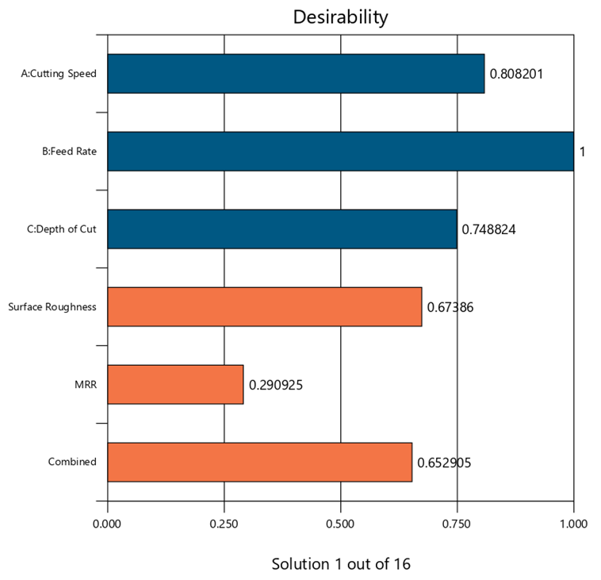
Figure 5. Desirability function plot for multi-objective optimization

3.5. Confirmation
Table 6 summarizes the predicted performance statistics for Solution 1 of the 27 optimal solutions found in the multi-objective optimization study (previously analyzed via the Ramp Plot and Desirability Chart) and provides a detailed statistical breakdown of the expected values for the two responses: surface roughness and MRR. The table presents the statistical confidence and variability associated with the predicted results at the optimized factor settings (A = 200 m/min, B = 0.1 mm/rev, C = 0.598 mm). The table confirms the specific trade-off achieved by Solution 1 and critically provides the statistical uncertainty around the predicted results. The predicted mean surface roughness of 0.7327 μm is highly precise. The 95% Confidence Interval (CI) is relatively narrow (0.667 to 0.798), meaning the model is very confident in this mean prediction.
Furthermore, even accounting for natural variation, 99% of parts are predicted to have surface roughness below 0.944 μm (the 95% TI high), confirming the success of the minimization goal. The predicted mean MRR of 47.6791 mm³/s confirms the significant sacrifice made to achieve the low surface roughness. Because the MRR data has a higher overall standard deviation, the statistical intervals are much wider than those for surface roughness. In summary, the optimized settings provide a highly confident prediction of low surface roughness and optimum MRR.
Table 6. Confirmation for predicted performance
Solution 1 of 27 Response | Predicted Mean | Predicted Median | Observed | Std Dev | SE Mean | 95% CI low for Mean | 95% CI high for Mean | 95% TI low for 99% Pop | 95% TI high for 99% Pop
Surface Roughness | 0.7327 | 0.7327 | 0.7327 | 0.043671 | 0.031127 | 0.66703 | 0.79837 | 0.52105 | 0.94435
MRR | 47.6791 | 47.6791 | 47.6791 | 7.76677 | 5.53582 | 35.9995 | 59.3586 | 10.038 | 85.3202

4. Conclusion
The main objective of this study was to perform multi-objective optimization of dry CNC turning parameters for Al6061 alloy with the simultaneous aims of minimizing surface roughness and maximizing material removal rate (MRR). Based on the experimental investigation, statistical analysis, and multi-objective optimization results, the following conclusions can be drawn:
- Regression model development: Second-order quadratic regression models were successfully developed for both surface roughness and MRR using the experimental data. The models adequately described the relationships between the machining parameters and the corresponding responses and demonstrated good predictive capability within the investigated experimental range.
- Significance of machining parameters: Feed rate was the most influential machining parameter affecting surface roughness, indicating its dominant role in determining machined surface quality. For MRR, feed rate and depth of cut were the most significant factors, highlighting their importance in controlling machining productivity.
- Trade-off between surface quality and productivity: The optimization results demonstrated that minimizing surface roughness and maximizing MRR are competing objectives. Increasing machining parameters to promote higher material removal can adversely affect surface quality. Therefore, a multi-objective optimization approach is necessary to obtain a practical compromise between machining productivity and surface finish.
- Optimal machining condition: The multi-objective optimization identified a cutting speed of 200 m/min, a feed rate of 0.10 mm/rev, and a depth of cut of 0.598 mm as the optimal combination of machining parameters. Under these conditions, the predicted/optimized performance was a material removal rate of approximately 48.7 mm³/s and a surface roughness of 0.674 µm. This parameter combination provides a suitable balance between productivity and surface quality under the investigated dry-turning conditions.
- Practical significance: The findings provide useful guidance for selecting machining parameters for dry CNC turning of Al6061 alloy where both productivity and surface quality are important. The developed models and optimized parameter combination can help manufacturers select appropriate operating conditions within the investigated experimental range.
Acknowledgements
The financial support provided by Norway Grants through the INDMET project (NORHED II program) is highly acknowledged.
References
- Samuel A U, Araoyinbo A O, Elewa R R, and Biodun M B 2021 Effect of machining of aluminum alloys with emphasis on aluminum 6061 alloy–a review. IOP Conf. Ser.: Mater. Sci. Eng. 1107 012157
- Abellán-Nebot J V, Vila Pastor C and Siller H R 2024 A review of the factors influencing surface roughness in machining and their impact on sustainability. Sustainability. 16(5) 1917.
- Danil Y P, Mozammel M et al. 2024 Resource saving by optimization and machining environments for sustainable manufacturing: A review and future prospects. Renewable Sustainaible Energy Rev. 166, 112660.
- Kuntoğlu, M, Aslan A, Pimenov D Y, Giasin K, Mikolajczyk T, and Sharma S 2020, Modeling of cutting parameters and tool geometry for multi-criteria optimization of surface roughness and vibration via response surface methodology in turning of AISI5140 steel, Mater. 13(9), 4242.
- Manjunath K, Tewary S, Khatri,N and Cheng K 2021 Monitoring and predicting the surface generation and surface roughness in ultraprecision machining: A critical review, Mach. 9(12), 369.
- Deepak D and Rajendra B 2016 Optimization of machining parameters for turning of Al6061 using robust design principle to minimize the surface roughness. Procedia Technol. 24, 372-78.
- Sumesh C S, and Ramesh A 2018 Numerical modelling and optimization of dry orthogonal turning of Al6061 T6 alloy. Period. Polytech., Mech. Eng. 62(3), 196-202.
- Zain A M, Haron H and Sharif S 2010 Prediction of surface roughness in the end milling machining using Artificial Neural Network. Expert Syst. Appl. 37(2), 1755-68.
- Putra Y M, Timuda G E, Darsono N, Chollacoop N and Khaerudini D S 2023 Optimization of machining parameters on the surface roughness of aluminum in cnc turning process using taguchi method. Int J Innov Mech Eng Adv Materials, 5, 56-62.
- Nguyen V, Do H and Tran T 2025 Experimental study and multi-objective optimisation of CNC turning parameters of AL6061 materials. Australian J.l Eng. 23(3), 499-508,
- Palová K, Kelemenová T and Kelemen M 2023 Measuring procedures for evaluating the surface roughness of machined parts. Appl. Sci. 13(16), 9385.
- Yau L C and Chockalingam P 2023 Material removal rate study on turning of Al alloy. In: Proc. Multimedia University Eng. Conf. (MECON 2022) AER 214, 68-81.
- Gutema, E. M., Gopal, M., & Lemu, H. G. 202). Minimization of Surface Roughness and Temperature during Turning of Aluminum 6061 Using Response Surface Methodology and Desirability Function Analysis. Materials, 15(21), 7638.
- Deepak, D., & Rajendra, B. 2016. Optimization of Machining Parameters for Turning of Al6061 Using Robust Design Principle to Minimize the Surface Roughness. Procedia Technology, 24, 372–378.
- Sudianto A, Saedon J and Adenan S 2024 Optimization of machining parameters for product quality and productivity in CNC machining of aluminium alloy. J. Mech. Eng. 21(3), 145-64.
- Mahbubah N A, Nuruddin M, et al. 2022 Optimization of CNC turning parameters for cutting Al6061 to achieve good surface roughness based on Taguchi method. J. Adv. Res. Appl Mech. 99(1) 1-9.
- Zhang T, Uba F, Kuusana Y and Ibrahim A 2023 Experimental optimization of high-precision turning parameters of AL6061 materials for automotive industry based on grey relational analysis. Int. J. Automot. Mech. Eng. 20(4) 10878-93.
- Gutema E M, Gopal M and Lemu H G 2022 Minimization of surface roughness and temperature during turning of aluminum 6061 using response surface methodology and desirability function analysis. Mater. 15(21), 7638.
- Mahdi B L, Ali A H, Hussein H K and Abdulateef O F 2024 The influence of cutting parameters on the surface hardness in turning of 6061 aluminum alloy. Eng. Technol. Appl. Sc. Res. 14(5), 17118-24.
- Abdulridha H, Helael A and Al-duroobi A 2020 Prediction the influence of machining parameters for CNC turning of Aluminum alloy using RSM and ANN. Eng. Technol. J., 38(6), 887-95.
- Shabeeb A H, Abdulridha H H, Obaeed N H and Mohammed M M 2025 Multi-objective optimization and prediction of milling parameters for Al 6061 alloy using desirability analysis and artificial neural networks. Eng. Res. Express 7(2), 025528.
- Sudianto A, Saedon J and Adenan S 2024 Optimization of machining parameters for product quality and productivity in CNC machining of Aluminium alloy. J. Mech. Eng. 21(3) 145-64.

