Modeling of domestic AC performance to improve energy efficiency
A E Kattaia^{1,*}, A R Elsayed¹ , N A Mahmoud¹, R A Sweif² and M El Morsi³
¹ Mechanical Power Engineering Department, Faculty of Engineering, Ain Shams University, 1 Elsarayat Street, Abbassia 11517, Cairo, Egypt
² Electrical Power & Machines Department, Faculty of Engineering, Ain Shams University, Cairo, Egypt
³ Department of Mechanical Engineering, American University in Cairo, AUC Avenue, New Cairo 11835, Cairo, Egypt
* Corresponding author: 2102148@eng.asu.edu.eg
Abstract. This paper experimentally characterizes a commercial 1.5 HP R-32 inverter split air conditioner in an ISO/IEC 17025:2017 accredited psychrometric laboratory following ISO 5151:2017. Twenty-seven steady-state operating points covered outdoor dry-bulb temperatures of approximately 35, 43, and 46 °C, three indoor-fan modes, and compressor frequencies from 15 to 95 Hz. Each test used one hour of stabilization followed by 30 minutes of measurements at 5-second intervals. Cooling capacity ranged from 2,273.76 to 15,124.37 BTU/h, electrical power from 200.0 to 1,822.3 W, and EER from 7.33 to 12.77 BTU/W·h. At the ISO 5151 T1 condition, the unit delivered 14,115.10 BTU/h at 1,819.1 W with an EER of 7.76 BTU/W·h and an SHR of approximately 0.63. A five-predictor linear regression outperformed a squared-terms alternative in leave-one-out cross-validation, with RMSE values of 882.34 BTU/h for cooling capacity, 1,168.04 BTU/h for sensible capacity, 77.00 W for input power, and 0.858 BTU/W·h for EER. The resulting equations support interpolation within the measured envelope, while Appendix A provides the raw data for independent verification.
Keywords: Domestic air conditioner; energy efficiency ratio; inverter compressor; psychrometric testing; sensible heat ratio; hot-climate performance; ISO 5151; ISO/IEC 17025; multivariable regression; leave-one-out cross-validation.

Nomenclature
Symbol | Description / Unit
AC | Air conditioner
BTU/h | Cooling capacity unit, British thermal unit per hour
CFM | Airflow rate, cubic feet per minute
DBT | Dry-bulb temperature, °C
EER | Energy efficiency ratio, BTU/W·h
f | Compressor frequency, Hz
HP | Horsepower
LOOCV | Leave-one-out cross-validation
MPC | Model predictive control
PMV | Predicted mean vote
Q | Measured indoor airflow rate, CFM
R² | Coefficient of determination
RMSE | Root-mean-square error
Tₒ | Outdoor dry-bulb temperature, °C
Tᵢ,DB | Indoor dry-bulb temperature, °C
Tᵢ,WB | Indoor wet-bulb temperature, °C
W | Electrical power, watt
Y | Predicted model output
β₀–β₅ | Regression coefficients
Qt | Total cooling capacity, BTU/h
Qs | Sensible cooling capacity, BTU/h
Qlat | Latent cooling capacity, BTU/h
SHR | Sensible heat ratio = Qs / Qt
W_el | Electrical power input, W
WBT | Wet-bulb temperature, °C

1. Introduction
Energy optimization is central to the sustainable operation of modern buildings. Heating, ventilation, and air-conditioning systems contribute substantially to electricity demand, particularly during periods of high cooling load. Direct-expansion split air-conditioning systems are widely used because of their compact configuration and ability to provide individual-zone cooling. Inverter-driven compressors improve part-load operation by adjusting compressor speed to match the required thermal load instead of relying only on-off cycling. However, unit performance remains dependent on compressor frequency, indoor airflow, and indoor and outdoor psychrometric conditions. Controlled laboratory characterization is therefore required to quantify the interaction among cooling output, electrical input, and efficiency and to provide data suitable for predictive modeling. The present work targets a controlled empirical model that simultaneously spans compressor frequency, indoor airflow and hot-ambient conditions representative of the Middle East and North Africa summer, and that is validated for interpolation using leave-one-out cross-validation and quantified measurement uncertainty.

2. Literature Review
Previous studies have shown that inverter control, airflow, operating conditions, and component design strongly affect split air-conditioner performance. Sheu and Adagunodo (2019) evaluated an inverter drive for regulating compressor speed and cooling output, while Elsayed and Kayed (2020) experimentally showed that a 7 °C rise in condenser inlet-air temperature increased power consumption by 18% and reduced COP by 15%. Berman et al. (2020) improved a wall-mounted split unit using a capillary tube-in-tube heat exchanger, increasing refrigeration effect by 13.2% and COP by 14.9%. Amoabeng et al. (2023) and Zeyang Li et al. (2023) further demonstrated that optimized or dynamic temperature setpoints can reduce energy consumption and operating cost while maintaining thermal comfort.
Model predictive control has been widely investigated as a means of balancing energy use and comfort. Pandey et al. (2021) developed a PMV-constrained MPC for a residential split unit and reported cooling-energy savings of 8.8-17.5%. Bohara et al. (2023) experimentally applied MPC and adaptive MPC to a 1.5-ton inverter air conditioner, maintaining PMV within ±0.5 for almost the full test day and achieving more than 7.06% energy saving with adaptive MPC. Shao et al. (2023) tested a practical MPC algorithm on laboratory and commercial DX systems and reported savings of 23.3% and more than 32%, respectively. Wang et al. (2022) extended MPC to demand response, shifting 6.34-21.60% of peak-hour energy use and reducing electricity cost by 13.44-27.43%. Hou et al. (2022) also showed that correcting weather-forecast errors considerably improves MPC cost and comfort performance.
Accurate performance models are therefore essential for control and building simulation. Yu et al. (2021) found deterministic grey-box models more suitable for MPC than equivalent stochastic models. Cheng et al. (2021) developed load-based testing and performance-mapping methods that preserve interactions between integrated controls and building loads, while Pizzatto et al. (2024) produced an empirical inverter AC model from 96 psychrometric tests with mean absolute errors below 5% within the tested range.
Three gaps remain for engineering use in hot climates. First, few open empirical models simultaneously relate outdoor dry-bulb up to 46 °C, indoor dry- and wet-bulb, compressor frequency across the inverter envelope and measured indoor airflow to cooling capacity, sensible capacity, input power and EER within a single multivariable fit. Second, the model-selection step is rarely reported with cross-validated error, so overfitting risk cannot be independently judged. Third, the dependence of sensible heat ratio on fan setting and compressor frequency is seldom quantified from the same dataset. The present study addresses these three gaps using an ISO 5151 T1-anchored, ISO/IEC 17025-traceable dataset of 27 steady operating points on a 1.5 HP R-32 inverter split unit, with leave-one-out cross-validation between a five-term linear model and a ten-term squared-terms quadratic model, and with a per-point SHR analysis.

3. Methodology

3.1 Test facility and unit under test
The experimental program was conducted in a psychrometric laboratory accredited to ISO/IEC 17025:2017 and operating against standard operating procedure SOP-PSY2-7.2-1 for ISO 5151:2017 tests. The two psychrometric rooms are independently conditioned so that the indoor and outdoor dry-bulb and wet-bulb set points can be held while the unit under test (UUT) operates at a selected compressor frequency and indoor-fan mode. The UUT is a commercial 1.5 HP R-32 inverter split, model 53KHEFT12DN8-708F, with inverter rotary compressor model KSK103D32UEZ31 and refrigerant charge R-32 / 580 g. The indoor unit installation and laboratory arrangement are shown in Figure 1. The indoor and outdoor sections are installed in controlled test spaces and are connected through insulated refrigerant piping.

3.2 Experimental variables and test matrix
The test matrix comprises 27 steady operating points distributed among three condition groups, designated A, B, and C. Group A is tested at an outdoor dry-bulb temperature of approximately 35 °C and indoor conditions of approximately 27 °C dry bulb and 19 °C wet bulb. Group B and C are tested at outdoor dry-bulb temperatures of approximately 43 °C and 46 °C, respectively, with indoor conditions of approximately 32 °C dry bulb and 23 °C wet bulb.
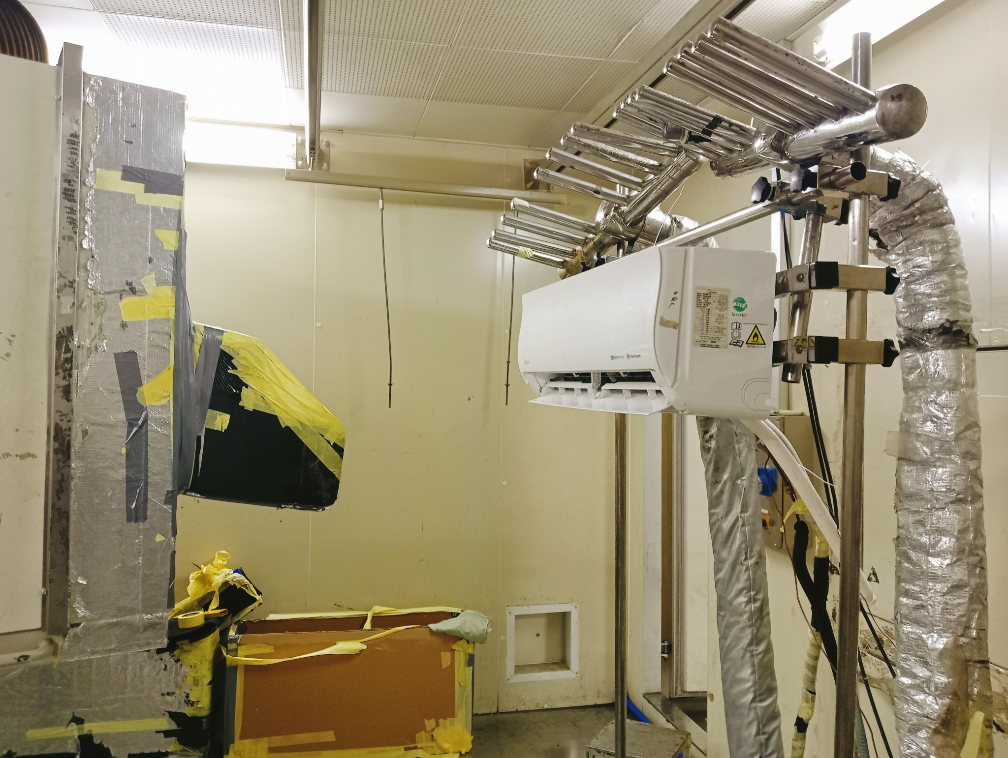
Figure 1. Psychrometric laboratory installation and indoor unit installation
For each condition group, tests are conducted at high, medium, and low indoor-fan modes. Compressor-frequency settings are 15, 30, and 95 Hz for group A; 15, 30, and 77 Hz for group B; and 20, 35, and 81 Hz for group C. Measured airflow ranges from 180.85 to 320.02 CFM.

3.3 Measured quantities
The recorded quantities are outdoor dry- and wet-bulb temperature, indoor dry- and wet-bulb temperature, atmospheric pressure, compressor frequency, applied voltage and current, electrical power consumption, air-side nozzle differential pressure and nozzle dry-bulb (for airflow derivation per the ISO 5151 Annex code-tester method), total cooling capacity and sensible cooling capacity obtained from the indoor-side air-enthalpy balance. Indoor airflow is measured at the indoor unit fan outlet as illustrated in Figure 2, while the outdoor unit installation used during testing is shown in Figure 3. EER is evaluated in BTU/W·h as total cooling capacity in BTU/h divided by electrical power consumption in W. The sensible heat ratio is evaluated as SHR = Qs / Qt.
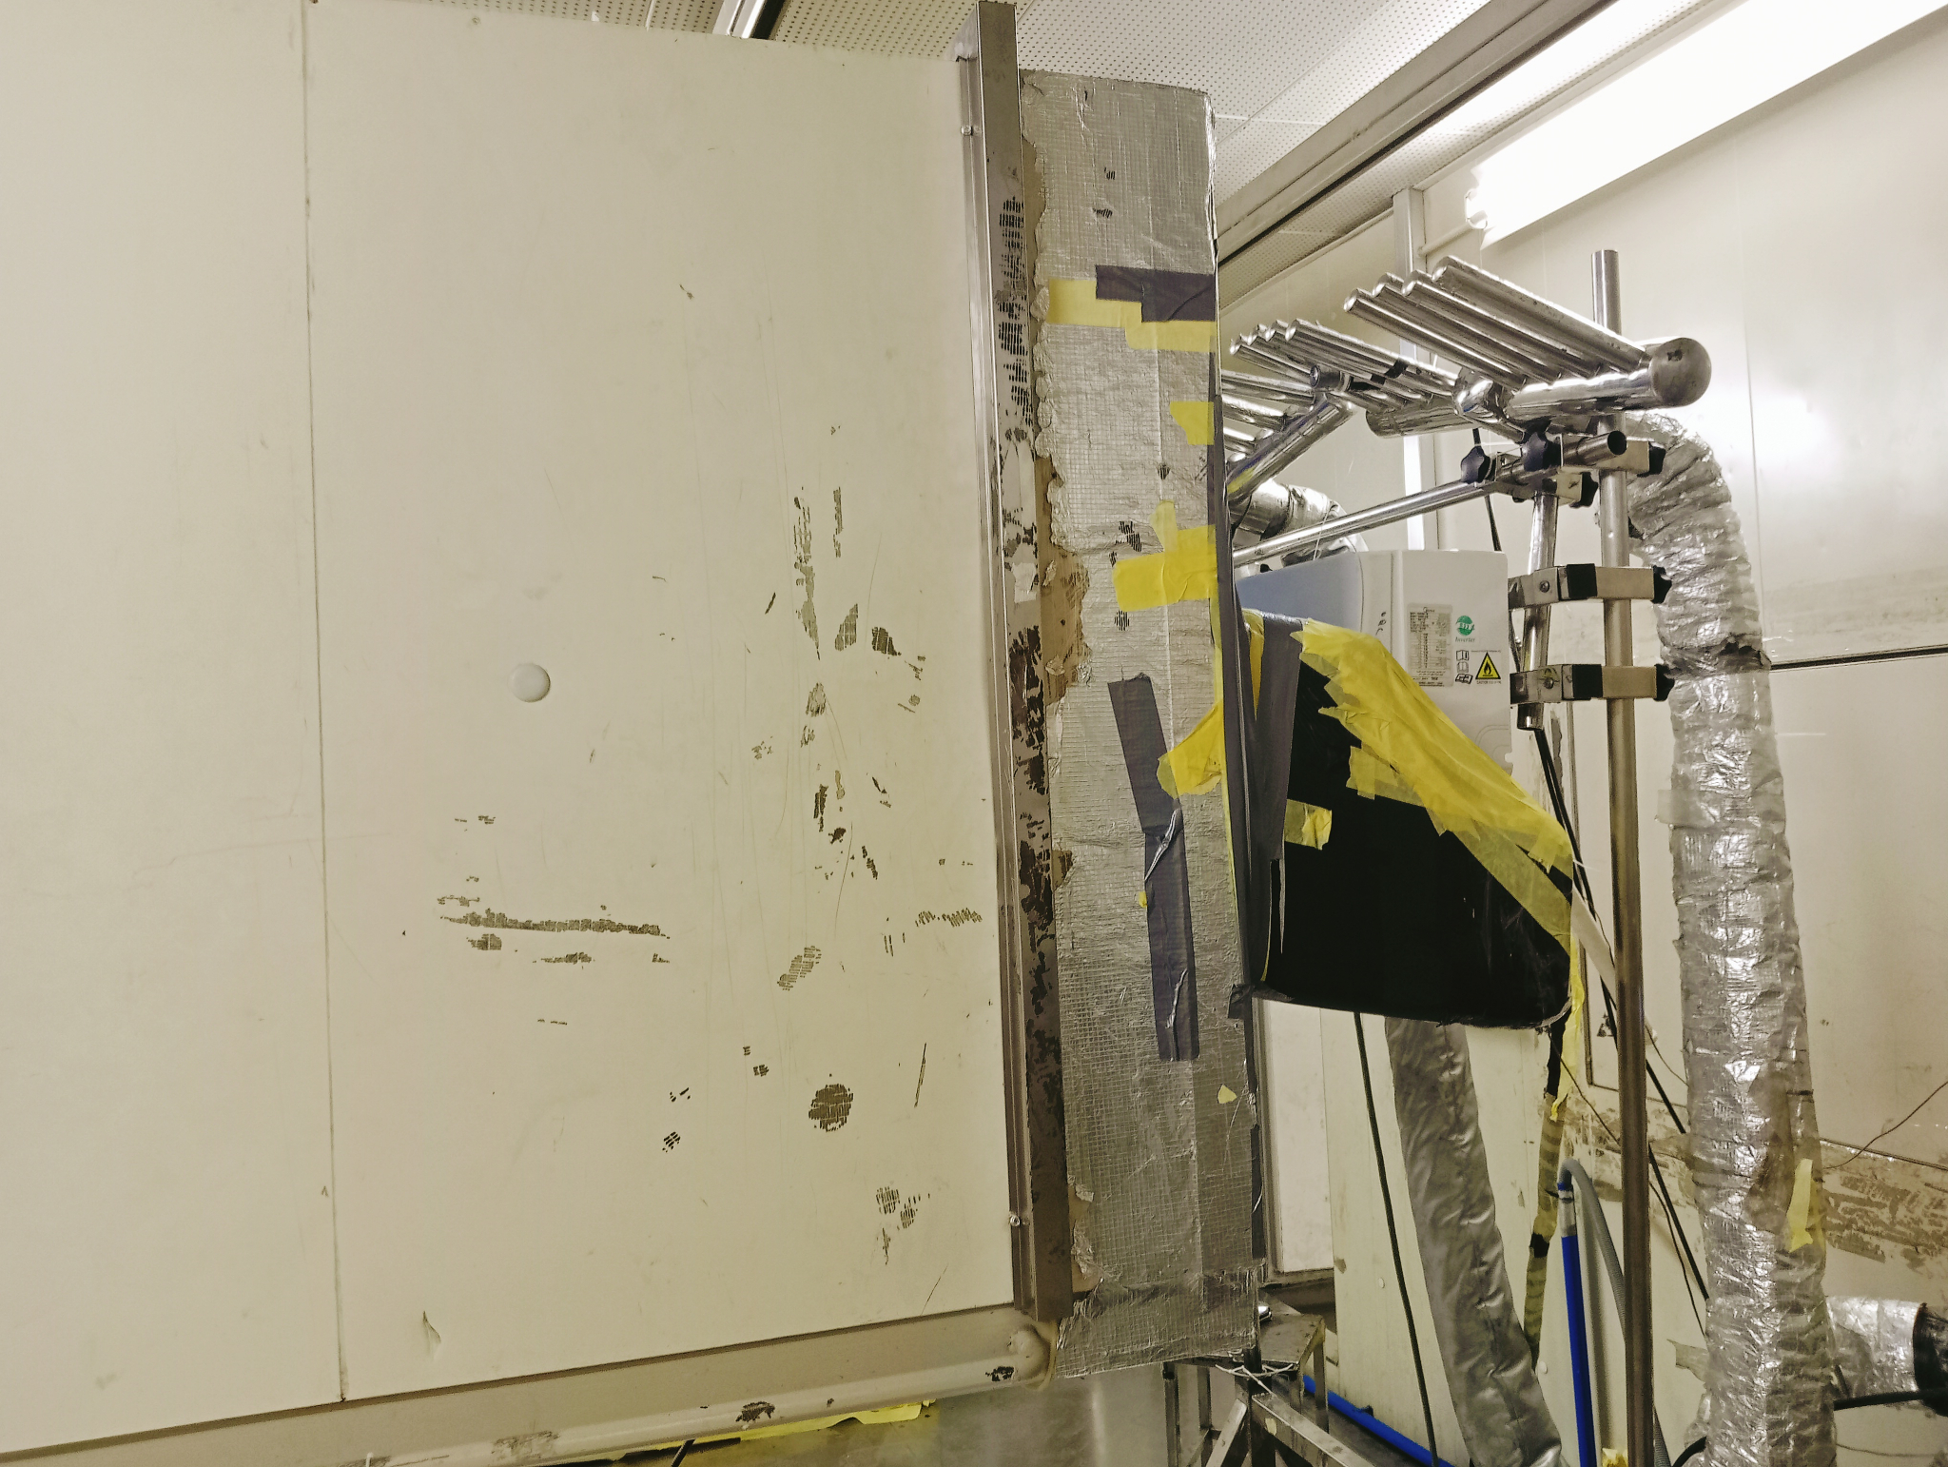 | 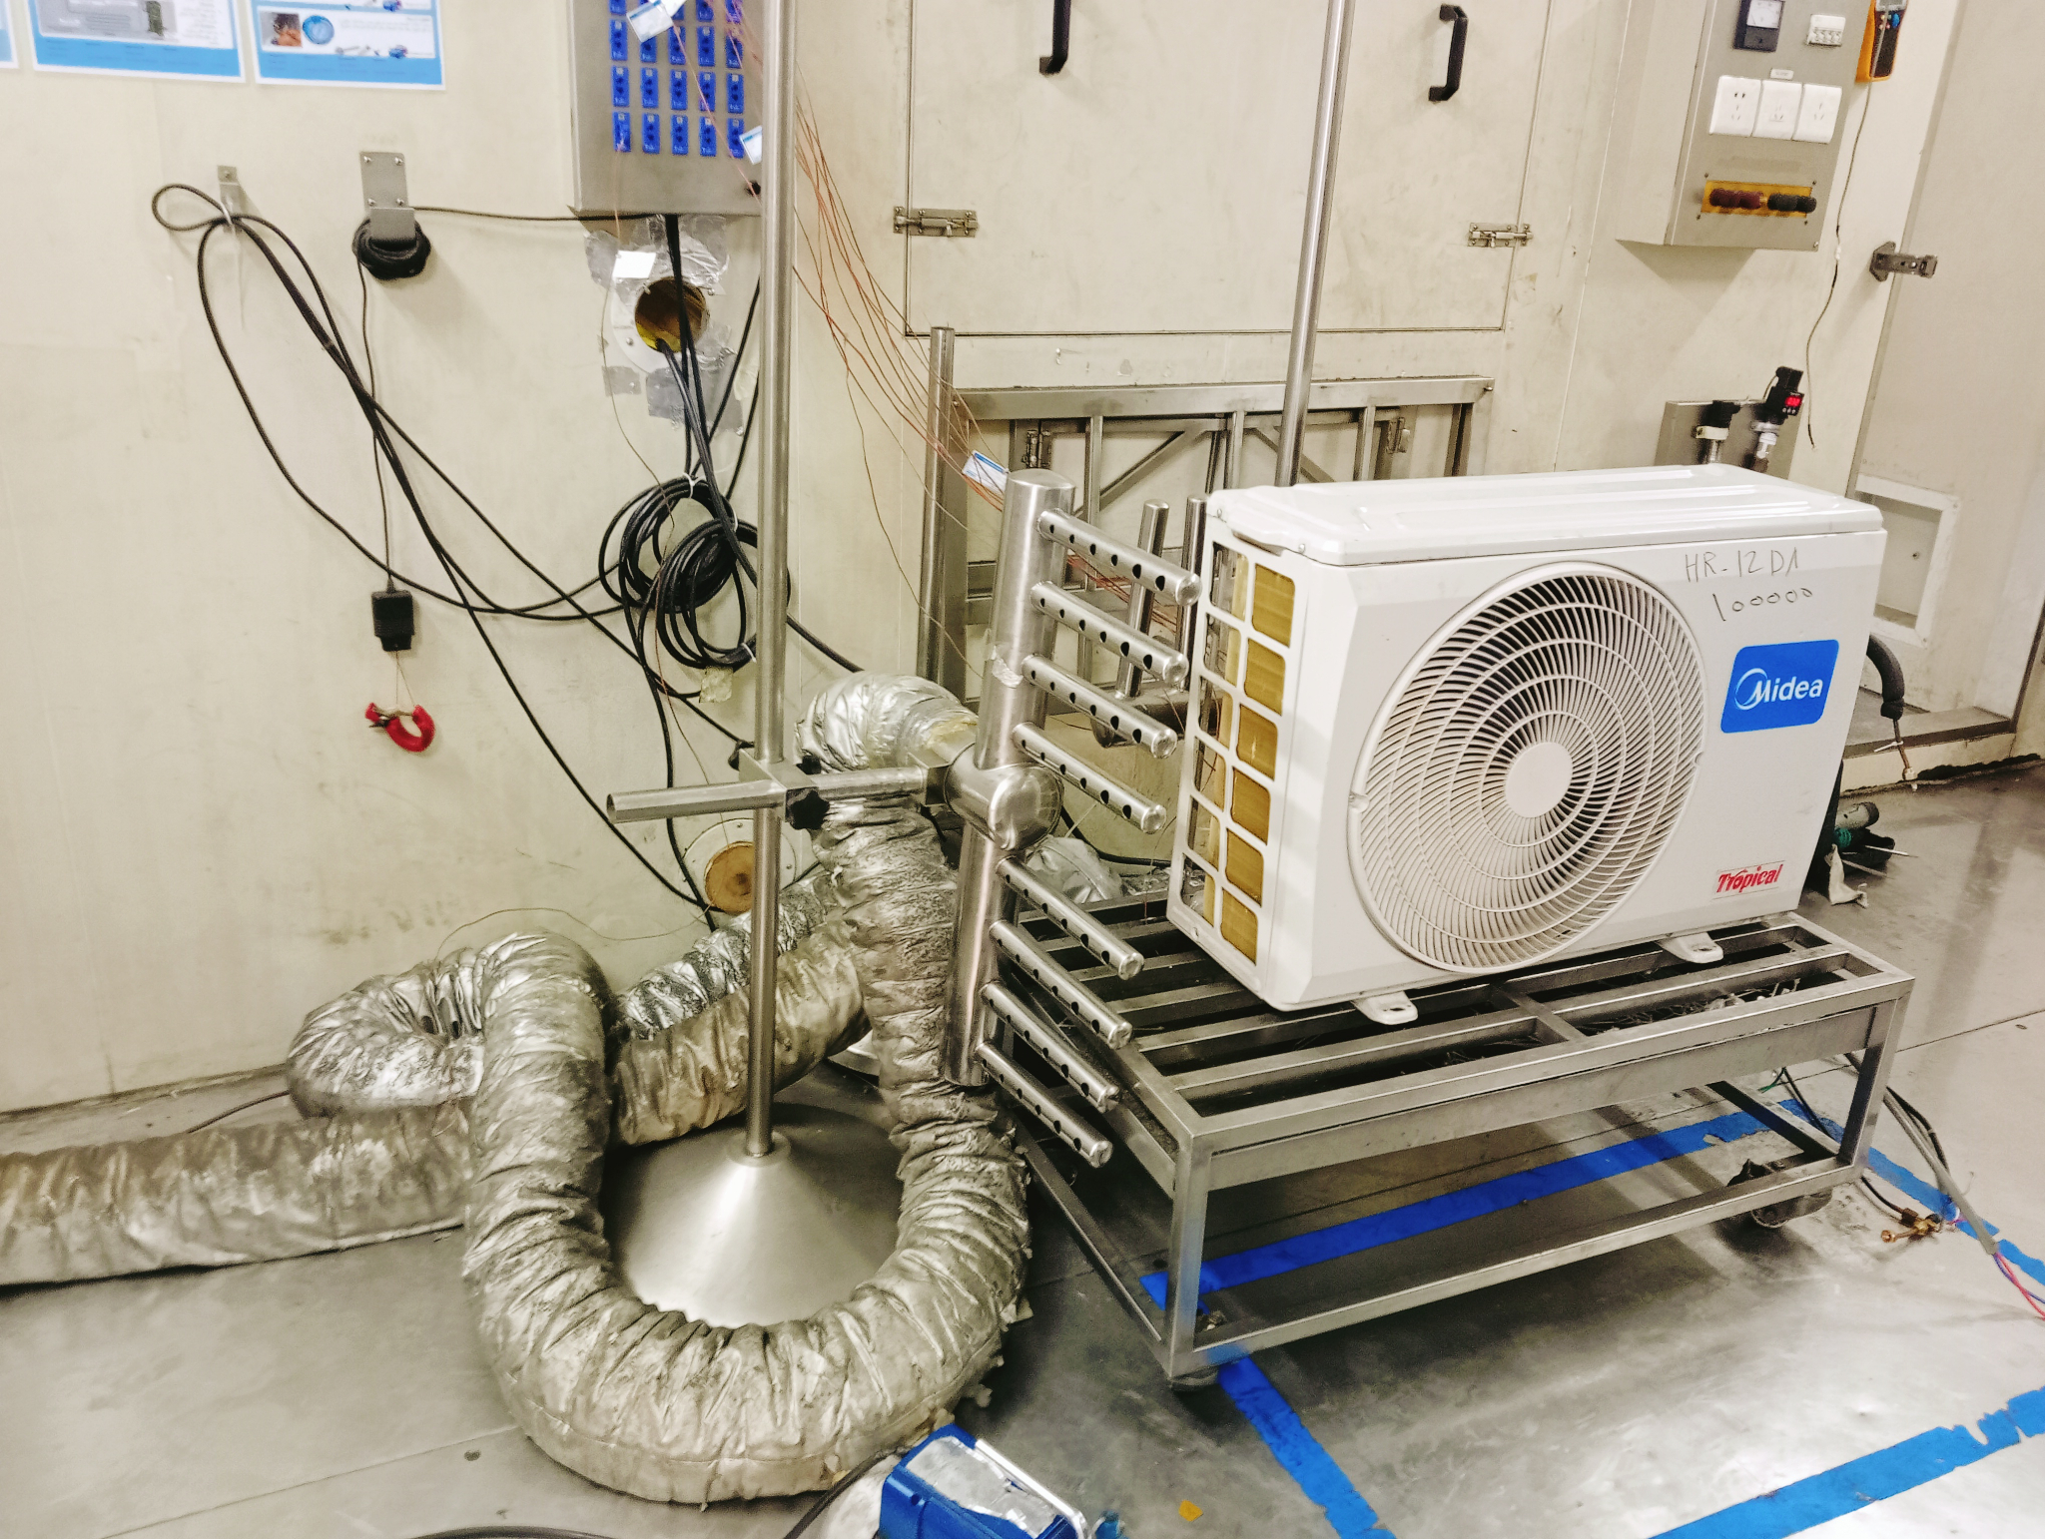
Figure 2. Psychrometric laboratory installation: airflow-rate measurement of the indoor-unit fan | Figure 3. Psychrometric laboratory installation: outdoor-unit installation

3.4 Test procedure, steady-state criteria and data acquisition
For each operating point, the specified indoor and outdoor psychrometric conditions, compressor frequency and indoor-fan mode were imposed. Testing was conducted in accordance with ISO 5151:2017 and the laboratory procedure SOP-PSY2-7.2-1. Before recording the reported performance data, the air-conditioning unit was operated continuously for one hour to achieve full stabilization under the prescribed test conditions. Following this stabilization period, measurements were recorded for an additional 30-minute data-acquisition period at equal intervals of 5 seconds, corresponding to approximately 360 recorded readings for each measured parameter at each operating point. These recorded measurements were used to determine the reported steady-state performance values. The indoor and outdoor psychrometric conditions were maintained within the applicable test tolerances of ±0.3 °C on dry-bulb, ±0.2 °C on wet-bulb and ±0.1 kPa on atmospheric pressure throughout the data-acquisition period.

3.5 Measurement uncertainty and tolerances
The uncertainty budget follows ISO/IEC 17025:2017. For the ISO 5151 Standard Cooling T1 test, the reported expanded uncertainty on cooling capacity is ±2.74 % and on heating capacity is ±2.06 %, both at coverage factor k = 2, corresponding to a level of confidence of approximately 95 %, with traceability of the measurement to SI units. Control tolerances during the data window are ±0.3 °C on indoor and outdoor dry-bulb, ±0.2 °C on wet-bulb and ±0.1 kPa on atmospheric pressure. These tolerances govern the admissible drift of the controlled conditions, while the ±2.74 % value governs the reported capacity measurement.

3.6 Controlled and measured factors
The indoor dry- and wet-bulb and outdoor dry-bulb were controlled set-point variables; the compressor frequency was a controlled set-point imposed on the inverter drive; the indoor fan setting (Low, Medium, High) was a controlled discrete factor imposed through the unit's own three-step controller; and the outdoor-unit fan was maintained at a fixed speed throughout the test campaign so that outdoor-side airflow was held constant across all 27 operating points. The measured indoor airflow in CFM is a dependent variable, since the indoor-fan controller does not guarantee a constant volumetric airflow across all condition groups. The regression therefore treats indoor airflow as a measured covariate rather than as an independently controlled factor.

3.7 Predictive-model method
Multiple linear regression models are fitted using outdoor dry-bulb temperature, indoor dry-bulb temperature, indoor wet-bulb temperature, compressor frequency, and measured airflow as predictors. Separate models are developed for total cooling capacity, sensible capacity, power consumption, and EER. Squared-terms quadratic alternatives include the same five linear and five squared terms without interaction terms.
Model selection uses leave-one-out cross-validation. Each model is repeatedly fitted with one test-omitted, and prediction errors for the omitted observations are summarized using root-mean-square error. The formulation with lower held-out RMSE is retained. Predictions outside any measured input range are classified as extrapolations.
The three compressor-frequency settings per condition group correspond to the inverter drive's low, mid-load and maximum operating points. The maximum frequency differs between groups because the inverter controller limits the maximum compressor frequency as outdoor-ambient temperature rises to protect the compressor envelope. The three values are therefore not placed on a uniform grid, and this is treated as a limitation when interpreting isolated frequency effects.

4. Results

4.1 Test matrix and overall performance range
The measured dataset covers outdoor dry-bulb temperatures from 35.01 to 45.97 °C, indoor dry-bulb temperatures from 26.98 to 32.05 °C, indoor wet-bulb temperatures from 18.95 to 23.05 °C, compressor frequencies from 15 to 95 Hz, and measured airflows from 180.85 to 320.02 CFM. Across all 27 tests, cooling capacity ranges from 2,273.76 to 15,124.37 BTU/h, electrical power input from 200.0 to 1,822.3 W, and EER from 7.33 to 12.77 BTU/W·h.
Table 1. Summary of the tested operating envelope
Condition  group | Nominal outdoor  DBT | Frequency  settings | Airflow range
A | ≈35 °C | 15, 30, 95 Hz | 192.40–314.01 CFM
B | ≈43 °C | 15, 30, 77 Hz | 180.85–320.02 CFM
C | ≈46 °C | 20, 35, 81 Hz | 196.27–313.25 CFM

4.2 Effect of airflow on energy efficiency
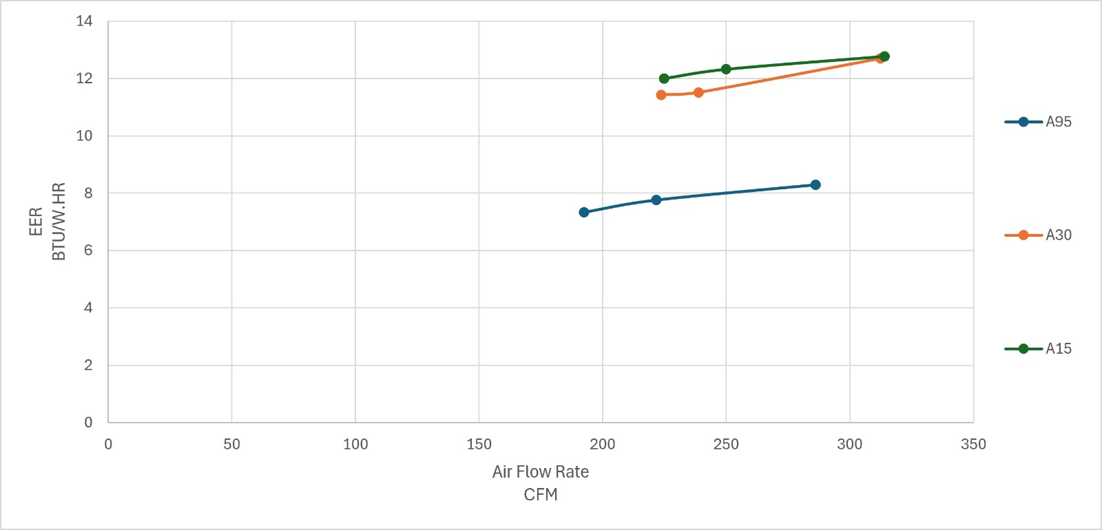
Figure 4. EER versus airflow rate for condition group A
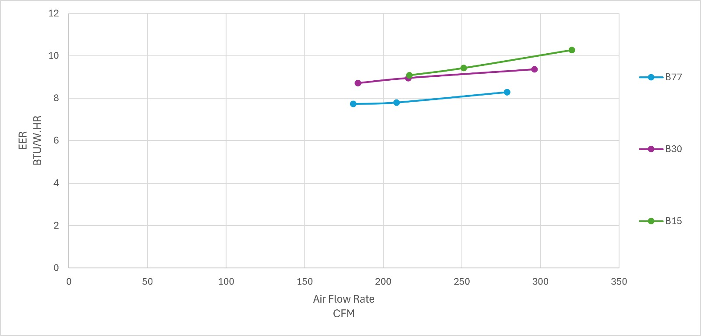
Figure 5. EER versus airflow rate for condition group B
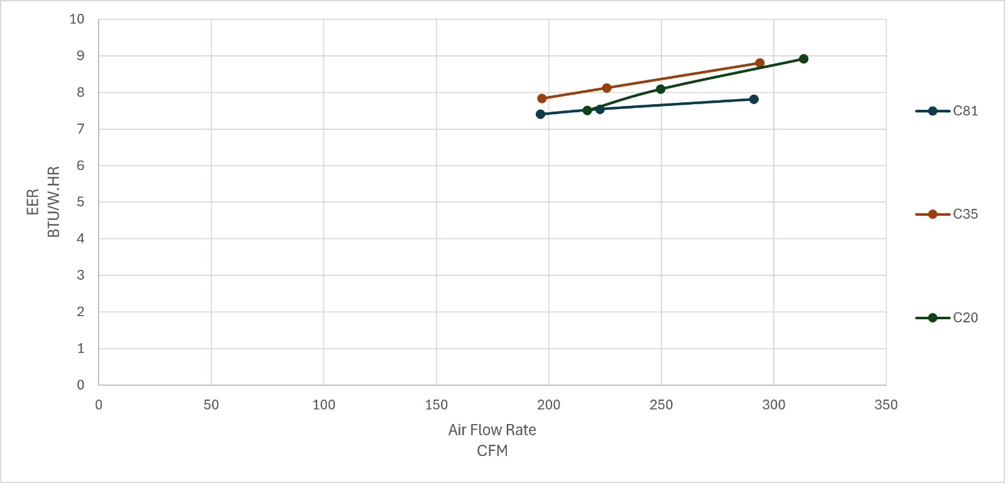

Figure 6. EER versus airflow rate for condition group C
Figures 4–6 present EER as a function of airflow at constant compressor-frequency settings within each condition group. Every constant-frequency series shows a positive net change in EER from the low-fan to the high-fan operating point. The increase ranges from 5.5% to 18.6%, while the airflow increase ranges from 39.6% to 61.1%. This confirms that, within the measured operating points, higher indoor airflow improves the ratio of delivered cooling to electrical input.
The airflow effect is achieved mainly through increased cooling capacity rather than a proportional rise in power. Moving from low to high fan mode increases cooling capacity by 10.2–26.9%. By comparison, power changes by only 0.4–6.0% in eight of the nine constant-frequency comparisons. The exception is condition B at the intermediate setting, where power increases by approximately 18.1% while capacity increases by 26.9%. The capacity gain remains larger than the power increase, so EER still improves by 7.5%.

4.3 Cooling-capacity and EER relationship
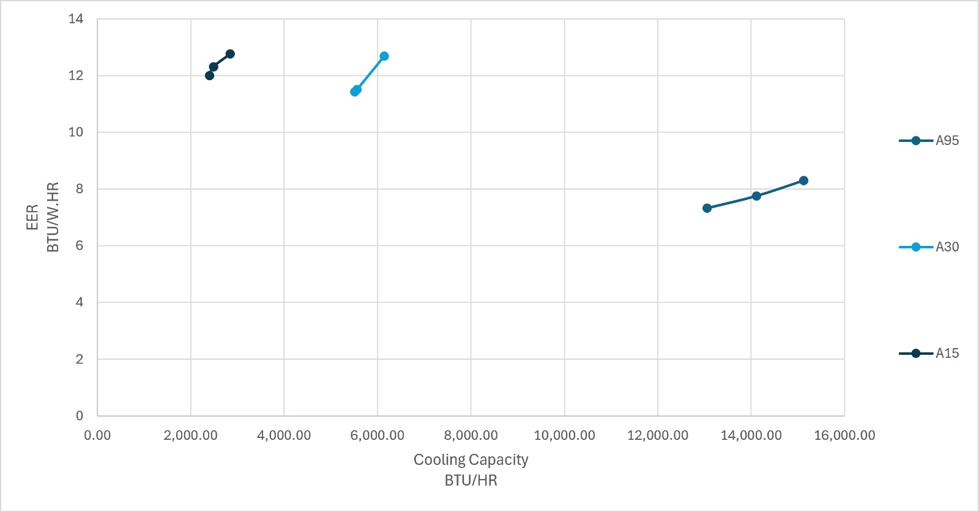
Figure 7. EER versus cooling capacity for condition group A
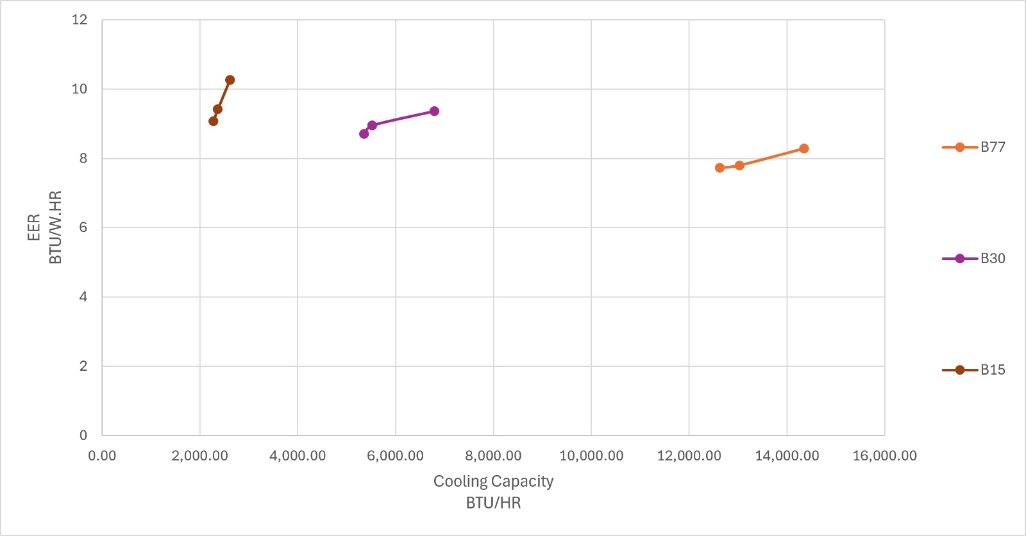
Figure 8. EER versus cooling capacity for condition group B
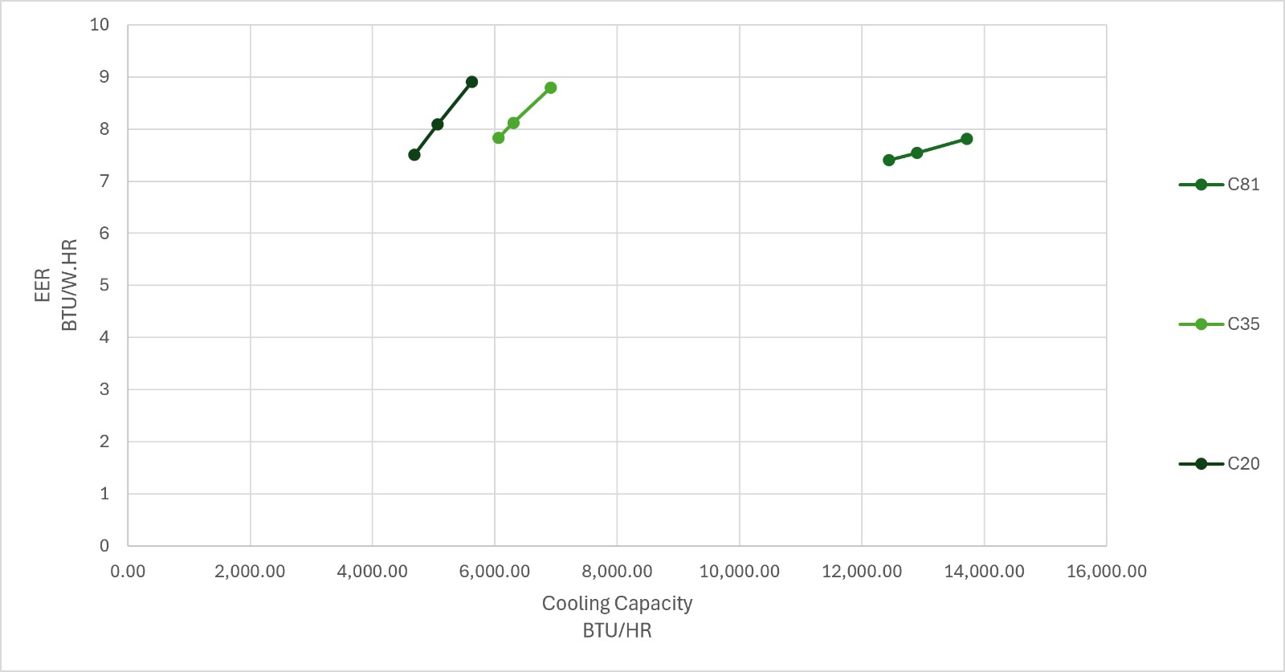
Figure 9. EER versus cooling capacity for condition group C
Figures 7–9 show that the operating points form three distinct capacity bands corresponding to low, intermediate, and high frequency. Higher frequency produces a substantial increase in cooling capacity, but the associated power increase is proportionally larger, causing EER to decline. From the lowest to the highest frequency, cooling capacity increases by 432.0–467.3% in condition A and by 448.7–455.5% in condition B. Over the same comparisons, power increases by 718.6–800.5% in condition A and by 551.9–579.2% in condition B. Consequently, EER decreases by 35.0–38.9% and 14.8–19.3%, respectively.
Condition C exhibits a smaller frequency-related capacity gain because the low setting is 20 Hz and the high setting is 81 Hz rather than the 15–95 Hz sweep used in condition A. Across the three fan modes, capacity rises by 144.0–165.6%, power by 169.6–178.9%, and EER declines by 1.5–12.3%. The relatively small EER decline for the low-fan series should be interpreted as a characteristic of the tested endpoints rather than evidence of frequency independence.
At each frequency, moving from low to high airflow shifts the operating point toward both higher capacity and higher EER. The clearest capacity benefit occurs in condition B at the intermediate frequency: cooling capacity increases from 5,353.09 BTU/h at 183.91 CFM to 6,792.71 BTU/h at 296.23 CFM, while EER increased from 8.71 to 9.36 BTU/W·h.

4.4 Power requirement for increased cooling capacity

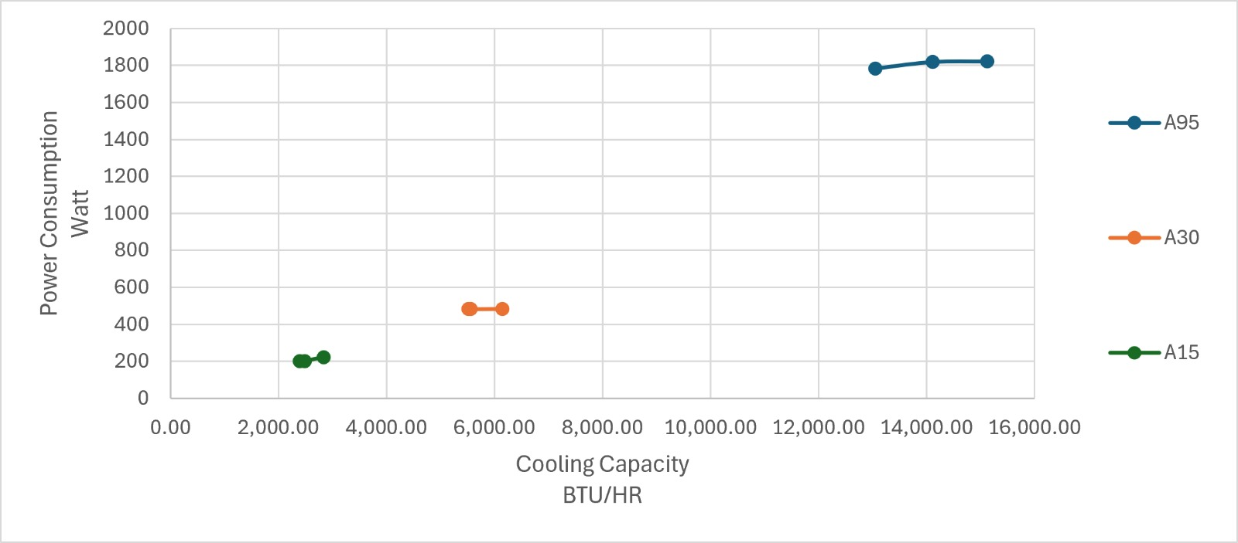
Figure 10. Power consumption versus cooling capacity for condition group A
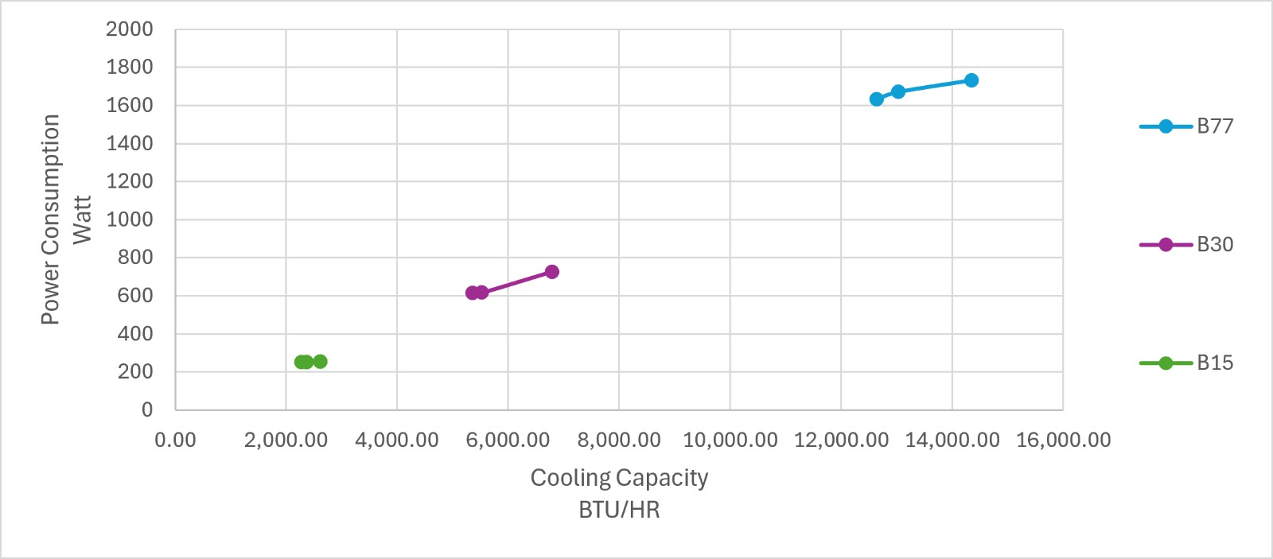
Figure 11. Power consumption versus cooling capacity for condition group B
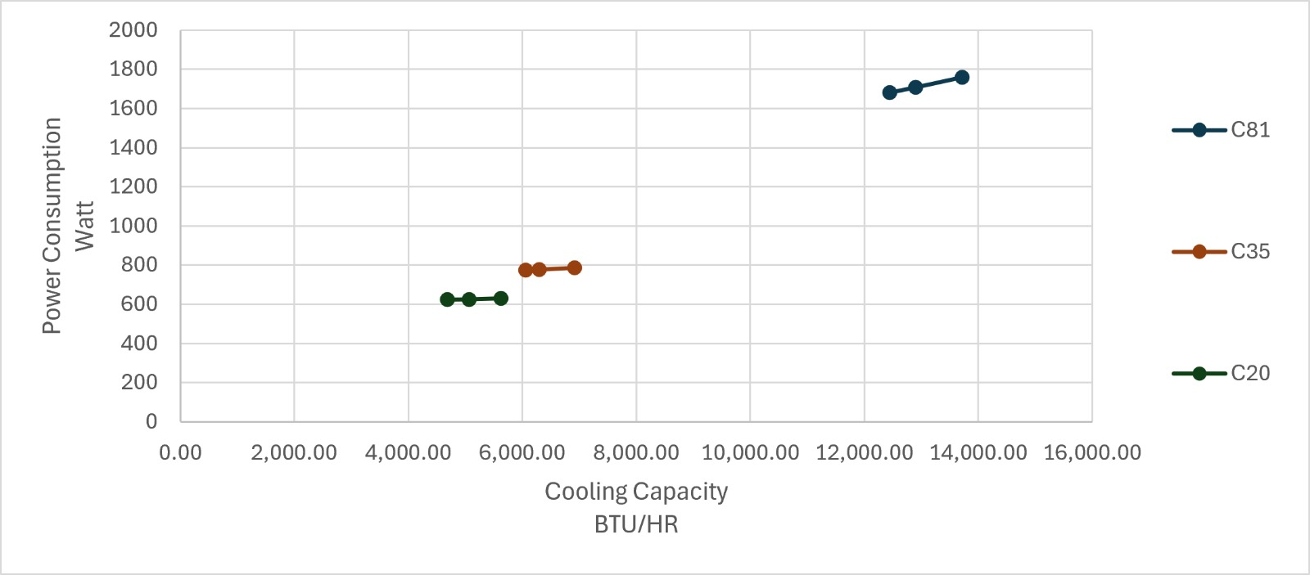
Figure 12. Power consumption versus cooling capacity for condition group C
Figures 10–12 demonstrate that electrical input increases strongly as cooling capacity moves from the low-frequency band to the high-frequency band. The maximum measured capacity, 15,124.37 BTU/h, occurs in condition A at 95 Hz and high fan mode, with a power input of 1,822.3 W and an EER of 8.30 BTU/W·h. The maximum measured EER, 12.77 BTU/W·h, occurs in the same condition group at 15 Hz and high fan mode, where capacity and power are 2,842.88 BTU/h and 222.6 W, respectively. Therefore, the operating point that maximizes efficiency does not maximize delivered capacity.
Within a fixed frequency, the increase in cooling capacity from greater airflow is generally obtained with a comparatively small power penalty. For example, in condition A at 95 Hz, increasing airflow from 192.40 to 286.11 CFM raises capacity from 13,055.00 to 15,124.37 BTU/h, whereas power increases only from 1,781.6 to 1,822.3 W. EER therefore increases from 7.33 to 8.30 BTU/W·h. Similar rightward shifts with modest vertical movement are visible in most constant-frequency series.

4.5 Influence of test-condition group
The absolute EER level decreases across the condition groups. Group A produces EER values of 7.33–12.77, group B produces 7.73–10.27, and group C produces 7.40–8.91 BTU/W·h. This pattern is consistent with an efficiency penalty at more severe thermal conditions. However, the groups are not separated by outdoor temperature alone: group A also uses lower indoor dry- and wet-bulb temperatures, and the available compressor-frequency endpoints differ among A, B, and C. Accordingly, the figures support a condition-group effect, but they do not by themselves isolate a causal outdoor-temperature coefficient.

4.6 Predictive model development and validation
To extend the experimental results beyond the individual measured operating points, multiple linear regression models are developed using all 27 laboratory tests. The predictor variables are outdoor dry-bulb temperature, indoor dry-bulb temperature, indoor wet-bulb temperature, compressor frequency, and measured indoor airflow rate. Separate response models are fitted for total cooling capacity, sensible cooling capacity, electrical power consumption, and energy efficiency ratio (EER).
The general form of the selected model is:
Y = β₀ + β₁Tₒ + β₂Tᵢ,DB + β₃Tᵢ,WB + β₄f + β₅Q,
Where: Y is the predicted output,
Tₒ is outdoor dry-bulb temperature,
Tᵢ,DB and Tᵢ,WB are indoor dry- and wet-bulb temperatures,
f is compressor frequency,
Q is measured airflow rate.
Table 2 presents the fitted coefficients. The signs and magnitudes of individual coefficients should be interpreted within this multivariable model and the tested operating envelope, rather than as isolated physical effects.
Table 2. Coefficients of the selected multiple linear regression models. Temperature coefficients are per °C, frequency coefficients per Hz, and airflow coefficients per CFM
Output | β₀ | Outdoor DBT | Indoor DBT | Indoor WBT | Frequency | Airflow
Cooling capacity | 407.735 | 68.770 | −1926.477 | 2476.314 | 151.119 | 10.065
Sensible capacity | 19427.104 | 194.144 | −6805.274 | 8228.099 | 76.057 | 12.730
Power consumption | −355.675 | 27.010 | −174.201 | 204.219 | 20.595 | 0.404
EER | 19.364 | −0.251 | −0.308 | 0.405 | −0.0335 | 0.00903
Model quality is assessed using the coefficient of determination and Leave-One-Out Cross-Validation (LOOCV). The linear models explain 97.7% of the measured variation in cooling capacity and 99.0% of the variation in power consumption. The corresponding R² values for sensible capacity and EER are 0.862 and 0.862, respectively. These lower values indicate greater unexplained variation for the sensible-capacity and efficiency responses than for total capacity and power.
Table 3. Training fit and leave-one-out cross-validation results for the linear and squared-terms quadratic models
Output | Linear R² | Quadratic R² | Linear LOOCV RMSE | Quadratic LOOCV RMSE | Selected
Cooling capacity | 0.977 | 0.987 | 882.34 BTU/h | 952.02 BTU/h | Linear
Sensible capacity | 0.862 | 0.949 | 1168.04 BTU/h | 1238.85 BTU/h | Linear
Power consumption | 0.990 | 0.990 | 77.00 W | 109.02 W | Linear
EER | 0.862 | 0.939 | 0.858 BTU/W·h | 1.168 BTU/W·h | Linear
Although the squared-terms quadratic models produce higher training R² values, they give larger held-out errors for every response. Linear-model LOOCV RMSE values are 882.34 BTU/h for cooling capacity, 1168.04 BTU/h for sensible capacity, 77.00 W for power consumption, and 0.858 BTU/W·h for EER. The corresponding quadratic-model errors are 952.02 BTU/h, 1238.85 BTU/h, 109.02 W, and 1.168 BTU/W·h. The linear formulation is therefore retained because it generalizes better to omitted tests and reduces the risk of overfitting the relatively small experimental dataset.
The selected equations can be used to interpolate system performance for combinations of the five inputs that remain within the experimental ranges: 35.01–45.97 °C outdoor dry-bulb temperature, 26.98–32.05 °C indoor dry-bulb temperature, 18.95–23.05 °C indoor wet-bulb temperature, 15–95 Hz compressor frequency, and 180.85–320.02 CFM airflow. Predictions outside any of these limits are extrapolations and should not be treated as validated laboratory results.

4.7 Measured performance at the ISO 5151 T1 standard condition
The ISO 5151 T1 standard rating condition is defined by outdoor dry-bulb/wet-bulb of 35 / 24 °C and indoor dry-bulb/wet-bulb of 27 / 19 °C. The traceable T1 point in this study is operating point A2M95 (medium indoor fan, 95 Hz compressor frequency, outdoor-unit fan at fixed speed) at measured outdoor 35.04 / 20.27 °C and indoor 27.00 / 18.99 °C. The measured performance at the T1 condition is reported in Table 4.
Table 4. Measured performance at the ISO 5151 T1 standard condition
Parameter | Measured value
Total cooling capacity, Qt | 14,115.10 BTU/h
Expanded uncertainty on Qt (k = 2) | ±2.74 % → 13,728 – 14,502 BTU/h
Sensible cooling capacity, Qs | 8,855.50 BTU/h
Latent cooling capacity, Qlat | 5,259.60 BTU/h
Sensible heat ratio, SHR | ≈ 0.63
Electrical power input, W_el | 1,819.1 W
Energy efficiency ratio, EER | 7.76 BTU/W·h
Compressor frequency, f | 95 Hz
Indoor airflow, Q | 221.59 CFM
Refrigerant / charge | R-32 / 580 g

The reported values are averaged from approximately 360 readings per measured parameter obtained during the 30-minute data-acquisition window following one hour of stabilization, with controlled conditions held within ±0.3 °C dry-bulb, ±0.2 °C wet-bulb and ±0.1 kPa throughout the window.

4.8 Sensible heat ratio
The sensible heat ratio was computed for every operating point as SHR = Qs / Qt. Values are reported per point in Appendix A, Table A1. Group-level, fan-level and frequency-level summaries are reported in Tables 5 and 6.
Table 5. SHR summary by condition group and indoor-fan mode (mean and min–max)
Fan mode | Group A  (≈35 °C) | Group B  (≈43 °C) | Group C  (≈46 °C) | All groups
High | 0.884  (0.660–1.000) | 0.880  (0.654–0.996) | 0.889  (0.666–1.000) | 0.884  (0.654–1.000)
Medium | 0.861  (0.627–0.986) | 0.842  (0.592–0.983) | 0.835  (0.609–1.000) | 0.846  (0.592–1.000)
Low | 0.847  (0.615–0.983) | 0.810  (0.572–0.978) | 0.809  (0.589–1.000) | 0.822  (0.572–1.000)

Table 6. SHR summary by frequency category across all three condition groups
Frequency category | Mean SHR | Range | Points
Low (15 Hz for A and B; 20 Hz for C) | 0.990 | 0.978–1.000 | 9
Mid (30 Hz for A and B; 35 Hz for C) | 0.942 | 0.839–1.000 | 9
High (95 Hz for A; 77 Hz for B; 81 Hz for C) | 0.620 | 0.572–0.666 | 9

Three observations are supported by this dataset. First, compressor frequency is the dominant observed lever on SHR: mean SHR drops from approximately 0.99 at the lowest tested frequency category to approximately 0.62 at the highest, a swing of approximately 0.37. Second, low-frequency operation is essentially sensible cooling on this unit; at the minimum tested frequency the measured SHR is 0.98 or higher, which is consistent with evaporator surface temperatures remaining at or above the entering-air dew point. Third, fan setting has a secondary association with SHR: within each frequency category, moving from low indoor fan to high indoor fan generally increases SHR by approximately 0.03–0.07.

5. Discussion
The combined results show a consistent control trade-off. Compressor frequency is the primary driver of delivered cooling capacity and electrical power, while indoor airflow acts as an efficiency-supporting variable. Increasing frequency moves the system to a much higher-capacity operating region, but power rises faster than capacity over most tested comparisons, reducing EER. Increasing airflow at the same frequency improves heat-side utilization: capacity increases more than power, so EER rises in all nine low-to-high fan comparisons.
From an operational perspective, low-frequency operation is advantageous when the thermal load is modest because it provides the highest measured EER. High-frequency operation is necessary when rapid pull-down or high capacity is required, but the energy cost per unit of cooling is higher. Where acoustic, comfort, and fan-energy constraints permit, increasing indoor airflow can partially mitigate this efficiency penalty by increasing capacity with relatively little additional unit power.
The regression workbook supports a linear predictive model within the measured operating envelope. Linear training R² values are 0.9768 for cooling capacity, 0.8615 for sensible capacity, 0.9901 for power consumption and 0.8616 for EER, with leave-one-out cross-validation RMSE of 882.34 BTU/h, 1,168.04 BTU/h, 77.00 W and 0.858 BTU/W·h respectively. The squared-terms quadratic alternative with ten regressors raises training R² but increases LOOCV RMSE on every output (952.02 BTU/h for cooling capacity, 1,238.85 BTU/h for sensible capacity, 109.02 W for power and 1.168 BTU/W·h for EER), which is a classical overfitting signature on a 27-point dataset. The linear model is therefore retained for interpolation.

5.2 Limitations
The following limitations should be stated. First, the regression is trained on 27 operating points; leave-one-out cross-validation reduces the risk of over-reporting training fit but does not substitute for an independent test set and does not characterise behaviour outside the measured envelope. Second, condition groups A, B and C change outdoor dry-bulb and indoor dry- and wet-bulb simultaneously, and the compressor-frequency endpoints differ by group; the isolated outdoor-temperature coefficient in the regression should not be interpreted as a pure outdoor-temperature derivative from a fully factorial design. Third, the indoor fan is set through the unit's three-step controller, so measured indoor airflow is a dependent variable rather than an independently controlled factor. Fourth, all results relate to a single unit; unit-to-unit variation is not characterised. Fifth, each operating point is a single ISO 5151 steady-state measurement averaged over the 30-minute data-acquisition window following one hour of stabilization. Sixth, the dataset characterises steady-state behaviour only; start-up, cycling and transient controller behaviour are outside the scope of this study.

6. Conclusion
Laboratory testing of the 1.5 HP inverter air-conditioning unit demonstrates that compressor frequency and indoor airflow have distinct and complementary effects on performance. Increasing compressor frequency substantially increases cooling capacity and electrical power consumption. Because power generally increases faster than capacity, EER decreases as the unit is driven toward maximum output. Across conditions A and B, the low-to-high frequency transition increases capacity by approximately 432–467% and 449–455%, respectively, while EER declines by approximately 35–39% and 15–19%.
At a given frequency, increasing airflow consistently improves EER. Across all nine constant-frequency comparisons, moving from low to high fan mode increases capacity by 10.2–26.9% and EER by 5.5–18.6%. In most cases, the associated increase in unit power is less than 6%, indicating that airflow enhancement improves cooling delivery more strongly than electrical demand. The highest measured EER is 12.77 BTU/W·h at 15 Hz under condition A, while the highest measured capacity is 15,124.37 BTU/h at 95 Hz under the same condition; these are different operating objectives and require different control settings.
Overall, the results support a load-responsive operating strategy: use the lowest compressor frequency that satisfies the cooling requirement, then use adequate indoor airflow to improve capacity utilization and EER. The findings also show that performance deteriorates across the more severe condition groups, although additional frequency-matched tests with independently controlled indoor and outdoor conditions are required to quantify the isolated ambient-temperature effect. Within the tested envelope, the validated linear regression provides the more reliable predictive basis and should be preferred to the more complex quadratic formulation.
The multivariable predictive model provides an additional outcome of the study. The selected linear formulation achieves R² = 0.977 for cooling capacity and R² = 0.990 for power consumption, with held-out RMSE values of 882.34 BTU/h and 77.00 W, respectively. Linear models are also retained for sensible capacity and EER because their cross-validation errors are lower than those of the quadratic alternatives. Accordingly, the equations provide a compact engineering method for interpolation within the tested operating envelope, while extrapolated predictions require further experimental verification.
The validated multivariable linear regression, the per-point sensible-heat-ratio analysis and the ISO 5151 T1 measured-performance results together provide an engineering-grade characterization of this 1.5 HP R-32 inverter split unit that is reproducible from the raw data in Appendix A and the coefficients in Table 2, and that is bounded by a documented ±2.74 % expanded cooling-capacity uncertainty.

7. Data availability
The complete raw dataset for the 27 operating points is reproduced in Appendix A, Table A1. The fitted model coefficients and leave-one-out cross-validation results are reproduced in Tables 2 and 3 of this manuscript.

8. References
- Sheu A L and Adagunodo T A 2019 Performance evaluation of inverter-equipped drive to regulate the speed of motor and cooling output of air conditioner J. Phys.: Conf. Ser. 1299 012029
- Elsayed A O 2020 Management of condenser fan speed and its influence on the split air conditioner performance Global Journal of Engineering and Technology Research Updates
- Berman E T, Komaro M, Miftakhudin M, Mutaufiq M and Suherman A 2020 Enhancing performance of wall mounted split air conditioner using capillary tube in a tube heat exchanger IOP Conf. Ser.: Mater. Sci. Eng. 830 042033
- Amoabeng K O, Opoku R, Boahen S and Obeng G Y 2023 Analysis of indoor set-point temperature of split-type ACs on thermal comfort and energy savings for office buildings in hot-humid climates Energy Built Environ. 4 368–376
- Li Z, Meng Q, Wei Y, Zhang L, Sun Z, Lei Y, Yang L and Yan X 2023 Dynamic room temperature setpoints of air-conditioning demand response based on heat balance equations with thermal comfort model as constraint: on-site experiment and simulation J. Build. Eng. 63 105798
- Pandey B, Bohara B, Pungaliya R, Patwardhan S C and Banerjee R 2021 A thermal comfort-driven model predictive controller for residential split air conditioner J. Build. Eng. 42 102513
- Bohara B, Pandey B, Patwardhan S C and Banerjee R 2023 Experimental implementation of model predictive control for an inverter air conditioner considering thermal comfort and energy saving
- Shao S, Zhang H and Wang S 2023 A practical application-oriented model predictive control algorithm for direct expansion air-conditioning systems that balances thermal comfort and energy consumption Build. Simul.
- Wang H, Mai D, Li Q and Ding Z 2024 Evaluating machine learning models for HVAC demand response: the impact of prediction accuracy on model predictive control performance Buildings 14 2212
- Hou J, Li H, Nord N and Huang G 2022 Model predictive control under weather forecast uncertainty for HVAC systems in university buildings Energy Build. 257 111793
- Yu Y et al 2021 Comparative study of deterministic and stochastic grey-box models for model predictive control of HVAC systems
- Cheng Y et al 2021 Load-based testing and performance mapping methods for air-conditioning systems with integrated controls
- Pizzatto M et al 2024 Empirical performance model for inverter air conditioners based on psychrometric testing
- International Organization for Standardization 2017 ISO 5151:2017 Non-ducted Air Conditioners and Heat Pumps—Testing and Rating for Performance (Geneva: ISO)
- International Organization for Standardization and International Electrotechnical Commission 2017 ISO/IEC 17025:2017 General Requirements for the Competence of Testing and Calibration Laboratories (Geneva: ISO/IEC)

Appendix A — Raw data from the 27 ISO 5151 operating points
Table A1. Full per-point raw and derived dataset. Codes follow Group × Fan × Frequency index. Units: OD/ID DBT and ID WBT in °C; Freq in Hz; Airflow in CFM; Qt, Qs, Qlat in BTU/h; P in W; EER in BTU/W·h. The outdoor-unit fan was maintained at a fixed speed throughout all operating points
Cond. | Reading  code | OD DBT  (°C) | ID DBT  (°C) | ID WBT  (°C) | Freq.  (Hz) | Fan  mode | Airflow  (CFM) | Qt  (BTU/h) | Qs  (BTU/h) | Power  (W) | EER  (BTU/W·h)
A | A1H15 | 35.02 | 26.99 | 19.02 | 15 | H | 314.01 | 2,842.88 | 2,820.36 | 222.6 | 12.77
A | A1H30 | 35.01 | 26.99 | 18.95 | 30 | H | 312.36 | 6,143.31 | 6,143.31 | 484 | 12.69
A | A1H95 | 35.02 | 26.99 | 18.99 | 95 | H | 286.11 | 15,124.37 | 9,976.01 | 1,822.3 | 8.30
A | A2M15 | 35.02 | 26.99 | 19.04 | 15 | M | 249.90 | 2,488.03 | 2,452.55 | 202 | 12.32
A | A2M30 | 35.01 | 26.98 | 19.04 | 30 | M | 238.84 | 5,561.22 | 5,396.08 | 483 | 11.51
A | A2M95 | 35.04 | 27.00 | 18.99 | 95 | M | 221.59 | 14,115.10 | 8,855.50 | 1,819.1 | 7.76
A | A3L15 | 35.02 | 26.99 | 19.00 | 15 | L | 224.88 | 2,400.34 | 2,359.40 | 200 | 12.00
A | A3L30 | 35.02 | 26.99 | 19.03 | 30 | L | 223.59 | 5,514.13 | 5,199.89 | 482.3 | 11.43
A | A3L95 | 35.06 | 26.99 | 19.00 | 95 | L | 192.40 | 13,055.00 | 8,032.87 | 1,781.6 | 7.33
B | B1H15 | 42.97 | 32.02 | 23.00 | 15 | H | 320.02 | 2,615.30 | 2,592.10 | 255 | 10.27
B | B1H30 | 42.97 | 32.00 | 23.05 | 30 | H | 296.23 | 6,792.71 | 6,768.73 | 725.3 | 9.36
B | B1H77 | 42.99 | 32.03 | 22.99 | 77 | H | 278.75 | 14,349.51 | 9,387.44 | 1,731.9 | 8.29
B | B2M15 | 42.97 | 32.01 | 23.00 | 15 | M | 251.14 | 2,366.22 | 2,326.30 | 251.4 | 9.42
B | B2M30 | 42.97 | 32.01 | 23.04 | 30 | M | 215.94 | 5,521.98 | 5,250.39 | 616.9 | 8.95
B | B2M77 | 42.98 | 32.03 | 23.00 | 77 | M | 208.40 | 13,028.38 | 7,715.90 | 1,670.9 | 7.80
B | B3L15 | 42.97 | 32.01 | 23.00 | 15 | L | 216.64 | 2,273.76 | 2,223.94 | 250.5 | 9.08
B | B3L30 | 42.98 | 32.05 | 23.03 | 30 | L | 183.91 | 5,353.09 | 4,705.49 | 614.3 | 8.71
B | B3L77 | 42.98 | 32.01 | 23.00 | 77 | L | 180.85 | 12,630.54 | 7,219.79 | 1,633.1 | 7.73
C | C1H20 | 45.96 | 32.01 | 23.00 | 20 | H | 313.25 | 5,621.95 | 5,621.95 | 630.7 | 8.91
C | C1H35 | 45.95 | 32.01 | 23.01 | 35 | H | 293.82 | 6,914.08 | 6,914.08 | 785.1 | 8.80
C | C1H81 | 45.97 | 32.01 | 23.01 | 81 | H | 291.17 | 13,717.26 | 9,138.02 | 1,759 | 7.81
C | C2M20 | 45.96 | 32.01 | 23.00 | 20 | M | 249.79 | 5,063.75 | 5,063.75 | 625 | 8.09
C | C2M35 | 45.96 | 32.01 | 23.00 | 35 | M | 225.83 | 6,301.62 | 5,649.25 | 776.9 | 8.12
C | C2M81 | 45.95 | 32.01 | 23.01 | 81 | M | 222.71 | 12,904.53 | 7,852.72 | 1,707.6 | 7.54
C | C3L20 | 45.96 | 32.02 | 23.02 | 20 | L | 217.17 | 4,686.72 | 4,686.72 | 623.4 | 7.51
C | C3L35 | 45.96 | 32.02 | 23.02 | 35 | L | 196.96 | 6,062.10 | 5,087.56 | 774.4 | 7.83
C | C3L81 | 45.96 | 32.02 | 23.00 | 81 | L | 196.27 | 12,445.61 | 7,332.39 | 1,680.6 | 7.40

