Response to reviewer’s comments
The authors would like to express our sincere gratitude to the reviewers for their valuable and constructive feedback, which has significantly improved the quality of our manuscript. We have carefully considered all the concerns raised and have made the necessary revisions in accordance with their suggestions. For clarity, reviewer comments are presented in blue font, our corresponding responses are provided in black font, and the revised portions of the manuscript are shown in black font, highlighted in yellow. We believe that these revisions have strengthened the manuscript accordingly.
Reviewer #1
1. Only first letter of paper title is capitalized. For example as "Process parameter optimization ....
Response:
We thank the reviewer for the clarification. The paper title has been revised to follow the required sentence-case capitalization format:
“Process parameter optimization for porosity reduction in selective laser melting of AlSi10Mg using finite element simulation and response surface methodology.”

2. Author names must be corrected as K Lemma, M Alemu and M. Meseret..
Response: Thank you for the correction. The author names have been revised throughout the manuscript and are now presented in the required format as:
K Lemma, M Alemu and M. Meseret

3. Do not write a single affilliation three times.
Response: We thank you for the clarification. Since all authors share the same affiliation, the affiliation has been consolidated and is now presented only once beneath the author names, in accordance with the conference formatting requirements.
¹Mechanical Engineering, Jimma Institute of Technology, Jimma University, Jimma, Ethiopia

4. Headings and subheading: Only first letter is capitalized. For instance, "2. Finite element thermal model"
Response: Thank you for the observation. All section and subsection headings have been revised to use sentence-case capitalization in accordance with the conference template. All section and subsection headings have been changed to:
2 Finite element thermal model.
2.1 Boundary conditions, material, and mesh.
2.2 Governing equation.
2.3 Numerical porosity index Results and discussion
5 Limitations and future work
5. Figure and table captions must be bold. For example "Table 1." and "Figure 1." must be in bold. Avoid repetetive definition of abbreviations
Response: Thank you for the comment. The formatting of all figure and table captions has been revised according to the conference guideline. The figure and table labels, including “Figure” and “Table” followed by their respective numbers, are now presented in bold format.
#Figures
Figure 1: Extraction of melt volume from the FE simulation: elements exceeding the liquidus temperature are identified and used to calculate the total melted volume.
Figure 2: Representative FE temperature contours under different process conditions: (a) low-energy condition, P = 100 W, v = 1200 mm/s, d = 0.10 mm; (b) intermediate condition, P = 150 W, v = 800 mm/s, d = 0.08 mm; and (c) high-energy condition, P = 200 W, v = 800 mm/s, d = 0.06 mm.
Figure 3: Statistical effects of process parameters on maximum temperature: (a) Pareto chart and (b) main-effects plot.
Figure 4: Statistical effects of process parameters on NPI: (a) Pareto chart and (b) main-effects plot.
Figure 5: Interaction effects of laser power, scanning speed, and spot diameter on the NPI.
Figure 6: Comparison of melt pool dimensions between the present numerical results and published experimental data [26].
Figure 7: Representative SEM micrographs showing variations in defect morphology and distribution observed in the fabricated AlSi10Mg specimens.
Figure 8: Representative SEM micrographs illustrating the microstructural features observed under selected experimental processing conditions.
#Tables
Table 1: Selected process parameters and their corresponding levels.
Table 2: Representative optimized process parameters obtained from RSM optimization.
Table 3: Comparison of FE-predicted and experimental melt-pool dimensions.
6. Avoid repetetive definition of abbreviations.
Response: Thank you for the observation. The manuscript has been checked for repeated abbreviation definitions. Abbreviations are now defined at their first occurrence after abstract and subsequently used consistently in abbreviated form throughout the manuscript. Repetitive definitions of terms such as SLM, FEM, DOE, RSM, VED, and NPI have been removed where appropriate.
- SLM
- FEM
- NPI
- RSM
- DOE
- VED
7. Format reference list according to the recommended style. For example, the correct format for the second reference will be [2] Mughir W A 2022 A review in 3d printing technique: Types, applications and process parameters. J. Univ. Babylon Eng. Sci., 30(3),33–49. Note: journal titles are in italic, and volume number s are in bold.
Response: We thank the reviewer for the detailed guidance. The complete reference list has been reformatted according to the recommended COTech reference style. Journal titles are now italicized, volume numbers are presented in bold, and the year, issue number, page range, DOI, and other bibliographic information have been checked and standardized where applicable. The formatting and bibliographic details of the cited references have also been checked for consistency throughout the manuscript.
References
[1] Gao B, Zhao H, Peng L, Sun Z 2023 A review of research progress in selective laser melting (SLM), Micromachines 14(1), 57.
[2] Mughir W A 2022 A review in 3D printing technique: types, applications and process Parameters, J. Univ. Babylon Eng. Sci. 30(3), 33–49.
[3] Shrestha S, Starr T, Chou K 2019 A study of keyhole porosity in selective laser melting: single-track scanning with micro-CT analysis, ASME J. Manuf. Sci. Eng. ASME 141(7), 071004.
[4] Castro Rodas EG, Buitrago Diaz JC, Ortega-Portilla C, G´omez-Ortega A, Piamba JF, Salazar D, et al. 2025 Analysis of porosity in aluminum alloy (AlSi10Mg) using tomographic image processing, J. Manuf. Mater. Process. 9(11), 374.
[5] Wilbig J, Wilson-Heid A, Bernard L, Baptista J, Obaton AF 2025 Comparison of porosity analysis based on X-ray computed tomography on metal parts produced by additive manufacturing, Appl. Sci. 15(18), 9876.
[6] Liu W, Chen C, Shuai S, Zhao R, Liu L, Wang X, et al. 2020 Study of pore defect and mechanical properties in selective laser melted Ti6Al4V alloy based on X-ray computed tomography, Mater. Sci. Eng., A 797, 139981.
[7] Kan WH, Chiu LNS, Lim CVS, et al. 2022 A critical review on the effects of process-induced porosity on the mechanical properties of alloys fabricated by laser powder bed fusion, J. Mater. Sci. 57, 9818–65.
[8] Yusuf SM, Chen Y, Boardman R, Yang S, Gao N 2017 Investigation on porosity and microhardness of 316L stainless steel fabricated by selective laser melting, Metals 7(2), 64.
[9] Voznesenskaya A, Zhdanov A and Raznoschikov A 2021 evolution of porosity depending on SLM mode and subsequent HIP processing, J. Phys. Conf. Ser. vol 2077, 012023.
[10] Pokorn´y P, V´aclav ˇS, Petru J and Samardziova M 2021 Porosity analysis of additive manufactured parts using CAQ technology Mater. 14.
[11] Aggarwal A and Kumar A 2019 Particle scale modelling of porosity formation during selective laser melting process using a coupled DEM–CFD approach, IOP Conf. Ser.: Mater. Sci. Eng. vol 529, 012001.
[12] Stwora A, Teimouri R, Habel J 2025 Role of laser powder bed fusion process factors in determining the porosity formation in 3D printing of stainless steel 316L: theoretical modeling and experimental verification, Mater. 18(24), 5490.
[13] Cheng B and Tuffile CD 2019 Numerical study of porosity formation with implementation of laser multiple reflection in selective laser melting, ASME 2019 14th Int. Manuf. Sci. Eng. Conf. (Erie, Pennsylvania, USA) vol 1, V001T01A011.
[14] Tan JL, Tang C and Wong CH 2018 A computational study on porosity evolution in parts produced by selective laser melting Metall, Mater. Trans. A 49(8), 3663–73.
[15] Wang Y, Jing X, Li Z and Liu B 2024 Molecular dynamics research on the effect of selective laser melting parameters on porosity and properties of parts, Mater. Today Commun. 41, 110626.
[16] Nandhakumar R and Venkatesan K 2023 A process parameters review on selective laser melting-based additive manufacturing of single and multi-material: microstructure, physical properties, tribological, and surface roughness Mater, Today Commun. 35, 105538.
[17] Zhang C, Liao Q, Zhang X, Ma F, Wu M and Xu Q 2023 Characterization of porosity in lack of fusion pores in selective laser melting using the wavefunction, Mater. Res. Express. 10(1), 016501.
[18] Modaresialam M, Roozbahani H, Alizadeh M, Salminen A and Handroos H 2022 In-situ monitoring and defect detection of selective laser melting process and impact of process parameters on the quality of fabricated SS 316L, IEEE Access 10, 46100-13.
[19] Podolskyi RV, Adzhamskyy SV, Kononenko GA and Badyuk SI 2025 The influence of physical phenomena and material properties on the quality of parts during selective laser melting, Phys. Met. 26(4), 796-827.
[20] Voznesenskaya AA, Zhdanov AV and Raznoschikov AS 2021 Evolution of porosity depending on SLM mode and subsequent HIP processing, J. Phys. Conf. Ser. vol 2077, 012023.
[21] Ansari M, Nguyen DS and Park H 2019 Investigation of SLM process in terms of temperature distribution and melting pool size: modeling and experimental approaches, Mater. 12, 1272.
[22] Depboylu F N, Mishin O V, Leissner T and Popa A A 2025 Microstructure and mechanical properties of parts produced by laser powder bed fusion of AlSi10Mg powder with coarse particle size, Mater. Charact. 229, 115573. doi:10.1016/j.matchar.2025.115573
[23] Hirata T, Kimura T and Nakamoto T 2020 Effects of hot isostatic pressing and internal porosity on the performance of selective laser melted AlSi10Mg alloys, Mater. Sci. Eng. A 772, 138713.
[24] Hyer H, Zhou L, Park S, Gottsfritz G, Benson G and Tolentino B 2020 Understanding the laser powder bed fusion of AlSi10Mg alloy, Metall. Microstruct. Anal. 9, 484-502.
[25] Aversa A, Bosio F, Marola S, Lorusso M, Manfredi D and Battezzati L 2018 Laser single scan tracks of new aluminium alloys compositions, Euro PM2018 Proceedings: AM Special Materials (Bilbao, Spain: European Powder Metallurgy Association) pp 15–20.
[26] Xu Y, Li Y, Wang L, Song Y, Li K, Xing H, Chen B and Wang J 2024 Molten pool macroscopic thermodynamic analysis during selective laser melting of AlSi10Mg: Simulations and experiments, J. Mater. Res. Technol. 33, 2506–2518. doi:10.1016/j.jmrt.2024.09.216

Reviewer #2
1. The novelty of the NPI needs to be established more clearly against existing energy-density, melt-pool, and porosity criteria.
Response: We thank the reviewer for this important comment. The manuscript has been revised to clarify the distinction between the proposed Numerical Porosity Index (NPI) and commonly used indicators such as volumetric energy density (VED), melt-pool dimensions, and experimentally measured porosity.
The revised discussion explains that VED represents the nominal energy input per unit volume but does not directly account for the predicted spatial extent of melting or the effect of spot diameter on the energy distribution. Melt-pool width and depth provide important geometric information but do not directly quantify the balance between the predicted melted volume and the nominal track volume. In contrast, the proposed NPI is calculated from the finite-element-predicted melted volume relative to the nominal track volume and provides a dimensionless computational indicator of the melting balance.
The manuscript has also been revised to clarify that NPI is a porosity-tendency indicator within the single-track/single-layer modelling framework and is not intended to represent the actual three-dimensional pore volume of a fabricated component.

An NPI value close to zero indicates that the predicted melted volume approximately corresponds
to the nominal track volume and represents a balanced melting condition. A positive
NPI indicates insufficient melting relative to the nominal track volume and, consequently, a tendency
toward lack-of-fusion defects. A negative NPI indicates that the predicted melted volume
exceeds the nominal track volume, representing excessive melting and a potential tendency toward
thermal instability. Therefore, NPI is used as a porosity tendency indicator rather than a
direct measurement of physical void volume. Unlike VED, which represents
the nominal laser energy input per unit volume, and melt-pool dimensions, which describe the
resulting melt-pool geometry, NPI evaluates the balance between the predicted melted volume
and the nominal track volume directly from the finite element results. It therefore provides
a complementary FE-based criterion for assessing the tendency toward insufficient or excessive
melting under different process conditions. Values closer to zero were considered desirable during
process optimization.
2. Methodology of the experiment: Section 3.5, with the help of Figures 6-7, provides some experimental optical micrographs; however, it does not provide any description of the way the experiment was conducted (no methodological evidence). In the case of original experiments, the authors should add a section on Experimental Method, including SLM machine information, powder characteristics and particle size distribution, thickness of the layer, hatch spacing, parameters of the process, preparation of the specimen, applying microscopy (characterization techniques), and all supporting illustrations or diagrams.
Response: We thank the reviewer for identifying this important omission. We also acknowledge that the experimental images in the original manuscript were incorrectly described as optical micrographs. The images were acquired using scanning electron microscopy (SEM) and have therefore been correctly identified as SEM images in the revised manuscript. In response to the reviewer’s comment, a new subsection on the experimental method has been added, providing the available information on the SLM equipment, AlSi10Mg material, layer thickness, hatch spacing, laser power, scanning speed, specimen preparation, and SEM characterization. The relationship between the experimentally investigated processing conditions and the corresponding numerical cases has also been clarified. Information that was not available in the experimental records, such as detailed powder particle-size distribution, has not been estimated or introduced. The revised methodology provides the experimental and characterization context necessary for interpreting Figures 6–7.
2.4 Experimental method
AlSi10Mg specimens were fabricated using an Xact Metal XM200G laser LPBF system. Detailed descriptions of AlSi10Mg fabrication using the XM200G have been reported in previous studies [22]. In the present experimental investigation, laser powers of 100 and 200 W, scanning speeds of 800, 1000, and 1200 mm/s, laser spot diameters of 0.05 and 0.10 mm, a layer thickness of 0.10 mm, and hatch spacings of 0.035 and 0.070 mm were employed. These experimental conditions represent selected combinations of the process-parameter levels considered in the numerical investigation and were used to provide experimental observations for comparison with the finite element predictions.
Prior to scanning electron microscopy (SEM) characterization, the specimens were sectioned and metallographically prepared by sequential grinding and polishing to obtain a suitable surface finish. The polished surfaces were examined in the unetched condition to preserve the original microstructural and defect features. The prepared specimens were subsequently characterized using SEM. Representative SEM images were acquired at a magnification of 500×, using an accelerating voltage of 20 kV, a 60 μm aperture, and a working distance of approximately 14.3 mm. The images were acquired using the backscattered-electron (BSE) signal and are presented with a 20 μm scale bar.
3. The model uses a 1 × 2 × 0.1 mm3 computational domain and a single linear laser scan. However, the lack of fusion porosity in LPBF is strongly affected by hatch spacing, track overlap, and multilayer thermal accumulation. The authors acknowledge this limitation, but it should be emphasized when interpreting the NPI as a porosity indicator for actual three-dimensional parts.
Response: Thank you for this important observation. The manuscript has been revised to explicitly acknowledge the limitations associated with the single-track, single-layer modelling domain.
The interpretation of NPI has also been clarified. NPI is now described as a computational indicator of porosity tendency based on the melting balance within the investigated single-track/single-layer domain, rather than as a direct prediction of the final three-dimensional porosity fraction of a multilayer component.
The revised limitations section also acknowledges that hatch spacing, track-to-track overlap, multilayer thermal accumulation, and successive-layer interactions are not explicitly represented in the present model. These factors are identified as important considerations for future multilayer investigations.

5 Limitations and future work
The present study was limited to a single-track, single-layer thermal model and therefore did not account for multilayer thermal accumulation or track-to-track interactions. The FE model also involved several simplifying assumptions, including the use of a moving Gaussian heat source and the exclusion of melt-pool fluid flow, Marangoni convection, recoil pressure, and evaporation. These simplifications limit the ability of the model to reproduce the detailed Multiphysics behavior of the melt pool and associated defect-formation mechanisms. In addition, the optimization considered only laser power, scanning speed, and spot diameter, while other influential process parameters, including hatch spacing, layer thickness, powder characteristics, and scanning strategy, were not investigated. The experimental investigation using the XM200G was conducted for selected processing conditions and was used primarily for qualitative comparison of microstructural and defect features, rather than for comprehensive quantitative measurement of porosity or NPI. Quantitative assessment of the FE model was limited to comparison of selected melt-pool dimensions with experimentally reported values from the literature.
Future work should therefore extend the model to multiple tracks and layers and incorporate additional thermophysical phenomena to improve the prediction of melt-pool behavior and defect formation. The effects of hatch spacing, layer thickness, powder characteristics, and scanning strategy should also be incorporated into a broader optimization framework. Coupled thermomechanical and multiphysics simulations could further be employed to investigate residual stress, distortion, and microstructural evolution. Finally, more extensive experimental measurements of melt-pool dimensions and porosity should be conducted to provide quantitative validation of the optimized processing window.
4. Validation of the model: The finite element model (FEM) must be validated against at least two or three experimental conditions. The validity test conducted on the model so far concerns only one experimental parametric combination (Ref. [24]), which is insufficient for a multiparameter model. The validation should be completed with alternative combinations of process parameters, including low- and high-power combinations listed in the approved experimental conditions, covering the melt-pool width and depth.
Response: Thank you for this important recommendation. The validation section has been expanded to provide additional graph that shows trend of melt pool width and melt pool depth from experimentally reported study with the finite element predictions.
To further evaluate the model with the trend of melt pool width and melt pool depth with scanning speed was compared with published experimental observations, as shown in Figure 6. Although the published experimental data were obtained using a laser power of 250 W while the present study employed 200 W, both studies exhibit the same trend. Increasing the scanning speed decreases both melt pool width and melt pool depth due to the reduction in energy input per unit length. This agreement demonstrates that the developed finite element model successfully captures the thermal behaviour of the selective laser melting process.
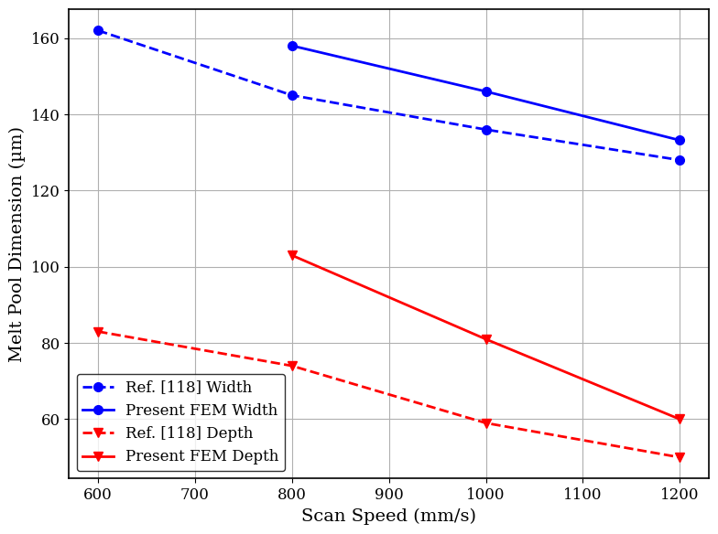
Figure 1: Comparison of melt pool dimensions between the present numerical results and published experimental data [26]
5. The validity test conducted on the model so far concerns only one experimental parametric combination (Ref. [24]), which is insufficient for a multiparameter model. The validation should be completed with alternative combinations of process parameters, including low- and high-power combinations listed in the approved experimental conditions, covering the melt-pool width and depth.
Response: We thank the reviewer for the clarification. We agree that the thermal finite element model does not explicitly resolve melt-pool fluid flow, Marangoni convection, recoil pressure, evaporation dynamics, or keyhole formation.
Accordingly, the manuscript has been revised to remove the direct interpretation of negative NPI as evidence of keyhole formation. Negative NPI is now interpreted as an indication of excessive melting/overmelting or a tendency toward thermal instability, because the predicted melted volume exceeds the nominal track volume within the defined NPI formulation.
Keyhole-related defects observed experimentally are discussed separately as experimental observations under high-energy processing conditions and are not claimed to be directly predicted by the thermal FEM.
# 2.3 Numerical porosity index
A negative NPI indicates that the predicted melted volume exceeds the nominal track volume, representing excessive melting and a potential tendency toward thermal instability. Therefore, NPI is used as a porosity tendency indicator rather than a direct measurement of physical void volume.
# 3.1 Thermal response and numerical porosity tendency
This temperature is well above the melting range of AlSi10Mg, indicating a highly energetic thermal condition with extensive melting.
6. Maximum Temperature: The predicted maximum temperature of 2127.6 °C needs to be explained in accordance with the melting behavior of AlSi10Mg and the possible evaporation of materials.
Response: Thank you for this observation. The discussion of the maximum temperature has been expanded to clarify its physical interpretation.
The revised manuscript explains that the predicted temperature of 2127.6 °C is substantially above the melting range of AlSi10Mg and therefore indicates complete melting within the highly heated region. The high local temperature results from the concentrated energy input of the moving Gaussian heat source.
The manuscript also clarifies that evaporation or vaporization effects may become relevant at such elevated temperatures; however, evaporation, recoil pressure, and vapor-driven melt-pool dynamics are not explicitly included in the present thermal finite element model. Therefore, the predicted maximum temperature is treated primarily as an indicator of the local thermal response rather than as a direct prediction of material vaporization.
The representative temperature contours in Figure 2 illustrate the transition between insufficient, relatively balanced, and excessive melting conditions. At low energy input, represented by P = 100 W, v = 1200 mm/s, and d = 0.10 mm, the thermal field was relatively weak and localized, resulting in a maximum temperature of 346.37 ◦C and an NPI of 0.898. This condition indicates insufficient melting and a strong tendency toward lack-of-fusion defects. In contrast, the combination of P = 200 W, v = 800 mm/s, and d = 0.06 mm produced the highest predicted temperature of 2127.6 ◦C and an NPI of −1.18. This temperature is well above the melting range of AlSi10Mg, indicating a highly energetic thermal condition with extensive melting. At such elevated temperatures, evaporation of relatively volatile alloy constituents may become relevant and may contribute to additional melt-pool phenomena such as recoil pressure. The negative NPI further indicates that the predicted melted volume exceeds the nominal track volume, corresponding to excessive melting under this processing condition. In comparison, the intermediate condition of P = 150 W, v = 800 mm/s, and d = 0.08 mm produced a maximum temperature of 1142.7 ◦C and an NPI of 0.0583, indicating a more balanced melting condition with the predicted melted volume close to the nominal track volume.
7. Formatting of Figures and Equations: The expression given in the equation in Section (7) should be reformatted to ensure that the piecewise definitions are properly aligned. Figure (7) needs corrections for larger and more visible labels, especially for the ones that read “Circularity < 0.35” and “AR > 2.5.”
Response: We thank the reviewer for the formatting recommendations. Equation (7) has been reformatted using an aligned piecewise structure to improve readability and consistency with the manuscript. In addition, the labels in Figure 7, have been enlarged and adjusted for improved visibility and readability in the final manuscript.
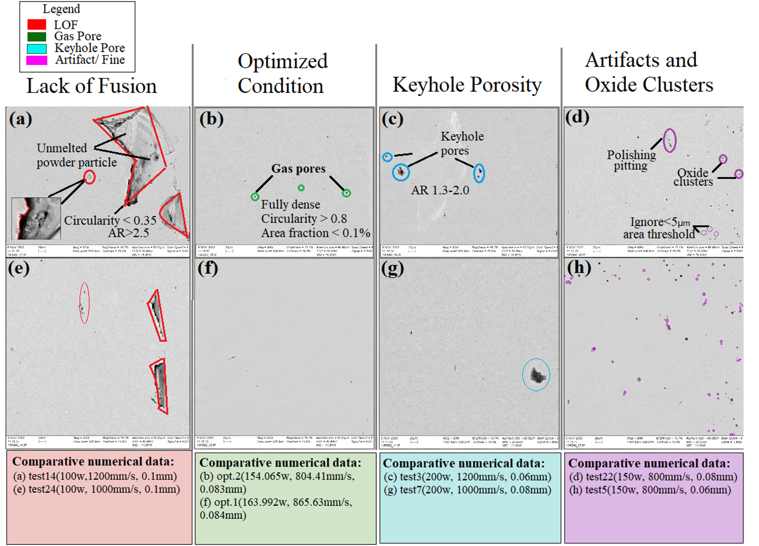
Figure 2: Representative SEM micrographs illustrating the microstructural features observed under selected experimental processing conditions.
Equation (7)
8. Affiliation: Change “Jimma univerisity” to “Jimma University
Response: We thank the reviewer for identifying the typographical error. The affiliation has been corrected throughout the manuscript to read “Jimma University.”
Jimma University
9. References: All the references should be checked for consistency, and the final bibliographic details should be confirmed, in particular for References [4], [5], and [19], including the year of publication, volume, issue, pages, and DOI if applicable.
Response: We thank the reviewer for this recommendation. The reference list has been carefully checked and the bibliographic information of all references has been verified and corrected where necessary. The year, journal title, volume, issue, page range/article number, and DOI information have been checked against the corresponding publication details. The remaining references have also been reviewed to ensure consistency between the in-text citations and the reference list and to comply with the required COTech reference style.
References
[1] Gao B, Zhao H, Peng L, Sun Z 2023 A review of research progress in selective laser melting (SLM), Micromachines 14(1), 57.
[2] Mughir W A 2022 A review in 3D printing technique: types, applications and process Parameters, J. Univ. Babylon Eng. Sci. 30(3), 33–49.
[3] Shrestha S, Starr T, Chou K 2019 A study of keyhole porosity in selective laser melting: single-track scanning with micro-CT analysis, ASME J. Manuf. Sci. Eng. ASME 141(7), 071004.
[4] Castro Rodas EG, Buitrago Diaz JC, Ortega-Portilla C, G´omez-Ortega A, Piamba JF, Salazar D, et al. 2025 Analysis of porosity in aluminum alloy (AlSi10Mg) using tomographic image processing, J. Manuf. Mater. Process. 9(11), 374.
[5] Wilbig J, Wilson-Heid A, Bernard L, Baptista J, Obaton AF 2025 Comparison of porosity analysis based on X-ray computed tomography on metal parts produced by additive manufacturing, Appl. Sci. 15(18), 9876.
[6] Liu W, Chen C, Shuai S, Zhao R, Liu L, Wang X, et al. 2020 Study of pore defect and mechanical properties in selective laser melted Ti6Al4V alloy based on X-ray computed tomography, Mater. Sci. Eng., A 797, 139981.
[7] Kan WH, Chiu LNS, Lim CVS, et al. 2022 A critical review on the effects of process-induced porosity on the mechanical properties of alloys fabricated by laser powder bed fusion, J. Mater. Sci. 57, 9818–65.
[8] Yusuf SM, Chen Y, Boardman R, Yang S, Gao N 2017 Investigation on porosity and microhardness of 316L stainless steel fabricated by selective laser melting, Metals 7(2), 64.
[9] Voznesenskaya A, Zhdanov A and Raznoschikov A 2021 evolution of porosity depending on SLM mode and subsequent HIP processing, J. Phys. Conf. Ser. vol 2077, 012023.
[10] Pokorn´y P, V´aclav ˇS, Petru J and Samardziova M 2021 Porosity analysis of additive manufactured parts using CAQ technology Mater. 14.
[11] Aggarwal A and Kumar A 2019 Particle scale modelling of porosity formation during selective laser melting process using a coupled DEM–CFD approach, IOP Conf. Ser.: Mater. Sci. Eng. vol 529, 012001.
[12] Stwora A, Teimouri R, Habel J 2025 Role of laser powder bed fusion process factors in determining the porosity formation in 3D printing of stainless steel 316L: theoretical modeling and experimental verification, Mater. 18(24), 5490.
[13] Cheng B and Tuffile CD 2019 Numerical study of porosity formation with implementation of laser multiple reflection in selective laser melting, ASME 2019 14th Int. Manuf. Sci. Eng. Conf. (Erie, Pennsylvania, USA) vol 1, V001T01A011.
[14] Tan JL, Tang C and Wong CH 2018 A computational study on porosity evolution in parts produced by selective laser melting Metall, Mater. Trans. A 49(8), 3663–73.
[15] Wang Y, Jing X, Li Z and Liu B 2024 Molecular dynamics research on the effect of selective laser melting parameters on porosity and properties of parts, Mater. Today Commun. 41, 110626.
[16] Nandhakumar R and Venkatesan K 2023 A process parameters review on selective laser melting-based additive manufacturing of single and multi-material: microstructure, physical properties, tribological, and surface roughness Mater, Today Commun. 35, 105538.
[17] Zhang C, Liao Q, Zhang X, Ma F, Wu M and Xu Q 2023 Characterization of porosity in lack of fusion pores in selective laser melting using the wavefunction, Mater. Res. Express. 10(1), 016501.
[18] Modaresialam M, Roozbahani H, Alizadeh M, Salminen A and Handroos H 2022 In-situ monitoring and defect detection of selective laser melting process and impact of process parameters on the quality of fabricated SS 316L, IEEE Access 10, 46100-13.
[19] Podolskyi RV, Adzhamskyy SV, Kononenko GA and Badyuk SI 2025 The influence of physical phenomena and material properties on the quality of parts during selective laser melting, Phys. Met. 26(4), 796-827.
[20] Voznesenskaya AA, Zhdanov AV and Raznoschikov AS 2021 Evolution of porosity depending on SLM mode and subsequent HIP processing, J. Phys. Conf. Ser. vol 2077, 012023.
[21] Ansari M, Nguyen DS and Park H 2019 Investigation of SLM process in terms of temperature distribution and melting pool size: modeling and experimental approaches, Mater. 12, 1272.
[22] Depboylu F N, Mishin O V, Leissner T and Popa A A 2025 Microstructure and mechanical properties of parts produced by laser powder bed fusion of AlSi10Mg powder with coarse particle size, Mater. Charact. 229, 115573. doi:10.1016/j.matchar.2025.115573
[23] Hirata T, Kimura T and Nakamoto T 2020 Effects of hot isostatic pressing and internal porosity on the performance of selective laser melted AlSi10Mg alloys, Mater. Sci. Eng. A 772, 138713.
[24] Hyer H, Zhou L, Park S, Gottsfritz G, Benson G and Tolentino B 2020 Understanding the laser powder bed fusion of AlSi10Mg alloy, Metall. Microstruct. Anal. 9, 484-502.
[25] Aversa A, Bosio F, Marola S, Lorusso M, Manfredi D and Battezzati L 2018 Laser single scan tracks of new aluminium alloys compositions, Euro PM2018 Proceedings: AM Special Materials (Bilbao, Spain: European Powder Metallurgy Association) pp 15–20.
[26] Xu Y, Li Y, Wang L, Song Y, Li K, Xing H, Chen B and Wang J 2024 Molten pool macroscopic thermodynamic analysis during selective laser melting of AlSi10Mg: Simulations and experiments, J. Mater. Res. Technol. 33, 2506–2518. doi:10.1016/j.jmrt.2024.09.216
Additional updates
In response to the constructive feedback from the reviewers, we have thoroughly revised the manuscript. General updates include:
- All sections: Introduction, Method, Results, and Discussion
- Figures, Tables, and References have been updated
- Language improvement (spelling, tone, etc.) has been made.
- Others
Thank you for all the helpful comments.
Sincerely,

Authors
October 1, 2026

