Assessing CFD parameter influence on TUDFlow3D
R Costa-Antunes^{1, *}, L de Wit², T Fzeres-Ferradosa¹, Y Broekema², F Miranda¹, F Taveira-Pinto¹ and E Carvalho¹
¹ Department of Civil Engineering and Georesources, Faculty of Engineering, University of Porto, Rua Dr. Roberto Frias s/n, 4200-465, Porto, Portugal
² Deltares, Boussinesqweg 1, 2629 HV Delft, the Netherlands

* up202109638@up.pt
Abstract. The rapid expansion of offshore wind has increased the demand for reliable scour protection systems to ensure the long-term stability of turbine foundations. Rip-rap scour protections are widely used to mitigate local scour around monopiles. However, edge scour can develop around the protection perimeter, compromising stability and increasing maintenance costs. Optimising scour protection design therefore requires accurate prediction of edge scour. CFD modelling offers a promising approach, but its application remains limited by the calibration of key model parameters. For instance, in the TUDFlow3D framework, previous results have shown an overprediction not only in the depth of the edge scour hole but also in the slope of the bathymetry. This study focused on the assessment of the influence of CFD parameters, such as MORFAC and avalanche slope angle, on the edge scour prediction. The calibration process successfully mitigated edge scour overprediction using a geomechanical parameterisation of the avalanche slope angle. Additionally, a threshold was identified at a mobility ratio of 71 (bed-to-berm mobility parameter ratio). Numerical results proved accurate near this value but led to mispredictions when deviating far from it. The findings of this study provide guidance for the selection and calibration of TUDFlow3D numerical models to predict edge scour around offshore scour protections.
- Introduction
Scour protections are frequently used in offshore foundations to mitigate scour, reducing both its depth and extent. However, the installation of these countermeasures, typically consisting of rip-rap armour layers, introduces a macroscopic roughness transition that alters local hydrodynamics. This transition causes a localized increase in flow velocity and bed shear stress driven by wave and current interactions. Consequently, this hydrodynamic amplification leads to the onset of edge or secondary scour, defined as the erosion of the seabed at the outer perimeter of the protection material, as established by Whitehouse et al. [1].
As the edge scour hole develops, the peripheral armour stones lose support and progressively slide or roll into the resulting depression, a phenomenon commonly known as the falling apron effect. If not properly accounted for in the design phase, this process can lead to perimeter instability, excessive deformation of the armour layer, and the potential loss of the protection's overall functionality [2–6].
A comprehensive review of the literature reveals that the mechanisms of local scour have been extensively investigated through scaled laboratory experiments (e.g., De Vos et al. [7] and Petersen et al. [5]) and three-dimensional numerical simulations (e.g., Baykal et al. [8]). However, despite these broad advancements, the precise replication of edge scour phenomena, specifically around rip-rap protections, using computational models remains a significant challenge. As highlighted by Fazeres-Ferradosa et al. [9], the numerical modelling of scour protections in the marine environment is particularly limited due to the high computational costs of resolving individual armour stones and the highly complex fluid-soil-structure interactions. Current numerical tools frequently struggle to replicate these intricate boundary conditions, often leading to an unrealistic overprediction of edge scour depths. This highlights the importance to refine, calibrate and validate internal numerical components within advanced CFD frameworks such as TUDFlow3D [10,11].
To investigate and optimize the numerical modelling of the edge scour phenomenon around offshore structures supported by monopile foundations and protected by rip-rap systems, CFD software TUDFlow3D was employed, seeking to accurately capture the complex hydrodynamic and morphodynamical interactions occurring at the transition between the rigid protection and the sandy seabed. To ensure precise model calibration, an in-house experimental dataset from Deltares was used. Furthermore, to validate the model's predictive trends and ensure its robustness across representative scenarios, physical model tests conducted by Petersen et al. [5] were established as the primary baseline. Both the calibration and validation procedures are strictly performed under current-only conditions. Ultimately, the objective was to seek out the key parameters influencing the overprediction of edge scour results in TUDFlow3D, such as MORFAC and avalanche slope angle, aiming to significantly improve the accuracy and reliability of the computational predictions.

- Methodology

Description of the Numerical Model
    - Framework used - TUDFlow3D The numerical investigation was conducted using TUDFlow3D, an open-source CFD solver developed by Delft University of Technology (TU Delft) and further adapted for engineering applications by Deltares and Svašek Hydraulics [12]. This model is designed to simulate near-field phenomena, with a particular focus on sediment plume dispersion, non-cohesive sediment transport, and scour processes around complex hydraulic structures.
TUDFlow3D employs a fully three-dimensional, non-hydrostatic formulation that resolves flow structures where vertical velocity components and turbulent fluctuations are critical. The code operates on a curvilinear structured grid with a discretisation that ensures robust conservation of mass and momentum while minimising numerical pressure oscillations. Furthermore, the solver is parallelised via Message Passing Interface (MPI), allowing for efficient computation of high-Reynolds-number flows on multiprocessor clusters. This architecture allows the simulation of complex engineering-scale problems, involving millions of cells, within a manageable timeframe [13].
    - Spatial discretisation The discretisation of the computational domain in TUDFlow3D follows a structured grid approach, where the spatial resolution is independently configurable across the longitudinal, $i$ (4 m), lateral, $j$ (2.5 m), and vertical, $k$ (0.60 m of water depth plus a seabed thickness of 0.30 m), axis. To ensure both computational efficiency and physical accuracy, the model employs a hybrid grid strategy that combines high-resolution refinement zones from 15 to 5 mm (${D_{p}}/{40}$) with gradual expansion. This is achieved through two primary mechanisms:

- Geometric stretching, where a growth factor for consecutive cells permits the mesh to transition smoothly, preventing abrupt volume changes that could trigger numerical oscillations;
- Constant resolution zones, which maintain a uniform mesh density at critical boundaries until the next transition index is reached.
This hybrid approach enables the mesh to be refined at the structural boundaries and subsequently "telescoped" out towards the domain boundaries to reduce the total cell count without compromising resolution in high-gradient regions.
    - Temporal discretisation Temporally, the integration of the governing equations is achieved through highly stable numerical schemes, such as the Adams-Bashforth or Runge-Kutta methods. To maintain numerical stability across the highly dynamic turbulent flow regions, the time step is strictly governed by the Courant Friedrichs Lewy (CFL) criterion, dynamically adjusting to prevent divergence as local velocities escalate. The Courant number, $Cr$, represents the non-dimensional relationship between the simulation time step, $∆t$, the local fluid velocity, $U$, and the directional cell size, $∆x$, expressed by equation (1).
$$Cr=U\frac{∆t}{∆x}≤{Cr}_{max}$$ | (1)
Preliminary sensitivity investigations by Schotmeijer [14] in TUDFlow3D, assessing $Cr$ numbers of 0.25 and 0.50, demonstrated a negligible influence on the final morphodynamical patterns, confirming that adopting too conservative time steps does not noticeably improve accuracy, which led to a ${Cr}_{max}$ of 0.50.
Because morphological changes in the seabed occur at a significantly slower rate than fluid dynamics, the solver implements a morphological acceleration technique via Morphological Acceleration Factor (MORFAC) (for example, a MORFAC of 100 dictates that 1 second in the numerical model equates to 100 seconds in the real-world case). This allows the morphological updates to be temporally decoupled from the hydrodynamic calculations, scaling the simulated equilibrium time to a manageable computational timeframe without sacrificing physical accuracy.
    - Numerical schemes and boundary conditions To solve the advection-diffusion equations accurately, TUDFlow3D employs a combination of high-order numerical schemes. Convective terms are typically discretised using advanced hybrid formulations, such as a second order central scheme combined with a small amount of sixth order dissipation [12], to minimise numerical dissipation while accurately tracking sharp gradients in the flow field. Diffusion terms are handled using central differencing. Furthermore, a mass-conserving Shapiro low-pass filter can be applied to the 2D bed level, periodically redistributing sediment to eliminate non-physical bed wiggles.
To resolve the turbulent structures inherent in high-Reynolds-number flows, the model incorporates a Synthetic Eddy Method (SEM) algorithm that injects synthetic turbulent fluctuations into the domain, rather than relying on a simple laminar inflow [15]. As these structures propagate, they evolve into a physically consistent turbulent boundary layer. This capability is instrumental in reducing the required fetch length, allowing the flow to reach a fully developed state before interacting with the monopile and its scour protection.
At the downstream boundary, the solver employs a non-reflective outlet condition. A zero-gradient, Neumann approach, is applied to the velocity field, coupled with a zero-pressure boundary condition. This configuration ensures that turbulent wakes and transient vortices can exit the computational domain freely, preventing numerical instabilities or artificial pressure reflections that could compromise the accuracy of the flow field near the structure. Finally, the solid boundaries, including the seabed and the structural surfaces, are governed by specific slip or no-slip conditions. These are parametrised by Nikuradse roughness, $k_{n}$​, values to accurately reproduce the bed shear stresses that drive the sediment transport.
    - Hydrodynamic solver and sediment transport module The hydrodynamic core of TUDFlow3D is a fully three-dimensional, non-hydrostatic CFD solver. Unlike traditional RANS models that average all scales of turbulence, TUDFlow3D primarily employs a Large Eddy Simulation (LES) approach [16]. This methodology ensures that the most significant energy-containing large-scale eddies are directly resolved within the computational grid, providing a highly accurate representation of the turbulent flow field and its interaction with the seabed. To close the governing equations, the influence of the smaller, unresolved sub-grid scale turbulence is typically captured using advanced models such as the Wall-Adapting Local Eddy-viscosity (WALE) model [17].
Regarding sediment dynamics, the model incorporates a comprehensive transport module based on a Eulerian mixture approach, which allows the simulation of a multi-fraction sediment configuration. The morphological module is capable to track and compute multiple sediment fractions simultaneously, differencing between native bed material and scour protection elements. Each fraction is independently defined by its density, representative diameter, settling velocity, and critical shear stresses for erosion and deposition. The module is also capable of handling both cohesive and non-cohesive sediments while accounting for complex physical processes.
The interaction between the fluid and the bathymetry is handled dynamically through a bed update function. This feature allows the model to simulate both erosion and accretion processes, updating the bed level at each morphological step. To handle the presence of physical structures, the process-based 3D CFD model TUDFlow3D employs a high-order Immersed Boundary Method (IBM). This advanced numerical framework allows the monopile structure, the erodible bed, and the protective rock berm to be captured accurately within the structured grid without the need for complex mesh deformation, offering distinct advantages for high-resolution scour prediction. This conceptual mechanism can be visualized in Figure 1, with the representation of the Suspended Sediment Concentration (SSC) and the Bed Concentration (Cbed).

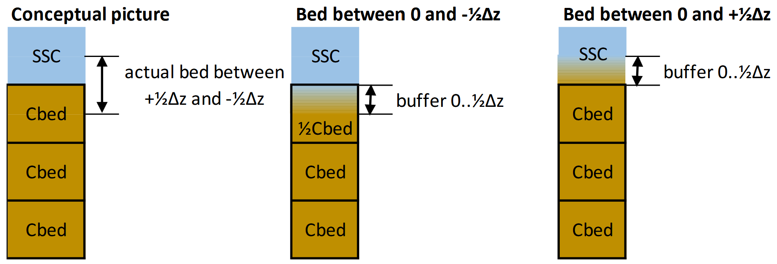
Figure 1. Illustration of the IBM applied to a fixed Cartesian grid [10].

The morphological evolution, encompassing these erosion and deposition processes, was modelled using a discrete rock berm representation for the riprap. Furthermore, the initial sediment transport mechanics were based on the formulation of van Rijn [18] for suspension pickup and van Rijn [19] formulation for bedload transport. To ensure the geotechnical validity of these morphological updates, the solver also features a robust avalanching mechanism, automatically redistributing sediment to a stable angle if the bed slope exceeds the critical internal angle of friction of the material.

Simulation Framework
The methodology adopted in this study was structured into two primary phases: numerical calibration and experimental validation. Initially, the calibration phase aimed to fine-tune the TUDFlow3D solver to mitigate the overprediction of edge scour. This was achieved through an iterative process involving five sequential numerical configurations (denoted by the prefix 'v', ranging from v01 to v05), which progressively adjusted internal parameters such as the morphological acceleration factor (MORFAC) and avalanche slope angles. To ensure robustness, every configuration was evaluated across four distinct mobility scenarios (labelled with 'C', from C1 to C4). These scenarios maintained an identical baseline test case, varying only the associated current velocities. The results from all four 'C' scenarios were assessed at each step to inform the improvements implemented in the subsequent 'v' configuration.
Note that all 'C' calibration tests were subjected to bi-directional currents, while the validation phase was performed against Petersen et al. [5] experiments with steady current conditions.
Following the initial calibration phase, as an initial trial, v02 was selected to proceed with the experimental validation. The primary objective was to evaluate the model's predictive capabilities and morphodynamical trends against established physical benchmark data. To accomplish this, seven specific laboratory test cases (designated by 't', such as t02 and t20) were simulated, replicating the conditions observed in Table 1 of Petersen et al. [5].
    - Numerical Calibration and Sensitivity Analysis
The calibration process is structured into five incremental stages, as summarized in Table 1. It begins with a baseline simulation (v01) that replicates an unpublished in-house experimental test case to identify the solver's default behaviour and error margins. This specific test case reflects a physical test of a monopile protected with rip-rap at its base, performed under bi-directional currents. Subsequently, morphodynamical improvements are introduced (v02), adjusting the sediment transport formulations and the threshold of motion, incorporating theoretical adjustments from Roulund et al. [11] integrated with D3D-style corrections. To further stabilise the temporal evolution of the scour hole, MORFAC is reduced to 50 (v03), allowing for a direct assessment of the differences in prediction results by MORFAC influence. Subsequently, a localised reduction of the avalanche angle is applied in critical zones (v04) to prevent the artificial numerical collapsing of the sand slopes. Finally, a further adjustment to the avalanche angles (av_slope) is implemented (v05).
Table 1. Naming Convention and Tests Description.
Test ID | Description of Numerical Test | MORFAC | Av_slope [º]
v01 | Preliminary numerical simulation (baseline) | 100 | 32
v02 | Sensitivity analysis of Morphodynamical Improvements | 100 | 32
v03 | Sensitivity analysis of MORFAC | 50 | 32
v04 | Evaluation of zoned Avalanche Slope reduction | 50 | Rock berm – 27  Seabed – 22
v05 | Geomechanical parameterisation of zoned Avalanche Slope | 100 | Rock berm – 33  Seabed – 27

To evaluate the stability boundaries of the rock armour, the tests (C1, C2, C3 and C4) spanned a Mobility number, $MOB$, range of 0.546 (0.23 m/s), 1.064 (0.33 m/s), 1.740 (0.43 m/s) and 2.573 (0.52 m/s), calculated according to DNV [20]. These variations have been done to the velocity of the current and not to the physical properties of the protection's material..
    - Experimental Validation - Benchmark Data In this phase, the primary objective is to replicate the results presented in Petersen et al. [5] and determine whether the morphodynamical trends observed in the laboratory are replicable within the numerical framework.
Considering the 7 selected cases from Table 1 of Petersen et al. [5] (t02, t20, t24, t27, t37, t39 and t47), this validation stage focuses strictly on evaluating the model's capability to accurately reproduce the physical outcomes reported in the benchmark paper, specifically concerning the equilibrium edge scour depths and the spatial lengths of the scour hole.
 | hw [m] | hb [m] | Wb,toe [m] | Uc [m/s] | T [s]
    - Definition of Numerical Variables and Temporal Scaling The accurate simulation of scour phenomena in CFD models requires a precise definition of the total simulation time, which is a direct input parameter in TUDFlow3D. Because the edge scour process is theoretically infinite, continuing to develop over time but at successively decreasing rates until it asymptotically approaches an equilibrium state, a standardized criterion must be adopted to define when the morphological equilibrium is reached.
Based on the experimental data provided by Petersen et al. [5], the temporal development of the scour depth, $S\left(t\right)$, can be mathematically described by the standard empirical exponential function, formulated by equation (2) [21],
$$S\left(t\right)=S_{eq}\left(1-e^{-\frac{t}{T}}\right)$$ | (2)
in which $S_{eq}$ is the equilibrium scour depth and $T$ is the time scale of far field scour.
The time scale conceptually represents the time it would take to reach the maximum equilibrium depth if the initial linear rate of scour, so the derivative of the curve at $t=0$,was maintained constant. This theoretical relationship and the geometric interpretation of $T$ as the intersection of the initial scour rate tangent with the asymptote of equilibrium depth are schematically illustrated in figure 7 of [22].
Practical equilibrium is widely defined following the criterion proposed by Melville and Chiew [23], which assumes the scour process is stable when the development rate does not exceed 5% within a 24-hour period. However, to systematically define the required input time for all numerical cases based on the physical benchmark data, widely accepted rule of thumb in offshore engineering is applied, establishing the target morphological time to reach practical equilibrium as five times the respective time scale ($5T$).
As derived from the exponential time-development function proposed by Sumer et al. [21] and Sumer and Fredsøe [24], it is mathematical proven through equation (2), that at $t=5T$, the scour depth reaches approximately 99.3% of its theoretical maximum value derived from the exponential fitting curve. When real scour developments follow the referred curve fit, the simplified threshold ensures that any further morphological evolution is marginal and well within the accepted tolerance margins, optimizing computational resources without compromising accuracy.

Numerical Model Setup and Parametrisation
    - Foundation geometric parametrisation and reference variables The physical domain is defined by a vertical monopile of diameter $D_{p}$, surrounded by a scour protection system consisting of a horizontal rip-rap berm and characterised by a median diameter, $D_{50}$. The transition between the protection layer and the sandy seabed, defined by $d_{50}$, creating a step-height discontinuity that is critical for the development of edge scour.
The protection extends to a radial distance from the pile centre, defined by the berm height, $h_{b}$, and the top and toe width, respectively $W_{b,top}$ and $W_{b,toe}$. Figure 2 alongside to Figure 3, provide a schematic of these fundamental geometric parameters and the metrics used for numerical validation.
As defined in Figure 3, the model performance is quantitatively assessed through the depth and slope deviation, $∆v$ and $∆i$, and the radial spatial deviation $∆r$, which represent the primary error metrics extracted during the calibration and sensitivity analysis phases.

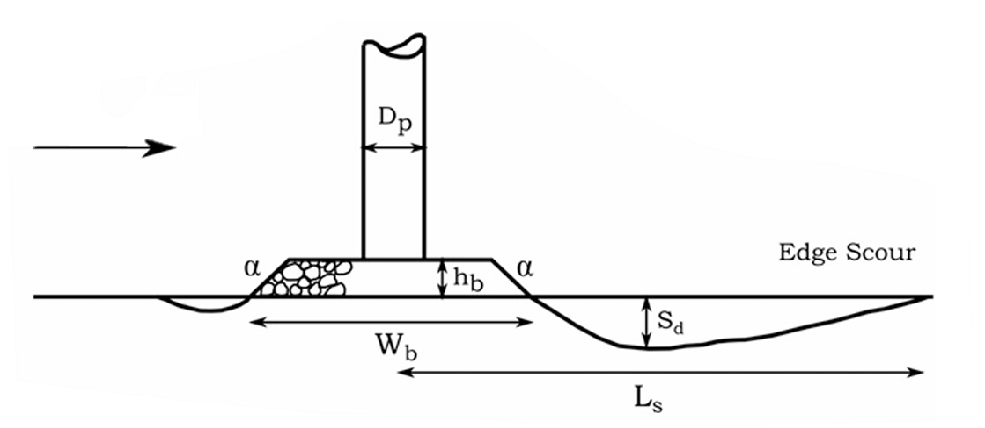 | 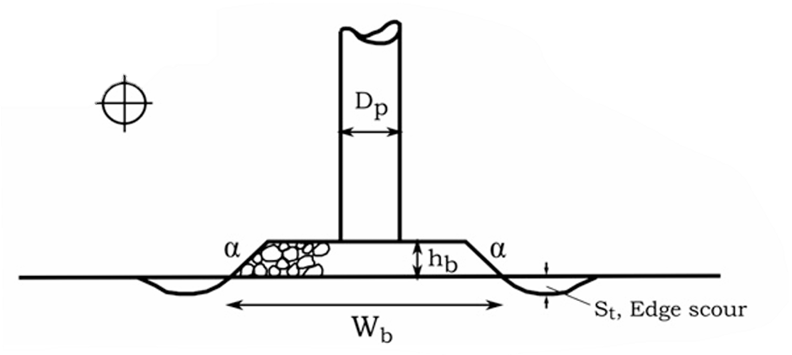
Figure 2. Edge scour downstream depth ($S_{d}$), transverse depth ($S_{t}$) and spatial length ($L_{s}$) representation [5].
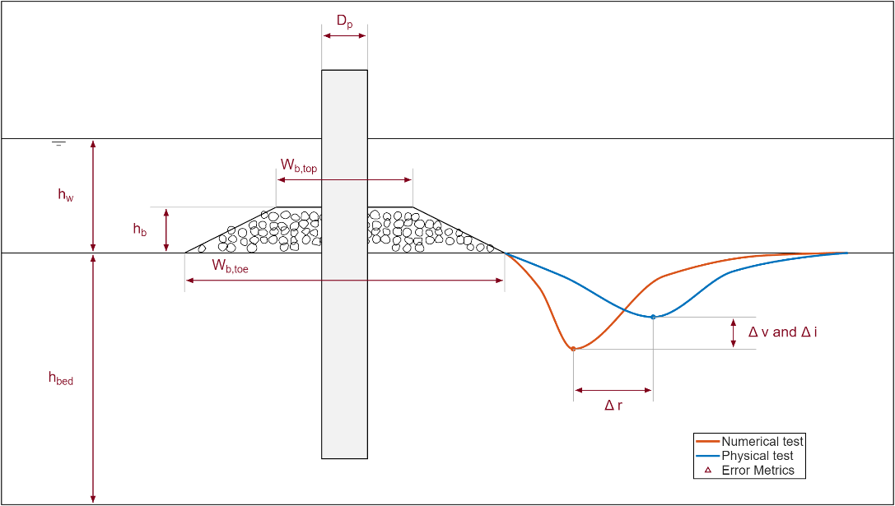
Figure 3. Schematic definition of geometric parameters and error metric variables.
    - Domain discretisation and mesh resolution The spatial discretisation strategy of the study is based on the necessity to capture the complex vortex structures inherent to monopile edge scour. Following established modelling practices within the TUDFlow3D framework to smoothly transition cell volumes and prevent computational instabilities, as demonstrated by Schotmeijer [14], the primary refinement zone surrounding the monopile and the protective berm adopts with a baseline spatial resolution of ${D_{p}}/{40}$ in both horizontal and vertical directions. To preserve the accuracy of the finite volume discretization, the maximum stretching factor between adjacent cells is limited to 1.03, while the maximum aspect ratio is kept below 3. Furthermore, inflow and outflow boundaries are positioned at distances between $5h_{w}$ and $10h_{w}$, providing sufficient fetch for the turbulent boundary layer to fully develop before interacting with the structure. The adequacy of the ${D_{p}}/{40}$ resolution is formally supported by recent literature regarding local scour simulations using the TUDFlow3D solver [10,25].
Confirming grid independence for local scour at the ${D_{p}}/{40}$ threshold, this optimised resolution was consequently adopted for the present edge scour simulations.
- Results and Discussion

Model Validation and Numerical Sensitivity
To clearly evaluate the impact of the varied setup parameters, the calibration results are initially clustered by $MOB$. Figure 4 to Figure 7 illustrate the deepest edge scour profile extracted from the resulting bathymetries for each numerical configuration tested under each specific $MOB$ scenario. It should be noted that the angle alongside each configuration in these figures corresponds to the spatial angular coordinate where the deepest bathymetric profile occurs, in relation to the pile centre axis.
The comparison between the different numerical configurations across the mobility scenarios reveals several clear morphodynamical trends. Firstly, it is evident that an increase in the $MOB$ parameter consistently leads to a deeper and wider edge scour hole, a behaviour accurately captured by both the physical benchmark and the numerical model.
The baseline numerical setup, v01, systematically overestimates the maximum scour depth across all $MOB$ scenarios, presenting a pronounced morphological deviation from the physical data. However, as the calibration iterations progress, a clear and positive evolution is observed. While configuration v04 yields the most accurate prediction regarding the absolute maximum scour depth, a slight degradation in this specific metric is noticeable in v05. Nevertheless, this marginal depth variation in v05 is counterbalanced by a notable improvement in the spatial positioning of the deepest point (as reflected by the previously mentioned spatial angles), aligning more accurately with the morphological scour hole observed in the laboratory measurements.

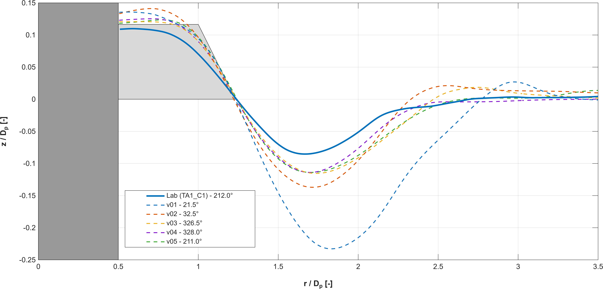
Figure 4. Deepest Edge Scour profiles for all configurations for C1 (bi-directional flow left-right). The angles in the legend represent the spatial angular coordinate, in relation to the pile centre axis.

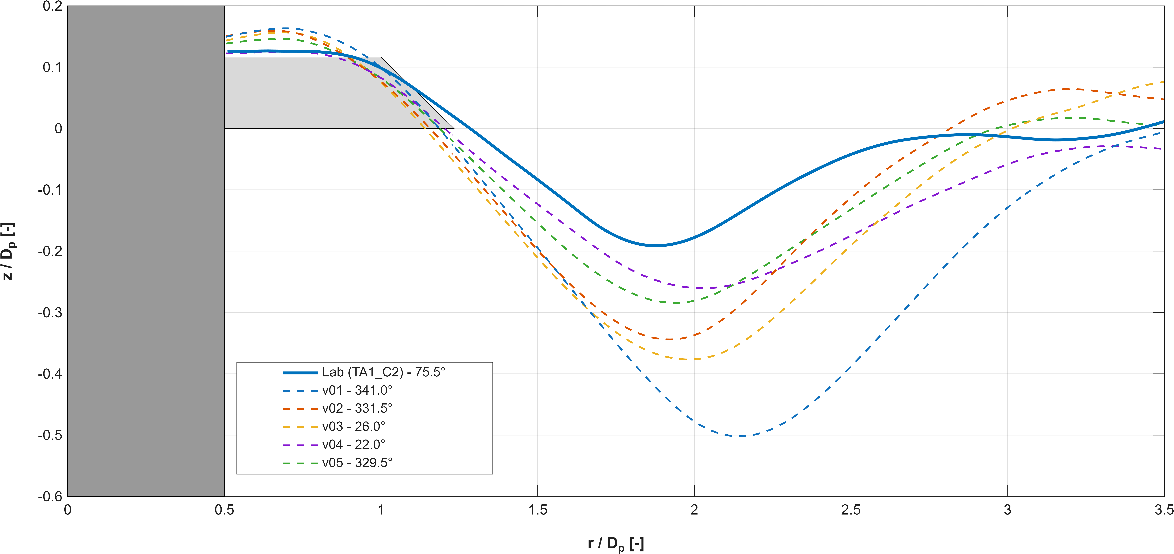
Figure 5. Deepest Edge Scour profiles for all configurations for C2 (bi-directional flow left-right). The angles in the legend represent the spatial angular coordinate, in relation to the pile centre axis.

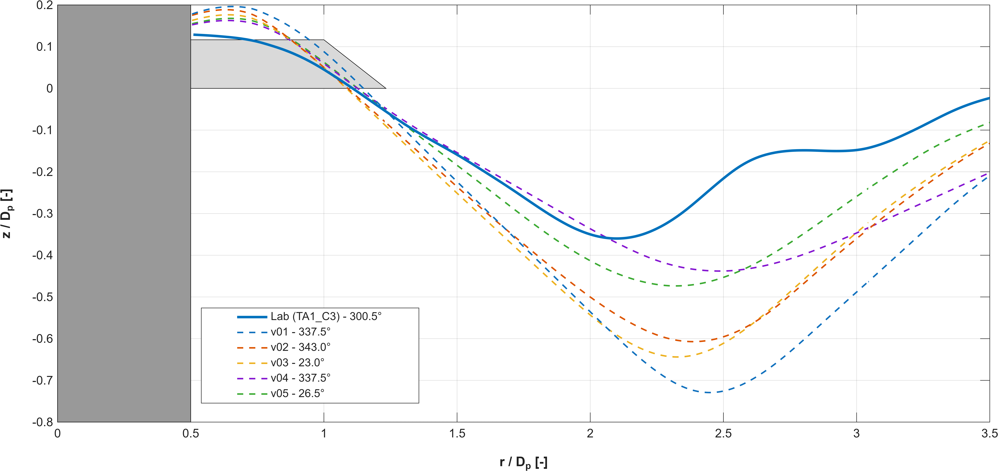
Figure 6. Deepest Edge Scour profiles for all configurations for C3 (bi-directional flow left-right). The angles in the legend represent the spatial angular coordinate, in relation to the pile centre axis.

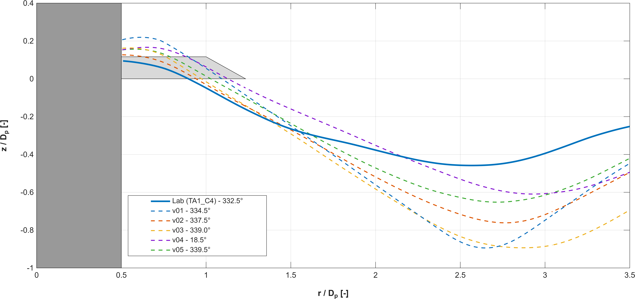
Figure 7. Deepest Edge Scour profiles for all configurations for C4 (bi-directional flow left-right). The angles in the legend represent the spatial angular coordinate, in relation to the pile centre axis.

Following the assessment of the maximum scour depth, a parallel evaluation is conducted on the steepest avalanche slope profiles. As the overprediction of edge scour is inherently linked to the morphodynamical stability of the rip-rap berm, analysing the maximum slope provides critical insights into the structural collapse mechanism and the solver's avalanche formulation. Figure 8 to Figure 11 illustrate the steepest edge scour profiles for each numerical configuration across the evaluated $MOB$ scenarios.
The visual analysis of these steepest profiles strongly corroborates the findings from the depth assessment. The baseline configuration, v01, systematically reaches the predefined avalanche angle of repose and maintains a flat minimum across a wide radial distance. This behaviour indicates an abrupt and excessive structural failure mechanism within the model, completely misaligned with the smoother, more gradual slopes recorded in the physical flume. As the numerical parameters are refined, configurations v04 and v05 demonstrate a clear mitigation of this excessive steepening. Particularly in the most extreme mobility scenario, C4, configuration v04 tends to overcompensate, resulting in an overly flat profile. Consequently, configuration v05 emerges as the most robust calibration, successfully replicating the morphological shape and slope steepness of the physical data without artificially pinning the bathymetry to the angle of repose.

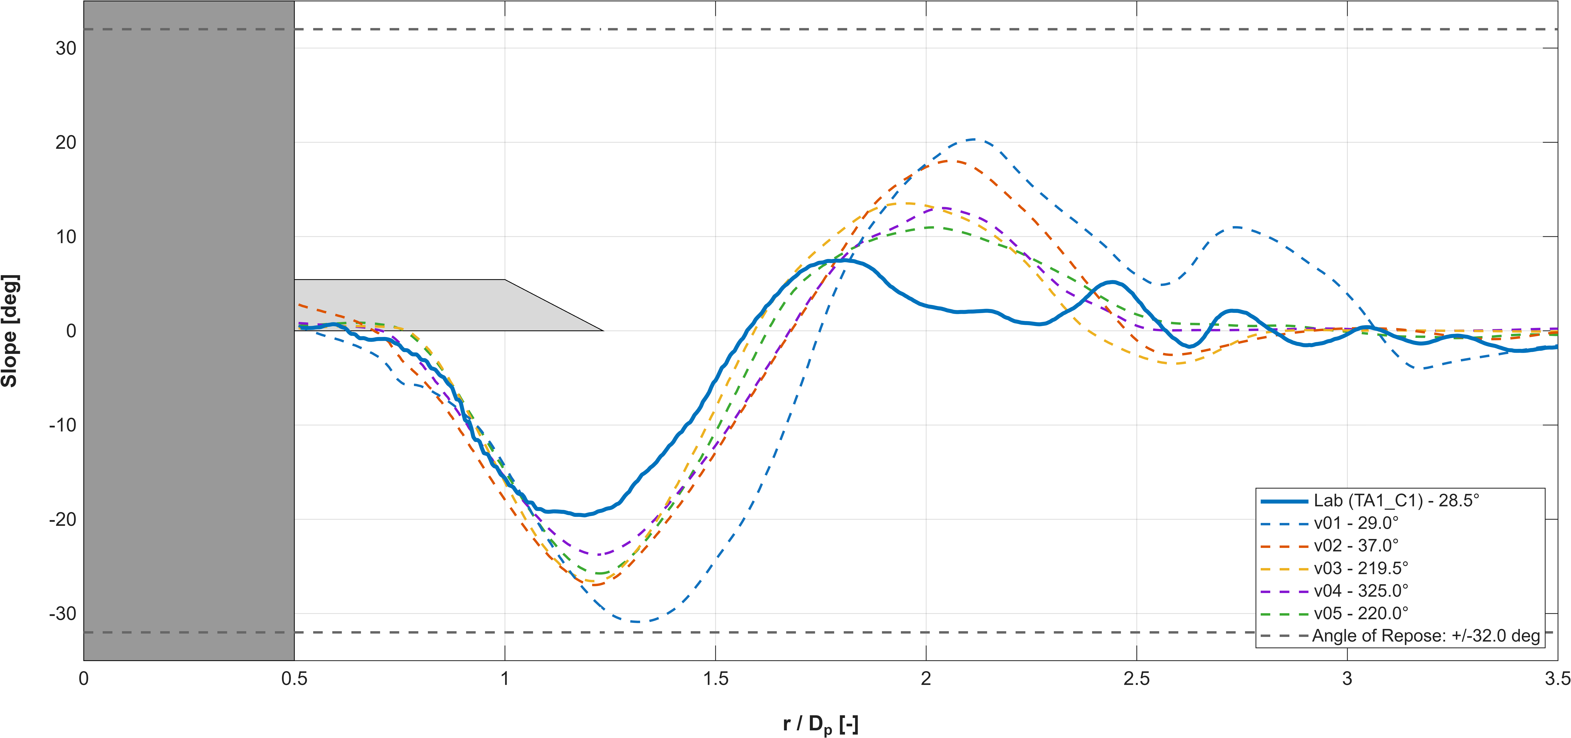
Figure 8. Steepest Edge Scour profiles for all configurations for C1 (bi-directional flow left-right). The angles in the legend represent the spatial angular coordinate, in relation to the pile centre axis.

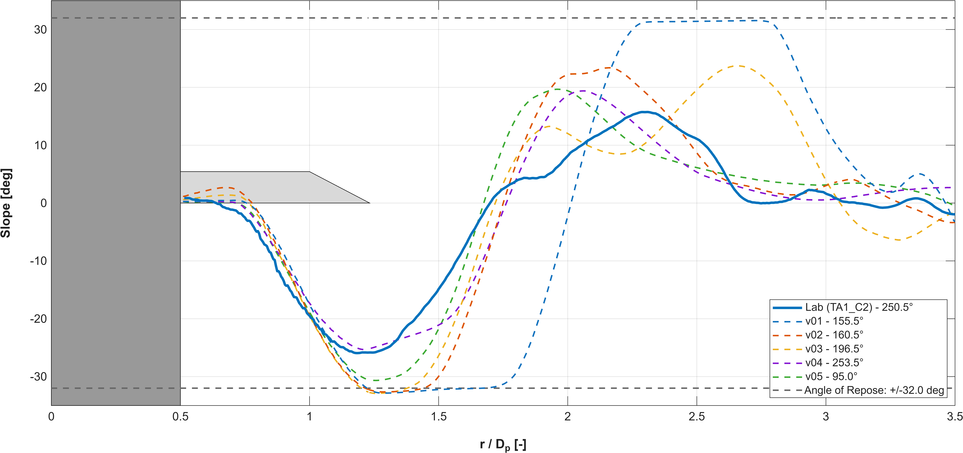
Figure 9. Steepest Edge Scour profiles for all configurations for C2 (bi-directional flow left-right). The angles in the legend represent the spatial angular coordinate, in relation to the pile centre axis.

Figure 10. Steepest Edge Scour profiles for all configurations for C3 (bi-directional flow left-right). The angles in the legend represent the spatial angular coordinate, in relation to the pile centre axis.

Figure 11. Steepest Edge Scour profiles for all configurations for C4 (bi-directional flow left-right). The angles in the legend represent the spatial angular coordinate, in relation to the pile centre axis.

Despite these substantial morphological improvements, the plots also demonstrate that as the mobility parameter reaches its maximum threshold, the structural deviations become more complex to mitigate. This behaviour is consistent with recent literature [26,27], which confirms that higher mobility regimes induce larger sediment displacements and highly complex damage patterns. Consequently, this increased physical complexity inherently limits the predictive accuracy of morphodynamical models, naturally leading to higher deviations under extreme hydrodynamic forcing.

Numerical Benchmark - Edge Scour Characterisation
The hydrodynamic simulations were executed under steady current conditions, according to the specific velocities established for each scenario in Table 1 of Petersen et al. [5]. It must be noted that the overarching parameterization for these simulations is based on the intermediate v02 calibration setup, to optimize computational feasibility on the cluster because of MORFAC value. Given the strict time constraints and the necessity to assess preliminary morphological trends while the progressive calibration workflow was still ongoing, adopting this baseline was a practical need to guarantee continuous progression.
To rigorously assess the actual time scale of the numerical model, the temporal development of the maximum edge scour depth was extracted. The resulting morphological trajectories over time are illustrated in Figure 12.
A best-fit curve based on the theoretical exponential function defined in equation (2) was applied to the numerical data points. This curve-fitting procedure enabled the determination of the effective numerical time scale, $T_{num}$, and the projected numerical equilibrium scour depth, $S_{eq,num}$, specific to the TUDFlow3D solver.
All simulations entered the asymptotic phase of morphological development when ${S\left(t\right)}/{S_{eq,num}}$ is higher than 0.97, corresponding to ${T_{num}}/T$ values ranging from 0.4256 to 1.6449. Consequently, the respective outputs were considered sufficiently accurate and representative of the ultimate edge scour depths, justifying their direct use in the subsequent parametric analysis without the need for computationally expensive re-runs.

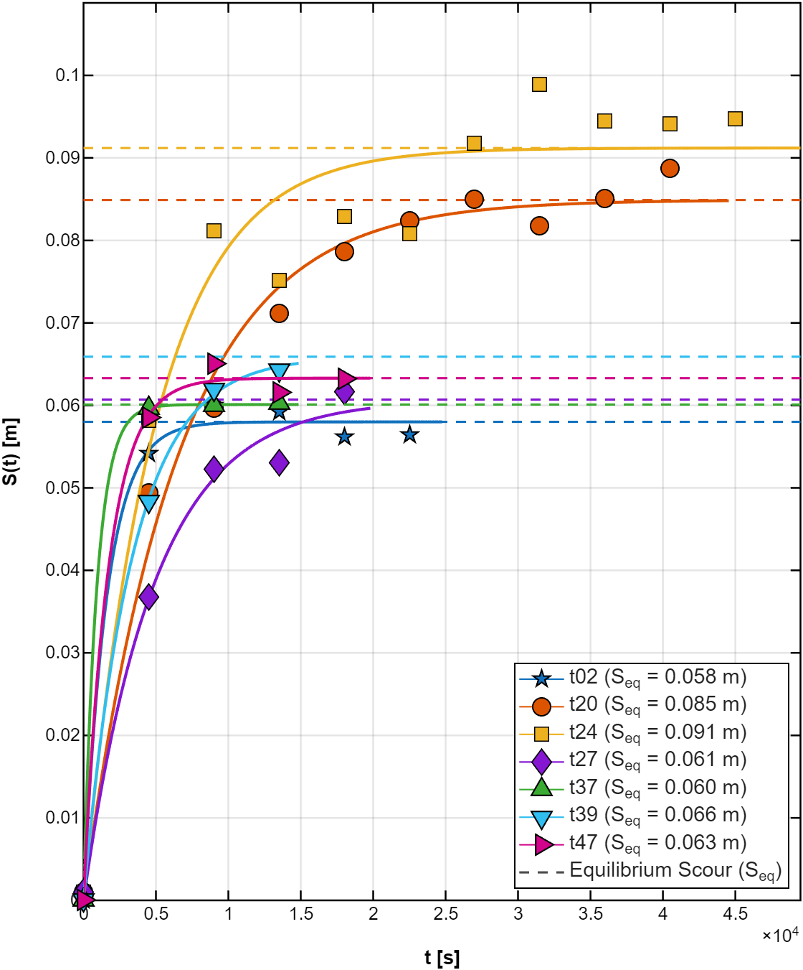
Figure 12. Temporal development of edge scour depth for the numerical simulations

In complement to this assessment, Table 3 presents the ultimate $S_{d,num}$, $S_{t,num}$, and $L_{s,num}$ values extracted for each test, including the quantification of the associated error.
A comprehensive cross-analysis of the three primary morphodynamical variables, $S_{d}$, $S_{t}$, and $L_{s}$, reveals that the TUDFlow3D solver exhibits a highly compartmentalised predictive capability. Accuracy within one spatial dimension does not inherently guarantee reliability across the others for a given structural configuration. Instead, the model's performance is complexly tied to the dominant geometric characteristics of each test case, alongside the fundamental kinetic threshold of $θ_{bed}=0.1$.

Table 3. Summary and comparison of numerical results.
Test no. | $S_{d,num} [m]$ | $S_{d,num}/S_{d}$ | $S_{t,num} [m]$ | $S_{t,num}/S_{t}$ | $L_{s,num} [m]$ | $L_{s,num}/L_{s}$
t02 | 0.0564 | 0.9246 | 0.0136 | 0.5037 | 1.2638 | 0.9873
t20 | 0.0888 | 1.0829 | 0.0346 | 1.0813 | 1.4730 | 1.6367
t24 | 0.0947 | 1.2461 | 0.0336 | 0.9333 | 1.6291 | 1.4946
t27 | 0.0616 | 1.3106 | 0.0353 | 4.7067 | 0.9728 | 0.8764
t37 | 0.0603 | 1.3109 | 0.0083 | 0.3192 | 1.3253 | 0.9535
t39 | 0.0643 | 2.5720 | 0.0169 | 1.3000 | 1.1658 | 0.9478
t47 | 0.0632 | 0.6136 | 0.0126 | 0.3706 | 1.1065 | 1.1291

Influence of relative mobility on numerical accuracy
To further investigate the underlying causes of the predictive divergences observed, a supplementary analysis was conducted based on the relative mobility of the distinct morphological domains. The rationale behind employing the mobility ratio, ${{MOB}_{bed}}/{{MOB}_{berm}}$, is to establish a comprehensive relationship between the hydrodynamic forcing and the critical stability conditions of both the protective rock berm and the surrounding sandy bed. This comparative metric offers a more realistic physical representation of the flow dynamics at the boundary transition between the two distinct bed roughness, which is the fundamental driver of the edge scour mechanisms.
The previously identified hydrodynamic threshold of 0.1 over the undisturbed bed corresponds directly to a relative mobility ratio of approximately 71. As shown across the three morphological variables, downstream depth (Figure 13), transverse depth (Figure 14), and spatial length (Figure 15), this specific ratio of 71 acts as a boundary for the numerical solver's predictive stability.
For scenarios where the mobility ratio remains below this threshold of 71, the solver maintains a generally acceptable alignment with the physical trends specifically for the spatial edge scour length. However, within this lower mobility regime, the predictive accuracy for the vertical dimensions, both downstream and transverse scour depths, is notably compromised. As the ratio exceeds 71, an inverse morphodynamical predictive behavior emerges.
In this upper mobility regime, the numerical model achieves highly satisfactory results for the maximum vertical erosion depths, $S_{d}$ and $S_{t}$. Conversely, the spatial scour length experiences a severe overprediction, most notably for tests t20 and t24. This divided response indicates that when the kinetic disparity between the highly mobile sandy bed and the fully stable rock berm becomes too extreme, the numerical sediment transport formulations successfully resolve the aggressive shear stress gradients directly at the roughness interface but likely struggle to accurately dissipate the longitudinal propagation of the wake, leading to the systematic overestimation of the spatial morphodynamical footprint.
Given the identification of this mobility threshold, future research should simulate additional test cases and compare the numerical predictions with diverse literature physical results to further validate this trend.

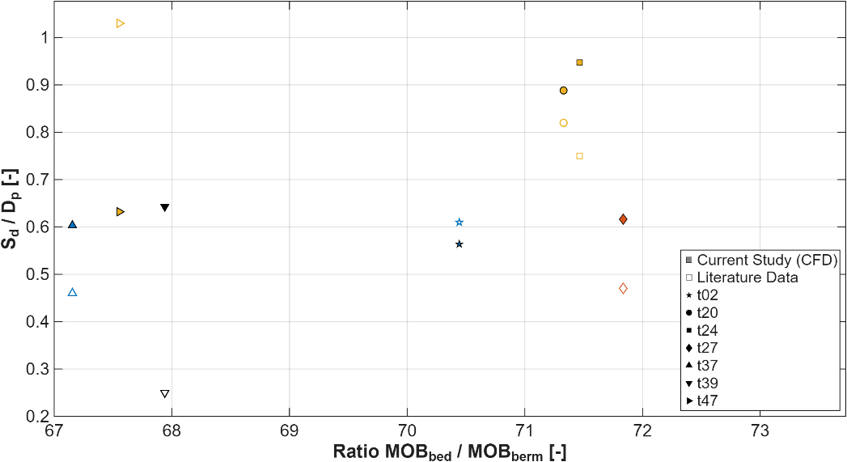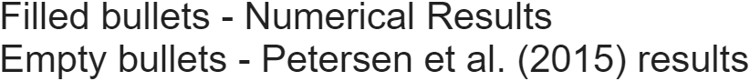
Figure 13. Numerical predictions and empirical trends for $S_{d}$, plotted against the mobility ratio.
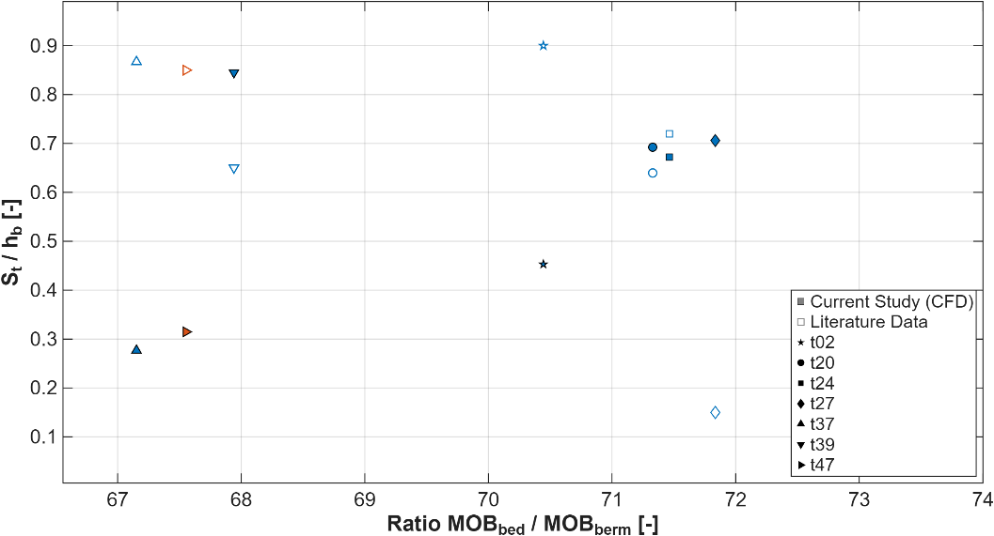
Figure 14. Numerical predictions and empirical trends for $S_{t}$, plotted against the mobility ratio.
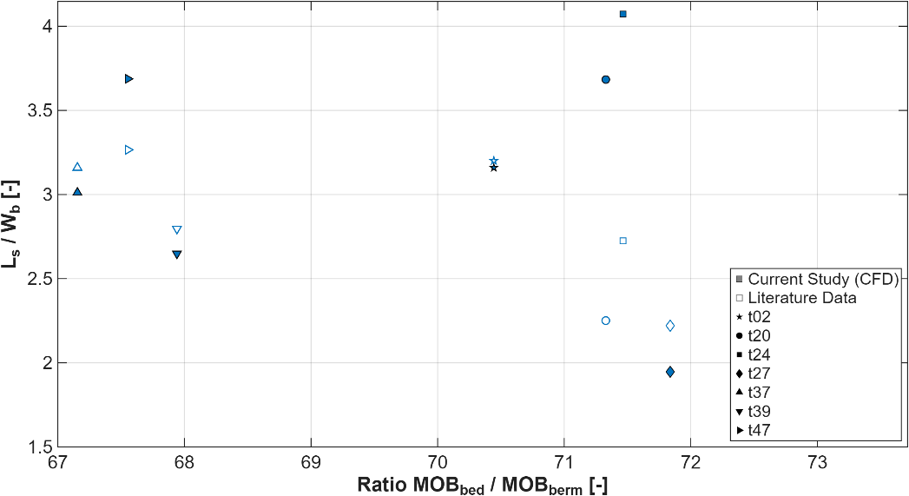
Figure 15. Numerical predictions and empirical trends for $L_{s}$, plotted against the mobility ratio.
- Conclusions
Through the extensive numerical campaign and the subsequent cross-validation with established empirical data from Petersen et al. [5], the following principal conclusions were drawn:

- Regarding the initial model calibration, the iterative workflow, encompassing five progressive numerical configurations (v01 to v05), successfully mitigated the systematic edge scour overprediction. Initial simulations with the baseline setup revealed a pronounced overestimation of the maximum scour depth, artificially locking onto predefined avalanche angles (v01). Subsequent attempts to mitigate this using generic sediment transport adjustments (v02) and a reduction in the Morphological Acceleration Factor (v03) proved that purely temporal scaling and standard morphodynamical changes are insufficient to correct spatial anomalies.
- The critical breakthrough was achieved through targeted spatial geotechnical interventions. While a localised reduction of avalanche angles yielded accurate quantitative predictions but lacked a rigorous physical basis (v04), a scientifically robust calibration was ultimately attained by decoupling avalanche slopes according to material properties (v05). Applying a lower critical state angle for the sand whilst maintaining the peak friction stability of the rock berm successfully replicated the morphological shape, maximum scour depth, and slope steepness without artificial steepening.

- In terms of the benchmark dataset development, a representative parametric matrix comprising seven distinct numerical simulations (t02, t20, t24, t27, t37, t39, and t47) was successfully executed, derived directly from Table 1 of the experimental dataset by Petersen et al. [5]. Through morphological equilibrium assessment, these simulations were confirmed to have reached a sufficient state of morphological maturity, surpassing the 5T theoretical threshold. The benchmark phase confirmed the solver's capability to capture the fundamental qualitative morphodynamical trends, accurately reproducing the progressive deepening and widening of the edge scour hole under increasingly energetic flow regimes.5T
- Finally, the parametric analysis of systematic deviations elucidated the specific operational boundaries of the numerical solver, revealing a highly compartmentalised predictive capability.
- The investigation established that the relative mobility ratio, ${{MOB}_{bed}}/{{MOB}_{berm}}$, constitutes the primary governing metric for predictive accuracy. A critical threshold value of approximately 71, corresponding to an undisturbed bed Shields parameter of $θ_{bed}=0.1$, separates two different predictive regimes. Below this threshold, TUDFlow3D solver maintains a generally acceptable alignment for $L_{s}$ but underestimates $S_{d}$ and $S_{t}$.
- Conversely, when the mobility ratio exceeds 71, the solver accurately resolves the maximum vertical scour depths directly at the roughness interface but systematically overestimates the spatial edge scour footprint. This divergence is driven by the extreme kinetic disparity between the highly mobile sandy bed and the stable rock berm under severe hydrodynamic forcing. Furthermore, geometric parameters, notably the aspect ratio ($A_{r}$) and the relative berm width (${W_{b}}/{D_{p}}$), were identified as secondary modulators, confirming that the numerical model demonstrates enhanced reliability in configurations featuring a smaller relative vertical flow obstruction.

References
[1] Whitehouse R J S, Harris J M, Sutherland J and Rees J 2011 The nature of scour development and scour protection at offshore windfarm foundations Mar. Pollut. Bull. 62 73–88
[2] Chiew Y-M 1995 Mechanics of Riprap Failure at Bridge Piers J. Hydraul. Eng. 121 635–43
[3] de Sonneville B, van Velzen G, Verheij H and Dorst K 2012 Falling aprons at circular piers under currents Proc. of 6th International Conference on Scour and Erosion (ICSE-6) (Paris, France: International Society for Soil Mechanics and Geotechnical Engineering) p 8
[4] Deltares 2023 Handbook of Scour and Cable Protection Methods (Delft, Netherlands: Deltares)
[5] Petersen T U, Sumer B M, Fredsøe J, Raaijmakers T C and Schouten J-J 2015 Edge scour at scour protections around piles in the marine environment — Laboratory and field investigation Coast. Eng. 106 42–72
[6] Wang X, Huang H, Lin P, Yuan J, Liu X, Wang M and Wang W 2025 Detailed observations of edge scour of riprap scour protection for offshore-wind monopile and its effect on monopile’s bearing capacity Appl. Ocean Res. 165 104822
[7] De Vos L, De Rouck J, Troch P and Frigaard P 2012 Empirical design of scour protections around monopile foundations. Part 2: Dynamic approach Coast. Eng. 60 286–98
[8] Baykal C, Sumer B M, Fuhrman D R, Jacobsen N G and Fredsøe J 2015 Numerical investigation of flow and scour around a vertical circular cylinder Philos. Trans. R. Soc. Math. Phys. Eng. Sci. 373 20140104
[9] Fazeres-Ferradosa T, Chambel J, Taveira-Pinto F, Rosa-Santos P, Taveira-Pinto F V C, Giannini G and Haerens P 2021 Scour Protections for Offshore Foundations of Marine Energy Harvesting Technologies: A Review J. Mar. Sci. Eng. 9 297
[10] de Wit L, Plenker D and Broekema Y 2023 3D CFD LES process-based scour simulations with morphological acceleration Proc. of 11th International Conference on Scour and Erosion (ICSE-11) (Denmark: International Society for Soil Mechanics and Geotechnical Engineering) p 11
[11] Roulund A, Sumer B M, Fredsøe J and Michelsen J 2005 Numerical and experimental investigation of flow and scour around a circular pile J. Fluid Mech. 534 351–401
[12] de Wit L 2015 3D CFD modelling of overflow dredging plumes PhD Thesis (Delft, Netherlands: Delft University of Technology)
[13] de Wit L 2025 Brochure_TUDflow3D (Delft, Netherlands: Deltares)
[14] Schotmeijer N G J 2025 Simulating Edge Scour: A Hydrodynamic Investigation and Validation of Scour LES (Delft, Netherlands: Deltares)
[15] Jarrin N, Benhamadouche S, Laurence D and Prosser R 2006 A synthetic-eddy-method for generating inflow conditions for large-eddy simulations Int. J. Heat Fluid Flow 27 585–93
[16] Choi H and Moin P 2012 Grid-point requirements for large eddy simulation: Chapman’s estimates revisited Phys. Fluids 24 011702
[17] Nicoud F and Ducros F 1999 Subgrid-Scale Stress Modelling Based on the Square of the Velocity Gradient Tensor Flow Turbul. Combust. 62 183–200
[18] van Rijn L C 1984 Sediment Transport, Part I: Bed Load Transport J. Hydraul. Eng. 110 1431–56
[19] van Rijn L C 2007 Unified View of Sediment Transport by Currents and Waves. III: Graded Beds J. Hydraul. Eng. 133 761–75
[20] DNV-RP-0618 2022 Rock scour protection for monopiles
[21] Sumer B M, Christiansen N and Fredsøe J 1992 Time Scale of Scour Around a Vertical Pile Ocean Waves, Superconducting Propulsions, Hydrodynamic Forces, Higher-Order Effects, Vortex and Oscillations, Dynamic Responses ed J S Chung, M Issacson and Maeda (San Francisco, California, USA: International Society of Offshore and Polar Engineer (ISOPE))
[22] Gazi A H, Afzal M S and Dey S 2019 Scour around Piers under Waves: Current Status of Research and Its Future Prospect Water 11 2212
[23] Melville B and Chiew Y-M 1999 Time scale for local scour at bridge piers J. Hydraul. Eng. 125 59–65
[24] Sumer B M and Fredsøe J 2002 The Mechanics of Scour in the Marine Environment vol 17 (Singapore: World Scientific)
[25] Garagorri Linares D 2025 Scour Prediction Around Jacket Wind Turbine Foundations under current-only conditions MSc Thesis (Delft, Netherlands: Delft University of Technology)
[26] Broekema Y, van Steijn P W, Wu M and Robijns T 2024 Predicting loose rock scour protection deformation around monopiles using the relative mobility number and the Keulegan–Carpenter number Ocean Eng. 300 117475
[27] van Steijn P W, Wu M and Broekema Y 2023 Towards a better understanding of loose rock scour protection stability around monopile foundations Proc. of 11th International Conference on Scour and Erosion (ICSE-11) (Copenhagen, Denmark: International Society for Soil Mechanics and Geotechnical Engineering) p 11

