Thermal Localisation in drag-braked railway wheels: Depth penetration and equalisation
G G Sirata^{1,3,*}, H G Lemu² and M A Tolcha¹
¹ Faculty of Mechanical Engineering, Jimma University, Ethiopia
² Faculty of Science and Technology, University of Stavanger, Norway
³ Faculty of Materials Engineering, Silesian University of Technology, Poland
* Corresponding author: goftilagudeta@gmail.com
Abstract. The complex heat transfer phenomenon in wheel-rail contact of drag-braked railway wheels remains a challenge to develop an accurate analysis model of the circumferential distribution of the thermal field. In this study, a three-dimensional transient thermal model of a 20° ER7 wheel sector, representing an eighteen-fold periodic pattern, was modelled to quantify how the redistribution of a fixed braking heat input alters the local tread temperature and the depth attenuation and post-release decay of the circumferential contrast. Considering a 50 kW, drag-braking duty lasting 45 min, the sector power was fixed at 2.50 kW, with 0, 8%, and 16% assigned to a localised elliptical component in L0, L1, and L2, respectively. The maximum tread temperature increased from 578.3 °C (L0) to 631.1 °C (L1) and 690.8 °C (L2), while inter-case differences in stored energy and surface loss remained below the approximately 0.9% energy-closure residual. The sector mode n = 1, corresponding to the full-wheel order m = 18, carried approximately 89% of the squared-amplitude sum, and the fitted attenuation lengths decreased from 22.4 mm (n = 1) to 8.2 mm (n = 3). The projected and centreline contrasts fell to 1/e at depths of 18.6 and 13.8 mm, respectively. After brake release, the first three modes decayed to 1/e within 5.8–34.1 s, whereas the wheel remained thermally elevated for beyond 3600 s. Therefore, the spatial distribution of the fixed total power controls the local tread maximum; the reported penetration depths and decay times apply to the imposed eighteen-fold periodic pattern.
- Introduction
Tread braking remains the predominant friction-based braking system for freight rolling stock and is still common in metropolitan rail vehicles. Mechanical simplicity, operational reliability, and relatively low cost are important practical advantages of tread braking. During braking, the mechanical energy dissipated at the wheel–block interface is converted into heat, a substantial fraction of which enters the wheel [1, 2]. The heat generated at the block–tread interface and its partition to the wheel has been characterised experimentally and numerically for cast iron blocks [3, 4] and reviewed comprehensively for railway friction braking [5, 6]. Prolonged drag braking can consequently increase the tread and rim temperatures by several hundred degrees Celsius [7–9].
For a tread-braked wheel, the key factors are the mean braking temperature increase and thermal non-uniformity. During the tread–brake block contact, each material point on the wheel tread experiences cyclic thermal loading: it is heated while in contact and subsequently cools during the remainder of the revolution. Non-uniform contact may also produce wheel-fixed temperature variations, ranging from compact hotspots to broader regions of elevated temperature [7, 10]. The rotating contact fluctuation and wheel-fixed circumferential contrast occur at different spatial and temporal scales. A circumferentially averaged temperature can represent the overall heating of the rim, but it cannot reproduce the local tread maximum.
Axisymmetric models are commonly used because they provide an efficient description of the circumferentially averaged wheel and brake-block temperatures [7, 11, 12]. Vernersson [7] represented the rapidly moving heat input by an equivalent uniform circumferential flux when calculating the mean wheel temperature and evaluated the local cyclic variation separately. Walia et al. [13] calibrated a thermal model against the wheel-tread, wheel-web, and brake-block temperatures measured on a commuter train in service. Kuciej et al. [14] compared two- and three-dimensional models for repeated long-duration braking and reported temperature differences generally below 3%, increasing to approximately 7–9% during cooling after the eighth braking application. These results support the reduced circumferential representations of the average quantities and loading conditions examined in these studies. However, they do not establish the suitability of a wheel-fixed local maximum.
The axisymmetric formulation neglects circumferential variations and therefore cannot fully represent wheel-fixed, localised hot spots on the tread. Accurately representing these features is important for predicting peak temperatures and the associated local thermally induced material responses [1]. Three-dimensional studies have therefore prescribed non-uniform tread heating, including an elliptical hot-spot flux on a wheel sector [10] and energy-equivalent moving heat source distributions for long-slope braking [15]. Zhang et al. [16] examined the contact area variation, contact position, and brake-force failure. Magelli and Zampieri [17] represented non-axisymmetric thermal loads using a circumferential Fourier series and found that at least 15 retained harmonics were required to reproduce the three-dimensional steady-state response. The harmonics were primarily used for load representation and temperature reconstruction. In the present study, the modal content of the computed zero-mean temperature contrast was used as a physical diagnostic tool for its depth attenuation and post-release decay.
Reduced-order models have also been developed for prolonged braking simulation. For example, Wang et al. [9] used a layered thermal formulation but did not resolve the circumferential evolution of localised hot spots. Wheel–rail contact provides an additional heat transfer path during braking, and Vernersson and Lundén [18] showed that rail chill can substantially reduce wheel temperatures during prolonged drag braking. The rail chill is omitted from the present model and may affect both the absolute temperature and local circumferential field. Therefore, the results isolate the response to the prescribed heat source distribution rather than reproducing the complete in-service heat transfer system.
Previous studies on drag-braked railway wheels [10, 15, 17] have considered non-uniform or energy-equivalent heat sources, three-dimensional sector models, and harmonic representations of non-axisymmetric loading. However, these studies do not jointly quantify the computed zero-mean circumferential contrast in terms of its amplification under fixed total power, mode-dependent attenuation through the rim, and mode-dependent decay after brake release. These quantities are distinct from the circumferential mean because different spatial harmonics have different characteristic depths and time scales. Resolving this local thermal history is relevant when temperature-driven material changes near the tread are of concern [10, 19]. Sustained tread temperatures in this range drive metallurgical and damage processes near the tread, including spheroidization and hardness loss in pearlitic wheel steels [20, 21], thermally induced tread roughness [22], and thermal-expansion-assisted tread cracking during long descents [23–25].
The present work examines how redistributing a fixed braking heat input between a uniform background and a localised tread region affects the thermal response of a three-dimensional periodic ER7 wheel sector. The nominal 50 kW, 45 min braking duty and the total sector power are held constant, while a single parameter controls the degree of heat-input localisation. The resulting thermal field was evaluated with three aims: (1) to quantify the increase in local tread temperature caused by the redistribution of a fixed thermal input; (2) to characterise the circumferential modal content and its attenuation with depth; and (3) to quantify the post-release decay of the imposed circumferential modes. Therefore, this study examines the thermal evolution of a prescribed eighteen-fold periodic non-uniformity rather than the mechanisms responsible for hotspot formation, migration, or the resulting thermomechanical response.
- Thermal model and analysis of localised tread heating
  - Wheel model, braking duty and thermal boundary conditions
In this study, an ER7 monobloc wheel with a nominal rolling radius $R = 460 mm$ was considered. As the analysis focused on circumferential localization, the computational domain was defined as a three-dimensional 20° sector (i.e., one of 18 identical sectors). The two meridional cut faces were assigned adiabatic boundary conditions consistent with the sector-symmetry assumptions, as shown in Figure 1(a). Therefore, this sector represents an eighteen-fold periodic repetition of the imposed thermal pattern.
The finite element tread surface was defined at the reference radius $R_{s}=460.5 mm$, which served as the geometric datum for surface identification and circumferential arc-length evaluation and was distinct from the nominal rolling radius $R$. The arc length subtended by the 20° sector at this datum defines the circumferential wavelength $L_{θ}=160.74 mm$. The local position was parameterised by the axial coordinate $y$, circumferential angle $θ$, and radius $r$. The depth below the tread surface was defined as $d=r_{s}\left(y\right)-r$, where $r_{s}\left(y\right)$ denotes the tread profile, as shown in Figure 1(b). The axial centreline of the hotspot was located at $y_{0}=82.2 mm$.
The temperature field $T\left(x , t\right)$ is governed by transient heat conduction with a constant density and temperature-dependent specific heat and thermal conductivity as follows:
$$ρc_{p}\left(T\right)\frac{∂T}{∂t}=∇⋅\left[k\left(T\right)∇T\right].$$ | (1)
Here, $ρ$ is the density, $c_{p}\left(T\right)$ is the specific heat capacity, and $k\left(T\right)$ is the thermal conductivity. The field started from a uniform ambient temperature $T_{0}=T_{∞}=25$ °C. On the exposed surfaces, the conductive flux balances the convective and radiative losses and the prescribed braking input,
$$- k\left(T\right) \frac{∂T}{∂n} = h \left(T-T_{∞}\right) + εσ \left(T^{4}-T_{∞}^{4}\right) - q$$ | (2)
Here, $n$ is the outward unit normal, with the heat flux defined as positive when directed into the body. A grey body emissivity of $ε=0.65$ was assumed, $σ$ is the Stefan–Boltzmann constant, and $q$ is the prescribed tread heat input, which is non-zero only over the heated band. The temperatures appearing in the fourth-power radiative terms are defined in absolute units (K). During braking, the convective film coefficient was evaluated using the Churchill–Bernstein forced convection correlation for a cylinder in crossflow [26]. Based on a running speed of $60 km{ h}^{-1}$, a wheel diameter of $0.921 m$ (twice the tread-surface datum radius, 460.5 mm), and air properties evaluated at 25 °C, the resulting Reynolds and Nusselt numbers were $9.83×{10}^{5}$ and 1.23 × 10³, respectively, yielding $h_{brake}=35.0 W m^{-2}K^{-1}$. This coefficient is held constant throughout the braking step; thus, the running speed enters the thermal model only through $h_{brake}$. A zero normal heat flux was imposed on the two meridional cut faces. The wheel–rail heat transfer was omitted. Rail chill can remove a substantial fraction of the heat during prolonged drag break; therefore, the calculated absolute temperatures are expected to exceed those from an otherwise comparable model that includes this mechanism [18]. Omission is common to the three loading cases, but its interaction with circumferential localization has not been evaluated. Consequently, the results constitute a controlled comparison of the prescribed heat source distributions rather than direct predictions of the in-service peak temperature.
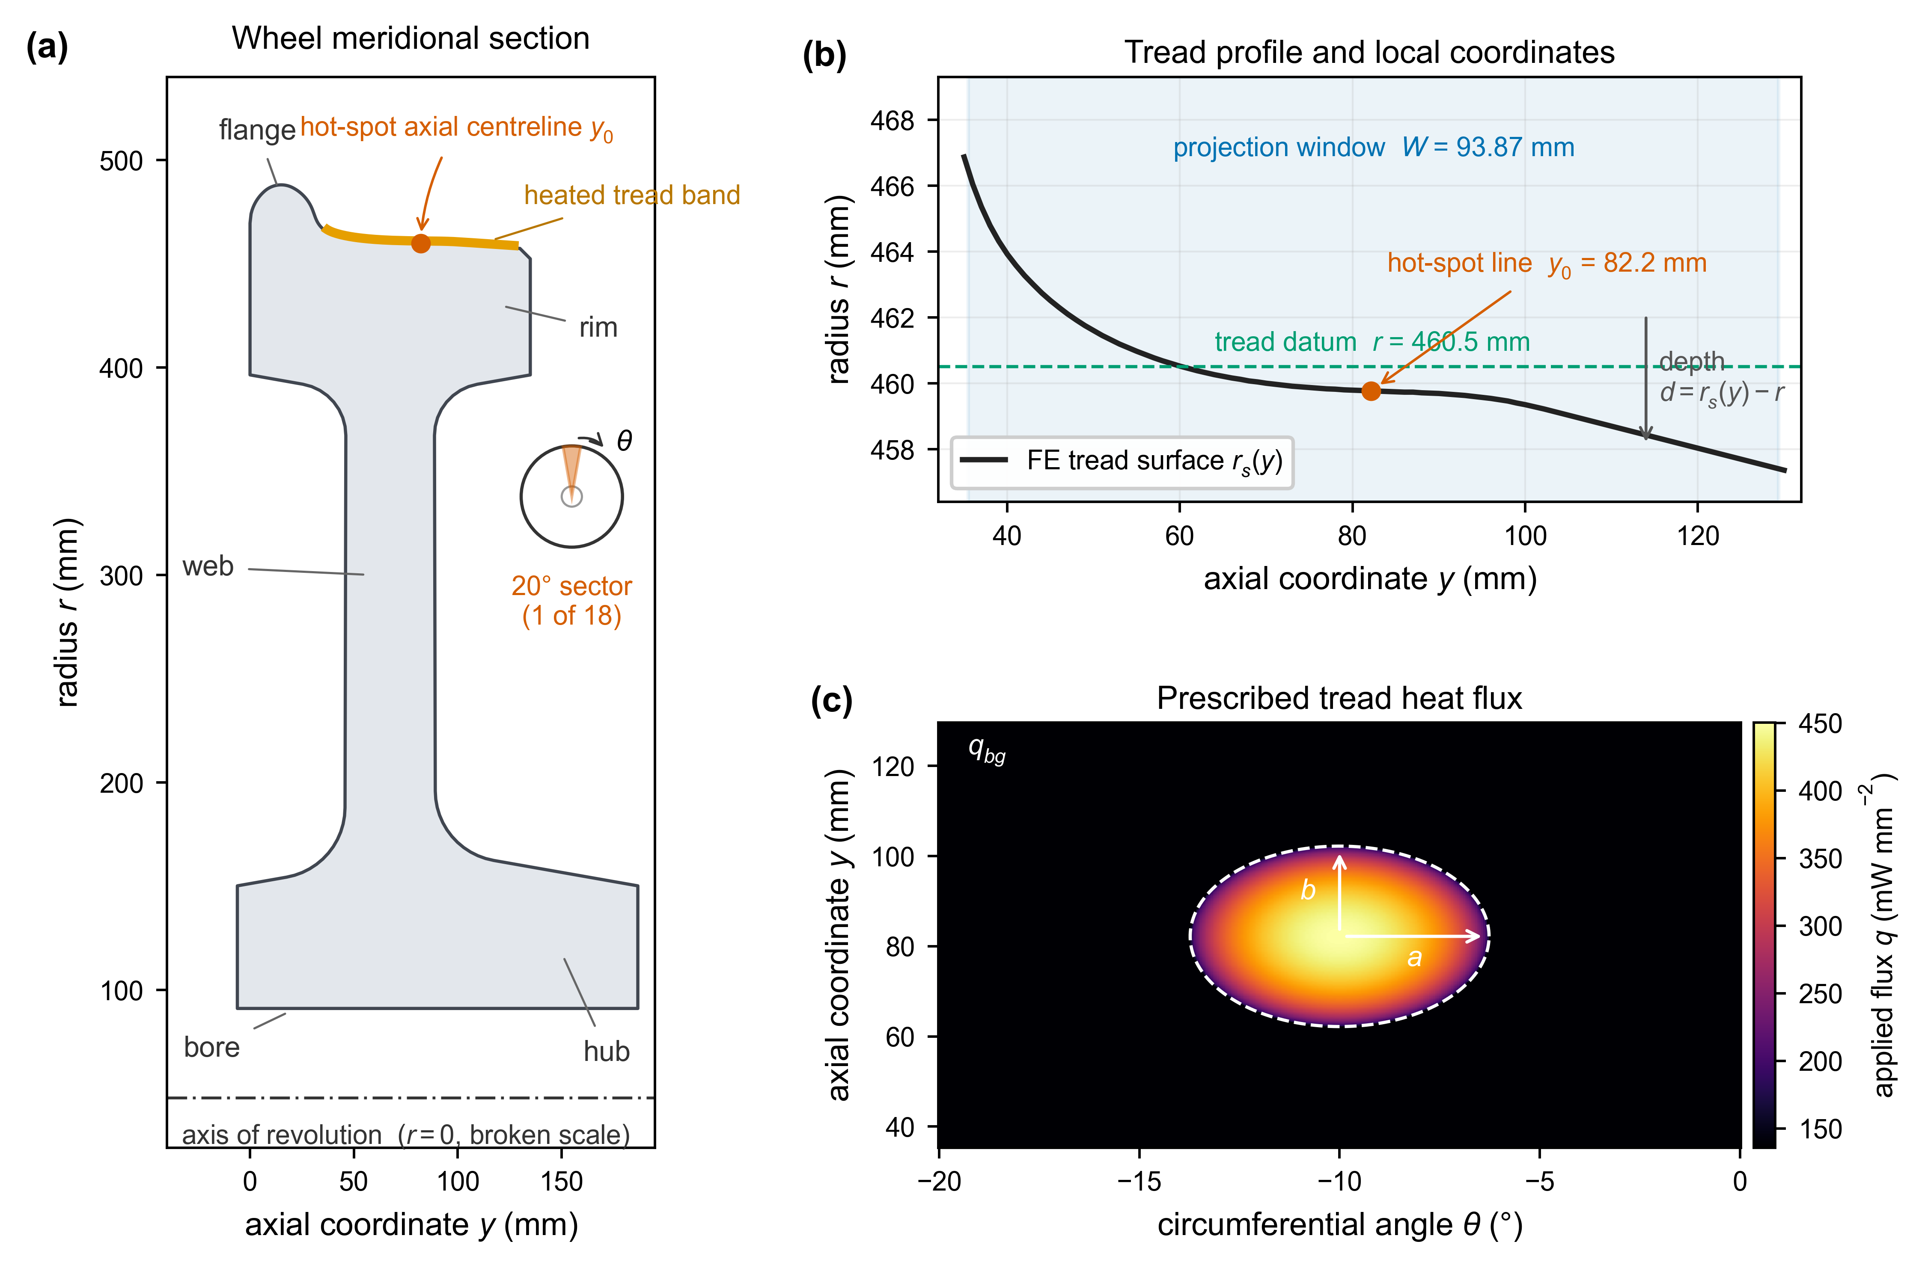
Figure 1. ER7 wheel model and defined thermal loading: (a) meridional section and 20° periodic sector (one of eighteen); (b) tread coordinate system, axial projection window and through-surface depth $d$; (c) uniform background heat flux with the elliptical excess distribution used for L2.
Steel was modelled with a constant density of $ρ=7818 kg m^{-3}$, specified as a separate model input. The temperature-dependent conductivity and specific-heat data for ER7 steel were adopted from Białowas [27], with the specific-heat values converted from $kJ kg^{-1} K^{-1}$ to $J kg^{-1} K^{-1}$. The thermal conductivity is $42.2 W m^{-1} K^{-1}$ at $20°C,$ reaches $42.9 W m^{-1} K^{-1}$ at $100°C$, and decreases to $33.9 W m^{-1} K^{-1}$ at $600°C$. The specific heat increased from $470 J kg^{-1} K^{-1}$ at $20°C$ to $856 J kg^{-1} K^{-1}$ at $700°C$, before decreasing to $604 J kg^{-1} K^{-1}$ at $750°C$, as tabulated in the source dataset. The complete property values are listed in Table A1 in Appendix A. The pronounced specific-heat peak near 700–750 °C reflects the ferromagnetic-to-paramagnetic and eutectoid transformations of the pearlitic steel, represented in the source dataset as an effective (apparent) specific heat rather than as a separate latent-heat term. Based on the constant density adopted in the model, the thermal diffusivity $α=k/\left(ρc_{p}\right)$, decreased from approximately $1.1×{10}^{-5} m^{2} s^{-1}$ to $5.9×{10}^{-6} m^{2} s^{-1}$ between $20$ and $600°C.$
The applied duty comprised a nominal wheel braking power of 50 kW sustained for 45 min, corresponding to the severe drag-braking condition of EN 13979-1 [28], used in European wheel design assessments [12]. A wheel heat-partition factor of 0.90 was adopted as a comparative modelling assumption. Because the brake-block material was not explicitly modelled, this value was not a material-specific prediction. The resulting wheel power was 45 kW, which corresponded to 2.50 kW and 6.75 MJ for the 20° sector over the 2700 s braking period. Table 1 summarises the model parameters.
Table 1. Principal model parameters.
Parameter | Value
Wheel heat-partition factor | 0.90
Applied sector power, $P_{sector}$ | 2.50 kW
Sector energy input, $Q_{in}$ | 6.75 MJ
Excess-power fraction, $χ$ | L0: 0; L1: 0.08; L2: 0.16
Hot-spot semi-axes, $\left(a , b\right)$ | $\left(30 , 20\right)$ mm
Initial and ambient temperature, $T_{0}=T_{∞}$ | $${25}^{∘}C$$
Braking convection coefficient, $h_{brake}$ | $$35.0 W m^{-2} K^{-1}$$
Cooling convection coefficient, $h_{cool}$ | $$6.86 W m^{-2} K^{-1}$$
Surface emissivity, $ε$ | 0.65
  - Tread heat-flux and finite-element model
In the wheel-fixed reference coordinate system, the applied tread heat flux is represented as the sum of a spatially uniform background term and a spatially localised elliptical component, parameterised according to the hot-spot distribution reported by Voortman Landström et al. [10]:
$$q\left(s,Δy\right)=q_{\left(bg\right)}+q_{\left(hs\right)}g\left(s,Δy\right)$$ | (3)
$$g\left(s , Δy\right)=\sqrt[ ]{\max\left[0 , 1-{\left(\frac{s}{a}\right)}^{2}-{\left(\frac{Δy}{b}\right)}^{2}\right]}.$$ | (4)
Here, $q_{bg}$ denotes the spatially uniform background heat flux, whereas $q_{hs}$ denotes the peak amplitude of the localised contribution. The dimensionless weighting function $g$ is defined such that $g=1$ at the centre of the ellipse and decreases monotonically to zero at the elliptical boundary. Outside this region, $g=0$, and the imposed flux reduces to $q=q_{bg}$. The local circumferential and axial coordinates relative to the centre of the heated region are denoted by $s$ and $Δy$, respectively.
$$s=R_{s}\left(θ-θ_{0}\right), Δy=y-y_{0}$$ | (5)
denote the circumferential arclength and axial distance from the hotspot centre, respectively. The profile was centred at $θ_{0}=-{10}^{∘}$ and $y_{0}=82.2 mm$, with circumferential and axial semi-axes $a=30 mm$ and $b=20 mm$, respectively.
The effective area associated with the dimensionless elliptical profile $g$ was evaluated analytically and by summation over the finite-element surface facets. The continuum value is
$$I_{g}^{cont}=\iint{g} dA=\frac{2}{3}πab,$$ | (6)
and its discrete finite-element counterpart is
$$I_{g}^{FE}=\sum_{f}{g_{f}}A_{f},$$ | (7)
where $g_{f}$ is the value of $g$ at the centroid of facet $f$, and $A_{f}$ is the corresponding facet area. For $a=30 mm$ and $b=20 mm$, the analytical value is $I_{g}^{cont}=1.26 ×{10}^{3} {mm}^{2}$. The centroid-based finite-element summation yielded $I_{g}^{FE}=1.27×{10}^{3} {mm}^{2}$, which is 1.3% greater than the continuum value.
The background and hot-spot heat flux amplitudes are determined from the prescribed sector power as follows:
$$q_{bg}=\frac{\left(1-χ\right)P_{sector}}{A_{band}},$$ | (8)
$$q_{hs}=\frac{χP_{sector}}{I_{g}^{FE}},$$ | (9)
such that
$$P_{sector}=q_{bg}A_{band}+q_{hs}I_{g}^{FE}.$$ | (10)
Here, $χ$ is the fraction of the sector power assigned to the localised excess heat input, and $A_{band}=1.55 ×{10}^{4} {mm}^{2}$ is the total area of the heated surface facets. The use of $I_{g}^{FE}$ in Equation (9) accounts for the discrete representation of the elliptical profile and maintains the applied sector power at $P_{sector}=2.50 kW$ in all three loading cases.
Three heat-loading cases, denoted as L0, L1, and L2, were considered to examine the effect of increasing heat localization while maintaining the same sector power of 2.50 kW. L0 is the uniform reference case with no localised component ($χ=0$). In L1 and L2, respectively, 8% ($χ=0.08$) and 16% ($χ=0.16$) of the sector power were transferred from the uniform background to the localised elliptical region. The corresponding excess powers were 0, 0.20, and 0.40 kW for L0, L1, and L2, respectively. For L2, the remaining background power was 2.10 kW, which gives $q_{bg}=135.8$ mW mm⁻² and $q_{hs}=314.3$ mW mm⁻². The sector was discretised using quadratic heat-transfer elements, comprising 20-node hexahedral elements and 15-node wedge transitions. The mesh had 47 392 elements and 204 937 nodes. Along the heat-input surface, 32 circumferential intervals were bounded by 33 meridional planes.
Transient heat transfer analyses were performed using Abaqus/Standard 2020 [29] with quadratic DC3D20 brick and DC3D15 wedge elements and automatic time incrementation. The temperature-dependent conductivity and specific heat, together with the convective and radiative surface fluxes, were re-evaluated at each increment, and the density and prescribed film coefficient remained constant within each step.
  - Circumferential contrast and depth-resolved modal analysis
In the circumferential direction, the tread heat-input surface was divided into 32 intervals bounded by 33 meridional sampling planes. Each plane provides temperature data across the prescribed axial analysis window and at depths below the tread. The two sector boundaries represent the same phase of the repeated ${20}^{∘}$ pattern. Including both would duplicate one periodic station in the Fourier analysis. One boundary station was omitted, leaving $N=32$ distinct circumferential stations. The depth $d$ is measured inward from the tread, with $d=0$ at the physical surface. The heat-input boundary was defined by the exposed tread facets of the three-dimensional thermal elements. Each facet corresponds to an element face, and its centroid is considered the geometric centre of that face. The physical heat-input region spanned the axial interval $y=35.0$ to $130.0$ mm. For post-processing, the axial averaging window was bounded by the centroids of the two outermost heated facets, located at $y_{1}=35.50$ mm and $y_{2}=129.37$ mm. These bounds fell within the first and last heated elements, respectively, yielding a window length of $W=y_{2}-y_{1}=93.87$ mm. For each circumferential station $θ_{j}$ and depth $d$, the three-dimensional temperature field $T\left(θ_{j},y,d\right)$ is averaged over this axial window:
$$\hat{T}\left(θ,d\right) = \frac{1}{W}\int_{y_{1}}^{y_{2}}{T}\left(θ,y,d\right) dy$$ | (11)
Here, $\hat{T}\left(θ_{j} , d\right)$ is the temperature averaged over the axial interval, $y_{1}≤y≤y_{2}$ at circumferential station $j$ and depth $d$. At the axial limits $y_{1}$ and $y_{2}$, the temperature values are evaluated by interpolation of the extracted field data. Therefore, Equation (11) reduces the three-dimensional temperature field to one circumferential profile at each investigated depth.
Two measures were used to quantify the circumferential temperature non-uniformity. The projected amplitude, $A_{pk}\left(d\right)$, is the maximum positive departure of the axially averaged temperature from its circumferential mean:
$$A_{pk}\left(d\right)=\max_{θ}\hat{T}\left(θ , d\right)-{mean}_{θ}\hat{T}\left(θ , d\right).$$ | (12)
The centreline amplitude, $ΔT_{cl}\left(d\right)$, was evaluated along the axial centreline of the localised heat input, $y=y_{0}=82.2 mm$:
$$ΔT_{cl}\left(d\right)=\max_{θ}T\left(θ , y_{0} , d\right)-{mean}_{θ}T\left(θ , y_{0} , d\right).$$ | (13)
In both definitions, ${mean}_{θ}$ denotes the arithmetic mean over the $N=32$ circumferential stations. The projected amplitude describes the circumferential contrast after averaging across the prescribed axial window, whereas the centreline amplitude retains the local contrast along the hot-spot centreline. The two measures were reported separately because axial averaging reduced the contribution of the local peak.
Modal analysis was applied to the non-uniform part of the projected temperature field. At each depth, the circumferential mean was subtracted from the axially averaged temperature as follows:
$${\hat{T}}^{ '}\left(θ , d\right)=\hat{T}\left(θ , d\right)-{mean}_{θ}\hat{T}\left(θ , d\right).$$ | (14)
This operation removes only the circumferentially uniform component, that is, $n=0$. All non-uniform components, $n≥1$, remain unchanged. Positive values of ${\hat{T}}^{ '}$ indicate positions warmer than the circumferential mean, whereas negative values indicate cooler positions. The absolute temperature field and its circumferential mean were retained separately.
The zero-mean field is decomposed into sector-periodic circumferential modes by applying a discrete Fourier transform over the $N$ stations:
$${\hat{A}}_{n}\left(d\right)=\frac{1}{N}\sum_{j=1}^{N}{{\hat{T}}^{ '}}\left(θ_{j} , d\right)exp⁡\left(-ik_{n}s_{j}\right), k_{n}=\frac{2πn}{L_{θ}}.$$ | (15)
The corresponding one-sided reconstruction is
$${\hat{T}}^{ '}\left(θ , d\right)=\sum_{n=1}^{N/2}{\left(2-δ_{n,N/2}^{K}\right)}\operatorname{Re}\left[{\hat{A}}_{n}\left(d\right)exp⁡\left(ik_{n}s\right)\right].$$ | (16)
Here, $s_{j}$ is the circumferential arclength coordinate of station $j$, $L_{θ}$ is the circumferential length of the analysed ${20}^{∘}$ sector at the tread datum, and $k_{n}$ is the wavenumber of sector mode $n$. The symbol $δ_{n,N/2}^{K}$ denotes the Kronecker delta, which equals one when $n=N/2$ and zero otherwise. Because the ${20}^{∘}$ sector repeats 18 times around the wheel, sector mode $n$ corresponds to the full-wheel order $m=18n$.
For the real-valued temperature field, the Fourier coefficients satisfy
$${\hat{A}}_{N-n}={\hat{A}}_{n}^{*}.$$
Therefore, the one-sided representation extends to the Nyquist mode, $n=N/2=16$. Unlike the other positive frequency terms, the Nyquist contribution was not doubled. The modal magnitudes and their relative contributions are independent of the chosen arclength origin; consequently, this origin need not coincide with the cap-centreed coordinate $s$ defined in Equation (5).
The relative contribution of mode $n$ is expressed as a fraction of the total single-sided squared amplitude:
$$S_{n}=\left(2-δ_{n,N/2}^{K}\right){∣{\hat{A}}_{n}∣}^{2},$$ | (17)
$$e_{n}=\frac{S_{n}}{\sum_{r=1}^{N/2}{S_{r}}}.$$ | (18)
Therefore, the Nyquist contribution is $S_{N/2}=∣{\hat{A}}_{N/2}∣^{2}$. Here, $S_{n}$ is a spectral squared-amplitude measure that does not represent the physical thermal energy.
The attenuation length $l_{n}$ of each examined mode is obtained by ordinary least-squares regression of $\ln{∣}{\hat{A}}_{n}\left(d\right)∣$ against depth over $0≤d≤d_{max}$, where $d_{max}=25 mm$. The fitted attenuation is expressed as:
$$\frac{∣{\hat{A}}_{n}\left(d\right)∣}{∣{\hat{A}}_{n}\left(0\right)∣}≈\exp\left(-\frac{d}{l_{n}}\right).$$ | (19)
The resulting regressions yielded $R^{2}>0.9999$. The fitted lengths are compared with the constant-property, semi-infinite solution $T_{n}^{'}\left(s , d\right)∝cos⁡\left(k_{n}s\right)exp⁡\left(-k_{n}d\right)$ for a spatially harmonic surface perturbation, which gives
$$δ_{n}=\frac{1}{k_{n}}=\frac{L_{θ}}{2πn}.$$ | (20)
The projected penetration depth $δ_{Δ}$, is defined as the depth at which $A_{pk}\left(d\right)$ decreases to $1/e$ of its surface value. The centreline penetration depth is defined in the same manner using $ΔT_{cl}\left(d\right)$. The projected depth was evaluated for both localised loading cases, whereas the centreline depth was reported for L2 to compare the local and axially averaged measures at the highest prescribed localization. Both penetration depths reflect the combined modal content of the temperature field and are therefore distinct from the individual modal attenuation lengths $l_{n}$.
  - Cooling after brake release and energy balance
The cooling analysis was initiated using the L2 nodal temperature field at the end of braking. Because the finite element mesh remains unchanged, these temperatures are transferred directly to the corresponding nodes and used as the initial condition at brake release, $t=0$. The braking heat flux was then removed. The wheel remains stationary during the cooling stage; therefore, the forced convection coefficient associated with the running speed is replaced by a natural convection coefficient. The Churchill–Chu correlation for an isothermal horizontal cylinder [30] gives $h_{cool}=6.86 W m^{-2} K^{-1}.$ This constant value is approximately one-fifth of the braking coefficient, $h_{brake}=35.0 W m^{-2} K^{-1}$. The radiative heat exchange and zero-normal-heat-flux conditions on the two sector cut faces were retained during cooling.
The decay of the circumferential temperature contrast was characterised using the projected modal amplitudes at the tread surface, $d=0$. For each sector mode $n$, the modal $1/e$ time, $τ_{n}$, is measured from the brake release and defined as
$$∣{\hat{A}}_{n}\left(τ_{n}\right)∣=e^{-1}∣{\hat{A}}_{n}\left(0\right)∣.$$ | (21)
For comparison, a one-dimensional circumferential diffusion model gives the characteristic modal timescale
$$τ_{n}^{ 1D}=\frac{1}{αk_{n}^{2}}, α=\frac{k}{ρc_{p}},$$ | (22)
where $α$ is the thermal diffusivity, and $k_{n}$ is the circumferential wavenumber, as defined in Eq. (15). This reference model considers only circumferential heat diffusion and neglects radial and axial conduction, surface heat losses, and the finite three-dimensional geometry of the wheel. Using a representative hot-state diffusivity of $α≈7×{10}^{-6} m^{2} s^{-1}$, equation (22) yields approximately 94, 23, and 10 s for $n=1$, $2$ and $3$, respectively. These values were used only as reference timescales. For comparison, the bulk thermal penetration over the braking period is of order √(αt_{b}) ≈ 0.13 m, so the circumferential contrast is confined to a layer approximately an order of magnitude thinner than the depth reached by the mean rim heating.
The consistency of the transient solution was assessed using an energy ledger over the braking period. The prescribed input energy was $Q_{in}=P_{sector}t_{b}=6.75 MJ$, where $P_{sector}=2.50 kW$ and $t_{b}=2700 s$. The energy balance is expressed as
$$Q_{in}=ΔU+Q_{conv+rad}+R,$$ | (23)
where the increase in stored internal energy is
$$ΔU=\int_{V}{ρ}\left[\int_{T_{0}}^{T}{c_{p}}\left(ϑ\right) dϑ\right]dV,$$ | (24)
and the accumulated convective and radiative heat loss is
$$Q_{conv+rad}=\int_{0}^{t_{b}}{\int_{Γ_{loss}}{\left[h_{brake}\left(T-T_{∞}\right)+εσ\left(T^{4}-T_{∞}^{4}\right)\right]}}dA dt.$$ | (25)
The relative energy-closure error is
$$r_{E}=\frac{∣R∣}{Q_{in}}×100\%.$$ | (26)
Here, $V$ is the finite element domain, $ρ$ is the material density, $c_{p}\left(ϑ\right)$ is the temperature-dependent specific heat, $T_{0}$ is the initial temperature, and $ϑ$ is the temperature integration variable. In equation (25), the surface integral extends over all boundaries exposed to convection and radiation, while $R$ denotes the signed energy-balance residual. The temperatures in the radiative term are expressed in Kelvin. The energy ledger is used to check the consistency among the prescribed heat input, increase in stored energy, and accumulated boundary losses.
- Results
  - Temperature redistribution at constant input power
Figure 2 shows the L2 temperature field at the end of the 45 min braking interval. While Figure 2(a) shows the analysed ${20}^{∘}$ sector within the full-wheel geometry, the localised tread maximum superimposed on a broader temperature increase across the rim is illustrated in Figure 2(b). Furthermore, the meridional section is given in Figure 2(c), which shows that the maximum temperature occurs at the tread surface and decreases with depth, whereas the web and hub remain comparatively cool. The three loading cases received the same sector power of 2.50 kW but differed in their circumferential distributions.
Figure 3 compares the temperature fields for the three loading cases, and Table 2 lists the corresponding end-of-braking quantities. The maximum tread temperature increased from 578.3 °C for L0 $\left(χ=0\right)$ to 631.1 °C for L1 $\left(χ=0.08\right)$ and 690.8 °C for L2 $\left(χ=0.16\right)$. Relative to L0, the increases were 52.8 °C for L1 and 112.5 °C for L2. Because the total sector power is unchanged, these differences result from reallocating part of the uniform background input to the localised elliptical component. The variation in the surface contrast with the excess power fraction is shown in Figure A1 in the appendix.
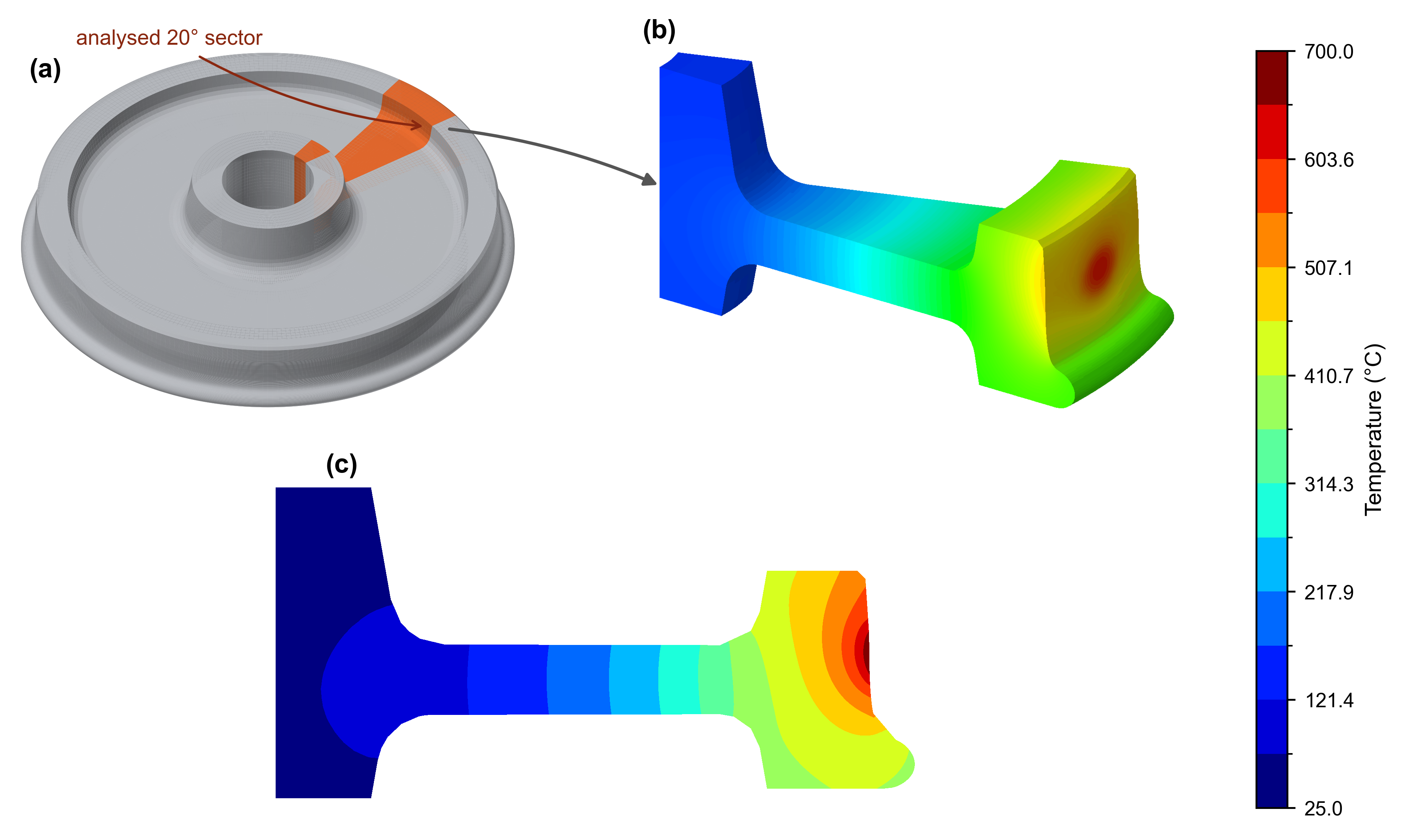
Figure 2. L2 temperature field at the end of braking: (a) full-wheel geometry locating the analysed ${20}^{∘}$ sector; (b) temperature distribution on the sector surface; and (c) meridional temperature distribution through the hot-spot centre. Panels (b) and (c) use the same 25–700 °C scale.
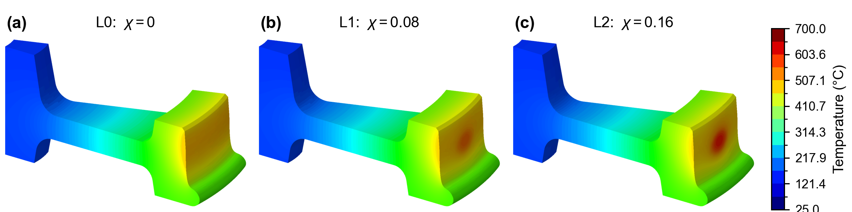
Figure 3. End-of-braking temperature fields for (a) L0 ($χ=0$), (b) L1 ($χ=0.08$) and (c) L2 ($χ=0.16$), evaluated at equal sector power and on a common temperature scale.
Table 2. End-of-braking thermal quantities for the three localisation cases at a constant sector power of 2.50 kW.
Quantity | L0 ($χ=0$) | L1 ($χ=0.08$) | L2 ($χ=0.16$)
Peak tread temperature (°C) | 578.3 | 631.1 | 690.8
Projected peak-to-mean $A_{pk}$ (K) | 0.0055 | 19.9 | 40.4
Centreline peak-to-mean $ΔT_{cl}$ (K) | 0.018 | 44.2 | 90.8
Projected $1/e$ depth, $δ_{Δ}$ (mm) | - | 18.8 | 18.6
Centreline $1/e$ depth (mm; L2 only) | - | - | 13.8
A dash indicates an undefined quantity: the centreline 1/e depth was evaluated only for L2, and no penetration depth was defined for the uniform reference case because the residual circumferential variation was numerical noise and did not exhibit monotonic exponential attenuation.
  - Circumferential modal content and attenuation with depth
Figure 4(a) shows the modal composition of the axially averaged surface temperature contrast. For both L1 and L2, sector mode $n=1$ accounts for approximately 89% of the single-sided squared-amplitude sum, whereas mode $n=2$ contributes approximately 10%. The first three modes together account for more than 99% of the squared amplitude sum. The similar modal fractions obtained for L1 and L2 show that, over the two prescribed localization levels, increasing $χ$ mainly increases the contrast amplitude without materially changing its normalised circumferential spectrum. Among the non-zero sector-periodic modes, $n=1$ has the longest circumferential wavelength. Because the ${20}^{∘}$ sector repeats 18 times around the wheel, sector mode $n=1$ corresponds to full-wheel harmonic order $m=18$, or 18 circumferential cycles around the wheel.
Figure 4(b) shows an approximately exponential decrease in the modal amplitude with depth, with regression coefficients $R^{2}>0.9999$. For L2, the fitted attenuation lengths were $l_{1}=22.4$, $l_{2}=12.1,$ and $l_{3}=8.2$ mm. The corresponding constant-property reference values were $δ_{1}=25.6$, $δ_{2}=12.8$ and $δ_{3}=8.5$ mm. Therefore, the finite element values were approximately 12.5%, 5.5%, and 3.5% smaller than their respective analytical references. The ordering $l_{1}>l_{2}>l_{3}$ shows that shorter-wavelength modes attenuate more rapidly, causing the subsurface contrast to be progressively dominated by $n=1$. The analytical length $δ_{n}$ describes a single harmonic imposed on a semi-infinite medium with constant properties. The finite element model also includes finite rim geometry, curvature, axial heat conduction, surface heat losses, and temperature-dependent properties. These effects may contribute to the differences between $l_{n}$ and $δ_{n}$; however, their individual contributions were not evaluated separately.
Figure 4(c) compares the projected contrasts for L1 and L2 with the centreline contrast of L2. At the tread surface, the L2 centreline amplitude was more than twice its projected amplitude because the axial averaging reduced the local peak. The projected and centreline contrasts for L2 decreased to $1/e$ of their surface values at depths of 18.6 and 13.8 mm, respectively. These quantities are not interchangeable: the projected depth describes the attenuation of the temperature field averaged over the prescribed axial window, whereas the centreline depth describes the attenuation along the hot-spot centreline. Table 2 shows similar projected penetration depths for L1 and L2, at 18.8 and 18.6 mm, respectively, despite their substantially different surface amplitudes. This agreement is limited to the two prescribed localised cases and does not establish that the penetration depth is independent of $χ$.
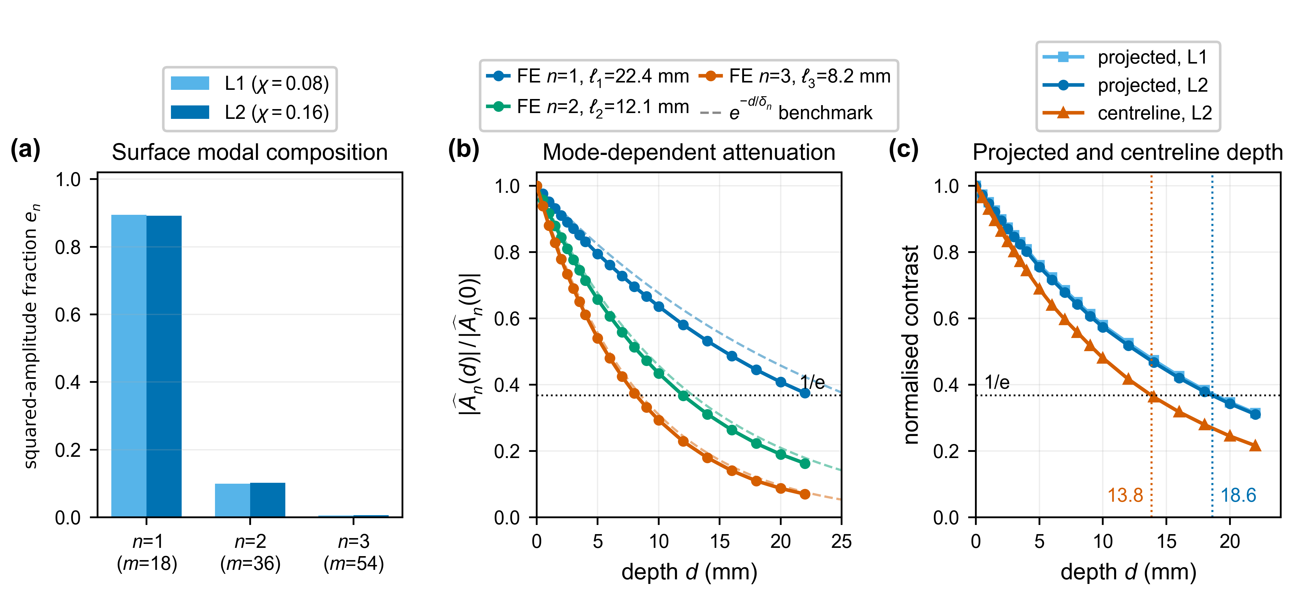
Figure 4. Modal composition and depth attenuation at the end of braking: (a) squared-amplitude sum fractions for L1 and L2; (b) normalised amplitudes of modes $n=1$–$3$ for L2, with the analytical references shown by dashed curves; and (c) normalised projected and centreline contrasts, with the $1/e$ depths indicated.
  - Sector-scale energy response and numerical verification
Each loading case received a sector power of 2.50 kW for 2700 s, corresponding to an identical heat input of $Q_{in}=6.75$ MJ. Figure 5 shows the change in the end-of-braking arithmetic nodal mean temperature relative to L0. Relative to L0, the arithmetic nodal mean decreased by approximately 0.56 °C for L1 and 1.24 °C for L2. The corresponding values were 423.13, 422.57, and 421.89 °C for L0, L1, and L2, respectively. Because this quantity is an unweighted average over all sector nodes, regions with greater mesh density contribute disproportionately.
Across L0 to L2, stored internal energy and accumulated surface losses together made up approximately 99.1% of the prescribed 6.75 MJ input, leaving an energy-closure residual of approximately 0.9%. Inter-case variations in stored energy and surface loss were below 0.05%; consequently, no meaningful difference among the three heat-input distributions was resolved for these sector-scale quantities.
The uniform reference case L0 provides an estimate of the numerical noise floor for the circumferential analysis. Because the applied heat flux was circumferentially uniform, this case should not produce a physical circumferential temperature contrast. The calculated projected peak-to-mean residual was 0.0055 K, and more than 99.999% of its single-sided squared-amplitude sum occurred at the highest resolvable mode, $n=16$. This small plane-to-plane variation is attributed to discretisation and nodal-temperature recovery and is therefore treated as numerical noise, as shown in Figure A2 in Appendix A. Its variation with depth is non-monotonic and cannot be represented by exponential attenuation; consequently, no penetration depth is defined for L0. A two-mesh check of the circumferential resolution is reported in Table A2 of Appendix A; the fitted attenuation lengths are mesh-insensitive, whereas the surface amplitude and modal partition are more sensitive to the mesh size.
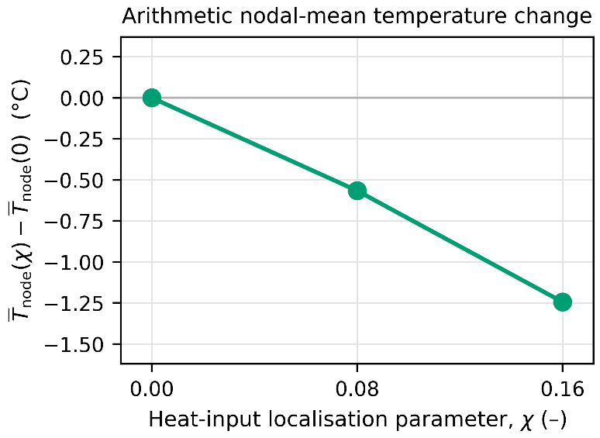
Figure 5. End-of-braking arithmetic nodal-mean temperature change relative to L0 at $Q_{in}=6.75$ MJ.
  - Post-release decay of the circumferential modes
Figure 6 shows the post-release decay of the first three circumferential modes for L2. Modes n = 1, 2, and 3 reach 1/e of their brake-release amplitudes after 34.1, 10.9, and 5.8 s, respectively; the corresponding post-release temperature fields are shown in Figure A3 of Appendix A. The decreasing decay time with increasing mode number shows that shorter-wavelength components equalise more rapidly. The corresponding one-dimensional circumferential diffusion estimates were approximately 94, 23, and 10 s. The finite element times are shorter because the three-dimensional model additionally permits radial and axial heat flow and includes surface heat losses, although the individual influence of these mechanisms is not separated. Because the 20° sector repeats 18 times, these results correspond to full-wheel orders of m = 18, 36, and 54. The reported decay times therefore describe the imposed eighteen-fold periodic non-uniformity and should not be applied directly to a single isolated hot region or to broader circumferential variations containing lower full-wheel orders.
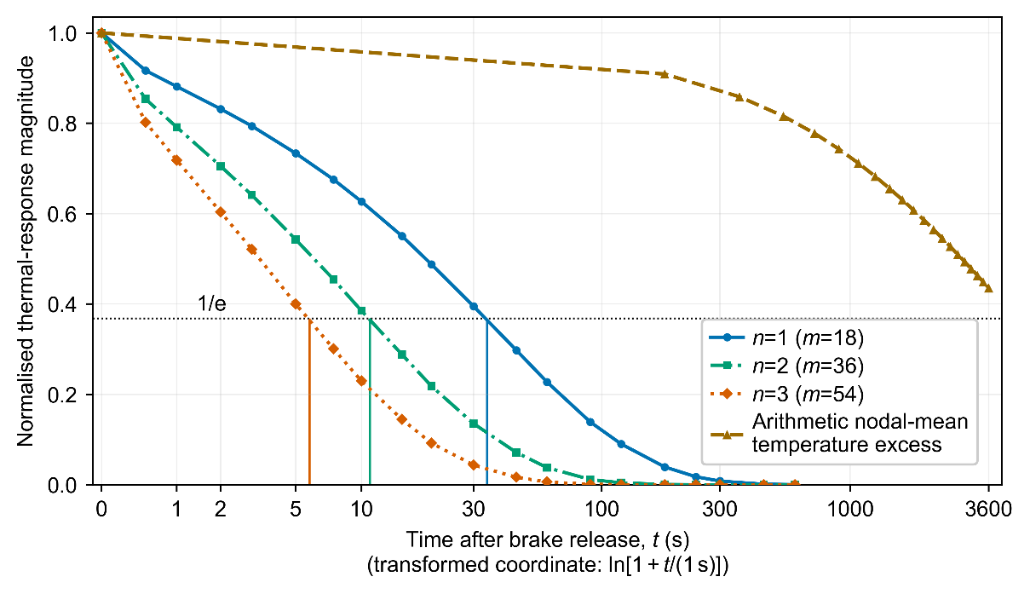
Figure 6. Post-release decay of the first three circumferential modal amplitudes and the arithmetic nodal-mean temperature excess normalised by their brake-release values.
- Discussion
Figure 3 and Table 2 show that redistribution of a fixed sector power can substantially increase the local tread temperature without changing the prescribed total input. Transferring 16% of the sector power from the uniform background to the localised component increased the end-of-braking maximum from 578.3 to 690.8 °C. Therefore, the total power is insufficient to determine the local surface maximum, and the spatial distribution of that power must also be represented.
The modal spectra and depth profiles in Figure 4, together with the post-release histories in Figure 6, show that the lowest sector mode dominates the imposed circumferential contrast and persists longest in depth and time. Figure 4(a) shows that sector mode $n=1$, corresponding to full-wheel order $m=18$, accounted for approximately $89$of the projected squared-amplitude sum. This mode also exhibited the greatest fitted attenuation length, as shown in Figure 4(b). The depth profiles in Figure 4(b) show that higher-order modes attenuate more rapidly with depth, while the post-release histories in Figure 6 show that they also decay more rapidly after brake release. Figure 4(c) and Table 2 show different $1/e$ depths for the projected and centreline contrasts because axial averaging and centreline sampling retain different spatial information. The reported penetration depths and decay times therefore characterize the prescribed eighteen-fold periodic heat source.
The contrast between the rapid decay of the circumferential modes shown in Figure 6 and the much slower reduction in the nodal-mean temperature is important when computed temperatures are compared with measurements. In the brake-rig experiments reported by Voortman Landström et al. [10], thermography resolved non-uniform tread temperatures, whereas sliding thermocouples provided an average tread temperature measurement. Megna et al. [31] reported that pyrometric measurements detected hot bands and localised hot spots that were not resolved by thermocouples because of their measurement position and thermal response. Comparison of the computed local maximum with experimental data requires measurements with adequate spatial and temporal resolution. Figure 4(c) and Table 2 show a computed contrast of approximately 40 K after axial averaging and 91 K along the centreline. Both values are lower than the hot-to-background differences exceeding 200 K measured using brake-rig thermography [10]. This difference reflects the relatively mild, spatially distributed heat source prescribed in the present controlled analysis, compared with the more concentrated hot spots observed experimentally.
The non-zero circumferential modes quantified in Figure 4 identify the local thermal information that is lost under circumferential averaging. An axisymmetric model retains the circumferentially uniform component but excludes the modes responsible for the local tread maximum and near-surface circumferential contrasts. It may still be suitable for sector-integrated quantities or for temperatures at depths and cooling times where the non-axisymmetric contribution is negligible. Kuciej et al. [14] reported temperature differences below 3% between their two-dimensional axisymmetric and three-dimensional models for the conditions examined. The less-than-3% difference reported by Kuciej et al. [14] supports axisymmetric modelling for the averaged response considered in their study; however, it does not establish its suitability for resolving local hot spots. Where local circumferential temperatures are required, the relevant spatial modes must be maintained. The required circumferential resolution can be retained using a three-dimensional sector model or a validated harmonic axisymmetric formulation, such as that presented by Magelli and Zampieri [17].
The applicability of the temperature, attenuation, and decay trends shown in Figures 3–6 and Table 2 is bounded by the prescribed heat-source representation and thermal boundary conditions. The localised heat flux remains fixed in the wheel coordinate system; therefore, the analysis determines the response to an imposed thermal non-uniformity but does not predict hot-spot formation or migration. Repeating the 20° sector produces an eighteen-fold periodic temperature pattern and does not represent a single isolated hot region on the complete wheel. The wheel–rail heat transfer was omitted, whereas convection during braking and cooling was represented by separate constant coefficients. The numerical comparison is further limited to one hot-spot geometry, three localisation fractions, and one braking duty. In particular, the three selected values of χ were insufficient to establish a general relationship between the localisation intensity and temperature response. These modelling choices preserve the controlled comparison among L0, L1, and L2, but they limit the extrapolation of the calculated temperatures to other braking and cooling conditions.
Identical total braking power does not imply identical local thermal severity: the peak tread temperature depends on the circumferential distribution of the heat input, not solely on its total magnitude. Higher-order non-uniformities attenuate more quickly with depth and decay more quickly after release; as a result, the near-surface contrast is controlled by the lowest imposed mode. However, the periodic-sector results should be validated against spatially and temporally resolved tread-temperature measurements before they are applied to in-service damage prediction. Future work should also consider isolated or migrating hot regions, wheel–rail heat transfer, other hot-spot geometries, and other braking duties.
- Conclusions
A three-dimensional transient thermal analysis was conducted for a periodic ${20}^{∘}$ sector of an ER7 railway wheel subjected to a nominal 50 kW drag-braking duty for 45 min. After heat partitioning and sector scaling, the applied sector power was 2.50 kW, corresponding to an input energy of 6.75 MJ. Three heat-input distributions were examined at the fixed sector power. L0 is a uniform reference case with $χ=0$. In L1 and L2, 8% and 16% of the sector power, corresponding to 0.20 and 0.40 kW, respectively, were assigned to the localised elliptical component, with the remaining power applied as a uniform background flux.
1. The maximum tread temperature at the end of braking increased from 578.3 °C for L0 to 631.1 °C for L1 and 690.8 °C for L2. Reallocating 16% of the fixed sector power to the localised component increased the maximum temperature by 112.5 °C. No corresponding inter-case difference in stored energy or accumulated surface loss was resolved above the approximately 0.9% energy closure residual. Therefore, the total braking power determines the energy supplied to the wheel but does not by itself determine the local tread maximum; the spatial distribution of that power must be represented, and localisation-sensitive quantities cannot be recovered from a solution that is converged only in absolute temperature and energy balance.
2. The sector mode $n=1$, corresponding to the full-wheel order $m=18$, accounted for approximately 89% of the projected squared-amplitude sum. The first three sector modes accounted for more than 99% of the total. L1 and L2 have similar normalised modal spectra. Consequently, circumferential averaging removes the dominant non-uniform component and cannot reproduce the local tread maximum or the near-surface contrast, so circumferential resolution is required whenever these local quantities are needed. This conclusion rests on the two localised cases compared here.
3. The fitted attenuation lengths for L2 were 22.4, 12.1, and 8.2 mm for modes $n=1$, 2, and 3, respectively. Their decrease with modal order shows that shorter circumferential wavelengths attenuate more rapidly with increasing depth. The projected and centreline contrasts reached $1/e$ of their surface values at depths of 18.6 and 13.8 mm, respectively. Higher-order modes are increasingly confined to the near-surface region. The projected attenuation metrics and centreline penetration depths are not interchangeable, because they describe different aspects of subsurface temperature fields sampled differently.
4. After brake release, modes $n=1$, 2, and 3 reached $1/e$ of their release amplitudes after 34.1, 10.9, and 5.8 s, respectively. The arithmetic nodal-mean temperature excess remained at 0.44 of its release value after 3600 s and did not reach $1/e$ during the simulated cooling interval. Therefore, the circumferential temperature contrast can decay substantially while the wheel remains thermally elevated. Accurate measurement of local maxima requires adequate spatial and temporal resolution during or immediately after braking, and assessments of near-tread temperature should not rely on averaged measurements.
In general, these results show that the local tread maximum, its penetration into the rim, and its persistence after release are governed by the circumferential distribution of the braking heat input and not by the total power alone. The reported penetration depths and decay times apply to the imposed eighteen-fold periodic pattern, one hot-spot geometry, and one braking duty.
References
- Bosso N, Cantone L, Falcitelli G, Gjini R, Magelli M, Nigro F M, Ossola E and Zampieri N 2023 Simulation of the thermo-mechanical behaviour of tread braked railway wheels by means of a 2D finite element model, Tribol. Int. 178, 108074. https://doi.org/10.1016/j.triboint.2022.108074
- Megna G and Bracciali A 2025 Tread-braked wheels: review and recent findings, Machines 13(7), 579. https://doi.org/10.3390/machines13070579
- Abbasi S, Teimourimanesh S, Vernersson T, Sellgren U, Olofsson U and Lundén R 2014 Temperature and thermoelastic instability at tread braking using cast iron friction material, Wear 314, 171–180. https://doi.org/10.1016/j.wear.2013.11.028
- Somà A, Aimar M and Zampieri N 2021 Simulation of the thermal behavior of cast iron brake block during braking maneuvers, Appl. Sci. 11(11), 5010. https://doi.org/10.3390/app11115010
- Wasilewski P 2020 Frictional heating in railway brakes: a review of numerical models, Arch. Comput. Methods Eng. 27(1), 45–58. https://doi.org/10.1007/s11831-018-9302-3
- Teimourimanesh S, Vernersson T and Lundén R 2016 Thermal capacity of tread-braked railway wheels. Part 2: Applications, Proc. Inst. Mech. Eng. F: J. Rail Rapid Transit 230(3), 798–812. https://doi.org/10.1177/0954409714566057
- Vernersson T 2007 Temperatures at railway tread braking. Part 1: Modelling, Proc. Inst. Mech. Eng. F: J. Rail Rapid Transit 221(2), 167–182. https://doi.org/10.1243/0954409JRRT57
- Faccoli M, Ghidini A and Mazzù A 2018 Experimental and numerical investigation of the thermal effects on railway wheels for shoe-braked high-speed train applications, Metall. Mater. Trans. A 49(10), 4544–4554. https://doi.org/10.1007/s11661-018-4749-2
- Wang B, Wu Q, Luo S, Spiryagin M, Ma W, Ding H and Yang Z 2024 Wheel tread temperature assessment and its impact on rolling contact fatigue under long-term braking conditions, Tribol. Int. 200, 110162. https://doi.org/10.1016/j.triboint.2024.110162
- Voortman Landström E, Vernersson T and Lundén R 2024 Analysis and testing of tread braked railway wheel – effects of hot spots on wheel performance, Int. J. Fatigue 180, 108116. https://doi.org/10.1016/j.ijfatigue.2023.108116
- Vernersson T 2007 Temperatures at railway tread braking. Part 2: Calibration and numerical examples, Proc. Inst. Mech. Eng. F: J. Rail Rapid Transit 221(4), 429–442. https://doi.org/10.1243/09544097JRRT90
- Teimourimanesh S, Vernersson T and Lundén R 2016 Thermal capacity of tread-braked railway wheels. Part 1: Modelling, Proc. Inst. Mech. Eng. F: J. Rail Rapid Transit 230(3), 784–797. https://doi.org/10.1177/0954409714566039
- Walia M S, Vernersson T, Lundén R, Blennow F and Meinel M 2019 Temperatures and wear at railway tread braking: field experiments and simulations, Wear 440–441, 203086. https://doi.org/10.1016/j.wear.2019.203086
- Kuciej M, Grześ P and Wasilewski P 2020 A comparison of 3D and 2D FE frictional heating models for long and variable applications of railway tread brake, Materials 13(21), 4846. https://doi.org/10.3390/ma13214846
- Zhang J, Ding J and Zuo J 2025 Development of a non-uniform heat source model for accurate prediction of wheel tread temperature on long downhill ramps, Lubricants 13(6), 235. https://doi.org/10.3390/lubricants13060235
- Zhang J, Zuo J and Gou Q 2026 Numerical investigation of thermo-mechanical behavior of railway wheel treads under contact variation and brake-force failure during long-slope braking, Int. J. Transp. Sci. Technol., in press. https://doi.org/10.1016/j.ijtst.2025.09.003
- Magelli M and Zampieri N 2025 A new finite element axisymmetric model with non-axisymmetric thermal loads for thermal analyses of tread braked wheels, Tribol. Int. 209, 110675. https://doi.org/10.1016/j.triboint.2025.110675
- Vernersson T and Lundén R 2007 Temperatures at railway tread braking. Part 3: Wheel and block temperatures and the influence of rail chill, Proc. Inst. Mech. Eng. F: J. Rail Rapid Transit 221(4), 443–454. https://doi.org/10.1243/09544097JRRT91
- Steyn E and Ahlström J 2024 Thermo-mechanical response of near-pearlitic steel heated under restriction of thermal expansion, J. Mater. Res. Technol. 32, 1714–1724. https://doi.org/10.1016/j.jmrt.2024.07.107
- Faccoli M, Ghidini L and Mazzù A 2024 Experimental study on the influence of thermal loading caused by shoe braking on microstructure and mechanical properties of railway wheels, J. Mater. Eng. Perform. 33(24), 14471–14482. https://doi.org/10.1007/s11665-024-10211-4
- Fan M, Zhang G, Li X, Li G, Sun S, Wu Y and Liu P 2026 Experimental investigation of microstructural evolution and fatigue damage of pearlite wheel steel during tread braking based on a full-size wheel–rail test rig, Metals 16(6), 662. https://doi.org/10.3390/met16060662
- Vernersson T 1999 Thermally induced roughness of tread-braked railway wheels. Part 1: Brake rig experiments, Wear 236(1–2), 96–105. https://doi.org/10.1016/S0043-1648(99)00260-4
- Zhang J, Chen X, Tao G and Wen Z 2024 Effect of thermal load caused by tread braking on crack propagation in railway wheels on long downhill ramps, Lubricants 12(10), 356. https://doi.org/10.3390/lubricants12100356
- Lu C, Zhao J, Yuan B, Ye Z, He J and Martínez-Esnaola J M 2026 The influence of braking heat and thermal expansion on tread crack of railway wheels, Machines 14(2), 173. https://doi.org/10.3390/machines14020173
- Wei Y, Han J, Yang T, Wu Y and Chen Z 2024 Research on wheel/rail contact surface temperature and damage characteristics during sliding contact of a wheel, J. Eng. Appl. Sci. 71, 201. https://doi.org/10.1186/s44147-024-00540-5
- Churchill S W and Bernstein M 1977 A correlating equation for forced convection from gases and liquids to a circular cylinder in crossflow, J. Heat Transf. 99(2), 300–306. https://doi.org/10.1115/1.3450685
- Białowas J 2023 Process Models for the Manufacturing of Railway Components, Doctoral thesis (Leoben: Montanuniversität Leoben). https://doi.org/10.34901/mul.pub.2023.196
- CEN 2020 EN 13979-1: Railway applications — Wheelsets and bogies — Monobloc wheels — Technical approval procedure — Part 1: Forged and rolled wheels (Brussels: European Committee for Standardization).
- Dassault Systèmes 2020 Abaqus/Standard 2020 Documentation (Providence, RI: Dassault Systèmes Simulia Corp.).
- Churchill S W and Chu H H S 1975 Correlating equations for laminar and turbulent free convection from a horizontal cylinder, Int. J. Heat Mass Transf. 18(9), 1049–1053. https://doi.org/10.1016/0017-9310(75)90222-7
- Megna G, Bracciali A and Francesconi A 2026 In-service surface temperature measurement of tread braked wheels with a novel on-board infrared rugged device, Railw. Eng. Sci. https://doi.org/10.1007/s40534-026-00447-2

Appendix A
Note: Reference numbers refer to the reference list of the main paper.
Table A1. Temperature-dependent thermal conductivity and specific heat of ER7 used in the model, reproduced from Białowas (2023), Table 4.5, p. 80 (reference [27] of the main paper); specific heat was converted from $kJ kg^{-1} K^{-1}$ to $J kg^{-1} K^{-1}$. A constant density of $7818 kg m^{-3}$ was used as a separate model input.
$T$ (°C) | $k$ (W m⁻¹ K⁻¹) | $c$ (J kg⁻¹ K⁻¹)
20 | 42.2 | 470
100 | 42.9 | 500
200 | 42.3 | 534
300 | 40.5 | 567
400 | 38.4 | 606
500 | 36.4 | 658
600 | 33.9 | 732
700 | 30.4 | 856
750 | 25.0 | 604
800 | 25.7 | 609
850 | 26.3 | 614

Table A2. Numerical sensitivity of the end-of-braking L2 contrast metrics to circumferential mesh resolution, reported as verification rather than a convergence demonstration. The surface $A_{pk}$ here is the geometric-projection value used for the two-mesh assessment and differs slightly from the exact-window value in Table 2 of the main paper.
Quantity (L2) | 16-plane mesh | 32-plane mesh
Elements/nodes | 23 696 / 107 041 | 47 392 / 204 937
Surface projected mean (°C) | 557.4 | 557.4
Surface $A_{pk}$ (K) | 42.7 | 40.0
Modal $e_{1}/e_{2}/e_{3}$ | 0.851 / 0.131 / 0.014 | 0.892 / 0.102 / 0.006
Attenuation $l_{1}/l_{2}/l_{3}$ (mm) | 22.4 / 12.2 / 8.3 | 22.4 / 12.1 / 8.2

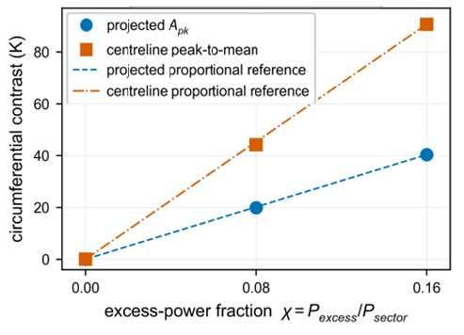
Figure A1. Projected and centreline end-of-braking contrast versus the excess-power fraction $χ$. The lines are proportional reference guides between the $χ=0$ and $χ=0.16$ values, not fitted laws.
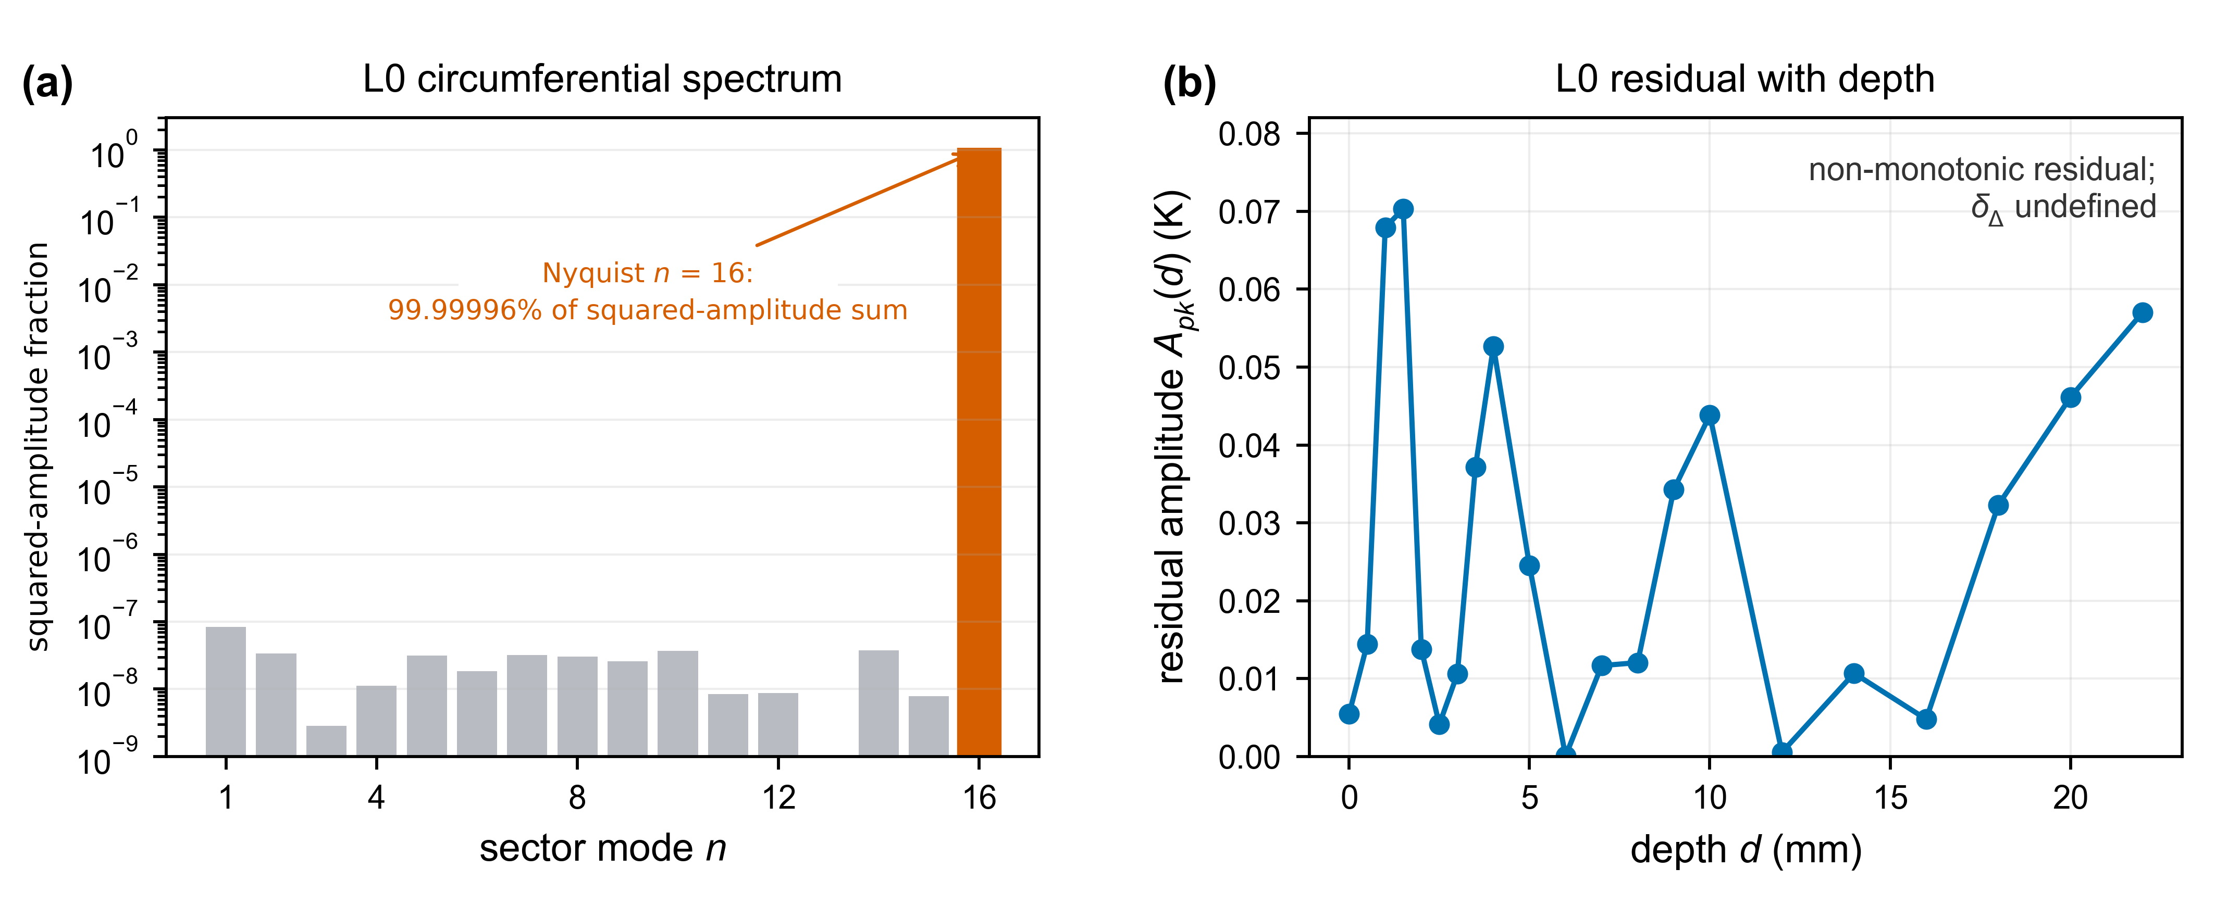
Figure A2. Uniform-loading numerical control (L0): (a) squared-amplitude spectrum of the projected surface temperature, 99.99996% of which lies in the highest resolvable mode $n=16$; (b) non-monotonic residual amplitude with depth, for which no penetration length is defined.
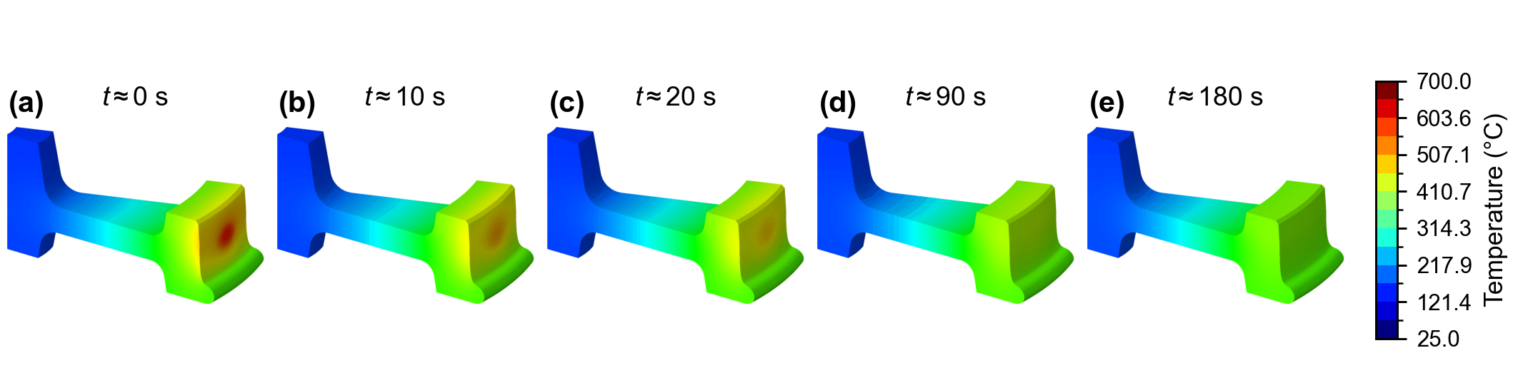
Figure A3. Post-release L2 temperature fields at selected times after brake release; all panels share the same temperature scale.

