Multiaxial Rolling Contact Fatigue Assessment of R260 Rail Steel: Effects of Cyclic Plasticity and Longitudinal Traction
G G Sirata^{1,3,*}, H G Lemu² and M A Tolcha¹
¹ Faculty of Mechanical Engineering, Jimma University, Ethiopia
² Faculty of Science and Technology, University of Stavanger, Norway
³ Faculty of Materials Engineering, Silesian University of Technology, Poland
* Corresponding author: goftila.sirata@polsl.pl
Abstract. Repeated wheel passages subject rails to non-proportional multiaxial stress–strain cycles that progressively modify the material state through plastic deformation, residual-stress development, and cyclic hardening. These changes influence both the severity and spatial localisation of rolling contact fatigue (RCF). This study investigates the effects of cyclic plasticity and longitudinal traction on multiaxial rolling contact fatigue in R260 rail steel. Ten wheel passages were simulated using a local three-dimensional railhead model subjected to a moving Hertzian pressure corresponding to a wheel load of 110.325 kN. Two loading conditions were considered: pure rolling without tangential traction (C0) and rolling with a traction ratio T/Q of 0.30 applied as a Carter-type partial slip distribution (C30). The cyclic response of R260 steel was modelled using a finite-strain plasticity framework, and the relative rolling contact fatigue susceptibility was evaluated using the Jiang–Sehitoglu critical plane parameter. At passage 10, the maximum fatigue parameter was 0.748 MPa at a depth of 1.80 mm for C0 and 5.869 MPa at the first resolved integration-point depth of 0.20 mm for C30. At the corresponding coordinates, longitudinal traction increased the near-surface value by a factor of 20.0, compared to 1.27 at the subsurface location. The representative C0 response remained non-stabilised within ten wheel passages, whereas the C30 near-surface response satisfied the persistent ratcheting criterion. Under C30, two nearly orthogonal candidate plane families yielded almost equal values, with the secondary maximum reaching 99.1% of the primary. Therefore, tangential traction increased the fatigue parameter, shifted its maximum value toward the rail surface, and produced two nearly equivalent candidate plane families.
Keywords: rolling contact fatigue; longitudinal traction; critical plane; cyclic plasticity; R260 rail steel
- Introduction
Rolling contact fatigue (RCF) is a primary degradation mechanism in modern rail networks. It arises from repeated wheel–rail interactions that impose high contact pressures and multiaxial, non-proportional loading on the surface and subsurface of the rail, where cumulative plastic deformation and the associated microstructural evolution promote crack initiation. The resulting damage appears as head checks, squats, spalling, and shelling [1]. The initiation depth is a key determinant of both the service life and maintenance effectiveness; cracks nucleating in the shallow surface layer can often be removed by wear or preventive grinding before they reach a critical size. Cracks that are initiated deeper or grow beyond the depth reachable by grinding may remain in the rail and continue to grow until failure [2]. Therefore, a reliable assessment of RCF is not governed by the number of loading cycles alone, but also by the location of the crack initiation and the orientation of the initiation plane, which together influence whether the damage is removable and how a crack subsequently grows [3].
The load history experienced by a material point beneath a rolling contact is inherently multiaxial and non-proportional. As the wheel approaches, passes over, and moves away from a fixed material point, predominantly compressive normal stresses coexist with shear components, and their magnitudes and directions evolve throughout the passage. The principal stress directions undergo continuous rotations [4]. Moreover, the multiaxial stress–strain history evolves from cycle to cycle owing to cyclic hardening/softening, mean stress relaxation, and elastic shakedown or persistent ratcheting. Xu et al. [5] predicted 7816 cycles when non-proportional additional hardening was included and 1684 cycles when it was omitted; neglecting this effect therefore reduced the predicted life by approximately a factor of 4.6.
A material point in the railhead enters each loading passage with residual stress and work hardening inherited from the prior passages. The long-term behavior may be elastic shakedown, plastic shakedown (a stabilised closed hysteresis loop with zero net plastic strain accumulation per passage), or ratcheting, where plastic strain accumulates in each passage and can exhaust ductility [6–7]. Plastic shakedown and ratcheting typically correspond to different damage modes: fatigue under stabilised cyclic plasticity versus ductility exhaustion from progressive plastic-strain accumulation [8, 9]. These regime boundaries are not fixed: the measured shakedown limits for rail steels are below the classical shakedown-map predictions and decrease with increasing shear yield strength [10], and the reconstructed limits depend on the constitutive model used [11]. Shakedown maps classify the response in the normalised pressure–traction space but do not predict the crack-initiation life or damage depth/orientation [6]. Ductility-exhaustion methods are typically applied to ratcheting [8]. Critical-plane methods evaluate a damage parameter on candidate planes to identify the likely crack-initiation location, depth, and orientation, and then use a calibrated fatigue law to estimate the life. Common parameters include Jiang–Sehitoglu (normal and shear energies) [12], Smith–Watson–Topper (normal stress and strain) [13], and Fatemi–Socie (shear-strain range with maximum normal stress correction) [14]. All approaches rely on constitutive model stress–strain histories, and errors in hardening, mean stress relaxation, or ratcheting directly affect crack initiation predictions.
Recent studies have further clarified the interaction between shear and normal stress components under proportional and non-proportional multiaxial loading. Pezeshki et al. [15] combined stress-state analysis with experimental testing to determine the loading parameters governing this interaction and to quantify their effects on fatigue behavior. In a subsequent associated study [16], these parameters were incorporated into a multiaxial fatigue-damage formulation, and the model’s predictive performance was evaluated through comparison with experimental observations. These studies indicate the importance of considering the effect of combined shear and normal stress effects when assessing fatigue under non-proportional stress histories, including those induced by rolling contact.
Previous critical plane studies simplified the cyclic material behavior and its evolution under repeated passages by restricting the loading history or evaluation domain. For example, Leung et al. [17] defined the tenth cycle as representative of the stabilised response, Nazari and Hosseini Tehrani [18] computed the relevant parameter at a single, preselected surface element following a sequence of wheel passages; and Zheng et al. [19] considered a single explicit transient wheel traversal. Zhang et al. [20] predicted crack-initiation life from the stabilised ratcheting strain rate and material ductility and used a critical-plane method to predict crack orientation. However, the passage-by-passage evolution of the spatial critical plane response remains unclear. Repeated passages cause severe near-surface shear in pearlitic rail steel [21]. Finite-strain kinematic hardening models have been calibrated with large biaxial deformation data [22], the evolution of plastic anisotropy after severe shear has been quantified [23], and distortional-hardening extensions have been proposed [24]. Prior shear can increase the torsional fatigue life when subsequent loading aligns with the predeformation direction [25] and alters the crack characteristics under 90° out-of-phase loading [26], indicating the importance of the deformation history. For the extreme full-slip case with a traction coefficient of 0.4 examined by Talebi et al. [27], omitting the deformed material state and evolved profile increased the predicted damage by factors of approximately 5 and 30, respectively. Under identical rolling–sliding conditions, different plasticity models can predict different accumulated shear values [28]. Efficient 3D numerical frameworks now make repeated simulations of the elastic-plastic passage feasible [29,30], and both stabilisation and accumulated plastic deformation depend on the applied traction [31].
Despite these advances, most studies have investigated repeated cyclic plasticity and critical-plane crack initiation separately, rather than combining both within the same passage-resolved analysis. Three-dimensional rolling contact studies predict the evolution of stress and plastic strain under repeated wheel–rail passages [28–32], but typically do not compute a spatial field of a critical-plane crack-initiation parameter, whereas critical plane studies typically analyze a single passage or an assumed stabilized cycle [17–19]. Talebi et al. [27] included the depth-dependent properties of predeformed R260 in a critical-plane framework but used a two-dimensional generalised plane-strain model that neglected the longitudinal history of the moving contact and could not fully represent the three-dimensional plane orientations. Consequently, the influence of the evolving cyclic state of R260 on the passage-resolved critical-plane initiation field under moving contact and the effect of longitudinal traction on this field under constant normal load remain insufficiently resolved.
The present analysis combines repeated-passage cyclic plasticity with a three-dimensional critical plane evaluation of R260 rail steel. Two cases with identical normal force are analysed: pure rolling (C0) and rolling with longitudinal traction (traction-to-load ratio 0.30) applied via a Carter-type partial-slip distribution (C30). The cyclic response of R260 is described by a finite-strain plasticity model, and fatigue susceptibility is assessed using the Jiang–Sehitoglu critical-plane parameter. The residual stress, accumulated plastic deformation, and internal hardening variables are carried over between passages, and the net plastic-strain drift per passage classifies the local cyclic regime at the selected points. The full stress/strain tensor histories are then used in a critical plane search, reporting passage-by-passage fatigue parameters and damage increments. The comparison isolates the effect of longitudinal traction under identical normal loading while reporting passage-resolved fatigue parameters and ten-passage damage indices.
- Contact loading and moving passage model
  - Wheel–rail geometry and Hertzian contact loading
The local contact curvatures were derived from a 60E1 rail crown [33] and an EN 13715 S1002 wheel profile [34]. The finite element domain was a local rectangular railhead block with a locally flat loaded surface; the wheel body and deformable wheel–rail contact were not modelled. The wheel has a nominal rolling radius of 460 mm and a transverse osculating radius of 332.0 mm at the nominal contact point. The analyses assumed a straight track with a contact patch at the rail crown. The used axle load was 22.5 t, corresponding to the maximum axle-load level associated with the EN 15528 category D load models [35], and gave a static wheel load of Q = 110.325 kN.
The Hertzian contact solution [4] was evaluated using $E_{w}=185 GPa$ and $ν_{w}=0.30$ for the ER7 wheel steel [36], and E_{r}=212.0 GPa and $ν_{r}=0.317$ for the R260 rail steel [22]. These properties yield a combined contact modulus of $E*=109.1$ GPa. The Hertz theory for the given geometry provides semi-axes $a=8.2704$ mm (rolling) and $b=4.0642$ mm (lateral) and a maximum contact pressure $p_{0}=1567.18$ MPa. The normal pressure, from the Hertz solution [4], is
$p\left(x,y\right)=p_{0}\sqrt{1-{\left(ξ/a\right)}^{2}-{\left(y/b\right)}^{2}}$ (1)
with $ξ=x-x_{c}(t)$ the longitudinal distance from the moving patch centre. Equation (1) is assumed to hold within the elliptical contact patch, whereas the pressure is zero outside the domain. The resulting pressure distribution recovers the prescribed normal load according to $Q=\left(2/3\right)πab p_{0}$.
The stress field generated by the distributed Hertzian pressure was computed by numerically integrating the Boussinesq elastic half-space solution [4]. The resulting stress magnitude and depth were used to guide mesh refinement.
The Hertzian contact solution was employed to determine the contact dimensions and to prescribe the surface pressure distribution. Mesh refinement was guided by the elastic Boussinesq solution, which also served as the reference benchmark in Section 4.1. Stress–strain histories for the fatigue evaluation were obtained from finite-strain elastoplastic finite element analyses; residual stresses, plastic strains, and constitutive state variables were retained between successive load passages.
The present approach adopts the classical assumptions of smooth, nonconforming contacting bodies with locally quadratic surface geometry, a contact patch that is small relative to the principal radii of curvature, homogeneous and isotropic linear-elastic material behaviour for the contact solution, and quasi-static loading conditions. The imposed Hertzian pressure distribution and the Carter/Haines–Ollerton tangential traction fields were translated along the rail surface while holding their dimensions and magnitudes constant. Table 1 summarises the contact and loading parameters, and Figure 1 shows the rail geometry and the analysed half-symmetry domain, including the applied boundary conditions and the mesh-refinement region.
Table 1. Contact geometry and loading parameters.
Parameter | Symbol | Value
Rail profile / head crown radius | $$R_{ry}$$ | 60E1, 300 mm
Wheel profile / rolling radius / transverse radius | $R_{wx}$, $R_{wy}$ | S1002, 460 mm, 332.0 mm
Design wheel load | $$Q$$ | 110.325 kN
Elastic constants and Poisson’s ratio for ER7 wheel | $E$, $ν$ | 185 GPa, 0.30
Elastic constants and Poisson's ratio for R260 rail | $E$, $ν$ | 212.0 GPa, 0.317
Hertzian semi-axes (rolling, lateral) | $a$, $b$ | 8.2704, 4.0642 mm
Hertzian peak pressure | $$p_{0}$$ | 1567.18 MPa
Friction coefficient and traction ratio (C30) | μ, T/Q | 0.40, 0.30
Longitudinal motion of the contact-patch per passage | $$x_{c}$$ | $-37→+37$ mm
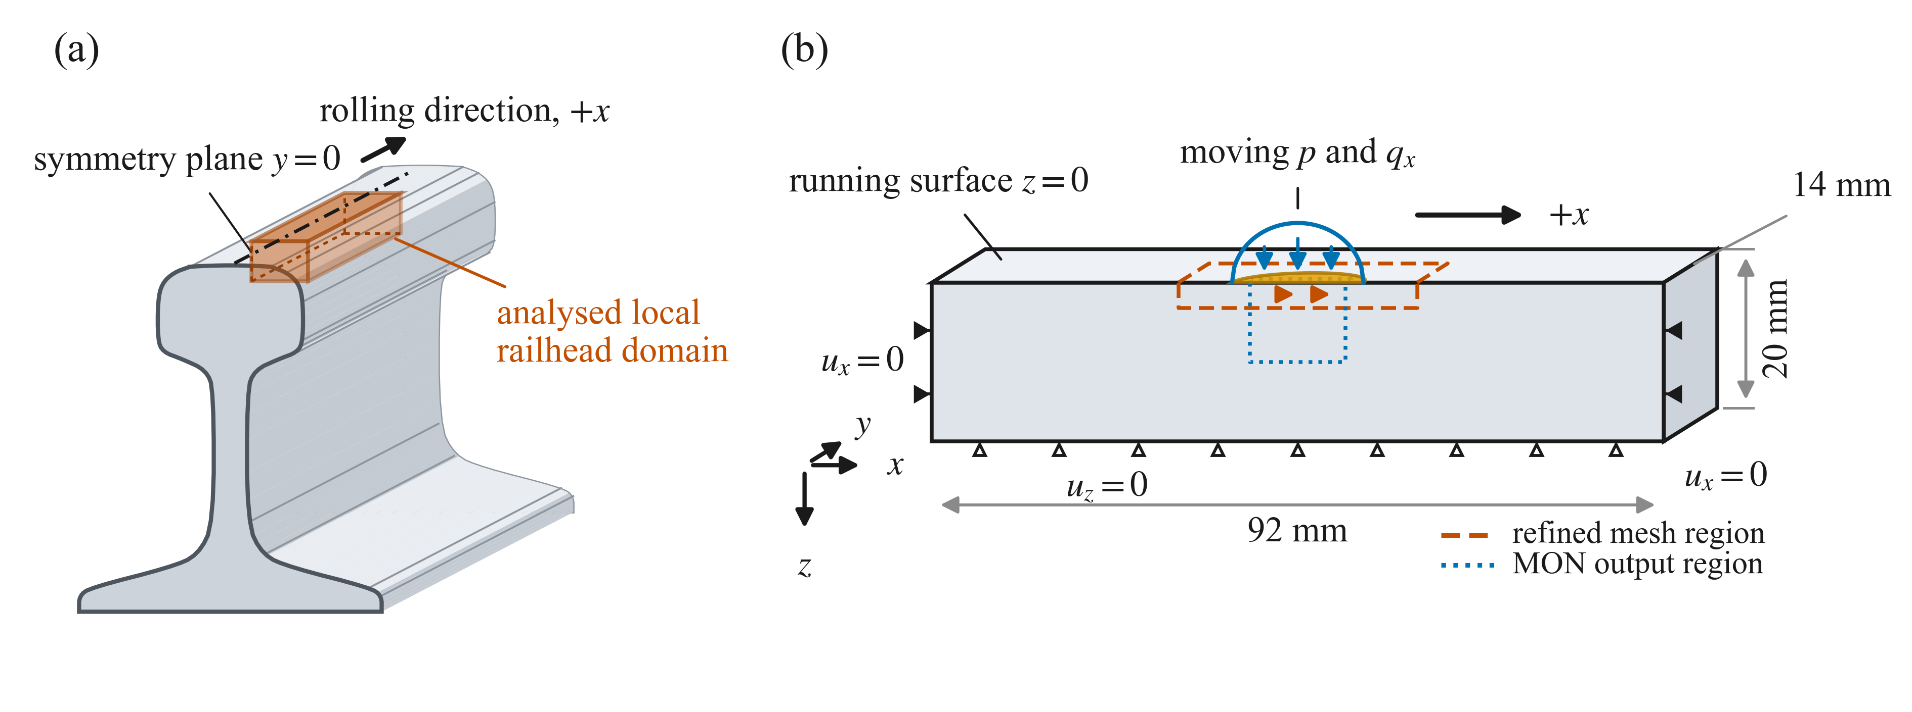
Figure 1. Geometry and loading of the local 60E1 railhead model: (a) location of the analysed half-symmetry domain; (b) domain dimensions, boundary conditions, refinement and monitoring regions, and moving pressure $p$ and longitudinal traction $q_{x}$.
  - Moving contact loading and repeated-passage procedure
Each wheel passage was represented by translating the surface pressure and, for C30, the tangential traction along the railhead. The contact-patch centre travelled from $x_{c}=-37$ mm to $x_{c}=+37$ mm within a geometrically nonlinear static step, nominally divided into 160 equal increments of 0.4625 mm. There were 161 nominal load positions, including the initial state. The step time served only as a normalised traversal coordinate, making the analysis quasi-static and independent of the rolling speed. A cosine ramp applied over the initial and terminal 15% of the traverse ensured that the monitored region experienced zero load at both endpoints, which allows direct determination of the residual state. The ramp was positioned outside the monitored volume for quantitative fatigue assessment. Ten successive passages were analysed for each loading condition.
Passage 1 started with a virgin, stress-free material state. Passages 2 to 10 were performed through restart-read continuation from the preceding, converged end state. Therefore, the displacement field, complete residual stress tensor, and all constitutive state variables were transferred directly without reconstruction or remapping. Only moving surface loads were applied during each passage. This procedure preserved the loading history and allowed the residual stresses, plastic strains, and internal hardening variables to evolve continuously over the successive passages.
Both loading cases used the same Hertzian normal pressure distribution. For case C0, no tangential traction was imposed; therefore, the traction ratio was $η=T/Q=0$ and the tangential traction was $q_{x}=0$. For case C30, the traction ratio was $η=0.30$ and the coefficient of friction was $μ = 0.40$. Here, $η$ governs the resultant tangential force, whereas $μ$specifies the local frictional bound. Since $T/\left(μQ\right)=0.75<1$, case C30 lies within the partial-slip regime. The Carter/Haines–Ollerton partial-slip solution was applied strip-wise across the elliptical contact patch [4,37]. For the lateral coordinate $y$, the contact half-length is
$a_{y}=a\sqrt{1-{\left(\frac{y}{b}\right)}^{2}}.$ (2)
The longitudinal traction was calculated as
$q_{x}\left(ξ , y\right)=μ\left[p\left(ξ , y\right)-p^{*}\left(ξ , y\right)\right],$ (3)
where $p^{*}$ is a corrective Hertzian-shaped distribution used only to calculate the tangential traction. Its half-length and longitudinal centre are
$c_{y}=Ka_{y}, ξ_{s}=a_{y}-c_{y},$ (4)
respectively, and
$p^{*}\left(ξ , y\right)=\left\{\begin{matrix}\frac{p_{0}}{a}\sqrt{c_{y}^{2}-{\left(ξ-ξ_{s}\right)}^{2}}, & ∣ξ-ξ_{s}∣≤c_{y}, \\ 0, & ∣ξ-ξ_{s}∣>c_{y}.\end{matrix}\right.$ (5)
Here, $ξ=x-x_{c}$, and the leading edge of the strip is located at $ξ=+a_{y}$. Therefore, the corrective distribution occupies the interval $a_{y}-2c_{y}≤ξ≤a_{y}$, producing a leading-edge stick region; outside this interval, $p^{*}=0$ and $q_{x}=μp$. For C30,
$K=\sqrt{1-\frac{η}{μ}}=\sqrt{1-\frac{0.30}{0.40}}=0.50,$ (6)
Therefore, the leading and trailing halves of each strip correspond to the stick and slip regions, respectively. Because the resultant of $p^{*}$ is $K^{2}$ times that of $p$, integration over the contact patch gives
$\frac{T}{Q}=μ\left(1-K^{2}\right)=0.30.$ (7)
Numerical integration gives $T/Q=0.30000$, while the local traction satisfies $∣q_{x}∣≤μp$. The pressure and traction distributions were multiplied by the same cosine amplitude ramp at the beginning and end of each passage. Figure 2 shows the pressure and traction distributions and defines the critical plane angle. A prescribed moving load was used to impose the same normal pressure history on C0 and C30. The fixed rail mesh also allowed the residual stresses and constitutive variables to remain associated with the same material points between the passages. Similar approaches have been used in critical plane and repeated-passage elastic–plastic analyses [17,20,29,30].
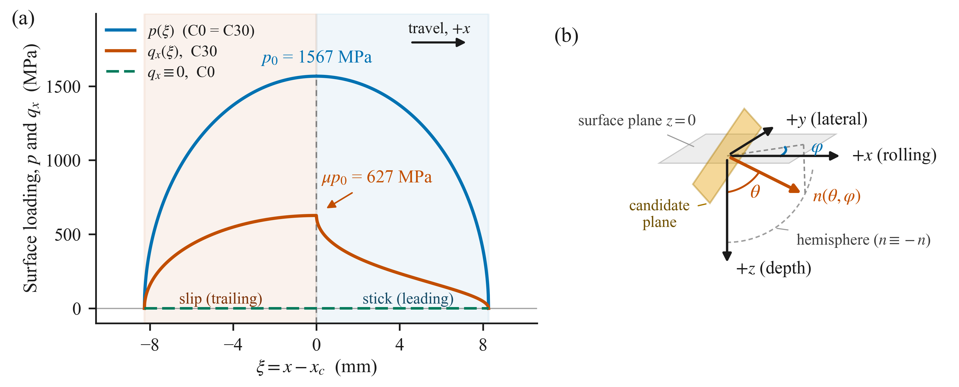
Figure 2. (a) Hertzian pressure and longitudinal traction distributions for pure rolling (C0) and tractive rolling (C30). (b) Candidate plane orientation used in the critical plane search; θ is measured from +z and φ from +x.
  - Finite element model, boundary conditions and field output
For the finite element analysis, the railhead was represented by a local rectangular block with a flat loaded surface based on the tangent plane approximation at the nominal contact point. The lateral contact semi-axis $b=4.0642$ mm is only 1.35% of the 300 mm rail-crown radius; consequently, the crown deviates from the tangent plane by approximately 0.028 mm, equivalent to 0.68% of $b$, and has a maximum local slope of only ${0.78}^{∘}$ within the contact patch. The maximum geometric deviation was small relative to the contact-patch dimensions, supporting the tangent-plane representation adopted for the local near-contact analysis. Nevertheless, the wheel and rail curvatures were retained in the calculation of the Hertzian contact dimensions and the maximum pressure. The block extended 92 mm in the rolling direction ($x∈\left[-46 , 46\right]$ mm) and 20 mm in depth. Because the normal pressure and longitudinal traction were symmetric about $y=0$, only a lateral half-width of 14 mm was modelled, with $u_{y}=0$ imposed on the symmetry plane. In addition, uₓ = 0 was specified at x = ±46 mm, and u_z = 0 at z = 20 mm.
The domain was discretized using 52,326 eight-node reduced-integration hexahedral elements (C3D8R) with enhanced hourglass control, yielding a total of 57,680 nodes in the model. In the vicinity of the contact region, the mesh was locally refined to a uniform cubic element size of 0.4 mm over 𝑥 ∈ [−15, 15] mm, 𝑦 ∈ [0, 8] mm, and 𝑧 ∈ [0, 3.2] mm, corresponding to approximately 41 elements spanning the contact length 2𝑎 and 20 elements spanning the contact width 2𝑏. The mesh was subsequently coarsened via graded transitions towards the model boundaries.
The first element layer extended from $z=0$ to 0.40 mm. Because the C3D8R elements have one integration point, the first resolved stress and strain values occur at $z=0.20$ mm. Therefore, this is the shallowest reported depth, and the precise location of the maximum between this plane and the physical surface cannot be resolved. The Cauchy stress, logarithmic strain, and all constitutive state variables were recorded at every converged increment within the monitored volume |x| ≤ 6 mm, 0 ≤ y ≤ 1.5 mm, and 0 ≤ z ≤ 10 mm, which comprised 1,800 elements. The equivalent plastic strain was calculated from the stored plastic deformation gradients. The maximum deviation of det(Fₚ) from unity was 7.3 × 10⁻⁴, supporting the use of the isochoric plastic deformation gradient in the Hencky strain calculation. For the critical plane calculation, Abaqus LE12, LE13, and LE23 were divided by two when assembling the logarithmic strain tensor. All field plots present unaveraged integration point values, and all reported extrema, depths, and critical plane orientations refer to the integration points.
- Cyclic plasticity and critical-plane fatigue assessment
  - Finite-strain cyclic-plasticity model for R260 steel
The cyclic response of the R260 steel was modelled using the finite-strain two-backstress elastoplastic model proposed by Meyer et al. [22]. An open-source implementation of this model as a user material subroutine (UMAT) for Abaqus was used in the study [38]. The model was applied to ten successive three-dimensional rolling contact passages, with residual stresses and all constitutive state variables retained between the passages. The elastic response is governed by a compressible hyperelastic law characterised by a shear modulus $G=80.5$ GPa and a bulk modulus $K=193$ GPa, corresponding to $E≈212$ GPa and $ν≈0.317$. Plastic yielding is governed by the von Mises criterion expressed in terms of the Mandel stress and incorporates two kinematic hardening components (backstress). Isotropic hardening was represented by a Voce-type evolution law with an initial yield stress of 451 MPa. Each backstress evolves according to a combined Armstrong–Frederick/Burlet–Cailletaud formulation as follows: The blend parameter δ = 0.290 weights the Armstrong–Frederick and Burlet–Cailletaud dynamic recovery contributions.
Table 2 lists the twelve entries supplied to the material implementation. Ten entries define the active elastic and hardening responses. The remaining dimensionless entries, $m_{k1}=m_{k2}=1.0$, are required by the generic input card format but do not enter the constitutive evolution equations used in this study. The inverse saturation parameters corresponded to saturation stresses of 169 MPa for isotropic hardening and 293 and 322 MPa for the first and second kinematic hardening components, respectively. Each integration point stores 28 constitutive state variables, namely the accumulated plastic multiplier 𝜆, the plastic deformation gradient $F_{p}$, and two kinematic internal deformation gradients $F_{k1}$ and $F_{k2}$. These state variables were transferred across successive analyses using the restart procedure described in Section 2.2.
Table 2. Parameters of the finite-strain two-backstress model for the R260 steel.
Parameter | Symbol | Value | Parameter | Symbol | Value
Shear modulus | $$G$$ | 80, 500 MPa | Kinematic hardening modulus 1 | $$H_{k1}$$ | 1450 MPa
Bulk modulus | $$K$$ | 193, 000 MPa | Inverse kinematic saturation 1 | $$Y_{k1}^{-1}$$ | 0.0034130 MPa⁻¹
Initial yield stress | $$Y_{0}$$ | 451 MPa | Inactive exponent entry 1 | $$m_{k1}$$ | 1.0
Isotropic hardening modulus | $$H_{iso}$$ | 212 MPa | Kinematic hardening modulus 2 | $$H_{k2}$$ | 10 148 MPa
Inverse isotropic saturation | $$κ_{∞}^{-1}$$ | 0.0059172 MPa⁻¹ | Inverse kinematic saturation 2 | $$Y_{k2}^{-1}$$ | 0.0031056 MPa⁻¹
AF/BC blend | $$δ$$ | 0.290 | Inactive exponent entry 2 | $$m_{k2}$$ | 1.0
The model represents isotropic expansion/contraction and kinematic translation of an otherwise shape-preserving von Mises yield surface. It captures cyclic isotropic and kinematic hardening but not the distortional evolution observed in R260 after severe shear loading [23,24]. The accumulated plastic multiplier 𝜆 (the model’s first state variable) is a monotonically increasing internal variable, whose incremental evolution is indicative of ongoing plastic flow.
  - Passage-resolved material-state evaluation
The plastic deformation at the end of each passage was obtained from the stored plastic deformation gradient $F_{p}$. The plastic Hencky strain tensor and its scalar equivalent were calculated as follows:
$E_{p}=\frac{1}{2}ln\left(F_{p}^{T}F_{p}\right), ε_{p}=\sqrt{\left(\frac{2}{3}\right) E_{p}:E_{p}}$ (8)
The tensor logarithm was evaluated using a spectral decomposition. The derived $ε_{p}$ is a Hencky equivalent plastic strain, which is distinct from the Abaqus equivalent plastic strain (PEEQ), plastic multiplier $λ$, and any cumulative damage measure.
The passage-to-passage evolution was evaluated based on the unloaded residual states. For passage $N$, the net plastic-strain increment and its scalar magnitude were defined as
$ΔE_{p}^{N}=E_{p}^{N}-E_{p}^{N-1}, d_{N}=∥ΔE_{p}^{N}∥_{F}$ (9)
Because $d_{N}$ is based on the tensor difference, it remains sensitive to changes in the strain direction even when the scalar strain magnitude is unchanged. This is a state-drift measure defined for this study and differs from the ratcheting strain used in ductility-exhaustion approaches [8]. Plastic activity during passage $N$ was measured using $Δλ_{N}=λ_{N}-λ_{N-1}≥0$. This quantity identifies whether plastic flow occurs, but does not measure net strain accumulation or fatigue damage.
The following regime labels are operational classifications for the simulated ten-passage window and are not universal material definitions. The response regime was classified using $d_{N}$, $Δλ_{N}$ and $ε_{p}$, with a common numerical threshold of ${10}^{-5}$. The late-passage window comprised P8–P10. A non-zero drift plateau was identified when
$d_{10}≤d_{9}≤1.10d_{8}, \frac{∣d_{10}-d_{9}∣}{max⁡\left(d_{9} , {10}^{-5}\right)}≤0.10, d_{10}>{10}^{-5}, d_{10}≥0.90d_{8}.$ (10)
A point was classified as elastic when the plastic-activity increment $Δλ_{N}$ remained at or below the threshold in every passage and $ε_{p}$ never exceeded it. If $d_{9}$ and $d_{10}$ were below the threshold, the response was classified as elastic shakedown when late plastic activity ceased and as plastic shakedown when it persisted. Persistent ratcheting requires a non-zero drift plateau above the threshold. All remaining responses were classified as non-stabilized within the P1–P10 period. Residual stress was used as a supporting diagnostic tool but was not included in the classification.
  - Critical-plane search
A candidate plane at a given point is characterised by its associated unit normal vector, which is represented as a point on the unit sphere.
$n\left(θ,ϕ\right)={\left[sinθcosϕ, sinθsinϕ, cosθ\right]}^{T}, θ∈\left[0,π/2\right], ϕ∈\left[0,2π\right)$ (11)
Here, 𝜃 is defined with respect to the depth direction $+z$ and $ϕ$ with respect to the rolling direction $+x$, as illustrated in Figure 2(b). Because the antipodal normal vectors correspond to the same physical plane, the orientation search was restricted to a single hemisphere. For each stored frame, the stress and logarithmic-strain tensors were projected onto the plane. The corresponding normal components are given by 𝜎ₙ = 𝐧·𝛔·𝐧 and 𝜀ₙ = 𝐧·𝛆·𝐧. The shear stress and engineering shear strain are retained as in-plane vectors,
$τ\left(t\right)=σ\left(t\right)⋅n-σ_{n}\left(t\right) n, γ\left(t\right)=2\left[ε\left(t\right)⋅n-ε_{n}\left(t\right) n\right]$ (12)
A cycle is defined as a complete passage represented by a full set of converged frames. For a given plane, all ordered pairs of frames ($t_{1},t_{2})$ are evaluated, and the corresponding ranges are formed from pairwise differences. In particular, the shear ranges are computed as the norms of the vector differences, rather than as differences between the scalar magnitudes,
$Δε_{n}=\left|ε_{n}\left(t_{2}\right)-ε_{n}\left(t_{1}\right)\right|, Δτ=∥τ\left(t_{2}\right)-τ\left(t_{1}\right)∥, Δγ=∥γ\left(t_{2}\right)-γ\left(t_{1}\right)∥$ (13)
The maximum normal stress was defined as $σ_{max}=\max_{t}σ_{n}\left(t\right)$. Vector differences were used to compute the shear stress ranges because the shear direction may rotate during wheel passage, and subtracting only scalar magnitudes would not account for such changes. For each material plane, a pair of time frames that maximised the selected fatigue parameter was identified. The hemispherical orientation space was initially searched using a 5° angular resolution, with the number of azimuthal orientations scaled by $\sin{θ}$ to maintain an approximately uniform density of the plane orientations [39]. The maximum was subsequently refined using a 1° resolution within $±6^{∘}$. Angular maps were evaluated separately on a uniform $2^{∘}$ grid. At the selected C0 and C30 material points, the critical plane responses were computed for each passage (P1–P10). Spatial fatigue fields, critical depths, and angular response landscapes were assessed only for P10; therefore, the global critical location was not monitored on a passage-by-passage basis. Nearly equal maxima from different plane families indicate competing values.
  - Jiang–Sehitoglu fatigue parameter and damage indices
Fatigue damage was evaluated using the Jiang–Sehitoglu critical-plane parameter defined below, computed from the full histories of the stress and logarithmic strain tensors projected onto each candidate material plane (Section 3.3). Plastic yielding was governed via a von Mises-type criterion defined in terms of the Mandel stress (Section 3.1). The von Mises equivalent Cauchy stress reported in the figures was employed solely for descriptive and comparative characterization of the stress fields in Sections 4.5 and 4.6. For each candidate plane, the Jiang–Sehitoglu fatigue parameter was calculated as follows [12,39]:
$FP\left(x , n , i\right)=σ_{max}\left(x , n , i\right)\frac{Δε_{n}\left(x , n , i\right)}{2}+JΔτ\left(x , n , i\right)Δγ\left(x , n , i\right),$ (14)
In this expression, 𝐱 denotes the material point, 𝐧 is the normal to the candidate plane, and 𝑖 is the passage index. Here, $σ_{max}$ represents the maximum normal stress on the plane during the passage and thereby accounts for mean-stress effects. $Δε_{n}$ is the normal strain range, whereas $Δτ$ and $Δγ$ denote the shear-stress range and the engineering shear-strain range, respectively, as defined in equation (13). The parameter $J$ is a dimensionless shear-weighting coefficient. Consequently, 𝐹𝑃 has units of MPa. Consistent with the calibration proposed by Talebi et al. [39], no Macaulay bracket is applied separately to $σ_{max}$ in equation (14).
A critical plane search was conducted independently for each passage. The plane-maximised fatigue parameter is defined as
$FP_{i}^{max}\left(x\right)=\max_{n}FP\left(x , n , i\right).$ (15)
The associated passage-wise damage increment and cumulative N-passage damage index were computed as follows
$ΔD_{i}\left(x\right)={\left[\frac{\left\langle FP_{i}^{max}\left(x\right)-FP_{0}\right\rangle }{C_{0,R}}\right]}^{m}, D_{N}\left(x\right)=\sum_{i=1}^{N}{ΔD_{i}\left(x\right)},$ (16)
Here, the Macaulay bracket is defined as $\left\langle x\right\rangle =\left(x+∣x∣\right)/2$. Accordingly, any passage satisfying $FP_{i}^{max}≤FP_{0}$ yields a zero-damage increment. Because the critical plane search is repeated separately for each passage, the maximising plane may vary from one passage to another. Hence, $D_{N}$ represents a passage-wise, plane-maximised scalar damage index as prescribed by the calibrated formulation, and it does not correspond to damage accumulation on a single persistent material plane.
Talebi et al. [39] calibrated the Jiang–Sehitoglu formulation using their fatigue dataset and reported the parameter set $m=2.22$, $C_{0,R}=91.2$ MPa and $J=0.20$. The notation $C_{0,R}$ is retained to distinguish the fatigue-resistance constant from loading case C0. In addition, the threshold value $FP_{0}=0.62$ MPa was derived in that study from previously reported high-cycle fatigue results for pearlitic grade 900A rail steel. Within the adopted modelling framework, $D_{N}=1$ denotes the nominal fatigue crack-initiation threshold.
  - Spatial fields and comparison quantities
Because the independently plane-maximised damage increment is a monotonic function of $FP_{i}^{max}$ above the threshold, their spatial maxima coincide for P10. The cumulative index $D_{10}$ was evaluated only at the selected case-specific representative points and therefore does not constitute a global spatial maximum of the ten-passage damage index. The locations of the maximum loaded von Mises stress, maximum plastic drift, and maximum fatigue parameters were determined independently. They need not coincide because the Jiang–Sehitoglu parameter combines normal and shear contributions, the relative importance of which depends on the loading case.
- Results and discussion
This section first presents the elastic benchmark and then examines the passage-scale stress histories, cyclic material response, spatial localisation of the fatigue parameter, critical plane orientations, and damage accumulation for C0 and C30. The quantitative results were obtained directly at the element integration points on the $y=0.20$ mm section, without nodal extrapolation or averaging. The first resolved integration-point row lies $0.20$ mm beneath the loaded surface and is referred to as the near-surface row.
  - Loading and elastic benchmark verification
Numerical integration confirmed that the applied pressure and traction reproduced the prescribed force resultant. The analytical Boussinesq solution predicted a peak elastic von Mises stress of approximately 945 MPa at a depth of 2.57 mm, whereas the elastic FE model predicted 965–968 MPa at 2.60–2.75 mm with an approximate 2.5% deviation. After unloading, the model returned to a negligible residual stress state, confirming linear elasticity and correct moving-load implementation. These comparisons verified the prescribed moving-load implementation and mesh against the analytical elastic solution.
  - Passage-scale stress paths and cyclic adaptation
Both loading cases generated non-proportional multiaxial stress paths as the contact patch traversed a fixed material point. The normal stress $S_{33}$ remains predominantly compressive, while the shear stress $S_{13}$ evolves throughout the passage. The component load histories were transient and non-harmonic; consequently, a fixed sinusoidal phase angle was not specified. Their non-proportional character was instead represented explicitly through the time-varying stress paths and the full stress-tensor histories employed in the critical-plane assessment of Eq. (13). Figure 3 compares the P10 stress paths at the matched near-surface and subsurface points. At $z=0.20$ mm, adding traction increases the maximum absolute shear stress, $\max{∣}S_{13}∣$, by a factor of approximately 4.56 and changes the sign-reversing C0 history into a larger, predominantly one-signed excursion. At $z=1.80$ mm, the corresponding ratio was only approximately 1.23. Thus, the traction effect is much larger at the evaluated near-surface point than at the evaluated subsurface point.
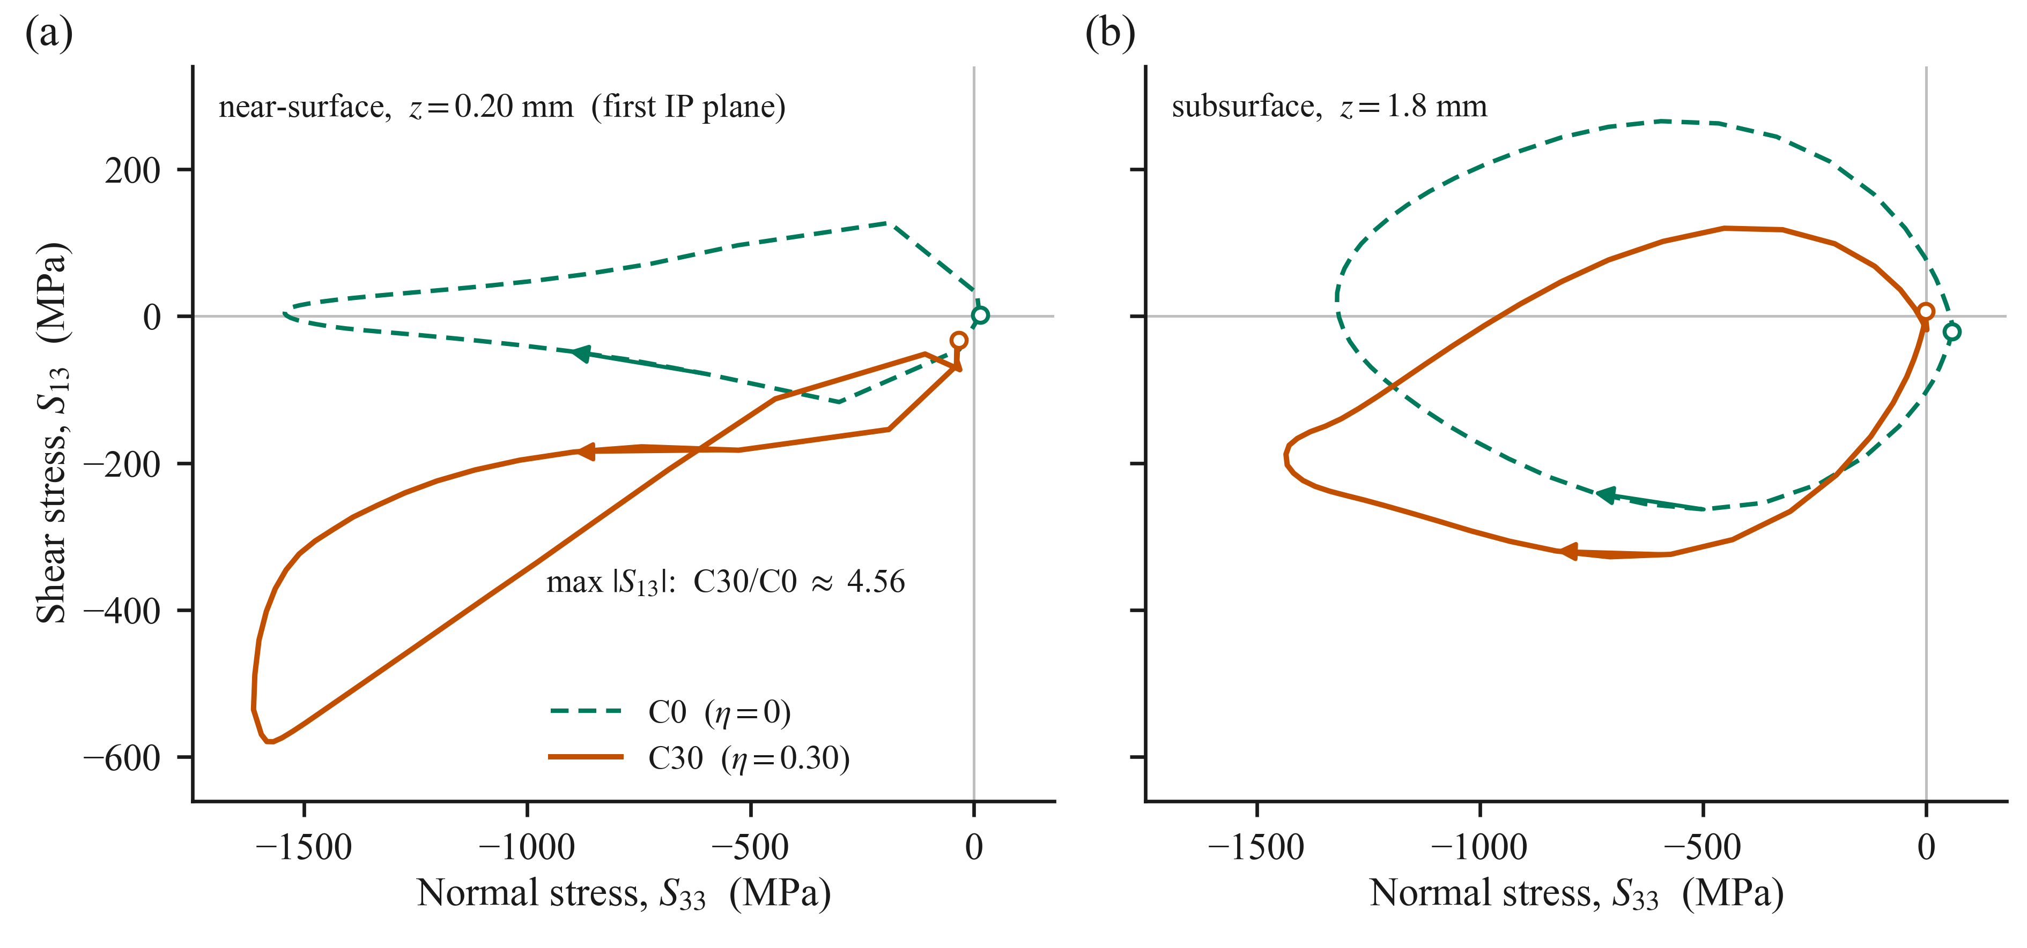
Figure 3. Passage-10 S₁₃–S₃₃ stress paths at matched (a) near-surface (z = 0.20 mm) and (b) subsurface (z = 1.8 mm) points for C0 and C30. Open circles mark the passage starts, and arrows show the traversal direction.
This altered shear history is accompanied by distinct cyclic adaptation. Figure 4 shows, at the selected representative material points, the end-of-passage Hencky equivalent plastic strain, $ε_{p}$, and the net drift, $d_{N}$, between successive unloaded states. At the C0 subsurface location, additional plastic deformation is limited ($ε_{p}$ increases from 0.013 to 0.019 over ten passages), and $d_{N}$ decreases toward, but does not fall below, the ${10}^{-5}$ threshold; accordingly, this point is classified as non-stabilised within the simulated interval. At the C30 near-surface location, approximately one order of magnitude more plastic strain accumulates ($ε_{p}$ increases from 0.089 to 0.259), and $d_{N}$ remains approximately $2×{10}^{-2}$ over passages P8–P10, thereby satisfying the persistent-ratcheting criterion defined in Section 3.2. The corresponding stress path and residual response histories are shown in Figure 5. A comparison of the matched-coordinate fatigue parameters for these points is shown in Figure 9.
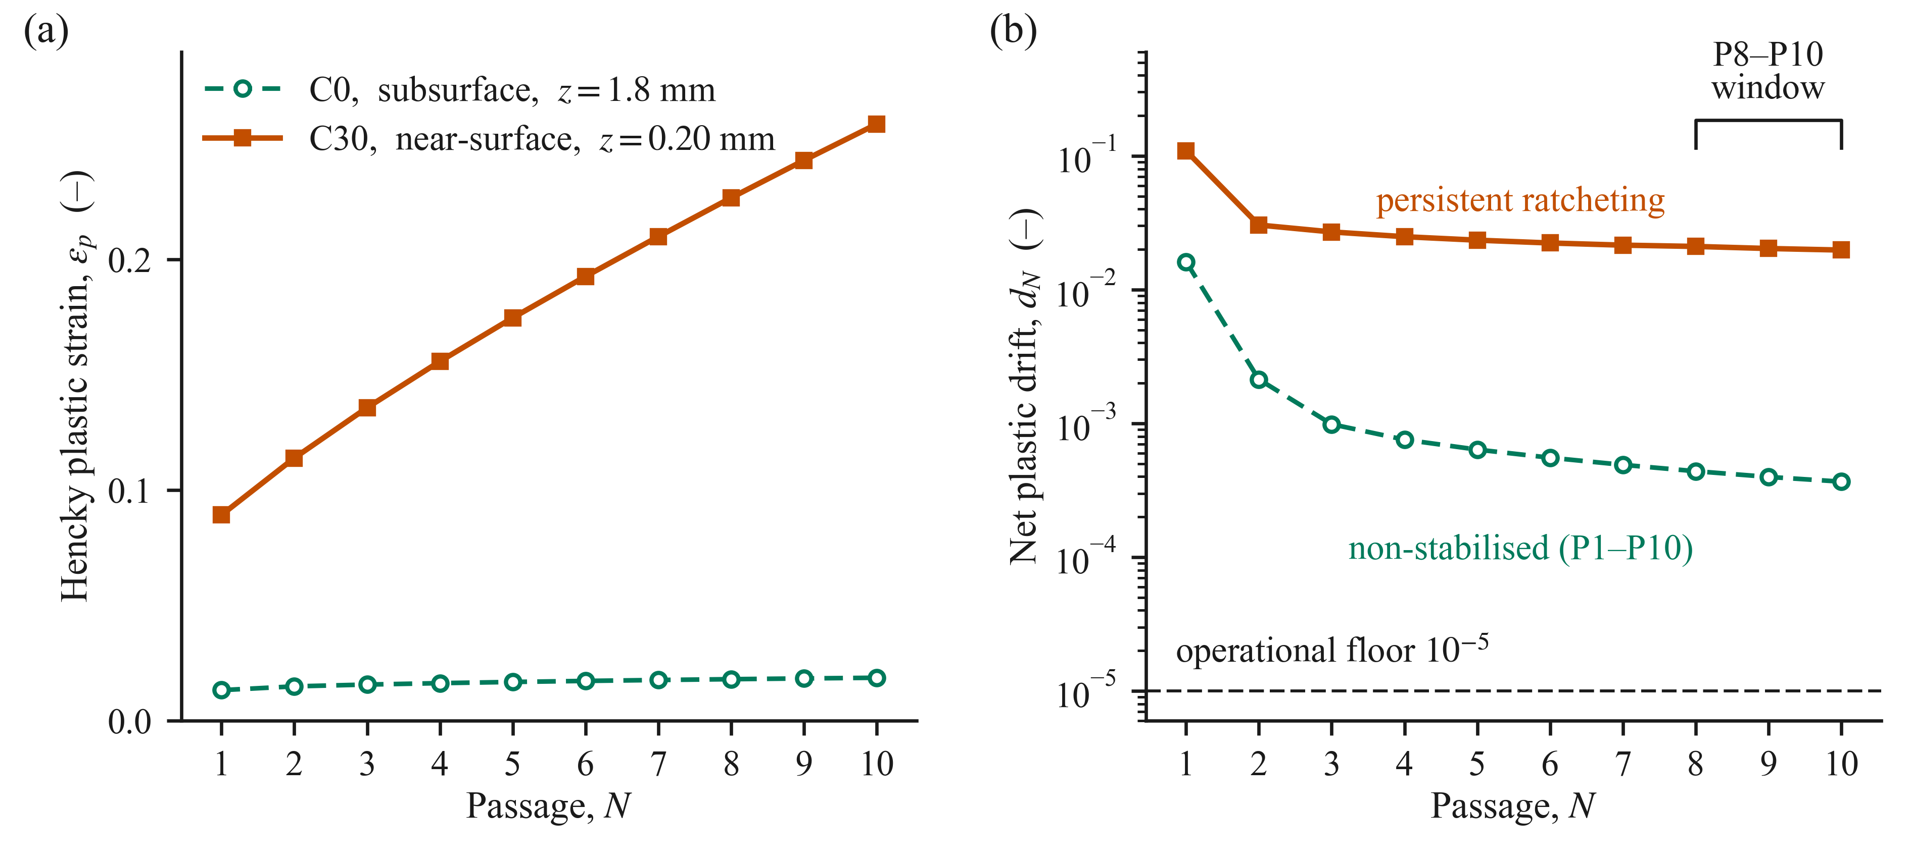
Figure 4. Passage evolution at fixed C0 subsurface and C30 near-surface points. (a) End-of-passage Hencky equivalent plastic strain ε_{p}. (b) Net plastic drift; the shaded interval denotes the P8–P10 classification window and the dashed line denotes the 10⁻⁵ threshold.
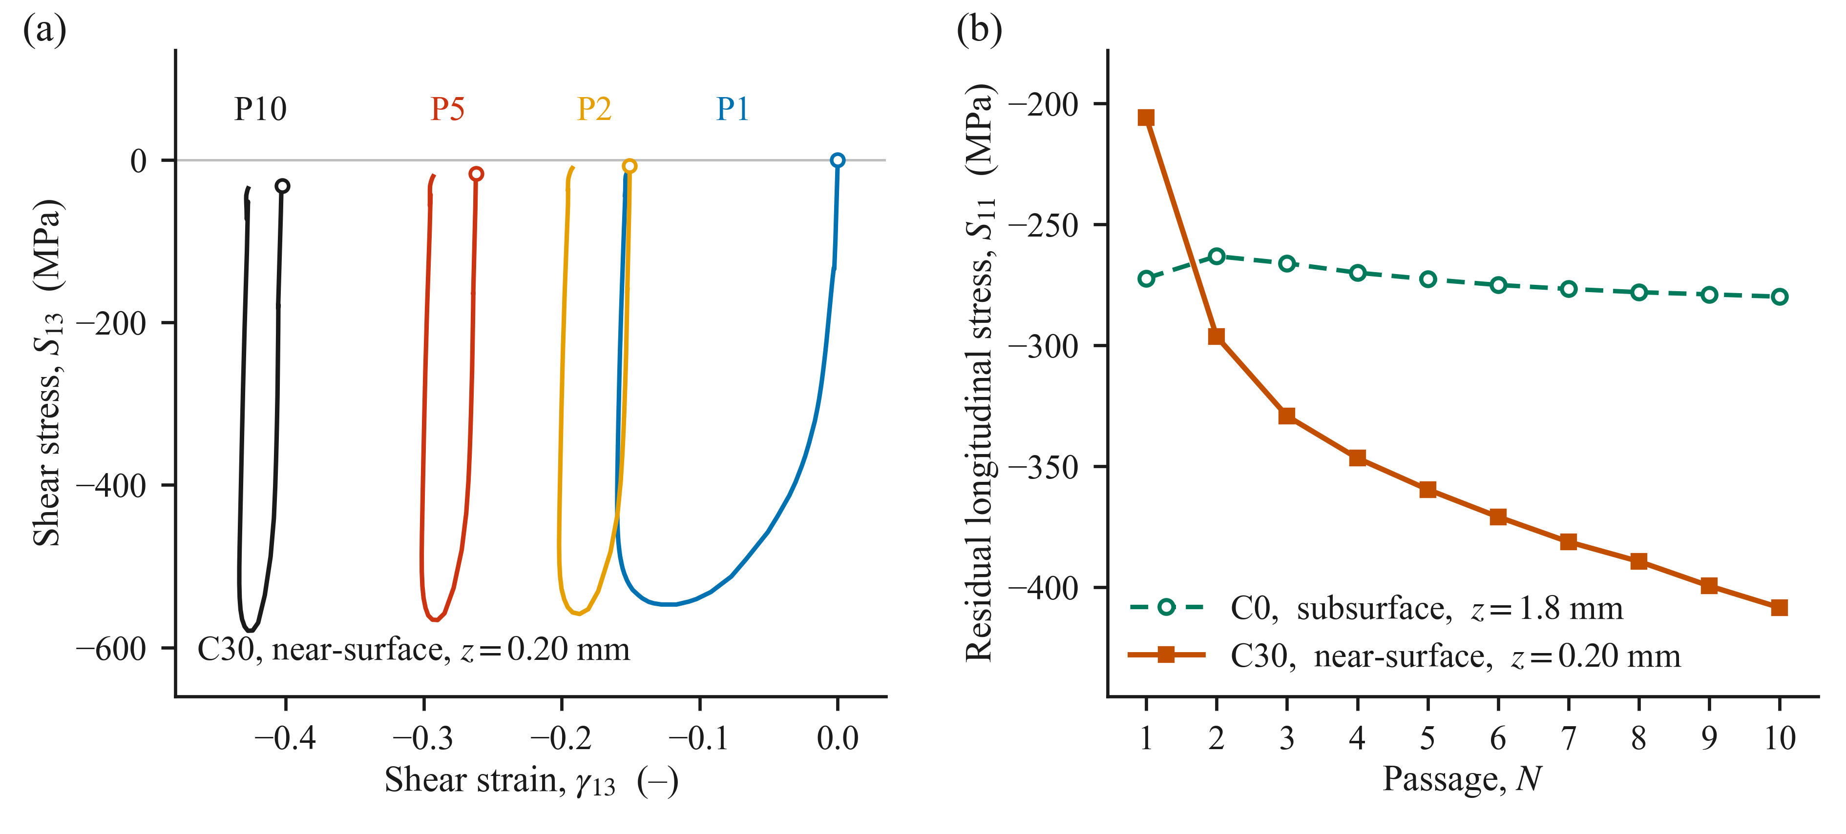
Figure 5. (a) C30 near-surface S₁₃–γ₁₃ paths for selected passages. (b) End-of-passage residual S₁₁ evolution at fixed C0 and C30 representative points. In panel (a), the open circles mark the passage starts.
  - Spatial localisation of the fatigue parameter
Figure 6 shows the spatial distributions of the P10 Jiang–Sehitoglu fatigue parameter for C0 and C30 on a logarithmic scale. For C0, the section maximum was 0.748 MPa and occurred within a subsurface band at $z=1.80$ mm. The predicted depth lies within the range reported in previous rail studies, including approximately 1 mm beneath a heavy-haul wing rail [20] and 0.5–2.5 mm for the traffic cases examined in a curved-rail model [17], although the loading conditions and modelling approaches differ. With longitudinal traction in C30, the maximum increases to 5.869 MPa and shifts to the first resolved integration-point row at $z=0.20$ mm, giving a C30-to-C0 ratio of approximately 7.8. This shift is qualitatively consistent with the contact mechanics expectation that tangential loading moves the region of maximum shear stress toward the surface [4], although the maxima of the shear stress and fatigue parameter need not coincide. In the present simulations, the relocation was accompanied by a larger near-surface $S_{13}$ excursion and the resulting increase in the shear contribution $JΔτΔγ$. The variation along the rolling direction was small within each critical depth row, producing several nearly equivalent longitudinal positions. Therefore, the results identified a subsurface critical region for C0 and a resolution-limited near-surface region for C30.
At the representative P10 points, the Jiang–Sehitoglu parameter was shear-dominated in both cases. For C0, the normal and shear contributions were 0.040 and 0.704 MPa, respectively, so the shear term accounted for approximately 94.6% of the fatigue parameter. For C30, the corresponding contributions were 0.077 and 5.627 MPa, respectively, giving a shear share of approximately 98.6%. Therefore, the traction-induced increase is governed primarily by the coupled shear term JΔτΔγ rather than by the normal term.
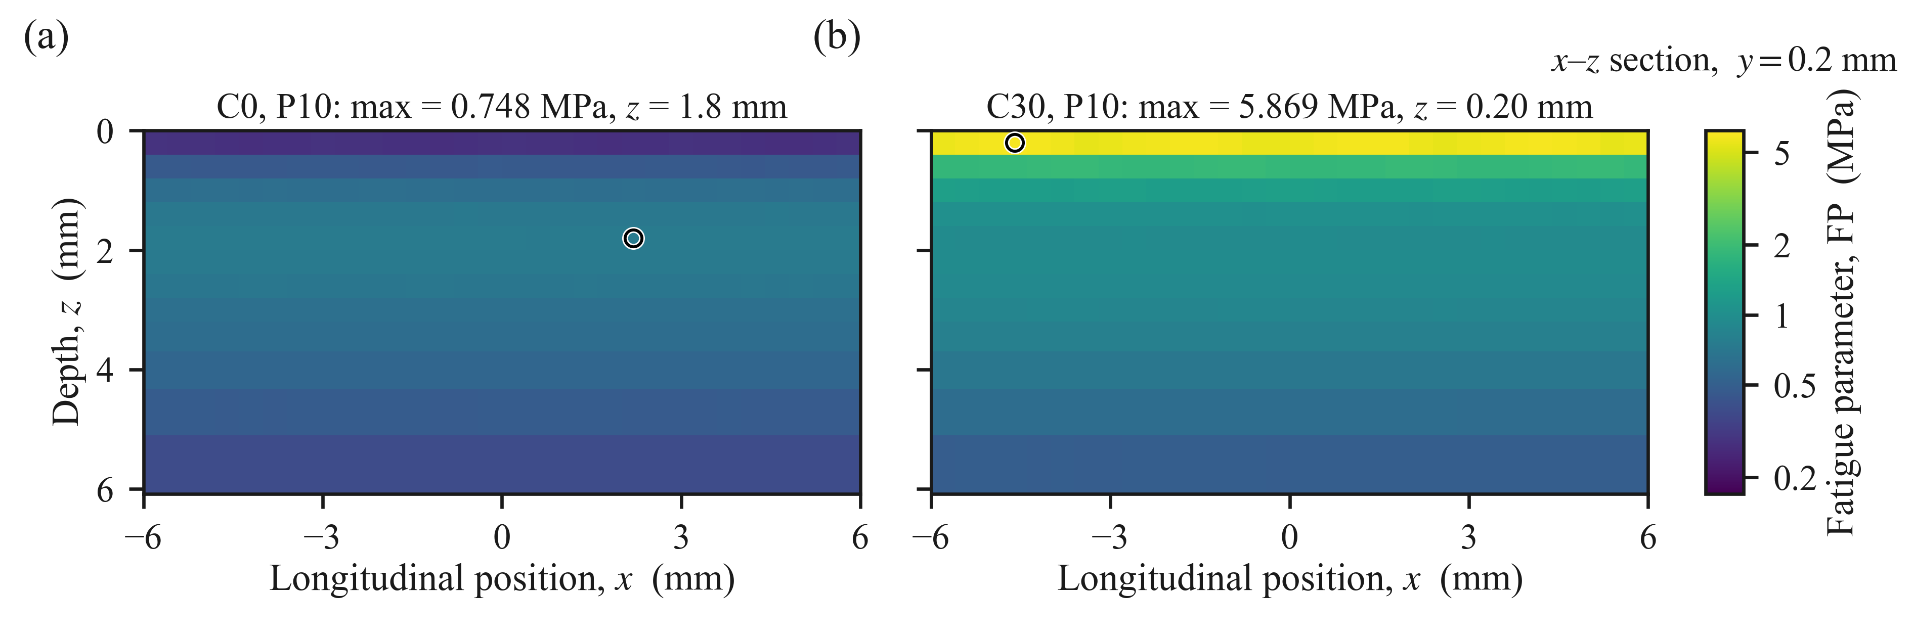
Figure 6. Passage-10 Jiang–Sehitoglu fatigue parameter on the y = 0.20 mm section for (a) C0 and (b) C30, shown on a common logarithmic color scale.
  - Critical-plane orientation
The critical-plane orientation also depends on the loading condition. Figure 7 shows the normalised angular distribution of the P10 fatigue parameter at the section maximum for each case. For C0, shown in Figure 7(a), the refined search identified a dominant near-surface-parallel plane family with a maximum at $\left(θ , ϕ\right)=\left(9^{∘} , 6^{∘}\right)$. The secondary family, separated from the primary by approximately ${84}^{∘}$, reached 93.2% of the maximum. For C30, Figure 7(b) shows two well-separated but nearly equivalent plane families. The numerical maximum occurred at $\left({64}^{∘} , 0^{∘}\right)$, corresponding to a more steeply inclined plane, whereas the secondary family reached 99.1% of this value and was separated from it by approximately ${88}^{∘}$. The two maxima differed by only 0.9%, which identifies both plane families as candidate orientations for subsequent crack growth assessment.
The near-tie is consistent with a shear-dominated fatigue response. Under non-proportional multiaxial loading, widely separated planes can experience similar shear ranges, whereas the relatively small normal contribution provides only weak differentiation between them. Therefore, the two maxima represent alternative candidate plane orientations for the simulated loading history. The predicted C0 and C30 inclinations differ from the 33–44° range reported using the Smith–Watson–Topper (SWT) criterion [17]. This difference may be due to the two studies using different loading conditions, constitutive descriptions, geometries, fatigue criteria, and angle conventions.
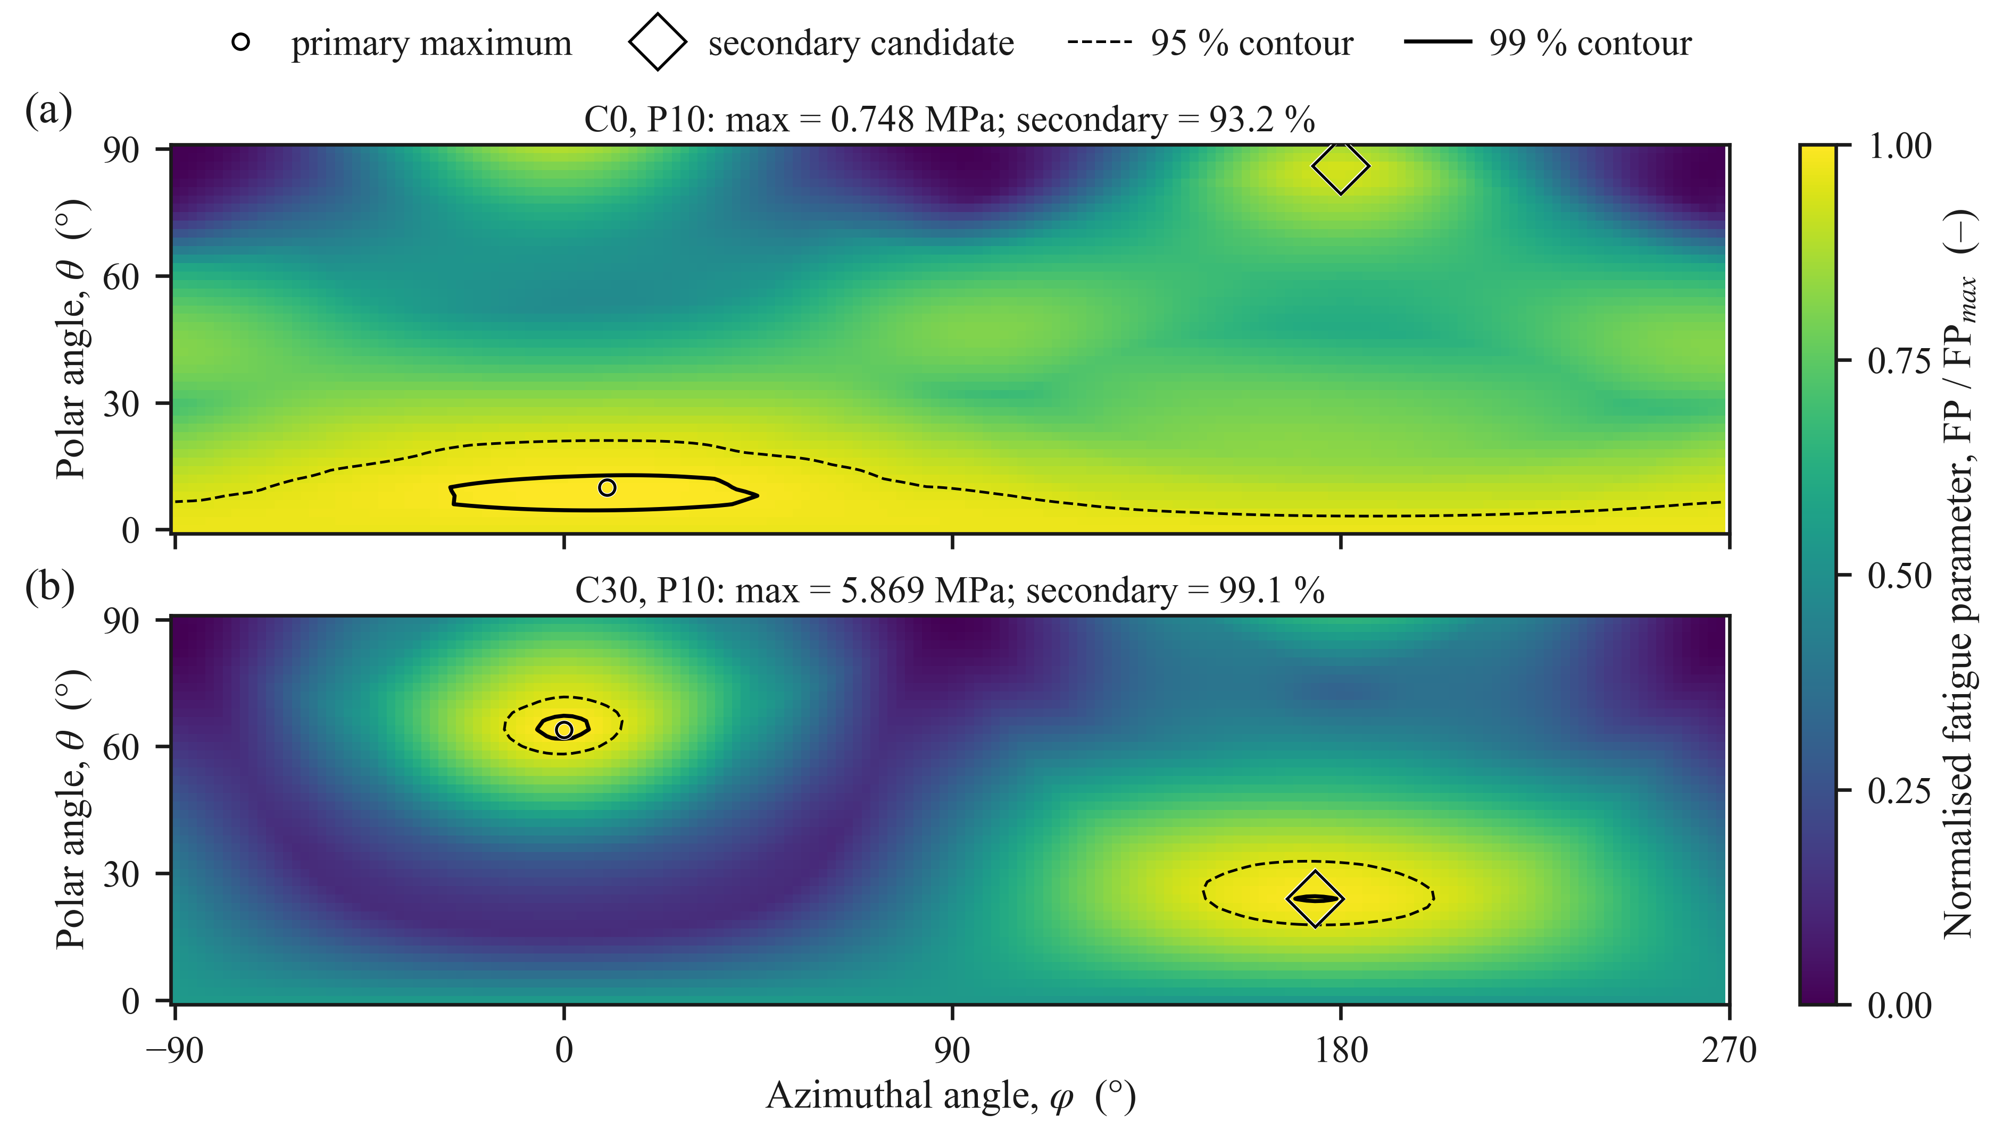
Figure 7. Normalised passage-10 angular Jiang–Sehitoglu fatigue parameter distributions at the case-specific maximum locations for (a) C0 and (b) C30. The symbols mark the primary and secondary candidate plane families, and the contours indicate 95% and 99% of each maximum.
  - Damage accumulation and comparative severity
Figure 8 shows the independently plane-maximised fatigue parameter, $FP_{i}^{max}$, and the corresponding damage increment, $ΔD_{i}$, at the case-specific representative points over passages P1–P10. The first passage accounted for 96.6% of $D_{10}$ for C0 and 72.9% for C30, reflecting the substantially larger response of the initially virgin material followed by cyclic adaptation. For C0, $ΔD_{i}$ decreased by a factor of approximately 334 between P1 and its minimum at P3, followed by a small gradual increase. For C30, the increments remained between $1.65×{10}^{-3}$ and $2.81×{10}^{-3}$ during P2–P10, whereas the selected near-surface point satisfied the persistent ratcheting criterion over P8–P10. The accumulated ten-passage indices were $D_{10}=1.06×{10}^{-4}$ for C0 and $D_{10}=6.66×{10}^{-2}$ for C30, giving a C30-to-C0 ratio of approximately 629. Because the representative locations differ between C0 and C30, the ratio compares the severity of the selected ten passage histories. The traction effect at the matched locations is examined separately in Figure 9. These values also reflect the response from an initially virgin material state and may differ from those of an in-service rail with an existing deformation history.
As a sensitivity check, the damage increments were also accumulated separately on each fixed material plane before maximizing over the plane orientation. This procedure gave $D_{10}^{fix}=1.03×{10}^{-4}$ for C0 and $D_{10}^{fix}=6.59×{10}^{-2}$ for C30. The primary passage-wise plane-maximised values exceeded the corresponding fixed-plane values by 3.05% and 1.09%, respectively, whereas the C30-to-C0 ratio changed from 629 to 641. The small differences between the two procedures confirm the substantially greater fatigue severity obtained for C30. Both primary $D_{10}$ values remained below the nominal $D=1$ threshold of the adopted criterion.
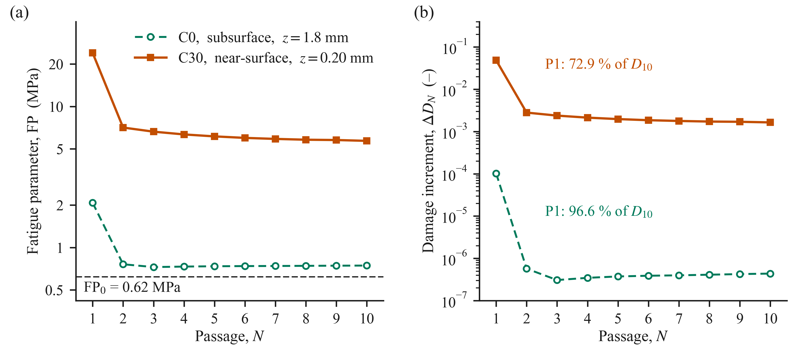
Figure 8. Passage-resolved fatigue response at the case-specific representative points: (a) independently plane-maximised Jiang–Sehitoglu fatigue parameter $FP_{i}^{max}$ and (b) corresponding damage increment $ΔD_{i}$. The dashed line in panel (a) denotes the threshold $FP_{0}=0.62$ MPa.
Figure 9 presents a comparison of the passage-10 fatigue parameter evaluated (i) at the corresponding spatial coordinates and (ii) at the locations of the maximum von Mises equivalent stresses. At the near-surface location, the applied traction increased the fatigue parameter by a factor of 20.0, whereas at the subsurface location, the increase was limited to 1.27. This result is consistent with the larger traction-induced modification of the near-surface shear history discussed in Section 4.2. For C30, the P10 fatigue parameter at the maximum von-Mises stress location was effectively equal to the spatial maximum (≈100%), whereas for C0, it was 65.6%. Therefore, a single load-state equivalent stress maximum is not a reliable general proxy for the passage-resolved critical-plane maximum.
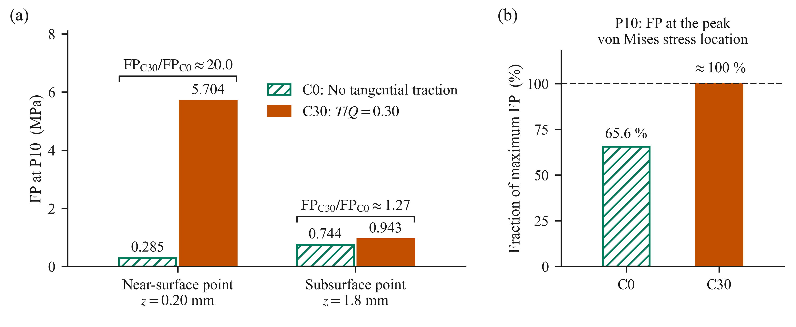
Figure 9. Comparison of the P10 fatigue parameter: (a) at matched near-surface and subsurface coordinates and (b) at the maximum von Mises stress location.
  - Stress-field context for the critical-plane results
Figure 10 and Appendix Figures A1 and A2 provide the mechanical context for the critical plane results in Sections 4.3–4.5. Figure 10 shows the loaded $S_{13}$ stress fields on the 𝑦 = 0.20 mm section for closely matched full-load states during P10. Compared with C0, C30 exhibited a more extensive and higher-magnitude near-surface negative shear band. The plotted ranges for the displayed section were −239.6 to +264.8 MPa for C0 and −583.6 to +188.0 MPa for C30. The passage-scale shear reversal and traversal history at fixed locations are presented separately in Figure 3.
Figure A1 shows the unloaded residual $S_{11}$ stress field after passage 10. Condition C30 yields a compressive band of greater magnitude and reduced depth, with a minimum value in the displayed section of −458.0 MPa at 𝑧 = 0.6 mm. In contrast, for C0 the minimum is −304.6 MPa at 𝑧 = 2.6 mm. In both cases, the stress field transitioned to slightly tensile values in the deepest monitored rows.
Figure A2 shows the corresponding von Mises stress field under the applied loading conditions. The maximum von Mises stresses were 708.4 MPa for C0 and 1019.9 MPa for C30 within the section shown. In the first resolved row of integration points below the contact centre, $S_{33}$ reached $-1543.5$ MPa for C0 and $-1610.6$ MPa for C30, whereas the von Mises stresses at the same locations were $490.1$ and $896.9$ MPa, respectively. The applied pressure is a boundary traction, and S33 is the internal depth-normal stress component. They coincide only through the normal-traction boundary condition at z = 0; the values quoted here were evaluated at the first integration-point row, z = 0.20 mm. The smaller von Mises values do not contradict the large compressive S33 values because the von Mises stress depends only on the deviatoric stress tensor [4].
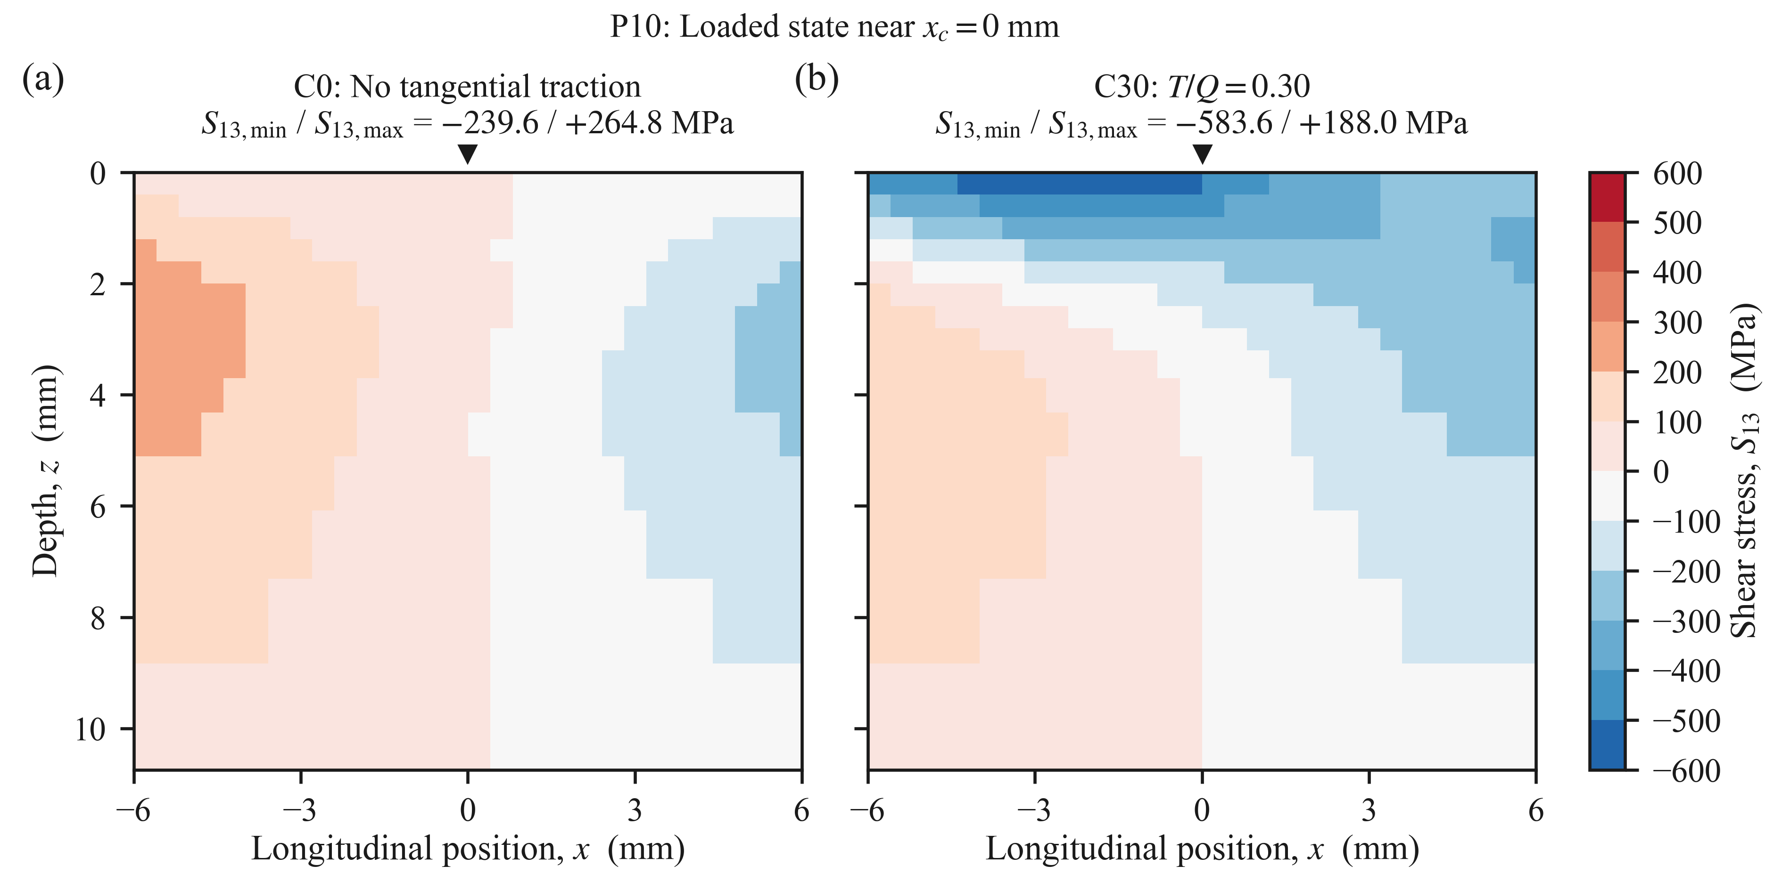
Figure 10. Loaded S₁₃ fields on the y = 0.20 mm section at closely matched full-load states during passage 10: (a) C0 and (b) C30.
- Conclusions
A passage-resolved finite-strain cyclic plasticity framework, combined with the Jiang–Sehitoglu critical-plane fatigue parameter, was employed to compare pure rolling (C0) and rolling with longitudinal traction ($T/Q=0.30$; C30) under an identical normal load. By passage 10, the maximum plane-maximised fatigue parameter increased from 0.748 MPa at z = 1.80 mm in C0 to 5.869 MPa at the first resolved row of integration points (z = 0.20 mm) in C30. Comparisons at matched spatial coordinates indicated a strong depth dependence of the traction-induced amplification: the fatigue parameter increased by a factor of 20.0 in the near-surface region, but only by 1.27 at the corresponding subsurface location. Decomposition of the parameter into constituent terms further showed that the response was dominated by the $JΔτΔγ$ contribution, accounting for 94.6% of the fatigue parameter for C0 and 98.6% for C30 at the representative passage-10 locations.
The selected C0 location did not satisfy the stabilisation criterion within ten load passages, whereas the selected near-surface C30 location satisfied the operational persistent ratcheting criterion over passages 8–10. The C30 angular-response landscape exhibited two candidate critical plane families separated by 87.9°, with the secondary peak attaining 99.13% of the global maximum. At the location of the maximum von Mises stress, the P10 fatigue parameter reproduced 65.6% of the spatial maximum for C0, whereas it accounted for approximately 100% for C30. This comparison shows that the maximum von Mises stress under a single load state does not generally identify the location of the maximum passage-resolved fatigue parameter. For both cases, the ten-passage damage indices remained below the nominal threshold (D = 1) and should, therefore, be interpreted as relative severity measures rather than predicted initiation lives.
The computed parameters quantify the relative fatigue susceptibility of the evaluated locations and material planes. The analysis considered a single wheel load and one non-zero traction ratio on a straight track, without thermal loading, vehicle–track dynamic effects, environmental influences, material defects, or wear. Experimental validation is required to relate these numerical predictions to physical crack initiation and crack initiation life. Future work should (i) extend the simulations to longer loading sequences and a broader range of operational conditions, (ii) incorporate coupled wheel–rail contact and the anisotropic near-surface response of in-service rails, and (iii) conduct experimental validation to assess the predicted critical regions and candidate plane orientations.​
References
- Ekberg A and Kabo E 2005 Fatigue of railway wheels and rails under rolling contact and thermal loading — an overview Wear 258 1288–300 doi:10.1016/j.wear.2004.03.039
- Boyacioglu P and Bevan A 2025 Rail surface damage management through monitoring and modelling Int. J. Rail Transp. 13 231–47 doi:10.1080/23248378.2024.2337364
- Zhang S, Liu Q, Spiryagin M, Wu Q, Ding H, Wen Z and Wang W 2023 Gaps, challenges and possible solution for prediction of wheel–rail rolling contact fatigue crack initiation Railway Eng. Sci. 31 207–32 doi:10.1007/s40534-023-00302-8
- Johnson K L 1985 Contact Mechanics (Cambridge: Cambridge University Press) doi:10.1017/CBO9781139171731
- Xu X, Ding L, Miao H, Wen Z, Chen R, Kan Q and Kang G 2023 Nonproportionally multiaxial cyclic plastic deformation of U75 rail steel: experiment and modeling Int. J. Fatigue 168 107480 doi:10.1016/j.ijfatigue.2022.107480
- Johnson K L 1989 The strength of surfaces in rolling contact Proc. Inst. Mech. Eng. C 203 151–63 doi:10.1243/PIME_PROC_1989_203_100_02
- Ponter A R S, Hearle A D and Johnson K L 1985 Application of the kinematical shakedown theorem to rolling and sliding point contacts J. Mech. Phys. Solids 33 339–62 doi:10.1016/0022-5096(85)90033-X
- Kapoor A 1994 A re-evaluation of the life to rupture of ductile metals by cyclic plastic strain Fatigue Fract. Eng. Mater. Struct. 17 201–19 doi:10.1111/j.1460-2695.1994.tb00801.x
- Ringsberg J W 2001 Life prediction of rolling contact fatigue crack initiation Int. J. Fatigue 23 575–86 doi:10.1016/S0142-1123(01)00024-X
- Xie Y, Shi Z, Ding H, Meli E, Xue H, Liu Q, Lewis R and Wang W 2024 Influence of shear yield strength of rail material on the shakedown limit in shakedown map Tribol. Int. 194 109490 doi:10.1016/j.triboint.2024.109490
- Zhou Z, Yang C, Tao G and Wen Z 2025 A finite element method for reconstruction of shakedown map in wheel–rail rolling–sliding contact Comput. Struct. 319 107998 doi:10.1016/j.compstruc.2025.107998
- Jiang Y and Sehitoglu H 1999 A model for rolling contact failure Wear 224 38–49 doi:10.1016/S0043-1648(98)00311-1
- Smith K N, Watson P and Topper T H 1970 A stress-strain function for the fatigue of metals J. Mater. 5 767–78
- Fatemi A and Socie D F 1988 A critical plane approach to multiaxial fatigue damage including out-of-phase loading Fatigue Fract. Eng. Mater. Struct. 11 149–65 doi:10.1111/j.1460-2695.1988.tb01169.x
- Pezeshki H, Pavlou D, Siriwardane S C and Adeli H 2026 Shear–normal stresses interaction in multiaxial fatigue under nonproportional loading part 1: theoretical aspects and experimental investigation Int. J. Struct. Integr. 17 486–509 doi:10.1108/IJSI-09-2025-0228
- Pezeshki H, Pavlou D, Siriwardane S C and Adeli H 2026 Shear-normal stresses interaction in multiaxial fatigue under nonproportional loading, part 2: multiaxial fatigue damage model and validation Int. J. Struct. Integr. 17 510–27 doi:10.1108/IJSI-09-2025-0229
- Leung J, Hossein-Nia S, Olsson M and Casanueva C 2026 Computational methods to predict RCF crack initiation hot spots in rails using critical plane SWT damage indicator parameter Railway Eng. Sci. 34 294–313 doi:10.1007/s40534-025-00405-4
- Nazari A and Hosseini Tehrani P 2025 Crack initiation study in railway curves under coupled thermomechanical loading using finite element simulation Acta Mech. 236 399–420 doi:10.1007/s00707-024-04174-9
- Zheng Z, Dong Z, Hu J, Xu J, Wang K and Wang P 2026 Investigation on the rolling contact fatigue cracks initiation of subway fixed frogs based on transient dynamics Railway Eng. Sci. 34 275–93 doi:10.1007/s40534-025-00388-2
- Zhang E, Pun C L, Lai Q and Yan W 2026 Crack initiation in wing rails of swing nose crossings in heavy haul railways Eng. Fail. Anal. 189 110705 doi:10.1016/j.engfailanal.2026.110705
- Meyer K A, Nikas D and Ahlström J 2018 Microstructure and mechanical properties of the running band in a pearlitic rail steel: comparison between biaxially deformed steel and field samples Wear 396–397 12–21 doi:10.1016/j.wear.2017.11.003
- Meyer K A, Ekh M and Ahlström J 2018 Modeling of kinematic hardening at large biaxial deformations in pearlitic rail steel Int. J. Solids Struct. 130–131 122–32 doi:10.1016/j.ijsolstr.2017.10.007
- Meyer K A, Ekh M and Ahlström J 2020 Anisotropic yield surfaces after large shear deformations in pearlitic steel Eur. J. Mech. A Solids 82 103977 doi:10.1016/j.euromechsol.2020.103977
- Meyer K A and Menzel A 2021 A distortional hardening model for finite plasticity Int. J. Solids Struct. 232 111055 doi:10.1016/j.ijsolstr.2021.111055
- Gren D and Meyer K A 2024 Effects of predeformation on torsional fatigue in R260 rail steel Int. J. Fatigue 179 108031 doi:10.1016/j.ijfatigue.2023.108031
- Gren D, Ahlström J and Ekh M 2024 Fatigue crack characteristics in gradient predeformed pearlitic steel under multiaxial loading Adv. Eng. Mater. 26 2400950 doi:10.1002/adem.202400950
- Talebi N, Andersson B, Ekh M and Meyer K A 2025 Influence of a highly deformed surface layer on RCF predictions for rails in service Wear 578–579 206173 doi:10.1016/j.wear.2025.206173
- Pletz M, Meyer K A, Künstner D, Scheriau S and Daves W 2019 Cyclic plastic deformation of rails in rolling/sliding contact — quasistatic FE calculations using different plasticity models Wear 436–437 202992 doi:10.1016/j.wear.2019.202992
- Meyer K A, Skrypnyk R and Pletz M 2021 Efficient 3D finite element modeling​ of cyclic elasto-plastic rolling contact Tribol. Int. 161 107053 doi:10.1016/j.triboint.2021.107053​
- Ansin C, Larsson F and Larsson R 2025 Prediction of evolving plasticity in rails under steady state rolling contact based on reduced-order modeling Comput. Methods Appl. Mech. Eng. 438 117828 doi:10.1016/j.cma.2025.117828
- Ren F, Yang Z and Li Z 2024 An efficient 3D finite element procedure for simulating wheel–rail cyclic contact and ratcheting Tribol. Int. 198 109878 doi:10.1016/j.triboint.2024.109878
- Zhou Z, Li W, Wen Z, Zhou S and Tao G 2024 Three-dimensional elastic–plastic stress analysis of wheel–rail cyclic rolling contact using finite element method Wear 542–543 205277 doi:10.1016/j.wear.2024.205277
- European Committee for Standardization 2017 EN 13674-1:2011+A1:2017 Railway applications — Track — Rail — Part 1: Vignole railway rails 46 kg/m and above (Brussels: CEN)
- European Committee for Standardization 2020 EN 13715:2020 Railway applications — Wheelsets and bogies — Wheels — Tread profile (Brussels: CEN)
- European Committee for Standardization 2021 EN 15528:2021 Railway applications — Line categories for managing the interface between load limits of vehicles and infrastructure (Brussels: CEN)
- Landström E, Steyn E, Ahlström J and Vernersson T 2023 Thermomechanical testing and modelling of railway wheel steel Int. J. Fatigue 168 107373 doi:10.1016/j.ijfatigue.2022.107373
- Haines D J and Ollerton E 1963 Contact stress distributions on elliptical contact surfaces subjected to radial and tangential forces Proc. Inst. Mech. Eng. 177 95–114 doi:10.1243/PIME_PROC_1963_177_014_02
- Meyer K A 2022 MaterialModels [Online]. Available: https://github.com/KnutAM/MaterialModels (accessed 1 September 2026)
- Talebi N, Ahlström J, Ekh M and Meyer K A 2024 Evaluations and enhancements of fatigue crack initiation criteria for steels subjected to large shear deformations Int. J. Fatigue 182 108227 doi:10.1016/j.ijfatigue.2024.108227

Appendix A. Residual and loaded stress fields
This appendix contains the supporting material referenced in Section 4. Figure A1 shows the passage-10 unloaded residual S11 field, and Figure A2 shows the loaded passage-10 von Mises field.
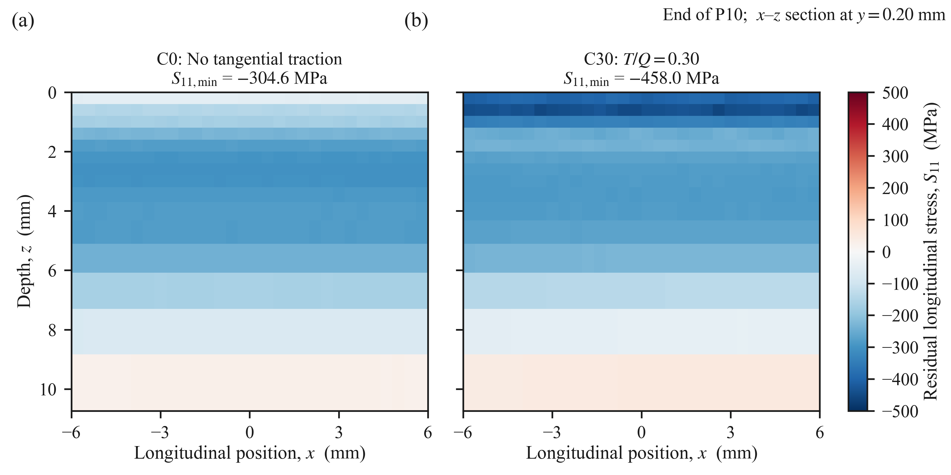
Figure A1. Residual S₁₁ fields after passage 10 on the y = 0.20 mm section: (a) C0, and (b) C30. Both panels use a common ±500 MPa scale.
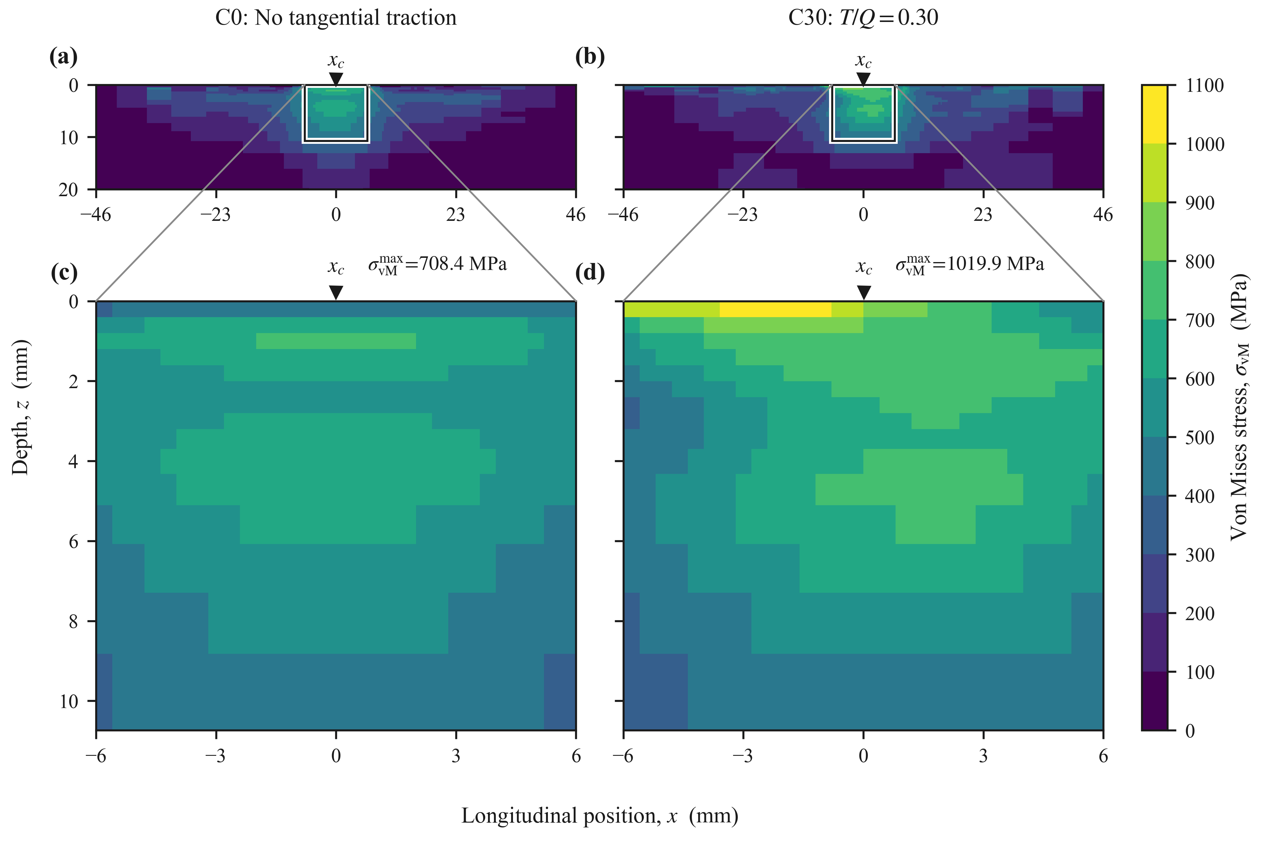
Figure A2. Loaded von Mises stress during passage 10 for (a, c) C0 and (b, d) C30. The upper panels show the full section, and the lower panels show the enlarged central region; all panels use a common 0–1100 MPa scale.

