Boundary expansion of spectral-domain modeling approach for marine renewables

J Tan^{1*} and G Lavidas¹
1 Faculty of Civil Engineering and Geosciences, Delft University of Technology, Delft, the Netherlands
*Email: J.tan-2@tudelft.nl
Abstract. This work investigates the methodology and applicability of spectral-domain modeling for incorporating multi-variate non-differentiable nonlinearities, focusing on floating renewable energy devices. Spectral-domain modeling provides a highly competitive approach for analyzing floating renewable energy structures, such as wave energy converters (WECs) and floating wind turbines, by combining adequate accuracy with high computational efficiency. Its high accuracy stems from representing nonlinear effects through statistical linearization. However, existing formulations have only been applicable for a limited range of nonlinearities, primarily those with simple, differentiable mathematical expressions. In practice, floating renewable energy devices exhibit complex dynamic mechanisms involving highly nonlinear behaviors, such as external machinery force saturation and nonlinear hydrostatics of non-uniform floaters, which can significantly influence system responses. Extending spectral-domain modeling to accommodate nonlinearities of increasing complexity is therefore essential.
In this work, spectral-domain modeling is extended to address nonlinear effects expressed as multi-variate non-differentiable functions. The mathematical formulation is first reviewed for single-variate differentiable, single-variate non-differentiable, and multivariate differentiable nonlinearities before being generalized to the targeted class of nonlinearities. Several case studies demonstrate the application of the extended approach to representative nonlinearities in floating renewable energy devices. Its accuracy and computational efficiency are assessed against nonlinear time-domain (TD) and linear frequency-domain (FD) models. Despite the complexity of the nonlinearities considered, the extended spectral-domain modeling achieves relative errors below 6%, while requiring computational times comparable to the FD model and remaining hundreds of times faster than the TD model. In contrast, the FD model produces relative errors exceeding 70% in some cases.
- Introduction
Floating renewable energy devices must operate across a wide range of irregular sea states, making efficient prediction of their dynamics essential for design and performance assessment. Wave height and period affect both structural response and energy capture, while changes in geometry and power take-off (PTO) settings introduce further design variables. Evaluating these combinations requires many simulations. Computational cost is therefore particularly important when comparing candidate designs, selecting machinery ratings or tuning control parameters, for which a detailed nonlinear calculation at every iteration may be impractical.
The available modelling approaches offer different balances between fidelity and computational effort. Linear frequency-domain (FD) models provide response spectra and statistical performance estimates efficiently, but cannot directly represent force saturation or changes in wetted geometry. Nonlinear time-domain (TD) models can include these mechanisms explicitly, although reliable estimates under irregular waves require sufficiently long simulations and multiple random-phase realizations. Statistical linearization (SL) offers an intermediate approach: nonlinear forces are replaced by equivalent linear terms determined from response statistics, allowing their average influence to be incorporated into a spectral calculation. Its value lies in retaining much of the efficiency of FD modelling while improving the representation of the selected nonlinear effects.
Previous studies demonstrate the potential of this approach for wave energy converters (WECs). Folley and Whittaker [1] developed spectral modelling of WECs, and Silva et al. [2] examined nonlinear stochastic response using statistical linearization. Subsequent applications addressed PTO sizing under machinery constraints [3] and extended spectral modelling to the wave-to-wire conversion process [4]. More recent work has investigated efficient control synthesis [5] and hydrostatic restoring forces that depend on both wave elevation and body displacement [6]. Together, these developments support the use of SL for repeated engineering calculations, while motivating further assessment of force laws involving several interacting variables and piecewise operating regimes.
Such force laws arise naturally in floating energy systems. Under reactive control, a saturated PTO force depends on both displacement and velocity, so force limiting changes the effective stiffness as well as the damping. For a non-uniform spar buoy, hydrostatic force depends jointly on body displacement and wave elevation, with different expressions applying as the water plane crosses geometric regions. The statistical relationship between these inputs also matters: stationary displacement and velocity are uncorrelated, whereas wave elevation and body displacement are generally correlated. A consistent linearization must account for this distinction. The mean-square formulation of SL [7,8] provides a direct route through force-response moments and input covariance, without requiring differentiation of the piecewise force law.
This paper applies that multivariate moment formulation to two representative heave-motion problems: PTO force saturation in a reactively controlled point absorber and nonlinear hydrostatics of a non-uniform spar buoy. These examples assess uncorrelated and correlated inputs within a common iterative spectral framework. The contribution is an application and numerical assessment of the formulation for these two classes of piecewise force, with emphasis on mean absorbed power, displacement standard deviation and computational cost. Comparisons with nonlinear TD simulations and fully linear FD models establish the accuracy achieved over the investigated conditions and clarify the scope of the resulting efficiency gains.
- Statistical linearization and numerical implementation
  - Mean-square equivalent force
Statistical linearization replaces each selected nonlinear force by an affine function of the variables on which it depends. Let $u$ denote their zero-mean fluctuations about the operating equilibrium, and let $f(u)$ be the corresponding scalar force. The equivalent coefficients are chosen to minimize the expected squared force error [7,8]:
$J=E[(f(u)-N^{T}u-Q)^{2}]$ (1)
Here $N$ contains the equivalent linear coefficients and $Q$ is the mean-force term. Differentiating this quadratic objective with respect to the unknown coefficients, rather than differentiating the nonlinear force law, makes the residual orthogonal to both a constant and every input variable. Since $E[u]=0$, the resulting normal equations give
$CN=E[uf(u)],Q=E[f(u)]$ (2)
where $C=E[uu^{T}]$ is the input covariance matrix. For nonsingular $C$, the coefficient vector is therefore
$N=C^{-1}E[uf(u)]$ (3)
This formulation requires finite force and input second moments, but the least-squares result itself does not require Gaussian inputs. It applies to a force defined by several operating branches because only the force values enter the expectations. The constant term is included in the mean equilibrium balance; the equivalent linear terms govern fluctuations about that equilibrium. Thus, a nonzero mean force should not be discarded merely because the fluctuation variables have zero mean.
  - Gaussian closure and input correlation
The expectations are evaluated using a joint Gaussian approximation for the force inputs. This closes the problem in terms of their covariance and permits numerical integration of the complete piecewise force law. In particular, the force-response moment entering equation (3) is
$E[u_{i}f]=\int_{R^{n}}{u_{i}}f(u)p_{G}(u;C)du$ (4)
where $p_{G}$ is the zero-mean multivariate Gaussian density with covariance $C$. Each branch contributes over its applicable region, so saturation limits and geometric transitions remain explicit in the integrand. The same integration provides the mean force. The approximation concerns the input distribution and equivalent dynamics; it does not reproduce individual switching events or the full nonlinear response distribution.
Correlation determines how these moments are converted into coefficients. If the inputs are uncorrelated, $C$ is diagonal and equation (3) reduces to
$N_{i}=\frac{E[u_{i}f(u)]}{σ_{u_{i}}^{2}}$ (5)
For stationary displacement and velocity, $E[z\overset{˙}{z}]=\frac{1}{2}dE[z^{2}]/dt=0$. Their joint Gaussian approximation therefore permits the diagonal form for the saturated PTO considered below. Wave elevation and body displacement, however, generally have nonzero covariance. Their hydrostatic coefficients must be obtained from the coupled system in equation (2); applying separate variance divisions would omit this interaction. A nearly singular covariance matrix also makes the coefficient calculation sensitive, even when the individual moments are well defined.
  - Iterative spectral solution
The equivalent coefficients depend on response statistics, while those statistics depend on the equivalent coefficients. They are consequently updated through an iterative frequency-domain calculation. With an equivalent restoring stiffness $K_{eq}$ and damping $R_{eq}$ placed on the left-hand side, the generic heave equation is
${\hat{F}}_{e}=\{-ω^{2}[M+M_{r}(ω)]+K+K_{eq}+iω[R_{r}(ω)+R+R_{eq}]\}\hat{z}$ (6)
Here $M$ is the body mass, $M_{r}$ and $R_{r}$ are the frequency-dependent added mass and radiation damping, and $K$ and $R$ collect the remaining linear stiffness and damping. Hats denote complex amplitudes and $ω$ is angular frequency. An equivalent term proportional to wave elevation modifies the excitation instead, as shown for the spar buoy. The signs of the equivalent coefficients follow the force convention used in each case.
For a wave-to-displacement transfer function $H=\hat{z}/\hat{η}$ and one-sided wave spectrum $S_{η}$, the response spectrum is $S_{z}=|H|^{2}S_{η}$. The displacement and velocity variances follow from its spectral moments:
$σ_{z}^{2}=\int_{0}^{∞}{S_{z}}(ω)dω,σ_{v}^{2}=\int_{0}^{∞}{ω^{2}}S_{z}(ω)dω$ (7)
When needed, the simultaneous wave-displacement covariance is obtained by integrating $Re[H]S_{η}$ over angular frequency. Starting from estimated input statistics, the calculation evaluates the force moments, solves for the equivalent coefficients, updates the transfer function, and recomputes the covariance. This sequence is repeated until the relative change in response standard deviation is below 0.01%. Convergence establishes consistency of the selected statistical closure; it does not by itself establish agreement with the nonlinear response.
  - Numerical comparison
The two applications use linear wave excitation and hydrodynamic coefficients obtained with Nemoh [9]. Irregular waves follow a JONSWAP spectrum and are represented by 1000 harmonics with random phases. Nonlinear TD comparisons use the Cummins formulation with a state-space representation of radiation memory [10], retaining the original nonlinear force laws. MATLAB ODE45 is used with a time increment of $0.01T_{p}$. Each realization lasts $125T_{p}$, with the first $25T_{p}$ discarded to remove transients, where $T_{p}$ is the peak wave period. Statistics are averaged over 30 independent phase realizations. Reported errors are absolute relative differences from these TD means, so the comparison tests the combined force linearization and Gaussian closure under a common hydrodynamic description.
- PTO force saturation under reactive control
The first example is a spherical point absorber restricted to heave and connected to a bottom-founded PTO. The radius and draft are both 2.5 m, the buoy mass is 33 543 kg, and the water depth is 100 m. Water density is 1025 kg/m³. The PTO combines a damper and a spring, allowing the force to depend on velocity $v$ and displacement $z$. Reactive control motivates the inclusion of stiffness, including negative stiffness for some operating conditions [11,12].
The limited force is described by the saturated control command
$F_{pto}(v,z)=sign(a)min(|a|,F_{m}),a=R_{pto}v+K_{pto}z$ (8)
where $F_{m}$ is the force limit and $R_{pto}$ and $K_{pto}$ are the commanded damping and stiffness. The PTO force enters the heave equation as a resisting force. For a stationary differentiable response, displacement and velocity have zero covariance [7]. Equation (5) therefore gives
$R_{eq,pto}=\frac{E[vF_{pto}]}{σ_{v}^{2}},K_{eq,pto}=\frac{E[zF_{pto}]}{σ_{z}^{2}},P_{abs}=R_{eq,pto}σ_{v}^{2}$ (9)
The mean force vanishes under the symmetric zero-mean approximation. The last expression is the mean absorbed mechanical power; the stiffness term contributes no mean power because displacement and velocity are uncorrelated. The frequency-domain motion equation uses $K_{hs}+K_{eq,pto}$ as total stiffness and $R_{r}+R_{eq,pto}$ as damping. The TD comparison applies equation (8) directly, while the linear FD comparison uses the unsaturated command.
We consider significant wave height $H_{s}=4$ m, peak period $T_{p}=10$ s and force limits from 50 to 150 kN. Two settings are compared: $R_{pto}=100$ kN s/m with $K_{pto}=40$ kN/m, and $R_{pto}=80$ kN s/m with $K_{pto}=-20$ kN/m. Figures 1 and 2 show the resulting power estimates and relative errors.
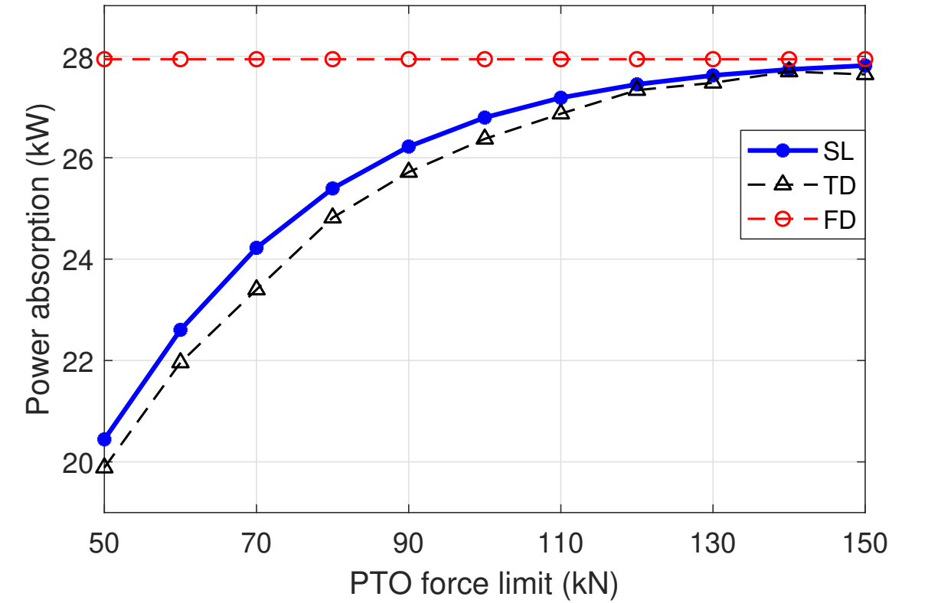  (a) Mean absorbed power | 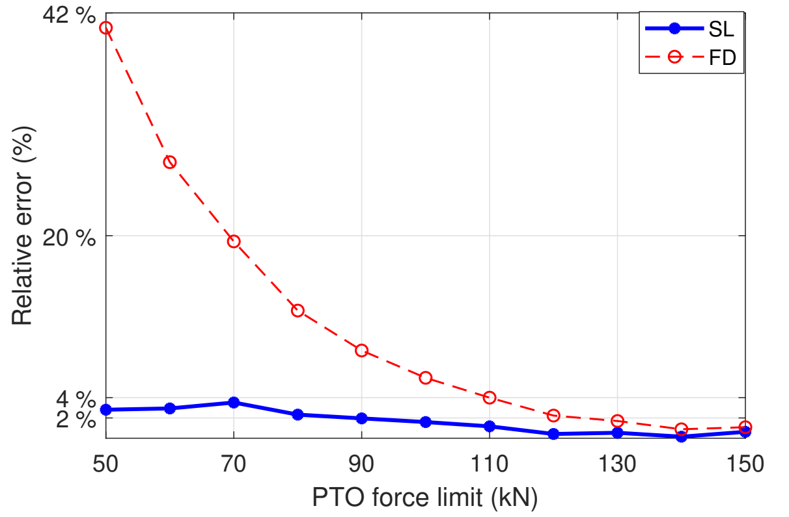  (b) Relative error
Figure 1. PTO results for positive stiffness: Hₛ = 4 m, Tₚ = 10 s, Rₚₜₒ = 100 kN s/m and Kₚₜₒ = 40 kN/m. TD denotes the mean of 30 realizations.
With positive PTO stiffness, the TD power rises from approximately 20 kW at a force limit of 50 kN to nearly 28 kW at 150 kN. The unsaturated FD model predicts almost constant power and overestimates the result by approximately 41-42% at the lowest limit. SL follows the increasing power trend and keeps the relative error below 4%. As the limit increases, saturation becomes less influential and the three models approach one another.
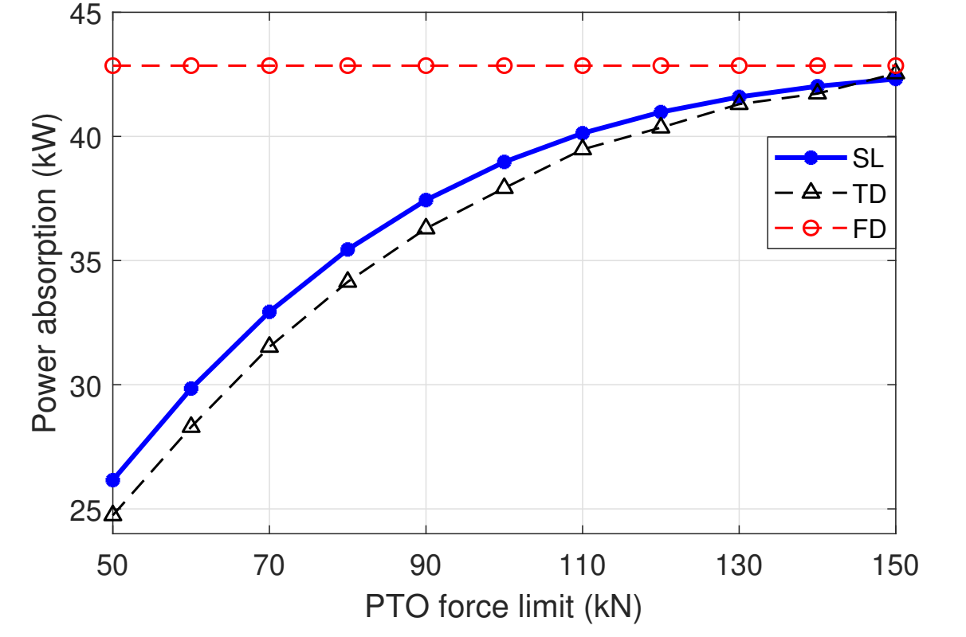  (a) Mean absorbed power | 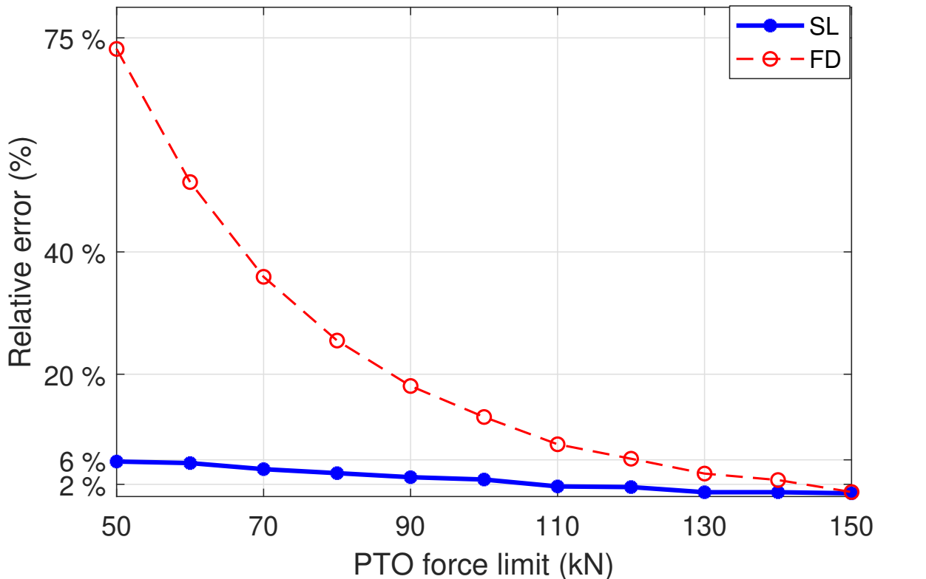  (b) Relative error
Figure 2. PTO results for negative stiffness: Hₛ = 4 m, Tₚ = 10 s, Rₚₜₒ = 80 kN s/m and Kₚₜₒ = −20 kN/m. Relative errors use the mean TD power.
For the negative-stiffness setting, TD power reaches approximately 43 kW at the highest force limit, compared with approximately 28 kW for the positive-stiffness setting. This difference is specific to the two controller settings and sea state tested; it does not establish a general advantage of negative stiffness. The FD discrepancy increases to approximately 75% at the 50 kN force limit, whereas SL remains below 6% throughout the sweep. Thus, equivalent damping alone is insufficient to describe the complete reactive PTO action: the equivalent stiffness must also enter the motion model.
The comparison demonstrates why force limits should be represented during performance assessment. A linear model cannot distinguish different force ratings when the unconstrained controller remains unchanged. SL captures their influence through coefficients that depend on the response statistics, retaining a spectral calculation while accounting for the mean effect of clipping. Its accuracy here concerns mean mechanical power, rather than the instantaneous electrical output or extreme PTO loads.
- Nonlinear hydrostatics of a non-uniform spar buoy
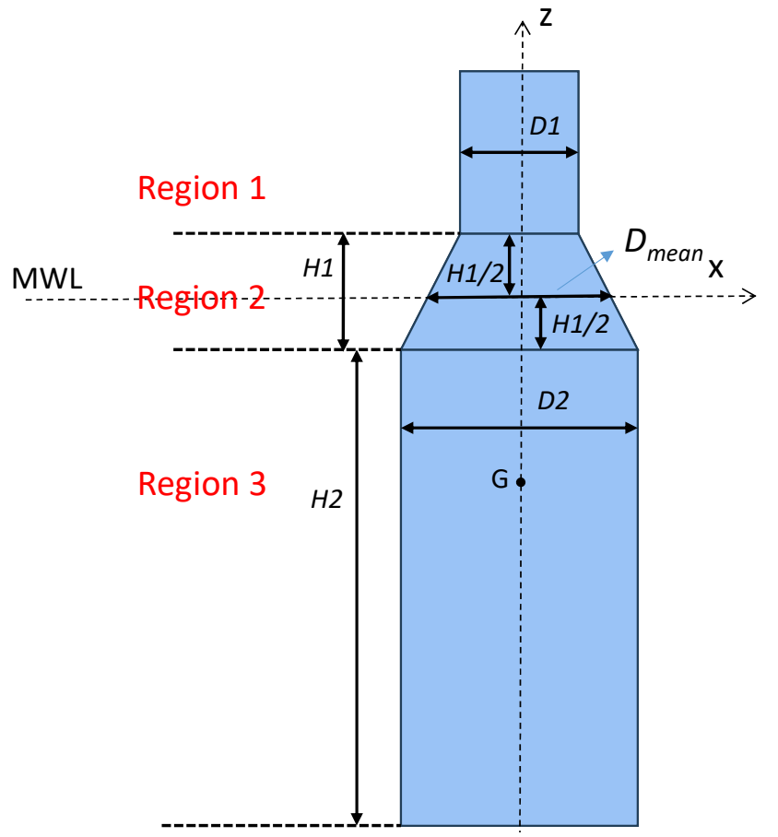
Figure 3. Spar geometry: D₁ = 4 m, D₂ = 8 m, Dmean = 6 m, H₁ = 4 m and H₂ = 8 m. MWL denotes the mean water level; G is the centre of gravity.
The second example considers heave of a spar buoy with cylindrical upper and lower regions connected by a tapered section. The upper and lower diameters are 4 and 8 m, respectively. The tapered section is 4 m high, its midpoint lies at the still-water level, and the lower cylinder is 8 m high. The still-water-plane diameter is 6 m. The buoy mass is 487 900 kg, water depth is 200 m, and water density is 1025 kg/m³. A linear heave mooring stiffness of 50 kN/m and constant viscous damping of 30 kN s/m are used to isolate the hydrostatic nonlinearity.
Figure 3 defines the three geometric regions used to evaluate the wetted volume and water-plane area.
The hydrostatic model accounts for the changing wetted geometry and the instantaneous free-surface elevation $η$. Following the pressure-integration formulation in [6,13], the vertical force, including gravity, is
$F_{hs}(z,η)=ρgV_{sub}(z,η)-ρgηA_{wp}(z,η)-Mg$ (10)
Here $V_{sub}$ is submerged volume, $A_{wp}$ is instantaneous water-plane area, $ρ$ is water density and $g$ is gravitational acceleration. Volume and area are evaluated in the upper cylinder, taper or lower cylinder according to the relative elevation $η-z$. The resulting piecewise expression changes slope at the geometric transitions. In contrast, the FD model uses constant hydrostatic stiffness $K_{hs}=ρgπD_{mean}^{2}/4$, with $D_{mean}=6$ m.
Wave elevation and buoy displacement are correlated. Their covariance must therefore remain in the coefficient calculation:
$K_{eq,η}=\frac{σ_{z}^{2}E[ηF_{hs}]-σ_{ηz}E[zF_{hs}]}{Δ},K_{eq,z}=\frac{σ_{η}^{2}E[zF_{hs}]-σ_{ηz}E[ηF_{hs}]}{Δ}$ (11)
Here $Δ=σ_{η}^{2}σ_{z}^{2}-σ_{ηz}^{2}$ is the covariance determinant and $σ_{ηz}$ is the wave-displacement covariance.
The coefficients act on different sides of the spectral force balance. The wave-elevation term modifies excitation, whereas the displacement term modifies restoring stiffness:
${\hat{F}}_{e}+K_{eq,η}\hat{η}=\{-ω^{2}[M+M_{r}]+K_{mooring}-K_{eq,z}+iω[R_{r}+R_{vis}]\}\hat{z}$ (12)
All frequency-dependent hydrodynamic terms are evaluated at $ω$. The covariance in equation (11) is obtained consistently from the wave-response cross-spectrum and updated with the response variance. Treating these inputs as uncorrelated would remove the off-diagonal terms and change the fitted force coefficients.
Figure 4 compares the displacement standard deviation for $H_{s}=1-5$ m at $T_{p}=10$ s. The TD model evaluates the complete piecewise hydrostatic expression. All three approaches give similar results at low wave heights. As wave height increases, the varying wetted geometry becomes more influential and the linear FD approximation increasingly overpredicts the response.
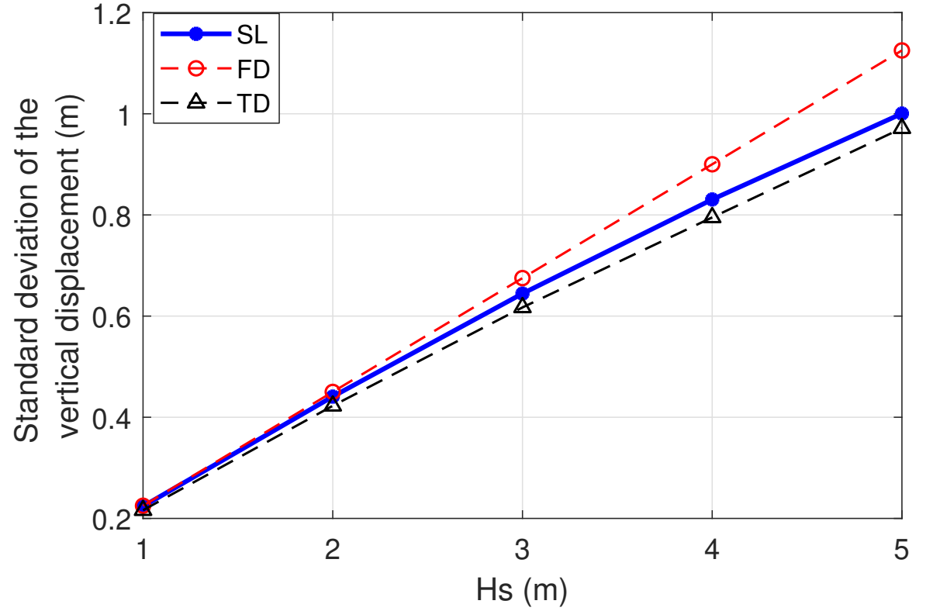  (a) Displacement standard deviation | 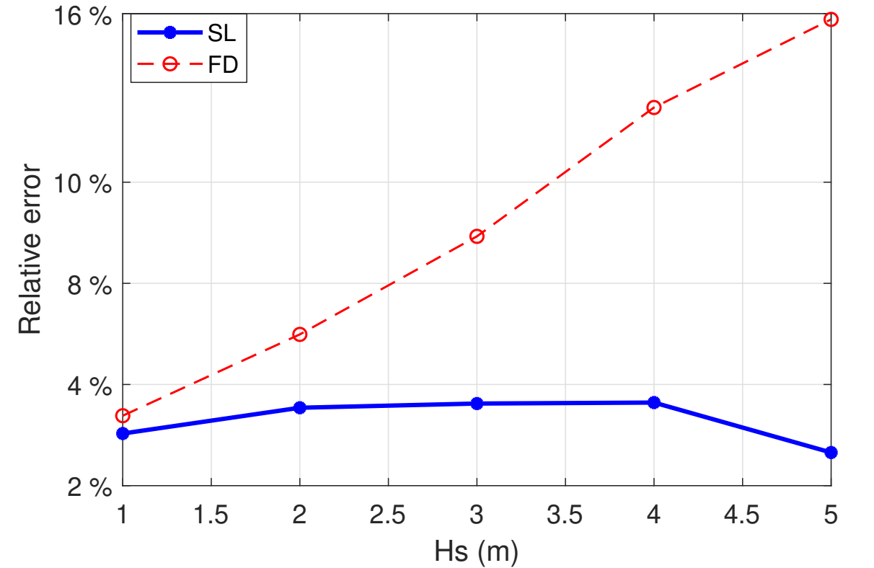  (b) Relative error
Figure 4. Spar-buoy heave response for Tₚ = 10 s, Rᵥᵢₛ = 30 kN s/m and Kₘₒₒᵣᵢₙᵍ = 50 kN/m. Relative errors use the mean TD displacement standard deviation.
The FD error exceeds 10% above approximately 3.5 m significant wave height and reaches about 16% at 5 m. SL remains below 4% over the entire range, including the conditions with the greatest departure from constant hydrostatic stiffness. This example supports retaining the joint wave-response statistics when linearizing a force that depends on both environmental excitation and body motion.
- Computational efficiency and scope
Table 1 reports the measured computational cost on the same Intel i7 processor operating at 2.80 GHz. The PTO timing case uses a 90 kN force limit with positive stiffness; the spar timing case uses a 3 m significant wave height. Each TD time includes 30 realizations, matching the averaging procedure used for the reference response statistics.
Table 1. Computational time for the two benchmark conditions.
Case | FD (s) | SL (s) | TD, 30 runs (s)
PTO saturation | 0.041 | 0.28 | 155.2
Spar hydrostatics | 0.039 | 0.49 | 161.7
SL is approximately 6.8 times slower than FD for the PTO benchmark and 12.6 times slower for the spar benchmark, reflecting the moment integration and iterative spectral solution. Nevertheless, both calculations complete in less than half a second. Relative to the complete TD benchmark, the reductions are approximately 554 and 330 times. If normalized by one TD realization, the corresponding ratios are approximately 18.5 and 11.0. The ensemble comparison is relevant when averaged stochastic performance is required, but should not be interpreted as a universal speed-up for every simulation task.
The results establish accuracy for mean PTO power and the standard deviation of spar heave within the tested parameter ranges. They do not validate tail probabilities, peak loads, response histories or strongly non-Gaussian motions. The Gaussian closure is an approximation, and the equivalent coefficients depend on the sea state and response statistics. The hydrodynamic description also retains linear wave theory and linear radiation, supplemented by the selected nonlinear forces. It therefore does not resolve strongly nonlinear flow phenomena such as breaking waves or vortex shedding.
For applications requiring many sea-state or controller evaluations, these limitations still leave a useful role for SL. It can identify promising configurations efficiently, with nonlinear TD calculations retained for detailed verification. Further work should assess coupled degrees of freedom, stronger departures from Gaussian response, and combined machinery or mooring nonlinearities before extending the quantitative accuracy claims beyond the present examples.
- Conclusions
A compact multivariate SL formulation has been applied to PTO force saturation and piecewise spar-buoy hydrostatics. Equivalent coefficients are obtained directly from force-response moments, using diagonal covariance for stationary displacement and velocity and full covariance for wave elevation and buoy displacement. This provides a common procedure without differentiating the piecewise force laws.
Across the investigated conditions, SL reproduces mean WEC power with errors below 6% and spar-heave standard deviation with errors below 4% relative to nonlinear TD simulations. The linear FD error reaches approximately 75% in the restrictive negative-stiffness PTO case. Reported SL runtimes of 0.28-0.49 s are approximately 330-550 times shorter than the 30-realization TD benchmarks. The method is therefore useful for repeated statistical performance estimates, while its Gaussian closure and simplified hydrodynamics require further verification for extreme-response and strongly nonlinear applications.
References
- Folley M and Whittaker T 2010 Spectral modelling of wave energy converters Coast. Eng. 57 892-897.
- Silva L, Sergiienko N, Pesce C, Ding B, Cazzolato B and Morishita H 2020 Stochastic analysis of nonlinear wave energy converters via statistical linearization Appl. Ocean Res. 95 102023.
- Tan J, Polinder H, Laguna A J and Miedema S 2022 The application of the spectral domain modeling to the power take-off sizing of heaving wave energy converters Appl. Ocean Res. 122 103110.
- Tan J, Tao W, Laguna A J, Polinder H, Xing Y and Miedema S 2023 A spectral-domain wave-to-wire model of wave energy converters Appl. Ocean Res. 138 103650.
- Bonfanti M, Faedo N and Mattiazzo G 2024 Towards efficient control synthesis for nonlinear wave energy conversion systems: impedance-matching meets the spectral-domain Nonlinear Dyn. 112 11085-11109.
- Tan J and Lavidas G 2024 A modified spectral-domain model for nonlinear hydrostatic restoring force of heaving wave energy converters Ocean Eng. 309 118581.
- Roberts J B and Spanos P D 2003 Random Vibration and Statistical Linearization (Courier Corporation).
- Brahma S and Ossareh H R 2018 Stochastic linearization of multivariate nonlinearities arXiv 1807.06135.
- Penalba M, Kelly T and Ringwood J 2017 Using NEMOH for modelling wave energy converters: a comparative study with WAMIT Proc. 12th European Wave and Tidal Energy Conf.
- Pérez T and Fossen T 2008 Time- vs. frequency-domain identification of parametric radiation force models for marine structures at zero speed Model. Identif. Control 29 1-19.
- Hals J, Bjarte-Larsson T and Falnes J 2002 Optimum reactive control and control by latching of a wave-absorbing semisubmerged heaving sphere Proc. 21st Int. Conf. Offshore Mechanics and Arctic Engineering pp 415-423.
- Ringwood J V 2020 Wave energy control: status and perspectives 2020 IFAC-PapersOnLine 53 12271-12282.
- Giorgi G and Ringwood J V 2017 Nonlinear Froude-Krylov and viscous drag representations for wave energy converters in the computation/fidelity continuum Ocean Eng. 141 164-175.

