AI based optimal design of concentrated solar power plant integrated thermal energy storage system in Hurghada, Egypt
N A Hussien ^{1*}, R A Swief ^{1,2}, R A Ibrahim³, M Assadi^{4,5} and H H Fayek ¹
¹ Energy and Renewable Energy Engineering Department, Egyptian Chinese University, Cairo, Egypt.
² Electrical Power and Machines Department, Faculty of Engineering, Ain Shams University, Cairo, Egypt.
³Electrical and Control Engineering Department, College of Engineering and Technology, Arab Academy for Science, Technology and Maritime Transport, Alexandria, Egypt
⁴Department of Energy and Petroleum Engineering, University of Stavanger, Kjell Arholms gate 41, 4021 Stavanger, Norway
⁵Energy and Modelling Division, NORCE Research, Professor Olav Hanssens Vei 15, 4021 Stavanger, Norway.

*E-mail: nahla.ahmed@ecu.edu.eg

Abstract. The increase in demand for electricity all over the world has driven strong interest in Concentrated Solar Power (CSP) integrated with Thermal Energy Storage (TES). This paper offers an AI-assisted design framework for a 100 MW solar power tower plant in Hurghada, Egypt, integrating simulation, metaheuristic optimization, and artificial intelligence. System Advisor Model (SAM) simulations determine plant performance across 54 parametric Solar Multiple (SM)–TES combinations. The Aquila Optimizer (AO) determined the SM and TES duration minimizing the Levelized Cost of Energy (LCOE), subject to constraints on solar field area, TES capacity, and annual energy, and was benchmarked against the Grey Wolf Optimizer (GWO). An Artificial Neural Network (ANN) surrogate model, trained on AO-derived optimal configurations from seven Red Sea locations, was developed to rapidly predict the optimal solar field area and TES capacity from Direct Normal Irradiance (DNI) and mean ambient temperature. Results indicated that the AO identified an optimal configuration of SM = 2.646 and TES = 9.89 h, yielding an LCOE of 11.18 ¢/kWh, annual electricity generation of 516.22 GWh, and a capacity factor of 55.3%, where AO and GWO produced nearly identical optimal solutions over five independent trials, with GWO slightly more repeatable and AO settling in fewer iterations on average. The ANN model achieved R² values of 0.9987 and 0.9983 for solar-field area and TES capacity, respectively, on the seven training sites, whereas leave-one-out cross-validation gave a mean TES-capacity error of 5.4%; the surrogate is therefore presented as a proof of concept for rapid preliminary design screening that requires more training sites.

1. Introduction
The global energy sector faces the challenge of meeting the rapidly growing demand for electricity while reducing environmental impacts due to fossil-fuel consumption. Rapid urbanization, industrialization and population growth have pushed energy consumption to unprecedented levels across the globe. Global emissions of carbon dioxide increased by 1.7% in 2018. If the current trends continue, global warming could reach 1.5°C between 2030 and 2052. The shift to clean energy systems is thus more urgent than ever, especially considering that non-renewable sources still account for ~74% of the demand for energy worldwide [1]. This is a particularly relevant challenge for the Middle East and North Africa (MENA) region, where energy demand has doubled between 1980 and 2005 and is projected to double again by 2050. Therefore, the development of sustainable energy technologies in the region is very promising and strategic. Solar technologies to account for much of the growth as worldwide renewable electricity generation nearly triples by 2030 [2].
CSP is one of the most promising large-scale renewable energy technologies, especially in regions with abundant solar resources. Compared to conventional PV systems, CSP plants can be integrated with TES for dispatchable power generation outside of daylight hours, thus improving grid flexibility and reliability. The solar power tower (SPT) of the CSP configuration uses a field of heliostats to concentrate solar radiation on a central receiver, thus operating at temperatures exceeding 500°C, and resulting in higher thermodynamic efficiency and greater potential for cost reduction compared to other CSP technologies. Thus, SPT technology is expected to become one of the most economically competitive CSP options with projected levelized costs of energy (LCOE) as low as 0.09 USD/kWh [24]. In July 2022, 29 CSP projects were under construction globally, with a total capacity of 15.8 GW, broken down as follows: solar power towers (about 70%), parabolic trough systems (25%), and linear Fresnel systems (5%) [3].
Numerous studies have studied the techno-economic performance of CSP technologies through various geographical contexts. In the African continent, Mohamed et al.[4] performed a comprehensive SAM-based techno-economic analysis of three 20 MW molten salt SPT plants in Algeria, demonstrating that an optimal configuration of SM = 1.8 and 10 hours of TES achieves a capacity factor of 51.49% with a minimum LCOE of 0.097 $/kWh. Also, Agyekum & Velkin [5] studied the techno-economic performance of both SPT and parabolic trough collector (PTC) technologies at two locations in Ghana using SAM, supplying a comparative basis for technology selection in high-DNI African environments. Outside of Africa, Hirbodi et al. [6] evaluated SPT and PTC plant performance in Iran, stating that a 100 MWe dry-cooled SPT configuration with SM = 3.0 and 14 hours of TES represents the most effective design for their site. Also, Lykas et al. [7] investigated solar-powered cogeneration system that combined PTC with TES and a PEM electrolyzer for green hydrogen production, achieving an overall energy efficiency of 14.03% and a payback period of 8.9 years. Khosravi et al. [8] applied a Neuro-Fuzzy Inference System combined with Genetic Algorithms to optimize SPT design parameters, showing the potential of AI-based and metaheuristic methods for CSP system optimization. One of the nature-inspired metaheuristics, the Grey Wolf Optimizer (GWO) [9] has been widely used in renewable energy optimization problems because of its simple structure and strong convergence behavior, making it a suitable standard for validating newer algorithms such as the Aquila Optimizer.
Egypt offers highly favourable conditions for the large-scale deployment of CSP systems. Hurghada, in particular, is located within a high-solar-resource region with annual direct normal irradiance reaching up to 2,300 kWh/m². CSP development is also aligned with Egypt’s national Strategy 2030, which targets 30 GW of renewable electricity generation [1]. However, research addressing the comprehensive optimization of SPT plants under Egyptian climatic and economic conditions remains limited. Previous studies have mainly focused on evaluating CSP performance or investigating the effect of different design parameters. In particular, the use of a metaheuristic optimization algorithm together with an AI-based surrogate model for determining the optimal solar field and TES design has received limited attention in the Egyptian context [1].
To close this gap, this paper creates an AI-based framework for the optimal design of a 100 MW SPT plant linked with molten salt TES in Hurghada, Egypt. The proposed framework combines SAM simulations with the AO to minimize the LCOE subject to land area constraints, annual energy production, and TES capacity [10]; the resulting optimum is then benchmarked against the GWO to verify solution robustness and convergence performance. An ANN surrogate model is then created and trained on AO-derived optimal design data from seven representative locations across Egypt's Red Sea region, aiming at rapid estimation of the optimal solar-field area and TES capacity directly from site-specific annual DNI and mean ambient-temperature inputs.
The main contributions of this work are threefold. First, a unified framework that links SAM-based parametric simulation, constrained metaheuristic optimization and an ANN surrogate is proposed for the design of SPT plants with TES, a combination that has received limited attention for Egyptian sites. Second, the AO is benchmarked against the GWO on the same constrained LCOE problem to assess solution quality, repeatability and convergence speed. Third, an ANN surrogate trained on AO-optimal designs from seven Red Sea locations is developed, with the aim of estimating the optimal solar-field area and TES capacity from only annual DNI and mean ambient temperature, and thereby reducing repeated simulation\u2013optimization cycles; its predictive accuracy is assessed by leave-one-out cross-validation. The novelty of the study therefore lies in the integration of these tools into a fast, site-adaptable design workflow for SPT plants in the Egyptian Red Sea region.
The paper is organized into five main sections. Following the literature review presented in the "Introduction" section, the study location, system description, and the methodology, including the SAM parametric study, the mathematical formulation of the AO, its benchmarking against GWO, and the development of the ANN surrogate model, are presented in the "Methodology" section. The optimization and ANN prediction results are presented in the "Results" section. Finally, the interpretation of the findings and the concluding remarks are given in the "Discussion" and "Conclusion" sections, respectively.
2. Methodology
This study aims to develop an integrated framework that combines simulation, optimization, and an AI framework for the techno-economic design of a 100 MW solar power tower plant with molten-salt TES. First, System Advisor Model (SAM) is used to evaluate plant performance for different combinations of SM and full-load TES duration. AO then determines the combination that minimizes the LCOE while satisfying the land-area, annual-generation, and storage-capacity constraints. The AO solution is benchmarked against GWO using the same computational settings. Finally, an ANN surrogate model estimates the corresponding optimal solar-field area and TES capacity from annual DNI and mean ambient temperature.
2.1 Study location and system description
In this study, the selected study site is Hurghada, Egypt (27.15°N, 33.72°E, 14 m above sea level) along the western coast of the Red Sea. This location benefits from high sun irradiance. Ambient temperature averages about 25.2°C throughout the year. The location was chosen due to its high potential for solar irradiation and because it is the capital of the Red Sea Governorate and one of Egypt's leading tourist attractions, with a resident population of about 214247 as of 2023 [11] and served by Hurghada International Airport, Egypt's second-busiest airport, which handled over 7 million passengers annually as of 2022 [12].This combination of a large resident population and a high volume of tourist-related activity translates into significant and growing local electricity demand; siting a large-scale renewable generation facility near such a demand center is expected to support local grid reliability and reduce transmission losses associated with power delivery from remote generation sites. The typical meteorological year (TMY) weather data was obtained from the National Solar Radiation Database (NSRDB) [13] and loaded into the SAM [14] for simulation.
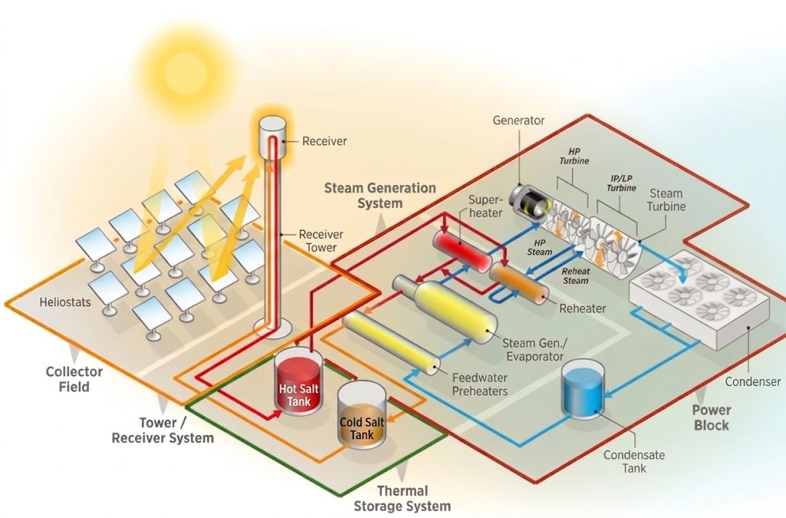
The SPT system model, featuring two-tank molten salt TES system was developed using SAM version 2025.4.16 from the National Renewable Energy Laboratory (NREL) for a 100 MW nominal capacity of the SPT system. The three main components of the SPT system are illustrated in Figure 1 which consists of a power block, a central receiver, and a heliostat field. Molten salt (60% NaNO₃/40% KNO₃) is used as a heat transfer fluid (HTF) and storage medium. It circulates between a cold storage tank at 290°C and a hot storage tank at 574°C [5], thus offers dispatchable solar energy generation by storing extra thermal energy during high-irradiance periods and releasing it during nighttime or cloudy conditions [1], [15]. The power cycle employs an air-cooled Rankine cycle with a gross turbine output of 115 MWe and a design-point cycle thermal efficiency of 41.2%. The key technical parameters adopted in this study are summarized in Table 1 [14].

Figure 1. System diagram for SPT

Table 1. Technical design parameters
Parameter |  | Value
Nominal net capacity |  | 100 MW
Design turbine gross output |  | 115 MWe
Cycle thermal efficiency |  | 41.2%
HTF hot temperature |  | 574°C
HTF cold temperature |  | 290°C
Design point DNI |  | 950 W/m²
Receiver type |  | External cylindrical
Condenser type |  | Air-cooled
Heliostat width × height |  | 12.2 m $×$12.2 m
Mirror reflectance |  | 0.90

The financial parameters adopted are summarized as follows. The analysis used a real discount rate of 6.4% and an inflation rate of 2.5% over a period of 25 years. The cost of the heliostat field was assumed to be 100 $/m2 and the reference cost of the receiver was assumed to be 80 million $. The thermal energy storage (TES) cost was taken as $22/kWhₜₕ. Contingency and EPC and owner costs were assumed to account for 7% and 8% of the direct cost, respectively. An annual insurance rate of 0.5% of the installed cost was considered. The PPA electricity price was set at 15 ¢/kWh.

2.2 Key performance indicators
The following performance characteristics were used to evaluate and compare plant configurations throughout this study.
The formula for calculating the total incoming thermal energy is provided in Eq.(1)[4]
$$Q_{h}=I_{d}×A_{h}×N_{h}$$ | (1)

where $Q_{h}$ is the total incoming thermal energy, $I_{d}$ is the DNI, $A_{h}$ is the reflective area of one heliostat $N_{h}$ is the total number of heliostats. To determine the Efficiency of the field, expressed as $η_{h}$ , Eq.(2) [4] can be used:
$$η_{h}=\frac{Q_{rec}}{Q_{inc}}=\frac{Q_{rec}}{I_{d}×A_{h}×N_{h}}$$ | (2)
where $Q_{rec}$ represents the thermal energy transferred to the receiver, and $Q_{inc}$ is the thermal energy transferred to the incident. Several factors, such as cosine, shading, blocking, overflow, reflection, and dispersion, contribute to the losses considered in the efficiency calculation. The resulting calculation can be represented by the following Eq.(3)[4], [16]:
$$η_{h}=η_{cos}×η_{omb}×η_{bloc}×η_{deb}×η_{ref}×η_{disP}$$ | (3)

where $η_{cos}, η_{omb}, η_{bloc},η_{deb},η_{ref}$ and $η_{disP}$ represent cosine, shading, blocking, atmospheric attenuation, intercept/spillage, and mirror-reflectance efficiencies, respectively. All computed internally by SAM based on the heliostat field layout and site-specific parameters. The ratio of the energy generated by the system in partial time and the energy generated in full-time determines the capacity factor and is given by Eq.(4) [4]
$$CF=\frac{Egp}{365.24⋅Egf}$$ | (4)
where $CF$ is the capacity factor, $Egp$ is the energy generated during the operating period, and $Egf$ is the is the potential energy generation if the plant operates continuously at full capacity. The SM is the proportion of thermal energy output by the solar field at the design specification level of DNI and the heat power demand of the power block at nominal operating conditions [4], [17].
$$SM=\frac{Q_{sF}}{Q_{Pb}}$$ | (5)
where $SM$ is the solar multiple, $Q_{sF}$ is the energy generated by heliostats, and $Q_{Pb}$ is the energy required by the power block.
The LCOE represents the average cost per unit of electricity generated over the plant's lifetime, accounting for all capital, operational, and financial costs in Eq.(6) [5], [18]:
$$LCOE=\frac{\sum_{n=0}^{N}{\left[\frac{C_{n}}{{\left(1+d\right)}^{n}}\right]}}{\sum_{n=0}^{N}{\left[\frac{Q_{n}}{{\left(1+d\right)}^{n}}\right]}}$$ | (6)
where $C_{n}$ is the total cost incurred in year $n$, $Q_{n}$ is the net electricity output in year $n$(measured in kWh), $N$ is the total number of years in the analysis period, $d$ is the nominal discount rate.
The Net Present Value (NPV) is another economic indicator used to evaluate the economic viability of power facilities and is presented in Eq. (7) [5]. a positive NPV indicates that the project is financially viable, whereas a negative NPV indicates otherwise.
$$NPV=\sum_{i=1}^{N}{Cash(i)}⋅{\left(1+IRR\right)}^{-i}$$ | (7)
where $IRR$ represents the internal rate of return; $Cash(i)$ cash flow in year $i$ and $N$ the total project period.
2.3 Parametric study
To obtain training data for the optimization and machine learning stages, parametric research was undertaken in SAM by altering two critical design parameters, namely the SM and the full-load TES hours. Nine values of SM were assessed from 1.4 to 3.0 in increments of 0.2, and six TES durations from 4 to 14 hours in increments of 2 hours, generating a total of 54 simulation cases. For each combination, the LCOE (nominal), annual AC energy output, solar field area, and TES design capacity were recorded.
2.4 Optimization using the Aquila Optimizer
The AO, a nature-inspired metaheuristic algorithm introduced by Abualigah et al.[10], was selected to identify the optimal combination of SM and TES hours that minimizes the LCOE. The AO imitates the four hunting strategies of the Aquila eagle: expanded exploration, narrowed exploration, expanded exploitation, and narrowed exploitation, controlled by the iteration counter as following Eq. (8-11):
$$X_{1}\left(t+1\right)=X_{best}\left(t\right)×\left(1-\frac{t}{T}\right)+\left(X_{M}\left(t\right)-X_{best}\left(t\right)×rand\right)$$ | (8)
$$X_{2}\left(t+1\right)=X_{best}\left(t\right)×Lⅇvy\left(D\right)+X_{R}\left(t\right)+\left(y-x\right)×rand$$ | (9)
$$X_{3}\left(t+1\right)=\left(X_{best}\left(t\right)-X_{M}\left(t\right)\right)×α-rand+\left(\left(UB-LB\right)×rand+LB\right)×δ$$ | (10)
$$X_{4}\left(t+1\right)=QF(t)×X_{best}\left(t\right)-\left(G_{1}×X\left(t\right)×rand\right)-G_{2}×Lⅇvy\left(D\right)+rand×G_{1}$$ | (11)

where $X_{best}\left(t\right)$ is the best solution up to iteration $t$, $X\left(t\right)$ is the current candidate solution, $X_{M}\left(t\right)$ is the mean population position, and $X_{R}\left(t\right)$ is a randomly selected solution from the population. The iteration index $t=1,2,…, T$, where $T=200$ is the maximum number of iterations with the population on $N=30$ agents in a search space dimension $D=2$. Lower and upper bound vectors are represented by $LB=\left[1.4,4\right]$, and $UB=\left[3,14\right]$, respectively. The term $rand$ is a uniformly distributed random number in $\left[0,1\right]$, $α=δ=0.1$are control parameters. $Lⅇvy\left(D\right)$ represents the Lévy flight distribution in space, with $x$ and$y$ set the spiral-search trajectory, $QF(t)$is a quality function, and $G_{1}$, $G_{2}$ are adaptive parameters [10]. Figure 2 summarizes the AO procedure used in this study. The population is initialized within the specified SM and TES bounds, after which the penalized LCOE fitness of each candidate is evaluated. During the first two-thirds of the iterations, AO applies its expanded- and narrowed-exploration strategies. During the remaining iterations, the expanded- and narrowed-exploitation strategies are applied. After each position update, the decision-variable bounds and design constraints are enforced, the fitness is recalculated, and $X_{best}$ is updated. The process continues until $T=200$iterations are completed, after which the best feasible solution is retained.
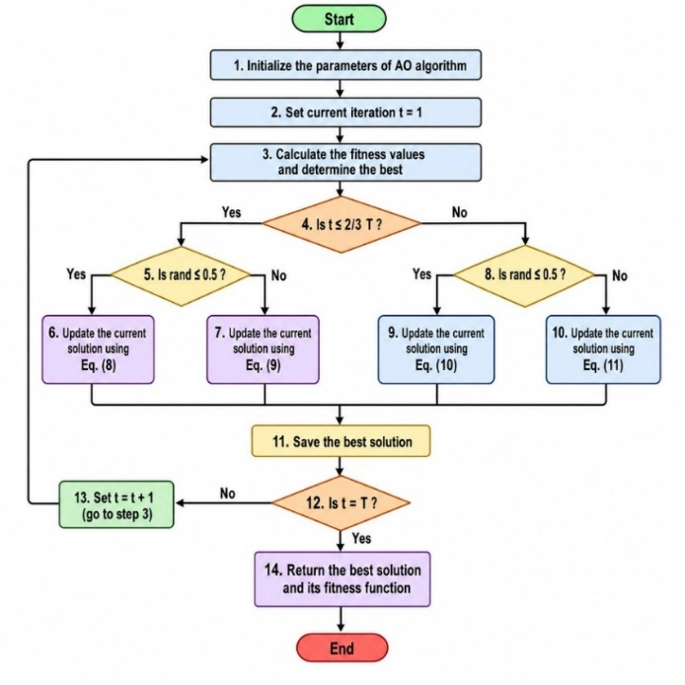
Figure 2 Flowchart of the AO [19]
A 2D continuous response surface was created from the 54 SAM simulation results, using spline interpolation in MATLAB, allowing the AO to evaluate the LCOE at any continuous (SM, TES) combination within the examined range. The optimization problem is formulated as:
$$\min_{SM,TES} LCOE\left(SM,TES\right)$$ | (12)
Subject to:
$$A_{Field}\left(SM\right)≤1,483,600 m^{2}$$ | (13)
$$E_{annuaL}\left(SM,TES\right)≥400GWh/year$$ | (14)
$$C_{TES}\left(TES\right)≤3,907.77 MWht$$ | (15)

The decision-variable bounds were $1.4≤SM≤3.0$and $4≤TES≤14$h. The AO was set up with a population of 30 agents and 200 iterations, executed across 5 independent trials, Keeping the best outcome. Constraint violations were penalized using a weighted penalty method added to the objective function.
2.5 Optimization framework and comparative analysis
To determine the optimal solar field area and TES capacity for the Hurghada site, both the AO and GWO algorithms were applied to the interpolated LCOE response surface. To ensure a fair comparison, both algorithms were set up with the same 200 iterations, same five independent trials, and same population size of 30 agents [20].
Mirjalili et al. [9] introduced the GWO, which divides the population into alpha, beta, delta, and omega wolves based on the social structure and hunting habits of grey wolves. The ideal solution is represented by the alpha wolf, and the other wolves adjust their positions based on the alpha, beta, and delta positions according to [21]:
$$\vec{X}\left(t+1\right)=\frac{{\vec{X}}_{1}+{\vec{X}}_{2}+{\vec{X}}_{3}}{3}$$ | (16)
where ${\vec{X}}_{1}$​, ${\vec{X}}_{2}$​, and ${\vec{X}}_{3}$​ are the positions estimated based on the alpha, beta, and delta wolves respectively.
2.6 ANN surrogate model
An ANN-based surrogate model was developed to estimate the optimal solar field area and TES capacity for any location within Egypt's Red Sea region using only local climatic inputs, namely annual DNI (kWh/m²/year) and average ambient temperature (°C). This is intended to reduce the need for repeated SAM simulations and expands the optimization framework beyond site-specific SAM simulations. The AO was applied to the SAM parametric data of seven locations in the region, namely Hurghada, Sharm El-Sheikh, Marsa Alam, Dahab, Quseir, Ras Sedr, and Saint Catherine. The ANN's training targets were the AO-derived ideal design configurations, with the input variables being the average ambient temperature and annual DNI. The ANN architecture consists of a 2-neuron input layer, two hidden layers (8 neurons each) with logistic activation functions, and a 2-neuron output layer, trained using the Levenberg-Marquardt backpropagation algorithm. The network architecture is shown in Figure 3.
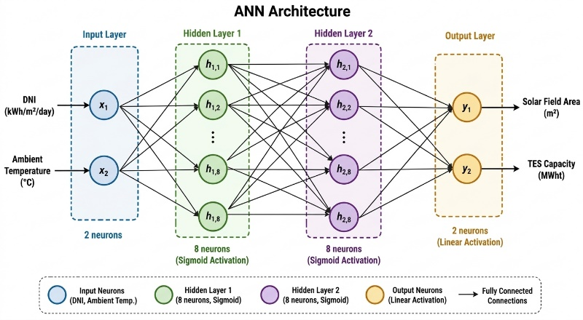

Figure 3 ANN architecture diagram
The dataset used to train the ANN consists of seven samples, one per location, each comprising two inputs (annual DNI and mean ambient temperature) and two targets (the AO-optimal solar-field area and TES capacity). Within each of the 20 training runs, MATLAB’s default random division of the seven samples into training, validation and test subsets (70/15/15%, i.e., about five, one and one samples) was applied, and the network with the highest average R² computed over all seven samples was retained; the R² values reported in Section 3.3 therefore describe the fit to the AO-derived designs rather than independent prediction accuracy. The architecture was selected by trial, balancing approximation capability against the risk of over-fitting on this small dataset: two hidden layers of eight logistic neurons capture the nonlinear dependence of the optimal design on DNI and temperature, while the Levenberg–Marquardt algorithm is well suited to small networks and small datasets. Two smaller networks (2-4-2 and 2-2-2) and a linear regression were also tested in the leave-one-out evaluation described below (Section 3.3). To examine generalization beyond the fitted samples, a leave-one-out cross-validation was also carried out, in which the network was trained on six locations (repeating the 20 random initializations and the selection on those six sites only) and used to predict the seventh; the results are reported in Section 3.3.
The model accuracy is evaluated using the coefficient of determination R² presented by Eq. (17)[22]
$$R^{2}=1-\frac{\sum_{i=1}^{N}{{\left(y_{i}-{\hat{y}}_{i}\right)}^{2}}}{\sum_{i=1}^{N}{{\left(y_{i}-\overline{y}\right)}^{2}}}$$ | (17)
where $y_{i}$ is the actual value, ${\hat{y}}_{i}$ is the ANN-predicted value, $\overline{y}$ is the mean of actual values, and $N$is the number of data points. Training was repeated 20 times with random weight initialization, and the best-performing model was selected based on the average R² across both output variables

3. Results
This section presents the results of the proposed framework. Section 3.1 reports the SAM parametric results and the resulting LCOE response surface. Section 3.2 presents the AO-based optimal design for Hurghada, its economic performance and its comparison with the GWO. Sections 3.3 and 3.4 then describe the performance and validation of the ANN surrogate model.
3.1 SAM simulation results
The SAM parametric study for the Hurghada site comprised 54 simulation runs covering SM values from 1.4 to 3.0 and TES durations from 4 to 14 h. The LCOE response surface, illustrated in Figure 4, shows a low-LCOE region at SM values between 2.4 and 2.8, with TES hours between 8 and 12 hours. As shown in Figure 4, smaller solar field installations are accompanied by higher LCOE values, while increasing the SM beyond the low-cost region provides limited economic benefit. This trend is a trade-off between the additional investment required for a larger heliostat field and the resulting increase in electricity generation. Annual electricity generation also varies with the solar-field and storage configuration, reaching 262.5 GWh at SM = 1.4 and a TES duration of 4 h, compared with 521.7 GWh at SM = 2.6 and a TES duration of 14 h. The SAM parametric results were employed to generate a continuous LCOE response surface through spline interpolation, as illustrated in Figure 4. The AO-based optimisation was conducted using this surface as the objective function to determine the optimal combination of SM and TES duration within the continuous design space, while adhering to the prescribed design constraints.

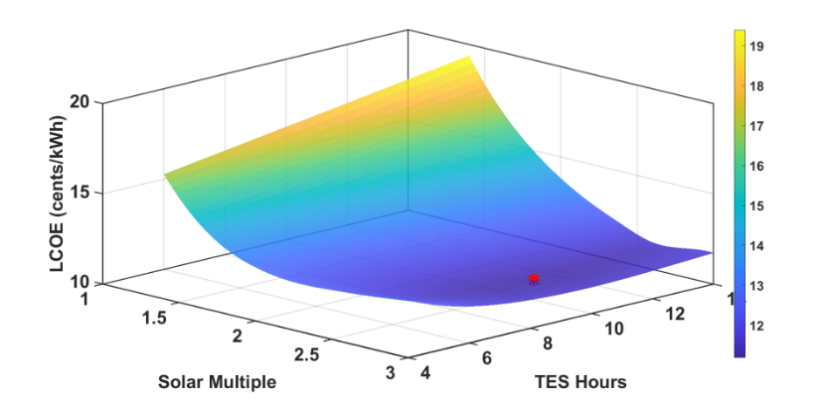

Figure 4 LCOE Surface with optimal point
3.2 Optimization results
The AO was applied to the interpolated LCOE response surface to identify the best feasible combination of SM and TES duration for the Hurghada site. The selected configuration corresponds to SM = 2.646 and a TES duration of 9.887 h, with a nominal LCOE of approximately 11.18 ¢/kWh. Figure 5 presents the feasible design region and the location of the selected solution relative to the prescribed constraints. Figure 6 illustrates the variation in LCOE with SM at a fixed TES duration of approximately 9.89 h. The curve decreases towards a minimum near SM = 2.65 and then increases slightly, suggesting a trade-off between the additional investment in the heliostat field and the associated electricity-generation benefit. To guarantee solution reliability, the optimization was carried out over five separate trials, and the best outcome was retained. The ideal design parameters and associated performance indicators for the Hurghada SPT plant are compiled in Table 2.
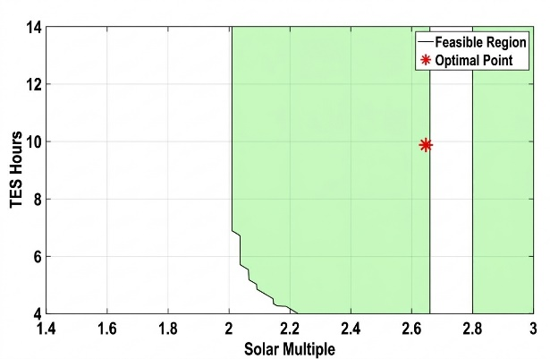 | 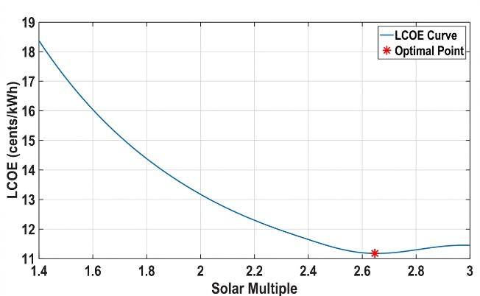
Figure 5 Feasible design region in the SM–TES duration space | Figure 6 Variation in nominal LCOE with SM at a fixed TES duration

Table 2. Optimal design configuration and performance results for Hurghada
Parameter |  | Value
Optimal SM |  | 2.646
Optimal TES Hours |  | 9.887 h
Optimal LCOE (nominal) |  | 11.18 ¢/kWh
Annual AC Energy |  | 516.22 GWh/year
Capacity Factor |  | 55.3 %
Solar Field Area |  | 1,481,055 m²
TES Design Capacity |  | 2,759.6 MWht
Net Capital Cost |  | $621.7 M
NPV |  | +$234.3 M
Internal Rate of Return (IRR) |  | 22.67%

Table 2 summarizes the optimal design data. At the optimal point, all three design constraints were achieved: the TES capacity (2,759.6 MWht) stayed below the maximum limit of 3,907.77 MWht, the solar field area (1,481,055 m²) was below the limit of 1,483,600 m², and the annual energy output corresponding to 516.22 GWh exceeded the minimum requirement of 400 GWh/year. The obtained LCOE of 11.18 ¢/kWh compares favourably with reported results in literature for similar SPT designs in high-DNI African and MENA regions. Rouibah et al. [4] estimated a minimum LCOE of 9.7 ¢/kWh for a 20 MW SPT plant at Mechria, Algeria, at SM = 1.8 and 10 hours of TES. In line with utility-scale CSP economics, the bigger plant scale (100 MW) and higher capital cost estimates used in this analysis are reflected in the higher LCOE. Molten-salt power towers have the most potential for cost reduction among CSP technologies, according to the NREL Annual Technology Baseline [3],[23], which supports the suggested configuration's economic feasibility
3.2.1 Comparison with GWO
Table 3 presents a direct comparison of the optimization results obtained by both algorithms. Both algorithms converged to almost identical ideal solutions, with a negligible LCOE difference of 0.0001 ¢/kWh, confirming the robustness of the optimal design point. The AO and the GWO therefore differ mainly in repeatability and convergence behaviour, as discussed below. Since both algorithms reach the same optimum, the AO was retained as the primary optimization tool for the multi-location analysis used to generate the ANN training targets, with the GWO serving as an independent benchmark.
To assess robustness, both algorithms were run for five independent trials starting from different random populations (Table 3). The optimal LCOE was 11.18112 ± 0.00020 ¢/kWh for the AO and 11.18085 ± 0.000005 ¢/kWh for the GWO (mean ± standard deviation), so that all ten runs lie within 0.0005 ¢/kWh (about 0.004%) of each other. The GWO was the more repeatable algorithm and reached practically the same solution in every trial (SM = 2.6487 ± 0.0008, TES = 9.883 ± 0.006 h), whereas the AO showed a slightly larger spread in the decision variables (SM = 2.650 ± 0.004, TES = 9.94 ± 0.07 h). This spread has a negligible economic effect because the LCOE surface is very flat around the optimum (Figure 4): the trial-to-trial differences in SM (up to 0.009) and TES (up to 0.15 h) change the LCOE by less than 0.0005 ¢/kWh. Regarding convergence speed, the best LCOE stayed within 0.0001 ¢/kWh of its final value after 114 ± 64 iterations for the AO and 164 ± 19 iterations for the GWO. The AO therefore settled earlier on average, but with a much larger trial-to-trial variability (55–193 versus 142–184 iterations), so that this difference is not conclusive with five trials. Both algorithms used the same population size, number of iterations and constraint-penalty scheme, so the differences reflect their search behaviour rather than the experimental setup.

Table 3: Comparison of AO and GWO results -Hurghada site; the first six rows refer to the best of five trials, and the last four rows give the mean ± standard deviation over the five independent trials (convergence iteration: first iteration after which the best LCOE stays within 0.0001 ¢/kWh of its final value)
Parameter | Aquila Optimizer (AO) | Grey Wolf Optimizer (GWO)
SM | 2.6459 | 2.6487
TES Hours (h) | 9.887 | 9.890
LCOE (¢/kWh) | 11.1809 | 11.1808
Annual Energy (GWh) | 516.22 | 516.29
Solar Field Area (m²) | 1,481,055 | 1,481,700
TES Capacity (MWht) | 2,759.6 | 2,760.6
LCOE mean ± SD (¢/kWh) | 11.18112 ± 0.00020 | 11.18085 ± 0.000005
SM mean ± SD | 2.64983 ± 0.00355 | 2.64868 ± 0.00076
TES hours mean ± SD (h) | 9.94367 ± 0.06701 | 9.88307 ± 0.00635
Convergence iteration (mean ± SD) | 114 ± 64 | 164 ± 19

3.3 ANN surrogate model results
The best design configurations obtained from the AO for seven locations in the Red Sea region were used to train the ANN surrogate model. The trained ANN reached an coefficient of determination R² = 0.9987 for the predicted solar field area and an R² value of 0.9983 for TES capacity prediction, as shown in Figures 7 and 8 respectively. These values indicate that the ANN closely reproduced the AO-derived optimal CSP design parameters across the training dataset. As shown in Figure 7, the predicted solar field area values are nearly identical to the AO-derived actual values across all seven locations, reflecting the near-uniform optimal area driven by the land area constraint. Figure 8 indicates that the ANN accurately predicts the TES capacity, which shows greater variation across locations, ranging from 2,350 MWht at Ras Sedr to 2,885.4 MWht at Saint Catherine, possibly due to variations in ambient temperature.

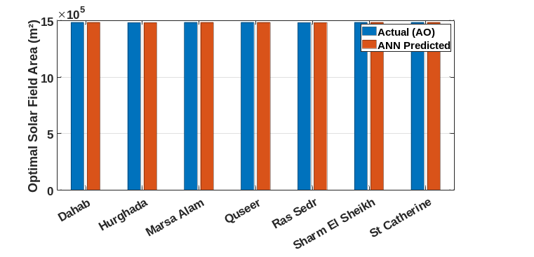
Figure 7 ANN solar field area prediction
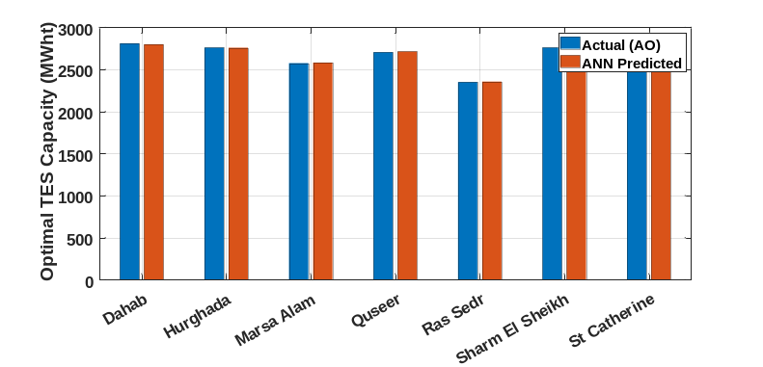
Figure 8 ANN TES capacity prediction

Figure 9 shows the relationship between annual DNI and optimal solar field area across the training locations. The near-flat trend indicates that although the Red Sea region's DNI ranges (2,131–2,628 kWh/m²/year), the optimal solar field area is primarily constrained by the permitted land area rather than climatic variability. In contrast, results in Figure 10 may indicate that colder sites require greater storage capacity to compensate for increased thermal losses and to maintain continuous power generation during cooler periods. When applied to a simulated new location with DNI = 2,400 kWh/m²/year and average temperature = 24°C, the ANN predicted an optimal solar field area of 1,483,012 m² and a TES capacity of 2,825.50 MWht, consistent with the local patterns seen in the training data and illustrating the intended use of the surrogate, although this prediction has not been verified against an independent SAM–AO optimization and the leave-one-out results below indicate limited predictive accuracy.
A leave-one-out cross-validation gives a more demanding assessment than the R² values above, which describe the fit to the training sites. When each site was excluded from training and then predicted, the selected 2-8-8-2 network gave a mean error of 5.35% for the optimal TES capacity (R² = −0.31), with errors between 0.5% and 4.9% for six sites and 18.7% for Ras Sedr, which has the lowest DNI and the second-lowest temperature and therefore requires extrapolation. The solar-field area was predicted within 0.13% at every site, but this mainly reflects its near-constant value (1.481–1.484 million m²) rather than a learned dependence. The smaller networks (2-4-2 and 2-2-2) and a linear regression gave comparable TES errors (5.1%, 5.8% and 6.9%), and simply predicting the mean TES capacity of the training sites gave 5.9%. With seven sites, the surrogate therefore reproduces the training designs but shows only a small improvement over a simple average for TES capacity, and more sites are needed before it can be used for reliable screening.
3.4 ANN validation against AO results
To verify the ANN model, its predictions were compared against the AO-derived optimal values for the main study location (Hurghada). As shown in Table 4, the ANN predicted a solar field area of 1,481,073 m² and a TES capacity of 2,758.44 MWht, with prediction errors of 0.00% and 0.04%, respectively, relative to the AO optimal results. This strong agreement shows that the ANN closely reproduces the optimization result at the site on which it was verified without the need for further simulation. Since Hurghada is one of the seven training locations, this comparison verifies the fitting accuracy at that site rather than independent predictive performance.

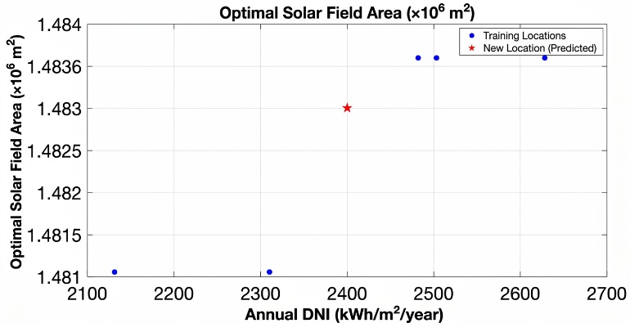
Figure 9 Annual DNI and optimal solar field area
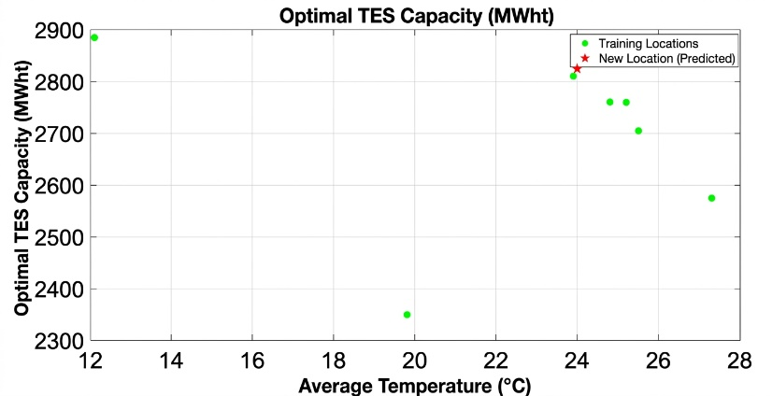
Figure 10 Average temperature and optimal TES capacity

Table 4 ANN Validation Against AO Optimal Results — Hurghada
Parameter | AO Result | ANN Predicted | Error (%)
Solar Field Area (m²) | 1,481,055 | 1,481,073 | 0.00%
TES Capacity (MWht) | 2,759.60 | 2,758.44 | 0.04%

4. Discussion
4.1 Optimal design configuration
Based on the aforementioned results, AO was able to successfully obtain the optimal SPT configuration of Hurghada, Egypt, with the lowest LCOE of 11.18 ¢/kWh at a SM of 2.646, 9.887 TES hours, and a high-capacity factor of 55.3%. This configuration balances the additional investment in the solar field and storage against the benefits of extended electricity generation beyond daylight hours. Additionally, the storage duration is comparable to the 10 h reported by Rouibah et al. [4] for a 20 MW SPT plant in Algeria, although their optimal SM was lower at 1.8, which can be interpreted due to difference in plant scale, site conditions, and design constraints. Although the estimated LCOE was slightly below the reported global weighted average [24], this study provides context rather than a direct benchmark because project costs and financing assumptions differ. The positive NPV of +$234.3M and IRR of 22.67% further confirm the high economic viability of the proposed design with the adopted financial parameters, including a PPA price of 15¢/kWh, and a study period of 25 years. These results are in line with the Egyptian national energy strategy to reach 30 GW of renewable electricity by 2030 with CSP as an important technology to provide dispatchability for grid stability.
4.2 ANN Surrogate Model Performance
The ANN surrogate model reproduced the AO-derived designs of the training sites, achieving R² values of 0.9987 and 0.9983 for solar field area and TES capacity prediction, respectively. The highly accurate solar field area prediction shows the low variability of the ideal solar field area across the Red Sea region sites, driven by the dominance of the land area restriction. An inverse association between average ambient temperature and optimal TES duration was observed across the investigated sites. For example, Saint Catherine, with an average temperature of 12.1°C, required 10.33 h of storage. This trend highlights the relevance of local climatic conditions but does not establish temperature as the sole cause of the variation, since storage sizing also depends on solar-resource availability and plant operation. The surrogate gives a rapid approximation of the optimized design without repeating the full SAM-based optimization process and agrees closely with the Hurghada result in Table 4, which is, however, one of the training sites; its application to a hypothetical site illustrates how it could be used for preliminary regional screening.
The leave-one-out cross-validation in Section 3.3 shows the practical limits of the surrogate: the mean error of the predicted TES capacity was 5.4%, only slightly lower than the 5.9% obtained by simply predicting the average TES capacity of the training sites, and it reached 18.7% at Ras Sedr, which lies at the edge of the training range. The potential advantage of the surrogate is computational, since it replaces the 54 SAM simulations and the repeated optimizer runs required for each new site by a single forward pass, but this advantage is only useful if the accuracy is sufficient; the current surrogate should therefore be regarded as a proof of concept. It was trained on only seven locations, so its accuracy outside the sampled DNI range (2,131–2,628 kWh/m²/year) and the sampled temperature range is unknown, and the prediction for the hypothetical site (DNI = 2,400 kWh/m²/year, 24°C) was not verified against an independent SAM–AO optimization. In addition, because the optimal solar-field area is dominated by the land-area constraint, its prediction mainly reflects that constraint rather than climatic sensitivity. Future work will extend the training set with additional sites, repeat the AO runs several times per site to reduce the noise of the training targets, and test the surrogate on locations outside the training set.
5. Conclusion
This study presented an optimization, AI-based design framework for a 100 MW SPT plant with molten salt TES in Hurghada, Egypt integrating SAM simulations, the AO, and an ANN surrogate to identify configurations that minimize LCOE. First, the AO algorithm identified an optimal SPT design configuration for Hurghada, with SM = 2.646 and TES = 9.887 hours, leading to a minimum nominal LCOE of 11.18 ¢/kWh, an annual energy output of 516.22 GWh/year and a capacity factor of 55.3% with all design constraints met. Additionally, positive NPV of +$234.3 M and IRR of 22.67% were reported, confirming the economic viability of the optimized plant configuration under the chosen financial parameters, and aligning with Egypt’s national renewable energy targets. Next, the LCOE response surface revealed a balance between capital cost and energy yield, beyond which additional heliostat area offered no further cost reduction. Across the seven investigated locations, optimal solar field areas varied narrowly, reflecting the influence of the imposed area constraint. TES capacity showed greater variation, with colder sites generally associated with larger storage requirements. AO and GWO achieved nearly identical minimum LCOE values over five independent trials; the GWO was slightly more repeatable, whereas the AO settled in fewer iterations on average. Finally, the resulting AO-derived configurations were used to train an ANN surrogate, which reproduced them with R² values above 0.998 for both solar field area and TES capacity at the seven locations; however, leave-one-out cross-validation gave a mean TES error of 5.4% (up to 18.7%), so the surrogate should be regarded as a proof of concept for rapid preliminary design screening that needs more training sites.

Acknowledgment
The authors would like to acknowledge the AIESI project (NORPART-2021/10403) and funding received from the Norwegian Directorate for Higher Education and Skills (HK-dir) through the NORPART scheme. This publication reflects only the authors' views, and the HK-dir is not liable for any use that may be made of the information contained therein.
References
[1] Elfeky K E and Wang Q 2023 Techno-economic assessment and optimization of the performance of solar power tower plant in Egypt’s climate conditions Energy Convers. Manag. 280 116829 https://doi.org/10.1016/j.enconman.2023.116829
[2] IEA 2024 Renewables 2024 (Paris: International Energy Agency) https://www.iea.org/reports/renewables-2024 (accessed 29 August 2026)
[3] NLR 2024 Annual Technology Baseline 2024b: Electricity—About https://atb.nlr.gov/electricity/2024b/about (accessed 29 August 2026)
[4] Mohamed L, Abdelkader R, Laroussi K, Singh A R, Bajaj M and Tuka M B 2025 Comprehensive techno-economic optimization and performance analysis of molten salt concentrated solar power tower plants in Algeria Sci. Rep. 15 14456 https://doi.org/10.1038/s41598-025-97236-4
[5] Agyekum E B and Velkin V I 2020 Optimization and techno-economic assessment of concentrated solar power (CSP) in South-Western Africa: a case study on Ghana Sustain. Energy Technol. Assess. 40 100763 https://doi.org/10.1016/j.seta.2020.100763
[6] Hirbodi K, Enjavi-Arsanjani M and Yaghoubi M 2020 Techno-economic assessment and environmental impact of concentrating solar power plants in Iran Renew. Sustain. Energy Rev. 120 109642 https://doi.org/10.1016/j.rser.2019.109642
[7] Lykas P, Georgousis N, Kitsopoulou A, Korres D N, Bellos E and Tzivanidis C 2023 A detailed parametric analysis of a solar-powered cogeneration system for electricity and hydrogen production Appl. Sci. 13 433 https://doi.org/10.3390/app13010433
[8] Khosravi A, Malekan M, Pabon J J G, Zhao X and Assad M E H 2020 Design parameter modelling of solar power tower system using adaptive neuro-fuzzy inference system optimized with a combination of genetic algorithm and teaching learning-based optimization algorithm J. Clean. Prod. 244 118904 https://doi.org/10.1016/j.jclepro.2019.118904
[9] Mirjalili S, Mirjalili S M and Lewis A 2014 Grey wolf optimizer Adv. Eng. Softw. 69 46–61 https://doi.org/10.1016/j.advengsoft.2013.12.007
[10] Abualigah L, Yousri D, Abd Elaziz M, Ewees A A, Al-qaness M A A and Gandomi A H 2021 Aquila optimizer: a novel meta-heuristic optimization algorithm Comput. Ind. Eng. 157 107250 https://doi.org/10.1016/j.cie.2021.107250
[11] Central Agency for Public Mobilization and Statistics (CAPMAS) Population clock https://www.capmas.gov.eg/Pages/populationClock.aspx (accessed 29 August 2026)
[12] CEIC Egypt | Air transport: number of passengers: annual https://www.ceicdata.com/en/egypt/air-transport-number-of-passengers-annual (accessed 29 August 2026)
[13] Sengupta M, Xie Y, Lopez A, Habte A, Maclaurin G and Shelby J 2018 The National Solar Radiation Data Base (NSRDB) Renew. Sustain. Energy Rev. 89 51–60 https://doi.org/10.1016/j.rser.2018.03.003
[14] OpenEI System Advisor Model (SAM) https://openei.org/wiki/System_Advisor_Model_(SAM) (accessed 29 August 2026)
[15] Boretti A 2024 Optimizing concentrated solar power: high-temperature molten salt thermal energy storage for enhanced efficiency Energy Storage 6 e70059 https://doi.org/10.1002/est2.70059
[16] Tascioni R, Arteconi A, Del Zotto L and Cioccolanti L 2020 Fuzzy logic energy management strategy of a multiple latent heat thermal storage in a small-scale concentrated solar power plant Energies 13 2733 https://doi.org/10.3390/en13112733
[17] Khan M I, Gutiérrez-Alvarez R, Asfand F, Bicer Y, Sgouridis S, Al-Ghamdi S G, Jouhara H, Asif M, Kurniawan T A, Abid M, Pesyridis A and Farooq M 2024 The economics of concentrating solar power (CSP): assessing cost competitiveness and deployment potential Renew. Sustain. Energy Rev. 200 114551 https://doi.org/10.1016/j.rser.2024.114551
[18] Achkari O and El Fadar A 2020 Latest developments on TES and CSP technologies—energy and environmental issues, applications and research trends Appl. Therm. Eng. 167 114806 https://doi.org/10.1016/j.applthermaleng.2019.114806
[19] Sasmal B, Hussien A G, Das A and Dhal K G 2023 A comprehensive survey on Aquila optimizer Arch. Comput. Methods Eng. 30 4449–4476 https://doi.org/10.1007/s11831-023-09945-6
[20] Ragab M M, Ibrahim R A, Desouki H and Swief R 2023 A probabilistic renewable energy allocation applying metaheuristics optimization methodologies Proc. 2023 11th International Conference on Smart Grid (icSmartGrid) (IEEE) pp 1–6
[21] Guo M W, Wang J S, Zhu L F, Guo S S and Xie W 2020 An improved grey wolf optimizer based on tracking and seeking modes to solve function optimization problems IEEE Access 8 69861–69893 https://doi.org/10.1109/ACCESS.2020.2984321
[22] Yaseen Z M and Alawi O A 2025 Artificial intelligence models development for profitability factor prediction in concentrated solar power with dual backup systems Sci. Rep. 15 5085 https://doi.org/10.1038/s41598-025-87584-6
[23] NLR Annual Technology Baseline (ATB) https://atb.nlr.gov/ (accessed 29 August 2026)
[24] IRENA 2024 Renewable Power Generation Costs in 2023 (Abu Dhabi: International Renewable Energy Agency) https://www.irena.org/Publications/2024/Sep/Renewable-Power-Generation-Costs-in-2023 (accessed 29 August 2026)

