Energy management strategy for triple hybrid energy storage systems in smart grids
R Elfaham¹, M Hamad² and A Karimi³
¹Electrical Smart Grid Engineering, Arab Academy for Science, Technology and Maritime Transport, Alexandria, Egypt
²Electrical Engineering, Arab Academy for Science, Technology and Maritime Transport, Alexandria, Egypt
³Department of Energy and Petroleum Engineering, University of Stavanger (UiS), Stavanger, Norway

E-mail: rewaa.mohammad3@gmail.com
Abstract. A solar- and wind-rich feeder must balance mismatches lasting from seconds to days, which no single storage device can cover. This paper dispatches a triple hybrid energy storage system (T-HESS), with a battery, a supercapacitor bank and a hydrogen branch, on the enhanced IEEE 33-bus feeder over a full year at one-minute resolution. A pro-rata baseline (PRB) with fixed shares is compared with a two-layer rule-based (TLRB) controller, in which a 10-minute low-pass filter sends the fast part of the imbalance to the supercapacitor and an 11-state machine with a 45-rule fuzzy layer shares the slow part between the battery and the hydrogen branch. The TLRB lowers the local supply deficit from 31.8% to 31.1%, cuts curtailment from 2.9% to 0.6% and keeps a tenth of the hydrogen tank all year, whereas the PRB empties it within 25 days. The larger difference is executability: the plant refuses 47%, 98% and 59% of the battery, supercapacitor and hydrogen energy the PRB commands, but no supercapacitor or hydrogen energy under the TLRB, a gap the deficit alone does not reveal. The cost is voltage compliance, which falls from 98.3% to 89.0% because the electrolyser draws power at the weakest bus. Four seasonal days show that the reserve rule protects the tank but loses load on an ordinary autumn day.
Keywords: hybrid energy storage, supercapacitor, hydrogen, energy management, rule-based control.
Table 1. Nomenclature.
Abbreviations
EMS | energy management system | PV | photovoltaic | SoE | SC state of energy
ESR | equivalent series resistance | PRB | pro-rata baseline | SoH_{H2} | hydrogen tank level
FC | fuel cell | TLRB | two-layer rule-based EMS | T-HESS | triple hybrid energy storage system
HHV, LHV | higher, lower heating value | SC | supercapacitor
pu, mpu | per unit, milli-per-unit | SoC | battery state of charge
Symbols
P_{L}, P_{res} | load, renewable power | D_{L}, C_{curt} | deficit, curtailment (%) | V_{i} | voltage at bus i
P_{PV}, P_{W} | PV, wind power | R_{T} | terminal hydrogen reserve | p_{j}, q_{j} | net injection at bus j (pu)
P_{cmd,k}, P_{act,k} | command, delivery of device k | δ_{k} | delivered fraction | R_{ij}, X_{ij} | path resistance, reactance
P̄_{k} | rated power of device k | σ_{S} | SC request served (%) | S_{i} | voltage sensitivity (mpu/MW)
P_{net}⁰, P_{net} | imbalance pre-, post-storage | κ_{V} | time with all buses in band | Δf, Δω | frequency deviation
P_{slow}, P_{fast} | slow, fast part of imbalance | φ_{k} | pro-rata share | ΔP | imbalance on the MVA base
r | residual after the SC | β | fuzzy blending weight | H, D, ω₀ | inertia, damping, rated speed
P_{def}, P_{curt} | unserved, curtailed power | Δt | time step | V_{S}, R_{S}, C_{S} | SC voltage, ESR, capacitance
η_{el}, η_{FC} | electrolyser, FC efficiency | h, d, ε | hour, day, load noise | E_{S,max} | SC energy at full voltage
ṁ_{el}, ṁ_{FC} | hydrogen produced, consumed | G | irradiance | η_{PV}, A_{PV} | PV efficiency, area
v | wind speed | T_{a}, T_{c} | ambient, cell temperature | α_{T} | PV temperature coefficient
v_{ci}, v_{r}, v_{co} | cut-in, rated, cut-out speed

- Introduction
Distribution networks are absorbing a rising share of variable solar and wind generation, which turns the local balance between supply and demand into an operational problem rather than a planning one [1]. A triple hybrid energy storage system (T-HESS) combines a battery, a supercapacitor and a hydrogen branch. These branches differ in rated power, round-trip efficiency and discharge duration, which shifts the difficulty from sizing to dispatch [2]. The energy management strategy (EMS) must decide not only how much power to move at each instant but also which branch should move it. The branches are not interchangeable: the hydrogen stock depletes irreversibly over the operating year, because the electrolyser refills the tank only from surplus, and surplus is scarce in exactly the conditions where the reserve is needed [3].

Literature review
Storage is classified by the energy it holds relative to the power it delivers. Beyers et al. use that trade-off to compare technologies and to size them for a given duration [4]. Batteries paired with supercapacitors are an established hybrid at the short end. In electric vehicles the battery supplies energy and the supercapacitor supplies power, which improves range, acceleration and battery life at the price of higher cost and more complex control [5]. Hydrogen sits at the long end, where compression sets the practical limit. A competitive storage volume needs at least 350 bar. Compressing to that pressure costs about a tenth of the fuel’s calorific value, and a three-stage compressor keeps the work below 10 MJ kg⁻¹ [6]. These studies size or pair devices, and none of them dispatches all three branches together.
Learning-based and optimisation-based controllers have been applied to storage dispatch. Zhu et al. schedule an island microgrid with battery and hydrogen storage in three stages, pairing deep reinforcement learning with a wavelet split of power fluctuations, reducing both cost and emissions on island data [7]. Huang et al. solve a receding-horizon problem with storage in a look-ahead market, reducing both cost and price volatility [8]. Such controllers need a clear baseline to show what they add, and a transparent rule-based controller on the same plant provides one.
This work builds on a standard test network and standard component models. The IEEE 33-bus radial feeder of Baran and Wu is the usual test system, and the simplified DistFlow equations of the same paper give its voltages [9]. The enhanced version of that benchmark adds distributed generation and storage at four buses, reactive compensation and a 0.95 to 1.05 pu band [10], while European operating rules set the frequency bands a plant is judged against [11]. At the device level, lithium-ion cells are described by equivalent circuits with RC branches [12], and PV modules by a linear temperature correction of their efficiency [13]. Wind turbines are described by piecewise cubic power curves [14], and supercapacitor banks by the capacitance and series resistance of their modules [15]. Electrolyser and fuel-cell efficiencies follow published status and target values [16, 17].
The dispatch studies above treat one or two storage types, report an aggregate outcome, and place the plant behind a single point of common coupling. Three gaps follow. First, no study dispatches all three branches of a T-HESS under one protocol. Second, none reports whether the plant could physically execute the dispatch it credits. Third, none resolves the minute-scale behaviour that a supercapacitor exists to provide. This paper addresses these gaps with a transparent two-layer rule-based controller and a pro-rata baseline on a common plant, so that learning and optimisation controllers have a fair reference.
Section 2 presents the plant models and the two controllers, section 3 the case study, section 4 the results and section 5 the conclusions.
- Models and control strategies
Both controllers act on the same plant model through the same interface, so they differ only in how they turn measurements into commands.

Problem statement and indicators
At each one-minute step a controller sends a power command P_{cmd,k} to each device k ∈ {B, S, H} (battery, supercapacitor, hydrogen), positive when discharging. A negative hydrogen command runs the electrolyser. Each device returns the power P_{act,k} it can deliver within its rating and state limits. The balance with load P_{L} and renewable output P_{res} gives the unserved and curtailed power:
 | $$P_{net} = P_{res} + \sum_{k}{P_{act,k}} - P_{L}, P_{def} = \max\left(0, -P_{net}\right), P_{curt} = \max\left(0, P_{net}\right)$$ | (1)
The plant is operated for local self-sufficiency, so P_{def} is the power the substation must import. Summed over the year, these two powers give the local supply deficit D_{L} and the curtailment C_{curt}, and the delivered fraction δ_{k} tells whether the plant could carry out the dispatch:
 | $$D_{L} = 100\frac{\sum_{t}{P_{def}}}{\sum_{t}{P_{L}}}, C_{curt} = 100\frac{\sum_{t}{P_{curt}}}{\sum_{t}{P_{L}}}, δ_{k} = \frac{\sum_{t}{|P_{act,k}|}}{\sum_{t}{|P_{cmd,k}|}}$$ | (2)
Three indicators complete the set. The terminal hydrogen reserve R_{T} is SoH_{H2} at the end of the year. The share σ_{S} is the part of the supercapacitor’s request that is served, measured before any clipping by the controller. The voltage compliance κ_{V} is the share of steps in which every bus lies between 0.95 and 1.05 pu.

Device models
The battery is a second-order Thévenin equivalent circuit, one of the models compared in [12], and its state of charge follows Coulomb counting. The supercapacitor bank is a series RC circuit whose resistance R_{S} and capacitance C_{S} are derived from the module data [15], with SoE = V_{S}²/V_{S,max}². Both devices are limited by their current and converter ratings and by their state windows. The electrolyser and the fuel cell change the stored hydrogen mass at the rates
 | $$ṁ_{el} = \frac{η_{el} P_{el}}{HHV}, ṁ_{FC} = \frac{P_{FC}}{η_{FC} LHV}$$ | (3)
The electrolyser efficiency η_{el} = 0.75 (HHV basis) lies between the 2022 status and the 2026 target of the US Department of Energy [16]. The fuel-cell efficiency η_{FC} = 0.60 (LHV basis) is the same agency’s status for peak system efficiency [17]. The tank follows the ideal gas law, and SoH_{H2} is its pressure normalised between 5 and 350 bar. A full tank holds 14.0 t of hydrogen, or 281 MWh at the fuel-cell output.

Network and frequency
Bus voltages come from the lossless simplified DistFlow equations of Baran and Wu [9], written in closed form,
 | $${V_{i}}^{2} = 1 + 2\sum_{j}{\left(R_{ij} p_{j} + X_{ij} q_{j}\right)}$$ | (4)
where p_{j} and q_{j} are the net injections at bus j in per unit, and R_{ij} and X_{ij} are the resistance and reactance of the path that buses i and j share back to the substation. The capacitors enter through q_{j}, bus loads scale with P_{L}(t)/3.715 MW, and the substation is the slack bus.
The frequency deviation is obtained from the swing equation with damping [18]. The imbalance ΔP is expressed in per unit on the 10 MVA base, with H = 5 s and D = 0.05 pu per rad s⁻¹ (a droop of 6.4%). The resulting time constant, 0.64 s, is far shorter than the one-minute step, so Δf settles at ΔP/(2πD), or 0.32 Hz per megawatt, and is limited to ±1 Hz. Δf is therefore a static imbalance indicator. The 0.5 Hz maximum steady-state deviation of the Great Britain, Ireland and Nordic areas [11] serves only as a reference scale.

Pro-rata baseline
The baseline splits the net imbalance into fixed shares,
 | $$P_{cmd,k}(t) = φ_{k}\left(P_{L}(t) - P_{res}(t)\right), (φ_{B}, φ_{S}, φ_{H}) = (0.5, 0.2, 0.3)$$ | (5)
It uses no state feedback. The fuel cell carries 30% of every deficit whatever the tank holds, and the supercapacitor is asked for 20% of every imbalance however little energy it has.

Two-layer rule-based EMS
The rule-based controller works in three stages (figure 1). A first-order low-pass filter with a 10-minute time constant splits the imbalance P⁰_{net} = P_{res} − P_{L} into a slow and a fast part:
 | $$\begin{aligned}P_{slow}(t) = a P_{slow}(t - Δt) + (1 - a)P_{net}^{0}(t), a = e^{-Δt/600 s}, \\ P_{fast} = P_{net}^{0} - P_{slow}\end{aligned}$$ | (6)
The supercapacitor takes the fast part and is pulled back towards SoE = 0.6 with a 15-minute time constant,
 | $$P_{cmd,S} = \operatorname{clip}\left(-P_{fast} + \frac{(SoE - 0.6) E_{S,max}}{900 s}, -{\bar{P}}_{S}^{c}, {\bar{P}}_{S}^{d}\right)$$ | (7)
where P^{c}_{S} and P^{d}_{S} are the charge and discharge limits over the next step. The residual r = P⁰_{net} + P_{cmd,S} goes to the battery and the hydrogen branch.
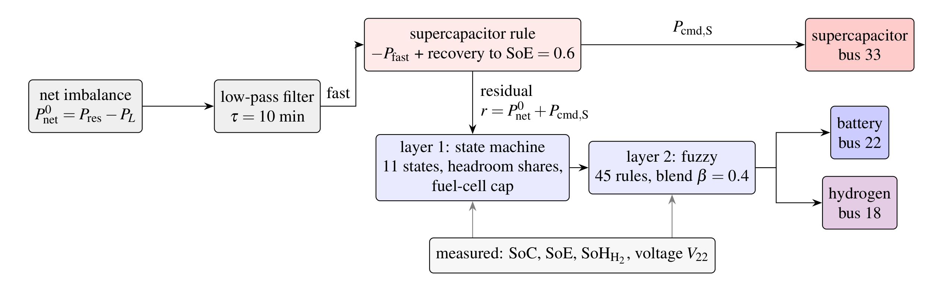
Figure 1. Two-layer rule-based EMS.
In the first layer, an 11-state machine classifies the operating condition from r, the storage levels and the voltage V₂₂ at the battery bus (table 3). It splits a deficit according to headroom, about 70% to the battery and 30% to the fuel cell, and a surplus with equal base shares for the battery and the electrolyser. When V₂₂ leaves the 0.96–1.04 pu range, the battery adds a voltage-support term. The fuel cell is capped by the tank level,
 | $${\bar{P}}_{FC}({SoH}_{H₂}) = \left\{\begin{matrix}1 MW, & {SoH}_{H₂} ≥ 0.20, \\ 1 MW · \max\left(0.10, \frac{{SoH}_{H₂} - 0.10}{0.10}\right), & 0.10 < {SoH}_{H₂} < 0.20, \\ 0, & {SoH}_{H₂} ≤ 0.10,\end{matrix}\right.$$ | (8)
and this cap stops the controller from draining the tank.
The second layer is a Mamdani fuzzy system that smooths the commands near nominal conditions, where a state machine switching on fixed thresholds would chatter. Its antecedents are the residual r, graded into five levels from large deficit to large surplus, and the states SoC, SoH_{H₂} and V₂₂, each graded into three. Nine rules per power level give the 45 rules of table 2, and each returns a per-unit increment for the three devices, positive when discharging. The rule base encodes one priority: within a level, the fuel-cell increment increases with SoH_{H₂}, so that a full tank carries the deficit the battery cannot and a near-empty one is spared, while the electrolyser increment is largest when SoH_{H₂} is low and the battery is full. The output is defuzzified by a weighted average over the fired rules. It is blended with the state-machine command as P_{cmd,k} = (1 − β)P^{fsm}_{k} + βP^{fz}_{k} with β = 0.4, but only when the machine is in its normal state or V₂₂ is within 0.02 pu of a trigger. This happens in 5.1% of the steps, so the state machine governs the rest of the year.
Table 2. Structure of the 45-rule fuzzy layer, with the nine rules of the large-deficit level in full. The other four levels follow the same nine antecedents with scaled consequents; increments are per unit of each device rating, positive when discharging.
Five power levels × nine antecedents = 45 rules
 | Antecedent (large deficit, rules 1–9) | ΔP_{B} | ΔP_{S} | ΔP_{H}
1 | SoC high, voltage normal | +0.90 | +0.80 | +0.70
2 | SoC high, voltage low | +1.00 | +1.00 | +0.80
3 | SoC medium, SoH_{H₂} high | +0.60 | +0.50 | +0.90
4 | SoC medium, SoH_{H₂} medium | +0.60 | +0.50 | +0.50
5 | SoC medium, SoH_{H₂} low | +0.70 | +0.60 | +0.10
6 | SoC low, SoH_{H₂} high | +0.20 | +0.30 | +0.90
7 | SoC low, SoH_{H₂} medium | +0.10 | +0.30 | +0.50
8 | SoC low, SoH_{H₂} low | +0.05 | +0.20 | +0.05
9 | voltage low (alone) | +0.80 | +0.60 | +0.40
Rules 10–18 deficit, 19–27 balanced, 28–36 surplus, 37–45 large surplus

Table 3. States of the rule-based EMS for layer one, their triggers and their share of the year.
 | State | Trigger | Share (%)
1 | Emergency | SoC≤0.205, SoH_{H₂}≤0.10 and deficit above 600 kW; or a deficit with every store at its lower threshold | 14.17
2 | Voltage support | V₂₂ below 0.96 or above 1.04 pu | 0.00
3 | Combined charge | surplus of 300 kW or more | 21.17
4 | Combined discharge | deficit of 600 kW or more | 44.62
5 | Battery charge | surplus of 30 kW or more and SoC<0.85 | 3.91
6 | Hydrogen production | surplus, battery full and SoH_{H₂}<0.85 | 0.01
7 | Supercapacitor charge | surplus, battery and tank full, SoE<0.88 | 0.00
8 | Battery discharge | deficit of 30 kW or more and SoC>0.25 | 4.68
9 | Hydrogen dispatch | deficit, SoC≤0.25 and SoH_{H₂}>0.10 | 8.41
10 | Supercapacitor discharge | deficit, battery and tank at their thresholds, SoE>0.15 | 1.95
11 | Normal | residual below 30 kW in magnitude | 1.07

Seasonal representative days
One day per season is examined in detail. A fixed rule picks each day, so the choice cannot be tuned to suit a result. Winter (days 335 to 365 and 1 to 59) takes the highest ratio of load to renewable energy, and spring (60 to 151) the net load closest to the seasonal median. Summer (152 to 243) takes the highest sum of load and renewable energy, and autumn (244 to 334) the most volatile minute-by-minute net load. Each day is taken from the full-year runs, so it starts from the storage state each controller actually reached.
- Case study
The network, placement, ratings and weather below are the same for both controllers, so any difference in the results comes from dispatch alone.

Network and component placement
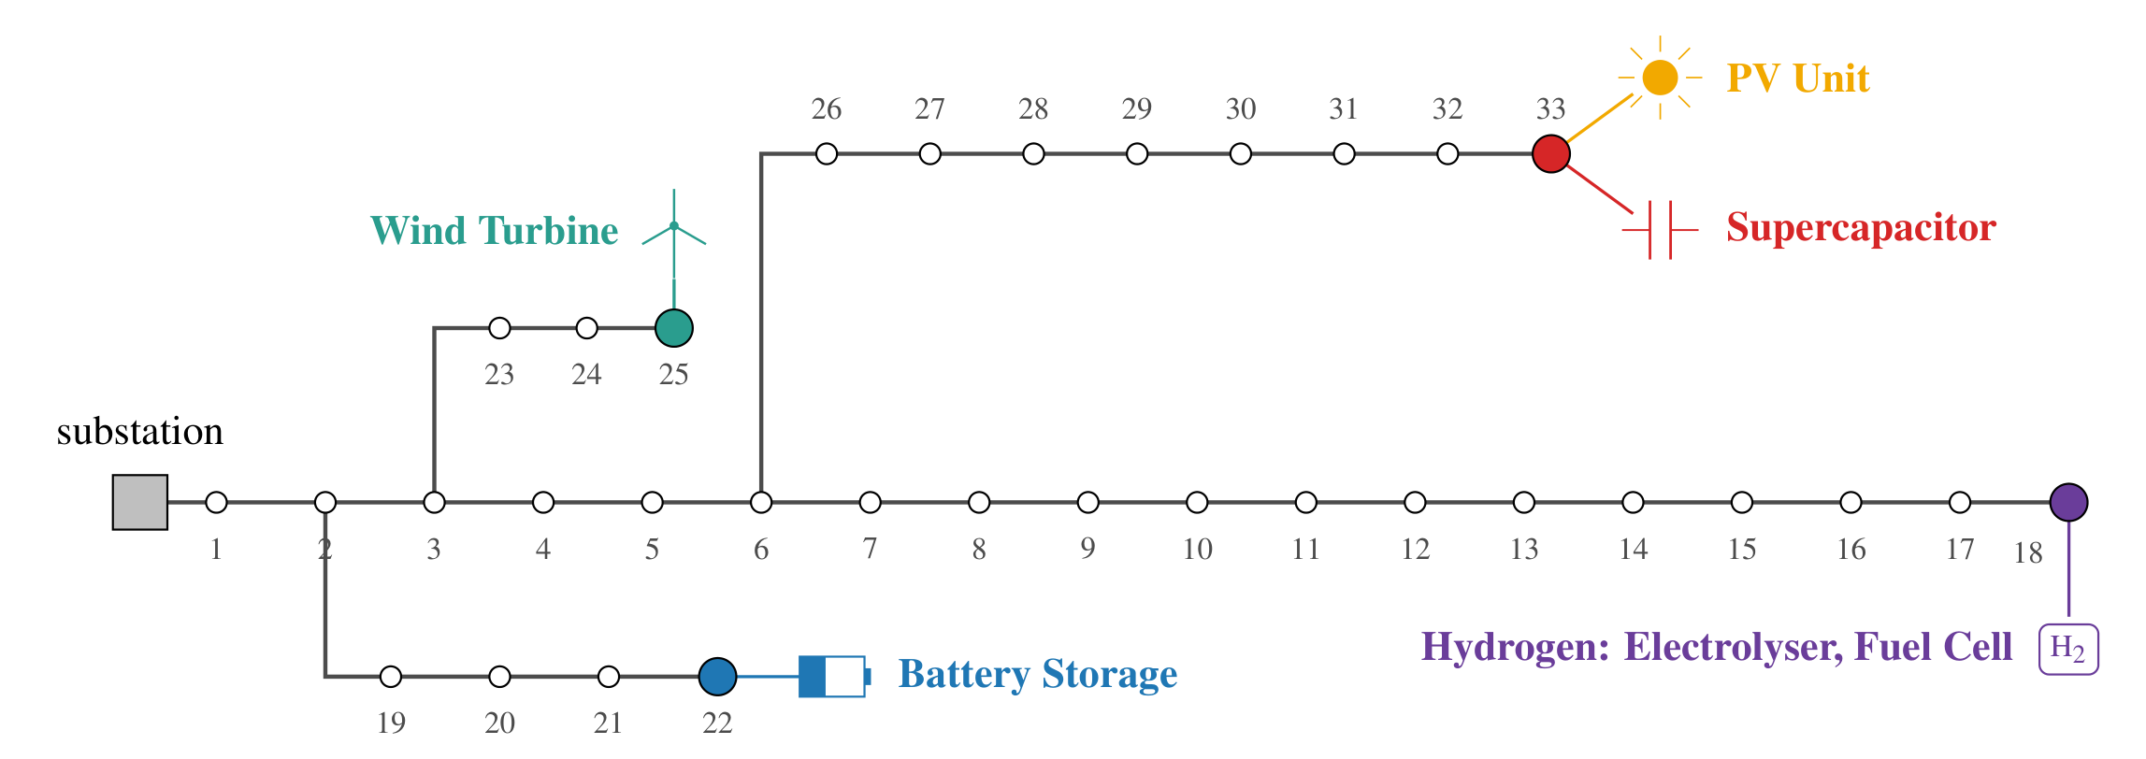
Figure 2. T-HESS units on the enhanced IEEE 33-bus feeder.
The test network is the IEEE 33-bus radial feeder at 12.66 kV and 10 MVA, with the branch impedances and bus loads of Baran and Wu [9]. Its total load is 3715 kW and 2300 kvar. The enhanced benchmark [10] connects its distributed generators and storage at buses 18, 22, 25 and 33, selected by voltage and loss sensitivity. It notes that these units can be replaced by wind and PV or equipped with local storage. It also adds capacitors of 0.4 Mvar at bus 18 and 0.6 Mvar at bus 33 and sets the voltage band to 0.95 to 1.05 pu. This paper keeps these four sites, the two capacitors and the band (figure 2). The assignment of units to these buses follows from voltage sensitivity. Injecting power p_{i} at bus i raises its own voltage by R_{ii}p_{i} in per unit, where R_{ii} is the resistance of the path from the substation to that bus (section 2.3).

Plant ratings and supercapacitor bank
Battery, hydrogen and generation ratings are design values, and the source of every parameter is given in table 4. The supercapacitor supplies fast power with a long cycle life [5]. Its bank uses 72 Maxwell BMOD0063 P125 modules [15], six in series and twelve strings, behind a 1.2 MW converter. Figure 3 shows that the current limit caps its power below SoE ≈ 0.95 and that the bank empties in 22 s at full power, so a step coarser than one minute would hide what the bank does.
Table 4. Plant, generation and network parameters, identical for both controllers. Design marks a rating chosen for this plant and derived a value computed from the module data.
Subsystem | Parameter | Value | Source
Battery (bus 22) | P̄_{B}; capacity | 1.2 MW; 8000 Ah at 1200 V (≈9.6 MWh) | design
 | R₀; (R₁, C₁); (R₂, C₂) | 5 mΩ; 2 mΩ, 20 kF; 3 mΩ, 80 kF | design, model [12]
 | Coulombic efficiency; SoC window | 0.98; 0.20 to 0.90 | design
SC module | Maxwell BMOD0063 P125 | 125 V, 63 F, 18 mΩ, 140 A, 140 Wh, 61 kg | [15]
SC bank (bus 33) | Arrangement | 6 in series × 12 strings = 72 modules | design
 | V_{S,max}, C_{S}, R_{S} | 750 V, 126 F, 9 mΩ | derived
 | Current; P̄_{S} | 1680 A; 1.2 MW | derived; design
 | Energy; time to empty | 7.38 kWh usable (SoE 0.25 to 1.0); 22 s at 1.2 MW | derived
Hydrogen (bus 18) | P̄_{el}; η_{el} | 1 MW; 0.75 (HHV basis) | design; [16]
 | P̄_{FC}; η_{FC} | 1 MW; 0.60 (LHV basis) | design; [17]
 | Tank; pressure; temperature | 500 m³; 5 to 350 bar; 298 K (14.0 t H2) | design, [6]
PV (bus 33) | A_{PV}; η_{PV}; α_{T} | 12 000 m²; 0.18 (2.16 MWp); 0.004 K⁻¹ | design; [13]
Wind (bus 25) | P̄_{W}; v_{ci}, v_{r}, v_{co} | 3.5 MW; 3, 12, 25 m s⁻¹ (restart 20 m s⁻¹) | design, model [14]
Network | Base; total load | 12.66 kV, 10 MVA; 3715 kW, 2300 kvar | [9]
 | Capacitors; voltage band | 0.4 Mvar (18), 0.6 Mvar (33); 0.95 to 1.05 pu | [10]
 | H; D | 5 s; 0.05 pu per rad s⁻¹ (6.4% droop) | [18]

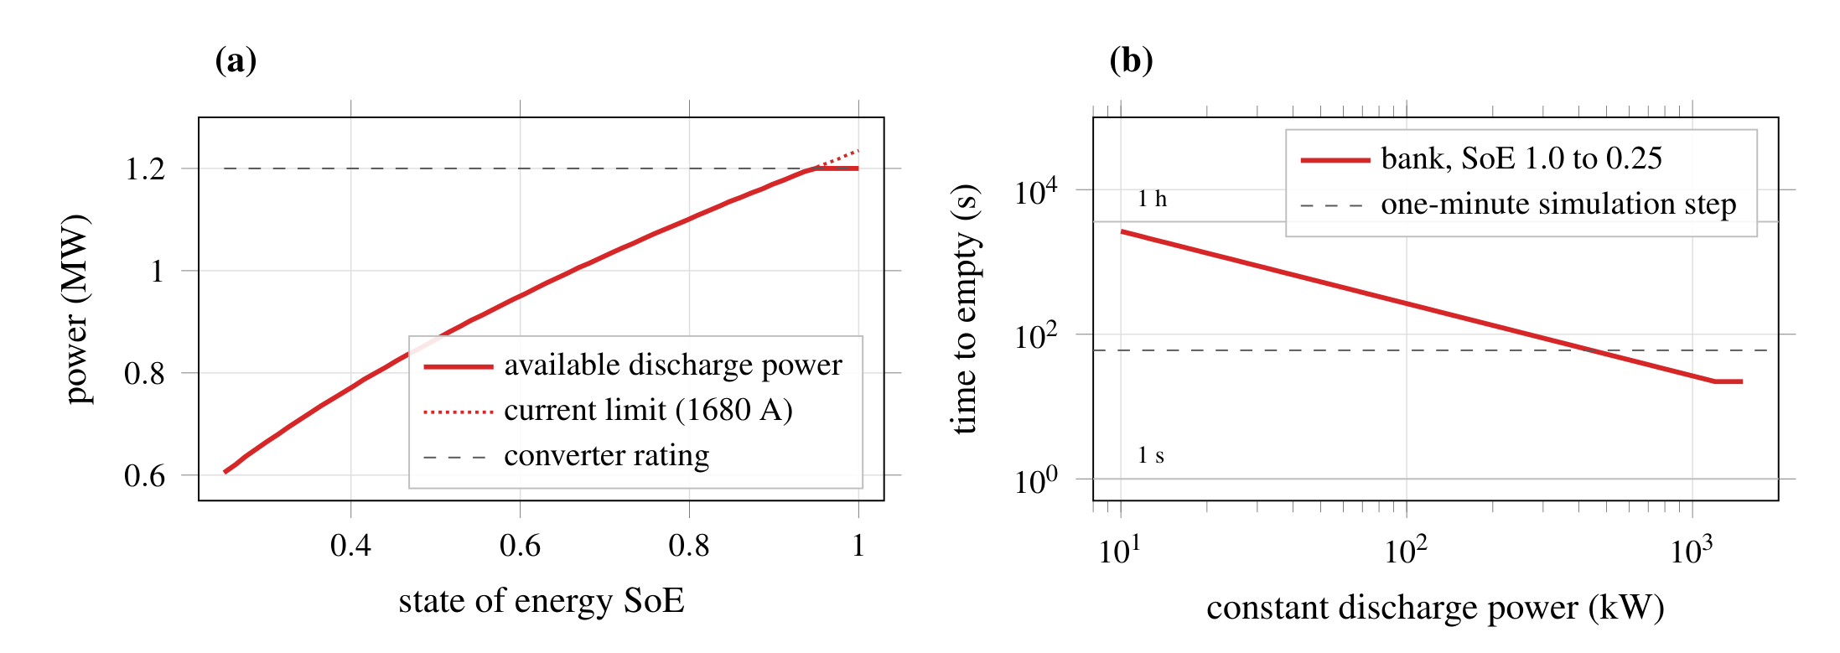
Figure 3. Supercapacitor bank of 72 Maxwell BMOD0063 P125 modules. (a) Available discharge power against state of energy; the current limit binds below SoE≈0.95. (b) Time to empty the usable energy at constant power, against the one-minute simulation step.

Weather data
The weather is generated rather than measured, so that both controllers face an identical year and every run is reproducible from its seed. Irradiance follows a clear-sky half-sine peaking at 900 W m⁻², with sunrise and sunset shifted by ±2 h over the year to give the seasonal daylight cycle. Each day is then given a cloud class: clear, broken or overcast, with probabilities 0.45, 0.35 and 0.20. On broken days, a cloud arrives with probability 1/15 and clears with probability 1/8 per minute, passing 25 to 55% of the clear-sky value; overcast days pass a steady 35%. This two-state cloud process produces the minute-scale ramps that the supercapacitor is sized for. A smooth irradiance model would remove the fast component of the imbalance and, with it, the reason for the timescale split in equation (6). Ambient temperature is a 20 °C mean with seasonal ±8 K and daily ±5 K cycles and 1 K of random variation, and enters the PV model through the cell-temperature correction of equation (9). Wind speeds are drawn hourly from a Weibull distribution (shape 2, scale 8 m s⁻¹), modulated by a ±30% daily cycle and 10% minute-scale turbulence, then passed through the power curve of equation (10).
PV power uses the linear temperature correction of module efficiency [13],
 | $$P_{PV} = η_{PV} A_{PV} G\left(1 - α_{T} (T_{c} - 25)\right), T_{c} = T_{a} + 0.03 G$$ | (9)
with temperatures in °C and G in W m⁻². The wind turbine follows a piecewise cubic power curve [14],
 | $$P_{W} = \left\{\begin{matrix}{\bar{P}}_{W} \frac{v^{3} - {v_{ci}}^{3}}{{v_{r}}^{3} - {v_{ci}}^{3}}, & v_{ci} ≤ v < v_{r}, \\ {\bar{P}}_{W}, & v ≥ v_{r}, \\ 0, & v < v_{ci},\end{matrix}\right.$$ | (10)
and trips above v_{co}, restarting only when the speed falls below 20 m s⁻¹.

Load and energy balance
The load follows a 2 MW base with daily and seasonal harmonics,
 | $$P_{L}(t) = 2 MW\left(1 + 0.3 sin\frac{2π(h - 6)}{24} + 0.15 sin\frac{2π d}{365} + ε(t)\right)$$ | (11)
where h is the hour and d the day. The noise ε adds an hourly Gaussian term (standard deviation 0.05) and a minute-scale autoregressive term (0.01), and the load is clipped to 0.5 to 3.5 MW. Over the year the load consumes 17 514 MWh, and renewables generate 12 820 MWh, equal to 73.2% of it. Without storage, 41.9% of the load energy is not met locally and a surplus equal to 15.1% is curtailed. Even perfect storage could only move that surplus into the deficit, so no controller can bring the deficit below 26.8%.
- Results
Both controllers run on the same plant and weather year, and the energy balance closes to within 10⁻¹² MWh in both runs.

Annual performance
Table 5 gives the annual indicators. The rule-based EMS lowers D_{L} from 31.77% to 31.10%. Of the 15.1 percentage points that storage could recover, the baseline recovers 10.1 and the rule-based EMS 10.8, so most of the gain comes from the storage itself. Curtailment falls by 78%, from 2.92% to 0.64%, because the controller spends 21% of the year in combined charge, where the battery and the electrolyser share the surplus.
Table 5. Annual indicators (seed 42, one-minute step, 365 days).
Indicator | PRB | TLRB
D_{L}, local supply deficit (%) | 31.77 | 31.10
C_{curt}, curtailment (%) | 2.92 | 0.64
R_{T}, terminal hydrogen reserve | 0.000 | 0.100
δ_{B}, δ_{S}, δ_{H}, delivered fractions | 0.53, 0.02, 0.41 | 0.38, 1.00, 1.00
σ_{S}, SC request served (%); time full or empty (%) | 2.1; 92.5 | 11.7; 73.6
SC delivered energy (MWh) | 41.2 | 231.2
Time at the SoC floor (%) | 43.1 | 53.3
Fuel-cell output; electrolyser input (MWh) | 442; 791 | 585; 1242
Mean |Δf| (Hz); time with |Δf| ≤ 0.5 Hz (%) | 0.221; 87.4 | 0.202; 87.1
κ_{V}, voltage compliance (%) | 98.3 | 89.0
Lowest; highest V_{i} (pu) | 0.950 (bus 18); 1.059 (bus 33) | 0.924 (bus 18); 1.070 (bus 33)

Frequency changes little: the mean deviation falls only from 0.221 to 0.202 Hz. Because Δf is a static image of the imbalance, it follows the deficit. The supercapacitor moves minute-scale swings away from the battery but leaves the total imbalance almost unchanged.

Commanded against delivered energy
The two controllers differ by only 0.67 percentage points in deficit, but their delivered fractions differ far more and show something the deficit cannot. Device limits are enforced downstream of the controller, so a command the plant cannot meet produces unserved load that is indistinguishable, in the annual total, from a command never issued.
Under the baseline the plant refuses 47.4% of the battery energy commanded, 97.9% of the supercapacitor energy and 58.8% of the hydrogen energy. Fixed shares ask each device for 20 to 50% of every imbalance regardless of its state: the bank has the power for its 20% share but only 7.38 kWh of usable energy, and the tank is empty from day 25 onwards, so 30% of every subsequent deficit is commanded from a branch that cannot respond. The baseline’s commanded dispatch is not the dispatch the plant executes, yet its 31.77% deficit cannot tell the two apart.
The rule-based EMS clips every command to the device limits it can compute from the measured states, so δ_{S} = δ_{H} = 1.00 by construction and no supercapacitor or hydrogen energy is refused. This is not the same as using the devices well. Measured before clipping, its supercapacitor serves 11.7% of the fast request against 2.1% under the baseline, and the bank is still full or empty for 73.6% of the year; its battery fraction of 0.38 reflects a battery that sits at its 0.20 floor for 53% of the year. Feasibility and utilisation are separate questions, and clipping settles only the first.

Timescale split
Figure 4 shows day 208, the day with the largest PV ramps. The slow part follows the trend of the imbalance, and the fast part carries cloud-edge steps of up to 2 MW. The bank delivers between −300 and 600 kW, but its state of energy swings between 1.0 and its lower bound many times. It has the power for the fast part but not the energy, and whatever it cannot take passes to the battery and the hydrogen branch in the same minute. Figure 5 gives the full dispatch of the rule-based EMS on the same day. Before hour 12 the renewables stay below the load for most minutes and the unserved trace reaches 1.4 MW, but the stores are exhausted rather than idle: the battery is at its 0.20 floor, the tank just above its 0.10 cut-off, and the supercapacitor is cycling between full and empty. What the plant lacks in the morning is stored energy, not converter rating.
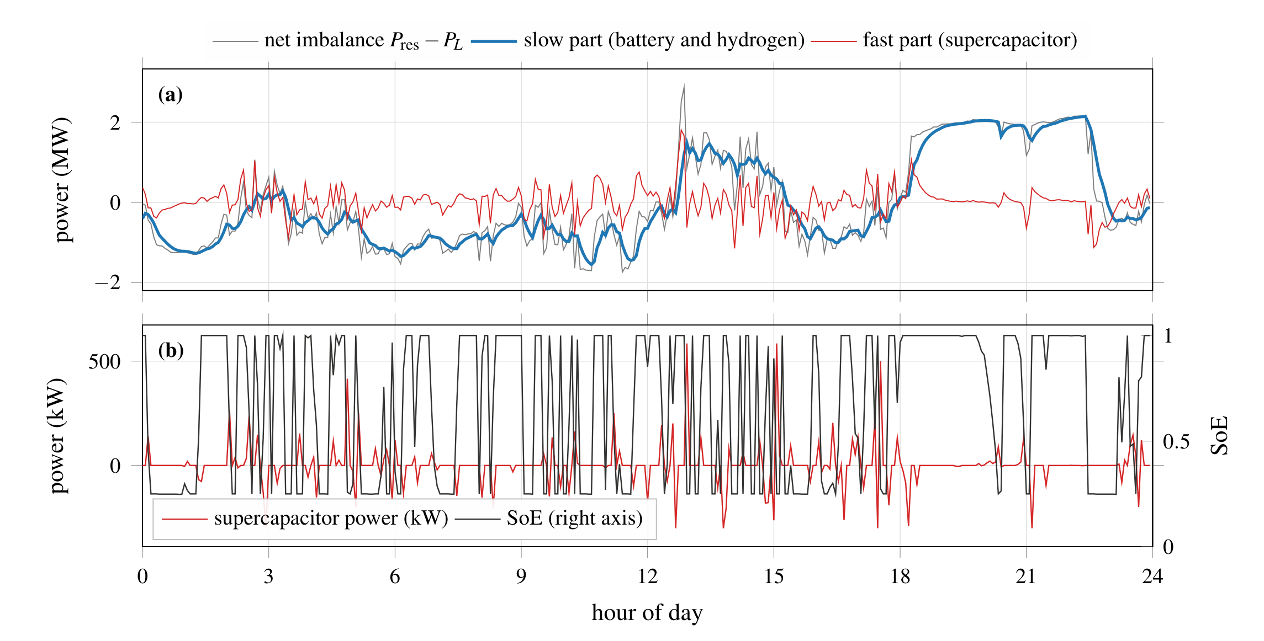
Figure 4. Timescale split on day 208, the day with the largest PV ramps. (a) Net imbalance and its slow and fast parts from the 10-minute filter. (b) Supercapacitor power and state of energy.
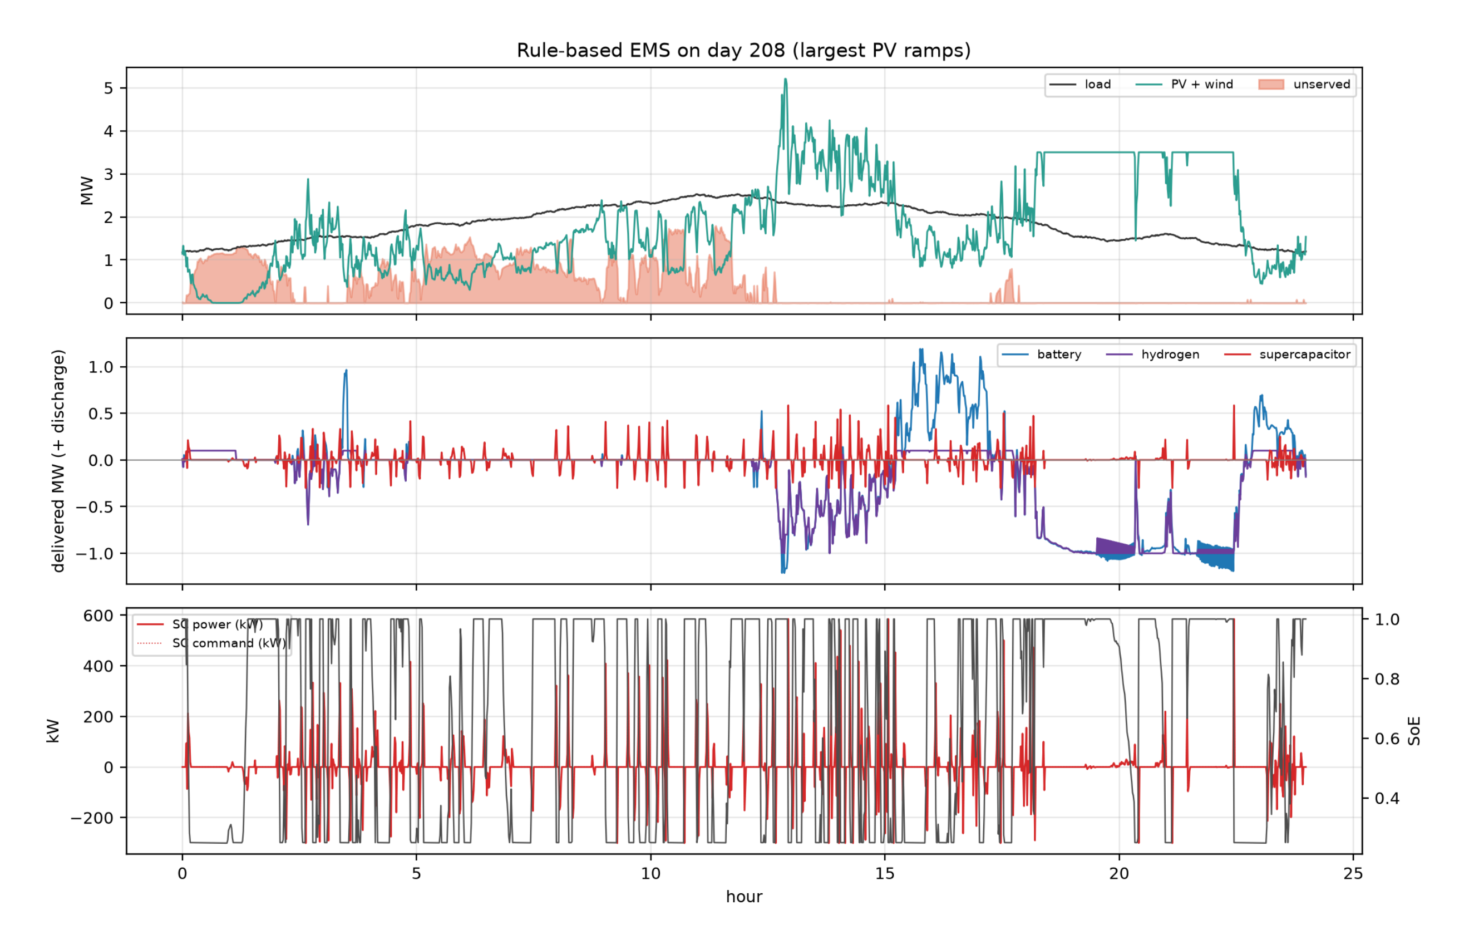
Figure 5. Rule-based EMS on day 208, the day with the largest PV ramps: (a) load, renewable output and unserved power; (b) delivered power per device, positive when discharging; (c) supercapacitor command, delivered power and state of energy.

Storage states over the year
Figure 6 gives the daily mean storage levels. The battery state of charge stays between 0.2 and 0.4 on most days. Both controllers start with a half-full tank. The baseline empties it by day 25 and never rebuilds it, while the rule-based EMS holds it between 0.10 and 0.12 for the rest of the year. Its hydrogen balance closes: the 1242 MWh absorbed by the electrolyser can return 473 MWh at the fuel-cell output. Together with the 140 MWh in the initial tank, this covers the 585 MWh delivered and the 28 MWh left at the end.
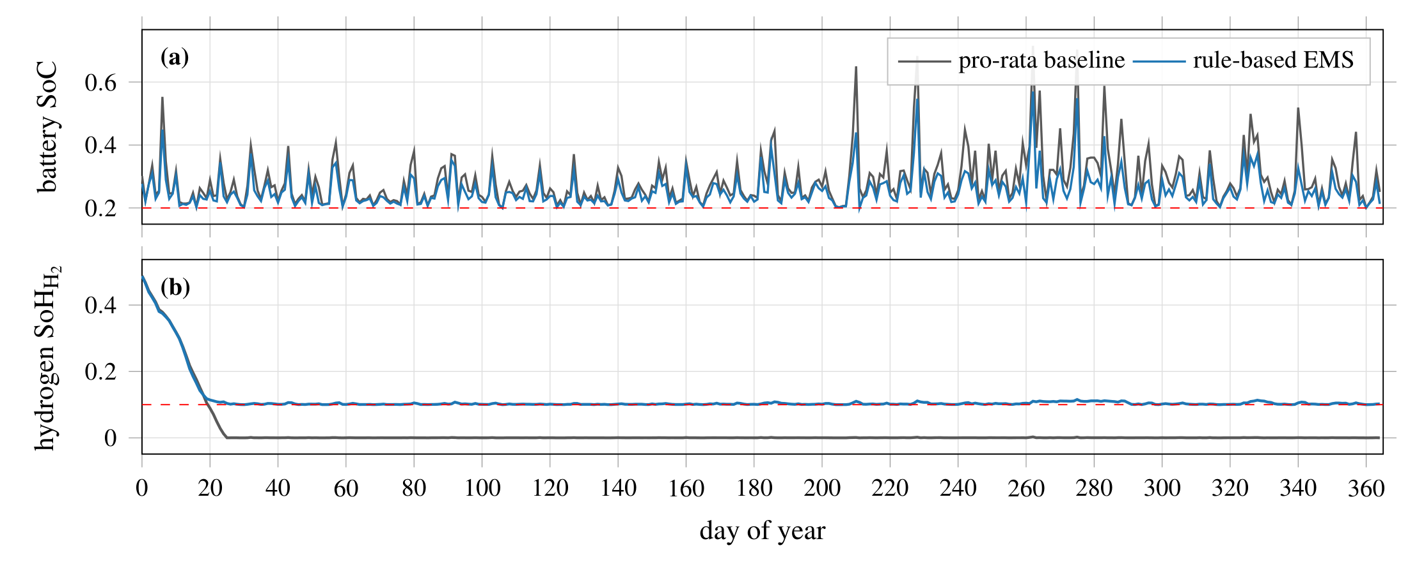
Figure 6. Daily mean storage levels over the year. (a) Battery state of charge, with its 0.20 floor. (b) Hydrogen tank level, with the 0.10 fuel-cell cut-off of the rule-based EMS.

Voltage and placement
Figure 7 gives the range of each bus voltage over the year. Under the baseline no bus falls below 0.95 pu, and the only violations are over-voltages at the end of the 26–33 lateral when PV peaks, in 1.7% of the year. The rule-based EMS leaves the band in 11.0% of the year. Under-voltage at bus 18 accounts for 9.4% of the year and occurs while the electrolyser is drawing power.
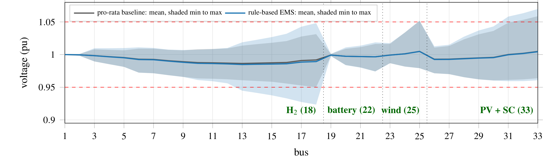
Figure 7. Bus voltages over the year with units at their buses (battery 22, PV and supercapacitor 33, wind 25, hydrogen 18): mean and minimum-to-maximum range for both controllers.

Seasonal representative days
The rules pick days 31, 82, 186 and 289 (table 6). The rule-based EMS lowers the deficit in winter by 0.2 percentage points, in spring by 2.7 and in summer by 2.2, and it lowers curtailment and the mean frequency deviation on all four days. On the autumn day, however, it raises the deficit from 29.06% to 31.46%, because the fuel-cell cap protects the tank instead of serving load (figure 8). The winter gain is small because the tank starts that day at its 0.10 cut-off.
Table 6. Day-level results on the four representative days; symbols and PRB, TLRB as in table 1, with SoH_{H₂} taken at 00:00.
Season | Day | SoH_{H₂} at start (PRB / TLRB) | D_{L} %, PRB / TLRB | Curtailed MWh, PRB / TLRB | κ_{V} %, PRB / TLRB | Mean |Δf| Hz, PRB / TLRB
Winter | 31 | 0.000 / 0.100 | 58.89 / 58.70 | 0.25 / 0.07 | 100.0 / 99.6 | 0.403 / 0.399
Spring | 82 | 0.000 / 0.106 | 39.39 / 36.72 | 0.72 / 0.00 | 100.0 / 93.3 | 0.293 / 0.265
Summer | 186 | 0.000 / 0.104 | 19.38 / 17.16 | 3.48 / 0.97 | 100.0 / 71.1 | 0.169 / 0.121
Autumn | 289 | 0.002 / 0.112 | 29.06 / 31.46 | 2.52 / 0.65 | 95.9 / 79.9 | 0.190 / 0.178

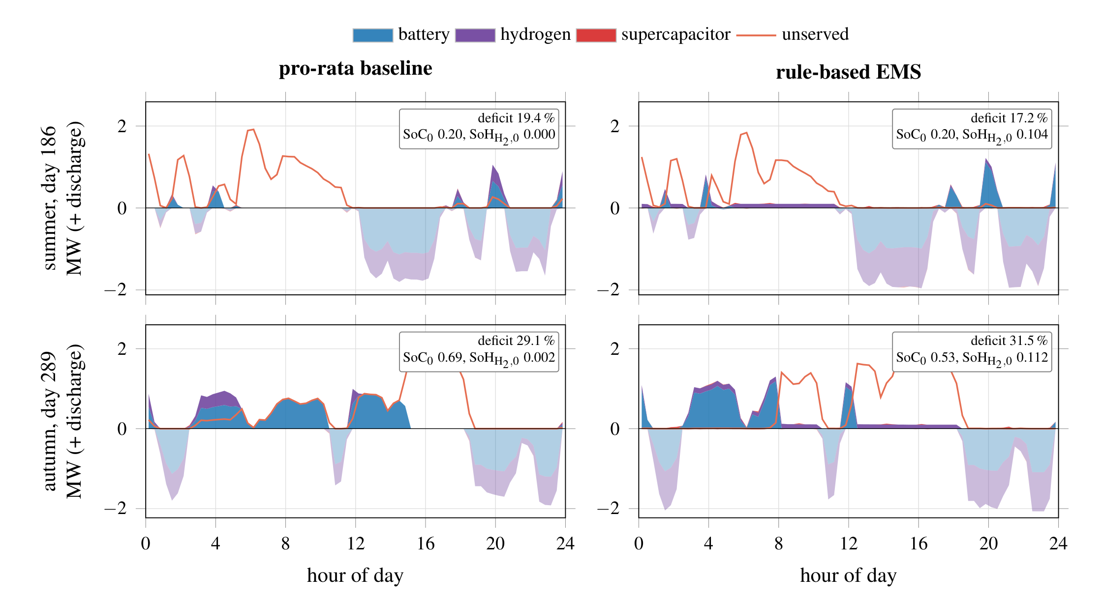
Figure 8. Dispatch on the summer (day 186) and autumn (day 289) representative days. Dark areas discharge and light areas charge; the line is unserved power. Boxes give the day’s deficit and the battery and tank levels at 00:00.
- Conclusions
This paper placed a battery, a supercapacitor bank, a hydrogen branch and their PV and wind sources at the four distributed-generation buses of the enhanced IEEE 33-bus benchmark, and compared a pro-rata baseline with a two-layer rule-based EMS over a full year at one-minute resolution. Placement follows from voltage sensitivity: the battery and the wind turbine go to the two stiffest buses, the PV and the supercapacitor to the end of the long lateral, and the hydrogen branch to the weakest bus. Renewable generation equalled 73.2% of the load energy, which bounds any controller’s deficit between 26.8% and 41.9%.
The rule-based controller reached a deficit of 31.10% against 31.77%, cut curtailment from 2.92% to 0.64%, and held a tenth of the hydrogen tank all year, whereas the baseline emptied it within 25 days. The cost was voltage compliance, which fell from 98.3% to 89.0% because the electrolyser draws power at the weakest bus. Judged on deficit alone, the two would be almost equivalent. The indicators that separate them are the reserve and the delivered fraction of commanded energy. On these, the plant refused 47%, 98% and 59% of the baseline’s battery, supercapacitor and hydrogen commands, but none of the rule-based EMS’s supercapacitor or hydrogen commands. The supercapacitor bank, built from 72 commercial modules, empties in 22 s at full power, so a step coarser than one minute would not resolve what it does. It delivered 231 MWh a year under the rule-based controller against 41 MWh under the baseline, yet served only 11.7% of the fast request, because it is short of energy rather than power.

Contributions
The contributions are:
- A T-HESS dispatched at one-minute resolution over a full year. The battery, the supercapacitor with the PV array, the wind turbine and the hydrogen branch are placed at the four distributed-generation buses of the enhanced IEEE 33-bus benchmark according to voltage sensitivity.
- Two strategies formulated on one interface: a pro-rata baseline with fixed shares and no state feedback, and a two-layer rule-based EMS combining a timescale filter, an 11-state machine with a tank-level cap on the fuel cell, and a 45-rule fuzzy layer.
- An evaluation on six indicators rather than one, adding the terminal hydrogen reserve and the delivered fraction of commanded energy to deficit, curtailment, frequency and the voltage at all 33 buses.
- A seasonal assessment on four representative days chosen by a fixed rule, which identifies when preserving the hydrogen reserve costs load.
Data availability
The three single-file Python programs used here and their outputs are available from the corresponding author on request.
Funding
The authors acknowledge the AIESI project (NORPART-2021/10403) and funding received from the Norwegian Directorate for Higher Education and Skills (HK-dir) through the NORPART scheme. This publication reflects only the authors’ views, and HK-dir is not liable for any use that may be made of the information contained therein.
Conflict of interest
The authors declare no competing financial or personal interests.
References
- Yang D, Lv H, Yan Y, Li M, Pan R and Liang J 2026 A hybrid deep reinforcement-supervised learning framework for energy management of fuel cell-battery hybrid vehicles IEEE Trans. Transp. Electrif. 12 4196–206 doi:10.1109/TTE.2026.3671072
- Guo J, He H and Guo S 2026 Energy management strategy for fuel cell buses based on airflow optimization and speed planning Int. J. Hydrogen Energy 198 152771 doi:10.1016/j.ijhydene.2025.152771
- Ashokkumar A and Amutha Prabha N 2026 Energy management strategy for photovoltaic, fuel cell, battery, and super capacitor in standalone direct current microgrid system J. Energy Storage 144 119600 doi:10.1016/j.est.2025.119600
- Beyers I, Bensmann A and Hanke-Rauschenbach R 2023 Ragone plots revisited: a review of methodology and application across energy storage technologies J. Energy Storage 73 109097 doi:10.1016/j.est.2023.109097
- Muralee Gopi C V V and Ramesh R 2024 Review of battery-supercapacitor hybrid energy storage systems for electric vehicles Results Eng. 24 103598 doi:10.1016/j.rineng.2024.103598
- Franco A and Giovannini C 2024 Hydrogen gas compression for efficient storage: balancing energy and increasing density Hydrogen 5 293–311 doi:10.3390/hydrogen5020017
- Zhu W, Wen S, Zhao Q, Zhang B, Huang Y and Zhu M 2025 Deep reinforcement learning based optimal operation of low-carbon island microgrid with high renewables and hybrid hydrogen–energy storage system J. Mar. Sci. Eng. 13 225 doi:10.3390/jmse13020225
- Huang Y, Gordon D and Scott P 2023 Receding horizon dispatch of multi-period look-ahead market for energy storage integration Appl. Energy 352 121856 doi:10.1016/j.apenergy.2023.121856
- Baran M E and Wu F F 1989 Network reconfiguration in distribution systems for loss reduction and load balancing IEEE Trans. Power Deliv. 4 1401–7 doi:10.1109/61.25627
- Dolatabadi S H, Ghorbanian M, Siano P and Hatziargyriou N D 2021 An enhanced IEEE 33 bus benchmark test system for distribution system studies IEEE Trans. Power Syst. 36 2565–72 doi:10.1109/TPWRS.2020.3038030
- European Commission 2017 Commission Regulation (EU) 2017/1485 of 2 August 2017 establishing a guideline on electricity transmission system operation Off. J. Eur. Union L 220 1–120
- Hu X, Li S E and Peng H 2012 A comparative study of equivalent circuit models for Li-ion batteries J. Power Sources 198 359–67 doi:10.1016/j.jpowsour.2011.10.013
- Skoplaki E and Palyvos J A 2009 On the temperature dependence of photovoltaic module electrical performance: a review of efficiency/power correlations Sol. Energy 83 614–24 doi:10.1016/j.solener.2008.10.008
- Carrillo C, Obando Montaño A F, Cidrás J and Díaz-Dorado E 2013 Review of power curve modelling for wind turbines Renew. Sustain. Energy Rev. 21 572–81 doi:10.1016/j.rser.2013.01.012
- Maxwell Technologies 2021 Ultracapacitor product matrix online https://maxwell.com/wp-content/uploads/2021/08/ProductMatrix.pdf (accessed 11 September 2026)
- US Department of Energy Technical targets for proton exchange membrane electrolysis online https://www.energy.gov/eere/fuelcells/technical-targets-proton-exchange-membrane-electrolysis (accessed 11 September 2026)
- US Department of Energy DOE technical targets for fuel cell systems and stacks for transportation applications online https://www.energy.gov/eere/fuelcells/doe-technical-targets-fuel-cell-systems-and-stacks-transportation-applications (accessed 11 September 2026)
- Kundur P 1994 Power System Stability and Control (New York: McGraw-Hill)

