Global screening of offshore renewable energy surplus around ports for maritime decarbonization
S Cho¹, J Dai^{2,*}, C Lu² and M O Kim¹
¹ Seoul National University of Science and Technology, Republic of Korea
² Oslo Metropolitan University, Norway
* Contact author: jiandai@oslomet.no
Abstract. Port electrification and maritime decarbonization are concentrating electricity demand on coastlines with substantial offshore renewable resources. This study develops a global, port-centred screen linking wind, wave and solar resource proxies with adjacent coastal electricity consumption. Annual densities derived from ten years of ERA5 are allocated without double counting to 3 669 World Port Index ports within 25, 50 or 100 km, and compared with demand estimated from population and national per-capita electricity use. Four assumption layers are distinguished: wind-term basis (A1), wave crest spacing (A2), usable-supply factor (A3) and access radius (A4), with usable sea-area fraction f examined separately. In the average 50 km case, 66.6 % of all ports have positive resource-flux mismatch, and 71.2 % of ports with positive allocated demand exceed 100 % coverage. Net mismatch changes by −72.5 % to +214.3 % with radius, by −32.2 % to +44.2 % with the usable-supply factor, and by −99.1 % at f = 1 %. Individual port classifications remain unchanged across the tested usable-supply factors at a fixed radius, while the surplus share spans 14.1 percentage points across radii. The framework identifies allocation radius as a key control on both magnitude and classification. These results describe resource-based screening; their extension to delivered electricity requires a generation model.
- Introduction
Maritime decarbonization is shifting energy demand onto the coast. International shipping carries about 80 % of global trade by volume and remains heavily dependent on fossil fuels, and the International Maritime Organization has adopted indicative checkpoints toward net-zero emissions from international shipping by or around mid-century [1,2]. Meeting those checkpoints requires more than efficient hulls and alternative fuels: much of the energy a decarbonized fleet will use must be generated, converted and delivered close to where vessels operate. Shore power for berthed vessels, battery-electric and hybrid ships on short-sea routes and electrified cargo handling each remove emissions from the vessel and place a new load on the coastal electricity system [3,4].
The offshore resource sits directly alongside that new load, and it is by now well characterized. Offshore wind has passed the multi-gigawatt scale as floating foundations open deeper water, while wave converters and floating photovoltaics remain earlier in commercialization but are under sustained assessment [5,6]. Reanalysis products have quantified global offshore wind potential and its variability [7,8], mapped and classified wave resources [9,10] and examined the combined exploitation of the two [11], consistently placing wind and wave in the mid-to-high latitudes and solar in the tropics, with the first two physically coupled and the third often complementary [12].
Knowing where the resource is, however, does not establish where it can be used. A raw-potential map is silent on whether the resource reachable from a particular port covers the consumption concentrated there, and on whether any excess has a use nearby. Work at the opposite extreme — techno-economic modelling of offshore wind-to-hydrogen plants, ammonia production or combined systems at candidate sites [13,14] — answers a viability question but only after the site has been chosen. Neither addresses the intermediate problem of deciding which stretches of coast are worth that modelling effort in the first place. Ports are the natural unit for such a decision, since they are simultaneously where coastal consumption concentrates, where vessels take on energy, and where any offshore generation, conversion or charging asset would be anchored.
This paper develops such a screen and applies it globally. Annual wind, wave and solar energy densities are derived from ten years of ERA5 reanalysis, placed on a common areal basis, allocated to 3 669 World Port Index ports by a nearest-port rule that prevents double counting, and compared with land-side coastal-belt electricity consumption estimated independently from gridded population and national per-capita use. A per-port mismatch index, an oversupply field and a demand-coverage ratio follow, while vessel-traffic intensity supplies geographical context without entering the energy balance or a recalculated quantitative overlap with port classes.
A screen of this kind is useful precisely because it is cheap, and for the same reason it is heavily parameterized. What it reports depends on how the wind resource is expressed, on how line-based wave power is converted to an areal quantity, on how much of the accessible sea is assumed developable, and on how far offshore a port is deemed to reach. None of these is a measurement; each is a modelling decision capable of moving the reported number by an order of magnitude or more. The literature has tended to treat such decisions as caveats rather than as results: assumptions are stated in a methods section and qualified in a limitations section, but the size of the envelope they generate is rarely reported, and neither is the question of whether the qualitative finding survives it. That question is the decisive one for a planner, because a result that changes sign under a plausible assumption is not actionable, whereas one that only changes magnitude can be acted on provided the magnitude is quoted together with its basis.
This paper therefore carries the assumptions through into the results rather than confining them to caveats. Four primary layers are examined: the wind-term basis (A1), wave crest spacing (A2), usable-supply factor (A3) and access radius (A4). The usable sea-area fraction f is an additional analytical sensitivity. Port-level numerical results are reported relative to one reference case; the wave-spacing comparison concerns resource dominance, and the wind-basis discussion uses literature context. Two wave-method details are examined in depth: the energy period entering the deep-water power flux and the crest spacing used to express that flux per unit area.
- Methodology
  - The screen in outline
The screen answers one question per port: does the annual energy incident on the sea that port can reach exceed the electricity consumed on the coastal land beside it? Five steps produce that answer. The wind, wave and solar fields are each converted from ERA5 into an annual energy per unit sea area, so that three dissimilar resources become one additive quantity; each density is scaled by a usable-supply factor; every ocean cell is assigned to exactly one port, retained only if it falls within an access radius, then area-weighted and summed; coastal demand is built independently on a 1 km grid, restricted to a belt of matched width and allocated to the same ports; and the two allocated quantities are differenced. Offshore operations run on a common 0.25° reference grid and demand operations on the 1 km grid, both referenced to EPSG:4326, and the sequence is repeated for every combination of usable-supply scenario and access radius.
Table 1 lists what enters each step. The ERA5 window spans 2016–2025 [15], long enough to carry both the mean resource and its seasonal structure, and the port set is the 3 669 entries of the World Port Index [18]. The supplied per-capita electricity file contains no observations for 2024 or 2025. Country means use available observations within the requested 2016–2025 window, effectively 2016–2023 where 2023 is available and 2016–2022 otherwise.
Table 1. Quantities required by the screen and the source of each.
Quantity required | Source, coverage and resolution | Ref.
10 m wind components | ERA5; global, 2016–2025, hourly, 0.25° | [15]
Significant wave height; mean wave period | ERA5; global, 2016–2025, hourly; 0.5° source fields regridded to 0.25° | [15]
Downward surface shortwave radiation (all-sky) | ERA5; global, 2016–2025, hourly, 0.25° | [15]
Coastal population | WorldPop Global2 constrained annual count; 1 km, 2016–2025 mean | [16]
Electricity use per capita | World Bank EG.USE.ELEC.KH.PC; national, available-year mean, 2016–2023 or 2016–2022 | [17]
Port positions | World Port Index (Pub. 150); 3 669 ports | [18]
Land–sea boundary and coastal belt | Natural Earth admin-0 countries, 1:110 m | [19]
Vessel-traffic intensity | World Bank Global Shipping Traffic Density; 2015–2021, 0.005° → 0.25° | [20]
  - Supply terms, and the assumption each one introduces
The three resources do not arrive on a common footing. Wind is a flux through a plane, wave a flux along a line and solar a flux through a surface, and the operations that place them on one areal basis are where the assumptions enter. Equations (1)–(3) give the instantaneous densities and table 2 states, for each, what had to be assumed to obtain it.
P_{wind} = ½ ρ U³ [W m⁻²] (1)
P_{wave} = (ρ_{w} g² / 64π) H_{s}² T_{e} ≈ 0.49 H_{s}² T_{e} [kW m⁻¹] (2)
P_{solar} = SSRD / Δt [W m⁻²] (3)
Here U is the 10 m wind speed and ρ = 1.225 kg m⁻³; ρᵥ, g, Hₛ and Tₑ are sea-water density, gravitational acceleration, significant wave height and the energy period; and SSRD is the accumulated downward shortwave radiation over the interval Δt. The 10 m wind is used without hub-height extrapolation, which makes the wind field conservative in that one respect while leaving the more consequential issue untouched, as set out below. For wave power, division by S precedes the areal integration. Integrating each instantaneous density across the hourly record and dividing by the number of years gives the annual density that enters the rest of the workflow,
E_{x} = (1 / N_{y}) Σ_{t} P_{x,t} Δt [MWh km⁻² yr⁻¹] (4)
Two points in table 2 warrant expansion because they are handled inconsistently in the screening literature. The first concerns the wave period. Equation (2) is written on the energy period, and the ERA5 mean wave period field is defined on the negative-first spectral moment, Tₘ₋₁,₀ = m₋₁ / m₀, which is the energy period itself [21]. No period conversion coefficient is therefore warranted; where one is applied it introduces a systematic bias that combines multiplicatively with the crest-spacing choice, and using the native energy period avoids that additional conversion uncertainty. Wave-field bias, the deep-water approximation and the choice of S remain sources of uncertainty.
The second concerns the wind term. Equation (1) is a flux through a vertical plane, and reporting it per unit of sea surface is what makes wind commensurable with solar; but the operation is not a conversion, and nothing in it accounts for how densely turbines could actually be placed. The field is a resource proxy, not an areal yield, and no choice of η repairs this: scaling a kinetic-energy flux returns a scaled flux. A1 is consequently the only layer in this paper that cannot be swept continuously, since moving from flux to yield requires a different supply model rather than a different parameter value; reported installed and output power densities of offshore wind farms provide context [22], but are not a substitute for a spatially explicit generation model. No port-level generation-basis result is inferred from that comparison.
The usable-supply factor is swept over 0.30 / 0.39 / 0.55 for wind, 0.10 / 0.25 / 0.40 for wave and 0.10 / 0.20 / 0.30 for solar. These are illustrative multipliers bracketing conversion uncertainty, not capacity factors; the scaled densities are then summed.
Table 2. The three supply terms: what each measures, how it is placed on an areal basis, and the assumption this introduces.
Resource | What Eq. (1)–(3) measures | Operation making it areal | Assumption introduced | Layer
Wind | Kinetic-energy flux through a vertical plane | Reported per unit sea surface | That a plane flux may stand for an areal yield; array density, wake, availability and electrical losses are all absent | A1
Wave | Power flux per metre of wave crest | Divided by a characteristic crest spacing S | A device layout, expressed as a single length; the wave term scales as 1/S | A2
Solar | Irradiance on a horizontal surface | None required | No tilt or temperature correction; cloud attenuation is already in the all-sky input | —
All three | Resource incident on the sea surface | Scaled by a usable-supply factor η | That conversion performance and system losses collapse into one coefficient | A3
  - Allocation and the demand reference
Cells are linked to ports in two stages, and the order matters. Every ocean cell centre is first assigned to its single nearest port by a k-d tree search on the unit sphere; only then is the assignment filtered by a great-circle distance threshold R. Assigning before filtering is what prevents a cell from being credited to two neighbouring ports where their catchments overlap, and it is why no double counting arises even at the widest radius. The wave and solar fields are reindexed to the wind reference grid by nearest-neighbour matching, land cells are removed using country polygons with mask rows aligned to the ascending latitude order of the resource arrays, and cell area is computed analytically from latitude, Aᵢ = (Δφ k)(Δλ k cos φᵢ) with k = 111.32 km per degree, so that the poleward contraction of the grid is carried correctly. For both supply and demand allocation, records with identical coordinates are assigned consistently to the lowest PORT_ID, retaining one credit per cell. Supply accessible to a port is then
S_{p} = Σ_{i ∈ p} E_{i}ᵘˢᵃᵇˡᵉ A_{i} [MWh yr⁻¹] (5)
R is the fourth assumption layer, A4. The three values examined — 25, 50 and 100 km — stand for successively more permissive views of what a port can reach rather than for engineering limits, and the narrowest of them spans no more than one or two cell centres at 0.25°, so results at 25 km carry a discretization effect and are read as indicative.
The demand reference is land-side coastal electricity consumption, excluding vessel propulsion and port-operation energy. Cell demand is mean population multiplied by the containing country's available-year mean electricity use. Missing annual observations are omitted without interpolation; countries without observations or valid code matches are excluded. France and Norway are linked explicitly to FRA and NOR because their Natural Earth ISO_A3 values are -99. Country polygons are merged to remove international land borders before constructing the coastal belt in WGS 84 / Pseudo-Mercator (EPSG:3857), by inward buffering through R and differencing. Periodic copies handle the antimeridian. Eligible cell centres are assigned to the nearest port on the unit sphere and retained within 150 km great-circle distance. The projection scale factor is approximately 1/cos φ, giving a ground width of approximately R cos φ. Higher-latitude ports therefore sample narrower physical belts, so cross-latitude comparisons are conditional on this geometry. Because belt width follows R, A4 changes both supply and demand.

  - Reference case, excursion measure and classification measure
For each port the screen returns the mismatch MI_{p} = S_{p} − D_{p}, its positive part O_{p} = max(MI_{p}, 0) and the demand coverage C_{p} = 100 S_{p} / D_{p}. Coverage is undefined when Dp = 0 and is stored as missing; such ports are excluded from coverage medians. Surplus and deficit shares use all N = 3 669 ports, whereas coverage-threshold shares state explicitly whether the denominator is all ports or only those with positive allocated demand. Comparing whole runs of the screen against one another, rather than comparing ports within one run, requires two further quantities that are defined here and used throughout section 3. Let θ denote a setting of the assumption layers and θ₀ the reference setting. The excursion in magnitude is the relative change in the net mismatch summed over all ports,
Δ(θ) = 100 [ MI_{net}(θ) − MI_{net}(θ₀) ] / MI_{net}(θ₀) [%] (6)
and the excursion in classification is the shift in the share of ports returned as being in surplus, ρ₊ = 100 N(MI_{p} > 0) / N,
σ(θ) = ρ₊(θ) − ρ₊(θ₀) [percentage points] (7)
A layer with large |Δ| and small |σ| changes aggregate magnitude more than the overall surplus share. This does not by itself establish stability at individual ports, which is checked separately. Equations (6) and (7) describe the port-level numerical sweeps and analytical sea-area scaling. A1 and A2 have different evidential roles, as specified in table 3. Reporting relative changes allows numerical cases of different absolute magnitude to be compared on one scale.
Table 3 collects the four primary layers and the additional sea-area sensitivity, the range over which each is varied and the mechanism by which each acts. They are not all varied simultaneously. A1 is a literature-informed discussion and does not yield recalculated port classifications. A3 and A4 are swept as a full three-by-three grid of nine cases, since both act on port-level totals and their interaction is of interest in itself. A2 is evaluated numerically on the unscaled annual resource fields, because it alters which resource is dominant before any port allocation occurs, and is reported using reclassification thresholds and counts of wave-dominant ocean cells. The usable sea-area fraction f is handled analytically: supply is linear in f, so coverage at every port and the aggregate supply-to-demand ratio rescale by the same factor, and f ∈ {100, 20, 10, 5, 1} % is evaluated by scaling rather than by recomputation. The reference setting θ₀ throughout is η = average, R = 50 km, S = 1000 m and f = 100 %.
Table 3. Four primary assumption layers and the additional sea-area sensitivity, with the treatment and scope of evidence for each.
Layer | Assumption | Range examined | Acts on | Treatment
A1 | Basis of the wind term | kinetic flux → delivered yield | Absolute supply magnitude; relative weight of wind against wave | Literature context only; no port-level generation recomputation
A2 | Characteristic crest spacing S | 1000 → 500 → 200 m | Wave density; dominant-resource classification | Numerical resource-field comparison; no port-level reallocation
A3 | Usable-supply factor η | low / average / high | Supply magnitude at every port | Swept, 3 × 3 grid with A4
A4 | Access radius R | 25 / 50 / 100 km | Accessible sea area and, through the belt, allocated demand | Swept, 3 × 3 grid with A3
f | Usable sea-area fraction | 100 → 1 % | Supply magnitude; required deployable area | Analytical rescaling of supply at fixed demand

- Results and discussion
All results below are for the combined wind–wave–solar supply, and the average scenario at 50 km is the reference unless another case is named. They are screening quantities throughout — spatial patterns and relative magnitudes on the flux basis of section 2.2 — and not site-level yields.
  - Offshore supply distribution
Both the wind and the wave field peak in the mid-to-high latitudes of the two hemispheres, the largest values lying in the Southern Ocean storm belt and in the northern North Atlantic and North Pacific; on the flux basis of equation (1) they reach the order of 10⁶ MWh km⁻² yr⁻¹, a strong westerly regime over long fetches being amplified by the cubic dependence of power on speed. Solar density is instead organized about the tropics and falls away toward the poles. These annual spatial patterns describe where resources are strong; they do not establish temporal complementarity at an individual location. The practical reading is geographic: the resource mix that suits a tropical port is not the one that suits a high-latitude port, while shared infrastructure is one potential benefit of combining wind and wave systems [11]. Temporal diversification requires separate time-resolved analysis.
  - The wave term: energy period and crest spacing (A2)
Because wave power is intrinsically line-based whereas wind and solar are area-based, the normalization length S is the single assumption that sets the wave contribution relative to the other two resources. Its effect is inversely proportional to S: the area-based wave density scales as 1/S, so reducing S from the 1000 m baseline to 500 m and 200 m multiplies the wave term by two and five respectively. Table 4 states the reclassification condition this implies: the threshold, relative to the leading resource in a cell, that the baseline wave density must exceed for that cell to become wave-dominant.
On the unscaled annual resource fields, no ocean cell is wave-dominant at S = 1000 or 500 m. At S = 200 m, 15 of the 693 571 evaluated ocean cells are wave-dominant, fewer than 0.003 %. Dominance thus remains overwhelmingly wind/solar on this flux basis. An array-based wind yield could change the relative resource magnitudes and sensitivity to S; this generation-basis comparison has not been computed.
The definitional point in section 2.2 compounds this. Where a screening study applies a conversion factor between the ERA5 mean wave period and the energy period, it introduces a systematic bias into the wave term that combines multiplicatively with the crest-spacing choice. Since the ECMWF mean wave period is already defined on the negative-first spectral moment and is therefore the energy period [21], no such factor is warranted, while uncertainties in the wave fields, deep-water approximation and spacing remain.
Table 4. Effect of the crest spacing S on the area-normalized wave density and on the dominant-resource classification of unscaled annual fields over 693 571 ocean cells.
Crest spacing S (m) | Wave density multiplier | Reclassification condition | Outcome
1000 (baseline) | 1.0× | baseline wave > leading resource | no wave-dominant cells
500 | 2.0× | baseline wave > 0.50 × leading resource | no wave-dominant cells
200 | 5.0× | baseline wave > 0.20 × leading resource | 15 wave-dominant cells (<0.003 %)
  - Coastal-belt electricity demand
At the 50 km belt, the median allocated demand across all 3 669 ports is 1.34 × 10⁵ MWh yr⁻¹, the mean is 1.51 × 10⁶ and the maximum is 9.76 × 10⁷. The distribution is strongly right-skewed, so a small number of ports contribute a large share of aggregate allocated demand.
In the reference case, 919 ports (25.0 %) receive no allocated demand, compared with 1 095 at 25 km and 828 at 100 km. Zero allocation can reflect geography, the allocation rule or missing data and does not establish absence of consumption. At 50 km, 484 of these ports have positive supply and enter the all-port surplus count; 435 have neither supply nor demand. All 919 are excluded from coverage medians and from the demand-bearing-port denominator.
  - Port-centred mismatch: classification and magnitude
The reference case has 2 443 surplus ports (66.6 % of all 3 669 ports), 791 deficit ports (21.6 %) and 435 ports with zero mismatch. The surplus count comprises 1 959 demand-bearing ports and 484 zero-demand ports with positive supply. Thus the share exceeding 100 % coverage is 53.4 % of all ports (1 959/3 669), or 71.2 % of the 2 750 demand-bearing ports. Aggregate accessible supply is about 1.29 × 10³ times allocated demand.
The aggregate ratio compares a scaled resource-flux proxy with estimated electricity consumption and cannot be read as deliverable generation. All 791 reference-case deficit ports have zero assigned offshore supply cells. Their classification therefore reflects allocation geometry at this grid resolution, rather than high demand exhausting an otherwise positive local resource. This result highlights the need to check grid resolution, coastline representation and nearest-port competition before interpreting deficits.
  - Access radius and usable-supply factor (A4, A3)
Table 5 and Figure 1 report the nine numerical usable-supply-by-radius cases. At average η, reducing R from 50 to 25 km changes aggregate net mismatch by -72.5 %, while increasing R to 100 km changes it by +214.3 %. Median per-port mismatch changes by -70.8 % and +112.0 %, respectively. At R = 50 km, the low and high usable-supply scenarios change aggregate net mismatch by -32.2 % and +44.2 %. Radius is the stronger of these two numerically swept controls.
The joint η–R design therefore reveals a wider range than varying η alone. This ranking applies to the tested ranges of these two port-level controls; A1 and A2 use the distinct treatments in table 3.
Between 25 and 100 km, aggregate supply increases by a factor of 11.42, allocated demand by 2.64 and allocated demand-cell area by 3.44. The supply-to-demand ratio consequently increases by 4.32. Accessible sea area, coastal geometry and nearest-port competition jointly determine this effect. Since demand also changes with R, the radius comparison represents a coupled supply-and-demand sensitivity.
Table 5. Change in the net and median per-port mismatch relative to the reference case (η = average, R = 50 km), for the nine usable-supply-by-radius combinations. Shares are of all 3 669 ports.
Usable supply η | R (km) | Net mismatch (% change) | Median per-port mismatch (% change) | Oversupply (%) | Deficit (%)
Low | 25 | −81.5 | −82.7 | 54.9 | 28.0
Low | 50 | −32.2 | −35.7 | 66.6 | 21.6
Low | 100 | +115.0 | +40.4 | 69.0 | 21.6
Average | 25 | −72.5 | −70.8 | 54.9 | 28.0
Average | 50 | 0 (reference) | 0 (reference) | 66.6 | 21.6
Average | 100 | +214.3 | +112.0 | 69.0 | 21.6
High | 25 | −60.3 | −57.2 | 54.9 | 28.0
High | 50 | +44.2 | +45.5 | 66.6 | 21.6
High | 100 | +352.6 | +206.9 | 69.0 | 21.6
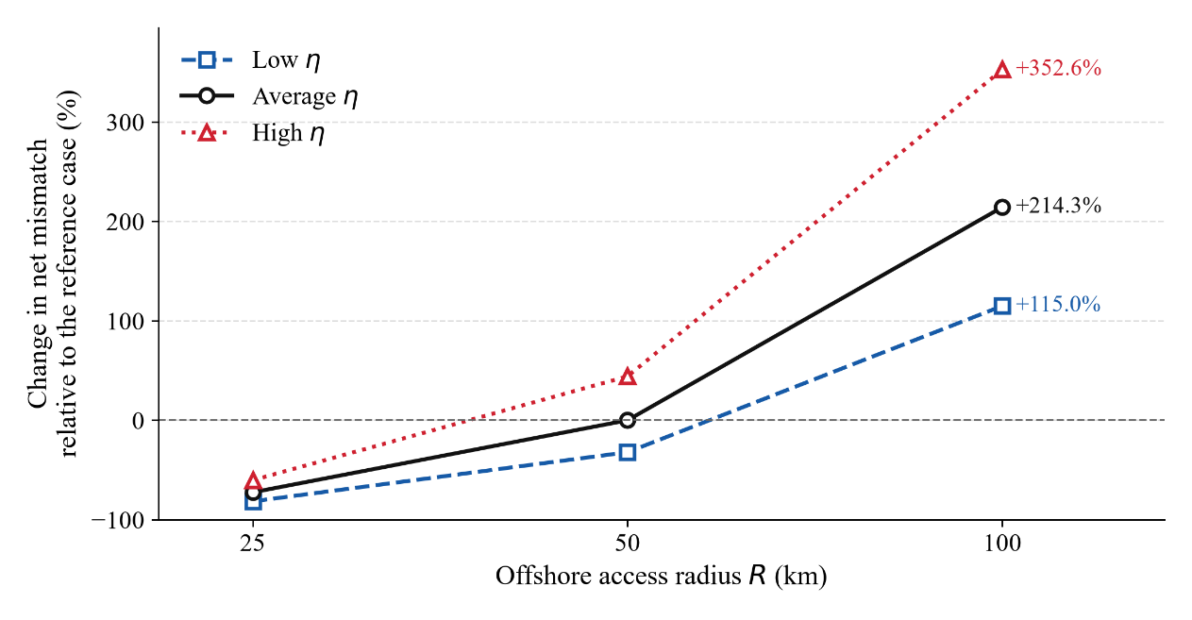
Figure 1. Net mismatch against the offshore access radius for the three usable-supply scenarios, as a change relative to the reference case (η = average, R = 50 km). The horizontal axis is logarithmic.
  - Deployable sea area (f)
The sea-area fraction f scales each port's reference supply at fixed demand. Coverage and the aggregate supply-to-demand ratio scale linearly with f (Figure 2), whereas net mismatch is fS − D. Reducing f from 100 % to 10 % lowers the all-port surplus share from 66.6 % to 66.5 %. Coverage exceeds 100 % at 53.4 % and 53.3 % of all ports, respectively, or 71.2 % and 71.1 % of demand-bearing ports. At f = 1 %, the all-port surplus share is 64.8 %.
Among demand-bearing ports, the median required sea-use fraction is approximately 0.077 % on this flux basis. However, 791 of the 2 750 ports have zero supply, so no finite f can meet their demand under the current allocation. This makes the upper quartile of required f unbounded. The median therefore needs to be read alongside the zero-supply count; actual deployability requires a generation model and spatial exclusions.
  - The combined assumption envelope
Figure 3 compares A3 and A4 numerical sweeps from table 5 with analytical sea-area scaling. At f = 1 %, net mismatch decreases by 99.1 % at fixed demand. A1 uses literature context on wind-farm power densities [22] and has no quantified bar, because a wind-component reduction is not an equivalent reduction in combined net mismatch. A2 is reported separately through resource dominance in table 4.
The surplus share spans 54.9–69.0 % across the nine cases, a range of 14.1 percentage points. Relative to the reference, σ ranges from -11.7 to +2.4 percentage points. The deficit share spans 6.4 percentage points. At each fixed radius, changing η leaves individual port classifications unchanged in these outputs. Changing radius from 50 to 25 or 100 km, however, changes the surplus/deficit/zero class at 594 and 176 ports, respectively. The access-radius assumption is therefore consequential for both magnitude and classification.

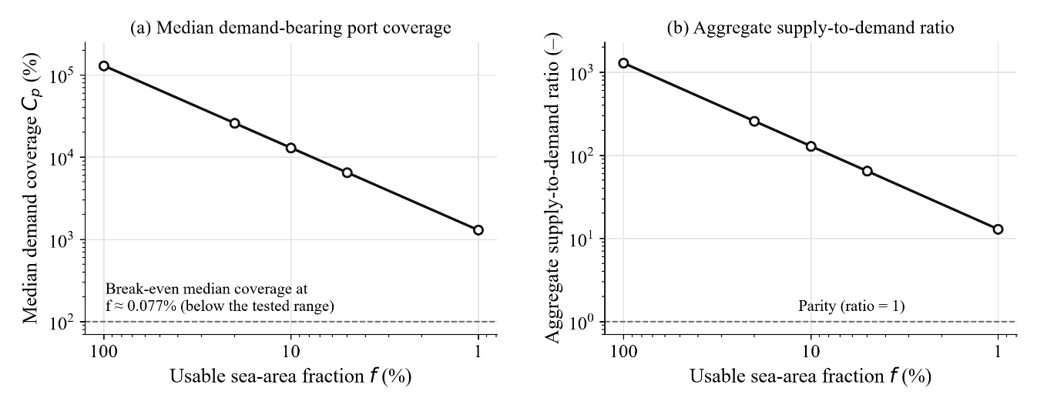
Figure 2. Analytical sea-area scaling for (a) median coverage among the 2 750 ports with positive allocated demand and (b) total supply divided by total demand over all 3 669 ports. The 919 zero-demand ports have undefined coverage and are excluded from panel (a), while their supply remains included in panel (b). Both panels use the average 50 km reference case, log–log axes and fixed demand. Dashed lines mark 100 % coverage and a supply-to-demand ratio of one.
The results support stable individual classifications across the tested η values at a fixed radius, alongside substantial sensitivity to radius. The framework thus distinguishes changes in resource magnitude from changes in which ports enter each class. Resource basis, allocation geometry and demand coverage remain necessary information for using the screen to guide further assessment.
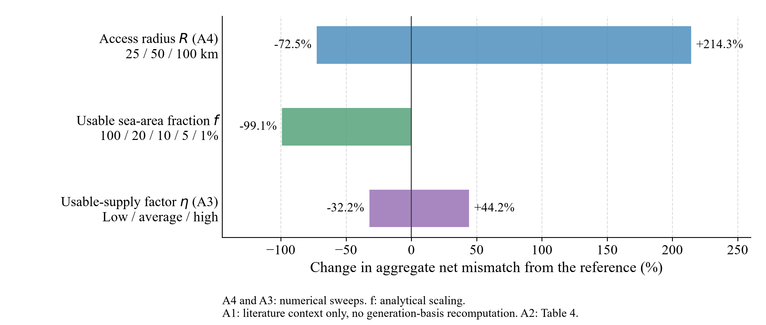
Figure 3. Change in aggregate net mismatch from the average 50 km reference. A4 varies R at average η; A3 varies η at R = 50 km. The f bar is analytical scaling from 100 % to 1 % at fixed demand. A1 is literature context without a numerical generation result; A2 uses resource dominance in table 4.
  - Maritime activity overlay
Traffic intensity provides context through the transoceanic corridors, the Europe–Asia route via the Mediterranean and Strait of Malacca, and the networks of East and Southeast Asia. It covers a different period from the energy inputs and is not converted into demand. It indicates locations for shipping-related follow-up; quantitative overlap with the revised port classes is not evaluated.
- Implications for screening practice
The planning implication depends on why a port enters a class. Positive flux mismatch identifies a case for further generation and siting assessment. A deficit with no offshore cells calls for checking spatial representation and allocation before inferring scarcity. Zero allocated demand requires checking data coverage. These distinctions determine what further analysis a screening result can support.
The reporting implication is to distinguish the basis of the resources, the treatment of each assumption and the outcome that was actually tested. Table 6 summarizes the information required to interpret the numerical ranges and their limits.
Table 6. Minimum reporting requirements for port-centred resource screening, reflecting the numerical, analytical and literature-based treatments in this study.
Item to report | Why it is necessary | Consequence of omitting it
Basis of each resource term (flux or delivered yield) | Separates a resource proxy from an array-based generation estimate | Flux-based resource ratios may be misread as deliverable electricity
Area-normalization length for any line-based resource | Fixes the wave contribution relative to wind and solar | Dominant-resource maps are not reproducible
Accessibility radius, stated as an assumption rather than a limit | Controls both accessible supply and which cells are assigned | Apparent feasibility is read as a physical result
Whether the demand reference moves with the accessibility assumption | Determines how much of a radius effect is supply and how much is demand | A coupled supply–demand change is misinterpreted as supply alone
Deployable-area treatment, with or without exclusion layers | Separates an accessibility envelope from technical potential | Upper envelopes are quoted as potentials
All-port and demand-bearing denominators; aggregate shares and individual transitions | Zero-demand ports and offsetting transitions can affect the interpretation | Stable aggregate shares are mistaken for unchanged individual classifications
For a port authority, a developer or a spatial planner the value of such a screen is that it narrows the field cheaply and shows what the narrowing rests on. It selects nothing and commits nothing, and its absolute magnitudes have to be recomputed on a delivered-generation basis before they can inform a decision.
- Limitations
The principal limitation is the resource-flux supply basis. Absolute totals and supply-to-demand ratios do not estimate delivered generation, and port classifications under a generation-basis wind model remain untested. Such a model requires turbine spacing, losses and capacity factors. Demand includes land-side coastal consumption but excludes vessel propulsion, port operations and cold ironing.
Spatial exclusions for navigation, conservation and competing sea uses are absent, so f is a uniform scaling exercise rather than a mapped developability estimate. Electricity averages differ in temporal coverage, and countries without usable data or valid code matches are excluded. The EPSG:3857 belt has latitude-dependent ground width, while the 0.25° supply grid, coarse coastline and nearest-port allocation can leave ports without ocean cells. Fixed air density, the deep-water wave approximation, crest spacing and horizontal solar irradiance introduce further uncertainties that require site-level assessment.
- Conclusions
This study links offshore resource proxies with coastal electricity demand at 3 669 ports and separates numerical, analytical and literature-based treatments of the main assumptions. The principal findings are:
- In the reference case, 2 443 ports (66.6 %) have positive flux mismatch, including 484 ports with zero allocated demand. Among the 2 750 demand-bearing ports, 1 959 (71.2 %) exceed 100 % coverage.
- Net mismatch changes by −72.5 % to +214.3 % with R at average η, by −32.2 % to +44.2 % with η at 50 km, and by −99.1 % when f falls to 1 %.
- Individual classifications are stable across the tested η values at fixed R, but the surplus share spans 14.1 percentage points across radii. All 791 reference-case deficit ports lack assigned supply cells, emphasizing the role of allocation geometry.
- Radius is the stronger of the two numerically swept port-level controls. A1 remains a literature-based comparison, and A2 concerns resource dominance; they do not support an equivalent overall ranking.
- The ERA5 mean wave period used here is the energy period, requiring no extra period conversion. Wave dominance is absent at S = 1000 and 500 m but occurs in 15 ocean cells at 200 m on the unscaled annual flux basis.
The framework provides a basis for selecting locations for further assessment and for reporting how allocation assumptions shape screening outcomes. Its next steps are a generation-basis supply model, which may change resource dominance and port classifications, and explicit spatial exclusions to estimate developable sea area.
Acknowledgements
This research has received funding from the Norwegian Directorate for Higher Education and Skills under the UTFORSK programme (UTF-2024-10350).
References
- International Maritime Organization 2023 Resolution MEPC.377(80): 2023 IMO Strategy on Reduction of GHG Emissions from Ships (London: IMO).
- UNCTAD 2023 Review of Maritime Transport 2023 UNCTAD/RMT/2023.
- Abu Bakar N N, Bazmohammadi N, Vasquez J C and Guerrero J M 2023 Electrification of onshore power systems in maritime transportation towards decarbonization of ports: A review of the cold ironing technology Renew. Sustain. Energy Rev. 178 113243.
- Kersey J, Popovich N D and Phadke A A 2022 Rapid battery cost declines accelerate the prospects of all-electric interregional container shipping Nat. Energy 7 664–74.
- Djalab A, Djalab Z, El Hammoumi A, Tina G M, Motahhir S and Laouid A A 2024 A comprehensive review of floating photovoltaic systems: Tech advances, marine environmental influences on offshore PV systems, and economic feasibility analysis Sol. Energy 277 112711.
- Benjamins S, Williamson B, Billing S-L, Yuan Z, Collu M, Fox C, Hobbs L, Masden E A, Cottier-Cook E J and Wilson B 2024 Potential environmental impacts of floating solar photovoltaic systems Renew. Sustain. Energy Rev. 199 114463.
- Soares P M M, Lima D C A and Nogueira M 2020 Global offshore wind energy resources using the new ERA-5 reanalysis Environ. Res. Lett. 15(10) 1040a2.
- Bosch J, Staffell I and Hawkes A D 2018 Temporally explicit and spatially resolved global offshore wind energy potentials Energy 163 766–81.
- Rusu L and Rusu E 2021 Evaluation of the worldwide wave energy distribution based on ERA5 data and altimeter measurements Energies 14(2) 394.
- Fairley I, Lewis M, Robertson B, Hemer M, Masters I, Horrillo-Caraballo J, Karunarathna H and Reeve D E 2020 A classification system for global wave energy resources based on multivariate clustering Appl. Energy 262 114515.

- Pérez-Collazo C, Greaves D and Iglesias G 2015 A review of combined wave and offshore wind energy Renew. Sustain. Energy Rev. 42 141–53.
- Jurasz J, Canales F A, Kies A, Guezgouz M and Beluco A 2020 A review on the complementarity of renewable energy sources: concept, metrics, application and future research directions Sol. Energy 195 703–24.
- Ramakrishnan S, Delpisheh M, Convery C, Niblett D, Vinothkannan M and Mamlouk M 2024 Offshore green hydrogen production from wind energy: Critical review and perspective Renew. Sustain. Energy Rev. 195 114320.
- Rogeau A, Vieubled J, de Coatpont M, Affonso Nobrega P, Erbs G and Girard R 2023 Techno-economic evaluation and resource assessment of hydrogen production through offshore wind farms: A European perspective Renew. Sustain. Energy Rev. 187 113699.
- Hersbach H et al 2020 The ERA5 global reanalysis Q. J. R. Meteorol. Soc. 146(730) 1999–2049.
- Bondarenko M, Priyatikanto R, Tejedor-Garavito N, Zhang W, McKeen T, Cunningham A, Woods T, Hilton J, Cihan D, Nosatiuk B, Brinkhoff T, Tatem A and Sorichetta A 2025 The spatial distribution of population in 2015–2030 at a resolution of 30 arc (approximately 1km at the equator), R2025A version v1 [dataset] (Southampton: WorldPop, University of Southampton) doi:10.5258/SOTON/WP00845.
- World Bank 2025 Electric power consumption (kWh per capita), EG.USE.ELEC.KH.PC, World Development Indicators.
- National Geospatial-Intelligence Agency 2019 World Port Index (Pub. 150) 27th Ed.
- Natural Earth 2022 Admin 0 – Countries, 1:110 m cultural vectors, v5.1.1 https://www.naturalearthdata.com (accessed 14 September 2026).
- World Bank 2021 Global Shipping Traffic Density, Data Catalog dataset 0037580.
- European Centre for Medium-Range Weather Forecasts 2016 IFS Documentation CY41R2, Part VII: ECMWF Wave Model (Reading: ECMWF).
- Enevoldsen P and Jacobson M Z 2021 Data investigation of installed and output power densities of onshore and offshore wind turbines worldwide Energy Sustain. Dev. 60 40–51.

