Global Motion Responses of a Pontoon-Type Floating Nuclear Power Plant under Marine Environmental and Aircraft Impact Loads
G Song¹, J-G Kim¹, S Kim¹, C Chung¹ and H-K Kim^{1,*}
¹ Seoul National University, Republic of Korea
* hokyungk@snu.ac.kr
Abstract. This study evaluates the global motion responses of a pontoon-type Floating Nuclear Power Plant (FNPP) moored in sheltered coastal waters under marine environmental loads and aircraft impact loads. The FNPP consists of a Small Modular Reactor (SMR)-deployed nuclear power plant on a 60 m × 60 m concrete pontoon hull moored by a dolphin-fender system at a water depth of 20 m. Using an integrated AQWA–OrcaFlex framework, time-domain simulations were performed for various sea states based on the JONSWAP spectrum with wind and current, and for three impact scenarios applying the force–time history of a light aircraft in still water. Under environmental loads, the maximum acceleration and rotation remained at 32.8% and 54.1% of the reference values of 0.2g and 7°, respectively, and the fender displacement remained within the allowable displacement, although the fender force reached the allowable force under the most severe wave condition. Under aircraft impact, the displacement and velocity during the 18 ms impact remained below 0.03 mm and 3.4 mm/s, so the FNPP behaved as a fixed target during the impact, and the subsequent motions after impact developed slowly. These results provide a preliminary technical basis for the combined hydrodynamic and impact assessment of pontoon-type FNPPs.
- Introduction
Small Modular Reactors (SMRs) have emerged as a promising carbon-free energy source, and their application has been extended from land-based to marine-based deployment. The Floating Nuclear Power Plant (FNPP), in which an SMR is installed on a floating hull, offers greater flexibility in site selection and allows efficient construction by utilizing established shipbuilding infrastructures [1]. However, unlike land-based structures, an FNPP is subject to continuous six degree of freedom (6-DOF) motions due to waves, wind, and currents. These motions are transmitted to the nuclear power plant as accelerations and rotations, which may affect the operability of the reactor systems, and generate mooring forces. Therefore, the design of an FNPP requires the evaluation of both the motion performance for maintaining the reactor functions and the integrity of the mooring system under marine environmental loads.
Aircraft impact is one of the representative external hazards considered in the design of nuclear power plants [2, 3]. For land-based plants, the impact force is generally derived using the Riera method [4], which assumes a rigid and fixed target. However, the FNPP is supported by the buoyancy of the floating hull and restrained horizontally by the mooring system. Since the hull motion induced by the impact generates motion-dependent hydrodynamic forces, the global response of an FNPP to aircraft impact can differ from that of a land-based plant.
This study addresses a pontoon-type FNPP moored by a dolphin-fender system in sheltered coastal waters, in which an SMR-deployed nuclear power plant is installed on a pontoon-type concrete floating module [5]. The global responses of the FNPP under marine environmental loads and aircraft impact loads are evaluated using a numerical model for nonlinear time-domain simulation. For the marine environmental loads, the motion and fender responses are examined for various sea states based on the JONSWAP spectrum and compared with the reference values compiled from nuclear ships and previous FNPP concept studies. For the aircraft impact loads, the impact force–time history is applied to the FNPP in still water without environmental loads, so that the global motion responses induced by the impact can be identified and evaluated. Through this approach, this study examines the range of sea states within which the pontoon-type FNPP satisfies the reference motion criteria, and evaluates the global responses of the FNPP under aircraft impact considering the hydrodynamic forces acting on the floating body.

- Methodology

Configurations of the FNPP
The FNPP is assumed to be deployed in sheltered coastal waters with a water depth of 20 m. As shown in Figure 1(a), the FNPP model consists of three components: a concrete pontoon hull, an SMR-deployed nuclear power plant, and a dolphin-fender mooring system. The pontoon hull is an expandable concrete floating module developed by the Korea Floating Infrastructure Research Center (FLORA) [5], which is a square pontoon of 60 m × 60 m with a depth of 9.5 m, a draft of 7.0 m, and a freeboard of 2.5 m. The nuclear power plant on the deck consists of a reinforced concrete nuclear power plant building. The mass properties of the FNPP model are summarized in Table 1. The origin of the coordinate system is located at the center of the waterplane, and the positive directions of the 6-DOF motions are shown in Figure 1(a). The translational motions in the x, y, and z directions correspond to surge, sway, and heave, respectively. The rotational motions about the x, y, and z axes correspond to roll, pitch, and yaw, respectively. A dolphin-fender mooring system [6, 7] was adopted for positional stability, which restrains the horizontal motions while allowing the vertical motion due to tidal variation. Two dolphins are installed on two adjacent sides of the pontoon, and each dolphin is equipped with four cone-type rubber fenders with a height of 2.5 m. At the equilibrium position, an initial gap of 0.2 m exists between each fender and the dolphin, so that the fenders provide restoring forces only after the horizontal displacement of the hull exceeds this gap.

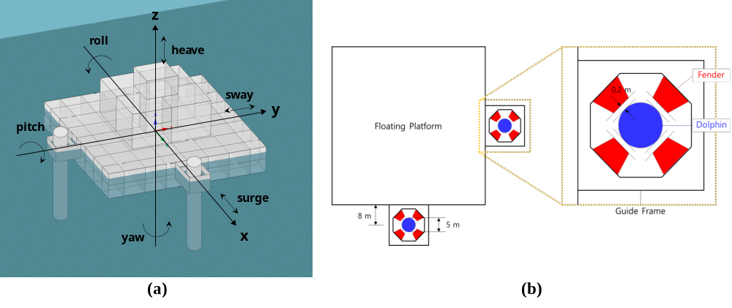
Figure 1. FNPP configurations: (a) perspective view with the coordinate system and 6-DOF motions, (b) plan view of the dolphin-fender mooring arrangement.

Table 1. Design parameters and mass properties of the FNPP.
 | Value | Unit
Length × Width × Depth | 60.0 × 60.0 × 9.5 | m
Draft / Freeboard | 7.0 / 2.5 | m
Water depth | 20.0 | m
Displacement | 25,830 | ton
CoG (x, y, z) | (0, 0, 4.234) | m
Roll moment of inertia | 6.59×10⁹ | kg·m²
Pitch moment of inertia | 6.59×10⁹ | kg·m²
Yaw moment of inertia | 1.01×10¹⁰ | kg·m²

Equations of motion
The FNPP was modeled as a rigid body, and the frequency-domain hydrodynamic coefficients obtained from linear potential flow theory were transformed into the time domain using Cummins’ equation [8] as follows:
$\left(M+A_{∞}\right)\ddot{x}\left(t\right)+\int_{0}^{t}{K}\left(t-τ\right) \dot{x}\left(τ\right) dτ+C x\left(t\right)=F_{ext}\left(t\right)+F_{moor}\left(t\right)$ (1)
where M is the mass matrix, A∞ is the added mass matrix at infinite frequency, C is the hydrostatic restoring stiffness matrix, x is the 6-DOF displacement vector, and F_{moor}(t) is the nonlinear mooring force vector. K(t) is the retardation function representing the fluid memory effect, which is derived from the frequency-domain radiation damping B(ω) as follows [9]:
$K\left(t\right)=\frac{2}{π}\int_{0}^{∞}{B}\left(ω\right)cos\left(ωt\right) dω$ (2)
In this study, the hydrodynamic analysis is performed for two load cases: the environmental load case, in which waves, wind, and current act on the FNPP, and the impact load case, in which the aircraft impact force acts on the FNPP in still water. The external force vector F_{ext}(t) for the two load cases is expressed as follows:
$F_{ext}\left(t\right)=\left\{\begin{matrix}F_{w}^{\left(1\right)}\left(t\right)+F_{w}^{\left(2\right)}\left(t\right)+F_{wind}+F_{cur} & \text{environmental load case} \\ F_{imp}\left(t\right) & \text{impact load case}\end{matrix}\right.$ (3)
where F_{w}⁽¹⁾ and F_{w}⁽²⁾ are the first- and second-order wave forces, and F_{wind} and F_{cur} are the wind and current forces, respectively. The wind and current forces were calculated using the drag formula based on the relative velocity as follows [10]:
$F_{D}=\frac{1}{2}ρ C_{D} A_{p} \left|u_{r}\right|u_{r}$ (4)
where ρ is the fluid density, u_{r} is the relative velocity, and C_{D} and A_{p} are the drag coefficient and projected area, respectively. Referring to DNVGL-RP-C205 [10], C_{D} of 0.9 and A_{p} of 631.5 m² were applied for the structure above the waterline, and C_{D} of 1.6 and A_{p} of 420 m² were applied for the submerged structure. The impact force vector F_{imp}(t) is defined by the force–time history of the aircraft impact described in Section 2.5.

Numerical model for hydrodynamic analysis
The hydrodynamic behavior of the FNPP was evaluated through a numerical framework integrating Ansys AQWA and OrcaFlex. AQWA was used to extract the frequency-domain hydrodynamic coefficients—added mass, radiation damping, and wave excitation forces—at the design draft, and the coefficients were imported into OrcaFlex [11]. The second-order slowly varying wave drift forces were calculated using Newman’s approximation [12], in which the difference-frequency quadratic transfer functions are approximated from the mean wave drift forces.
The dolphins were assumed to be rigid, and each fender was modeled as a compression-only nonlinear spring. As shown in Figure 2, the fender force increases up to 8,162.1 kN at a displacement of 0.875 m, decreases slightly during buckling, and recovers to 8,162.1 kN at the allowable displacement of 1.8 m. The fender displacement denotes the compression of the rubber fender. The numerical model of the FNPP is presented in Figure 3.

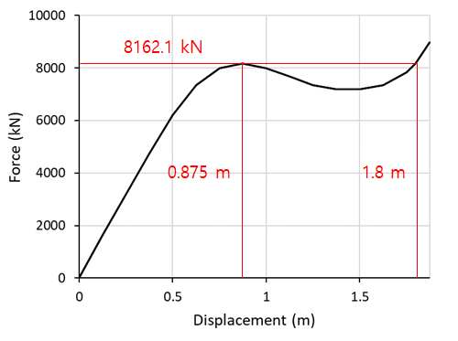
Figure 2. Force–displacement curve of the fender.

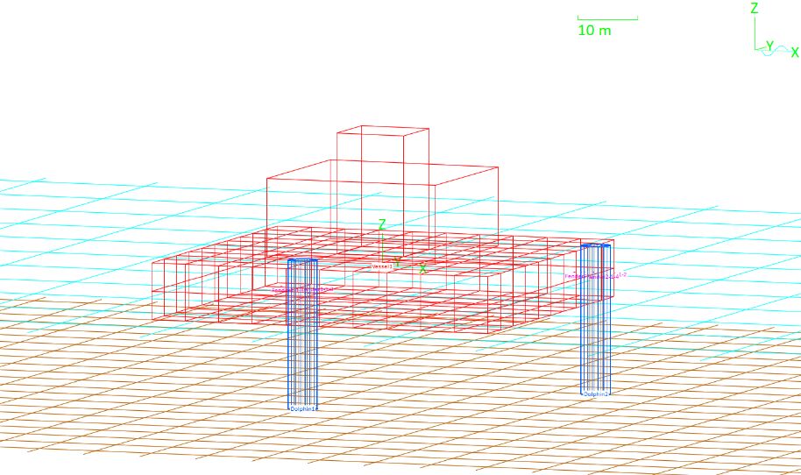
Figure 3. Numerical model of the FNPP in OrcaFlex.

Environmental load conditions
To simulate irregular wave conditions, the JONSWAP spectrum, which is widely used for fetch-limited coastal environments, was adopted. The JONSWAP spectrum is defined by the significant wave height (H_{s}), the peak period (T_{p}), and the peak shape parameter (γ) as follows [10]:
$S_{J}\left(ω\right)=A_{γ} \frac{5}{16} H_{s}^{2} ω_{p}^{4} ω^{-5}exp\left[-\frac{5}{4}{\left(\frac{ω}{ω_{p}}\right)}^{-4}\right]γ^{exp\left[-\frac{{\left(ω-ω_{p}\right)}^{2}}{2σ^{2}ω_{p}^{2}}\right]}$ (5)
where ω is the wave frequency, ω_{p} = 2π/T_{p} is the peak frequency, A_{γ} = 1 − 0.287 ln γ is a normalizing factor, and σ is the spectral width parameter taken as 0.07 for ω ≤ ω_{p} and 0.09 for ω > ω_{p}. The peak shape parameter γ was set to 3.3, the mean value recommended in DNVGL-RP-C205 [10]. Considering the sheltered coastal environment, in which the wave height is limited by the surrounding breakwaters, the significant wave height was varied from 0.5 m to 2.0 m at intervals of 0.5 m. For each H_{s}, the peak period was first estimated using the empirical relationship prescribed in the Korean design standard for harbor and fishing port facilities, KDS 64 10 10 [13]:
$T_{p}=3.86\sqrt{H_{s}}$ (6)
and three peak periods were selected to cover the range around the estimated value, in order to examine the variation of the motion and fender responses with the wave period. The resulting 12 wave conditions, together with the wind and current conditions described below, are summarized in Table 2.
A 1-minute mean wind speed of 51.5 m/s at 10 m reference height, corresponding to the survival condition in DNV-OS-C102 [14], and a current speed of 0.5 m/s [7] were applied as constant values. To represent the most critical loading condition, waves, wind, and current were assumed to act collinearly in the same direction. The environmental load direction θ is defined as the propagation direction, measured counterclockwise from the +x-axis. Among the eight directions from 0° to 315° at 45° intervals, θ is equivalent to 270° − θ by the symmetry of the system about the line y = −x. In addition, θ is equivalent to θ + 180° by the symmetric fender arrangement around each dolphin. The resulting groups, (0°, 90°, 180°, 270°), (45°, 225°), and (135°, 315°), are represented by 0°, 45°, and 135° as shown in Figure 4.

Table 2. Environmental load conditions.
H_{s} (m) | Estimated T_{p} (s) | Selected T_{p} (s) | Wind speed (m/s) | Current speed (m/s) | Load direction θ
0.5 | 2.73 | 2, 3, 4 | 51.5 | 0.5 | 0°, 45°, 135°
1.0 | 3.86 | 3, 4, 5 | 51.5 | 0.5 | 0°, 45°, 135°
1.5 | 4.73 | 4, 5, 6 | 51.5 | 0.5 | 0°, 45°, 135°
2.0 | 5.46 | 5, 6, 7 | 51.5 | 0.5 | 0°, 45°, 135°

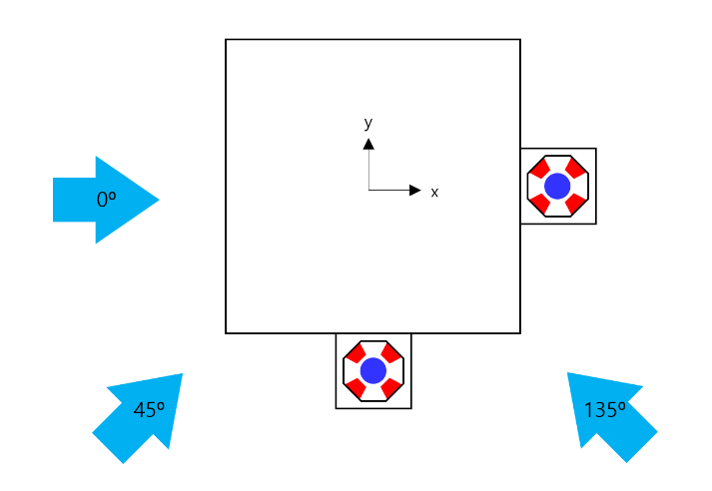
Figure 4. Representative environmental load directions.

Aircraft impact load
Since an FNPP can be located away from airports and flight routes owing to its flexibility in site selection, the accidental crash of a light aircraft was considered in this study as a preliminary assessment for the conceptual design. Accordingly, the Cessna-210 considered in the French nuclear design standard RCC-G [15], shown in Figure 5(a), was selected as a representative impact scenario. The design parameters of the Cessna-210 impact scenario are summarized in Table 3, and the impact force–time history provided by the Korea Institute of Nuclear Safety [16] is shown in Figure 5(b).

Table 3. Design parameters of the Cessna-210 impact scenario.
 | Value | Unit
Aircraft mass | 1.5 | ton
Impact velocity | 100 | m/s
Peak impact force | 7.0 | MN
Total impulse | 0.099 | MN·s
Load duration | 18 | ms

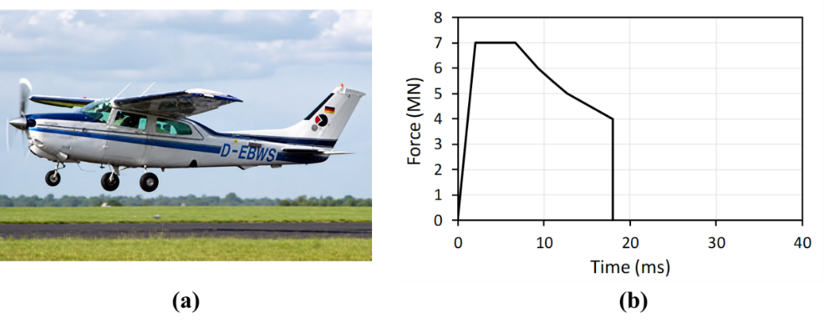
Figure 5. Cessna-210 impact scenario: (a) shape of Cessna-210 aircraft, (b) impact force–time history.

The impact force was applied at three locations as shown in Figure 6: (A) the roof of the reactor containment building at (0, 0, 22.75) m in the −z direction; (B) the external wall of the reactor containment building above the auxiliary building at (6, 0, 19) m in the −x direction; and (C) the external wall of the auxiliary building at (15, 7.375, 9.125) m in the −x direction. These locations correspond to the centers of the roof slab and wall panels, which are the points farthest from the boundaries connected to the adjacent walls and slabs, and thus represent the structurally most vulnerable locations of each member. The impact force–time history was applied at each impact location of the FNPP, and the corresponding force and moment about the origin of the coordinate system were included in the impact force vector F_{imp}(t) in equation (3).

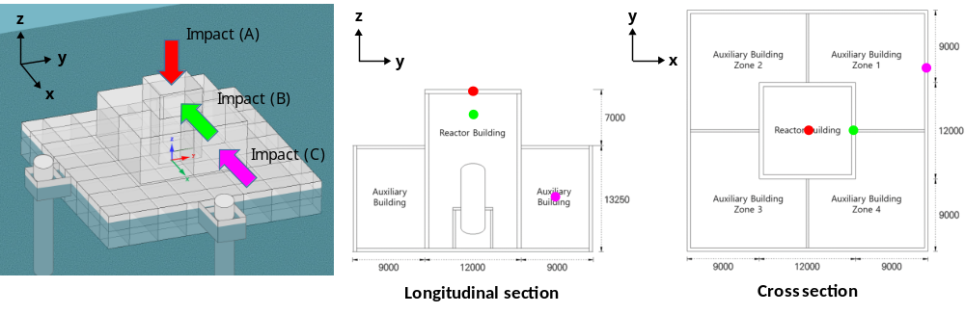
Figure 6. Impact locations A, B, and C and load directions.

Evaluation criteria
For the environmental load case, the maximum translational accelerations and the maximum roll/pitch angles of the FNPP were evaluated. Since criteria for the motion responses of FNPPs have not yet been established, reference values were compiled from the safety regulations for nuclear ships [17–19], the design conditions and operational records of the nuclear ships N.S. Savannah and N.S. Otto Hahn [20, 21], and the previous FNPP concept studies [22, 23], as summarized in Table 4. The regulations prescribe the rotations under which the reactor safety systems must operate normally, while the values from the nuclear ships and concept studies represent the design conditions or operational experience of the reactor systems. In this study, the most conservative values of 0.2g for acceleration and 7° for rotation were adopted as the reference values and compared with the maximum responses. Since the pontoon has identical geometry and moment of inertia in both horizontal directions, 7° was applied to both roll and pitch. The mooring integrity was evaluated by comparing the maximum fender displacement and force with the allowable displacement of 1.8 m and the allowable force of 8,162.1 kN, respectively [24].

Table 4. Reference values of acceleration and rotation for the motion response evaluation.
Category | Source | Acceleration | Roll | Pitch
Nuclear ship safety regulation | IMO [17] | – | 45° | –
Nuclear ship safety regulation | ABS [18] | – | 45° | 15°
Nuclear ship safety regulation | RMRS [19] | – | 22.5° | 7°
Operated nuclear ship | N.S. Savannah [20] | 0.25–0.30g | 30° | 7°
Operated nuclear ship | N.S. Otto Hahn [21] | 0.2g | – | –
FNPP concept study | OFNP [22] | 0.2g | 10° | 10°
FNPP concept study | SMART [23] | 1.0g | 45° | 45°

- Analysis and results

Motion responses for environmental load conditions
Figures 7–9 and 10–11 present the maximum translational accelerations and the maximum rotations of the FNPP for the 12 wave conditions and 3 environmental load directions, respectively. The maximum acceleration of 0.64 m/s² was observed in the surge direction under the 0° load direction for H_{s} = 2.0 m and T_{p} = 7 s, corresponding to 32.8% of the reference value of 0.2g. The maximum rotation was the pitch angle of 3.79° under the same condition, corresponding to 54.1% of the reference value of 7°. Therefore, the motion responses of the FNPP satisfied the reference criteria for all wave conditions considered.

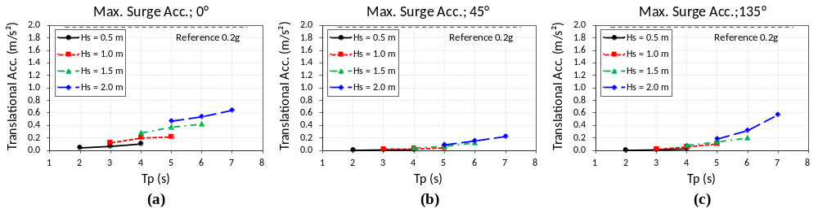
Figure 7. Maximum surge accelerations for 3 environmental load directions: (a) 0°, (b) 45°, (c) 135°.

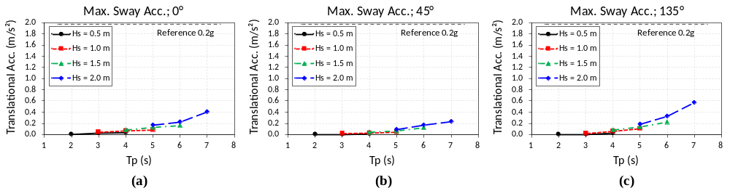
Figure 8. Maximum sway accelerations for 3 environmental load directions: (a) 0°, (b) 45°, (c) 135°.

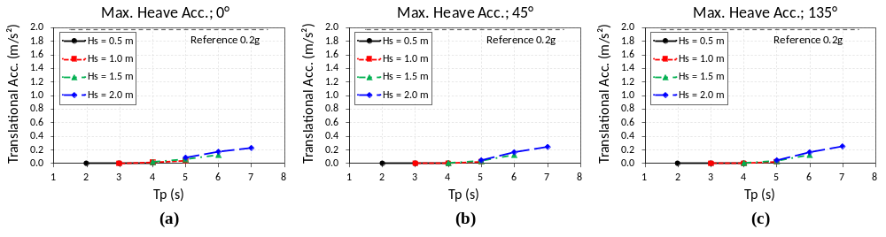
Figure 9. Maximum heave accelerations for 3 environmental load directions: (a) 0°, (b) 45°, (c) 135°.

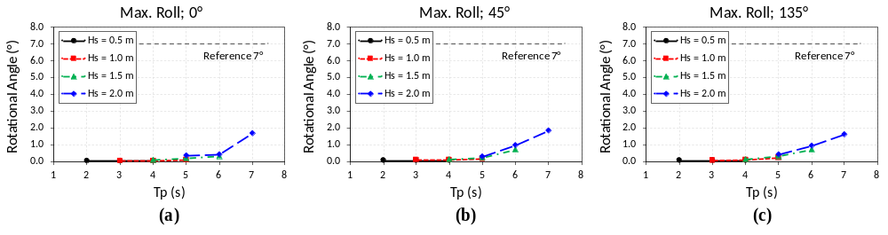
Figure 10. Maximum roll angles for 3 environmental load directions: (a) 0°, (b) 45°, (c) 135°.

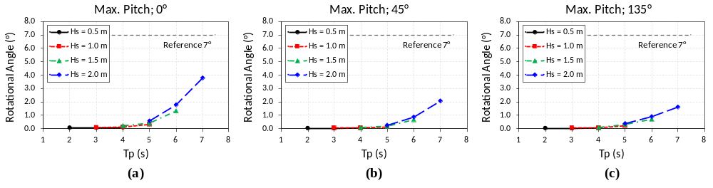
Figure 11. Maximum pitch angles for 3 environmental load directions: (a) 0°, (b) 45°, (c) 135°.

Fender responses for environmental load conditions
The mooring integrity was evaluated based on the fender showing the maximum response among the eight fenders. Figures 12 and 13 present the maximum fender displacements and forces for all wave conditions and load directions. The fender displacements remained below the buckling displacement of 0.875 m for all wave conditions except H_{s} = 2.0 m and T_{p} = 7 s. Under this condition, the maximum fender displacements reached 1.23 m and 1.41 m for the 0° and 135° load directions, respectively, entering the buckling range. However, the displacements remained within the allowable displacement of 1.8 m (up to 78.6%), and the maximum fender forces of 8,168 kN and 8,182 kN corresponded to the allowable force of 8,162.1 kN within 0.3%. Since buckling-type fenders are designed to absorb energy in the buckling range, the mooring integrity was satisfied for all wave conditions considered [24]. Nevertheless, the fenders reached their allowable force under this condition, indicating that the mooring system approaches its capacity at lower sea states than the motion responses approach the reference values. Repeated buckling deformation under continuous mooring may require further examination with respect to the fatigue and energy dissipation of the fender.

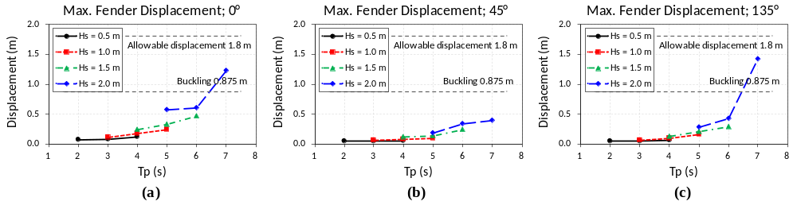
Figure 12. Maximum fender displacements for 3 environmental load directions: (a) 0°, (b) 45°, (c) 135°.

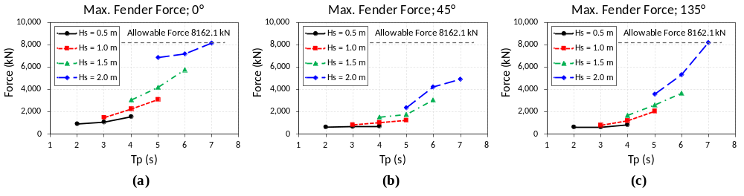
Figure 13. Maximum fender forces for 3 environmental load directions: (a) 0°, (b) 45°, (c) 135°.

Global responses for aircraft impact load
The responses for the roof impact (A), the containment wall impact (B), and the auxiliary wall impact (C) were examined separately during the impact (0–18 ms), using the results for the first 0.05 s, and after the impact, using the results over 100 s.
Figures 14–16 present the displacement, velocity, and acceleration during the impact. As shown in Figure 14, the displacements at the end of the impact were only 0.008 mm for A, 0.029 mm for B, and 0.032 mm for C. Figure 15 shows that the velocities increased only while the impact force acted and reached 0.83 mm/s for A, 3.13 mm/s for B, and 3.40 mm/s for C. As shown in Figure 16, the accelerations had the same shape as the impact force–time history in Figure 5(b), with peak values of 0.059 m/s² for A, 0.221 m/s² for B, and 0.240 m/s² for C. This similarity can be attributed to the dominance of the inertia force of the FNPP during the impact. Since the impact duration was short and the impact force was small relative to the mass of the FNPP, the velocity and displacement remained small, and thus the radiation force, which depends on the velocity history, and the hydrostatic restoring force, which depends on the displacement, are considered negligible during the impact. Therefore, in terms of the global motion during the impact, the FNPP can be regarded as a fixed target.

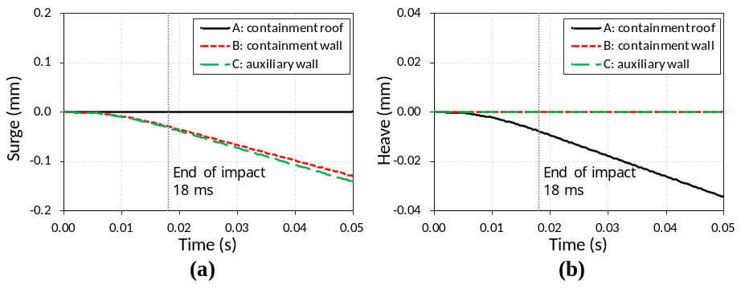
Figure 14. Displacement responses during the impact for the three impact locations: (a) surge, (b) heave.

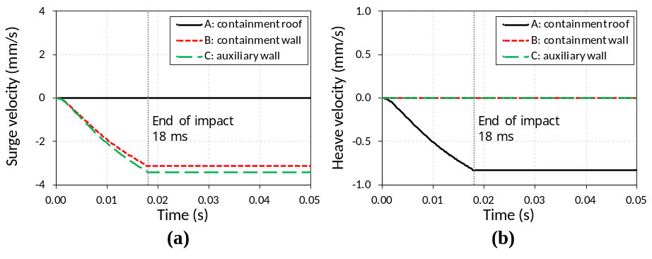
Figure 15. Velocity responses during the impact for the three impact locations: (a) surge, (b) heave.

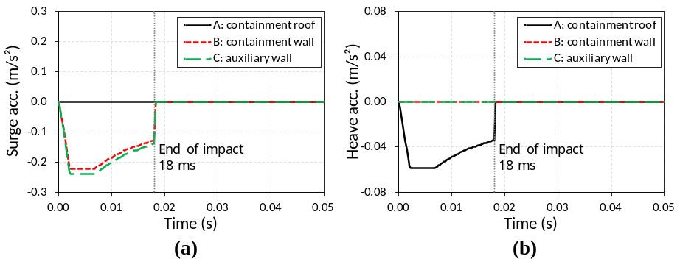
Figure 16. Acceleration responses during the impact for the three impact locations: (a) surge, (b) heave.

The global behavior after the impact was evaluated from the responses over 100 s shown in Figure 17. For the roof impact (A), the maximum heave displacement of 1.27 mm decayed within approximately 30 s owing to the hydrostatic restoring force and radiation damping. For the wall impacts (B and C), the FNPP drifted in the −x direction at an almost constant velocity of about 2.8 mm/s, since no restoring force acts in the horizontal plane before fender contact. The pitch angles induced by the moment of the impact force reached 0.0057° for B and 0.0021° for C and decayed with time. For C, the lateral eccentricity of the impact point additionally induced a yaw rotation, which increased to 0.19° until the FNPP came into contact with the fenders at approximately 57 s. After the contact, the yaw rotation reversed, the surge drift slowed down, and the pitch oscillation slightly increased.

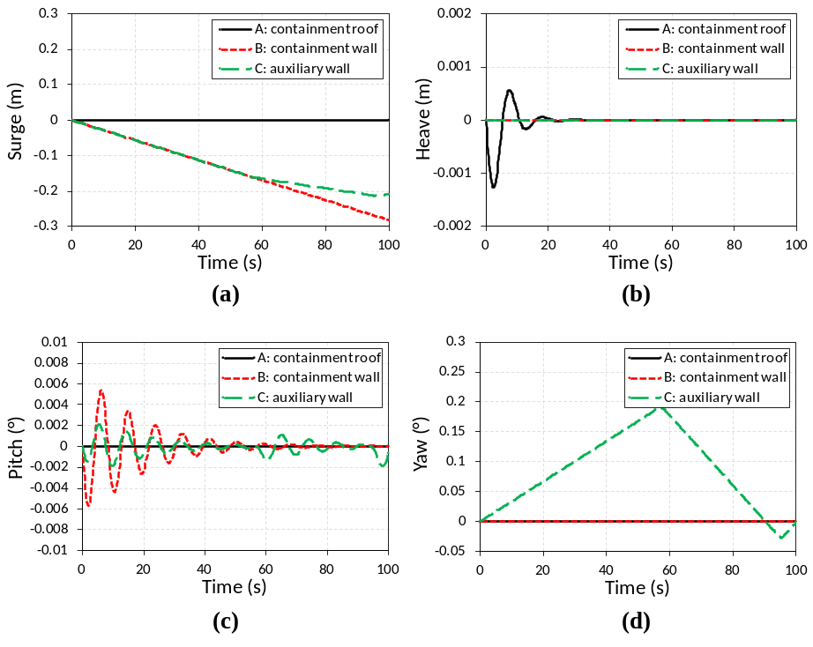
Figure 17. Global motion responses after the impact for the three impact locations: (a) surge, (b) heave, (c) pitch, (d) yaw.

Overall, the FNPP can be regarded as a fixed target during the impact, and its global motions after the impact develop slowly. Nevertheless, the global responses to the light aircraft impact remained small: the maximum acceleration of 0.240 m/s² and pitch angle of 0.0057° were far below the maxima of 0.64 m/s² and 3.79° under the marine environmental loads.

- Conclusion
This study evaluated the global motion responses of a pontoon-type FNPP under marine environmental loads and aircraft impact loads using an integrated AQWA–OrcaFlex framework. Time-domain simulations for 12 H_{s}–T_{p} combinations under survival wind and current conditions demonstrated that the maximum acceleration and rotation responses remain within the reference values of 0.2g and 7°, reaching only 32.8% and 54.1% of the respective values. Under the most severe condition of H_{s} = 2.0 m and T_{p} = 7 s, the fenders entered the buckling range and reached the allowable force, while the displacement remained within the allowable displacement. This indicates that the mooring system approaches its capacity earlier than the motion responses approach the reference values.
The Cessna-210 impact analysis showed that, during the 18 ms impact, the displacement and velocity of the FNPP remained below 0.03 mm and 3.4 mm/s, and the acceleration followed the impact force–time history. This suggests that the response during the impact is governed by the inertia of the FNPP, so that, in terms of the global motion, the FNPP can be regarded as a fixed target. After the impact, the global motions developed slowly: the heave displacement for the roof impact reached 1.27 mm and decayed within approximately 30 s, the wall impacts induced a slow surge drift of 2.8 mm/s, and the rotations remained below 0.2°.
It should be noted that the impact results represent only the global rigid-body responses, and the local damage, structural vibration, and containment integrity cannot be evaluated from the present model. In addition, the present impact assessment is a preliminary review of the conceptual design for the selected light aircraft scenario, and additional design modifications may be required when the impacts of large commercial aircraft and ships are considered in accordance with the design requirements for nuclear power plants. Future work will couple the global model with a nonlinear finite element model of the building, compare the Riera method [4] with a missile–target interaction method considering the fluid–structure interaction, and evaluate the loads acting on the dolphin piles.
Acknowledgement
This project is supported by the Korea Agency for Infrastructure Technology Advancement (KAIA) grant funded by the Ministry of Land, Infrastructure and Transport (Grant RS-2023-00250727) through the Korea Floating Infrastructure Research Center at Seoul National University.
References
- Lee K H, Kim M G, Lee J I and Lee P S 2015 Recent advances in ocean nuclear power plants Energies 8(10) 11470–92
- KINS 2016 Safety Assessment for Intentional Aircraft Impact KINS/RG-N19.04 Rev. 0 (Daejeon: Korea Institute of Nuclear Safety) (in Korean)
- IAEA 2018 Safety Aspects of Nuclear Power Plants in Human Induced External Events: Assessment of Structures Safety Reports Series No. 87 (Vienna: International Atomic Energy Agency)
- Riera J D 1968 On the stress analysis of structures subjected to aircraft impact forces Nucl. Eng. Des. 8(4) 415–26
- FLORA 2023 Expandable Concrete Modular Floating Structures Prototype Report No. 2023-B-2-1 (Seoul: Korea Floating Infrastructure Research Center) (in Korean)
- FLORA 2024 Analysis of Dynamic Behavior of Multi-Module Floating Structures Report No. 2024-B-2-1 (Seoul: Korea Floating Infrastructure Research Center) (in Korean)
- FLORA 2025 Design of Concrete Multi-Modular Floating Structures Report No. 2025-B-2-1 (Seoul: Korea Floating Infrastructure Research Center) (in Korean)
- Cummins W E 1962 The Impulse Response Function and Ship Motions Report 1661 (Washington, DC: David Taylor Model Basin)
- Ogilvie T F 1964 Recent progress toward the understanding and prediction of ship motions Proc. 5th Symp. on Naval Hydrodynamics (Bergen: Office of Naval Research) pp 3–80
- DNV GL 2017 Environmental Conditions and Environmental Loads DNVGL-RP-C205 (Høvik: DNV GL AS)
- Orcina Ltd 2023 OrcaFlex Documentation, version 11.4 (Ulverston: Orcina Ltd)
- Newman J N 1974 Second-order, slowly-varying forces on vessels in irregular waves Proc. Int. Symp. on Dynamics of Marine Vehicles and Structures in Waves ed R E D Bishop and W G Price (London: Institution of Mechanical Engineers) pp 182–6
- MOF 2024 Port and Fishing Port Design Standards: Design Conditions KDS 64 10 10 (Sejong: Ministry of Oceans and Fisheries) (in Korean)
- DNV 2014 Structural Design of Offshore Ships DNV-OS-C102 (Høvik: Det Norske Veritas AS)
- EDF 1998 Rules for the Design and Construction of Nuclear Power Plants Report RCC-G85-Rev2 (Paris: Électricité de France).
- KINS 2009 Evaluation and Assessment Procedure of the Aircraft Impact KINS/HR-986 (Daejeon: Korea Institute of Nuclear Safety) (in Korean)
- IMO 1981 Code of Safety for Nuclear Merchant Ships Resolution A.491(XII) (London: International Maritime Organization)
- ABS 2024 Requirements for Nuclear Power Systems for Marine and Offshore Applications (Spring, TX: American Bureau of Shipping)
- RMRS 2022 Rules for the Classification and Construction of Nuclear Ships and Floating Facilities ND No. 2-020101-168-E (St. Petersburg: Russian Maritime Register of Shipping)
- MARAD 2017 N.S. Savannah Updated Final Safety Analysis Report STS-004-002 Rev. IX (Washington, DC: U.S. Department of Transportation, Maritime Administration)
- Ulken D, Bianchi H and Kühl H 1972 Technical operation experiences of the N.S. Otto Hahn and problems of port entry Proc. Symp. on Nuclear Ships (Rio de Janeiro: Comissão Nacional de Energia Nuclear)
- Strother M B 2015 Hydrodynamic Analysis of the Offshore Floating Nuclear Power Plant Master’s thesis (Cambridge, MA: Massachusetts Institute of Technology)
- KAIST 2017 Core Technology Development of SMART Mounted 100MWe Floating-Type NPP Project No. 2014M2B2A9030561 (Daejeon: Korea Advanced Institute of Science and Technology) (in Korean)
- PIANC 2002 Guidelines for the Design of Fender Systems: 2002 Report of Working Group 33 (Brussels: PIANC)

