Effect of powder reuse on tensile strength of AlSi10Mg alloy produced by selective laser melting
Y A Tesfahunegn¹, J D Maddison² and D I Olafsson²
¹ Department of Engineering, Reykjavik University, 101 Reykjavik, Iceland
² Tæknisetur, 112 Reykjavik, Iceland

* yonatant@ru.is
Abstract. Selective laser melting (SLM) is widely used to manufacture AlSi10Mg components for aerospace, automotive, and biomedical applications, but its economic viability depends on efficient powder reuse. This study investigates the effect of powder reuse on the tensile properties of SLM-produced AlSi10Mg by blending virgin and reused powder at five ratios (100:0, 75:25, 50:50, 25:75, 0:100), in horizontal and vertical orientations, analysed by two-way ANOVA. The reused-powder fraction had no significant effect on ultimate tensile strength (UTS, p = 0.30) or on plastic strain at fracture (p = 0.94). Yield strength (YS) determined from crosshead displacement initially appeared to fall by up to 83 MPa with reused powder. However, the modulus reported by the testing machine, which reflects the stiffness of the whole load train (machine, grips and specimen) rather than of the material, varied between tests, and YS followed it closely (R² = 0.79 over all specimens). The differences in YS between virgin and reused powder were fully consistent with these compliance differences; only a modest decrease between 25–50% and 75–100% reused powder could not be excluded. Build orientation had a consistent effect, with vertically built specimens showing 5.7% higher UTS and about 10% higher plastic strain and horizontally built specimens showing higher YS. Within the range studied, blending this reused powder with virgin powder did not measurably degrade UTS or ductility. Yield strength measured without an extensometer can be dominated by load-train compliance and should be interpreted with caution.
- Introduction
Selective laser melting (SLM), a form of laser powder bed fusion (L-PBF), is a leading additive manufacturing route for producing lightweight, geometrically complex aluminium alloy components for aerospace, automotive, biomedical applications. Among aluminium alloys, AlSi10Mg is the most widely studied and industrially adopted for SLM due to its favourable processability and its ability to form a fine, supersaturated Al-Si microstructure through rapid solidification, yielding mechanical properties that can exceed conventionally cast AlSi10Mg [1].
Despite this extensive research base, SLM processing generates substantial quantities of unconsumed powder after each build. Because virgin metal powders are costly and energy intensive to produce, the economic and environmental viability of SLM depends on the ability to recover and reuse excess powder across multiple builds [2]. However, repeated exposure to the SLM process environment progressively alters the physical and chemical characteristics of the powder feedstock, affecting flowability, packing density, and melting behaviour in subsequent builds [2].
For AlSi10Mg specifically, powder recycling has been linked to a reduction in tensile properties, with oxide-film associated voids identified as a contributing defect mechanism [3]. A statistically designed study using one-way ANOVA on AlSi10Mg parts produced by SLM found that powder reuse had a statistically significant effect on both yield strength and ultimate strength [4]. Related work on powder recycling in alloy AM more broadly reports that porosity and property degradation intensify as the proportion of recycled powder in the feedstock increases, consistent with defect formation increasing with reused-powder content [2].
Comparable degradation mechanisms have been documented across reused metal powders more broadly, including progressive oxidation, morphological roughening, moisture uptake, and contamination, which collectively reduce flowability and increase susceptibility to defect formation [2]. Work addressing non-ideal powder storage conditions specifically shows that increased particle size and oxidation in reused powder can increase melt pool depth and porosity relative to virgin powder [5]- a consideration directly relevant to this study, as the reused powder pool includes a batch stored and cycled over approximately three years.
Independent of powder condition, SLM-fabricated AlSi10Mg is well known to exhibit anisotropic tensile behaviour as a function of build orientation. Horizontally built specimens have been reported to exhibit tensile strength approximately 8-10% higher than vertically built specimens under similar processing conditions [6, 7]. This anisotropy has been attributed to differences in columnar grain fraction, melt pool boundary orientation, and porosity distribution along the build direction [8].
Previous AlSi10Mg studies have mostly compared discrete reuse states, such as virgin powder against powder after a given number of cycles [3, 4], or have followed one powder lot through consecutive builds [9]. Reported effects are not uniform: some studies found reduced tensile properties with reuse [3, 4], while others found little change or a slight improvement [9, 10]. The effect of blending reused powder back into virgin stock at intermediate ratios, the common shop-floor practice [2], has received little systematic attention, and whether reuse effects depend on build orientation has not been tested formally as an interaction.
This study evaluates the tensile properties of AlSi10Mg specimens produced from five virgin/reused blend ratios (0–100% reused powder), each built in horizontal and vertical orientations, in a full factorial design analysed by two-way ANOVA. Because strain was derived from crosshead displacement, particular attention is paid to how the stiffness of the load train (the machine frame, load cell, grips and specimen together) affects the yield strength and elongation values. It is hypothesised that tensile properties decrease with increasing reused-powder fraction. The findings are intended to support practical powder reuse strategies, balancing mechanical performance with the economic and sustainability benefits of powder recycling in industrial SLM operations.
- Materials and methods

Powder materials
Commercially available AlSi10Mg powder, produced by gas atomization, was used in this study. To evaluate the effect of powder reuse on the tensile properties of parts fabricated by SLM, five powder feedstock conditions were prepared by blending virgin (unused) powder with a reused powder pool at defined mass ratios, as summarised in Table 1.
The reused powder pool consisted of a 50:50 mass blend of two powder batches with distinct reuse histories: powder that had undergone approximately 25 sieving and drying cycles over a service life of approximately 3 years, and powder that had undergone approximately 5 sieving and drying cycles over a service life of approximately 3 months. This blend was selected to represent typical shop-floor recycling practice, in which powder batches of varying reuse history are commonly combined in the machine hopper rather than tracked and used strictly by reuse count. All powder batches originated from the same supplier to minimise compositional variability unrelated to reuse. According to the supplier, the virgin powder had a particle size range of 15-53μm in diameter; the particle size distribution of the reused pool was not measured. The two batches were combined in equal masses to represent the mixed-history powder typically present in the machine hopper during production. Because they differ in both reuse count and storage time, the results of this study describe the effect of the fraction of this specific reused pool and cannot be attributed to a particular number of reuse cycles or storage duration. The longer-history batch, stored for about three years, may contribute disproportionately to any effect of reuse. Separating the effects of the two batches would require testing each on its own, which is identified as future work.
Table 1. Powder blend conditions.
Condition | Virgin powder (%) | Reused powder (%)
C1 | 100 | 0
C2 | 75 | 25
C3 | 50 | 50
C4 | 25 | 75
C5 | 0 | 100
Each condition was homogenised by shaking and stirring together 10 kg of combined virgin and reused powder prior to loading into the SLM system to ensure a uniform powder mixture across the build volume. Powder properties (particle size distribution, morphology, flowability and oxygen content) were not measured for either the virgin powder or the reused pool. Differences in feedstock condition between C1 and C5 are therefore not quantified in this study. Degradation reported for reused aluminium alloy powders includes oxidation and moisture uptake, morphological change and reduced flowability [2], oxide-film-related porosity in AlSi10Mg [3], and increased melt pool depth and porosity after storage under non-ideal conditions [5]. In Section 3.4 these mechanisms are discussed only as possible factors; none was verified in this study.

SLM processing
Specimens were fabricated using an iSLM160 selective laser melting system. Fixed process parameters were used across all powder conditions to isolate the effect of powder reuse from process-parameter variability (Table 2).
Table 2. Fixed SLM process parameters.
Parameter | Value
Laser power | 190 W
Scan speed | 900 mm/s
Hatch spacing | 0.04 mm
Layer thickness | 0.02 mm
Build plate temperature | 110 °C
Shielding gas | Nitrogen
Chamber O₂ level | ≤ 4000 ppm
Scan strategy | 67° rotation per layer

For each of the powder conditions, specimens were built in two orientations relative to the build plate – horizontal (long axis parallel to the build plate) and vertical (long axis parallel to the build direction) – to evaluate whether powder-reuse effects interact with the well-documented anisotropy of SLM fabricated AlSi10Mg. Five replicate specimens were fabricated per condition per orientation (5 conditions × 2 orientations × 5 replicates = 50 specimens total). Each powder condition was built in a separate job, with all horizontal and vertical specimens for that condition on the same build plate. Horizontal specimens were built on edge, with supports under the lower edge of the gauge section. Vertical specimens were built upright on one grip end, so the gauge section required no supports.

Specimen geometry and testing standard
Tensile tests were carried out at room temperature with the test speed controlled according to ISO 6892-1, Method A2. No extensometer was used; strain was calculated from crosshead displacement over the parallel length. Proof strength (R_{p0.2}) and elongation were therefore not determined as specified by ISO 6892-1 and include the compliance of the load train; they are reported for comparison within this data set only. Specimen geometry was constrained by the build volume of the iSLM160 system.
Flat dog-bone specimens with an overall length of 146 mm and a thickness of 3 mm were used. The specimen geometry is presented in Figure 1.

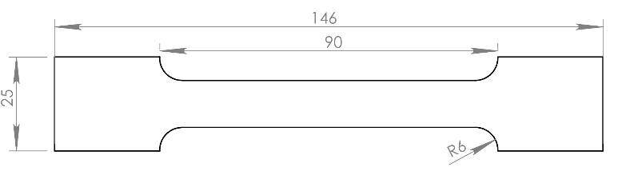
Figure 1. Specimen dimensions in mm.
Strain rate control followed Method A2 of the standard (crosshead-speed-based estimation of strain rate over the parallel length) for this testing setup. All specimens were tested in the as-built condition, with no post-build heat treatment applied, so that the tensile results reflect the direct effect of powder condition without confounding from thermal post-processing.

Tensile testing
Tensile tests were conducted using an Instron 34TM-50 dual-column universal testing machine (50 kN capacity) at a fixed crosshead speed of 1.5 mm/min, calculated to approximate a strain rate of approximately 0.00025 s⁻¹ over the parallel length (L_{c} = 90 mm), consistent with ISO 6892-1 Method A2 guidance for accurate yield strength determination in the absence of extensometer-based closed-loop control. A single constant crosshead speed was applied throughout each test, in accordance with the standard's allowance for a single estimated strain rate when precise elastic modulus determination is not required. For each specimen, ultimate tensile strength (UTS) and 0.2% offset yield strength (YS) were recorded directly; strain at fracture was not recorded directly but was instead derived from the corrected strain axis as described below. Full engineering stress–strain curves were recorded for all specimens to support comparison of ductility and fracture behaviour across conditions; representative raw curves for each powder condition are shown in Figure 2.

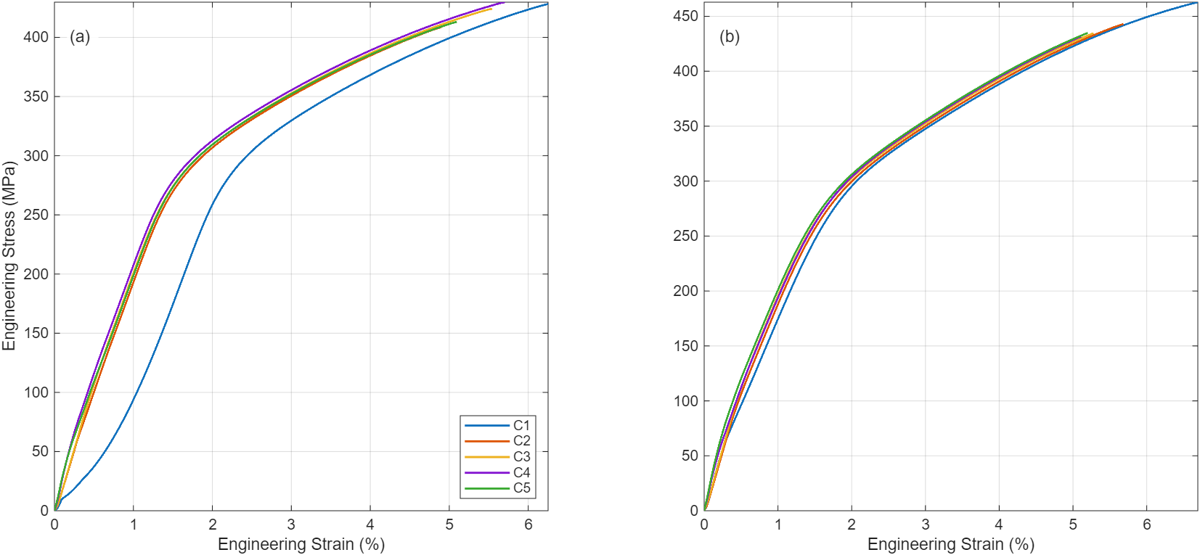
Figure 2. Representative raw engineering stress-strain curves for one specimen per powder condition, shown separately for a) horizontal and b) vertical build orientations.
Strain was calculated from the crosshead displacement δ over the parallel length Lc:
$ε_{raw}=\frac{δ}{L_{c}}$ (1)
An initial approach, in which the elastic modulus of each specimen was estimated from the stress window with the highest linear-fit quality (R²), proved unreliable. For some specimens several windows gave comparably high R² but substantially different moduli, changing the yield strength by up to about 85 MPa. The elastic modulus E_{ref} and 0.2% proof strength R_{p0.2,ref} reported by the testing software for each specimen were therefore used as reference values. Both are determined on the same crosshead-based strain axis as equation (1), so no separate machine-compliance correction was applied.
To make the strain axis consistent with these reference values, a specimen-specific toe offset $ε_{0}$was calculated. If $ε^{*}$is the raw strain at which the ascending curve first reaches R_{p0.2,ref}, the 0.2% offset line with slope E_{ref} passes through that point, when
$ε_{0}=ε^{*}-\frac{R_{p0.2,ref}}{E_{ref}}-0.002$ (2)

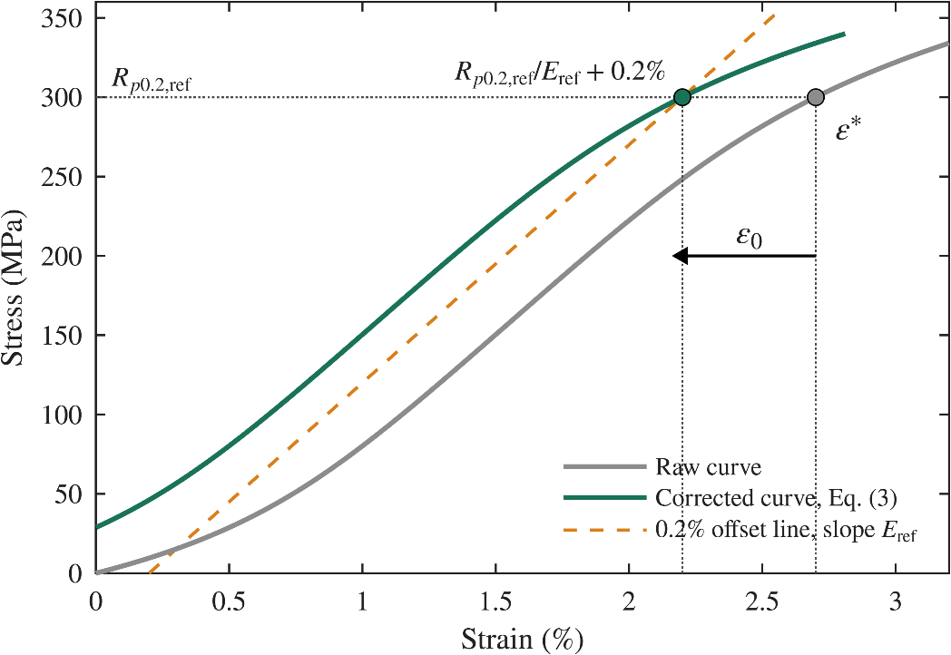
Figure 3. Schematic of the toe-offset construction. Illustrative curve; $ε_{0}$ is exaggerated for clarity.
This construction is illustrated schematically in Figure 3. The strain axis was then shifted by this offset,
$ε_{c}=ε_{raw}-ε_{0}$ (3)
so that the standard 0.2% offset construction reproduces R_{p0.2,ref} exactly. Figure 4 shows the effect of this shift on a representative specimen, and Figure 5 the resulting 0.2% offset construction for four specimens. The total strain at fracture $ε_{f}$ and plastic strain at fracture $ε_{p}$ were obtained as
$ε_{f}=ε_{raw,f}-ε_{0}, ε_{p}=ε_{f}-\frac{σ_{f}}{E_{ref}}$ (4)
where $ε_{raw,f}$ is the raw strain at fracture, taken at peak force because all specimens fractured without necking, and $σ_{f}$ is the fracture stress. Because E_{ref} describes the stiffness of the whole load train rather than the material, ${σ_{f}}/{E_{ref}}$ includes machine and grip deflection as well as the elastic strain of the specimen, and subtracting it removes both. UTS is unaffected by this procedure, since it depends only on the peak force and cross-sectional area. The offset $ε_{0}$ was 0.018 ± 0.078% (mean ± SD); it was at most 0.13% for 49 of the 50 specimens and 0.52% for one (C1_H1).

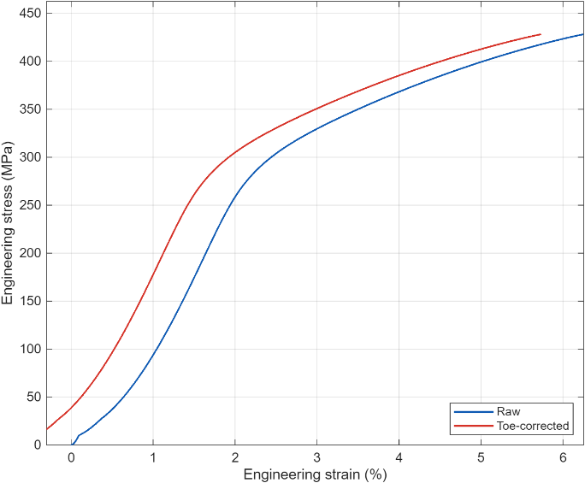
Figure 4. Effect of the toe-region correction on a representative specimen.

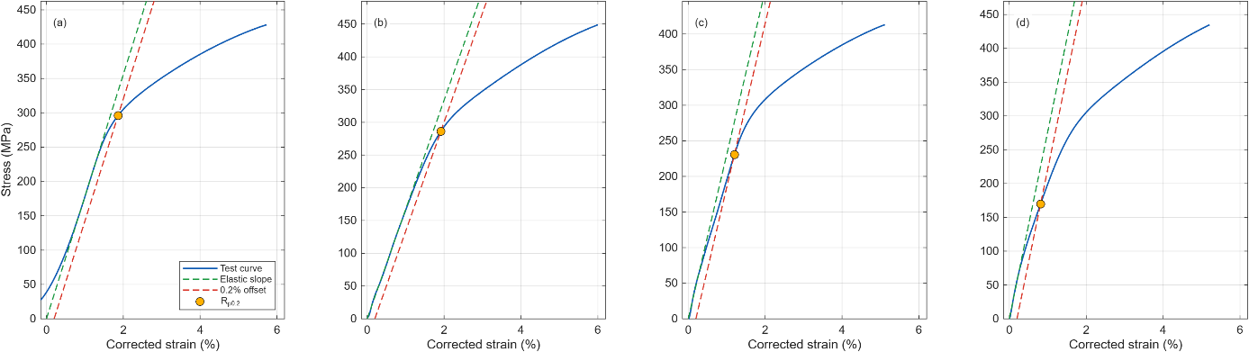
Figure 5. 0.2% offset yield strength (Rₚ₀.₂) construction for four representative specimens spanning both build orientations and the extremes of the powder-reuse range: (a) C1_H: Rₚ₀.₂ = 296.0 MPa ; (b) C1_V: Rₚ₀.₂ = 286.1 MPa; (c) C5_H: Rₚ₀.₂ = 230.7 MPa; (d) C5_V: Rₚ₀.₂ = 169.9 MPa. The toe-corrected test curve, elastic slope (from the reference modulus), 0.2% offset line, and resulting yield point are shown for each specimen.
The underlying cause of this window-selection ambiguity was investigated further by examining the local tangent modulus (fitted slope) across successive narrow sub-ranges of each specimen's ascending stress-strain curve, using the reference modulus as a benchmark (Figure 6). Two distinct patterns emerged across the dataset. Some specimens showed apparent stiffness increasing with load from an initially low value toward the reference modulus, consistent with grip-seating slack progressively resolving as loading proceeds. Other specimens instead showed apparent stiffness at its highest, and closest to the reference modulus, at the very start of loading, decreasing steadily thereafter — consistent with early-onset, spatially distributed microplasticity characteristic of the heterogeneous melt-pool and cellular substructure typical of SLM AlSi10Mg, rather than a sharp elastic-to-plastic transition. Because the dominant behaviour varied between specimens, no single fixed strain window could reliably capture the true elastic region across the dataset: a window positioned to avoid toe-affected specimens' early data would instead capture genuine pre-yield softening in others, and vice versa. An alternative window-selection strategy based on identifying the widest region of locally stable tangent modulus, rather than a fixed stress-range search, was also evaluated and found to preferentially select the post-yield strain-hardening plateau over the true elastic region for several specimens, performing worse than the original approach. This indicates that the ambiguity reflects a genuine property of the material's mechanical response rather than a deficiency specific to any one fitting strategy, and further supports anchoring yield strength determination to the modulus reported directly by the testing machine's software rather than an independently-derived value.
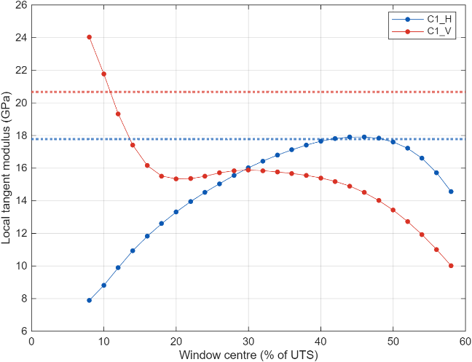
Figure 6. Local tangent modulus as a function of stress level for two representative specimens, illustrating the two local-modulus patterns described in the text: C1_H shows apparent stiffness increasing with load (consistent with resolving toe-region slack), while C1_V shows apparent stiffness decreasing with load from an initially high value (consistent with early-onset microplasticity). Dotted horizontal lines mark each specimen’s reference modulus.

Statistical analysis
A two-way analysis of variance (ANOVA) was performed with powder condition (C1–C5) and build orientation (horizontal/vertical) as independent factors, and UTS, YS and plastic strain at fracture as dependent variables, to evaluate the statistical significance of powder reuse, build orientation and their interaction. Post-hoc comparisons between powder conditions were performed for YS using Tukey's HSD test [11], based on the residual mean square of the two-way ANOVA. Normality of residuals was assessed with the Anderson–Darling test [12], and homogeneity of variance across the ten condition–orientation groups with the Brown–Forsythe test [13]. To confirm that the conclusions did not depend on the normality assumption, the two-way ANOVA was repeated on log-transformed data. The relationship between YS and E_{ref} was examined by linear regression over all specimens. A significance level of α = 0.05 was used throughout. Statistical analysis was performed using MATLAB [14].
- Results and discussion

Tensile properties
Ultimate tensile strength (UTS), 0.2% offset yield strength (YS), total and plastic strain at fracture, and the load train modulus E_{ref} were determined for all 50 specimens. Mean values ± standard deviation (SD) for each condition-orientation group are summarised in Table 3 and shown graphically in Figure 7.

Table 3. Tensile properties by powder condition and build orientation (mean ± SD).
Condition | Orientation | n | UTS  (MPa) | YS  (MPa) | $ε_{f}$  (%) | $ε_{p}$  (%) | $E_{ref}$  (GPa)
C1 | H | 5 | 423.59 ± 7.61 | 291.98 ± 6.61 | 5.63 ± 0.31 | 3.25 ± 0.28 | 17.84 ± 0.12
C1 | V | 5 | 451.08 ± 12.15 | 265.59 ± 41.20 | 6.19 ± 0.54 | 3.56 ± 0.60 | 17.31 ± 2.17
C2 | H | 5 | 415.51 ± 7.55 | 250.60 ± 11.84 | 5.16 ± 0.35 | 3.32 ± 0.32 | 22.70 ± 0.85
C2 | V | 5 | 442.62 ± 18.27 | 208.21 ± 5.15 | 5.66 ± 0.76 | 3.84 ± 0.71 | 24.22 ± 0.64
C3 | H | 5 | 415.50 ± 8.70 | 256.59 ± 4.58 | 5.14 ± 0.41 | 3.33 ± 0.39 | 22.88 ± 0.47
C3 | V | 5 | 439.04 ± 20.04 | 201.41 ± 9.40 | 5.49 ± 0.75 | 3.75 ± 0.71 | 25.29 ± 1.36
C4 | H | 5 | 422.36 ± 4.39 | 212.37 ± 30.85 | 5.34 ± 0.22 | 3.66 ± 0.32 | 25.37 ± 2.64
C4 | V | 5 | 432.50 ± 24.75 | 182.11 ± 6.57 | 5.18 ± 0.82 | 3.46 ± 0.72 | 25.27 ± 0.96
C5 | H | 5 | 408.64 ± 10.68 | 216.39 ± 16.53 | 4.91 ± 0.41 | 3.17 ± 0.42 | 23.56 ± 1.37
C5 | V | 5 | 440.02 ± 8.71 | 175.92 ± 4.86 | 5.41 ± 0.35 | 3.78 ± 0.32 | 27.00 ± 1.50
The patterns visible in Figure 7 are examined in Subsections 3.2 and 3.3. UTS (Figure 7(a)) varies little across powder conditions but is consistently higher for vertically built specimens than for horizontally built specimens. YS (Figure 7(b)) is higher for horizontally built specimens in every condition and is lower for the reused-powder conditions than for virgin powder. Plastic strain at fracture (Figure 7(c)) shows no consistent trend with powder condition and is slightly higher for vertically built specimens. The load-train modules E_{ref} (Figure 7(d)) was markedly lower for C1 than for all reused-powder conditions, the mirror image of the YS pattern in Figure 7(b).
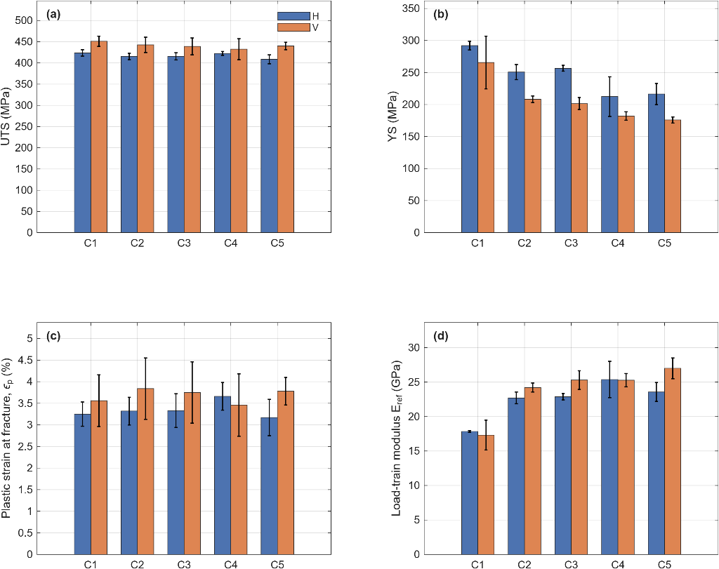
Figure 7. Tensile properties by powder condition and build orientation (mean ± SD, error bars): (a) UTS; (b) YS; (c) plastic strain at fracture; (d) load-train modulus. H = horizontal, V = vertical. Values correspond directly to Table 3.

Effect of load-train compliance
The modulus reported by the testing software, E_{ref}, ranged from 15.4 to 28.9 GPa (Table 3, Figure 7(d)), well below the 51–68 GPa reported for as-built SLM AlSi10Mg measured with extensometers [15, 16]. Because strain was derived from crosshead displacement, E_{ref} reflects the stiffness of the whole load train (machine frame, load cell, grips and specimen together) rather than of the material. The corresponding load-train compliance,
$C_{total}=\frac{L_{c}}{E_{ref}A}$ (5)
where L_{c} = 90 mm is the parallel length and A = 39 mm² is the cross-sectional area of gauge section. Table 4 gives C_{total} for each group, together with the machine-and-grip (C_{mg}) compliance,
$C_{mg}=C_{total}-C_{s}$ (6)
where C_{s} is specimen’s own compliance defined as,
$C_{s}=\frac{L_{c}}{E_{s}A}$ (7)
where E_{s} is the Young’s modulus of the material. Taking E_{s} from the literature for as-built SLM AlSi10Mg, 51 – 68 GPa [15, 16], C_{s} is 0.034 mm/kN (E_{s} = 68 GPa) to 0.045 mm/kN (E_{s} = 51 GPa), whereas C_{total} ranges from 0.086 to 0.133 mm/kN between groups. Most of the measured displacement therefore came from the machine and grips.

Table 4. Load train compliance by powder condition and build orientation (mean ± SD)
Group | C_{total}  (mm/kN) | C_{mg}  (mm/kN), E_{s} = 51 GPa | C_{mg}  (mm/kN), E_{s} = 68 GPa
C1-H | 0.1294 ± 0.0008 | 0.0842 | 0.0955
C1-V | 0.1333 ± 0.0167 | 0.0881 | 0.0994
C2-H | 0.1017 ± 0.0038 | 0.0565 | 0.0678
C2-V | 0.0953 ± 0.0025 | 0.0501 | 0.0614
C3-H | 0.1008 ± 0.0021 | 0.0556 | 0.0669
C3-V | 0.0912 ± 0.0049 | 0.0460 | 0.0573
C4-H | 0.0910 ± 0.0095 | 0.0458 | 0.0571
C4-V | 0.0913 ± 0.0035 | 0.0461 | 0.0574
C5-H | 0.0980 ± 0.0057 | 0.0528 | 0.0641
C5-V | 0.0855 ± 0.0048 | 0.0403 | 0.0516
The load-train compliance was not constant (Table 4). The machine-and-grip compliance was 0.084 – 0.099 mm/kN in the C1 tests but 0.040 – 0.068 mm/kN in the C2-C5 tests, depending on E_{s}, and correspondingly E_{ref} was 5.9 – 7.7 GPa lower for C1. All specimens had the same geometry, so C_{s} could differ between groups only through differences in E_{s}. Even if E_{s} differed between groups by the full range reported for as-built AlSi10Mg (51 – 68 GPa, 33%) [15, 16], C_{total} would change by only about 12%, whereas C_{total} was about 40% higher in the C1 tests than in the C2-C5 tests (0.131 vs 0.094 mm/kN on average). The difference therefore reflects the test set-up, for example grip seating, rather than the powder. Among the reused-powder conditions, Eref varied much less (23.5–25.3 GPa pooled across orientations), with C4 and C5 about 1.8 GPa higher than C2. A difference of this size could arise either from the test set-up or from a small change in the material's stiffness, and the two cannot be distinguished without extensometer-based measurement.
Figure 8 plots the measured YS of every specimen against its E_{ref.}, with colours denoting powder condition, circles horizontal and squares vertical specimens. The specimens form a single band in which YS falls as E_{ref} rises; a linear fit to all 50 specimens gives a slope of -10.7 MPa/GPa (R² = 0.79). The C1 specimens lie at the upper left of this band, with low E_{ref} and high YS, and the C2-C5 specimens further down at higher E_{ref}. Specimens that deviate from their own group, such as C1-V1 (E_{ref} = 20.7 GPa, YS = 198 MPa) and C4-H3 (E_{ref} = 20.8 GPa, YS = 266 MPa), also follow the band. At similar E_{ref}, horizontal specimens lie above vertical ones, indicating an orientation effect on YS that is not explained by E_{ref}.

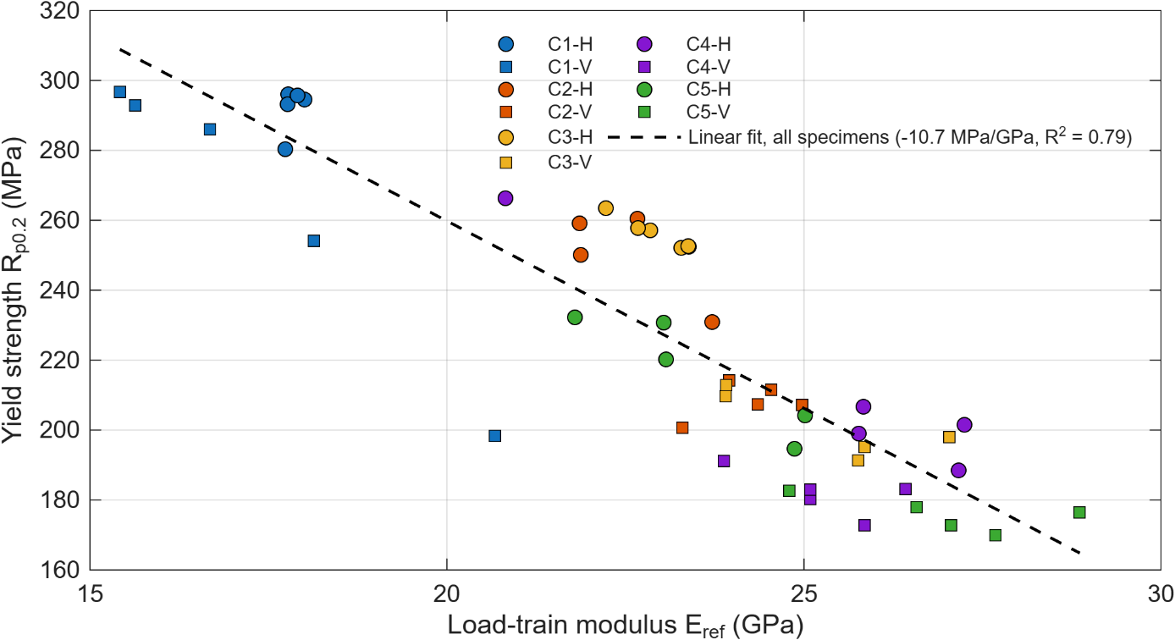
Figure 8. Yield strength against the load train modulus E_{ref} for all 50 specimens.
These variations affect the measured properties in two ways: First, the yield strength: the 0.2% offset line is drawn with slope E_{ref}, and on a gradually yielding curve a steeper line meets the curve at a lower stress. Figure 8 shows that this dependence holds within groups as well as across them. Within C1_V, the specimen with the highest E_{ref} (C1_V1, 20.7 GPa) has the lowest YS (198 MPa), and within C4_H the specimen with the lowest E_{ref} (C4_H3, 20.8 GPa) has the highest YS (266 MPa); both lie on the overall trend. Because specimens of the same group share the same powder and orientation, this dependence must arise from the measurement rather than the material. The C1 specimens lie on the same trend as the reused-powder conditions, at low-modulus end, so their higher measured YS is consistent with their lower E_{ref}. Second, strain at fracture: the total strain $ε_{f}$ includes the elastic stretch of the load train, $σ_{f}$/ E_{ref}, which was 2.4 – 2.6% for C1 but 1.6 – 1.8% for C2-C5.

Statistical analysis
As shown in Subsection 3.2, the measured YS difference between powder conditions is dominated by test-to-test differences in load-train compliance, so the effect of the powder reuse on YS can be assessed only approximately from these data; a reliable comparison would require extensometer-based strain measurement. Ductility, by contrast, can be corrected directly by removing the elastic term, and is assessed using the plastic strain at fracture $ε_{p}$ (Equation 4). The two-way ANOVA results for UTS, YS and plastic strain at fracture are summarised in Tables 5, 6 and 8, where SS is the sum of squares, df is the degrees of freedom, MS is the mean square (SS/df), and F is the F-statistic (the ratio of the source's mean square to the residual mean square), used to test the null hypothesis that the corresponding factor has no effect on the response variable.
Table 5. Two-way ANOVA summary for ultimate tensile strength (UTS).
Source | SS | df | MS | F | p-value
Condition | 967.33 | 4 | 241.83 | 1.28 | 0.296
Orientation | 7159.93 | 1 | 7159.93 | 37.78 | <0.001
Condition × Orientation | 671.24 | 4 | 167.81 | 0.89 | 0.481
Residual | 7581.06 | 40 | 189.53 | — | —
Total | 16379.56 | 49 | — | — | —
Two-way ANOVA (Table 5) showed that build orientation had a highly significant effect on UTS (F(1,40) = 37.78, p < 0.001), while powder condition did not reach statistical significance (F(4,40) = 1.28, p = 0.296), and the condition × orientation interaction was also not significant (p = 0.481). Pooled across orientation, mean UTS declined only modestly and non-monotonically from 437.3 MPa (C1) to 424.3 MPa (C5), a difference of less than 3%, well within the scatter observed between replicates. Orientation, by contrast, produced a substantial and consistent effect: mean UTS was 417.1 MPa for horizontally built specimens versus 441.1 MPa for vertically built specimens (approximately 5.7% higher in the vertical orientation), a pattern that held across all five powder conditions.
Table 6. Two-way ANOVA summary for 0.2% offset yield strength (YS), as measured.
Source | SS | df | MS | F | p-value
Condition | 45242.26 | 4 | 11310.57 | 34.18 | <0.001
Orientation | 18952.49 | 1 | 18952.49 | 57.27 | <0.001
Condition × Orientation | 1277.49 | 4 | 319.37 | 0.97 | 0.437
Residual | 13236.95 | 40 | 330.92 | — | —
Total | 78709.20 | 49 | — | — | —
Two-way ANOVA of the measured yield strengths showed significant effects of powder condition and orientation (Table 6). Tukey’s HSD comparisons (Table 7) showed that C1 had higher YS than all reused-powder conditions (p < 0.001), and C2 and C3 higher YS than C4 and C5 (p = 0.002 – 0.003), while C2 and C3, and C4 and C5, did not differ. This grouping is the reverse of that of E_{ref}, which was lowest for C1 and highest for C4 and C5 (Figure 7(d)), so it cannot be separated fully from the effect of load-train compliance (Subsection 3.2). The difference between C1 and the reused-powder conditions is consistent with compliance alone. Between C2 and C3 and C4 and C5, however, E_{ref} differed by only about 1.5 GPa, which would account for roughly half of the observed YS difference of about 32 MPa. A modest decrease in YS at high reused-powder fractions is therefore possible, but it cannot be confirmed without extensometer-based measurement. The orientation effect is different: horizontally built specimens had higher measured YS than vertically built specimens (245.6 vs 206.6 MPa pooled across conditions), whereas E_{ref} differed only slightly between orientations (22.5 vs 23.8 GPa), and at similar E_{ref} horizontal specimens lie above vertical ones (Figure 8). Compliance can therefore account for only a small part of the orientation difference, and horizontally built specimens can be considered to have higher YS, although its magnitude cannot be determined reliably from these data.
Table 7. Tukey HSD pairwise comparisons of measured YS between powder conditions
Pair | Difference (MPa) | p-value
C1-C2 | 49.4 | <0.001
C1-C3 | 49.8 | <0.001
C1-C4 | 81.5 | <0.001
C1-C5 | 82.6 | <0.001
C2-C3 | 0.4 | 1.000
C2-C4 | 32.2 | 0.003
C2-C5 | 33.3 | 0.002
C3-C4 | 31.8 | 0.003
C3-C5 | 32.8 | 0.002
C4-C5 | 1.1 | 1.000
Plastic strain at fracture $ε_{p}$ did not differ between powder conditions (F (4,40) = 0.20, p = 0.94; Table 8) but was higher for vertically than for horizontally built specimens (3.7% vs 3.4%; F (1,40) = 5.19, p = 0.028). The orientation effect was close to the significance limit on the log-transformed data (p = 0.047; Table 9) and should be regarded as modest. By comparison, the total strain at fracture $ε_{f}$ decreased from C1 to C5, a difference explained by the elastic term discussed in Subsection 3.2.

Table 8. Two-way ANOVA summary for plastic strain at fracture ($ε_{p}$).
Source | SS | df | MS | F | p-value
Condition | 0.21 | 4 | 0.05 | 0.20 | 0.937
Orientation | 1.35 | 1 | 1.35 | 5.19 | 0.028
Condition × Orientation | 0.98 | 4 | 0.25 | 0.95 | 0.446
Residual | 10.37 | 40 | 0.26 | — | —
Total | 12.91 | 49 | — | — | —
Residual diagnostics are summarised in Table 9. Variances did not differ significantly between groups for any property (Brown–Forsythe p ≥ 0.233). Residuals were normally distributed for plastic strain at fracture (Anderson–Darling p = 0.650) but departed from normality for YS (p < 0.001), mainly because of two C1-V specimens with low yield strength, and slightly for UTS (p = 0.022). For all properties, the ANOVA on log-transformed data identified the same significant effects as the original analysis, so their significance does not depend on the normality assumption. All 50 specimens were retained.

Table 9. Residual diagnostics and log-scale ANOVA results (p-values) for UTS, YS and plastic strain at fracture.
Property | Normality (p) | Equal variance (p) | Log transformed ANOVA (p)
Property | Normality (p) | Equal variance (p) | Condition | Orientation | Interaction
UTS | 0.022 | 0.554 | 0.299 | <0.001 | 0.456
YS | <0.001 | 0.233 | <0.001 | <0.001 | 0.344
Plastic strain at fracture | 0.650 | 0.588 | 0.956 | 0.047 | 0.404
Considered together, these results show that the reused-powder fraction had no significant effect on UTS or plastic strain at fracture. The measured YS varied between powder conditions, but the differences between virgin and reused powder are fully consistent with test-to-test differences in load-train compliance; only a modest decrease from 25–50% to 75–100% reused powder cannot be excluded. Build orientation affected all three properties, in different directions: vertically built specimens had higher UTS and plastic strain, while horizontally built specimens had higher YS. No significant condition × orientation interaction was found for any property, so the effects of powder reuse and build orientation can be interpreted independently.

Discussion
All specimens tested in this study exhibited brittle fracture with negligible reduction in cross-sectional area at the fracture surface, regardless of powder condition, orientation or fracture location; strain at fracture therefore reflects strain to failure rather than a ductile necking response, consistent with the fracture behaviour previously reported for as-built SLM AlSi10Mg [2, 3]. Within the range studied, the reused-powder fraction had no significant effect on UTS or plastic strain at fracture. Its effect on yield strength could not be determined reliably. The differences between virgin and reused powder are fully consistent with differences in load-train compliance between tests, so there is no indication that reuse reduced yield strength. Among the reused-powder conditions, compliance accounts for only part of the difference between 25–50% and 75–100% reused powder; this may reflect a non-linear dependence of YS on E_{ref} rather than an effect of the powder, but a modest decrease at high reused fractions cannot be excluded (Subsection 3.3). These results differ from studies reporting reduced tensile properties with reused AlSi10Mg powder [3, 4], although other studies found little change or a slight improvement [9, 10]. Several factors may contribute. The reused powder was sieved and dried before each use, which removes coarse particles and adsorbed moisture; half of the reused pool had a short history of about five cycles; and as-built SLM AlSi10Mg fails with limited ductility, so its tensile properties may be governed by features common to all conditions, such as surface condition and the cellular Al–Si microstructure, rather than by modest changes in the feedstock. A small increase in oxide content or porosity with reuse cannot be excluded, because neither the powder nor the built material was characterised.
Build orientation affected all three properties, but not in the same direction. Vertically built specimens had 5.7% higher UTS and about 10% higher plastic strain at fracture, while horizontally built specimens had higher yield strength (245.6 vs 206.6 MPa as measured), a difference that load-train compliance can explain only in small part (Subsection 3.3). These effects did not depend on powder condition (no significant interaction). The UTS result differs from studies reporting about 8–10% higher strength for horizontally built specimens [6, 7]. Reported orientation effects depend on processing conditions and on specimen condition, since many studies test machined specimens (in [7], for example, specimens were machined and polished to remove the as-built surface), whereas the specimens here were tested with as-built surfaces; the orientation effects reported here should therefore be read as applying to as-built material. Fracture location did not show a consistent pattern by orientation, with fractures near the grip, near the gauge midpoint and at intermediate positions in both orientations, so the origin of the lower UTS and plastic strain of horizontal specimens was not identified. Three explanations are possible, none of which was tested in this study. First, surface condition: because the horizontal specimens were built on edge, the lower edge of their reduced gauge section is a down-facing surface that was supported during the build; such surfaces are typically the roughest and can carry near-surface porosity and support marks that initiate fracture, whereas vertically built specimens have no such surface in the gauge section. Second, thermal history: vertical specimens have a small cross-section per layer and a long build height, which increases heat accumulation between layers and may coarsen the cellular Al–Si microstructure, reducing YS but increasing strain-hardening capacity. Third, melt-pool boundary orientation relative to the loading direction, which has been proposed to explain anisotropy in SLM AlSi10Mg [8].
Limitations. Several limitations constrain the interpretation of these results. First, strain was derived from crosshead displacement without an extensometer (Subsection 2.4). The load-train compliance varied between tests and strongly affected the measured 0.2% proof strength (Subsection 3.2), so the effect of powder reuse on YS could be assessed only approximately; a reliable comparison would require extensometer-based testing. The plastic strain at fracture removes the elastic stretch of the load train (Equation 4), but non-linear grip compliance or slip may still affect its absolute values. Second, powder properties (particle size distribution, morphology, flowability, oxygen content) were not measured, and porosity, microstructure, surface roughness and fracture surfaces were not characterised. Small changes in feedstock or defect content with reuse therefore cannot be excluded, and the origin of the orientation effects could not be identified; density measurement, oxygen analysis, surface-roughness measurement, microstructural characterisation and fractography would be needed to address both. Third, the reused pool combined two batches of different history, so the results cannot be attributed to a specific number of reuse cycles. Fourth, the reused-powder fraction was varied in steps of 25%, so the shape of any change between the tested levels, including between virgin powder and 25% reused powder, could not be resolved. Finally, because each powder blend must be built separately, each condition was produced in a single build job; with one job per condition, build-to-build variation cannot be separated from the effect of powder condition, which would require replicate builds of each condition. Horizontal and vertical specimens of each condition were built in the same job, so the orientation comparisons are not affected by build-to-build variation.
- Conclusion
This study evaluated the effect of powder reuse and build orientation on the tensile properties of as-built AlSi10Mg produced by selective laser melting, using five virgin/reused powder blends (0–100% reused powder) and two build orientations. Within the range studied, the reused-powder fraction had no significant effect on UTS (p = 0.30) or on plastic strain at fracture (p = 0.94), so the initial hypothesis that tensile properties decrease with increasing reused-powder fraction was not supported for these properties. Yield strength derived from crosshead displacement initially suggested a large reduction with reused powder. However, the measured values followed test-to-test differences in load-train compliance closely, and the differences between virgin and reused powder were fully consistent with these compliance differences; only a modest decrease between 25–50% and 75–100% reused powder could not be excluded. Build orientation had a consistent effect, with vertically built specimens showing higher UTS and plastic strain at fracture and horizontally built specimens showing higher yield strength. For practical powder management, these results indicate that blending this reused powder with virgin powder, up to complete replacement, did not measurably degrade UTS or ductility, and that build orientation is the more important consideration in this system. The results also show that yield strength determined without an extensometer can be dominated by load-train compliance and should be interpreted with caution. Confirming the yield-strength results by extensometer-based testing and characterising the reused powder are the main directions for future work.
References
- Trevisan F, Calignano F, Lorusso M, Pakkanen J, Aversa A, Ambrosio E P, Lombardi M, Fino P and Manfredi D 2017 On the selective laser melting (SLM) of AlSi10Mg alloy: process, microstructure, and mechanical properties, Mater. 10 (1), 76.
- Rezaei S, Biamino S, Bondioli F, Ugues D, Fino P and Lombardi M 2026 Powder degradation and recycling strategies for aluminum alloys in additive manufacturing: a comprehensive review, Appl. Sci. 16(13), 6822.
- Tradowsky U, White J, Ward R M, Read N, Reimers W and Attallah M M 2016 Selective laser melting of AlSi10Mg: influence of post-processing on the microstructural and tensile properties development, Mater. Des. 105, 212-22.
- Del Re F, Contaldi V, Astarita A, Palumbo B, Squillace A, Corrado P and Di Petta P 2018 Statistical approach for assessing the effect of powder reuse on the final quality of AlSi10Mg parts produced by laser powder bed fusion additive manufacturing, Int. J. Adv. Manuf. Technol. 97(5-8), 2231-40.
- Rehman U H, O’Brien, and Wisner B 2026 Degradation mechanisms in LPBF parts fabricated with recycled powder under suboptimal storage, JOM 78 (2), 1554-1567.
- Read N, Wang W, Essa K and Attallah M M 2015 Selective laser melting of AlSi10Mg alloy: process optimisation and mechanical properties development, Mater. Des. 65, 417-24.
- Awd M, Stern F, Kampmann A, Kotzem D, Tenkamp J and Walther F 2018 Microstructural characterization of the anisotropy and cyclic deformation behavior of selective laser melted AlSi10Mg structures, Metals 8 (10), 825.
- Li X, Yi D, Feng Y, Wu X, Wang J, Zhang J, Bai P, Liu B, Yang X and Liu Y 2021 Effect of construction angles on microstructure and mechanical properties of AlSi10Mg alloy fabricated by selective laser melting, J. Alloys Compd. 881, 160459.
- Weiss C, Haefner C L, and Munk J B 2022 On the influence of AlSi10Mg powder recycling behavior in the LPBF process and consequences for mechanical properties, JOM 74 (3), 1188-1199.
- Hadadzadeh A, Baxter C, Amirkhiz B S, and Mohammadi M 2018 Strengthening mechanisms in direct metal laser sintered AlSi10Mg: Comparison between virgin and recycled powders, Addit. Manuf. 23, 108-120.
- Tukey J W 1949 Comparing individual means in the analysis of variance, Biometrics 5 (2), 99-114.
- Anderson T W and Darling D A 1954 A test of goodness of fit, J. Am. Stat. Assoc. 49 (268) 765–769.
- Brown M B and Forsythe A B 1974 Robust tests for the equality of variances, J. Am. Stat. Assoc. 69 (346) 364–367.
- MATLAB 2025 version R2025b (Natick, Massachusetts: The MathWorks Inc.)
- Kempen K, Thijs L, Van Humbeeck J and Kruth J-P 2012 Mechanical properties of AlSi10Mg produced by selective laser melting, Phys. Procedia 39, 439-46.
- Yankin A, Seisekulova A, Perveen A and Talamona D 2024 Mechanical properties of additively manufactured AlSi10Mg under quasi-static and cyclic loading, Fatigue Fract. Eng. Mater. Struct. 47 (5), 1696-714.

