Preliminary performance evaluation of a pontoon-type concrete modular floating platform in the frequency domain
S H Wong¹, J Dai², T C Van¹ and S N Raman^{1, *}
¹ Monash University Malaysia, Malaysia
² Oslo Metropolitan University, Norway

*sudharshan.raman@monash.edu
Abstract. This numerical study presents the concept and preliminary performance evaluation of a pontoon-type concrete modular floating platform, designed to serve as a supporting structure for ocean renewable infrastructure applications. The modular floating structure is constructed by connecting individual lightweight hexagonal prismatic concrete modules in a circular manner, revolving around the six edges of the centre module and expanding outwards to form the global array. All the numerical simulations of this study were performed using Sesam packages by DNV, mainly based on potential flow theory for the frequency domain analysis. The proposed modular floating platform was subjected to several loading scenarios in this study: (i) Empty modular array (Self-weight), (ii) Ballasted to achieve the designated draft, (iii) Subjected to superstructure loading of a horizontal-axis wind turbine on the centre module. The hydrostatic performance of the individual module and floating platform was first evaluated and proved sufficient stability. Frequency domain responses, mainly on the first-order motion transfer functions, were then evaluated for each loading case, where the rigid array demonstrated acceptable preliminary results. This study served as a baseline for further time domain regular and irregular wave response studies, subsequently for hydroelastic and structural analysis for design optimisation as future work.
- Introduction
In recent decades, global warming has emerged as a critical issue that requires immediate action by the global community. Swift urbanisation and development escalate global warming through increased fossil fuel consumption to meet rising energy demands, as well as through the production of construction materials or deforestation for developable land. This phenomenon has led to concerning problems, including melting glaciers and eventually rising sea levels. As a result, nations have been working towards decarbonisation over the years to reduce the negative impacts of global warming.
From the energy consumption perspective, recent trends and behaviours have progressively replaced fossil fuels with renewable energy sources for energy generation. Common examples of renewable energy sources applied in varying scales to date include onshore solar power, wind power, geothermal power and hydropower in reservoirs. Meanwhile, from the perspective of creating artificial land for further development, land reclamation has been the conventional solution, but at the cost of permanent disruptions to the coastal environment and ecosystem [1,2]. Fortunately, recent innovations have been researching and exploring the possibilities of creating artificial land above water in the form of floating structures for further development, namely very large floating structures (VLFS) [3,4]. As a result, some researchers have been looking into floating ocean renewable applications on top of the overall research on floating marine structures.
Several research applications of ocean renewables include floating offshore wind turbines, floating solar photovoltaic (PV) panels, wave energy converters and others, and each has been researched to different extents to date. However, harsh oceanic conditions and complex hydrodynamic interactions, specifically in terms of the fluid-structure interactions of the supporting structures, remain major challenges for wider deployment and application of ocean renewable appliances in actual operations. In addition, many existing studies prioritised evaluating the performance of a single type of ocean renewable appliance, which limits the potential for more efficient offshore energy harvesting.
In this study, conceptual designs of pontoon-type concrete modular floating structures will be explored and discussed, which serve as supporting structures capable of housing various types of ocean renewable appliances within the same platform. Preliminary feasibility studies of the proposed concepts in the frequency domain will be presented as well, along with the validation of the numerical approach adopted for the study. This study represents the early part of an ongoing study, and the future work will be described towards the end of this study.
- Conceptual Design
This section presents the proposed concepts for the modular floating platform and its potential applications, followed by the configuration selected for investigation in this study.

Details of a single module
The individual modules of the modular floating platform are proposed to have a hexagonal shape, forming a 3-dimensional prism, as shown in Figure 1. The hexagonal modules will have a side length of 25 m and a total depth of 12 m, with a design draft of 6.6 m. Having a hexagonal module shape provides greater flexibility to form different global layouts suited to various applications, with 6 faces at 60° intervals where modules connect via inter-module connections.

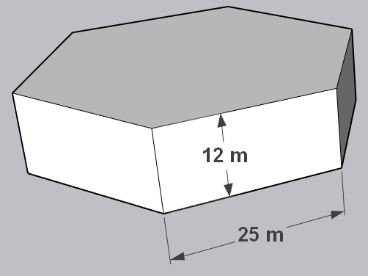
Figure 1. Standardised hexagonal module.

Lightweight yet high-performance concrete material would be an ideal option to fit its designated purpose, serving as a floating platform exposed to seawater. In this study, 1,800 kg/m³ and 65 MPa [5] are selected as the concrete density and 28-day compressive strength for geometrical properties estimation and upcoming numerical simulations, with the intention to ensure better floatability of the modules without compromising their structural performance. For the internal layout of the individual modules, Figure 2 shows two proposed examples, with a wall thickness or bulkhead of 1 m. The empty compartments act as air rooms that are necessary to ensure buoyancy of the module, while also serving as internal storage, locations for mechanical and electrical component installations, and ballasting whenever required. However, the detailed design and analysis of the internal layout are out of scope and will not be further discussed in this study. The internal layout in Figure 2(a) will be considered in this study for module mass estimation purposes only.
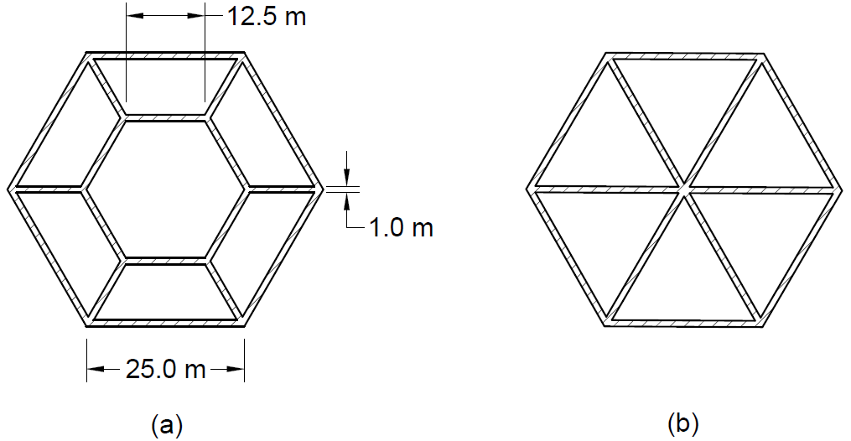
Figure 2. Standardised module internal layout proposals. (a) With large centre compartment.
(b) Equally divided compartments.

Global configuration and recommended applications
In general, the pontoon-type floating platform is designed to be modularly constructed, where the standardised hexagonal modules would be first manufactured and fabricated separately in dry docks. The modules can then be towed to the designated site for installation and construction, connected through inter-module connections of different rigidity as required.
Figure 3 shows two examples of global layouts, where the proposed concepts in this study are mainly targeted for coastal applications. The proposed pontoon-type modular floating platforms span over a long distance, with planar aspect ratios of 1.32 and 1.49 respectively. Comparing the planar dimensions of the floating platforms to the total depth of the individual modules, they will behave like a thin plate floating on the surface of the ocean, and therefore the hydroelastic performance would be a crucial aspect to be investigated and studied.

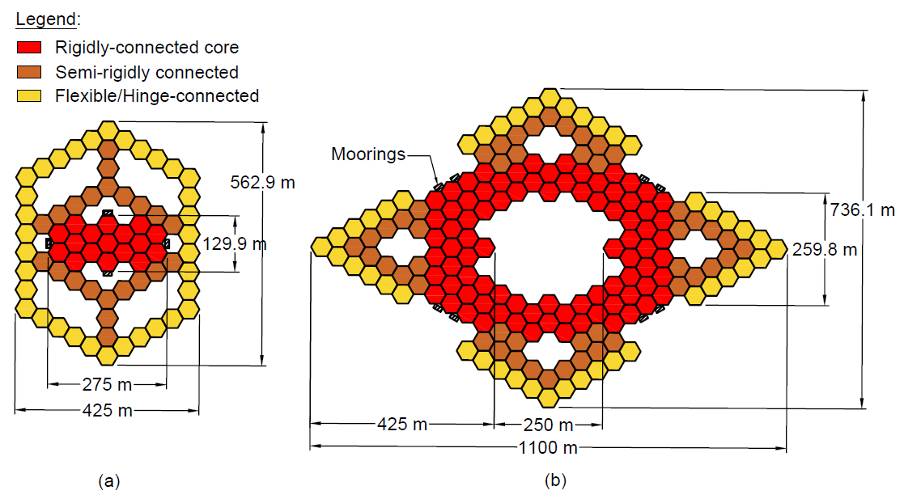
Figure 3. Proposed global configurations of modular floating structure.

Furthermore, the modular floating platforms are categorised into 3 main regions, differentiated based on the connection rigidity and stiffness of the inter-module connectors. Novel inter-module connectors with different rigidities will be developed at a later phase of this ongoing work, prioritising easy and speedy coupling or decoupling of the connectors, and therefore will not be discussed in depth in this study. The purpose of zoning within the platform is to allow for the installation of different ocean renewable appliances and some other potential applications, specifically:
- Rigidly connected core: Installation of horizontal or vertical axis wind turbines (heavy-duty applications).
- Semi-rigidly connected zone: Installation of photovoltaic solar panels.
- Hinge-connected zone: Installation of wave energy converters along the perimeter. Also partially acts as wave breakers to dissipate incoming wave energy.
- Moonpools: Installation of heaving-type wave energy converters. Additional space for aquaculture.
Among the recommended applications mentioned above, the operation of wind turbines would be the most sensitive towards motions and rotations of the floating platform, and therefore they should only be installed on the rigidly connected core. Given the planar dimension and scale of the proposed global layout, the floating structure may even be applied for other purposes, including residential, commercial, recreational and so on, depending on the performance and design of the platform at a later stage. Nonetheless, these global configurations and applications are just several examples out of the infinite combinations and possibilities of modular constructions, and the more essential part of the design intention is to ensure flexibility in altering the global layout, ensuring easy construction and expansion where required.

Selected configurations for study
Despite the recommended layouts being proposed as shown in Figure 3, this preliminary study first evaluates and presents the hydrodynamic performance of a single module and a smaller rigidly connected array in the frequency domain, with the studied array configuration as shown in Figure 4. The rigid array has a centre module, surrounded and connected by another layer of modules around the 6 side faces.

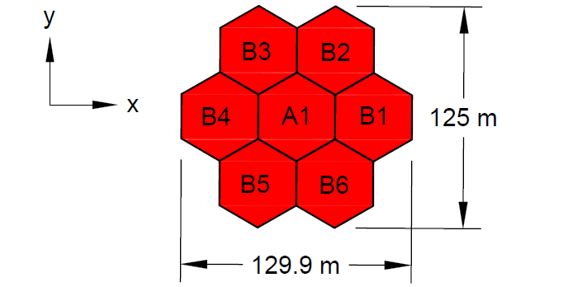
Figure 4. Rigid core array selected for investigation.

In this study, the performance evaluation and discussion will be focused on the single standardised hexagonal module, as well as 3 different scenarios: (i) Case 1: empty rigid array (self-weight), (ii) Case 2: ballasted to achieve the designated draft, (iii) Case 3: subjected to the superstructure loading of a horizontal-axis wind turbine (HAWT) on the centre module. The HAWT adopted in this study is the 5 MW reference wind turbine developed by the United States Department of Energy’s National Renewable Energy Laboratory (NREL) [6], with the specifications and important properties summarised in Table 1.

Table 1. Important properties of the 5 MW NREL Wind Turbine used in this study [6].
Parts | Properties | Values
Rotor-nacelle assembly (RNA) | Mass, kg | 350,000
Rotor-nacelle assembly (RNA) | Mass moment of inertia (I_{xx}), kg m² | 43,700,000
Rotor-nacelle assembly (RNA) | I_{yy}, kg m² | 23,500,000
Rotor-nacelle assembly (RNA) | I_{zz}, kg m² | 25,400,000
Rotor-nacelle assembly (RNA) | I_{xz}, kg m² | 1,170,000
Tower | Mass, kg | 249,718
Tower | Height, m | 77.60
Tower | I_{xx}, kg m² | 125,311,822
Tower | I_{yy}, kg m² | 125,311,822

Seawater is selected as the ballast type for Cases 2 and 3 in this study, with a density of 1,025 kg/m³ and an assumption that the sloshing effect of the liquid ballast is neglected at this stage of the study. Table 2 summarises the estimated module geometrical properties for different scenarios investigated. Attributed to the double symmetry of both the module and rigid array, the centre of gravity in the horizontal plane is located at the geometric centre of the module or array. The mass moments of inertia are computed about the centres of gravity respectively as reference points.

Table 2. Summary of the module and array properties in this study.
Properties | Single Module | Case 1 | Case 2 | Case 3
Total mass, kg | 10,984,700 | 79,837,400 | 84,192,300 | 84,192,100
Designated draft, m | 6.60 | 6.60 | 6.96 | 6.96
Z-axis centre of gravity (from waterline), m | -0.60 | -0.60 | -1.18 | -0.66
I_{xx}, kg m² | 1,930,000,000 | 79,700,000,000 | 83,500,000,000 | 86,600,000,000
I_{yy}, kg m² | 1,930,000,000 | 79,700,000,000 | 83,500,000,000 | 86,600,000,000
I_{zz}, kg m² | 3,420,000,000 | 156,000,000,000 | 164,000,000,000 | 164,000,000,000
I_{xz}, kg m² | 0 | 0 | 0 | 1,170,000
- Numerical Approach
This section describes the numerical approach adopted in this study, including a brief description of the theories involved and validation of the approach.

Numerical implementation
The commercial software package, Sesam by DNV, is utilised for the numerical simulation in this study, which includes GeniE for setting up the model geometry, the WADAM solver in HydroD for the frequency domain analysis, as well as SIMA for time domain analysis in the subsequent work.
To simplify the simulation setup and computational efficiency, the model geometry of the rigid array for Cases 1, 2 and 3 is created as a single continuous plate with the same planar shape. All the geometries of the wet surface or submerged portion are created in GeniE and meshed mainly with quadrilateral meshes and some triangular meshes as deemed necessary by the meshing tool, at element sizes of 0.5 m for the single standardised hexagonal module and 1.0 m for the simplified rigid arrays. This yields a total of 10,500 nodes and 10,432 elements for the single-module model, and a total of 15,098 nodes and 14,993 elements for the simplified panel model.
The model geometry and mesh are then imported into HydroD for subsequent frequency domain analysis to identify the hydrodynamic coefficients (added mass and radiation damping) and first-order motion and wave excitation force transfer functions with the use of the WADAM solver, which solves the linear potential flow theory and equations of motion through boundary element based modelling to evaluate the fluid-structure interaction in the frequency domain. The linear potential flow theory has several important assumptions, whereby the fluid is assumed to be incompressible, irrotational and inviscid, hence the velocity field can be represented by the gradient of a velocity potential ϕ (x, z, t), satisfying Laplace’s differential equation ${\text{∇}}^{\text{2}}\text{ϕ} \text{=} \text{0}$, as expressed in Equation $\left(1\right)$ [7]:
$$\begin{aligned}\frac{{\text{∂}}^{\text{2}}\text{ϕ}}{\text{∂}{\text{x}}^{\text{2}}}\text{ + }\frac{{\text{∂}}^{\text{2}}\text{ϕ}}{\text{∂}{\text{y}}^{\text{2}}}\text{ + }\frac{{\text{∂}}^{\text{2}}\text{ϕ}}{\text{∂}{\text{z}}^{\text{2}}}\text{ = 0} \#\left(1\right)\end{aligned}$$
In addition, the velocity potential has several boundary conditions to be defined [7,8]: (i) The impermeable floating body, (ii) Boundary conditions at the seabed, (iii) Free surface continuity boundary conditions, where the water particles at the free surface remain on the free surface (free surface kinematic boundary condition), and the pressure at the free surface is equivalent to the atmospheric pressure (free surface dynamic boundary condition), (iv) Infinity boundary where the radiated waves travel outwards towards infinity. With these boundary conditions, the wave potential can be expressed through the linear superposition principle as shown in Equation $\left(2\right)$:
$$\begin{aligned}\text{ϕ}\left(\text{x, y, z, t}\right) \text{=} {\text{ϕ}}_{\text{d}}\text{ +} {\text{ϕ}}_{\text{r}} \text{+} {\text{ϕ}}_{\text{w}} \#\left(2\right)\end{aligned}$$
where ${\text{ϕ}}_{\text{d}}$ is the wave diffraction potential, ${\text{ϕ}}_{\text{r}}$ is the radiation potential from the floating body motions, and ${\text{ϕ}}_{\text{w}}$ is the incident wave potential.
The hydrodynamic coefficients are then used to solve for the motion response of the floating body using the frequency domain equations of motion as expressed in Equation $\left(3\right)$ [7]:
$$\begin{aligned}\left(\text{M}\text{ + }\text{A}\right)\ddot{\text{x}}\text{ + }\text{C}\dot{\text{x}}\text{ + }\text{Kx}\text{ = }{\text{F}}_{\text{exc}} \#\left(3\right)\end{aligned}$$
where M is the structural mass matrix of the floating body, A is the added mass matrix, C is the radiation damping matrix, K is the hydrostatic stiffness matrix, while $\ddot{\text{x}}$, $\dot{\text{x}}$ and x represents the acceleration, velocity and displacement vectors of the floating body respectively, and F_{exc} is the wave excitation force vector.
For this study, the wave headings are only defined from 0° to 90° at an interval of 15° for computational efficiency, due to the double symmetry of the investigated concepts. The frequency sets are defined in terms of periods, from 1 second to 40 seconds, at intervals as shown in Table 3. The evaluated hydrodynamic coefficients and wave excitation transfer functions are then imported into SIMA for subsequent time domain analysis. In addition, additional viscous damping terms are not included in this stage to establish the baseline linear hydrodynamics of the floating structures.

Table 3. Period intervals for the frequency domain analysis.
Period (s) | Interval (s)
1 – 15 | 0.5
15 – 20 | 1.0
20 – 40 | 5.0

Although the time domain analysis of the proposed configurations is not discussed in this study, the validation case study involves the regular wave analysis using Airy’s linear wave theory in the time domain [7]. According to Cummins theory, the equation of motion for the floating body in the time domain can be expressed as shown in Equation $\left(4\right)$:
$$\begin{aligned}\left({\text{M}}_{\text{f}}\text{ +} {{\text{A}}_{\text{f}}}^{\text{∞}}\right){\ddot{\text{x}}}_{\text{f}}\left(\text{t}\right)\text{ +}\int_{\text{-∞}}^{\text{∞}}{{\text{K}}_{\text{r}}\left(\text{t - τ}\right){\dot{\text{x}}}_{\text{f}}\left(\text{τ}\right)\text{ dt}} \text{+ }{\text{K}}_{\text{h}}{\text{x}}_{\text{f}}\left(\text{t}\right)\text{ = }{\text{F}}_{\text{exc}}\left(\text{t}\right) \#\left(4\right)\end{aligned}$$
where M_{f} and A_{f} are the structural and added mass matrices at infinite wave frequency accordingly, ${\text{K}}_{\text{r}}\text{(t} \text{-} \text{τ)}$ is the retardation function that represents the fluid memory effect, K_{h} is the hydrostatic stiffness matrix, ${\text{F}}_{\text{exc}}\text{(t)}$ is the vector of wave excitation forces containing the drift and first-order wave force components, while ${\ddot{\text{x}}}_{\text{f}}$, ${\dot{\text{x}}}_{\text{f}}$ and ${\text{x}}_{\text{f}}$ are the acceleration, velocity and displacement vector components correspondingly.

Validation of numerical approach
To validate that the numerical approach adopted in this study is producing reliable results, a case study on an array of floating pontoons for floating solar applications by Baniya et al. [7] and Jiang et al. [9] is replicated using the described approach. Additional parameters, including linear and quadratic viscous damping coefficients, are introduced accordingly based on the values provided in the studies. This case study has been replicated and validated up to the regular wave analysis in SIMA, and the results are illustrated in Figure 5. The predicted heave and surge response amplitude operators (RAOs) of the floating bodies, over a series of wave amplitudes and periods as defined in the referenced studies, have demonstrated very good agreement with the numerical and experimental results by Baniya et al. [7] and Jiang et al. [9]. Therefore, the approach is validated and suitable to proceed with the subsequent numerical work on the proposed configurations.

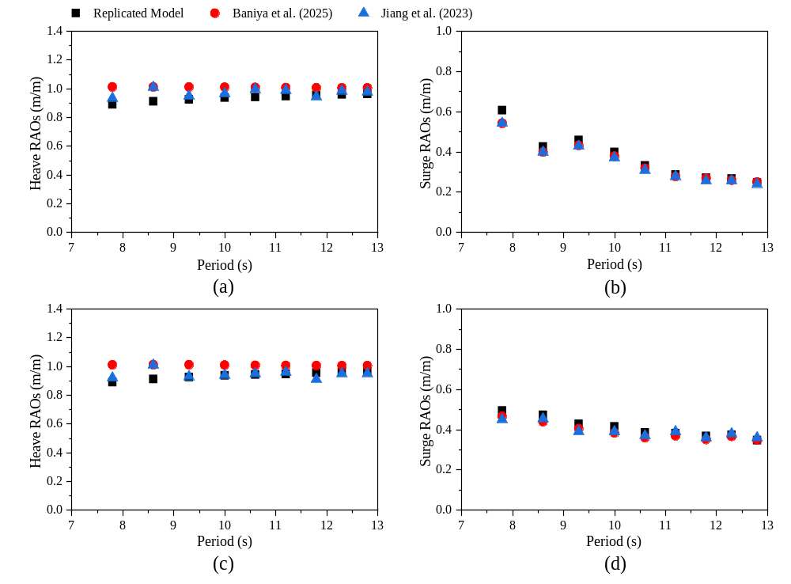
Figure 5. Comparison of RAO results between the replicated model and referenced studies.
(a) 0° wave heading heave. (b) 0° wave heading surge.
(c) 22.5° wave heading heave. (d) 22.5° wave heading surge.
- Hydrostatic Performance
Table 4 presents the hydrostatic results for the single hexagonal module and the 3 rigid array cases. As seen from the positive metacentric heights, it can be concluded that all investigated scenarios have positive initial stability. In addition, the installation of a 5 MW NREL Wind Turbine in the centre module of the rigid array is deemed feasible from the perspective of hydrostatic performance. This is considered reasonable since the total mass and mass moment of inertia of the wind turbine are comparatively lower than those of the rigid arrays, as listed in Table 1 and Table 2. Therefore, this has a minimal effect on the overall stability despite the high tower height and centre of gravity above the platform.

Table 4. Summary of hydrostatic results for each case.
Properties | Single Module | Case 1 | Case 2 | Case 3
Waterplane area, m² | 1,623.70 | 11,801.50 | 11,801.50 | 11,801.50
Displaced volume, m³ | 10,716.70 | 77,890.10 | 82,138.80 | 82,138.60
Z-axis centre of buoyancy (from waterline), m | -3.30 | -3.30 | -3.48 | -3.48
Transverse metacentric height, m | 17.03 | 144.11 | 136.89 | 136.39
Longitudinal metacentric height, m | 17.03 | 144.52 | 137.28 | 136.78
- Hydrodynamic Performance in the Frequency Domain
This section presents some preliminary results of the investigated cases, primarily focusing on the first-order motion transfer function obtained from the frequency domain analysis. The reported motion responses are extracted at the geometric centres of the module and rigid array accordingly at the mean water level.

Standardised single hexagonal module
Figure 6 shows the predicted behaviour of the single hexagonal module within each translational and rotational motion in the frequency domain. As a result of module symmetry, the surge and sway responses demonstrate the same response magnitudes inversely over the series of wave headings. The motions in the common wave periods of 5 – 15 seconds are below 1.0 m/m as well, which is a good indicator that the horizontal translational motions would not be amplified as much by the incoming wave amplitudes. This may help to reduce the inter-module connector or mooring forces, but would require further studies for verification. A similar trend and behaviour can be observed for the roll and pitch responses, but with a maximum rotational response of 20.71 °/m at 8.5 seconds. Although this may seem concerning, further investigations are required to conclude that the design is not feasible, since the additional viscous damping terms that compensates the inviscid assumption of the linear potential flow theory are omitted in this frequency domain study. In addition, the proposed applications would be a series of modules interconnected with various rigidities. The rotational motions are also anticipated to be controlled and relieved in the form of inter-module connector forces. Moving on, the module heave response is constant over the period intervals, with a peak response of 1.3038 m/m at 8.5 seconds, while the yaw motion is considered negligible due to its minimal magnitude compared with roll and pitch.

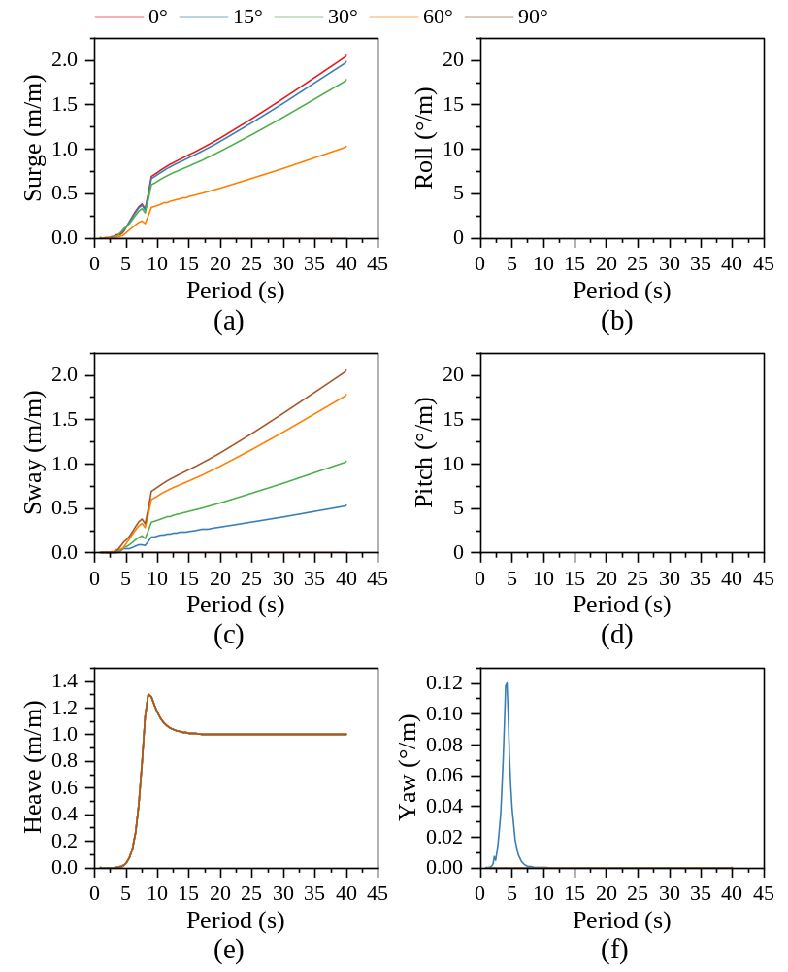
Figure 6. First-order motion transfer functions of a single hexagonal module. (a) Surge. (b) Roll.
(c) Sway. (d) Pitch. (e) Heave. (f) Yaw.

Rigid core hexagonal array under different loading conditions
Figure 7 compares the motions of each investigated case predicted in the frequency domain analysis. Despite the array configuration and loading scenarios, all the responses demonstrate similar behaviours in the overall trend as those for the single module in Figure 6. The similar inverse relationship still exists for surge and sway, as well as roll and pitch, while the magnitude of yaw motion is still negligible in these cases. Hence, for clarity in the comparisons, the motion responses are extracted from 0° wave heading only, which provides the largest response for surge, heave and pitch motions compared with other wave headings.
Generally, it can be observed that the rigid arrays demonstrate improved motion responses compared to those of the single hexagonal module. This is associated with several factors governed by the frequency domain equation of motions as outlined in Equation $\left(3\right)$, where forming a rigid array significantly increases the overall mass, mass moments of inertia and waterplane area. Meanwhile, a larger wetted hull surface varies the added mass, radiation damping and wave excitation forces. The increased mass and the increased wetted hull region of the rigid arrays that lead to larger added mass, provide a larger inertial resistance towards heave motions. The increased waterplane area instead contributes to a higher hydrostatic restoring stiffness, alongside the combined effects of mass moments of inertia, reducing the pitch motions. The larger inertial resistance also helps to shift the peak response period towards longer wave periods compared to the single module. These explain the shifted and lower peak motion responses observed in the rigid arrays compared to the single hexagonal module. In general, the 3 loading scenarios for the rigid arrays demonstrate similar motion responses, except for the surge motion of Case 2, which is attributed to the lower centre of gravity and hence lower pitch-induced surge motion of the array. The horizontal translational motions may seem concerning based on the outcome, but mooring systems will be introduced later in the time domain analysis for horizontal restraints. Therefore, this is anticipated to be optimised and resolved in future work.

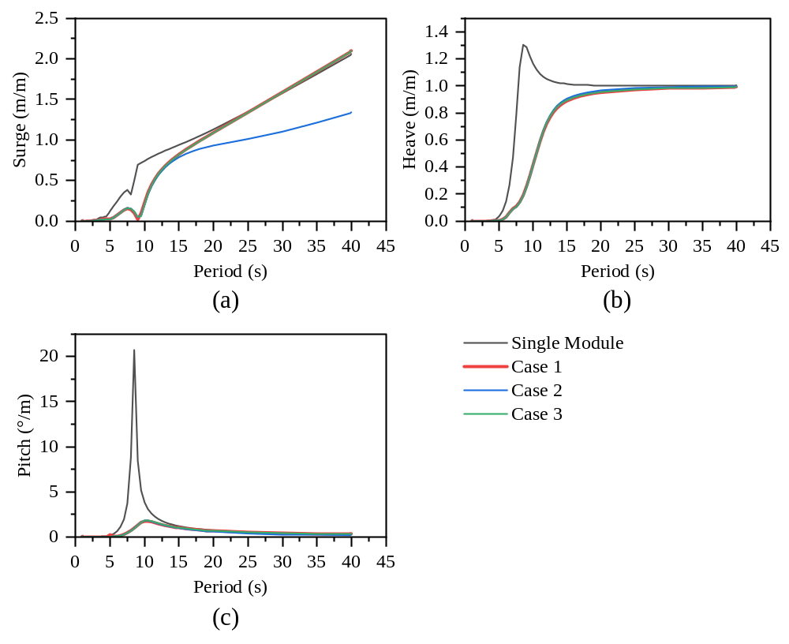
Figure 7. Comparison of first-order motion transfer functions for each case under 0° wave heading. (a) Surge. (b) Heave. (c) Pitch.
- Concluding Statement and Future Work
This study presents conceptual designs of pontoon-type concrete modular floating structures that serve as supporting structures for different ocean renewable applications. The platform is proposed to be constructed modularly by interconnecting standardised hexagonal modules with a side length of 25 m, a total depth of 12 m, and a design draft of 6.6 m. The possible internal structural layouts have also been presented, mainly providing internal compartments for buoyancy, as well as other purposes including storage, mechanical equipment installations and ballast. Two recommendations for the global configurations are presented as well, though flexibility to change the final layout is reserved, the platform is mainly separated into 3 different regions depending on inter-module connection rigidity, to house different ocean renewable appliances and serve for varying purposes. The potential ocean renewable applications include floating wind turbines, floating PV solar panels and wave energy converters.
However, in this particular study, a preliminary frequency domain analysis is conducted on a single hexagonal module and a rigid core array subjected to different loading scenarios, with a module in the centre connected by 6 additional modules around the 6 faces of the hexagon. The numerical simulation is conducted using Sesam packages by DNV (GeniE for geometry setup, HydroD-WADAM for frequency domain analysis, SIMA for time domain regular wave analysis), with good result agreements to another case study for validation purposes.
The rigid core array is analysed under 3 loading cases, including an empty array (self-weight), filled with seawater ballast, and subjected to the loading of a 5 MW NREL Wind Turbine at the centre of the array. Results showed that the single hexagonal module has a larger motion response compared to the rigid arrays, while the rigid array cases demonstrated very similar motion behaviours across different loading cases. Rigidly connecting several modules helps to lower the predicted motion responses, but the viscous damping and mooring effects have not been considered at this stage yet. Therefore, further time domain analysis is still required to assess and optimise the design, ensuring appropriate motion responses and overall stability of the floating platform.
As for the future work, regular and irregular wave analyses can be conducted to further study the hydrodynamic performance of the proposed concept. However, since the proposed global configuration is behaving like a thin plate floating on the ocean surface, the hydroelastic performance governs the structural and operational performance of the platform. Hydroelastic analyses will be conducted as part of the future work, considering the effects of different parameters including the rigidity of inter-module connectors and aspect ratios of the global layout. This helps to ensure the flexibility in altering the global configuration and retain the modularity of the floating platform. Structural analyses and design can also be conducted subsequently to optimise the module design.
Acknowledgement
Funding by the European Union’s Horizon Europe research and innovation programme under the Marie Skłodowska-Curie Action grant agreement No. 101129716 (LITEFLOATCON) is gratefully acknowledged by the authors. Views and opinions expressed are however those of the author(s) only and do not necessarily reflect those of the European Union or the granting authority. Neither the European Union nor the granting authority can be held responsible for them.
References
- Stauber J L, Chariton A and Apte S 2016 Chapter x - Global Change Marine Ecotoxicology Eds J Blasco et al (London: Academic Press) p 273–313.
- Magesh N S and Krishnakumar S 2019 Chapter viii - The Gulf of Mannar Marine Biosphere Reserve, Southern India World Seas: an Environmental Evaluation 2nd Ed. Eds C Sheppard (London: Academic Press) p 169–184.
- Lamas-Pardo M, Iglesias G and Carral L 2015 A review of very large floating structures (VLFS) for coastal and offshore uses, Ocean Eng. 109, 677–690.
- Wang C M and Tay Z Y 2011 Very large floating structures: applications, research and development, Procedia Eng. 14, 62–72.
- Lee H-J and Yang K-H 2023 Compressive and flexural toughness indices of lightweight aggregate concrete reinforced with micro-steel fibers, Constr. Build. Mater. 401, 132965.
- Jonkman J, Butterfield S, Musial W and Scott G 2009 Definition of a 5-MW Reference Wind Turbine for Offshore System Development (Golden: US Dept. Energy) p 75.
- Baniya J, Dai J, Jiang Z and Zhang C 2025 Numerical study of soft-connected modular offshore floating photovoltaic array, Mar. Struct. 104, 103893.
- Marten D, Saverin J, Behrens de Luna R and Perez-Becker S 2026 Linear potential flow theory, QBlade Documentation.
- Jiang Z, Dai J, Saettone S, Tørå G, He Z, Bashir M and Souto-Iglesias A 2023 Design and model test of a soft-connected lattice-structured floating solar photovoltaic concept for harsh offshore conditions, Mar. Struct. 90, 103426.

