Computational simulation and machine-learning prediction of 4D printing: Modeling PLA's time-dependent deformation using thermal response.
R A Asefa ^{a, b}*, H G Lemu ª and E M Gutema^{b}
ª University of Stavanger, Faculty of Science and Technology, Norway.
^{b} Wollega University, Institute of Technology, Ethiopia.

Corresponding author: 287134@uis.no
Abstract. Extending 3D printing to another dimension of shape transformation involves incorporating smart materials and programmability to enable time-dependent responses to external stimuli. Time-dependent responses are challenging because process and design parameters interact in complex, nonlinear ways. Related reviews have researched the design of active composites using hyperelastic materials. However, the brittle and tough properties of polylactic acid material require new computational and optimization techniques. Integrating machine learning with the computation and dynamic behaviour of 4D printing structures clearly predicts the model transformation. This work used deformation techniques to simulate the time-dependent evolution of kinematic structures under thermal stimuli to be employed in finite element analysis. The simulation considered the glass transition and melting point of polylactic acid to constrain thermal properties and simulation time. The computational modelling spanned 323.15 - 433.15 K over 50 s with a 10 s time interval to generate datasets. The rheological von Mises stress within 0 to 50 s reached a maximum value of 0.463 MPa at a surface displacement of 0.045 m. The variation in stress across uniform surface displacement was due to the negligible change in thermal stimulus from 384 to 394 K, which caused a shape response. All COMSOL Multiphysics dataset distributions were trained with a 70:30 ratio in an Extra Trees model, yielding an RMSE of 6.4e-5 mm and R² = 0.99 that ensured a close fit of the prediction. Therefore, during 12 simulations with 60 min of computation and 0.04 min of prediction, 99.93% of optimization fidelity is saved. The forward and inverse kinematics response of nodes and shear strains per 0.05 m confirm the applicability of the 4D printing framework in adaptive soft robot manufacturing.
Key words: 4D printing, Time dependent, Machine learning, simulation, thermal stimulus
- Introduction
Programmable additive manufacturing undergoes a shape transformation and exhibits feasible functional properties when exposed to several environmental stimuli. These environmental facilitators, such as light, pH, magnetic fields, or moisture, catalyze the emergence of time functions where they auto-transform due to their smart materials' natural attributes [1, 2]. However, the convectional additive manufacturing only behaves as a rigid object, whereas traditional modeling requires computational pre-architecture. Similarly, integrating such computationally predesigned structures with artificial intelligence enhances the analyzed computational simulation results. Applying this trial-and-error approach optimizes and predicts the accuracy of 4D-printed multi-material structured time response [3, 4].
The predictive data for the 4D-printed virtual framework and its deformation behavior are provided through computational simulation, where Finite Element Analysis (FEA) contributes to the numerical simulation. FEA enhances the accuracy of nonlinear material behavior, geometric nonlinearity, and stimulus intensity estimation during the experimental time function. The pre-investigation of printing parameters, material characterization, and architectural shape transformation preserves physical performance. In real-time processes, such reliable design requires merging traditional finite element simulation with surrogate-order model control through design optimization acceleration and the digital manufacturing approach [5].
The time-dependent shape evolution defines the 4D printing characterization based on external stimuli exposure. In this shape evolution behavior, mathematical modeling is implemented to solve the multi-physics challenges. Through this multi-physics analysis, the governing equations of smart material response, such as heat transfer, swelling, deformation, or viscoelasticity, provide theoretical outputs. Moreover, the universal mathematical principles of bi-exponential time constants demonstrate the time function shape transformation. In parallel, the activated system of smart polymers, elastomers, and hydrogels incorporates extended constructive mathematical modeling approaches. Consequently, the developed theoretical model predicts the transformed actuating mechanisms, including curvature, bending angle, recovery, and shape fixity ratio [6].
The iteration nature of finite element method (FEM) governing equations have led to machine learning as an efficient alternative for numerical simulation. The computationally intensive solution process requires repetitive work, whereas the machine learning (ML) algorithm responds to large FEA datasets. The algorithm formulates nonlinear generated data of the deformation response and process parameter simulations, while the approach optimizes computational sets with suitable prediction. Likewise, the prediction of polymer physical properties and estimation of material characterization demonstrate the physical testing and accurate properties of data-driven models. Although ML model tools are valuable for the design, optimization, and advanced application of polymer materials, the models require proper selection of printing parameters. These input data parameters, like printing speed, composition ratio, activation temperature, and layer thickness, support the smart structure of bending, displacement, and curvature shape transformation data for fast numerical design evaluation [7].
4D printing computational simulations require various machine learning techniques that effectively solve complex nonlinear deformation data relationships. For instance, Convolutional Neural Networks (CNNs) detect deformation defects in images, while Long Short-Term Memory (LSTM) and Recurrent Neural Networks (RNNs) are used to model sequential and time-dependent deformation. Furthermore, Support Vector Machines (SVMs) and Gaussian Process Regression (GPR) are employed to improve process optimization, predict the accuracy and reduce the amount of training data [8].
Literally, the hybrid of FEA physical mode and the ML algorithm's better compute improve the computational capacity and data-driven efficiency. It means, the rapid intelligence technology certainly facilitates the additive manufacturing product quality and the autonomous real-time prediction. This time dependence enhances, the time-function shape evolution over traditional additive printing. However, shape memory polymer (SMP) phase transitions in 4D printing require manipulations that include moisture diffusion and viscoelastic relaxation [9]. The consecutive model contributes to the accurate prediction of nonlinear material transformation and stimulus behavior. Simultaneously, it improves the accuracy of reduced-order modeling while incorporating multi-physics with simulation efficiency. This provides the structural shape response, which includes folding, curling, bending, and computational modelling taxonomy [10, 11]. The thermal stimulus-based self-folding and bending models are applicable specifically in hyper elastic’s soft robot design for drug delivery or grippers [12, 13]. However, in active composites, the distribution of material influences the shape transformation [14]. The freedom of inverse kinematics requires working with nonlinear geometry, time dependency, and viscoelasticity [15].
The FEA numerical tools are also used to model the time-dependent self-response behavior to retrieve the nonlinear smart material geometry, multi-physics interface, and thermo-chemo-hydro-mechanical characteristics under environmental stimuli. Furthermore, computational software such as ANSYS, COMSOL Multi-physics, and ABAQUS were employed to activate the SMPs, composite, and hydrogel materials [16].
The ML algorithm performs computational simulations while reducing prediction time and maintaining the accuracy of the deformation response. In parallel, it trains on experimental datasets and correlates the desired self-transforms with design parameters [17]. Real-time smart additive manufacturing faces several material and printing challenges. The variations in printing parameters affect the kinematic response and the time-dependent deformation. Likewise, the factors of smart material characteristics change the physical shape transformation uniformity. However, the computational 4D printing simulation provides high fidelity for complex internal structures, whereas machine learning improves the efficiency of the analysis. ML modeling easily generates the input datasets of the physical model to train and predict the shape transformation. Algorithms like linear or logistic regression, ANNs, and CNNs optimize the high-quality data where the true value and predicted value asymptote to a unit value.
The previous work utilized FEA and machine learning (ML) techniques to analyse shape-recovery polymers (SMP), especially in active composite responses. The existing review motivated the design of different materials and outlined its applicability for different materials and stimuli. However, all computational simulation works are inapplicable for every smart polymer, smart composite, and stimulus. Besides, the experimental work on 4D printing technology is inconvenient due to an undefined scope of materials, where this article aims to fill in the gap by focusing on PLA material predesign, limited thermal stimuli, and the latest ML model that utilized random data training.
This paper utilizes the COMSOL multi-physics 3D model computational simulation to retrieve high-quality input data. ML algorithms train the generated datasets to predict the thermal stimulus effect on shape transformation where the effect of thermal stimuli was sourced from boiled water. The simulation of 4D printing uses a time-dependent response to a varied thermal stimulus (<433.15 K) of PLA, where the tested datasets are optimized with several ML models to visualize the gradient magnitude. Subsequently, the FEA, ML, and MATLAB algorithm phenomena are illustrated in Figure 1 as a graphical abstract.
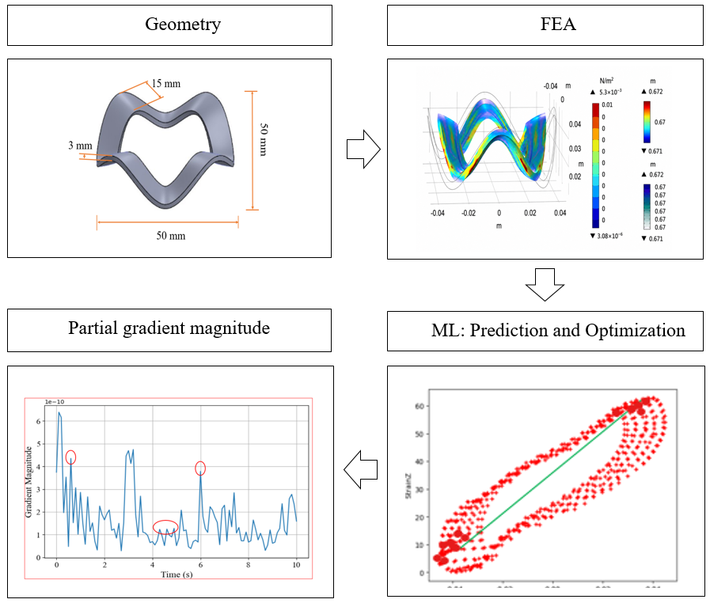
Figure 1: Graphical abstract

- Material and methods
This paper used computational and statistical software to predict shape transformation and optimize shape recovery time. The prediction of deformation morphology were performed through FEA and generating data for machine learning algorithm training. The ML models test, the COMSOL datasets and optimize the shape fixity ratio in parallel; where a Python-based MATLAB script improves the shape feature and parameter distribution profile.
Table 1. Material properties of Polylactic acid
S.no | Properties | Value | Units
1 | Glass transition | 331.15 | K
2 | Density | 1240 | kg/m³
3 | Thermal Conductivity | 0.13 | W/m.K
4 | Specific heat | 1800 | J/kg.K
5 | Young Modulus | 3.2 | GPa
6 | Melting point | 323.15 – 433.15 | K
The simulation datasets of training and the Table 1 material properties of Poly lactic acid (PLA) have direct relation. The change of gain mobility of thermal response referred to the melting point of 423.15 - 433.15 K of PLA to manipulate the stiffness magnitude. The stiffness of PLA is higher below 331 K of glass transition and decreases as thermal stimulus value increases. Consequently, thermal stimulus manipulate the stiffness of elastic modulus variance across shape transformation within 3.2 GPa ultimate young modulus.

Finite element analysis
The structural analysis using FEA predicts the actual shape morphological transformation considering external pressures such as heat, force, or vibration. In this paper, the process considered the CAD/CAM pre-designed irregular surface shown in Figure 2(a) and (b) with a thickness of 3 mm and a width of 15 mm across 50 mm × 50 mm to run the FEA model. The computational work involved study of the thermal, surface elastic, and structural stress, which explored the time-dependent interpolation effects on the preprogrammed shape. The thermal setup in the shape activation process used the melting point of Polylactic acid (PLA) and the preprocessing governing equation. As shown in Table 1, the glass transition and melting temperature of PLA guided the FEA to predict the mechanical deformation and heat transfer through the solid body. In parallel to predicting time-dependent rheological and shape transformation effects, the computational analysis was intended to generate large datasets.
a)
b)
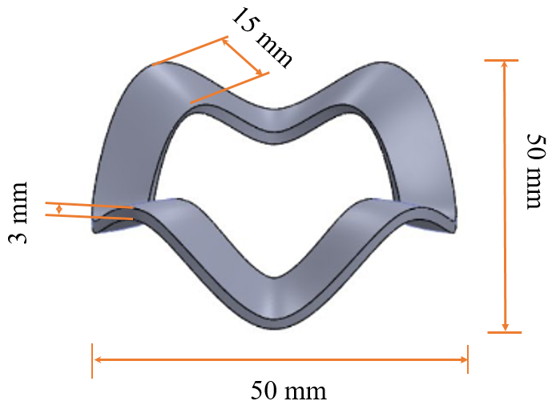
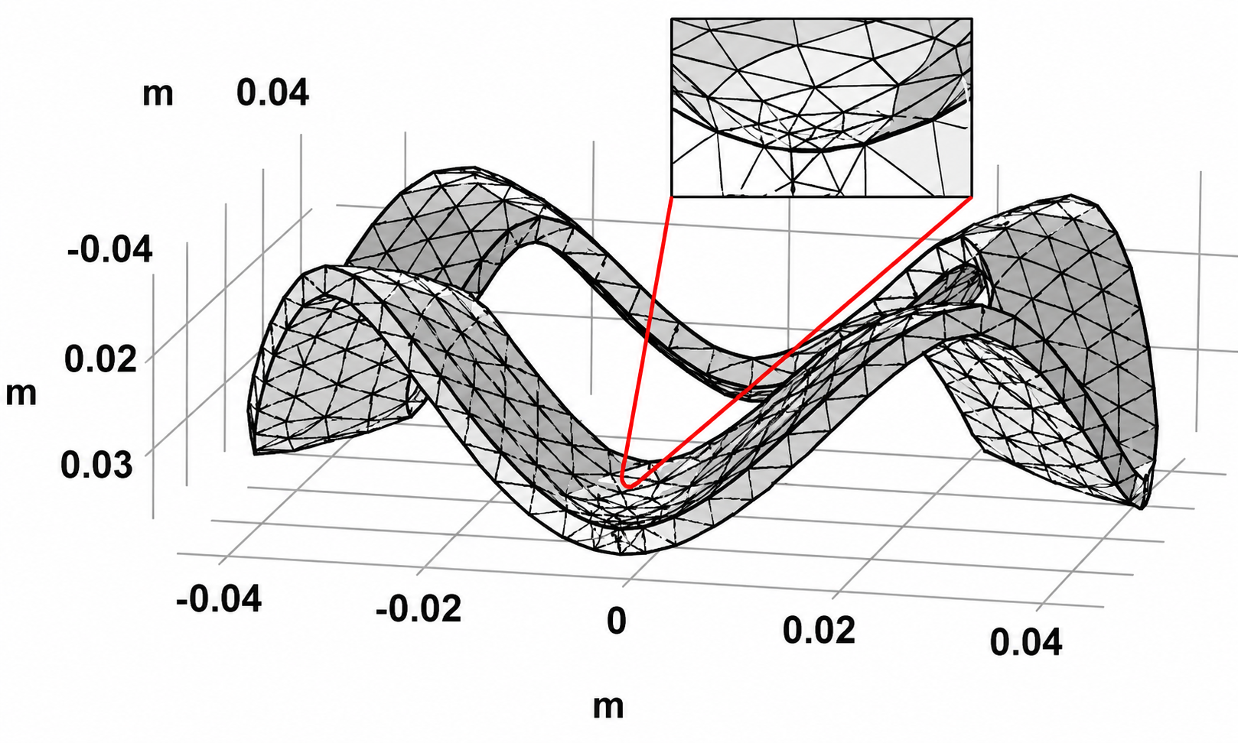
Figure 2: Preprogramed and meshed model
Independently, four number of simulation computed for various magnitude of temperature in between 323.15 - 433.15 K under 50 s, 60 s, 105 s within 10 s, 0.1s, 5 s of time interval, respectively. The shape response of the surface during the 0.1 s and 5 s time setups wasn't suitable for an undefined temperature change within the interval. Nonetheless, the generated datasets were comparable to those with the 10 s incremental value which provides satisfactory shape response. Finally, after comparative time setups simulation, the 628 shear strain and temperature distribution of datasets generated during 50 s time setups of 10 s of increment, across x, y, z -axis.

Machine learning algorithm
The machine learning instructional procedure accommodates any supervised or unsupervised large datasets and permits the computer to identify patterns in the training data. This implicitly programmed mathematical logic predicts the material characterization and optimizes the design of complex behavior during shape transformation. In this study, the COMSOL Multi-physics FEA deformation data were generated within the constraints of the PLA glass transition and melting points and computational time. The generated data for model training and preprocessing used several library algorithms for the nonlinear input-output relationship. However, the predicted performance evaluation requires Python libraries, such as root mean square error (RMSE), mean absolute error (MAE), and coefficient of determination (R²), to analyse the efficiency [18 - 20].
RMSE =$\frac{1}{n}\sum_{i=1}^{n}{{(yi-\overline{yi})}^{2}}$ (1)
MAE = $\frac{1}{n}\sum_{i=1}^{n}{|yi-\overline{yi}}$| (2)
R² =1 - $\frac{{\sum{\left(yi-\overline{yi}\right)}}^{2}}{{\sum{\left(yi-\overline{yi}\right)}}^{2}}$ (3)
where $yi$ is the actual value and $\overline{yi}$ is the predicted value for i = 1… n, whereas n is the total number of observations.
The substantial FEM simulation data on time and stimulating temperature were exported to a CSV file to identify patterns in model training. As shown in Figure 3, the sequential machine learning data processing utilized the time and temperature input features to enhance the model training-testing pattern based on an 80:20 data split. In parallel, the performance shape transformation was predicted from uniform temperature to varied thermal conditions to discuss the R² coefficient error.

SolidWorks: CAD/CAM
COMSOL Multi-physics
FEM

Time (50 s)
Temperature
(323.15 - 433.15 K)
Preprocessing

Stain. ε (x, y, z)
Gradient (U) x, y, z
Train Model

Deformation
Prediction
Figure 3: Workflow of self-response prediction

MATLAB algorithm
Mathematical, sequential, or scientific problems in computing often use high-level scripts or work naturally with matrices and vectors. However, live scripts make the complexity of loop design by replacing it with language programming and algorithm execution. This structured function defines time and temperature as inputs, and the thermal elasticity phenomenon is executed with several functions. As indicated in Figure 4, the Anaconda software with the Python package plots the gradient magnitude to reveal the rate of change of deformation. The steepness of the transformation is related to the gradient of the temperature x, y, and z within the set simulation time. As a result, the gradient temperature ($∇T)$ based on the differential temperature ($∂$Tx, $∂$Ty, and $∂$Tz) K/m determine the deformation error. The heat transfer rate (q) W/ (J. s) from the fluid ($T_{water}$) to the solid ($T_{Surface}$) during immersion in the (323.15 - 433.15 K) was considered to be 1240 kg.m³ density ($ρ)$, 500 - 1500 W/ (m². K) Convective heat transfer (h) and 1800 J/ (kg. K) of specific heat capacity ($C_{p}$) [21].
|$∇T$| =$\sqrt{{\left(\frac{∂T}{∂x}\right)}^{2}+{\left(\frac{∂T}{∂y}\right)}^{2}+{\left(\frac{∂T}{∂z}\right)}^{2}}$ (4)
q = h ($T_{water}$-$T_{surface}$) (5)
$ρC_{p}\frac{∂T}{∂t}=∇$. (k$∇T$) (6)
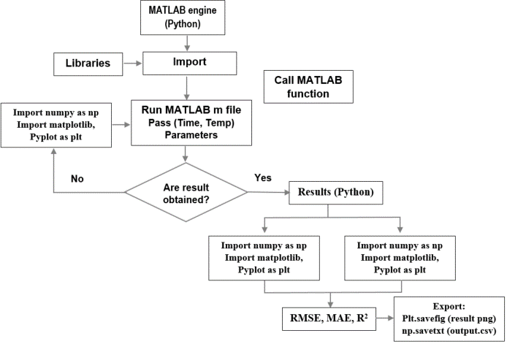
Figure 4: Python based sequence of gradient magnitude
- Results and discussion
The results of the FEA and different algorithms were combined to enhance the shape transformation. Among FEA, COMSOL Multiphysics provided the rheological input, such as stress and strain data, which were analyzed by the machine learning model.

COMSOL Multiphysics
The computational simulation in COMSOL Multiphysics models the physics and engineering phenomena. Real-time engineering rheology was predicted by the multi-user interface model while the physics simulation runs with appropriately tuned parameters. Integrating CAD/CAM models, such as SolidWorks, helped to check the feasibility of rheological effects in real-world breaking, twisting, heating, or bending under environmental factors.
Similarly, the time-dependent shape response is sensitive to internal structural changes affected by the environment. Environmental stimuli cause rheological stress and strain on the interlayer chain, resulting in tension and compression. As shown in Figure 5 (a-d), the soft floating robot's model shape transforms under thermal stimuli of 323.15 - 433.15 K. The temperature was set based on the glass transition and melting point of the PLA. In parallel, the computation time was adjusted to 0 - 50 s with 10 s intervals for the desired response. During 5 s, as shown in Figure 5(a), a maximum von Mises stress of 0.463 MPa was achieved across the surface from -0.04 to 0.045 m. As seen in Figure 5(b), the stress drops to 0.0887 MPa with a negligible change in temperature from 384-394 K at the same surface displacement. This indicates that maximum thermal energy and thermal surface instability reduce stress as simulation time increases by 15 s.
b) 15 s
a) 5 s

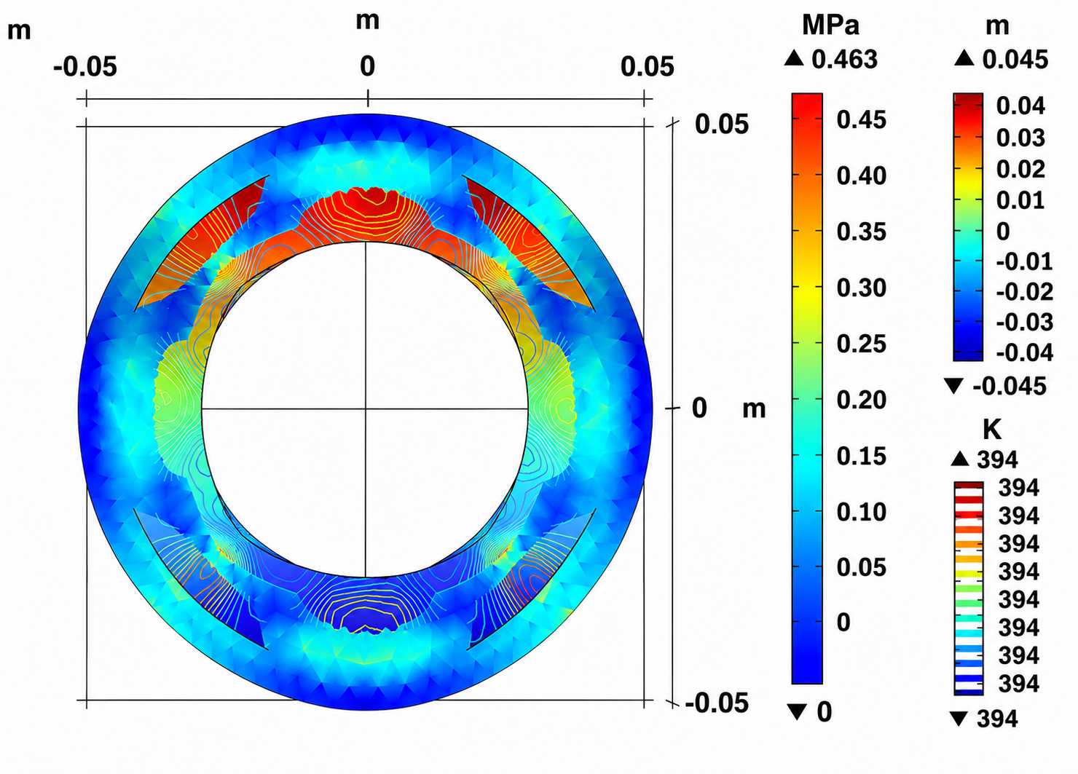
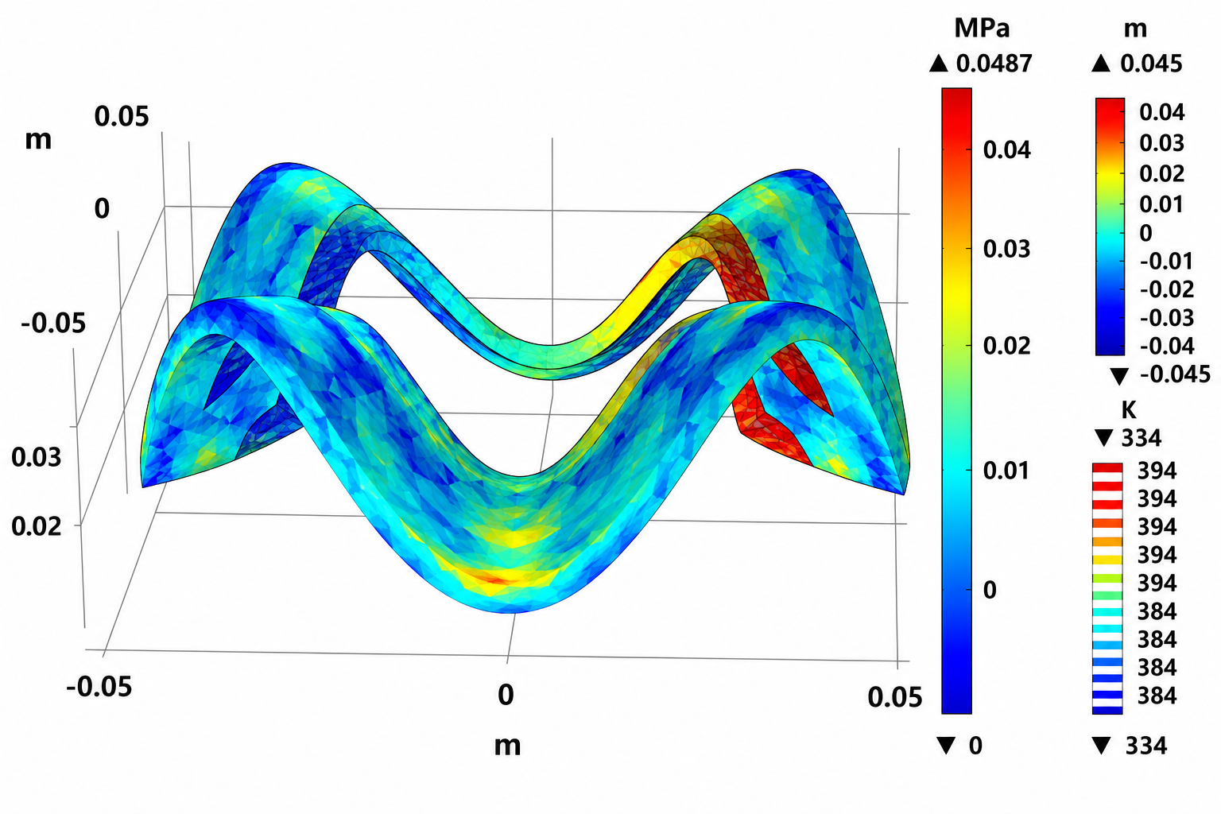
Moreover, as indicated in Figure 5(c), during the 35 s computational simulation, the 0.076 MPa von Mises stress continues to fall, and the thermal contour distribution stabilizes at the glass transition. The transformation exhibited reflects changes in the thermal properties of PLA as the computational time increases. However, the surface expands to 0.067 m after 50 s of simulation, as observed in Figure 5(d), which encourages the structure to recover with 0.0207 MPa. This expansion of the shape response reveals that the model is recovering to the permanent shape after reaching the permissible temporary shape [22].
c) 35 s

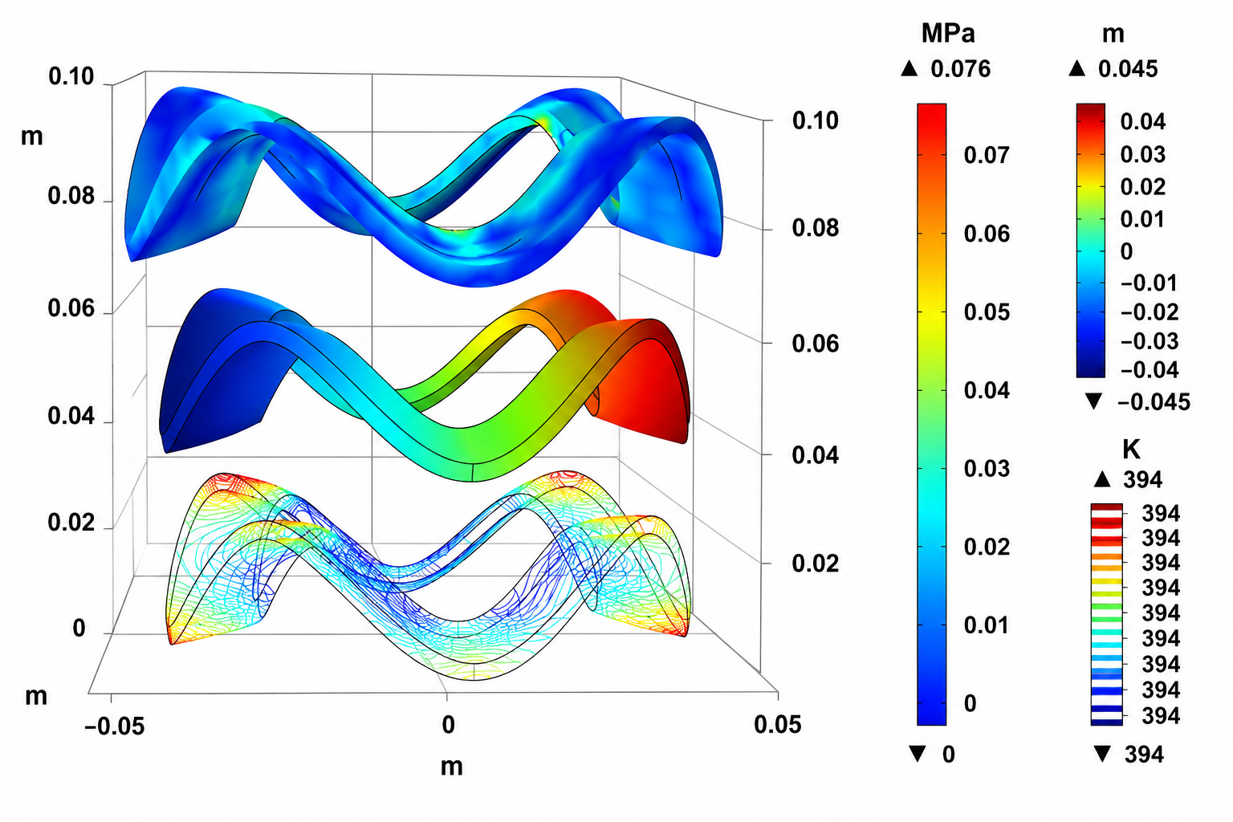
d) 50 s
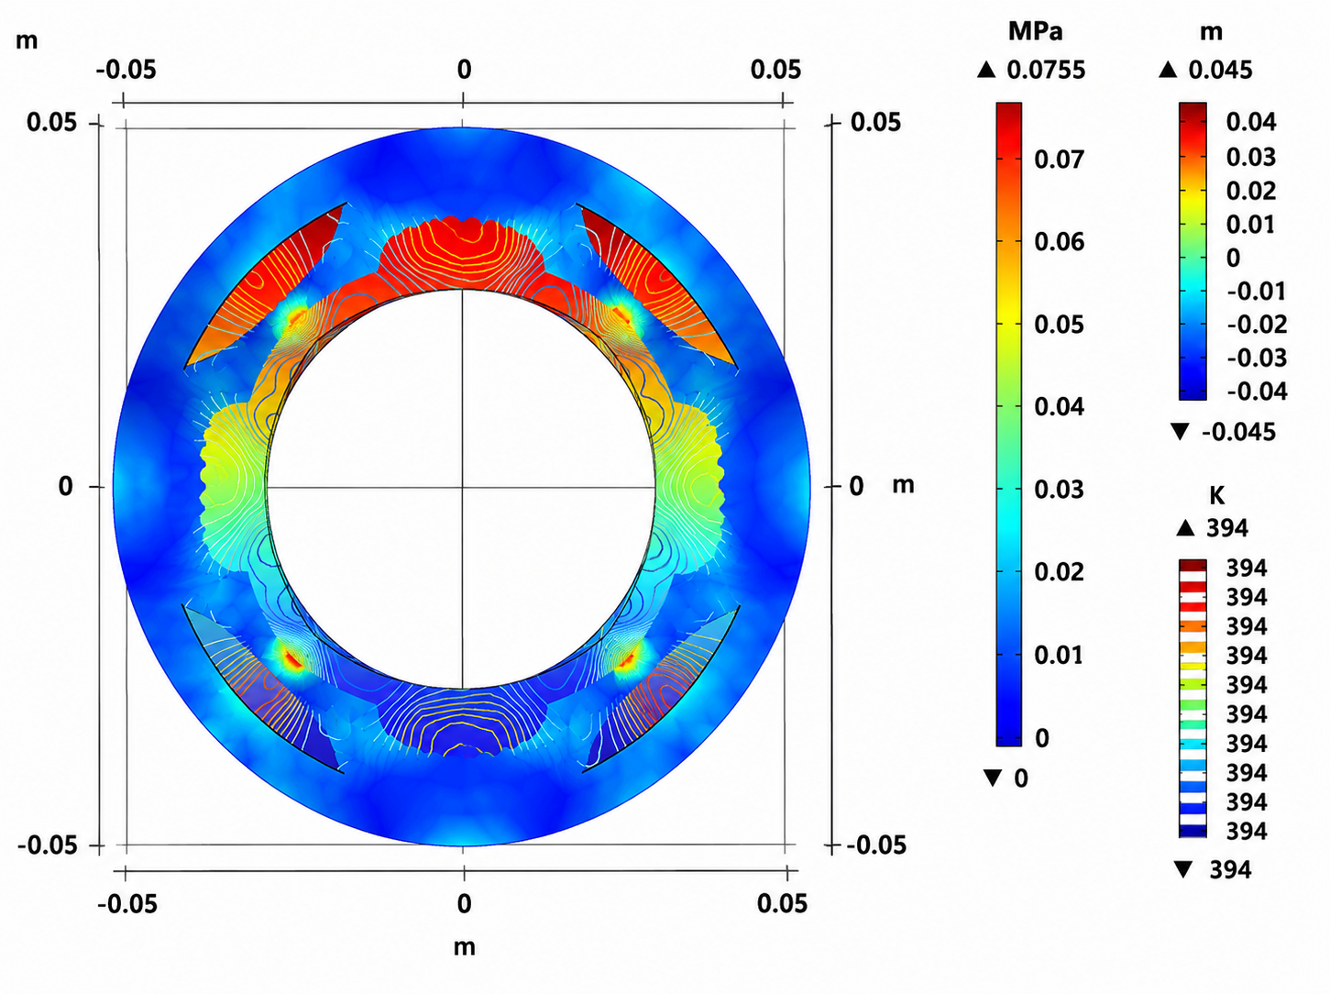
Figure 5: Time dependent COMSOL Multiphysics simulation
As a result, the FEA computational simulation shows that as time increases within the temperature range, the stress of each arc contracts and relaxes. Also, depending on the simulation and temperature, the strain fluctuates, changing the shape regardless of the stress load. This FEA of the soft floating robot indicates that it actuates following the predesigned shape as long as it stays in a hot environment.

Machine learning prediction
The machine learning model was trained on the preprocessed COMSOL Multiphysics input-output data relationship. The training targets the strain component, considering the limitations of PLA thermal properties in the time function. However, the algorithm implicitly predicts the deformation response to address the challenge of small strain changes. Several models exhibited different results in determining the coefficient shape transformation to improve the variances across the surface.
3.2.1 Linear regression model. This supervised ML algorithm modelled the relationship between the independent variable, PLA temperature (323.15 - 433.15 K), and the dependent response, i.e. deformation. The trained model established a linear relationship between COMSOL data to minimize errors in shape transformation to the best-fitting line.
As shown in Figure 6(a), the nodes fluctuate along the x, y, and z axes over time at a set temperature. The nodes on the x-axis were dispersed from -0.02 to -0.04 and from +0.02 to +0.04 during the first 0.02 s and the third 0.02 s of the simulation; however, within the range of -0.01 to 0.01, nodes were densely observed during the 40 - 50 s computational study. Controversy, the node shape response along the y-axis exhibited dispersion, indicating a uniform transformation. In the 20 - 40 s range, from 0.015 to 0.02, the nodes performed contraction. The contracting and stretching behavior along the x and y axes causes the shape of the nodes to become a slim ellipse along the z-axis. The shape profile indicates that high tension was observed during 25 to 60 s, with nodes ranging from -0.04 to 0.03. Similarly, as indicated in Figure 6(b), the predicted shape response completely reversed the direction of the original COMSOL nodes data distribution where some areas narrowed, and others expanded. The prediction was performed over the time range 0 - 60 s and trained for x-, y-, and z-direction nodes from 10 - 40 s within 10 s increments. The transformed shape expanded along the x-axis, where nodes scattered over a range of –0.01 to 0.02 during the 40-60 s response time, and at the two end edges the shape compressed, where nodes were dense. The thermal loads shifted the transformation mode from the x-axis to the y-axis, producing an unsymmetrical distribution. The scattered nodes throughout the shape response indicate the effect of twisting loads about the x- and z-axes. Also, along the z-axis, the nodes shifted downward from -0.02 to 0.02 during 30 - 60 s of computational time. Resulting in, the two peripheral regions were stretched by the tensile load on the x- and y-axes, which dispersed the nodes over the surface.
a)
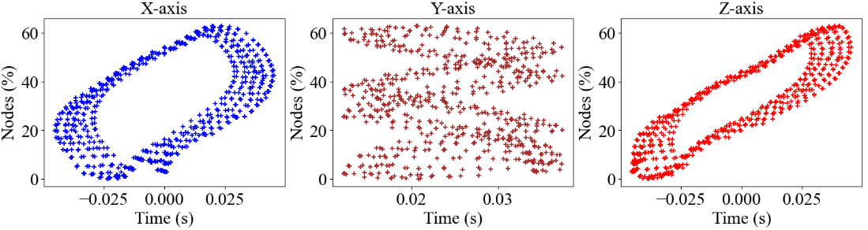
b)
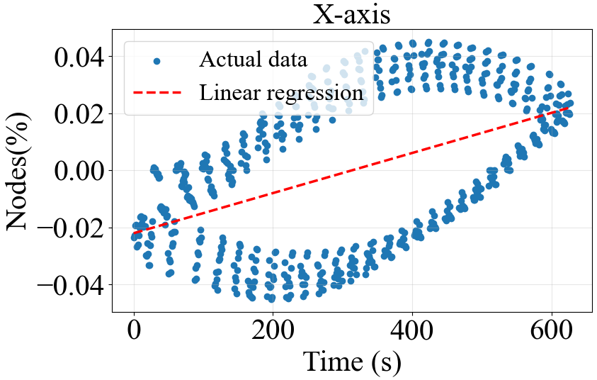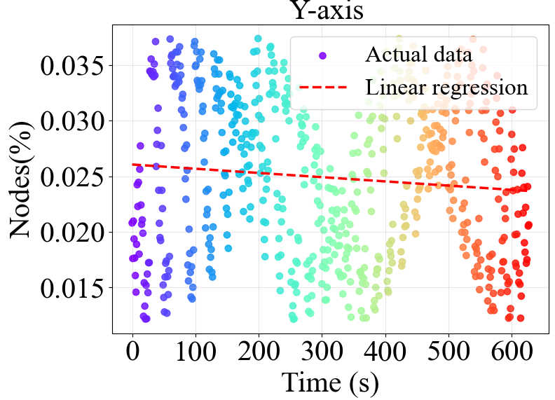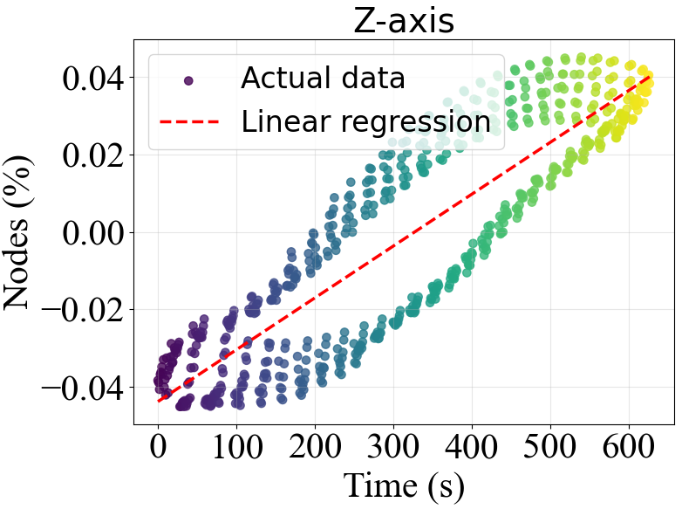
Figure 6: Shape transformed nodes and predicted shape response nodes of x, y, and z coordinates
Consequently, the irregular performance of contraction and tension occurred due to rheological von Mises stress, which was influenced by thermal stimuli. The dispersion and density of nodes across the surface of the mode indicate tension or stretching and compression or contraction, respectively. Additionally, the temperature response behavior of the PLA varied with simulation time, and this character makes 4D printing actuation possible.
3.2.2 Extra trees model. These randomized trees model used all the original COMSOL Multiphysics computed unpruned datasets. The base trees training combined the decision tress to exhibit regression and classification of data. Finally, the optimal split threshold identified through information gaining metrics to measure the displacement, strain and shear strain uncertainty.
- Displacement distribution
The field of displacement in shape transformation is shown through the spatial variation of displacement. This variation represents node displacement from their permanent positions due to external thermal loads. Subsequently, the displacement magnitude was simulated in COMSOL Multiphysics using the thermal properties of PLA. As observed from Figures 7(a) and (b), the non-uniform strain was simulated by thermal heating in the temperature range of 323.15 - 433.15 K, which led to variation of the surface shape. Simultaneously, the specimen underwent several response stages as the heating duration increased from 10 to 40 s. Figure 7(a) depicts that the specimen surface exhibited high feature deformation from -0.02 to 0.04 m, with a 0.001 m peak displacement at 0.035 m.
a)
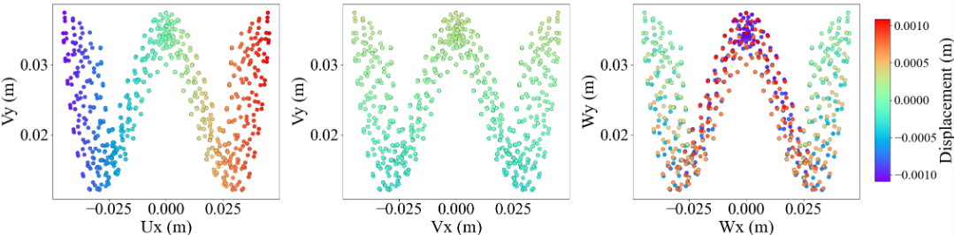
b)
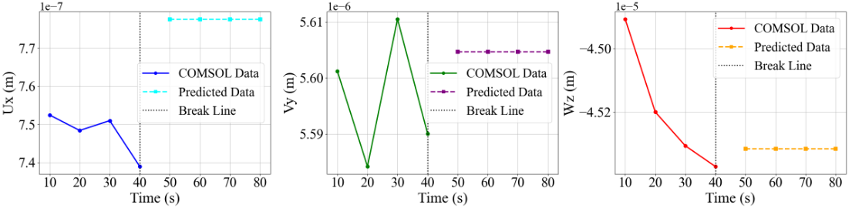
Figure 7: Predicted displacement (U, V, W) of x, y, z axis within 10-80 s
However, Figure 7(b) shows the deformation feature shifted through 0.75e-6, 5.6e-6, and -44.9e-6 within 10 to 40 s, whereas the predicted strain was seen as a regular surface as simulation time increased from 50 - 80 s. As far as the sample kept in thermal stimulus, the shape response across Ux and Vy in the first 40 s exhibited small activation, while the Wz strain distribution decreased. However, the uniform distribution in the second 40 s indicated that after the sample reached the glass transition, the response remained in an identical temporary shape.
- Spatial distribution
Spatial distribution defines the distribution of the strain deformation across the specimen at a specific time. The response of the 4D-designed sample exposed to thermal stimulus categorizes strain variations with color or graph profile fitting. As shown in Figure 8(a), the extra trees model learned the shear-strain COMSOL data with common spatial locations. The algorithm generated the overall actual data spatial deformation, indicating a low prediction error. However, a large error is observed at peaks and valleys from -0.0008 to -0.0001 during 20 to 60 s. This happened because the prediction doesn’t demonstrate the negligible difference in spatial deformation across the shear strain (solid ε_{xy}, solid ε_{yz}, and solid ε_{xz}). Nevertheless, as shown in Figure 8(b), the actual and predicted spatial distribution of the RMSE is registered below 6.4e-5. Besides, the slope increased the variation between the datasets, with a coefficient of determination of 0.92 to 0.99. The 92% RMSE indicates a small error, with effective spatial shape transformation of the 4D-designed structure.
a)
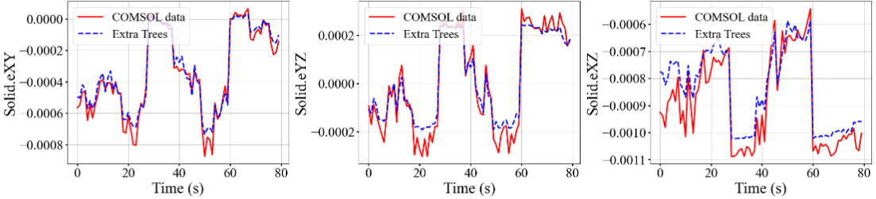
b)
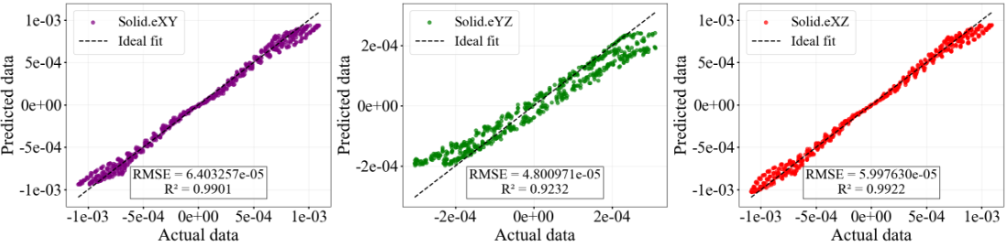
Figure 8: Shear strain across XY, YZ and XZ plane and coefficient of determination

Computational saving
Reducing computational simulation time increase the fidelity of large datasets and data exploitations. Machine learning save to 0.04 min from 60 min the total 12 computational time for three independent time setups. Through the four number of iteration, the individual simulation time speeded up to 15000 to save 99.93% resource [23, 24].
Cs=$\left(1-\frac{MLt}{COMSOLt}\right)$ x 100…………………. (7)
Speed up = $\frac{COMSOLt}{MLt}$……………………….. (8)
Where the measured data of Cs is computation saving, MLt is machine learning time and COMSOLt is COMSOL time.

Gradient magnitude
The rapid temperature distribution across the model surface is called the gradient magnitude, which represents the spatial rate of change of the quantity from one position to another. This rapid heat movement on the surface causes a non-uniform 4D shape transformation. As shown in Figure 9, the response irregularity is visualized across the sample, with a low RMSE recorded. The data distribution between 2 and 4 s shows the epoch incrementing with rapid RMSE in the solid.ε_{Xz} plane. However, a slow distribution is observed across the solid.ε_{xy} plane, indicating an abnormal shape response with a low coefficient of distribution in the range of 4 to 5 s. From this point of view, the glass transition occurs quickly at some points before other surfaces, which disturbs the desired shape transformation.
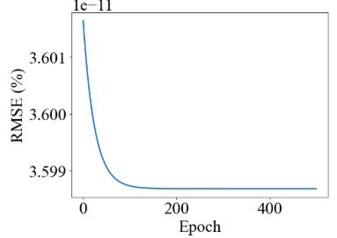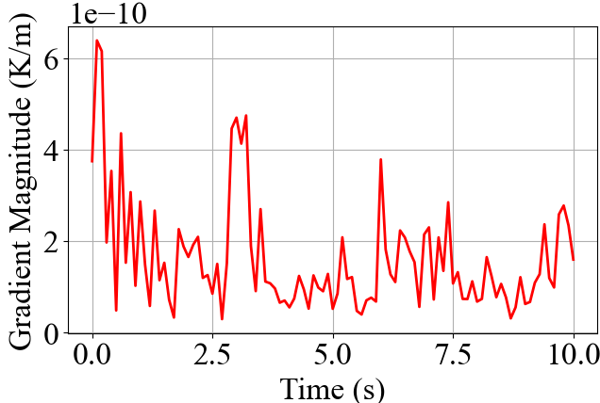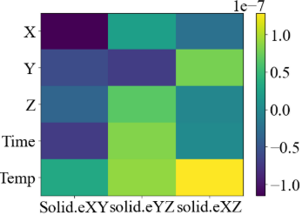
Figure 9: COMSOL datasets spatial rate of change through the surface
- Conclusion
The principle of time-dependent response of a 4D-printed polymer structure predicted the shape transformation from the COMSOL Multiphysics simulation data and Extra Trees machine learning models. Based in this study, the following conclusions can be drawn:
- The synergy of CAD/CAM and physics-based FEA simulation predicted the efficient 4D printing structural behavior through rheological von Mises stress of 0.463 MPa across 0.045 m displacement.
- During 40 s of simulation and prediction time, the stress decreased due to the sample reaching its ultimate glass transition, as long as the specimens were kept below their melting loads.
- The generated numerical model efficiently of the displacement and shear strain distribution demonstrate the deformation spatial evolution under the thermal properties of PLA.
- The COMSOL Physics predicted data have been compared through machine learning simulation approaches, where R² of 0.99 and RMSE of 6.4e-5 showed strong determination and low prediction error.
- ML produced a 99.93% simulation fidelity percentage within 15000 speed up by reducing the 60 minutes of 12 separate computations to 0.04 minutes.
Although the form response lowers computing cost, this work may be feasible in applications for soft robots, adaptive structures, and sophisticated smart material design. In the future, experimental validation and a sophisticated physical machine learning model will be added to this theoretical validation with earlier published works to increase accuracy.

Acknowledgement: This work has been financially supported by Norway Grants (Grant No. 62862) through the INDMET project, NORHED II program. This support to the stipend of the first authors is highly appreciated.
References
- Mehrpouya M, Vahabi H, Janbaz S, Darafsheh A, Mazur T R, and Ramakrishna S 2021. 4D printing of shape memory polylactic acid (PLA). Polym. 230, 124080. https://doi.org/10.1016/j.polymer.2021.124080
- Subash A and Kandasubramanian B 2020 4D printing of shape memory polymers. European Polym. J. 134, 109771. https://doi.org/10.1016/j.eurpolymj.2020.109771
- Pei E, and Loh G H 2018 Technological considerations for 4D printing: an overview. Prog.Addit. Manuf. 3(1–2), 95–107. https://doi.org/10.1007/s40964-018-0047-1
- Alli Y A, Anuar H, Manshor M R, et al. 2024. Optimization of 4D/3D printing via machine learning: A systematic review. Hybrid Adv. 6, 100242. https://doi.org/10.1016/j.hybadv.2024.100242
- ManshorM R, Alli Y A, Anuar H, Ejeromedoghene O, OmotolaEO, and Suhr J 2023 4D printing: Historical evolution, computational insights and emerging applications. Mater. Sci and Eng B, 295, 116567. https://doi.org/10.1016/j.mseb.2023.116567
- Momeni F, and Ni J. 2018, Laws of 4D printing. arXiv.org. Available at: https://arxiv.org/abs/1810.10376v1; Last accessed Sept. 11, 2026.
- Malashin I P, Tynchenko V S, Nelyub V A, Borodulin A S, and Gantimurov A P 2024. Estimation and prediction of the polymers' physical characteristics using the machine learning models. Polym. 16(1), 115. https://doi.org/10.3390/polym16010115
- Malashin I, Tynchenko V, GantimurovA, Nelyub V, and Borodulin A 2024 A multi-objective optimization of neural networks for predicting the physical properties of textile polymer composite materials. Polym. 16(12), 1752. https://doi.org/10.3390/polym16121752
- Ding A, Tang F, and Alsberg E 2025 4D printing: a comprehensive review of technologies, materials, stimuli, design, and emerging applications. Chem. Rev. 125(7), 3663–3771. https://doi.org/10.1021/acs.chemrev.4c00070
- Azher K, Nazir A, Farooq M U, et al. 2025 Revolutionizing the Future of Smart Materials: A review of 4D printing, design, optimization, and machine learning integration. Advanced Mater. Technol. 10(12). https://doi.org/10.1002/admt.202401369
- Nam S, and Pei E 2019 A taxonomy of shape-changing behavior for 4D printed parts using shape-memory polymers. Prog. Addit. Manuf. 4(2), 167–184. https://doi.org/10.1007/s40964-019-00079-5
- Zolfagharian A, Durran L, Gharaie S, Rolfe B, Kaynak A, and Bodaghi M 2021 4D printing soft robots guided by machine learning and finite element models. Sens Actuators A Phys, 328, 112774. https://doi.org/10.1016/j.sna.2021.112774
- Suryavanshi P, Wang J, Duggal I, Maniruzzaman M, and Banerjee S 2023 Four-Dimensional Printed Construct from Temperature-Responsive Self-Folding Feedstock for Pharmaceutical Applications with Machine Learning Modeling. Pharmaceutics. 15(4), 1266. https://doi.org/10.3390/pharmaceutics15041266
- Sun X, Yue L, Yu L, Forte C T, Armstrong C D, Zhou K, Demoly F, Zhao R R, and Qi H J 2024 Machine learning-enabled forward prediction and inverse design of 4D-printed active plates. Nat Commun, 15(1), 5509. https://doi.org/10.1038/s41467-024-49775-z
- Liu Z, Imani K B C, Wang M, Ma S, Furukawa H, Hirai S, and Wang Z 2025 Inverse design framework for 4D printed structures using the finite element method. Sci Rep, 15(1), 42481. https://doi.org/10.1038/s41598-025-26598-6
- Ge Q, Sakhaei AH, LeeH, DunnC K, Fang N X, and Dunn M L 2016 Multimaterial 4D Printing with Tailorable Shape Memory Polymers. Sci. Rep. 6(1), 31110. https://doi.org/10.1038/srep31110
- Gu G X, Chen C, Richmond D J, and Buehler M J2018 Bioinspired hierarchical composite design using machine learning: simulation, additive manufacturing, and experiment. Mater. Horiz. 5(5), 939–945. https://doi.org/10.1039/c8mh00653a
- James G, Witten D, Hastie T, and Tibshirani R 2021 An introduction to statistical learning with application in R. 1st Edition (Springer texts in statistics),vol. 103, 426.
- Khoshvaght H, Permala R R, Razmjou A, and Khiadani M 2025 A critical review on selecting performance evaluation metrics for supervised machine learning models in wastewater quality prediction. J. Environ. Chem. Eng. 13(6), 119675. https://doi.org/10.1016/j.jece.2025.119675
- Miller C, Portlock T, Nyaga D M, and O’SullivanJ M2024 A review of model evaluation metrics for machine learning in genetics and genomics. Front. Bioinf. 4, 1457619. https://doi.org/10.3389/fbinf.2024.1457619
- Li J, Xu D, Guo C, Chen Z, Jiang L, and Li R 2025 Analytical modelling of orthotropic transient heat conduction in the thermal therapy mask within the symplectic framework. Micromach. 16(11), 1277. https://doi.org/10.3390/mi16111277.
- Abebe A R, Lemu H G, Palani I, and Mosisa E G 2026 Analysis and characterization of influence of PLA printing parameters on 4D printing retention time under thermal stimulus. Polym. 358, 130199. https://doi.org/10.1016/j.polymer.2026.130199
- Ganti H, Kamin M, and Khare P 2020 Design space exploration of turbulent multiphase flows using Machine Learning-Based Surrogate Model. Energies, 13(17), 4565. https://doi.org/10.3390/en13174565
- Ramancha M K, Vega M A, Conte J P, Todd M D, and Hu Z 2022 Bayesian model updating with finite element vs surrogate models: Application to a miter gate structural system. Eng Struct. 272, 114901. https://doi.org/10.1016/j.engstruct.2022.114901

