A time-domain framework for response analysis of a long floating bridge under combined traffic and wave actions
Y Song^{1, 2}, J Dai^{2, *} and C Lu²
¹ School of Civil Engineering, Southwest Jiaotong University, Chengdu, China
² Department of Built Environment, Oslo Metropolitan University, Oslo, Norway

* jiandai@oslomet.no
Abstract. Reliable response assessment of long floating bridges requires the time-varying effects of road traffic to be considered together with stochastic wave excitation. This paper presents a numerical framework integrating microscopic traffic-flow simulation, the conversion of moving vehicle loads into consistent equivalent nodal loads, and time-domain hydrodynamic–structural analysis. Traffic flows representing free-flow, capacity, and congestion conditions are simulated using the intelligent driver model (IDM). The resulting vehicle trajectories are used to construct moving point loads, which are transformed into equivalent nodal vertical forces and bending moments and introduced at the corresponding girder nodes. Time-domain analysis is then performed in SIMA/RIFLEX to obtain the bridge response under combined traffic and irregular-wave loading. The framework is demonstrated using a 4.6 km side-anchored floating bridge under a 1-year wave condition. Traffic loading primarily modifies the vertical displacement of the bridge girder by introducing a downward quasi-static component and amplifying displacement fluctuations, with both effects most pronounced under congestion. Wave excitation dominates the vertical-acceleration response over most of the pontoon-supported segment, whereas capacity traffic produces the largest traffic-induced acceleration increment. The proposed framework provides a practical reference for evaluating the distinct effects of traffic states on floating-bridge responses under combined traffic and wave actions.
- Introduction
Floating bridges offer a practical solution for crossings over deep water or in areas with weak seabed conditions. Under such conditions, conventional pier-supported bridges may be technically difficult or uneconomical. By using buoyancy to support gravity loads, floating bridges reduce their reliance on seabed foundations and have been constructed at several locations, particularly in Norway [1, 2]. The planned Bjørnafjord crossing on the E39 coastal highway has further stimulated the development of floating bridge concepts extending over several kilometers [2]. Extremely long floating bridges are highly flexible and can exhibit global natural periods substantially longer than those of conventional bridges [3]. Assessing their response remains highly challenging due to the unique nature of their structure, combined with the complexities of the marine environment and the stochastic nature of traffic.
Researchers have investigated the environmental loading and responses of long floating bridges through numerical simulations, physical model tests, and field measurements [3]. Hydrodynamic-load formulations have been investigated under homogeneous waves, accounting for wave short-crestedness, second-order loading, and viscous drag [4]. Field measurements have revealed the spatial variability of the wave conditions in Bjørnafjord [5], while numerical studies have quantified the effects of inhomogeneous wave fields on the responses of long floating bridges [6, 7]. Wave–current interaction has also been shown to modify global response statistics and internal force distributions [8]. Collectively, these studies provide a sound basis for environmental-response analysis. However, operational traffic and the loading variability associated with different traffic states have generally not been considered in this line of research.
Traffic loads on long-span bridges have been represented using stochastic vehicle-queue models [9] and microscopic traffic simulations that reproduce individual vehicle movements and interactions [10-12]. These methods have been applied mainly to estimate characteristic or extreme traffic-load effects on conventional long-span bridges. With floating bridges in mind, Huang and Moan [13] modeled free-flow, congestion, and full-stop traffic as stationary Poisson spatial fields. Although their analytical formulation was intended to facilitate combination with wind and wave loading, it did not evaluate the response of a floating bridge under simultaneous traffic and environmental actions. Recent developments in traffic-load modeling include network-level microsimulation, monitoring-informed reconstruction of on-bridge vehicle loads, and data-driven simulation of vehicle movements [14-16]. These advances highlight the importance of capturing the evolving spatial distribution of vehicles when constructing time-varying traffic loads for bridge analysis. Notably, Yin et al. [17] developed a three-dimensional traffic–bridge coupled model that simultaneously considered Monte Carlo-simulated traffic, wind, and wave loads. Because that study concerned a cable-stayed bridge with piled foundations, its formulation did not involve the floating-body hydrodynamics or mooring-system effects relevant to long floating bridges.
Traffic-load analysis has also been extended to floating bridges, although with varying levels of idealization. Earlier studies examined idealized moving loads on floating beams and moored floating bridges [18, 19]. Miao et al. [20] further analyzed a floating bridge under the joint action of waves, current, and moving loads. Although that study provides a direct precedent for combined-load analysis, it did not investigate the effects of different operating traffic states. More recent studies have considered prescribed moving vehicles on a floating suspension bridge [21], random traffic generated from measured vehicle data without environmental excitation [22], and multi-lane moving vehicle loads combined with regular waves on a plate-type very large floating structure [23]. Taken together, these studies establish the feasibility of combined traffic–environmental analysis for floating structures. However, the effects of different operating traffic states under irregular-wave excitation remain insufficiently understood for multi-kilometer floating bridges. Traffic and wave actions may occur concurrently, but their spatial distributions and characteristic time scales differ. A unified time-domain framework is therefore needed to represent both loading processes while retaining their distinct spatial and temporal characteristics and to evaluate their combined effects on long floating bridges.
The main contribution of this paper is a unified time-domain framework for analyzing the response of long floating bridges under combined traffic and wave actions. The framework is distinguished by three features:
1. It represents free-flow, capacity, and congestion using microscopic traffic-flow simulation, thereby retaining the spatial and temporal variability of operational traffic.
2. It uses Hermite shape functions as a load-transfer interface between vehicle-level traffic simulation and the beam-element model, converting moving loads at arbitrary positions into equivalent nodal vertical-force and bending-moment histories for time-domain analysis.
3. It uses separately simulated wave-only cases as stochastic baselines for the corresponding combined cases, enabling the incremental effect of each traffic state to be quantified.
The moving-load conversion is verified against an analytical solution, and the complete framework is demonstrated on a 4.6 km straight, side-anchored floating pontoon bridge.
- Numerical framework

Overall framework
The numerical framework comprises three components, as shown in Figure 1: microscopic traffic-flow simulation, moving-load conversion, and time-domain bridge analysis. The traffic model generates vehicle trajectories for the three traffic states, after which vehicle weights are assigned and represented as moving point loads. Hermite beam shape functions are used to convert these loads into equivalent nodal vertical-force and bending-moment histories for the structural model. The corresponding bridge-girder displacement and acceleration responses under concurrent traffic and stochastic wave excitation are then obtained through time-domain analysis in SIMA/RIFLEX.
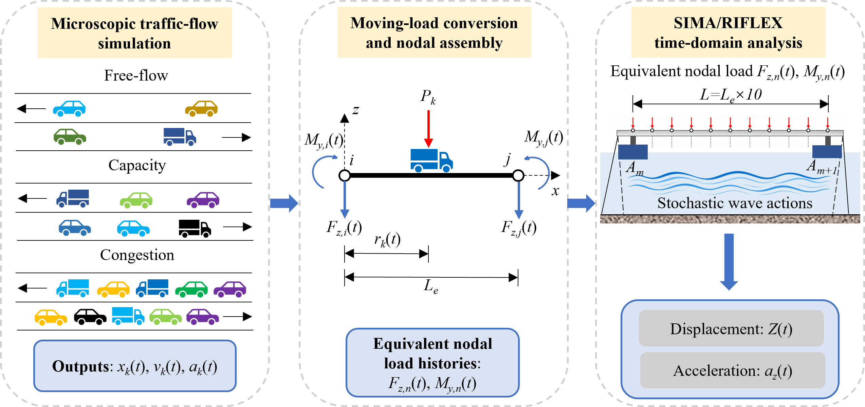
Figure 1. Proposed numerical framework.

Microscopic traffic-flow simulation
A microscopic traffic-flow model is employed to simulate vehicle movements along the floating bridge. As shown in Figure 2, the simulated road is a four-lane bidirectional road with two lanes in each travel direction. The total road length is 13.8 km, comprising a central 4.6 km floating-bridge segment and a 4.6 km approach segment at each end. The approach segments allow traffic conditions to develop before vehicles enter the floating bridge. Two vehicle classes, sedan cars and trucks, are considered, and both classes may travel in any lane. Lane changing and overtaking are not considered.
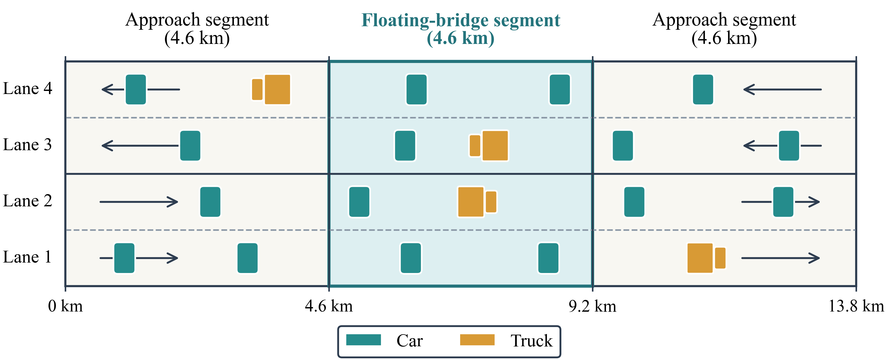
Figure 2. Schematic of the four-lane traffic-flow simulation domain.
The longitudinal car-following behavior in each lane is described using the intelligent driver model (IDM) [24]. For vehicle k, its longitudinal acceleration is jointly determined by its current speed, its speed relative to the leading vehicle, and the actual inter-vehicle spacing, as given by equations (1) and (2), respectively.
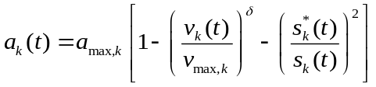 (1)
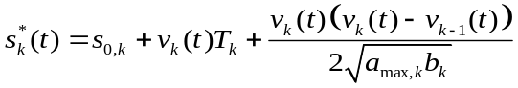 (2)
herein, v_{k}(t) and a_{k}(t) denote the velocity and acceleration of vehicle k, respectively; v_{k-1}(t) is the velocity of the immediately preceding vehicle in the same lane; 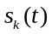and 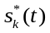 are the actual and desired inter-vehicle spacings, respectively; v_{max,k}, a_{max,k} and b_{k} are the maximum speed, maximum acceleration, and desired deceleration of vehicle k, respectively; and s_{0,k}, T_{k}, and δ denote the standstill spacing, desired time headway, and acceleration exponent, respectively. By updating the motion state of each vehicle at successive time steps, the position, velocity, and acceleration histories of all vehicles over the entire simulated road are obtained.
Trucks account for 20% of the simulated traffic-flow. Trucks and cars use different geometric and car-following parameters, as summarized in Table 1.
Table 1. Vehicle and IDM parameters used in the traffic-flow simulation.
Parameter | Symbol | Sedan car | Truck
Fleet proportion | — | 80% | 20%
Vehicle length | l_{v} | 4 m | 8 m
Mass | m | 2 t | 20 t
Maximum speed | v_{max} | 110 km/h | 80 km/h
Initial speed | v_{ini} | 90 km/h | 70 km/h
Maximum acceleration | a_{max} | 1.4 m/s² | 0.7 m/s²
Desired deceleration | b | 2.0 m/s² | 2.0 m/s²
Standstill distance | s₀ | 2 m | 4 m
Desired time headway | T | 1.5 s | 2.0 s
Acceleration exponent | δ | 4 | 4
To generate traffic-load processes with different vehicle-speed and spatial-occupancy characteristics, three traffic states are considered: free-flow, capacity, and congestion traffic. Free-flow and capacity traffic are generated using open inflow and outflow boundaries, with prescribed inflow demands of 600 and 1700 veh/h/lane, respectively. Both states adopt the initial and maximum vehicle speeds listed in Table 1. Congestion traffic is not generated by further increasing the inflow demand. Instead, vehicles are initially distributed along the road at a target density of approximately 85 veh/km/lane, and periodic traffic boundary conditions are employed to maintain a persistently high-density and low-speed traffic state. The three states represent sparse and fast-moving traffic, continuous traffic near road capacity, and slow-moving traffic with high road occupancy, respectively.
At each output time step, the traffic-flow model records the identifier and class of each vehicle, together with its position x_{k}(t), velocity v_{k}(t), and acceleration a_{k}(t). The vehicle position is subsequently used to determine whether the vehicle is located within the floating-bridge segment and to identify the girder element containing it, whereas the vehicle class is used to assign the corresponding vehicle weight.

Moving-load conversion and nodal load assembly
In this paper, the weight of each vehicle is represented as a vertical point load moving along the floating-bridge girder. At each time step, the longitudinal position x_{k}(t) of vehicle k is used to identify the girder element occupied by the vehicle and its position within that element. The algebraic value of the vertical vehicle load is denoted by P_{k}, whose absolute magnitude is determined by the vehicle weight and whose sign follows the local coordinate convention shown in Figure 3. Based on the vehicle position, the corresponding beam-element shape functions are evaluated, and the moving point load within the element is converted into equivalent vertical forces and nodal moments at the two end nodes. Because the present study focuses on the global vertical response of the floating bridge, the longitudinal positions of vehicles in all four traffic lanes are projected onto the centerline of the bridge girder. Lane eccentricity and the associated torsional effects are therefore neglected.
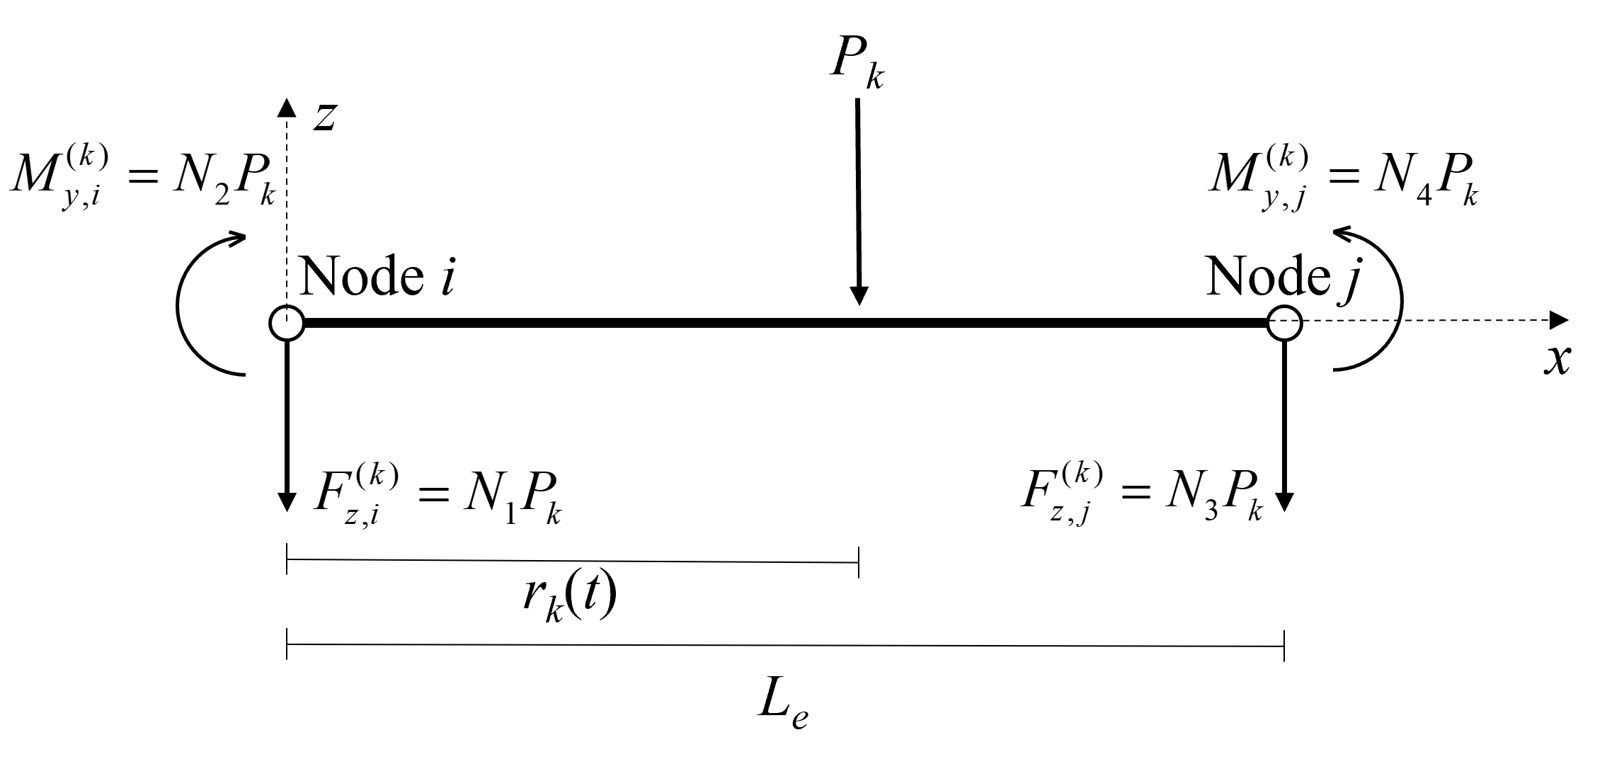
Figure 3. Conversion of consistent equivalent nodal forces and moments.
Figure 3 illustrates an arbitrary two-node girder element. The two end nodes are denoted by i and j, the element length is L_{e}, and the longitudinal coordinate of node i is x_{i}. The distance from node i to vehicle k, denoted by r_{k}(t), and the corresponding dimensionless local coordinate are defined as equations (3) and (4), respectively.
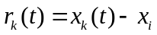 (3)
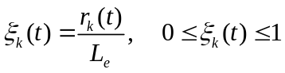 (4)
where 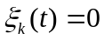and 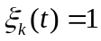 indicate that the vehicle is located at nodes i and j, respectively.
Under the centerline-loading idealization, the moving-load conversion is formulated for the vertical bending of a two-node Euler–Bernoulli beam element in the local x-z plane. According to Euler–Bernoulli beam kinematics, plane cross-sections remain plane and normal to the deformed neutral axis, and transverse shear deformation is neglected. The nodal variables required to interpolate the vertical displacement are therefore the vertical displacement and the rotation about the local y-axis. Accordingly, the vertical-bending nodal degree-of-freedom vector of element e is given by equation (5).
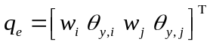 (5)
where q_{e} is the bending-degree-of-freedom vector of element e; w_{i} and w_{j} are the vertical displacements at nodes i and j, respectively; 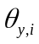and 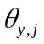 are the corresponding nodal rotations about the local y-axis; and the superscript Т denotes transpose.
The four nodal degrees of freedom provide the displacement and slope conditions required for cubic interpolation. Accordingly, the vertical displacement at the current position of vehicle k is expressed using the standard cubic Hermite interpolation [25] as equation (6).
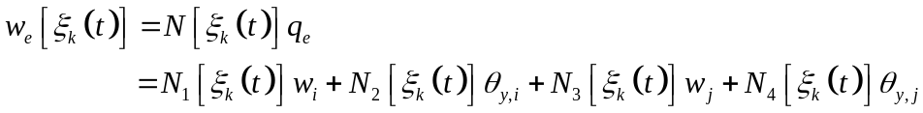 (6)
where w_{e} denotes the vertical-displacement field of element e, N(ξ) is the row vector of cubic Hermite shape functions, which is given by equation (7).
(7)
where ξ is the dimensionless local coordinate. And the four shape functions are given by equation (8).
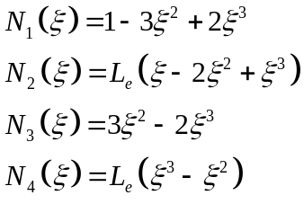 (8)
here, N₁ and N₃ are dimensionless displacement shape functions, whereas N₂ and N₄ have dimensions of length because they are associated with the nodal rotations.
To determine the nodal loads equivalent to the moving point load, an arbitrary admissible virtual nodal-displacement vector δq_{e} is considered. Based on the displacement interpolation in equation (6), equality of the virtual work performed by the moving point load and its equivalent nodal loads gives equation (9).
(9)
where δ denotes a virtual variation, δW_{p} and δW_{e} are the virtual work performed by the moving point load and the equivalent nodal loads, respectively; and 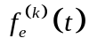 is the equivalent nodal load vector produced by vehicle k in element e.
Because equation (9) must hold for any admissible δq_{e}, the consistent equivalent nodal load vector is obtained as equation (10).
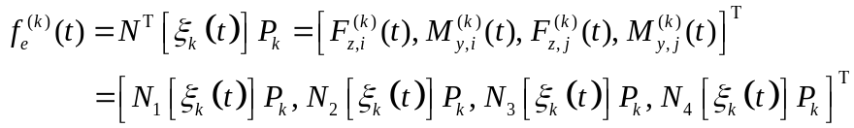 (10)
where 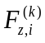(t), and 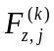(t), are the equivalent vertical forces contributed by vehicle k to the two end nodes, while 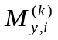(t), and 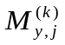(t) are the corresponding equivalent nodal moments about the local y-axis. The algebraic signs of the four components follow the local coordinate and degree-of-freedom conventions shown in Figure 3.
For a given vehicle, P_{k} remains constant during its passage over the bridge, whereas 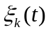 varies with its longitudinal position. The four shape functions and the corresponding equivalent nodal loads are therefore reevaluated at each time step. The vertical-force and bending-moment contributions from all vehicles on the bridge to the same global finite-element node are accumulated component-wise as equations (11) and (12), respectively.
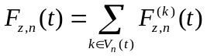 (11)
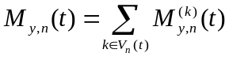 (12)
where F_{z,n}(t) and M_{y,n}(t) are the assembled vertical force and bending moment at global node n, respectively. V_{n}(t) denotes the set of vehicles contributing to global node n at time t. The vehicle-location, load-conversion, and global-assembly procedures are repeated for all vehicles at every time step to generate synchronized time histories of the nodal vertical forces and bending moments over the entire bridge. These load histories are subsequently introduced into the SIMA/RIFLEX model as external traffic loads for the time-domain analysis.

Floating bridge and traffic-wave time-domain analysis
To demonstrate the proposed numerical framework, a straight and side-anchored floating pontoon bridge based on the design concept for crossing the Bjørnafjord [26] is considered, as illustrated in Figure 4. The corresponding numerical model is established in SIMA/RIFLEX for nonlinear time-domain structural analysis. The bridge is 4.6 km long and is vertically supported by 35 pontoons, denoted by A1 to A35, at an equal spacing of 125 m. The south end (SE) of the bridge girder is fully restrained in all six degrees of freedom, whereas the north end (NE) is allowed to translate along the x-axis and rotate about the z-axis. In addition to the end supports, the lateral motion of the bridge is restrained by four mooring clusters, each consisting of eight taut mooring lines.
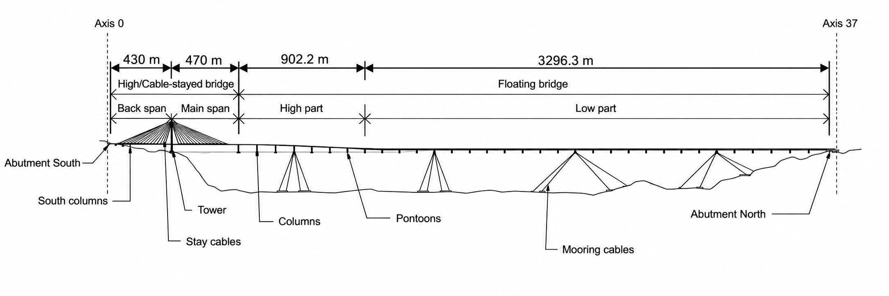
(a) design concept
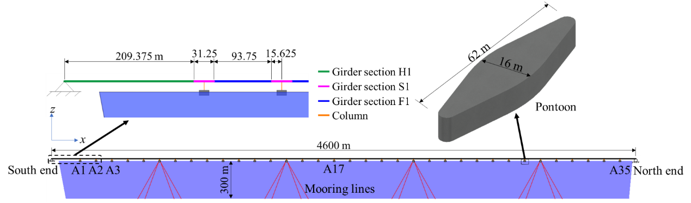
(b) idealized model
Figure 4. Straight and side-anchored floating bridge.
Consistent with the element type adopted for the moving-load conversion in Section 2.3, the bridge girder and columns in the SIMA/RIFLEX model are represented by Euler–Bernoulli beam elements. The 4.6-km-long bridge girder is discretized into 368 uniform elements of 12.5 m, resulting in 369 girder nodes. The pontoons are represented as rigid bodies interacting with the surrounding water, while the mooring lines are modeled using bar elements with pretension. Structural damping is represented using a Rayleigh damping model with a damping ratio of 0.5% [26]. The dynamic characteristics and wave-induced responses of this floating-bridge model have been examined in previous studies [7, 8], which also provide further details of the structural and hydrodynamic modeling.
The equivalent nodal force and moment histories generated from the moving vehicles are written to external load files at a time interval of 0.1 s, with one file assigned to each girder node. For global finite-element node n, the six-component external load vector is given by equation (13).
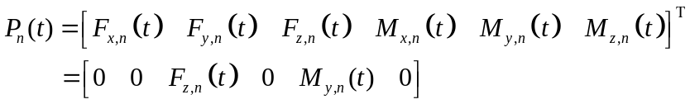 (13)
where P_{n}(t) denotes the external load vector applied at node n; F_{x,n}(t), F_{y,n}(t), and F_{z,n}(t) are the three nodal force components; and M_{x,n}(t), M_{y,n}(t), and M_{z,n}(t) are the corresponding nodal moment components. Due to the centerline-loading idealization adopted in this study, the vertical force F_{z,n}(t) and bending moment M_{y,n}(t) are nonzero. In the adopted RIFLEX implementation, each external load file is applied through a dummy massless body attached to the corresponding girder node. These bodies serve as load-application interfaces through which the prescribed traffic-load histories are transferred to the structural nodes and updated at each time step.
The wave environment is represented by short-crested irregular waves following the JONSWAP spectrum. The frequency-dependent hydrodynamic coefficients and wave-excitation forces of the pontoons are first evaluated using WAMIT [27] and are subsequently employed in the SIMA/RIFLEX time-domain analysis through the Cummins formulation [28]. Both first-order and second-order difference-frequency wave-excitation components are retained. The wave-induced hydrodynamic loads on the mooring lines are evaluated using Morison's equation. The present analysis considers the 1-year return-period wave condition, with a significant wave height of 1.3 m, a spectral peak period of 4.6 s, and a principal wave heading of 288°. The JONSWAP peak-enhancement factor and directional spreading coefficient are taken as 3.3 and 4, respectively [26].
In the time-domain analysis, the traffic-induced nodal load histories are applied simultaneously with the wave-induced hydrodynamic loads on the pontoons and mooring lines. The resulting responses include the vertical acceleration, and vertical bending moment of the bridge girder.

Numerical verification of the moving-load procedure
To verify the moving-load procedure described above, a simply supported beam subjected to a moving point load is considered. The beam has a span of 125 m, corresponding to the spacing between two adjacent pontoons in the floating-bridge model. The mass per unit length and vertical flexural rigidity of the girder are 16,040 kg/m and 6.74 × 1011 N·m², respectively. The beam is discretized into ten uniform elements, each having a length of 12.5 m. A moving point load corresponding to a mass of 1,500 kg traverses the beam at a constant speed of 90 km/h. Newmark’s constant-acceleration scheme is employed for the time-domain analysis, with a time step of 0.01 s.
Figure 5 compares the midspan vertical displacement obtained from the RIFLEX model with the analytical solution reported in Refs [29, 30]. The numerical result closely follows the analytical solution throughout the passage of the load. The maximum absolute difference between the two displacement histories is 0.0151 mm, corresponding to 1.47% of the peak analytical response, while the relative L₂-norm error over the complete response history is 1.17%.
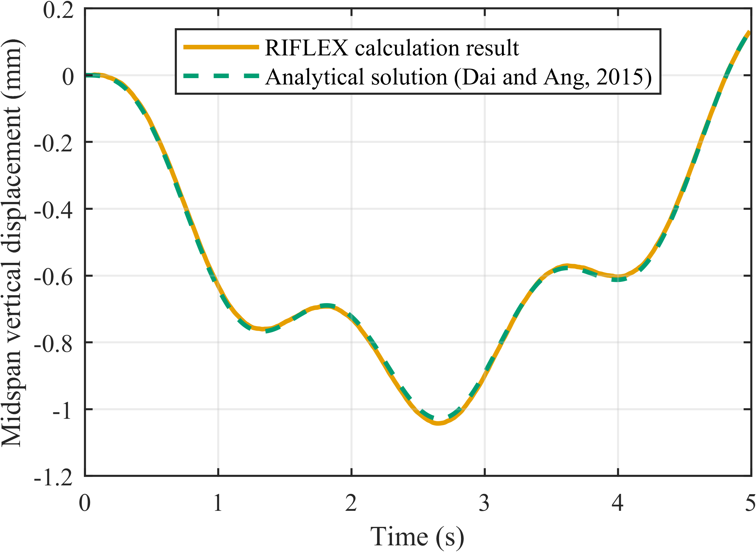
Figure 5. Comparison results from the RIFLEX model and the analytical solution.

Load cases and stochastic analysis procedure
Four load cases were considered: wave-only, wave combined with free-flow traffic, wave combined with capacity traffic, and wave combined with congestion traffic. The total duration of each simulation was 4800 s. The first 1200 s, which contained the initial transient response, was discarded, leaving a one-hour response time history for statistical analysis. Each load case was simulated using five random realizations with different wave seeds and, for the combined cases, different traffic seeds.
For each realization, the maximum absolute value, mean, and standard deviation of the response were first calculated from the retained one-hour time history at each bridge location. The maximum absolute value obtained for an individual realization represents the temporal response envelope at that location. The final maximum-response curve was then constructed as the envelope of the seed-wise temporal maxima absolute value over the five realizations. In contrast, the final mean and standard-deviation curves were obtained by averaging the corresponding seed-wise statistics.
Seed-to-seed variability was evaluated using selected global maximum responses and spatially averaged standard deviations. The coefficient of variation among the five realizations did not exceed 5.3%, corresponding to a standard error of approximately 2.4% for the five-realization mean. These results indicate that the five realizations provide sufficiently stable statistics for comparison among the considered load cases.
- Results and discussion

Traffic states and traffic-induced nodal-load processes
Table 2 summarizes the traffic flow, density, space-mean speed, vehicle count, truck proportion, and total traffic weight obtained from the three traffic simulations. The reported values are averaged over five random realizations.
Table 2. Realized traffic characteristics on the bridge.
Traffic state | q  (veh/h/lane) | ρ  (veh/km/lane) | $$v̄$$  (km/h) | N̄_{br}  (veh) | p_{tr}  (%) | W̄_{br}  (MN) | W_{br,max}  (MN)
Free-flow | 599.65 | 7.52 | 79.79 | 138.3 | 19.7 | 7.51 | 9.77
Capacity | 1636.44 | 26.89 | 60.96 | 494.8 | 20.1 | 27.28 | 30.17
Congestion | 776.46 | 85.07 | 9.13 | 1565.2 | 20.0 | 86.08 | 89.44
Note: For each realization, N̄_{br} and W̄_{br} denote the one-hour mean vehicle count and traffic weight on the bridge, respectively, whereas W_{br, max} denotes the corresponding one-hour maximum traffic weight. The table reports the averages of these quantities over the five realizations. In addition, q=ρ$v̄$, where $v̄$ is the space-mean speed, and p_{tr} denotes the proportion of trucks among all vehicles.
The simulations produce three clearly differentiated traffic states. The free-flow case is characterized by the lowest density and bridge occupancy and the highest realized space-mean speed. The capacity case produces the highest traffic flow, accompanied by increased density and a substantially larger number of vehicles on the bridge. In contrast, the congestion case maintains the highest density and bridge occupancy at a persistently low speed. Its realized flow is therefore lower than that of the capacity case, despite having the greatest vehicle count and total traffic weight on the bridge.
The realized space-mean speeds under the free-flow and capacity conditions are reduced relative to the prescribed class-specific free-flow speed settings. This is mainly because lane changing and overtaking are excluded, such that faster vehicles may be constrained by slower vehicles traveling ahead in the same lane. Since the truck proportion remains approximately 20% in all three cases, the differences in bridge occupancy and traffic weight arise primarily from the different traffic densities and vehicle movements rather than from changes in fleet composition.
Figure 6 presents the equivalent vertical nodal-force histories at the girder node above pontoon A18, located near the bridge midpoint. These histories were obtained using the moving-load conversion and nodal assembly procedure introduced in Section 2.3. A common 300-s interval, from 2400 to 2700 s, is extracted from the same fixed seed realization for the three traffic states. As shown in Figure 6, under free-flow traffic, the nodal force is highly intermittent and frequently returns to zero between successive vehicle passages. The isolated downward peaks approaching 200 kN are consistent with the passage of individual trucks, whereas the smaller and shorter events are mainly associated with cars. Under the capacity condition, loading events occur much more frequently and contributions from several vehicles increasingly overlap. The nodal force therefore remains negative for longer periods, and large downward peaks exceeding the weight of a single truck occur more frequently. In contrast, the congestion condition produces a continuously nonzero nodal force with a substantially larger sustained magnitude. Because the vehicles travel slowly and remain within the elements adjacent to the selected node for longer periods, the corresponding force history varies more gradually than those under free-flow and capacity traffic. These results demonstrate that the traffic state governs not only the magnitude of the nodal load but also its intermittency and rate of variation.
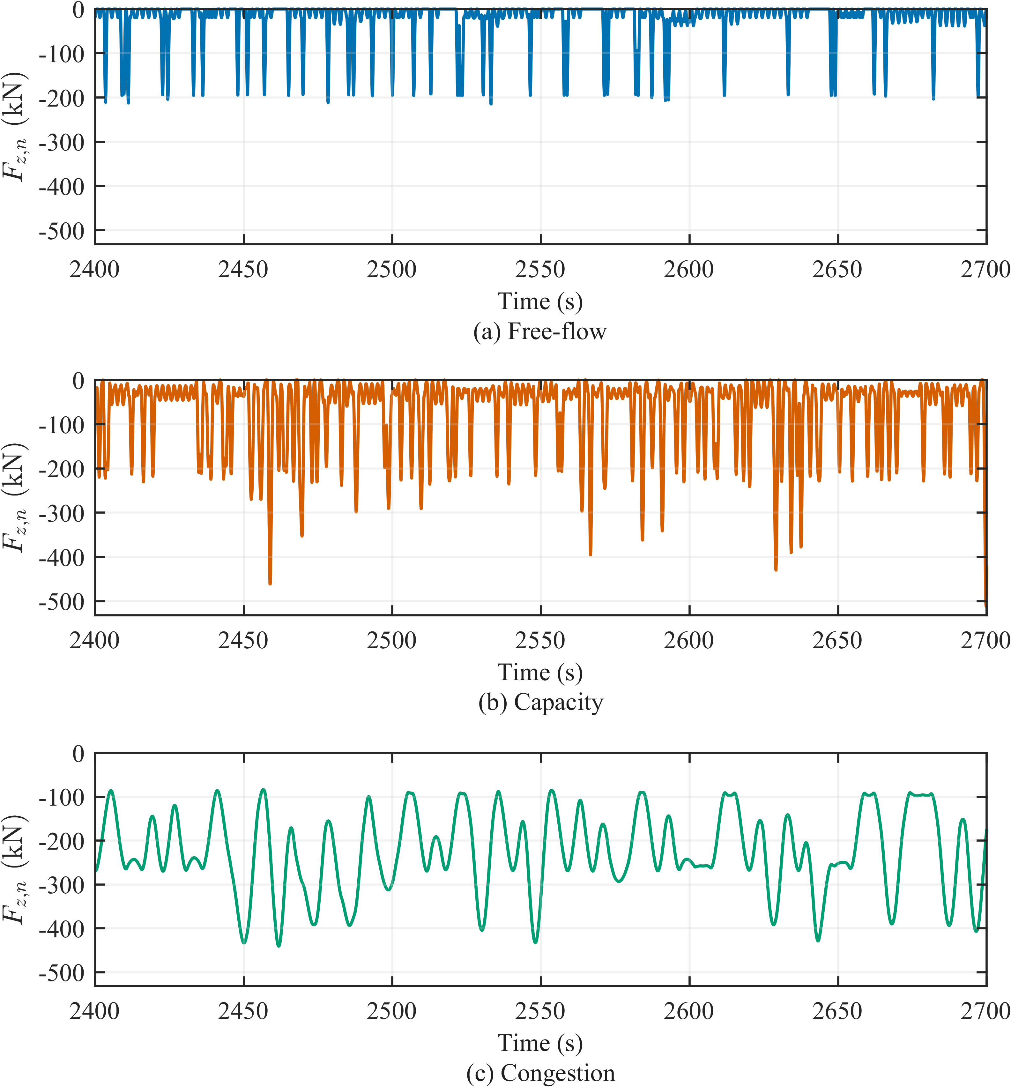
Figure 6. Equivalent vertical nodal-force histories at the girder node above pontoon A18.

Effects of traffic on vertical displacement
Figures 7 and 8 present the vertical-displacement statistics for the wave-only case and the changes produced by adding the three traffic states, respectively. For a response statistic (s) at bridge location (x), the change relative to wave-only is given by equation (14)
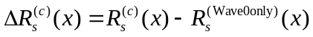 (14)
where 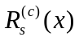 denotes the statistic obtained under combined wave–traffic case (c), and (s) represents the maximum, mean, or standard deviation. The legends in the relative-change figures therefore identify only the corresponding traffic states.
As shown in Figure 7, the vertical restraints at SE and NE enforce zero vertical displacement at both ends. The pronounced response between SE and A1 is associated with the idealization of the cable-stayed approach segment, which is represented by an equivalent uniform girder without stay cables. The resulting underestimation of local stiffness amplifies the calculated vertical-displacement response in this segment. The SE–A1 results are therefore retained only to show the complete spatial distribution and are excluded from the following quantitative comparisons. Along the pontoon-supported segment from A1 to A35, the maximum absolute displacement exhibits recurring spanwise peaks and troughs consistent with the regularly spaced pontoon supports. The mean response is positive over most of the intervening regions but develops pronounced negative troughs near the four mooring regions. The standard deviation is approximately 39–48 mm over most non-mooring regions and decreases to about 25–27 mm near A6, A14, A22, and A30. These local reductions indicate that the mooring constraints suppress the wave-induced vertical-displacement fluctuations.
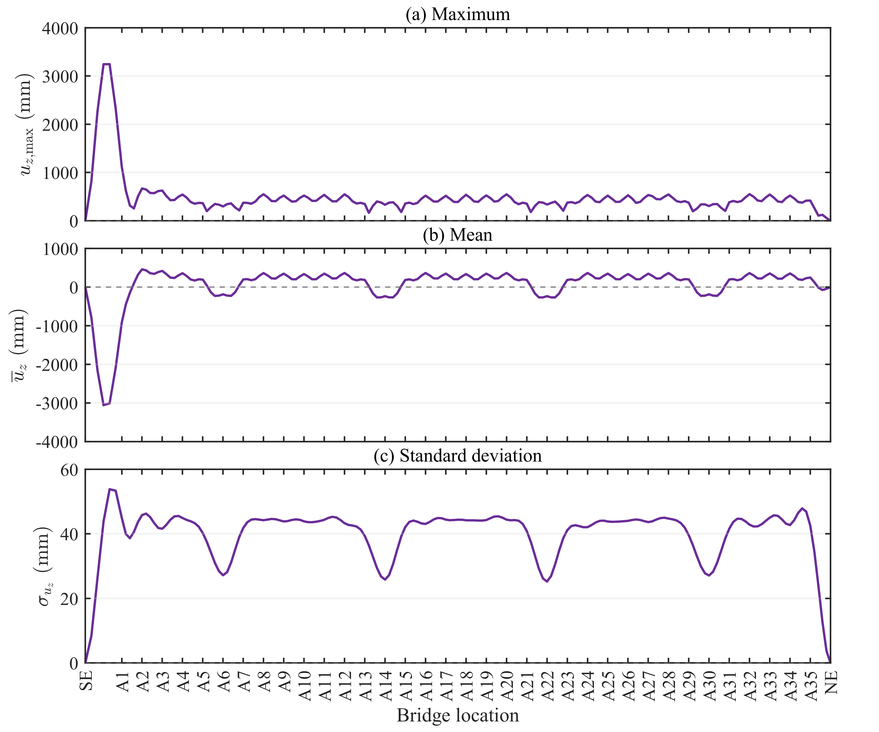
Figure 7. Vertical-displacement statistics of the bridge girder under wave-only: (a) maximum, (b) mean and (c) standard deviation.
Figure 8(a) shows that the changes in maximum absolute vertical displacement are spatially non-uniform and do not increase monotonically with traffic intensity at every bridge location. Over the pontoon-supported segment from A1 to A35, 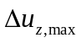 ranges from approximately -52.5 to 68.5 mm for free-flow traffic, -129.3 to 181.8 mm for capacity traffic, and -350.4 to 499.2 mm for congestion traffic. The changes alternate between positive and negative values along the bridge, with the largest amplitudes occurring under congestion. Pronounced positive bands recur around the four mooring regions, whereas negative changes occur over many of the intervening spans. Since 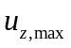 is defined as the maximum absolute response, a downward shift of the displacement time history can either decrease or increase , depending on whether the positive or negative excursion governs the local envelope. Accordingly, the sign of reflects the combined influence of the traffic-induced mean shift and the accompanying change in displacement fluctuations.
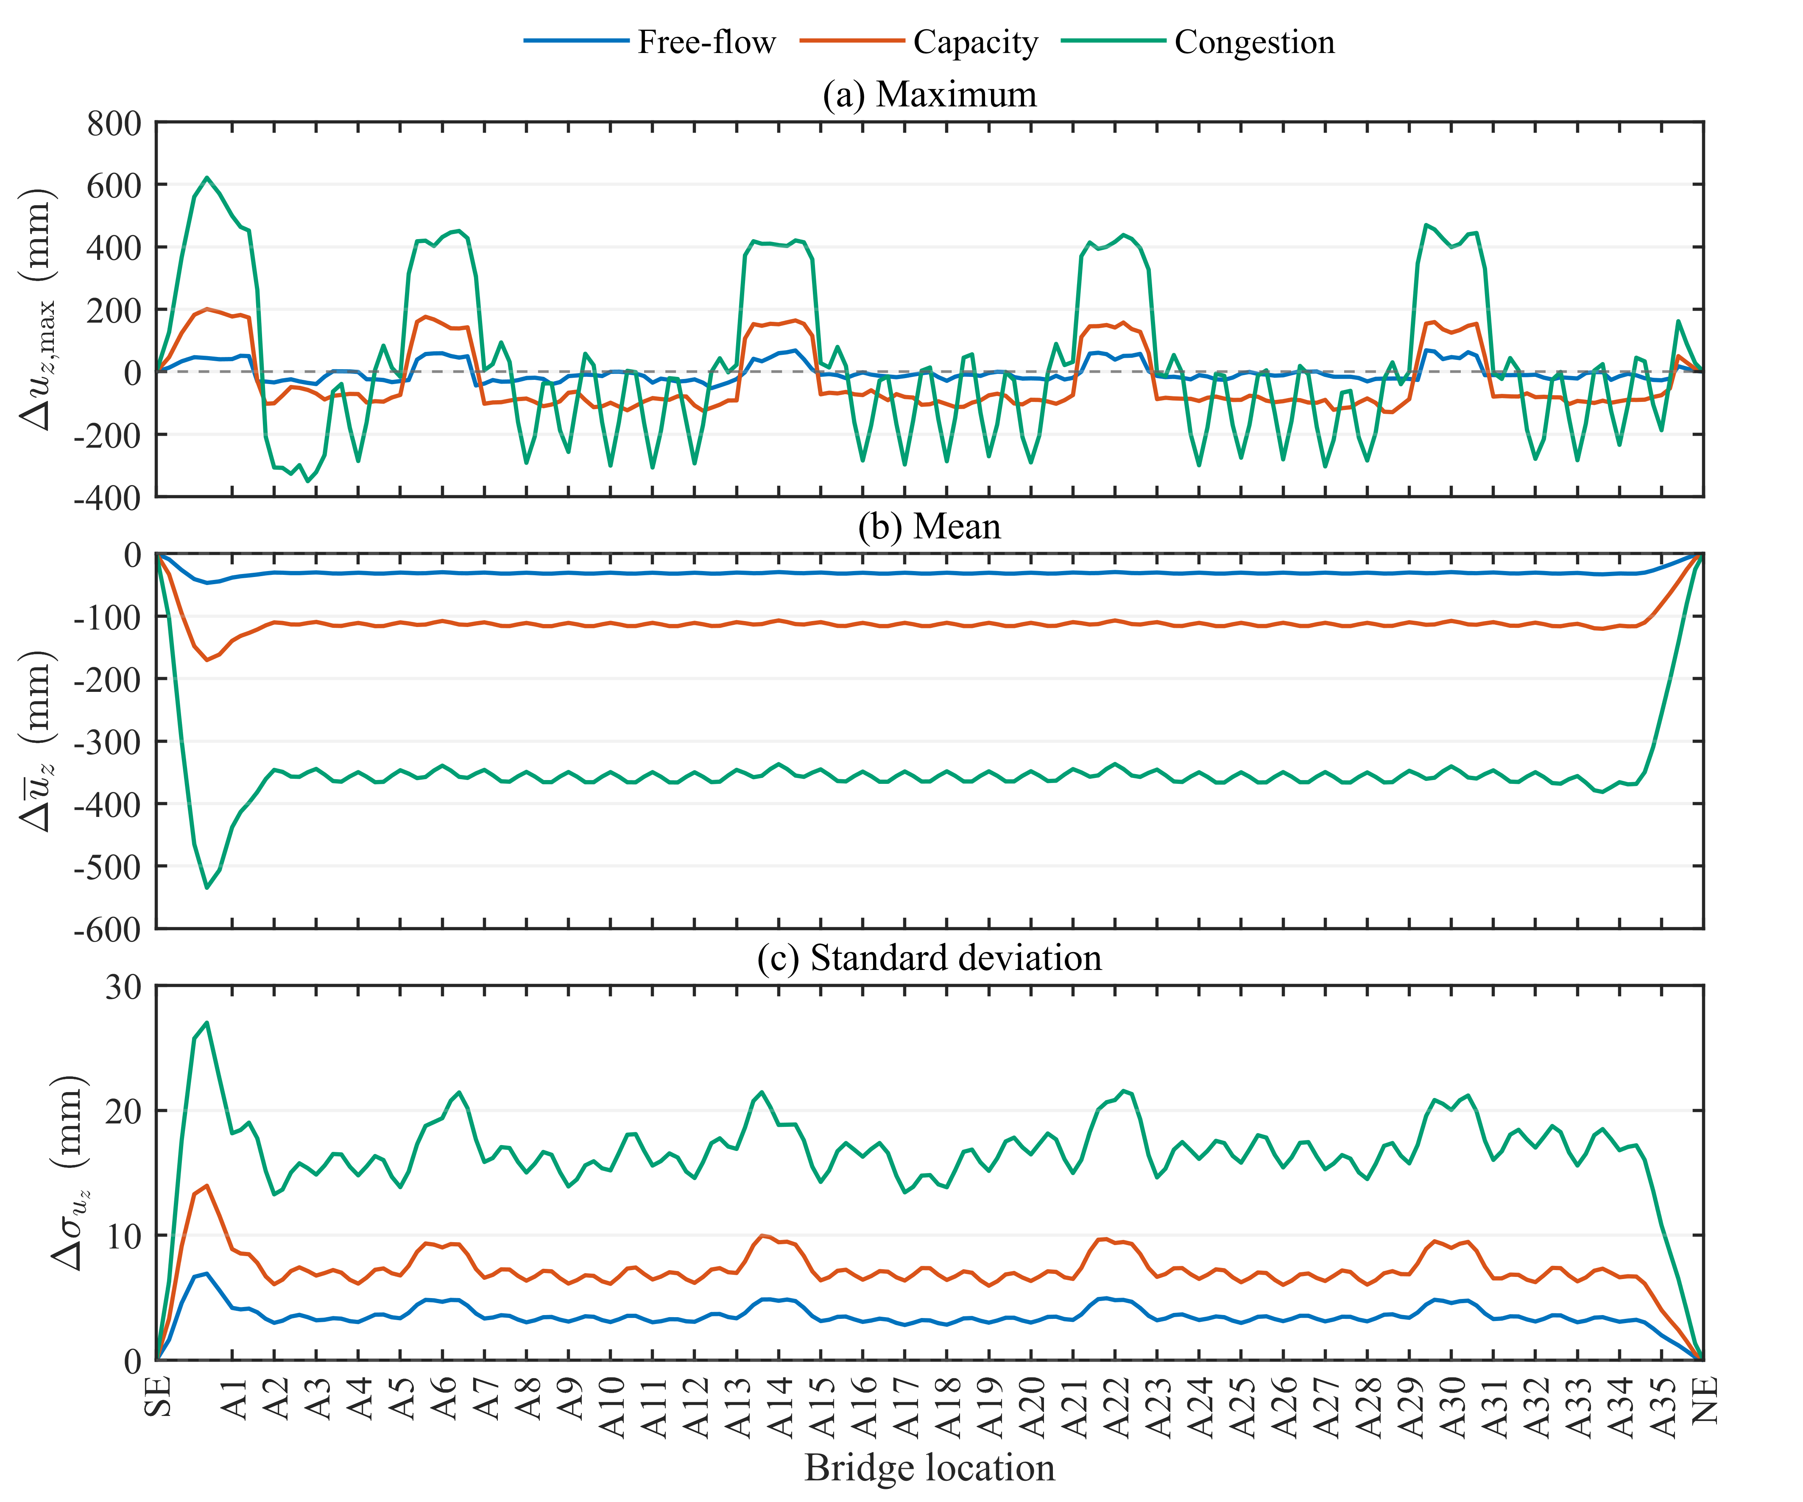
Figure 8. Changes in the vertical-displacement statistics of the combined wave–traffic cases relative to wave-only: (a) maximum, (b) mean and (c) standard deviation.
Figure 8(b) shows that traffic produces a negative change in the mean vertical displacement throughout the pontoon-supported segment. Over most of the segment, the changes are nearly uniform, with relatively small spanwise variations. The spatially averaged changes from A1 to A35 are approximately -31.2, -113.2, and -357.3 mm for free-flow, capacity, and congestion traffic, respectively. Their magnitudes increase in the same order as the bridge occupancy and mean traffic weight reported in Table 2. This correspondence supports the interpretation that traffic affects the mean displacement mainly by introducing a downward quasi-static component associated with the vehicle gravity loads.
Figure 8(c) shows that the inclusion of traffic increases the vertical-displacement standard deviation throughout the pontoon-supported segment. The spatially averaged increments from A1 to A35 are approximately 3.6, 7.2, and 16.9 mm for free-flow, capacity, and congestion traffic, respectively. The progressive increase is consistent with the greater bridge occupancy and traffic-load level from free-flow to congestion. Relatively large increments occur near the four mooring regions. When these increments are considered together with the wave-only baseline in Figure 7(c), however, the standard deviations of the combined responses in the mooring regions remain lower than those in the adjacent parts of the bridge. This indicates that the mooring constraints continue to suppress the vertical-displacement fluctuations after the traffic loads are included.

Effects of traffic on vertical acceleration
Figure 9 presents the maximum absolute value and standard deviation of the vertical acceleration under wave-only. The mean acceleration is not shown because it remains close to zero throughout the bridge, with values on the order of 10⁻⁵ m/s². This is consistent with the absence of a sustained static component in the acceleration response. The vertical acceleration is zero at SE and NE because vertical translation is restrained at both ends. As discussed in Section 3.2, the results within the idealized SE–A1 segment are retained only to show the complete spatial distribution and are excluded from the following quantitative comparisons.
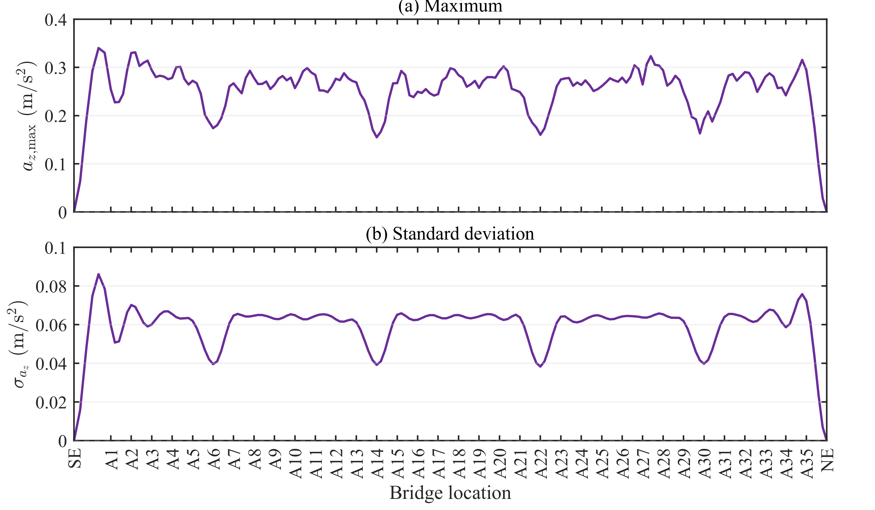
Figure 9. Vertical-acceleration statistics of the bridge girder under wave-only: (a) maximum and (b) standard deviation.
Along the pontoon-supported segment from A1 to A35, the maximum absolute acceleration ranges from approximately 0.155 to 0.331 m/s², while the standard deviation ranges from approximately 0.038 to 0.076 m/s². Both statistics exhibit repeated local reductions near the four mooring regions around A6, A14, A22, and A30. This spatial pattern is consistent with that observed for the wave-only displacement fluctuations and indicates that the mooring constraints locally suppress the wave-induced vertical motion.
Figure 10(a) shows the changes in maximum absolute acceleration produced by the three traffic states. Over the pontoon-supported segment, the changes range from approximately −0.0053 to 0.0950 m/s² for free-flow traffic, −0.0051 to 0.1055 m/s² for capacity traffic, and −0.0177 to 0.0225 m/s² for congestion traffic. The free-flow and capacity cases exhibit pronounced spanwise variations, with relatively small changes at the pontoon locations and larger positive increments between adjacent pontoons. Capacity traffic produces the largest local increase. In contrast, the congestion-induced changes remain close to zero over most of the segment and include small positive and negative values. Since the statistic represents the maximum absolute acceleration, a negative change indicates that the local envelope in the combined case is slightly smaller than that under wave-only.
As shown in Figure 10(b), the acceleration standard deviation increases at all sampled locations between A1 and A35. The largest local increments are approximately 0.0144, 0.0223, and 0.0010 m/s² for free-flow, capacity, and congestion traffic, respectively. The corresponding spatially averaged increments are approximately 0.00330, 0.00417, and 0.000559 m/s². The free-flow and capacity cases again show repeated inter-pontoon peaks and relatively small changes at the pontoon locations. Comparison with the wave-only baseline in Figure 9(b) indicates that wave excitation provides the dominant acceleration background over most of the pontoon-supported segment, although the localized amplification caused by capacity traffic is not negligible.
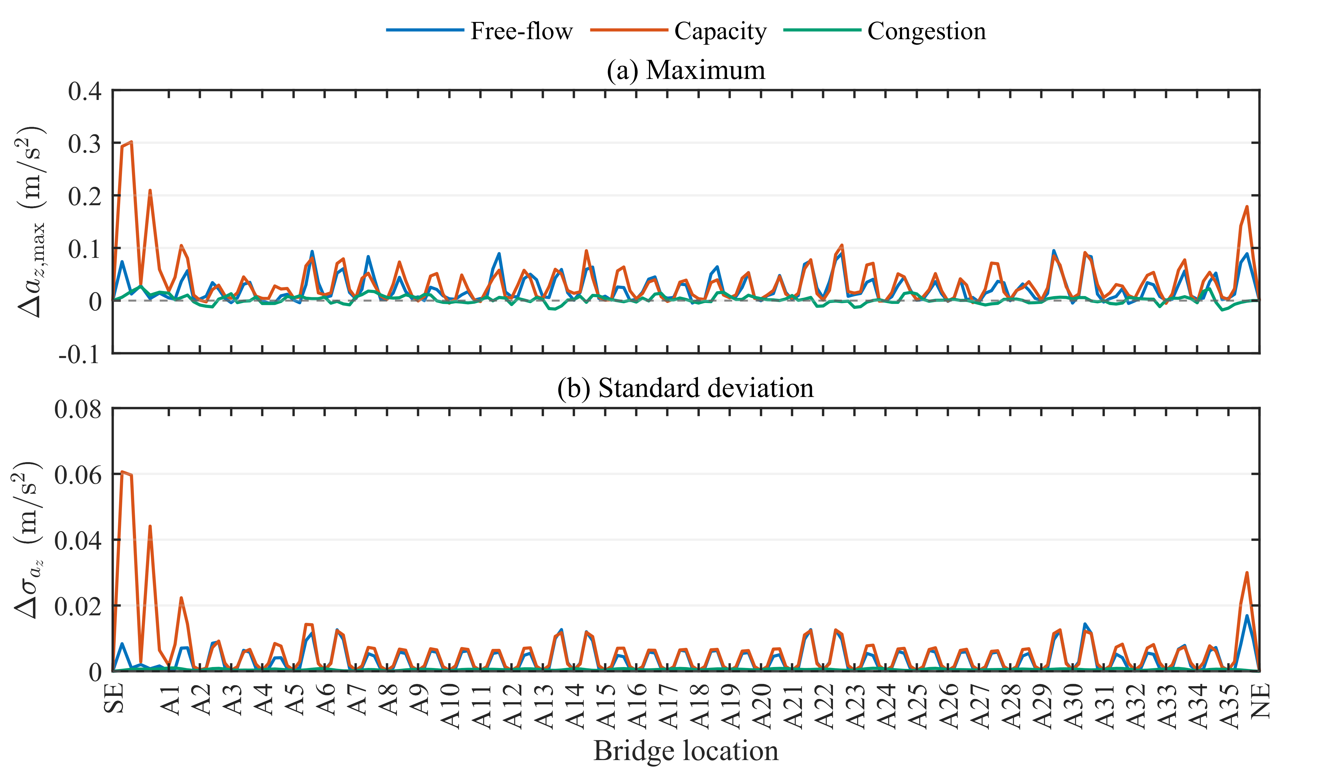
Figure 10. Changes in the vertical-acceleration statistics of the combined wave–traffic cases relative to wave-only: (a) maximum and (b) standard deviation.
The contrasting acceleration increments among the three traffic states indicate that vertical acceleration is governed more by the dynamic variation of the traffic loads than by their mean weight. Free-flow traffic involves high vehicle speeds but relatively few vehicles on the bridge, whereas capacity traffic combines greater bridge occupancy with a still relatively high space-mean speed of approximately 61 km/h. This combination produces the largest traffic-induced acceleration increments. In the congestion case, the mean traffic weight is the greatest, but the low mean speed of 9.13 km/h causes the load distribution to vary slowly. Congestion traffic therefore contributes mainly to the quasi-static displacement response and has only a limited effect on vertical acceleration. This explains why congestion produces the largest displacement changes in Figure 8 but the smallest acceleration changes in Figure 10.
- Conclusions
This study developed a numerical framework integrating microscopic traffic-flow simulation, consistent moving-load conversion, and SIMA/RIFLEX time-domain analysis for a long floating bridge under combined stochastic traffic and wave actions. The main findings are as follows.
(a) The three traffic states produce distinctly different nodal-load processes. Free-flow traffic results in intermittent loading, capacity traffic produces more frequent and overlapping load events, and congestion traffic generates large but slowly varying sustained loads.
(b) Traffic introduces a downward quasi-static component and increases the vertical-displacement fluctuations. From free-flow to capacity and congestion, the spatially averaged mean-displacement changes are -31.2, -113.2, and -357.3 mm, while the corresponding standard-deviation increments are 3.6, 7.2, and 16.9 mm. These trends are consistent with the increasing bridge occupancy and mean traffic weight.
(c) Wave excitation provides the dominant vertical-acceleration background over most of the pontoon-supported segment. Capacity traffic produces the largest localized acceleration increment, whereas congestion has only a limited influence on acceleration despite its greatest traffic weight. Traffic-induced acceleration therefore depends on both bridge occupancy and the temporal variation of the moving loads, rather than on traffic weight alone.
Acknowledgment
This research is funded by the Research Council of Norway through the InfraGuard project (project number 359685) and the European Union's Horizon Europe research and innovation programme under the Marie Skłodowska-Curie grant agreement No. 101129716. This research is also funded by the Norwegian Directorate for Higher Education and Skills under the UTFORSK programme (UTF-2021-10090).
References
[1] Watanabe E 2003 Floating bridges: past and present, Struct. Eng. Int. 13, 128–32.
[2] Moan T and Eidem M E 2020 Floating bridges and submerged tunnels in Norway—the history and future outlook, WCFS2019 ed C M Wang, S H Lim and Z Y Tay (Lecture Notes in Civil Engineering vol 41) (Singapore: Springer) pp 81–111.
[3] Wang C, Cui M, Cheng Z and Moan T 2024 A review on design and analysis of floating bridges: numerical simulations, model tests and field measurements, Ocean Eng. 306, 118065.
[4] Cheng Z, Gao Z and Moan T 2018 Hydrodynamic load modeling and analysis of a floating bridge in homogeneous wave conditions, Mar. Struct. 59, 122–41.
[5] Cheng Z, Svangstu E, Gao Z and Moan T 2019 Field measurements of inhomogeneous wave conditions in Bjørnafjorden, J. Waterw. Port Coast. Ocean Eng. 145, 05018008.
[6] Cheng Z, Gao Z and Moan T 2018 Wave load effect analysis of a floating bridge in a fjord considering inhomogeneous wave conditions, Eng. Struct. 163, 197–214.
[7] Dai J, Leira B J, Moan T and Kvittem M I 2020 Inhomogeneous wave load effects on a long, straight and side-anchored floating pontoon bridge, Mar. Struct. 72, 102763.
[8] Dai J, Abrahamsen B C, Viuff T and Leira B J 2022 Effect of wave-current interaction on a long fjord-crossing floating pontoon bridge, Eng. Struct. 266, 114549.
[9] Ditlevsen O and Madsen H O 1994 Stochastic vehicle-queue-load model for large bridges, J. Eng. Mech. 120, 1829–47.
[10] Chen S R and Wu J 2011 Modeling stochastic live load for long-span bridge based on microscopic traffic flow simulation, Comput. Struct. 89, 813–24.
[11] Caprani C C, O'Brien E J and Lipari A 2016 Long-span bridge traffic loading based on multi-lane traffic micro-simulation, Eng. Struct. 115, 207–19.
[12] Wang F Y and Xu Y L 2019 Traffic load simulation for long-span suspension bridges, J. Bridge Eng. 24, 05019005.
[13] Huang W and Moan T 2022 An analytical solution to traffic loads on long-span bridges, Probab. Eng. Mech. 68, 103244.
[14] Testa G, Zaccaria G, Montanino M, Baltzopoulos G, Bilotta A, Iervolino I et al. 2023 Infrastructure-level traffic micro-simulation for probabilistic analysis of bridge loads, Comput.-Aided Civ. Infrastruct. Eng. 38, 1217–35.
[15] Zhou J, Wu W, Caprani C C, Tan Z, Wei B and Zhang J 2024 A hybrid virtual–real traffic simulation approach to reproducing the spatiotemporal distribution of bridge loads, Comput.-Aided Civ. Infrastruct. Eng. 39, 1699–723.
[16] Dong Y, Pan Y, Wang D and Chen A 2024 Traffic load simulation for long-span bridges using a transformer model incorporating in-lane transverse vehicle movements, IEEE Trans. Intell. Transp. Syst. 25, 15600–13.
[17] Yin X, Xiao S, Feng K, Huang Z, Zuo L and Quan Y 2026 Three-dimensional stochastic traffic–bridge-coupled vibration analysis considering combined wind-wave action, Int. J. Struct. Stab. Dyn. 26, 2650364.
[18] Fu S, Cui W, Chen X and Wang C 2005 Hydroelastic analysis of a nonlinearly connected floating bridge subjected to moving loads, Mar. Struct. 18, 85–107.
[19] Wu J S and Shih P Y 1998 Moving-load-induced vibrations of a moored floating bridge, Comput. Struct. 66, 435–61.
[20] Miao Y J, Chen X J, Ye Y L, Ding J and Huang H 2021 Numerical modeling and dynamic analysis of a floating bridge subjected to wave, current and moving loads, Ocean Eng. 225, 108810.
[21] Wei K, Bai Z, Wu L and Hu K 2025 Effects of moving vehicles and running lane on the dynamic response of a long-span floating suspension bridge, Ships Offshore Struct. 20, 412–28.
[22] Wei K, Bai Z, Zhang J and Yang Q 2025 Numerical investigation into the dynamic response of a long-span floating suspension bridge under random traffic flow loads, Ocean Eng. 326, 120888.
[23] Jiang D, Yi J, Tay Z Y and Ding H 2026 Hydroelastic behavior of plate-type very large floating structures subjected to multi-lane moving vehicle loads, Mar. Struct. 109, 104103.
[24] Treiber M, Hennecke A and Helbing D 2000 Congested traffic states in empirical observations and microscopic simulations, Phys. Rev. E 62, 1805–24.
[25] Lin Y H and Trethewey M W 1990 Finite element analysis of elastic beams subjected to moving dynamic loads, J. Sound Vib. 136, 323–42.
[26] Statens Vegvesen 2018 SBJ-32-C3-SVV-90-BA-002: Design Basis Bjørnafjorden, Rev. E (Oslo: Statens Vegvesen).
[27] WAMIT, Inc. 2013 WAMIT User Manual, Version 7.0 (Chestnut Hill, MA: WAMIT, Inc.).
[28] Cummins W E 1962 The Impulse Response Function and Ship Motions, Hydromechanics Laboratory Research and Development Report 1661 (Washington, DC: David Taylor Model Basin, Department of the Navy).
[29] Dai J and Ang K K 2015 Steady-state response of a curved beam on a viscously damped foundation subjected to a sequence of moving loads, Proc. Inst. Mech. Eng. Part F J. Rail Rapid Transit 229, 375–94.
[30] Wan L, Dai J, Jiang D and Ang K K 2022 Parametric study and dynamic response analysis of three single curved discrete pontoon floating bridges, Ships Offshore Struct. 17, 1788–801.

