Model predictive control-based tool for multi-vector renewable energy integration on farms
M H Abdelrahman^{1*}, M M Majoumerd^{1,2}, D Ivanko², P Breuhaus², and Y N K Nasr Alarian¹
¹ Department of Energy and Petroleum Engineering, UIS, Stavanger, Norway
² Energy and Technology, NORCE, Stavanger, Norway

*E-mail: mhashem690@yahoo.com

Abstract. Widespread deployment of on-farm multi-vector energy systems is essential for the transition towards sustainable and efficient agriculture. Modelling and simulation tools are crucial for supporting farmers in informed decision-making at both the planning stage and throughout the operational lifetime of renewable energy systems. This article presents models for integrating multi-vector renewable energy systems on farms and a user-friendly web-based tool for practical application by farmers. The developed tool incorporates a wide range of technologies, including solar panels, wind turbines, hydropower, biogas units, wood-chip boilers, and energy storage systems, enabling them to operate as a coordinated system rather than as individual assets. To ensure efficient operation of the integrated energy system, a centralized Economic Model Predictive Control (MPC) framework and optimization function are incorporated into the model. The model and tool were tested using real operational data from a farm in Norway. The resulting energy production was compared with the farm’s energy demand and existing energy production, enabling case-study evaluation of the proposed model and assessment of its suitability for real-world agricultural applications. In addition, an integrated multi-vector configuration capable of meeting the farm’s annual energy demand was identified from multiple modelling-based alternatives.
1. Introduction
Nowadays, the agriculture sector is characterized by increasing energy intensity, growing adoption of automated farming systems, electrified machinery, and climate-resilient technologies. Agriculture is still closely dependent on centralized energy systems, particularly electricity grids and fossil-fuel supply chains. However, limited grid capacity, reliability challenges, outdated electrical infrastructure, and existing grid bottlenecks in the Norwegian energy system constrain the further development and expansion of farming activities [1]. These challenges are particularly critical for Norwegian farms situated far from centralised distribution networks, where grid expansion can be economically challenging [2]. In response to these challenges, modern farming systems are transitioning from traditional production models toward the Agriculture 4.0 concept. This concept enables data-driven agricultural systems with the integration of renewable and distributed energy systems [3]. Rising electricity prices, increasing energy demand, and decarbonization policies foster the integration of renewable energy technologies into agricultural systems [4]. Moreover, farms have the potential to contribute to the Norwegian energy system by shifting from passive energy consumers to active energy prosumers that produce, manage, and store energy while providing electricity and flexibility services to the grid. Consequently, renewable energy technologies are becoming an increasingly important component of modern agricultural systems. They provide opportunities to increase the energy resilience of food production, reduce greenhouse gas emissions, facilitate innovations in farming, and lower long-term operational costs [5].
The integration of hybrid and multi-vector renewable energy systems (RES), which exploit synergies among different renewable technologies and energy vectors, represents a more beneficial approach compared to stand-alone renewable systems. Hybrid and multi-vector RES can significantly enhance energy efficiency, flexibility, and resilience in local agricultural systems [6]. For example, according to [7], even integrating PV systems with battery storage and intelligent control can already significantly increase farm self-sufficiency and reduce dependence on the local grid.
Modelling tools for multi-vector RES are essential for enabling farmers to assess the performance of different energy technologies, evaluate system-level synergies, and support informed energy investment and operational decisions. Despite the importance of this topic, most current studies on multi-vector RES and hybrid energy system modelling focus on urban and industrial applications rather than farm-scale deployment [8]. Many existing models and decision-support tools applied to agricultural systems consider, for example, agrivoltaic [9], wind generation [10], and other renewable energy technologies independently. Far fewer publications optimize several renewable technologies simultaneously. For example, the model presented in [11] determines the capacities of PV, wind turbines, hydrogen storage, fuel cells, and electrolyzers using the General Algebraic Modelling System (GAMS). However, such approaches primarily focus on system sizing and techno-economic optimization rather than the coordinated operation of multiple energy vectors under the variable and site-specific demands of agricultural facilities. Furthermore, the operational characteristics of farms can vary considerably depending on production activities, equipment usage, and seasonal conditions, highlighting the need for flexible modelling and control approaches that can be adapted to individual farm energy profiles.
Model Predictive Control (MPC) has emerged as an effective advanced control strategy for microgrid energy management and renewable energy integration [13]. MPC can coordinate numerous interconnected variables while accounting for system constraints, making it suitable for complex multi-vector energy systems. Recent studies have demonstrated that MPC can increase renewable energy utilization, reduce operational costs, and improve microgrid stability under uncertain renewable generation [14]. Stochastic MPC can further enhance robustness to load uncertainty and forecasting errors [13]. However, the application of integrated MPC to farm-scale, multi-vector renewable energy systems remains limited, particularly in practical and farmer-oriented decision-support applications [13–15].
Overall, previous research has largely addressed farm renewable-energy assessment, hybrid energy-system modelling and sizing, and MPC-based energy management as distinct research areas. What remains insufficiently addressed is the integration of these aspects into a single farm-scale framework capable of representing multiple renewable energy technologies and energy vectors, coordinating their operation based on farm-specific demand and renewable-resource availability, and providing an accessible tool for practical farm-level decision support. This gap motivates the development of an MPC-based multi-vector renewable energy framework tailored to agricultural applications.
Several commercial and research-oriented software packages, including HOMER Pro, MATLAB/Simulink, TRNSYS, and EnergyPlus, are used to model renewable energy systems. While these tools provide advanced simulation capabilities, they can be costly, difficult to access, and technically demanding for practical use by farmers [8]. Moreover, they do not necessarily provide a single farmer-oriented workflow that combines farm-specific renewable-resource and demand data, multi-vector renewable-energy modelling, and MPC-based operational management. Therefore, there is a need for more accessible multi-vector RES modelling and decision-support tools tailored to farmers’ needs, capabilities, and practical experience.
This article addresses both challenges by developing models for hybrid and multi-vector RES integration on farms and by creating a user-friendly web-based tool that enables practical decision support for farmers. The tool incorporates a range of RES technologies, including photovoltaic, wind turbines, hydropower systems, biogas units, wood-chip boilers, and energy storage systems. Each technology is represented by a dedicated model that estimates its energy production. The proposed framework enables the operation of multi-vector RES technologies as a coordinated system rather than individual assets. To ensure optimal operation while satisfying operational constraints of the integrated energy system, a centralised Economic Model Predictive Control and optimisation function has been incorporated into the model. The Python model was embedded in a user-friendly open-source platform.
The main contribution of the paper is the farmer-oriented web tool with an integrated MPC framework, and the multi-vector model showcased in a study of a Norwegian farm. The rest of the paper is organized as follows. Section 2 briefly introduces models for different RES and the MPC-based model of the agricultural energy system and the tool developed for farmers. Section 3 gives a brief overview of the case study farm used to test the model. The results of modelling on the considered farm are presented in Section 4. Finally, the conclusions are presented in Section 5.
2. Model and tool
This work employs a simulation-based model of a multi-vector renewable energy system. The proposed model integrates several renewable energy technologies, including photovoltaic, wind turbines, biogas, and hydropower, together with energy storage systems, within a farm-scale microgrid architecture. Subsequently, a Model Predictive Control (MPC) strategy is employed to optimize system operation under variable weather conditions and fluctuating farm energy demand.
2.1 Models for renewable energy generation and storage components
The proposed framework includes the development of models for each renewable energy generation and storage component, which are presented in the following section.
Photovoltaic System. The PV cell temperature equation:
$T_{c}=T_{a}+\frac{NOCT-20}{800}G$ (1),
where: $T_{c}$ = PV cell temperature (°C), $T_{a}$ = ambient air temperature (°C), $NOCT$ = nominal operating cell temperature (°C), $20$ = reference ambient temperature used in the NOCT definition (°C), $800$ = reference solar irradiance used in the NOCT definition (W/m²), $G$ = solar irradiance incident on the PV panel surface (W/m²).
A physics-based model is used by calculating PV output power based on solar irradiation and PV cell temperature:
$P_{PV}=η_{ref}\left[1-β\left(T_{c}-T_{ref}\right)\right]AG$ (2),
where: $P_{PV}$ = PV power output (W), $η_{ref}$ = reference PV module efficiency (–), $β$ = temperature coefficient of PV efficiency (1/°C), $T_{ref}$ = reference cell temperature (°C), $A$ = total active surface area of the PV panels (m²).
Vertical Axis Wind Turbine(VAWT). The VAWT derives the output power from aerodynamic principles, therefore, a physics-based model is implemented utilizing the equation:
$\begin{matrix} & P_{wind}=\frac{1}{2}ρAV^{3}C_{p} & & \end{matrix}$ (3),
where: $P_{wind}$ = electrical power generated by the wind turbine (W), $ρ$ = air density (kg/m³), $A$ = swept area of the wind turbine blades (m²), $V$ = wind speed (m/s), $C_{p}$ = power coefficient of the wind turbine (–).
The swept area $A$ can be calculated as:
$A=πR^{2}$ (4),
where $R$ is the rotor radius (m).
Modeling vertical-axis wind turbines (VAWTs) and estimating their power output require mathematical calculations to determine the wind speed at the desired turbine hub height. Wind speed data obtained from the Global Wind Atlas are typically provided at specific reference heights, such as 10, 50, 100, 150, and 200 m. Therefore, when modeling turbines with different hub heights, the available wind speed data cannot be used directly and must be adjusted to the corresponding hub height. Two commonly used approaches can be applied to estimate wind speed at the desired hub height: 1) the power-law (Hellmann exponent) method; and 2) the logarithmic wind profile method.
The Height Correction Factor (HCF) is used to adjust the wind speed from the reference height to the desired hub height by multiplying it by the HCF. It uses the Hellmann exponent, a metric used in wind energy and fluid dynamics to explain how wind speeds rise with height above ground level. The interpolation equation is as follows:
$\begin{matrix}\text{Height Correction Factor}={\left(\frac{H_{hub}}{H_{ref}}\right)}^{α} & & \end{matrix}$ (5),
where: $H_{hub}$ = desired turbine hub height (m), $H_{ref}$ = reference height from the Wind Atlas (m), $α$ = Hellmann exponent (dimensionless).
The logarithmic wind profile is a semi-empirical model used to describe the vertical distribution of the mean horizontal wind speed within the atmospheric surface layer. It is primarily applicable under neutral atmospheric stability conditions, where buoyancy effects are negligible. The model assumes that wind speed increases logarithmically with height above the ground as a result of turbulent mixing and surface friction. The logarithmic wind profile equation can be written as:
$\begin{matrix} & u(z_{2})=u(z_{1})\frac{\ln\left(\frac{z_{2}}{z_{0}}\right)}{\ln\left(\frac{z_{1}}{z_{0}}\right)} & & \end{matrix}$ (6),
where: $u(z_{2})$ = estimated wind speed at the desired height $z_{2}$ (m/s), $u(z_{1})$ = known wind speed at the reference height $z_{1}$ (m/s), $z_{2}$ = desired turbine hub height (m), $z_{1}$ = reference height at which the wind speed is known (m), $z_{0}$ = aerodynamic surface roughness length (m), which depends on the land’s terrain type, whether it’s smooth open farmland, open land with low crops, or dense forests near the farm.
The investigation showed that the logarithmic wind profile has a bigger amplitude than the height correction factor interpolation method. Figure 1 illustrates the comparison of two approaches.
As seen in the image, the interpolation approach with the Hellmann exponent is closer to the reference height than the logarithmic wind profile, demonstrating that interpolation is the best option for calculating wind speeds at various hub heights. Therefore, the Hellmann exponent was used further in the model.
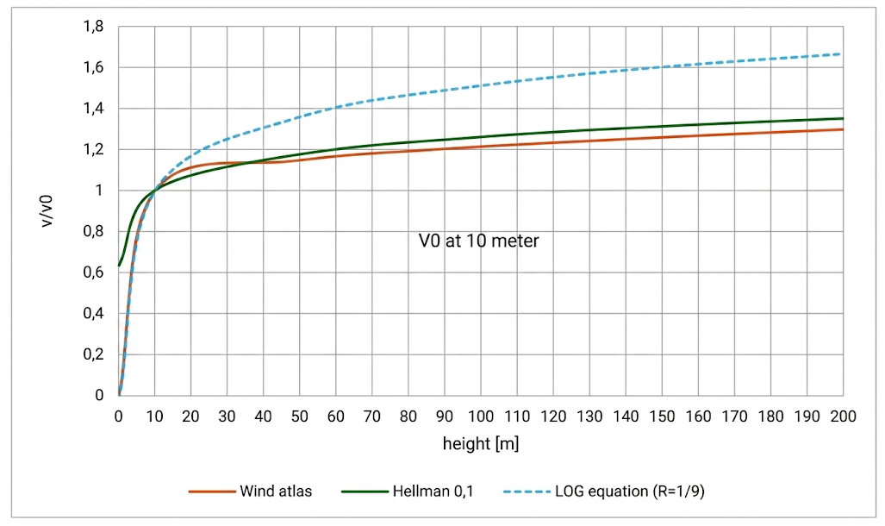
Figure 1. Comparison between two methods.
Blade-less Vertical Axis Wind Turbine. The major difference compared with conventional VAWTs is the absence of blades. Instead, a mast is mounted on a support structure that allows it to oscillate and move freely in multiple directions.
The bladeless VAWT operates based on a phenomenon known as vortex-induced vibrations (VIV) [16]. When the vortex-shedding frequency approaches the natural frequency of the turbine, a phenomenon known as lock-in occurs. This synchronization results in large-amplitude oscillations, thereby increasing the mechanical energy available for conversion into electrical power. The instantaneous electrical power generated can be expressed as:
$\begin{matrix} & P(t)=c_{elec}{\dot{y}}^{ 2} & & \end{matrix}$ (7),
where $P(t)$ is the instantaneous electrical power output (W), $c_{elec}$ is the electrical damping coefficient (N·s/m), and $\dot{y}$ is the vibration velocity of the turbine structure (m/s).
Combined Heat and Power (CHP) and Biogas. The electrical and thermal outputs for CHP determined by the available biogas volume, its energy content, and the respective conversion efficiencies of the CHP system. To calculate the electrical and thermal energy generated by the combined heat and power (CHP) system, the following equations are used:
$\begin{matrix} & P_{electric}=V_{biogas}E_{biogas}η_{electric} & & \end{matrix}$ (8),

$\begin{matrix} & P_{thermal}=V_{biogas}E_{biogas}η_{thermal} & & \end{matrix}$ (9),
where $V_{biogas}$ is the biogas production rate (m³/day), $E_{biogas}$ is the energy content of the biogas (kWh/m³), $η_{electric}$ is the electrical efficiency of the CHP unit, and $η_{thermal}$ is its thermal efficiency.
The daily biogas production is estimated based on the number of animals and the corresponding biogas yield per animal, as follows:
$\begin{matrix} & V_{biogas}=N_{slaughter}Y_{slaughter} & & \end{matrix}$ (10),
where: $N_{slaughter}$ = number of slaughtered animals or animals contributing slaughter waste, $Y_{slaughter}$ = biogas yield from slaughter waste (m³/animal/day)
Wood chip Boilers. The wood-chip boiler CHP system is modelled using a thermodynamic energy-balance approach. The fuel input power is determined from the wood-chip mass flow rate and the lower heating value (LHV) of the fuel, while accounting for the moisture content of the wood chips. The fuel energy input is calculated as:
$\begin{matrix} & {\dot{Q}}_{fuel}={\dot{m}}_{wood}LHV & & \end{matrix}$ (11)
where ${\dot{Q}}_{fuel}$ is the fuel energy input (kW), ${\dot{m}}_{wood}$ is the wood-chip mass flow rate (kg/h), and $LHV$ is the lower heating value of the wood chips (kWh/kg).
The electrical and thermal outputs of the CHP system are estimated using the corresponding conversion efficiencies.
For the electrical output:
$\begin{matrix} & P_{el}=η_{el}{\dot{Q}}_{fuel} & & \end{matrix}$ (12)
where $P_{el}$ is the electrical power output (kW) and $η_{el}$ is the electrical efficiency of the CHP system.
For the thermal output:
$\begin{matrix} & P_{th}=η_{th}{\dot{Q}}_{fuel} & & \end{matrix}$ (13)
where $P_{th}$ is the thermal power output (kW) and $η_{th}$ is the thermal efficiency of the CHP system.
Hydro-Turbines. The hydro-turbine is modeled based on the available water flow rate and hydraulic head. The electrical power output is calculated using the following equation:
$\begin{matrix} & P=ηρgQH & & \end{matrix}$ (14),
where: $P$ = electrical power output of the hydro-turbine (W), $η$ = overall hydro-turbine system efficiency (–), $ρ$ = water density (kg/m³), typically assumed to be $1000 kg/m^{3}$, $g$ = gravitational acceleration (m/s²), approximately $9.81 m/s^{2}$, $Q$ = water flow rate (m³/s), $H$ = hydraulic head or effective falling height of the water (m)
For micro- and small-hydropower systems, the overall efficiency $η$ typically ranges from approximately 50% to 75%, depending on the turbine type and system configuration [17].
Energy Storage System(ESS). The Energy Storage System (ESS) is modeled using a CIEMAT-inspired electrochemical approach that incorporates the dynamics of the battery state of charge (SOC). The SOC during the charging process is represented by:
$\begin{matrix} & SOC_{t+1}=SOC_{t}+η_{c}ΔSOC,P_{t}>0 & & \end{matrix}$ (15),
where $SOC_{t}$ and $SOC_{t+1}$ represent the state of charge at the current and subsequent time steps, respectively, $η_{c}$ is the charging efficiency, and $ΔSOC$ represents the change in state of charge during the time interval. The condition $P_{t}>0$ indicates that the ESS is operating in charging mode.
The model accounts for both charging and discharging efficiencies and incorporates constraints on the minimum and maximum SOC, as well as the depth of discharge (DOD), to ensure realistic ESS operation [18].
2.2 Combining the models to create a multi-vector renewable energy microgrid
The energy from the renewable energy sources, ESS, and demand subsystems is combined into a single multi-vector, farm-scale microgrid after separate models for each component have been developed. In order to simulate energy generation, conversion, storage, and consumption under various operating situations, the interactions between the energy sources and the ESS are modeled. Instead of functioning as separate, autonomous systems, this framework allows the multi-vector renewable energy technologies to function as a coordinated system. The load demand, availability of renewable energy, battery state of charge, and operating limits all influence how energy moves between the various system components.
This integrated structure provides the foundation for the development of a model predictive control (MPC) strategy for real-time energy management and optimization. The MPC enables us to coordinate the operation of the different energy generation and storage technologies while satisfying the system demand and respecting the operational constraints of the integrated microgrid. Model predictive control (MPC) is an optimal control technique in which estimated control actions reduce a cost function for a constrained dynamical system over a finite, receding time horizon. The basic structure of the MPC approach is shown in Figure 2.
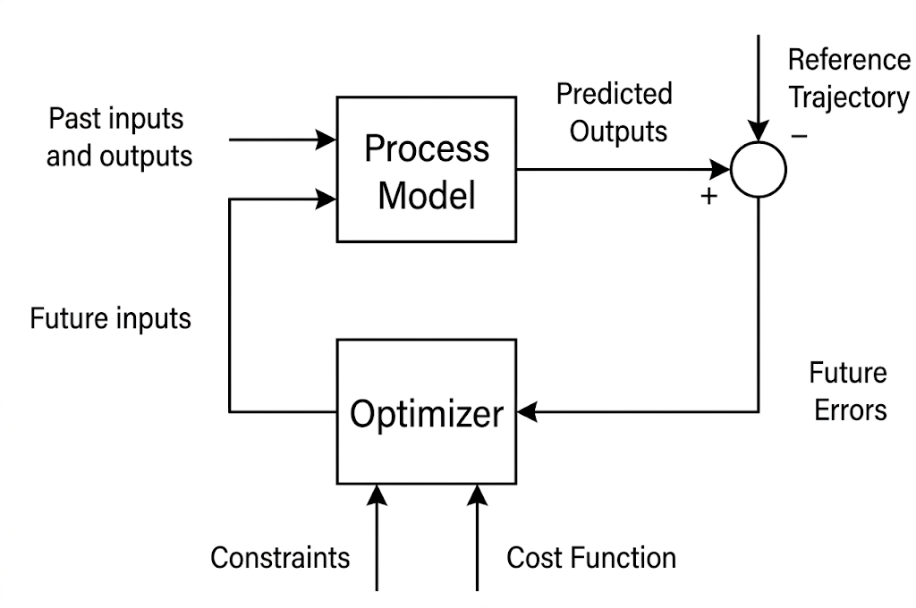
Figure 2. Basic Structure of a MPC
The objective function of the proposed MPC is formulated as follows:
$\begin{matrix} & \min{J}=w_{unserved}\sum_{k=1}^{N}{P_{unserved}}\left(k\right)+w_{curtail}\sum_{k=1}^{N}{P_{curtail}}\left(k\right)+ & & \end{matrix}$(16)
$$+w_{battery}\sum_{k=1}^{N}{\left[P_{charge}(k)+P_{discharge}(k)\right]}$$
where the decision variables are: $N$ which represents the prediction horizon, $k$ denotes the prediction time step, $P_{unserved}(k)$ represents the amount of load that remains unsatisfied at time step $k$, $P_{curtail}(k)$ represents the available renewable power that is curtailed rather than utilized or stored, and the terms $P_{charge}(k)$ and $P_{discharge}(k)$ represent the battery charging and discharging power, respectively. These variables determine how the available renewable energy is allocated between the farm load, battery storage, grid, and curtailed energy. The weighting coefficients of this objective function translate the various unfavourable operating situations into relative penalties, representing an operational cost function. Meeting farm demand is prioritized by decreasing the first term, which penalizes unserved load. The second phrase incentivizes the use of available renewable generation instead of discarding it by penalizing the curtailment of renewable energy. By penalizing battery charging and discharging, the third term discourages needless battery cycling and serves as a stand-in for battery deterioration. Therefore, load satisfaction, the use of renewable energy, and less battery cycling are all encouraged by decreasing the goal function. Therefore, rather than being a direct monetary cost function expressed in NOK, the goal function is an operational cost formulation.
A Centralized Economic MPC with a prediction model based on physics is the suggested MPC algorithm. The following equation represents the system state prediction:
$\begin{matrix} & SOC(k+1)=SOC(k)+\frac{η_{c}P_{charge}(k)-\frac{P_{discharge}(k)}{η_{d}}}{E_{batt,max}} & & \end{matrix}$ (17)
where charge efficiency $η_{c}$, discharge efficiency $η_{d}$, power for charge and discharge $P_{charge}$ and $P_{discharge}$, maximum battery energy capacity $E_{batt,max}$, and the state of charge of the battery.
The following equation represents the power balance in the microgrid:
$P_{renewable}(k)-P_{curtail}(k)+P_{discharge}(k)=P_{load}(k)-P_{unserved}(k)+P_{charge}(k)$ (18)
The controller forecasts future system behavior over a limited prediction horizon by using fundamental concepts of renewable generating and storage systems. In addition to meeting system demand, decisions about the system's functioning are made to reduce electricity costs, grid reliance, and battery degradation. In developed tool, the OSQP (Operator Splitting Quadratic Program) solver from numerical optimization package for solving convex quadratic programs is used to solve optimization problem in Python.
2.3 Web-based tool for decision support of farmers
The models presented in Sections 2.1–2.2 were integrated into the web-based tool. The interface of the web-based tool is shown in Figure 3. The user interface includes the renewable energy technologies implemented in the system. In step 1, the user can select the desired renewable energy technology or a combination of technologies by clicking on their icons.

Figure 3. An example of web-based tool interface, where a) selection combination of technologies, b) entering data for simulation, c) Results of the simulation
In step 2, users enter inputs for selected technologies. The main technical input data for the technologies are as follows: Wind atlas data for VAWT and VIV turbines; VIV: Hub height (m), Rated power (kW); VAWT: Hub height (m), Rotor diameter (m), Rated power (kW), Rated wind speed (m/s), Cut-in wind speed (m/s), Cut-out wind speed (m/s); Biogas: Number/month, Waste/animal (kg); Solar PV: Rated power (kW), solar atlas data; Woodchip Boiler: Unit size (kW), Mass flow (kg/hour), Hydro Turbine: Average flow rate (m³/s), Head height (m), Battery: Battery capacity (kWh). The interface also allows users to upload Excel files in XLSX or CSV format containing data such as farm energy demand, hourly data from a meteorological station, the farm’s wind and solar atlas data (for example, for a typical year), and other information relevant to the system’s operation. In step 3, once all the necessary inputs have been provided, the tool can perform the required computations. The results are then displayed, including the detailed energy performance of each technology (an example are shown in Section 4), as well as total generation of entire combined system. The button “Next” is used to switch between steps.
3. Case study
The studies were performed based on data collected from a farm located in Røysland Gård, which aims to become energy neutral and reduce reliance on the local grid. The farm enterprise raises cattle and pigs for high-quality meat production. In addition, it operates a butcher shop and restaurant, which rely on energy-dependent machinery and equipment. The farm also has hot-water tanks that supply hot water for farm operations and other applications while also providing space heating. As a result, the farm has an average annual energy demand of approximately 643,000 kWh, making its reliance on the electricity grid costly.
The farm is situated on open land adjacent to two lakes, one of which is approximately two metres higher than the other, providing favourable conditions for integrating multiple renewable energy technologies, including solar, wind, and hydropower. The renewable energy sources and technologies installed or planned are presented in Figure 4. These technologies include:
- A 50 kWp photovoltaic (PV) system, which is already installed and operational.
- Vertical-axis wind turbines (VAWTs).
- A biogas digester coupled with a combined heat and power (CHP) system.
- A woodchip boiler.
- A hydropower turbine.
- A battery energy storage system (ESS) with a capacity of 144-kWh.
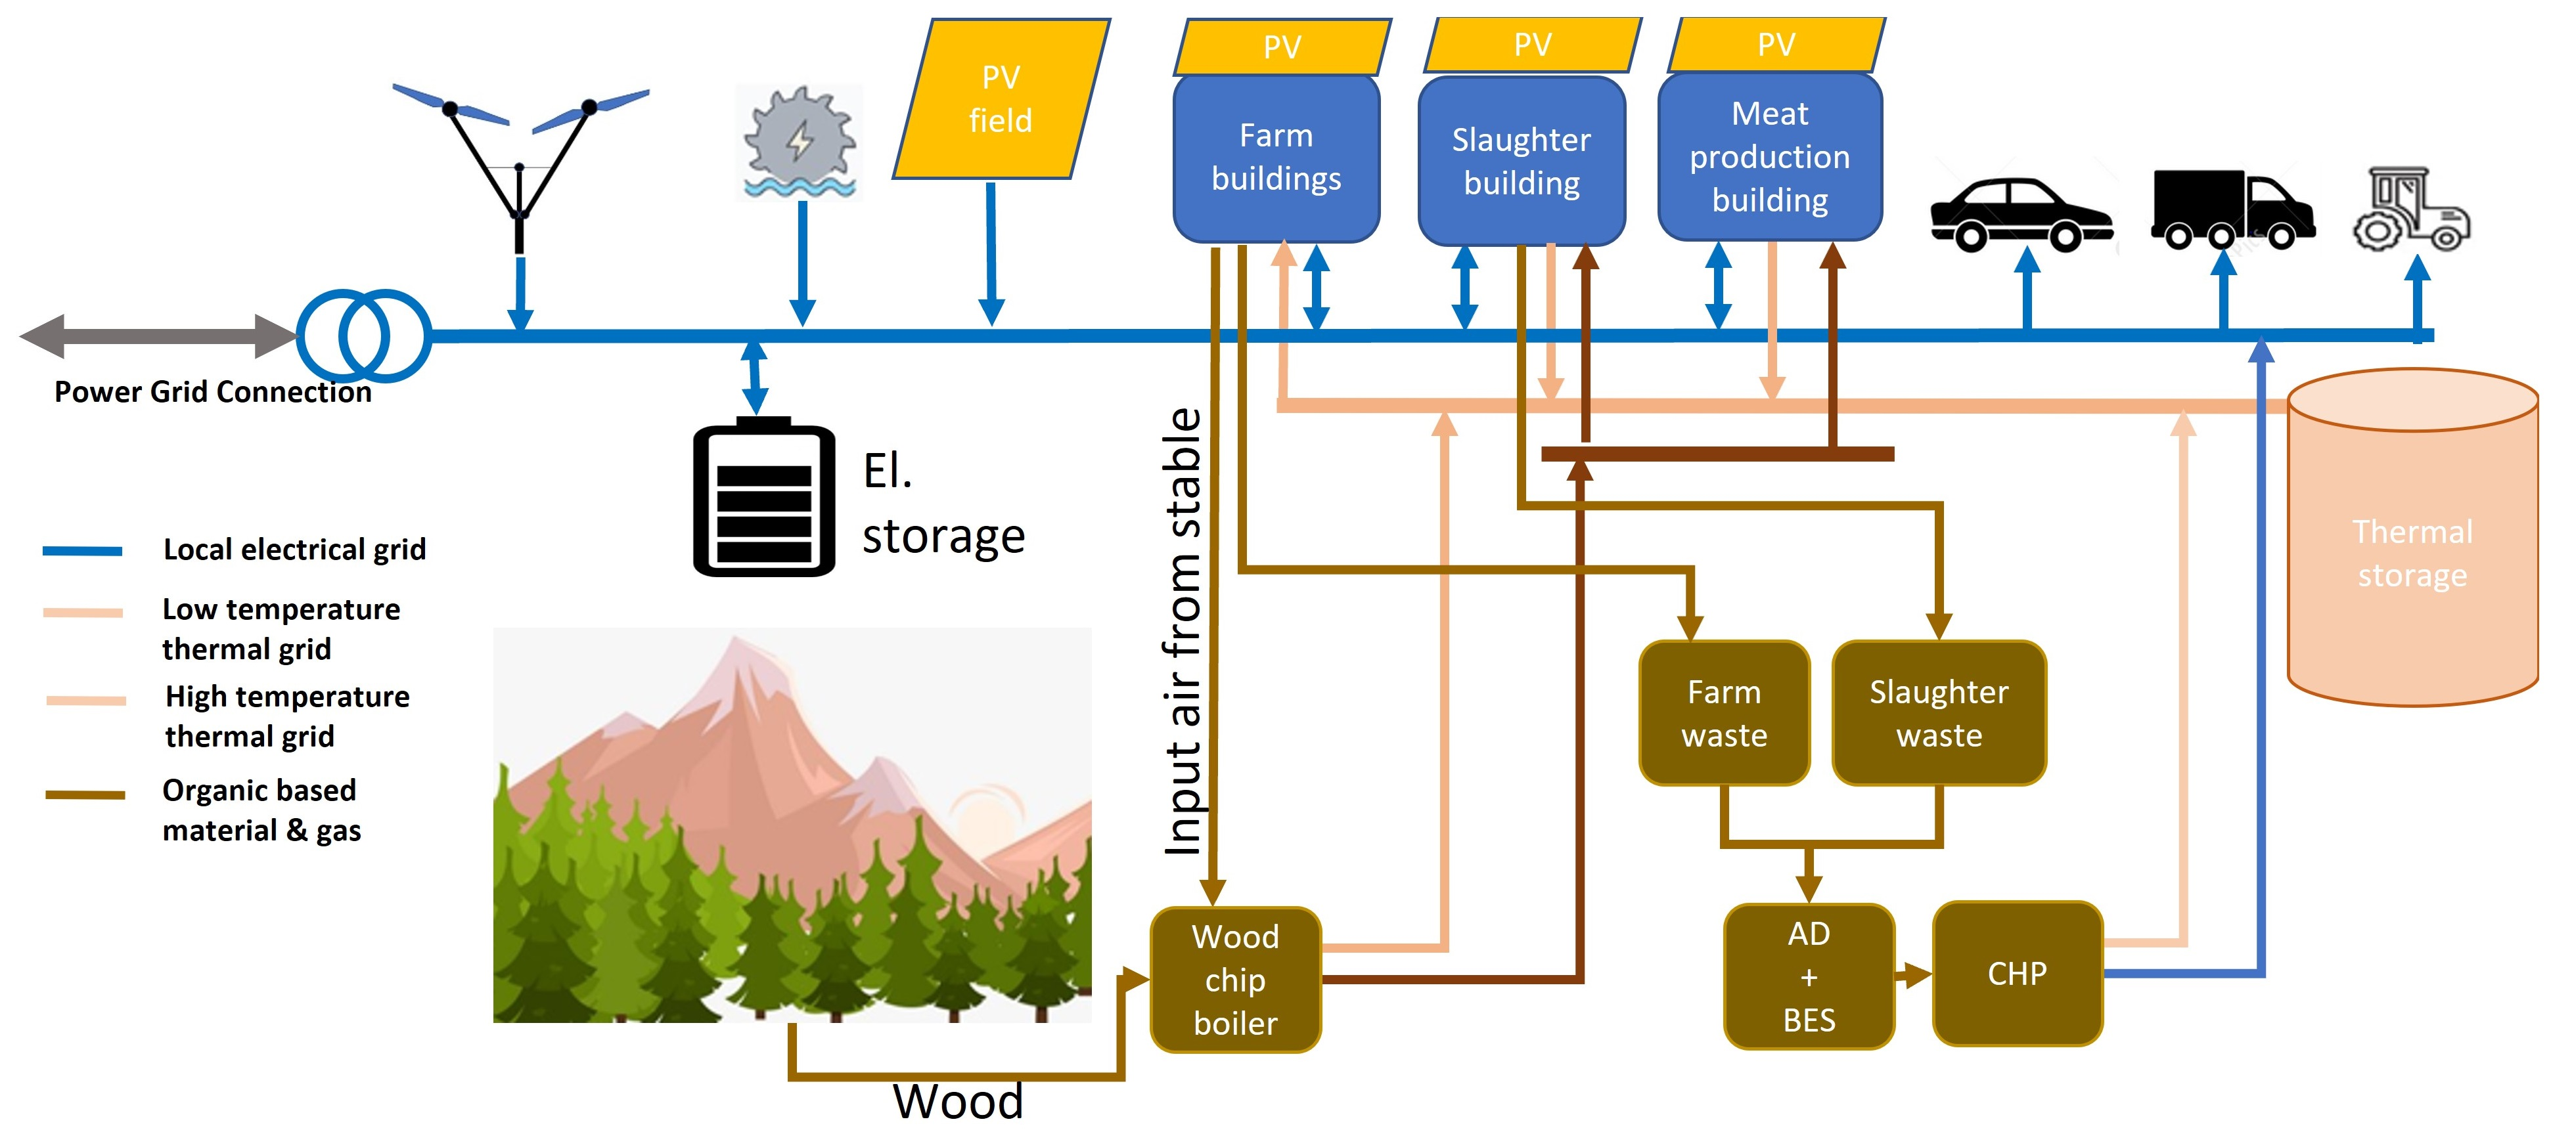
Figure 4. Energy system of the farm.
While testing the model on the use case, each energy source will first be modelled individually and subsequently integrated into a multi-vector energy system. Model predictive control (MPC) will then be implemented to control, manage, and optimize the integrated system.
The data that will be used in the model include the daily demand of the farm throughout 2025, as well as meteorological data obtained from a meteorological station near the farm and websites such as the Wind Atlas and Solar Atlas. The Wind Atlas data represented in Figure 5 take into consideration the ground elevation above sea level when calculating energy generation from wind turbines. The data obtained from Solar Atlas include the irradiance and hourly solar profile on the farm. As shown in Figure 5a, wind speed increases from approximately 4.5 m/s at midnight to a maximum of about 7.3 m/s around 10:00, before gradually decreasing to approximately 4.3–4.5 m/s in the late evening. Figure 5b indicates that wind speeds are most frequently distributed between approximately 4.5 and 6 m/s, while higher wind speeds occur less frequently. Overall, the results suggest that wind energy availability is highest during the morning and midday hours, which is relevant for scheduling wind-powered agricultural loads and energy storage.
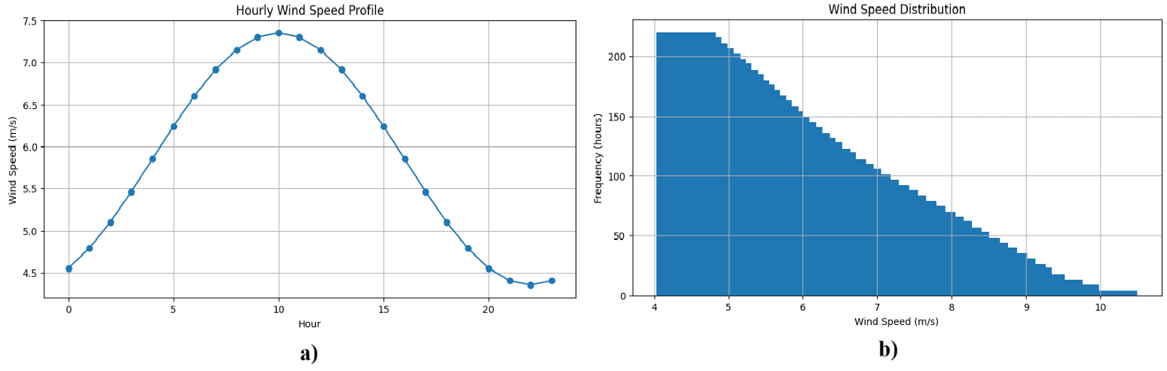
Figure 5. Hourly wind speed (a) and wind speed distribution (b) on the farm.
The average daily profile of energy demand on the farm is presented in Figure 6.
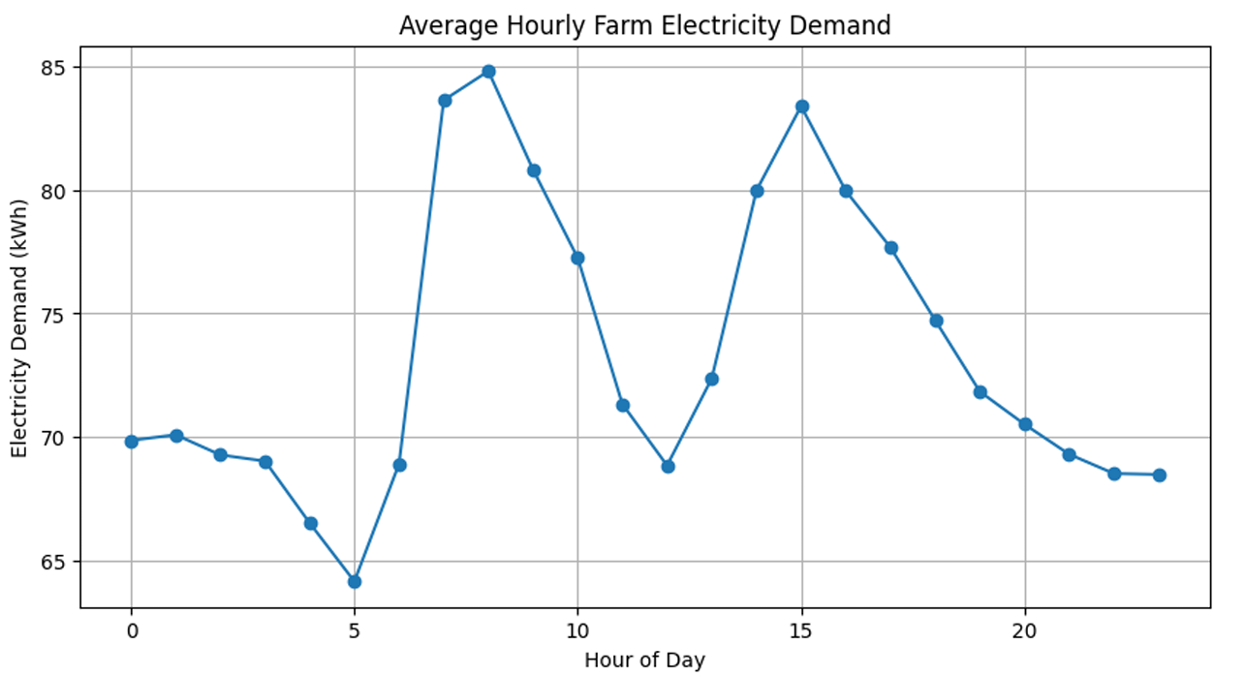
Figure 6. Average hourly demand on the farm.
The demand profile reveals two distinct peaks in farm energy consumption, one occurring at approximately 7:00-8:00 A.M. and another one around 3.00 P.M. The lowest energy consumption is in the evening/nighttime, from 8:00 P.M. to 5:00 A.M., and around 12:00 P.M. The proposed model in this article was evaluated against the actual farm’s energy demand.
4. Modelling Results
This section presents the results obtained from the proposed model. The performance of each individual renewable energy source is first evaluated, followed by an assessment of the integrated system incorporating the MPC algorithm. Finally, a cost analysis is conducted to evaluate the economic feasibility and cost-effectiveness of the proposed system.
4.1 Modelling renewable energy generation and storage components
Photovoltaic System. The figure below shows the average monthly and daily energy produced by the PV system. These results provide an estimate of the annual energy generation based on data obtained from the Solar Atlas. The observed generation profile is consistent with seasonal variations in the Norwegian climate, with energy production reaching its lowest levels between November and January and peaking in July.
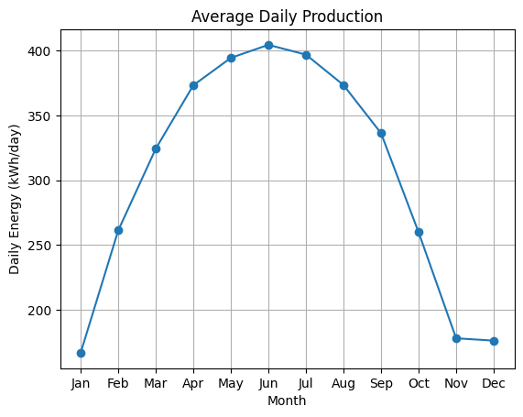
Figure 7. Daily PV production per month
Wind Turbines. The results of the VIV blade-less and the Darrieus wind turbines are shown in the Figure 8. The power output of the VIV blade-less wind turbines is calculated at a hub height of 30m and a rated power of 30kW. For the output power profile, a typical VAWT generally has a cut-out wind speed of approximately 25 m/s. However, the cut-out speed of a bladeless VAWT is considerably lower due to the operating characteristics and inherent limitations of its design.
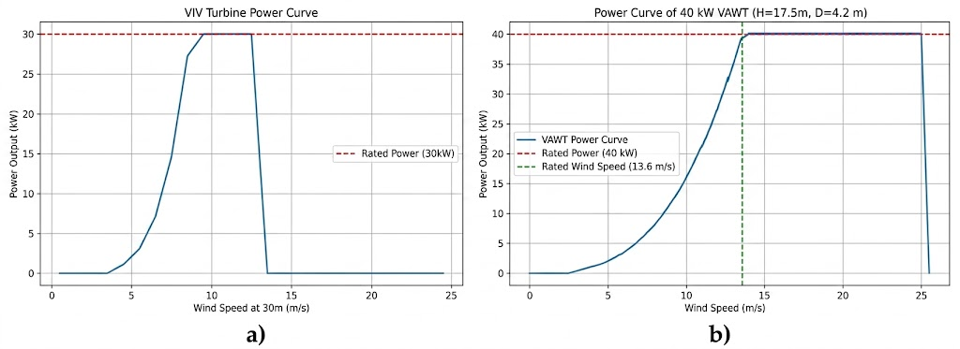
Figure 8. Output power profile of wind Turbines: a) bladeless VAWT, b) the Darrieus VAWT
The Darrieus VAWT has been modeled at 17.5m hub height and rated power of 40kW. When comparing the two systems, the bladeless VAWT achieves an average instantaneous output power of 10.32 kW and capacity factor of 24.1%, compared with 4.56 kW and of 11.39% of the Darrieus VAWT. This indicates a modest performance advantage for the bladeless VAWT, as it reaches its rated power more rapidly and has a higher capacity factor; however, its lower cut-out wind speed remains a notable limitation. These outcomes are simulation-based according the obtained wind profile and can vary based on location.
Biogas Digester and CHP System. The biogas digester and CHP system were modelled based on a farm housing 20 cows and slaughtering approximately 30 animals per month. The following results were obtained: biogas production rate: 3.39 m3/hour; annual electrical energy production: 62.39 MWh/year; annual thermal energy production: 89.13 MWh/year; average electrical power output: 7.12 kW; average thermal power output: 10.18 kW.
This energy output demonstrates the importance of biogas-derived energy to overall farm operations. The electrical energy generated by the CHP system can contribute to maintaining system stability during periods of low photovoltaic (PV) and wind energy generation.
Wood Chip Boiler and Biomass Heating System. Unlike biogas production, which is determined by the quantity of biogas generated on a daily basis, the energy output of the wood-chip boiler is directly proportional to the amount of wood chips supplied. By supplying 2 kg of wood chips per hour on a continuous basis, the following results are obtained: electrical power output: 2.0 kW; thermal power output: 4.8 kW; annual electrical energy production: 17.52 MWh/year; annual thermal energy production: 42.05 MWh/year; total system efficiency: 85.0%. Although the hourly supply of wood chips to the system is not always constant, the results indicate that the boiler has the capacity to provide sufficient energy to meet the farm’s needs.
Hydro-Turbine. The output of the hydro-turbine model presented in Figure 9. The model predicts variations in the water flow between the two lakes. Since these changes are not consistent and may occur over periods ranging from several hours to several days, the model provides an approximate representation of the variation in water flow rate on an hourly basis.
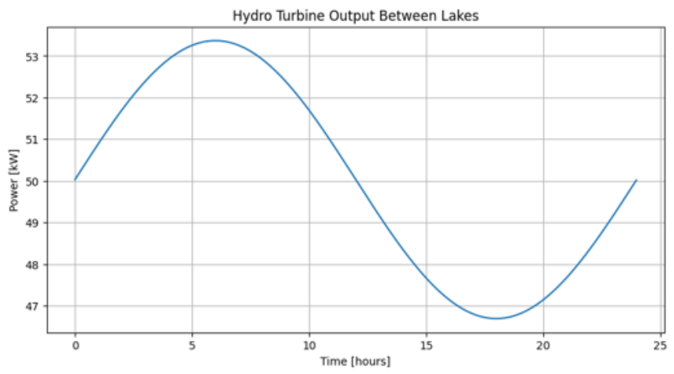
Figure 9. Output power profile for a hydro-turbine
Energy Storage System. The results of the 144-kWh Energy Storage System (ESS) are presented below, highlighting its operational performance and its contribution to balancing energy generation and demand within the integrated system. Figure 10 a) illustrates the charging behavior of the ESS during periods of low demand or excess energy generation. This is complemented by Figure 10 b), which shows the corresponding discharge periods when stored energy is supplied to meet the farm’s demand. The results demonstrate that the ESS contributes to the overall reliability and stability of the integrated energy system by balancing fluctuations between energy generation and demand.

4.2 Combined System with MPC algorithm
The combined results provide insight into the potential of integrating these technologies into a multi-vector renewable energy microgrid. The results presented focus on meeting the farm’s electrical energy demand, while the thermal energy output is converted into an equivalent electrical power value in kW to facilitate comparison and integration within the overall system. The results of the modelling are following: total renewable generation: 1787.48 kWh; renewable energy utilized locally: 1787.48 kWh; renewable utilization: 100%; farm load coverage: 100%; Renewable curtailment: 0 kWh; Battery throughput: 271.64 kWh.
Figure 11 presents the output of the MPC framework, indicating that the simulation-based result shows 100% coverage of the farm’s energy demand. However, since the MPC assessment is based on averaged demand and generation profiles, the reported 100% load coverage should be interpreted as a theoretical model-based outcome rather than definitive evidence of sustained autonomous operation under real-world, year-round conditions.
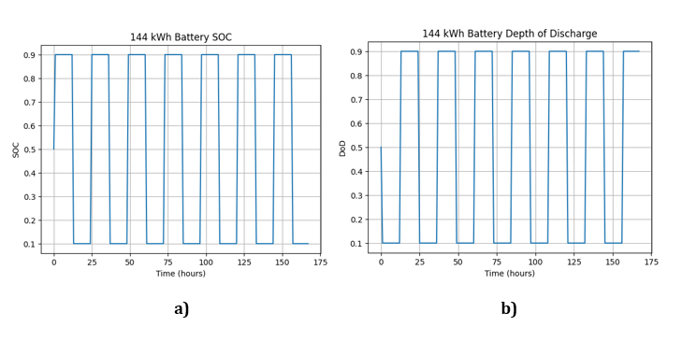
Figure 10. ESS states: a) ESS state of charge, b) ESS depth of discharge
The MPC optimization is followed by the economic evaluation described in this section. By minimizing the operational goal outlined in Section 2, which penalizes unserved demand, curtailment of renewable energy, and battery charging and discharging, the MPC makes operating decisions for the integrated energy system. The system's economic advantages are then determined using the optimized energy flows. Therefore, rather than being explicitly incorporated as monetary terms in the MPC objective function, the power price, network tariff, feed-in tariff, and system investment cost are employed for the post-optimization economic assessment. As a result, rather than being a financial goal that the MPC specifically minimizes, the reported annual savings and payback period reflect the operating schedule's economic worth as determined by the MPC.
The anticipated payback period was calculated using publicly available costs based on listed prices for renewable energy technologies: PV 0.5 MNOK; Battery 0.36 MNOK; Wind Turbine 0.8 MNOK; VIV 1 MNOK; Biogas 3 MNOK; Woodchip Boiler 0.5 MNOK; Hydropower 0.5 MNOK. System investment: 6.6 MNOK. An anticipated power cost of 1.50 NOK/kWh is used in the economic assessment. This amounts to a total electricity price of 0.95 NOK/kWh for the energy component, 0.35 NOK/kWh for network energy costs, and 0.20 NOK/kWh for taxes and other fees. The 2025 Statnett tariff framework serves as the foundation for the producer feed-in tariff. The overall feed-in tariff is 19.8 NOK/MWh according to Statnett, which defines a producer feed-in tariff of 13.8 NOK/MWh plus a 6.0 NOK/MWh surcharge for system running costs. tariff-booklet-2025[19].
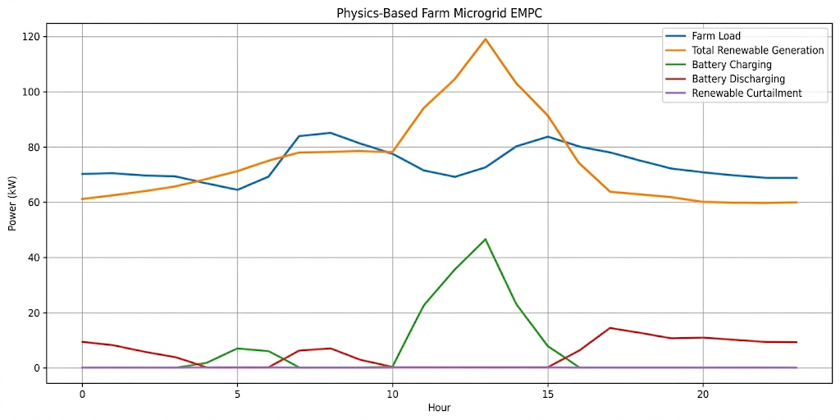
Figure 11. MPC framework output
The cost analysis, which quantifies the savings achieved through reduced energy costs: annual farm demand: 643 kWh/year; renewable generation: 2,212 kWh/year; electricity price: 1.5 NOK/kWh; peak demand reduction: 84.8 kW; reduced transmission tariff: 22,898 NOK/year; producer feed-in tariff cost: 43,799 NOK/year; Total annual savings: 964,319 NOK/year.
The simple payback period is 7.1 years. While the initial investment and payback period may still be high for farmers, additional funding may be available through government support programs, such as Enova in Norway, which can cover part of the cost of the renewable energy system. The results obtained from the proposed system demonstrate its potential to satisfy the farm’s energy demand while exporting excess energy to the electrical grid. This highlights the ability of the multi-vector energy system to improve the farm’s energy self-sufficiency while also providing additional economic benefits through the sale of surplus electricity.
5. Conclusion
Growing energy demand, limited grid capacity, and rising energy prices are challenging farm expansion and the transition towards more sustainable farming. Renewable energy technologies are increasingly being considered as a cost-effective solution. In meet these challenges, this article proposes an integrated multi-vector renewable energy system optimized using a centralized economic Model Predictive Control (MPC) strategy with a physics-based prediction model.
The proposed approach applies the MPC algorithm following the individual modelling of the renewable energy technologies using data collected from multiple sources for the selected farm. The integrated system is subsequently evaluated through a case study on a real Norwegian farm to assess its technical performance and ability to meet the farm's energy requirements. Under the assumptions in the study, the simulation results indicate that the proposed system could satisfy the farm's annual electrical energy demand 643 kWh/year, while excess energy can be transferred to the local electrical grid. This indicates the proposed system's ability to increase the farm's energy self-sufficiency and minimize its reliance on the electrical grid. However, integration of such technologies still needs high initial investment costs, 6.6 MNOK.
The system's effectiveness is heavily influenced by the farm's operating parameters and energy demand. They might differ dramatically among agricultural facilities. As a result, the modelling should be tailored to the specific energy requirements, operational schedules, and renewable resource availability of different farms. The proposed tool and model are designed to provide farmers with an accessible means of estimating the renewable energy generation potential of their farms without requiring extensive knowledge of complex engineering methodologies. The proposed study has several limitations that should be mentioned. First, the analysis uses averaged load and renewable-resource profiles. This may not fully capture short-term variations in energy demand and generation. The inherent uncertainty associated with renewable resources, not fully covered by profiles. In addition, simplified component models used in the tool do not fully consider detailed operational characteristics and degradation effects of technologies. The economic assessment depends on assumptions of prices, which change over time and across regions. Finally, the results in the use case are farm-specific.
Acknowledgment
This article was conducted as part of the EU-funded HarvRESt project (Harnessing the Vast Potential of Renewable Energy Technologies for Sustainable Farming). The authors gratefully acknowledge the support of Horizon Europe and project partners. Special thanks are extended to Grønn Gårdsenergi AS and Røysland Gaard, as well as NORCE and the UiS.
References
[1] Statnett 2026 Nordic TSOs: Strong growth in grid connection requests challenges the power system Statnett, 23 June 2026
[2] Hailu G, et al. 2025 Renewable energy sources for arctic food sufficiency and sustainability npj Sustain. Agric. 3 43
[3] Vijayakumar S, et al. 2025 Opportunities, challenges, and interventions for agriculture 4.0 adoption Discov. Food 5 265
[4] Pestisha A, et al. 2023 On-farm renewable energy systems: a systematic review Energies 16 862
[5] ] Hahn C, et al. 2025 The role of agriculture in a sustainable energy system – The farmers’ perspective Renew. Sustain. Energy Rev. 213 115437
[6] Habboush A, et al. 2026 Enhancing different hybrid energy systems management and their optimisation using AI technology 2026 1st International Conference on Emerging Technologies and Engineering Systems (ICETES) 366–371
[7] Rajendran G, Raute R and Caruana C 2025 A comprehensive review of solar PV integration with smart-grids: challenges, standards, and grid codes Energies 18 2221
[8] Bassey K E 2023 Hybrid renewable energy systems modeling Eng. Sci. Technol. J. 4 571–588
[9] Zainali S, et al. 2025 Modelling, simulation, and optimisation of agrivoltaic systems: a comprehensive review Appl. Energy 386 125558
[10] Rosca C-M and Stancu A 2025 A comprehensive review of machine learning models for optimizing wind power processes Appl. Sci. 15 3758
[11] Mohammed A 2025 Integrated hybrid renewable energy system optimization for sustainable agricultural operations Process Integr. Optim. Sustain. 9 367–386
[12] Korovushkin V, et al. 2025 Modern optimization technologies in hybrid renewable energy systems: a systematic review of research gaps and prospects for decisions Energies 18 4727
[13] Garcia-Torres F, et al. 2021 Model predictive control for microgrid functionalities: review and future challenges Energies 14 1296
[14] Bwambale E, et al. 2025 A review of model predictive control in precision agriculture Smart Agric. Technol. 10 100716
[15] Hu J, et al. 2021 Model predictive control of microgrids – An overview Renew. Sustain. Energy Rev. 136 110422
[16] Chizfahm A, Azadi Yazdi E and Eghtesad M 2018 Dynamic modeling of vortex induced vibration wind turbines Renew. Energy 121 632–643
[17] Energypedia 2026 Hydropower in Powering Agriculture Energypedia
[18] Lyu C, Jia Y and Xu Z 2021 Real-time operation optimization of microgrids with battery energy storage system: a tube-based model predictive control approach IEEE
[19] Statnett 2025 Transmission grid tariffs for 2025: Model description and rates Statnett.

