CFD analysis of additive manufacturing coils for pelvic congestion
I Kusano¹, R Mor-Gimeno¹, J Menacho¹, M Balcells², J Martorell¹ and A G Garcia-Granada^{1, *}
¹ IQS School of Engineering, Universitat Ramon Llull, Barcelona, Spain
² Institute for Medical Engineering and Science, Massachusetts Institute of Technology, Cambridge, MA, USA

* andres.garcia@iqs.url.edu
Abstract. Pelvic Congestion Syndrome (PCS) is characterized by venous insufficiency in ovarian and pelvic veins, leading to blood reflux and chronic pelvic pain. Current endovascular treatments rely on the deployment of multiple metallic coils, whose crimped length necessitates repeated implantation to effectively occlude varicose branches and redirect flow. In this study, we propose a biodegradable porous device as an alternative strategy to achieve flow redistribution while enabling complete resorption. An integrated approach combining experimental testing, theoretical analysis, and simulations was developed to determine optimal porosity and device dimensions. Flow on varicose veins with a porous coil changed from 22,700 mm³/s to 5,503 mm³/s. As a result, the proportion of flow travelling through the healthy branch increased from 26% to 82%, demonstrating effective flow redistribution. Controlled experiments were conducted to quantify pressure drop as a function of flow rate across porous structures. Complementary theoretical models were used to assess flow redistribution at vascular bifurcations, accounting for variations in branch diameters. The combined insights from simplified theory, numerical simulations using Computational Fluid Dynamics (CFD), and experimental validation enabled the identification of key design parameters, including porosity and device length, required to efficiently redirect flow away from varicose veins. This work provides a foundation for the development of next-generation biodegradable embolization devices with improved efficacy and reduced need for multiple implants.
- Introduction
Pelvic Congestion Syndrome (PCS) is a chronic condition characterized by non-cyclic pelvic pain lasting for at least six months. It is considered a common gynecological disorder and has been reported to account for approximately 10-40% of gynecological consultations. PCS is primarily associated with venous insufficiency in the ovarian and pelvic venous systems, where malfunctioning venous valves lead to blood reflux, venous dilation, and the formation of varicosities as reported already in 1984 by Beard et al [1]. The resulting increase in venous pressure can provoke chronic pain and discomfort by exerting mechanical stress on surrounding tissues, nerves, and organs. Figure 1, adapted from a recent (2026) publication of Krambek et al. [2], illustrates the progression from a healthy venous network to a varicose condition and the principle of embolization, where blood flow through the diseased vein is blocked and redirected toward healthy venous branches.

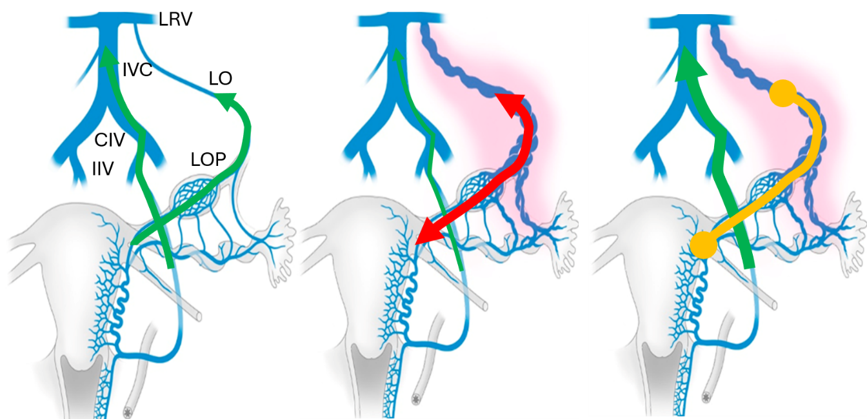
Figure 1. Healthy, varicose and embolized vein [2]. Left Renal Vein (LRV), Inferior Vena Cava (IVC), Common Iliac Vein (CIV), Internal Iliac Vein (IIV), Left Ovarian Vein (LOV), Left Ovarian Plexus (LOP).

Several embolization techniques have been developed for the treatment of PCS, including metallic coils, vascular plugs, foam sclerosants, and ethiodized oil as reported in 1993 by Edwards et al. [3]. Among these approaches, coil embolization remains one of the most frequently applied minimally invasive treatments. Clinical studies have demonstrated the safety and effectiveness of ovarian vein embolization using metallic coils, with high procedural success rates and substantial reductions in pelvic pain. However, successful occlusion often requires the deployment of multiple coils due to their limited crimped length and volumetric filling capacity. Furthermore, metallic implants remain permanently within the patient's body and, in rare cases, may lead to persistent pain or complications requiring surgical removal. These limitations motivate the development of alternative embolization devices capable of providing effective flow occlusion while avoiding the drawbacks associated with permanent metallic implants.
Kwon et al. [4] in year 2007 concluded that ovarian vein embolization using coils is a safe and effective therapeutic method for treatment of PCS. It is thought that surgical treatment should be considered in cases where embolization proves ineffective. They analysed 67 patients between November 1998 and June 2005. A recent (2026) review by Valencia et al. [5] analysed 1294 patients with average ovarian vein diameter of 6.60 mm ± 1.14 mm. Gonadal (also known as left ovarian LO) embolization was performed in 90.3% of patients. Gonadal embolization is a minimally invasive, outpatient procedure used to permanently block these abnormal veins, stopping blood from pooling and relieving pelvic pressure and pain. Wang et al. [6] studied 158 patients who underwent embolization between October 2019 and August 2024 with a 100% success with most patients experiencing significant pain relief by 3 months post-embolization. All studies concluded that several long coils are required to be introduced using small catheter diameters. Current metallic coils remain within patients and Medvediev et al, [7] reported cases of pain produced by coils to implement laparoscopic excision to retrieve coils through a protected port to avoid fragment loss.
In order to avoid using multiple coils researchers such as Canalejo et al. [8] and Ferreira et al. [9] studied several auxetic designs where the reduction of diameter during crimping did not result in a length increase. These researchers also included the use of biodegradable materials to avoid problems of permanent metallic coils. The influence of blood flow in cells is well reported for arteries [10] while Ansarizadeh et al [11] used microfluidic vessel-on-chip platform for investigation of cellular defects in venous malformations and responses to various shear stress and flow conditions.
CFD simulations are useful to predict distribution of flow on bifurcations and avoid pressure increase due to undesired pulsatile flow [12] and sloshing [13] as consequence of malfunctioning valves. With the use of simulations the coils can undergo a topological optimization [14] in order to obtain the desired flow redistribution. The combination of freedom of design and material personalization with the use of additive manufacturing techniques allow the creation of new biodegradable designs as reported by Derhambakhsh et al. [15] and specifically for vasculars stents by Aldawood [16]
This research tries to find the right design of a device that can produce embolization on varicose branch to redirect flow to healthy veins using biodegradable materials studying the influence of flow and shear stress on cells using CFD and experiments.
- Materials and methods

SolidWorks CAD design
Computer Aided Design (CAD) software SolidWorks 2024 (Dassault Systèmes , Waltham, MA, USA) was used to design healthy and varicose veins, embolization devices and personalised “Y” shape connectors. 3D geometry was exported as STL to be used in slicing software.
For straight tubes solid cylinders of inner vein diameter and different lengths were designed to obtain different porosities with parameters from slicing software.

Silicone tubes
In order to simplify experimental results this initial research was conducted using tubes of silicone (Biopharm Saint-Gobain, Paris La Defénse, France) with inner diameter of 7.9, 9.5 and 12.7 mm (references SPT60L-313-2, SPT60L-375-2 and SPT60L-500-2), thickness 1.6 mm and cut to different lengths. Lengths were chosen from medical images of patients to obtain similar pressure drops. Lengths are described later for validation in Table 1 using 400 mm and in table 2 for bifurcations combining 283 and 200 mm.

Additive manufacturing
Embolization devices were fabricated using a FDM (Fused deposition modelling) desktop printer Bambu Lab P2S (Shenzhen Tuozhu Technology, Shenzhen, China) with material PLA basic with a density of 1.24 (g/cm³) according to Winarso et al. [17]. PLA is not the final biodegradable material to be used in the project but it is used to validate the pressure drop for final designs to be printed using a biodegradable material. Personalised “Y” shape connectors were fabricated using a Polyjet advanced desktop printer Objet 30Prime (Stratasys, Kiryat Gat, Israel) with biocompatible transparent material MED610 according to Cohen et al. [18]. Coil cylinders of outer radius 10 mm and inner radius 2 mm (section reduction to 4%) with a length of 20 mm. Grid coils were manufactured from a solid cylinder defining in slicing the use of just grid infill without outer, top and bottom walls. For grids the length was set to 10 mm with a section reduction to 36%.

Slicing software
Bambu studio (Shenzhen Tuozhu Technology, Shenzhen, China) was used to slice STL geometry and create fabrication files for Bambu Lab P2S. For porous geometries the slicing removed side, top and bottom layers to create different infill patterns with different porosities. There was no need to create support structures for current geometries.
Objet Studio (Stratasys, Kiryat Gat, Israel) was used to slice parts for Objet 30Prime with a Mate finish and high quality. Support. Inner support was removed with a solution of 1 liter of osmotic water with 20 grams of NaOH caustic soda pellets (2%) and 10 grams of Na₂SO₃ sodium sulfite powder (1%).

Theoretical pressure drop on straight veins and bifurcations with coils
For a straight pipe we can calculate pressure drop assuming laminar perfect parabolic flow as follows:

$∆p=\frac{128μLQ}{πD^{4}}=\frac{8μLQ}{πR^{4}}=C_{i}Q=\frac{32μLv}{D^{2}}=\frac{8μLv}{R^{2}}$ (1)
where Δp is pressure drop between entrance and exit, μ is dynamic viscosity, L is pipe length, Q is volumetric flow rate, R is pipe radius (or D is pipe diameter) and v is pipe average velocity. The term that multiplies the flow rate we are going to call it flow resistance C_{i}. This value should be obtained experimentally.
The highest velocities occur for inferior vena cava in range 300-450 mm/s for diameters in range 15-21 mm while for medium veins such as femoral veins are in range 50-100 mm/s for diameters in range 11-13 mm. For pelvic veins such as external iliac veins velocity is in range 100-200 mm/s for diameters in range 13-15 mm (Hue et al. [19]).
Dynamic viscosity for water is 0.001 Pa.s while blood is about 3.5 more viscous. For the same pressure drop velocity in blood is therefore 3.5 times smaller than for water.
If we decrease the radius by a factor of √2 to keep constant section velocity in bifurcation from diameter 10 to 7 mm approximately, then Δp increases by a factor of 2.
Literature shows that blood flow on veins is laminar with Reynolds number below 2000.
$Re=\frac{ρDv}{μ}=\frac{ρ2Rv}{μ}=\frac{ρ∆pR^{3}}{4μ^{2}L}=\frac{ρ∆pD^{3}}{32μ^{2}L}$ (2)
where Δp is pressure drop between entrance and exit, μ is dynamic viscosity, L is pipe length, ρ is liquid density, R is pipe radius (or D is pipe diameter) and v is pipe average velocity.
Density for water is 1000 (kg/m³) while blood is very similar in density.
Observing equation 2 we can estimate that for the same pressure drop Reynolds number using blood is 3.5²=12.25 times smaller than for water.
For a pipe of radius R=5 mm, length L=400 mm and a pressure drop of 0.14 mmHg =18.7 Pa or just 1.9 mmH₂O, we will achieve velocity of 146 mm/s using water or 41.7 mm/s using blood confirming that is around 3.5 times smaller. We can express this velocity as flow rate obtaining 11400 mm³/s for water and 3270 mm³/s for blood. Reynolds numbers are for both water and blood in laminar region below 2000. We obtain a Reynolds number of 1450 for water and 119 for blood which confirms the reduction ratio of 12.25.
Using water for R=5 mm for testing is quite challenging to keep Reynolds number below 2000 to assure laminar region as we should be able to measure a pressure drop of just 1.9 mmH₂O.

Table 1. Theoretical flow values on straight pipe of L=400 mm for both water and blood.
 | Water (REF) | Water | Blood | Blood
R (mm) | 5 | 3.5 (/√2) | 5 (x1) | 5 (x1)
Δp (Pa) | 18.7 | 37.4 (x2) | 18.7 (x1) | 227 (x12.25)
Δp (mmH₂O) | 1.90 | 3.80 (x2) | 1.90 (x1) | 23.3 (x12.25)
Q (mm³/s) | 11400 | 5490 (/2) | 3270 (x3.5) | 40100(x3.5)
v (mm/s) | 146 | 146 (x1) | 41.7 (x3.5) | 510 (x3.5)
Re | 1450 | 1000 (/√2) | 119 (x12.25) | 1450 (x1)

Table 1 show a first column for a desired experiment using water with small pressure loss of just 1.9 mmH₂O which guarantees a laminar flow. The second column shows values for a smaller radius compared to reference where pressure drop is doubled to obtain the same velocity decreasing Reynolds number. In the third column, we use blood viscosity with the same pressure drop to check that Reynolds is very small. Finally, the fourth column shows blood with a similar Reynolds value to reference to check that velocity is multiplied by factor 3.5 of viscosity.
For a medical device to be used to stop flow we will assume Darcy’s law to be modelled as a porous medium with a pressure drop as follows:
$∆p=\frac{μLQ}{kπR^{2}}=\frac{4μLQ}{kπ{RD}^{2}}=\frac{μLv}{k}$ (3)
where Δp is pressure drop between entrance and exit of porous media, μ is dynamic viscosity, L is pipe length, Q is volumetric flow rate, k is permeability and v is pipe average velocity. Once again, we call flow resistance to the term that multiplies the flow rate.
Therefore, we want to calculate experimentally the permeability constant, and in this way the porous flow resistance, for each porous design to guarantee that we remain in laminar region.
Finally, we want to add the equation for a pressure drop in a “Y” shape junction as defined by Ghaedamini et al. [20]. On each branch of the bifurcation, we should have the Q₁₁ and Q₁₂ which obtain a total flow Q₁= Q₁₁+ Q₁₂. Pressure drop on each branch should be the same Δp₁₁=Δp₁₂ so that we can add resistance for each branch.
$∆p=Q\left(C_{1}+\frac{1}{\left(\frac{1}{C_{11}}+\frac{1}{C_{12}}\right)}\right)$ (4)
where Δp is pressure drop between entrance and exit of complete bifurcation, Q is the volumetric flow rate and C_{i} is the flow resistance for each branch.
We can compare in table 2 the results using water for each branch length of length 200 (mm) and first a healthy connection where we have a branch of radius 7 (mm) split into two branches of 5(mm). The same total drop pressure and length condition is applied for a branch of radius 7 (mm) split into two branches one of 4.17 (mm) and another one of 6 (mm) to simulate the varicose branch.

Table 2. Theoretical flow values on bifurcation using water for healthy and varicose branch.
 | Water (REF) | Healthy | Varicose | Blood
R₁/R₁₁/R₁₂ (mm) | 5/5/0 | 7/5/5 | 7/6/4.17 | 7/5/5
L₁/L₁₁/L₁₂ (mm) | 200/200/0 | 283/200/200 | 283/200/200 | 283/200/200
Δp (Pa) | 18.7 | 18.7 | 18.7 | 18.7
Δp (mmH₂O) | 1.90 | 1.90 | 1.90 | 1.90
Q₁ (mm³/s) | 11400 | 26800 | 30700 | 7670
Q₁₁ (mm³/s) | 11400 | 13400 | 24900 | 3830
Q₁₂ (mm³/s) | 0 | 13400 | 5790 | 3830
v₁ (mm/s) | 146 | 171 | 196 | 48.8
Re₁ | 1450 | 2410 | 2760 | 197

Table 2 shows that the flow is approximately four times larger on varicose branch, but we obtain larger Reynolds numbers using water for the same pressure drop as in a straight pipe.
However, this theory does not include pressure drop on the bifurcation itself which should be added as a new flow resistance parameter.,

CFD simulation
CFD simulations were performed using both SolidWorks Flow Simulation (Dassault Systèmes, Waltham, MA, USA) and the ANSYS 2021 R1 CFD module (ANSYS Inc., Canonsburg, PA, USA). The simulations were conducted to evaluate pressure losses and flow redistribution in straight vessels and bifurcation geometries, both in the presence and absence of porous embolization devices. To assess the validity of simplified theoretical assumptions, analyses were performed under both laminar and turbulent flow conditions. The obtained results were subsequently compared with analytical calculations and experimental measurements. Boundary conditions for CFD included a pressure on entrance and a reference pressure of 100 kPa on all exit faces. The CFD simulations were performed using a finite-volume formulation on a cartesian hexahedral mesh with local adaptive refinement and cut-cell technology to accurately represent complex geometric boundaries. A mesh sensitivity assessment was performed by comparing pressure-drop and velocity predictions obtained with progressively refined meshes. A global resolution corresponding to approximately five computational cells across the vessel diameter provided stable results while maintaining reasonable computational cost and was therefore selected for all simulations.

Experimental studies on flow
Experimental measurements were conducted to quantify the hydraulic resistance of straight tubes and bifurcation geometries with and without porous embolization devices. The experimental setup is shown in Figure 2. Water was supplied from an open reservoir connected to a custom-made inlet adapter fabricated using PolyJet technology. Flow then passed through silicone tubing containing the additively manufactured porous structures. For bifurcation studies, a personalized Y-shaped connector was incorporated into the system.
Volumetric flow rates were determined by collecting water in graduated cylinders over a measured time interval. The hydrostatic pressure driving the flow was controlled by adjusting the water level in the reservoir. During testing, measurements were only recorded once a stable water level had been reached, ensuring steady-state conditions. This methodology enabled the determination of pressure drop and flow distribution across different device geometries and porosities.
It must be noted that the flow in experimental setup is reversed with respect to real vein flow directions which go from small to large veins. In this initial research we do not consider the presence of antireturn valves and results are useful to feed simulations.
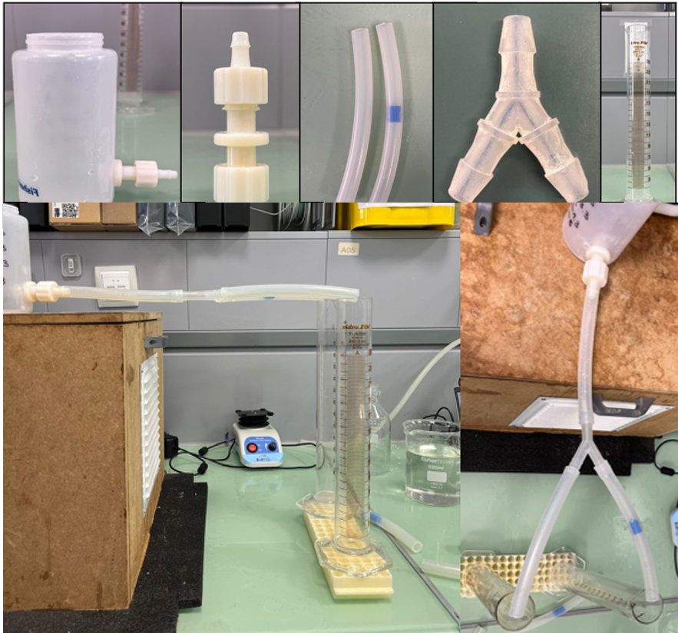
Figure 2. Experimental measurement of flow resistance.

- Results and discussion
First, we compare the effect of performing simulations on straight pipes using laminar and turbulent regimes. If we compare values obtained in Table 1, we observe that the parabolic flow obtains a maximum velocity at the centre of the pipe which is double of average velocity (285 (mm/s)=142.5*2 compared to 146*2 from Table 1).

Figure 3. Straight pipe simulation results for velocity and pressure drop for low and high Reynolds numbers using only laminar flow equations for water.

Next we perform simulations with a section reduction using a coil and grid design

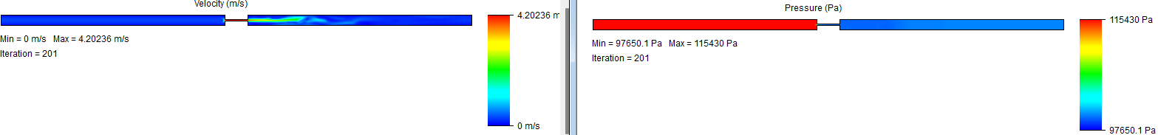
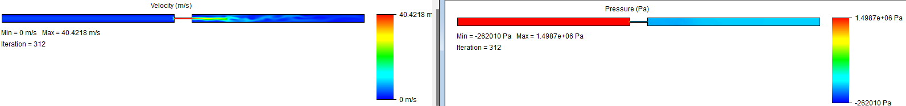
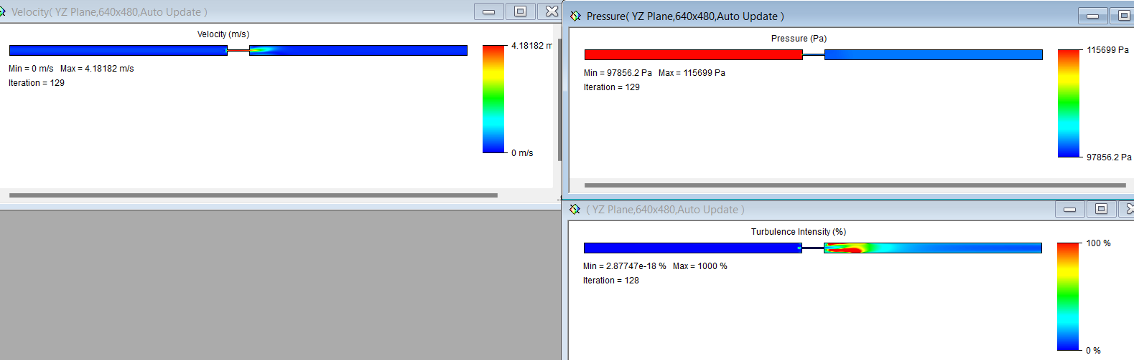

Figure 4. Straight pipe simulation results with coil section reducer to 4% for velocity and pressure drop for low and high Reynolds numbers using only laminar flow equations for water. Bottom picture simulations with turbulence and low Reynolds.

If we try to use equation (1) for water, we should obtain pressure drop linearly dependent of flow rate with a slope of $C_{i}=\frac{8μL}{πR^{4}}=0.0016(Pa.s/{mm}^{3})$. However, for flow rates above 20000 (mm3/s) for water we start to obtain turbulence. In this case the best fit of pressure drop corresponds to a power fit.

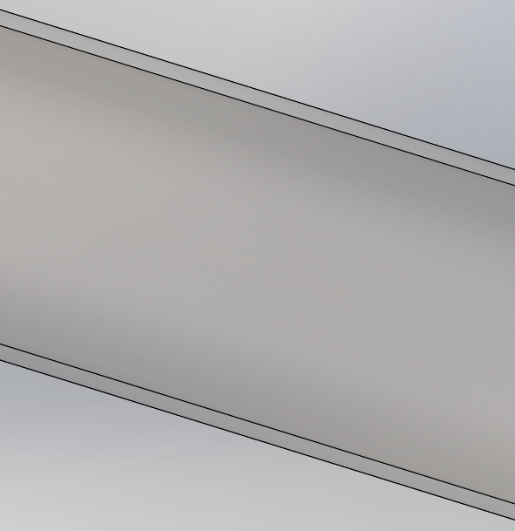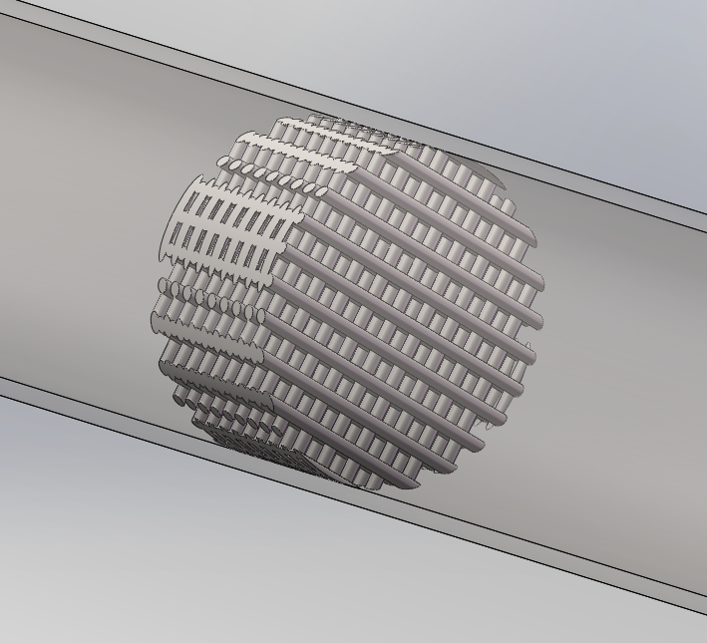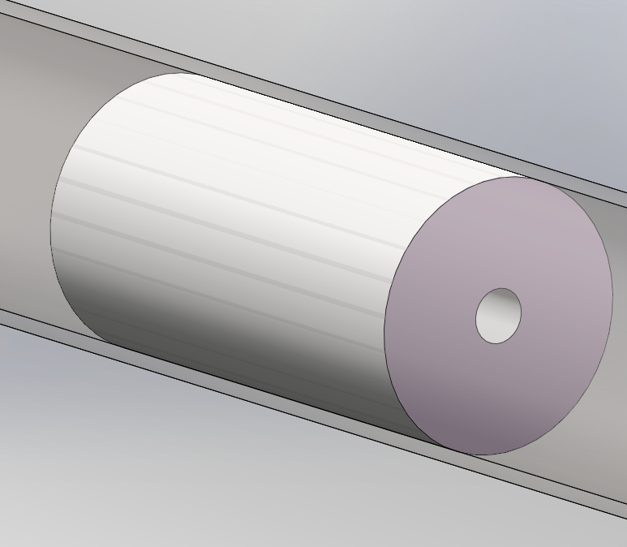
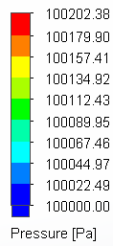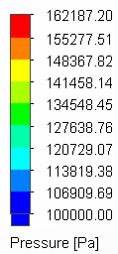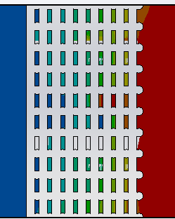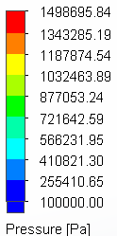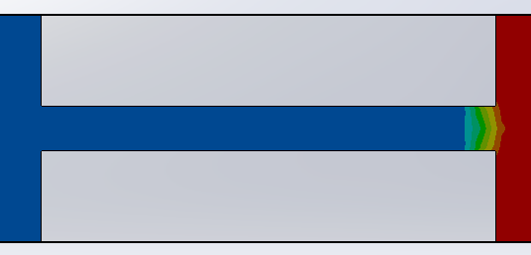
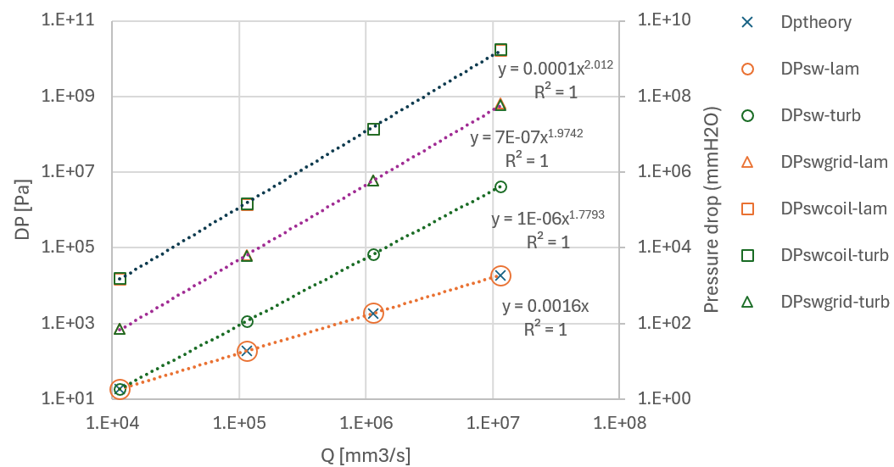
Figure 5. Straight pipe simulation using water for laminar and turbulent flow without coil, with a grid design reducing section to 36% and coil reducing section to 4%.

The simulation results obtained for straight tubes demonstrate that laminar flow predictions agree closely with the theoretical calculations presented in Table 1. Under laminar conditions, the velocity profile develops into the classical parabolic distribution, with the maximum velocity at the centreline being approximately twice the average velocity. However, as flow rate increases beyond approximately 20,000 mm³/s when using water, inertial effects become increasingly important and turbulence begins to develop. As a result, the relationship between pressure drop and flow rate deviates from the linear behaviour predicted by Poiseuille's law and is better represented by a power-law correlation.
In contrast, simulations performed on porous embolization devices (coil and grid) revealed relatively small differences between laminar and turbulent flow models. This observation suggests that pressure losses are dominated by the flow resistance introduced by the porous structure rather than by flow regime effects. Consequently, experimental measurements using water can be considered suitable for characterizing the hydraulic resistance of different coil and grid configurations and for guiding the optimization of embolization device designs. Furthermore, we can use CFD to obtain a desired pressure drop at the same time that other teams in the research group try to obtain a suitable design that can be crimped and driven to the right vein location with a catheter.
Once simulations are validated for pressure drop we need to validate flow redistribution from varicose vein to healthy vein.
In order to validate simulations on bifurcations the varicose configuration from Table 2 was built with diameters 7, 6, and 4.17 mm. The diameter of 6 mm tries to emulate a varicose enlarged vein. Simulations showed in Figure 6 are quite close to theoretical values. The flow of Q₁ 30700 (mm³/s) is distributed in two branches with similar results to theoretical calculations.

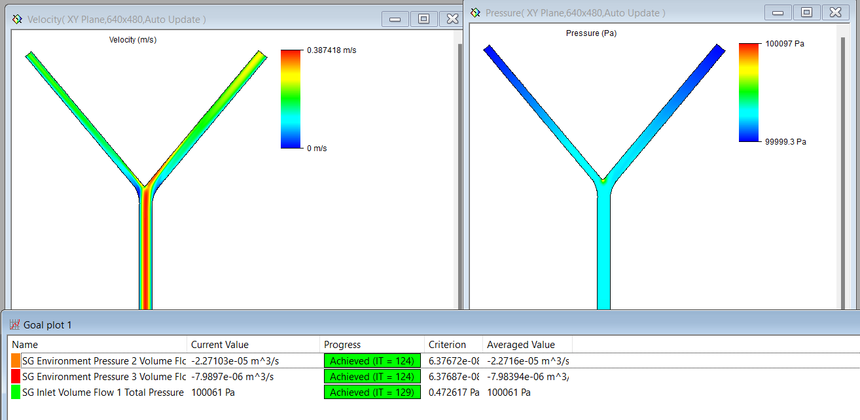
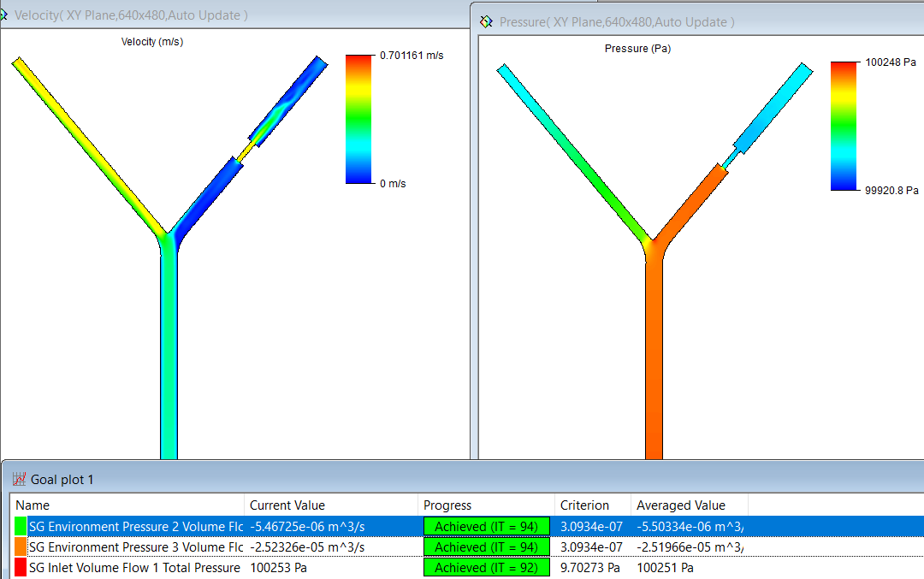
Figure 6. CFD simulation of a varicose bifurcation demonstrating flow redistribution. The enlarged branch attracts most of the flow before embolization, whereas the introduction of the porous coil increases hydraulic resistance and redirects the majority of the flow toward the healthy branch.

Table 3. Theoretical and simulation results for bifurcation using water.
 | Theory | Simulation | Difference | With coil
Δp (Pa) | 18.7 | 35.8 | +92% | 251
Δp (mmH₂O) | 1.90 | 3.64 | +92% | 25.5
Q₁ (mm³/s) | 30700 | 30700 | 0% | 30700
Q₁₁ (mm³/s) | 24900 | 22700 | -9% | 5503
Q₁₂ (mm³/s) | 5790 | 7990 | +38% | 25196
v₁ (mm/s) | 196 | 196 | 0% | 350
Re₁ | 2760 | 2760 | 0% | 15500

Table 3 demonstrates that the CFD model successfully reproduces the preferential flow through the enlarged varicose branch. In the absence of an embolization device, approximately 74% of the total flow (22,700 mm³/s) passes through the varicose vessel (Q₁₁), while only 26% (7,990 mm³/s) flows through the healthy branch (Q₁₂). After introducing the porous coil, the hydraulic resistance of the varicose branch increases substantially, reducing its flow rate to 5,503 mm³/s (Q₁₁). Consequently, approximately 82% of the total flow is redirected toward the healthy branch (25,196 mm³/s) (Q₁₂). These results confirm that the proposed embolization device is capable of achieving the intended flow redistribution and demonstrate the value of CFD simulations for device design optimization. Large values of Reynolds for the simulation with coil are only a reference number based on narrow channels. However, the objective of the simulations is to check that we can redistribute the flow to the healthy vein allowing the coagulation of the varicose vein.

- Conclusions
This work demonstrated the feasibility of using additively manufactured porous embolization devices to modify venous flow distribution in the treatment of pelvic congestion syndrome. Analytical calculations, CFD simulations, and experimental measurements showed good agreement and provided a practical methodology for device design. The porous device substantially increased the hydraulic resistance of the varicose branch, reducing its flow from 22,700 mm³/s to 5,503 mm³/s and increasing the proportion of flow through the healthy branch from 26% to 82%. These results support the potential of biodegradable porous embolization devices as an alternative to conventional metallic coils. Future work will focus on patient-specific geometries, optimization of porosity and device architecture, and validation using physiological blood-flow conditions. It should be emphasized that the present study focuses exclusively on hydraulic flow redistribution. Future work will investigate biodegradable implant materials, device crimpability and deployment, blood coagulation mechanisms, biodegradation behaviour, and validation under physiologically representative conditions.

Acknowledgements
The project is funded by the AEI 2024 Call – “Proyectos de Generación de Conocimiento, ref. PID2024-161387OB-C21″

References
[1] R. W. Beard, S. Pearce, J. H. Highman, and P. W. Reginald, “Diagnosis of pelvic varicosities in women with chronic pelvic pain,” Lancet, vol. 324, no. 8409, pp. 946–949, 1984, doi: 10.1016/S0140-6736(84)91165-6.
[2] C. Krambeck, K. Tesch, N. Watrowski Rafałand Maass, and I. Alkatout, “Pelvic Congestion Syndrome: The Gynecological Perspective,” J. Clin. Med., vol. 15, no. 4, p. 1655, 2026, doi: 10.3390/jcm15041655.
[3] R. D. Edwards, I. R. Robertson, A. B. MacLean, and A. P. Hemingway, “Case report: pelvic pain syndrome-successful treatment of a case by ovarian vein embolization,” Clin. Radiol., vol. 47, no. 6, pp. 429–431, 1993, doi: 10.1016/S0009-9260(05)81067-0.
[4] S. H. Kwon, J. H. Oh, K. R. Ko, H. C. Park, and J. Y. Huh, “Transcatheter ovarian vein embolization using coils for the treatment of pelvic congestion syndrome,” Cardiovasc. Intervent. Radiol., vol. 30, no. 4, pp. 655–661, 2007, doi: 10.1007/s00270-007-9040-7.
[5] L. F. G. Valencia, A. F. Bernal, C. Bautista, A. Garc\’\ia, I. G. Botero, and J. G. Botero, “Pelvic Congestion Syndrome: Retrospective Analysis Single-Institution Series Reported in Latin America (2019--2023),” Ann. Vasc. Surg., 2026, doi: 10.1016/j.avsg.2026.04.060.
[6] Y. Wang et al., “Evaluation of the feasibility, safety, and preliminary effectiveness of coil and foam embolization in patients with venous-origin chronic pelvic pain,” Front. Med., vol. 13, p. 1741818, 2026, doi: 10.3389/fmed.2026.1741818.
[7] M. Medvediev, D. Spesyvtsev, D. Pokrovenko, N. Medvedieva, P. Pampukha, and A. Tinelli, “Laparoscopic excision of a coil-loaded ovarian vein for refractory pelvic pain after embolization: A case report,” Int. J. Gynecol. Obstet., vol. 174, no. 2, pp. 1094–1096, 2026, doi: 10.1002/ijgo.70902.
[8] F. Canalejo-Codina, M. Cano-Morenilla, J. Martorell, M. Balcells, M. Pegueroles, and A. A. García-Granada, “3D printed polymeric stent design: Mechanical testing and computational modeling,” Mater. Des., vol. 247, p. 113395, 2024, doi: 10.1016/j.matdes.2024.113395.
[9] N. M. Ferreira et al., “Melt Electrowritten Biodegradable Mesh Implants with Auxetic Designs for Pelvic Organ Prolapse Repair,” J. Manuf. Mater. Process., vol. 9, no. 4, p. 111, 2025, doi: 10.3390/jmmp9040111.
[10] J. Martorell et al., “Engineered arterial models to correlate blood flow to tissue biological response.,” Ann. N. Y. Acad. Sci., vol. 1254, pp. 51–6, 2012, doi: 10.1111/j.1749-6632.2012.06518.x.
[11] M. Ansarizadeh et al., “Microfluidic vessel-on-chip platform for investigation of cellular defects in venous malformations and responses to various shear stress and flow conditions,” Lab Chip, vol. 25, no. 4, pp. 613–630, 2025, doi: 10.1039/d4lc00824c.
[12] H. Li, Z. Fan, N. Zhao, X. Deng, and Z. Zhang, “Hemodynamic alterations in portal hypertension: A CFD-based study with emphasis on helical flow characteristics,” Acta Bioeng. Biomech., vol. 27, no. 3, pp. 163–172, 2025, doi: 10.37190/abb/213616.
[13] X. Vallés Rebollo, E. Sadeghi, I. Kusano, and A.-A. García-Granada, “Study of the Sloshing Dynamics in Partially Filled Rectangular Tanks with Submerged Baffles Using VOF and LES Turbulence Methods for Different Impact Angles,” Computation, vol. 10, no. 12, 2022, doi: 10.3390/computation10120225.
[14] A. A. Garcia-Granada, J. Catafal-Pedragosa, and H. G. Lemu, “Topology optimization through stiffness/weight ratio analysis for a three-point bending test of additive manufactured parts,” in IOP Conference Series: Materials Science and Engineering, 2019. doi: 10.1088/1757-899X/700/1/012012.
[15] S. Derhambakhsh, N. Salehi, S. Changizi, and M. Solati-Hashtjin, “From 3D to 6D bioprinting: emerging additive manufacturing technologies for biomedical applications,” Biomed. Mater., vol. 21, no. 1, p. 12005, 2026, doi: 10.1088/1748-605X/ae3043.
[16] F. K. Aldawood, “An Overview of Advanced Materials and Manufacturing Strategies for 3D-Printed Bioengineered Vascular Stents: Toward Next-Generation Drug Delivery Applications,” Pharmaceutics, vol. 18, no. 6, p. 755, 2026, doi: 10.3390/pharmaceutics18060755.
[17] R. Winarso, T. Hidayat, B. Gunawan, F. Nugraha, and S. Mulyani, “Preliminary prototyping and parameter optimization of FDM-based custom bone plates: a feasibility study for orthopedic fixation,” Int. J. Interact. Des. Manuf., pp. 1–20, 2026, doi: 10.1007/s12008-026-02588-4.
[18] A. Cohen, S. Sharon, H. Rushinek, Y. Hershko, and N. Casap, “An Innovative Approach to Temporomandibular Joint Disorders: The Role of New Generation Surgical Cutting Guides,” J. Craniofac. Surg., vol. 37, no. 1/2, pp. e42--e47, 2026, doi: 10.1097/SCS.0000000000011773.
[19] K. Hu et al., “Investigating the impact of collateral circulation pathways on hemodynamics in iliac vein compression syndrome,” Front. Bioeng. Biotechnol., vol. 14, p. 1812311, 2026, doi: 10.3389/fbioe.2026.1812311.
[20] H. Ghaedamini, M. R. Salimpour, and A. S. Mujumdar, “The effect of svelteness on the bifurcation angles role in pressure drop and flow uniformity of tree-shaped microchannels,” Appl. Therm. Eng., vol. 31, no. 5, pp. 708–716, 2011, doi: 10.1016/j.applthermaleng.2010.10.005.

