Crimping analysis of additive manufacturing coils for pelvic congestion
J. Menacho¹, G. Perquel-Zamudio¹, F. Canalejo-Codina¹, I. Kusano¹, M. Balcells², J. Martorell¹ and A. A. Garcia-Granada^{1*}
¹ IQS School of Engineering, Universitat Ramon Llull, Barcelona, Spain.
² Institute for Medical Engineering and Science, Massachusetts Institute of Technology, Cambridge, MA, USA.

*E-mail: andres.garcia@iqs.url.edu

Abstract. Pelvic Congestion Syndrome (PCS) is a venous disorder characterized by ovarian and pelvic vein insufficiency, resulting in venous reflux and chronic pelvic pain. Current treatments rely on endovascular implantation of metallic coils, which undergo significant length changes during crimping for catheter delivery, often requiring multiple implants to achieve effective occlusion. In this study, we focus on the simulation of coil crimping behaviour using Finite Element Analysis (FEA) models to better understand deformation mechanisms and length variation. Numerical simulations of conventional steel coils were performed and validated against experimental measurements, showing good agreement in predicted length increase during crimping. To address this limitation, novel auxetic-inspired geometries based on sinusoidal wave patterns were designed using parametric Python scripts. These structures were fabricated via additive manufacturing and evaluated both experimentally and numerically. Results demonstrated that auxetic-inspired designs substantially reduced axial expansion during crimping relative to conventional helical coils the final sinusoidal-ring design, which is not strictly auxetic, showed axial elongations of 0.93–1.96 mm, and rings with a 0.5 mm wire were crimped without fracture. The combined simulation–fabrication approach provides valuable insight into deformation control and device performance during catheter-based deployment. These results are preliminary, as they rely on a surrogate material and a small number of specimens. This work establishes a foundation for the development of next-generation embolization devices, including future biodegradable solutions, with improved deliverability and reduced reliance on multiple implants.
1. Introduction and clinical background
Chronic Pelvic Pain (CPP) is a condition affecting millions of women worldwide and accounting for a significant proportion of gynaecological consultations. Despite its high prevalence, CPP remains poorly understood, frequently underdiagnosed, and often inadequately treated [1–3]. Among the numerous etiologies of CPP, Pelvic Congestion Syndrome (PCS) represents a clinically relevant and frequently overlooked cause.
PCS is a pelvic venous disorder characterized by insufficiency of the ovarian veins (Figure 1) and/or internal iliac veins, leading to venous reflux, vascular dilation, and chronic pain. Its origin is considered multifactorial and has been associated with venous valve incompetence, external compression of pelvic veins, the vasodilatory effects of oestrogen, as well as other factors such as multiparity, hormonal dysregulation, and genetic predisposition. The most common symptom is persistent pelvic pain that worsens with prolonged standing, fatigue, sexual intercourse, menstruation, or pregnancy [2,3]. The condition is additionally associated with anxiety, depression, and reduced quality of life.
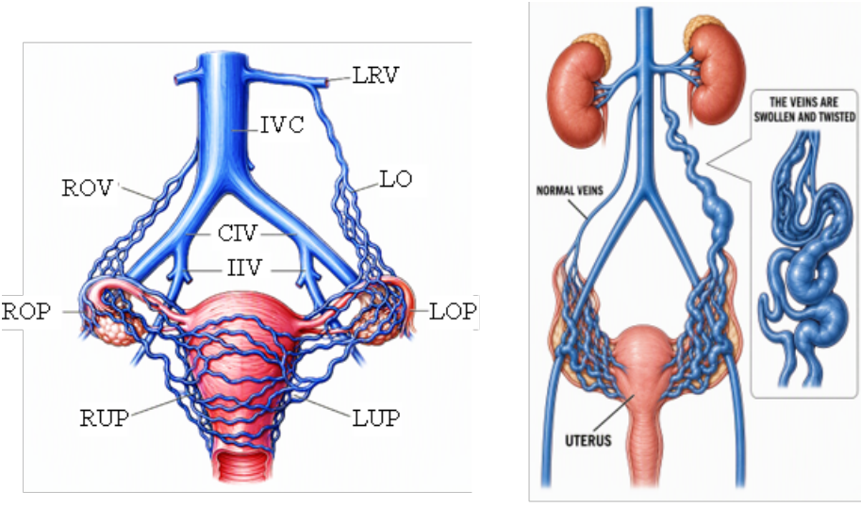
Regarding PCS, several treatment options are available. While compression garments may provide only symptom relief, pharmacological treatments, including analgesics, anti-inflammatory drugs, and hormonal therapies, are available, although their long-term use is limited by moderate effectiveness and potential side effects. Surgical interventions (including ovarian vein ligation, hysterectomy, and oophorectomy) are associated with significant morbidity, lengthy recovery periods, and recurrence rates that are clinically relevant.
Figure 1. PCS pelvic anatomy. LRV left renal vein; R/LOV right/left ovarian vein; IVC inferior vena cava; C/IIV common/internal iliac vein; R/LOP right/left ovarian plexus; R/LUP right/left uterine plexus. Figure adapted from [1,3].
The clinical relevance of PCS extends beyond technical considerations because the disease predominantly affects women of reproductive age and is directly linked to the broader issue of gender bias in healthcare, which has historically contributed to delayed diagnosis and inadequate treatment. Developing more effective therapies for PCS therefore represents a meaningful contribution to achieving greater gender equity in health care.
1.1 Endovascular embolization
Today, endovascular treatment is the preferred therapeutic option and is recommended by the Society of Vascular Surgery. The two most widely used techniques [1,4,5] are:
- Coil embolization, where metallic coils mechanically occlude the vessel and promote thrombosis.
- Foam sclerotherapy, where chemical sclerosants induce endothelial damage and fibrosis without leaving permanent implants.
Both approaches provide clinically significant pain relief in approximately 75% of patients and achieve high technical success rates. Nevertheless, important limitations remain. These include coil migration, which is the most frequently reported major complication; symptom recurrence caused by the development of untreated collateral venous pathways [5–7][2,5]; a lack of procedural standardization regarding embolic materials and techniques [2,5]; and long-term imaging challenges associated with permanent metallic implants. Although platinum coils are MRI-compatible, they can generate artefacts in computed tomography (CT) that compromise the diagnostic quality of future pelvic imaging studies [8,9] (Figure 2).
These limitations highlight an unmet clinical need for embolization devices that are safer, more anatomically adaptable, and capable of disappearing once their therapeutic function has been fulfilled.
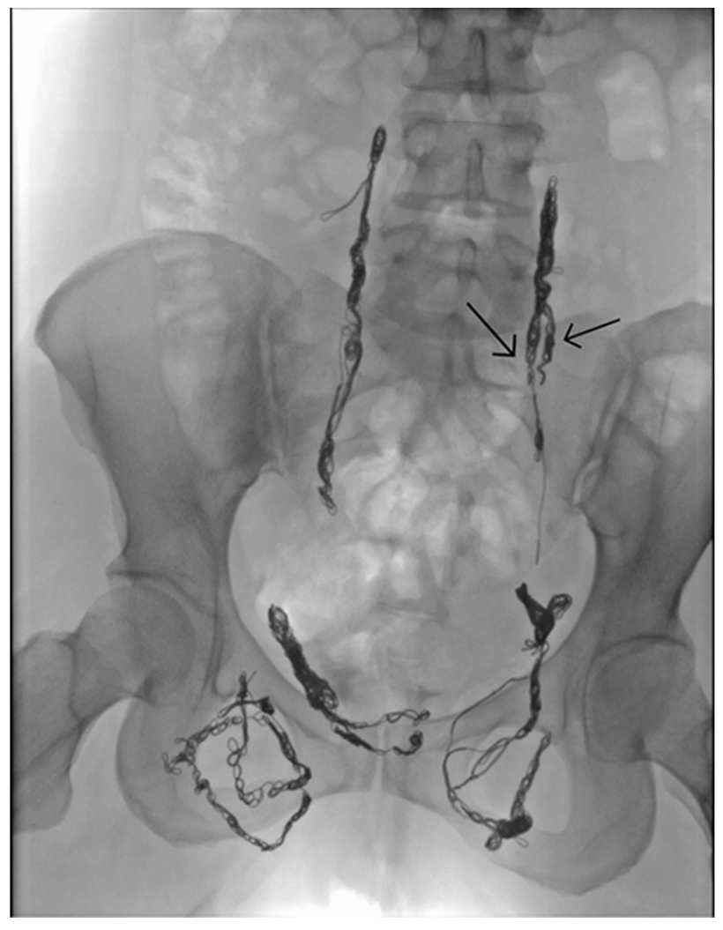
To address this need, the BIOCOIL project aims to develop a new generation of bioabsorbable embolization devices specifically designed for the treatment of PCS. The ideal device should adapt to tortuous venous anatomy, promote thrombus formation, remain stable during the embolization process, and safely degrade after successful vessel occlusion has been achieved.
Figure 2. PCS patient after coil embolization [2].
The underlying hypothesis is that bioabsorbable auxetic devices can reduce biological impact, lower failure rates, and require fewer implants per procedure. In addition, pro-thrombotic surface features may improve embolization efficiency. This work is part of this broader project and focuses on the investigation of several auxetic geometries through computational simulation, additive manufacturing, and experimental testing.
1.2 Auxetic structures as a design strategy
Auxetic structures are mechanical metamaterials characterized by a negative Poisson’s ratio. Unlike conventional materials, which contract laterally when stretched, auxetic structures expand laterally under tension and contract differently under compression. Their unusual behaviour arises primarily from geometry rather than material composition.
In embolization applications, auxetic structures offer several potential advantages. Whereas a conventional helical coil tends to elongate during crimping for catheter delivery, an auxetic structure shortens, remaining more compact and easier to navigate through highly tortuous vessels. Once deployed, it can conform more effectively to the vessel wall and achieve improved occlusion without requiring dense mechanical packing [10]. Furthermore, some biological tissues exhibit auxetic-like behaviour, suggesting enhanced biomechanical compatibility with the vascular environment.
To the authors' knowledge, the application of auxetic geometries to embolization devices has received limited attention in the literature.
1.3 Novelty and objectives
Two types of structures are considered in this work and should be clearly distinguished. The first are truly auxetic structures (ν < 0), whose negative Poisson’s ratio arises from a periodic network of interconnected cells: the missing-rib, re-entrant honeycomb and hexachiral lattices, and an axisymmetric chiral structure adapted from the literature. The second is the sinusoidal ring with an occluding membrane (SROM) proposed here: a single closed sinusoidal wire, without nodes or cell connectivity, which is therefore not strictly auxetic. Its design goal is not a negative Poisson’s ratio but a nearly constant length under radial compression. Since its lobes are already oriented predominantly along the axis, reducing the diameter only rotates them slightly further towards it, whereas in a helical coil the circumferential length of the wire is converted almost entirely into axial length. Unlike existing axisymmetric chiral designs, which are multi-cell lattices that are difficult to fabricate and to crimp at catheter scale, the SROM is a single-wire parametric geometry that separates the mechanical function (a crimpable supporting frame) from the occlusive function (a membrane). The novelty of this work therefore lies in the transfer of auxetic design principles to a cylindrical, catheter-deliverable embolization device, in the proposal of the SROM concept, and in its evaluation through a combined analytical, numerical and experimental crimping workflow. Therefore, the present work differs from previous axisymmetric chiral designs by proposing a simplified single-wire architecture specifically intended for catheter delivery and membrane-supported embolization.
The main objectives of this research [13] are:
- To establish and validate a crimping simulation methodology using conventional coils as a reference.
- To design, fabricate, and evaluate multiple auxetic candidate geometries.
- To perform theoretical, computational, and experimental evaluation of a sinusoidal-ring geometry with an occluding membrane.
2. Technical requirements
In symptomatic PCS patients, incompetent ovarian veins typically present with diameters ranging from 6 to 13 mm, with a pathological cut-off commonly defined at 5–6 mm and severe dilation classified at 8 mm or greater [14,15]. Pelvic variceal tributaries are generally smaller, with diameters in the 5–8 mm range [16]. The normal ovarian vein diameter in asymptomatic women is approximately 3.2–3.8 mm, confirming that the target vessels in PCS represent a substantial departure from baseline anatomy [14]. Any candidate device must therefore be capable of expanding to fill this anatomical range upon deployment while conforming to the highly tortuous and bifurcated morphology characteristic of the pelvic venous plexus.
Current clinical practice for ovarian vein embolization employs catheters ranging from 5F to 9F depending on procedural complexity, with 5F representing the standard minimum for coil delivery [1,8]. The right internal jugular vein, the preferred entry point for this procedure, has a median diameter of 17 mm in adults [17]; the intermediate vessels along the route, including the left renal vein through which the catheter must pass to reach the left ovarian vein, have a mean diameter of approximately 12 mm [18]. A 5F catheter, with an outer diameter of 1.67 mm, therefore remains well below the vessel diameter throughout the approach. The anatomical bottleneck along the catheter pathway is the ovarian vein itself, which in PCS patients measures between 6 and 13 mm [14,15]. Even at the lower end of the ovarian vein range, a 5F catheter occupies less than 28% of the vessel lumen, remaining below the established 33% safety threshold for catheter-related thrombosis risk [19]. The 5F standard is therefore driven primarily by the dimensions of currently available embolic coils rather than by any anatomical constraint [1,20]. From an anatomical standpoint, catheters up to 9F, the upper end of the range currently used in clinical practice, remain within safe operating limits throughout the delivery pathway. The crimped diameter achievable by the candidate geometries explored in this work will determine which catheter size within this 5F–9F range would be required for their clinical deployment, and this assessment constitutes one of the outcomes of the simulation and experimental work presented in the following sections.
These clinical and anatomical considerations, together with the mechanical demands of crimping, can be consolidated into a concise set of design requirements, summarised in Table 1. Beyond the dimensional targets already discussed, the device must exhibit favourable axial behaviour under radial compression and preserve its structural integrity throughout crimping, without fracture or permanent deformation. The dimensional and mechanical criteria fall within scope of this work, whereas blood flow occlusion, device deployment and in-situ vascular behaviour are left to future work.
Table 1. Technical requirements.
Requirement | Target value | In scope
Crimped outer diameter | Compatible with 5F–9F catheter range | Yes
Deployed diameter range | 6–13 mm | Yes
Auxetic behaviour under crimping | Axial contraction under radial compression | Yes
Structural integrity | No fracture or permanent deformation under crimping | Yes
Blood flow occlusion | — | No
Deployment and in-situ behaviour | — | No
Bioabsorbable material selection | — | No

3. Methodology
3.1 Design approach
Based on the requirements in Section 2, the research process was heuristic rather than predetermined: from basic geometries, a candidate emerged from the limitations identified in the previous ones.
The research adopts a simulation-driven approach based on FEA. This methodology allows numerous design alternatives to be evaluated rapidly and cost-effectively before manufacturing physical prototypes. Moreover, computational modelling is increasingly recognized by regulatory agencies such as the U.S. FDA [11] as a credible source of evidence in medical device development. Finally, prototype fabrication was carried out using additive manufacturing (3D printing), enabling the realization of complex geometries, including topology-optimized designs [12]. The methods common to the different candidate geometries are described in the following subsections.
3.2 Finite element modelling of crimping
The crimping of both the helical coil and the SROM was simulated with Ansys™ LS-DYNA dynamic explicit solver. Further simulation details can be found in [13]. The material was modelled with the mechanical properties of polylactic acid (PLA) used as a representative polymeric placeholder given that the definitive device material had not yet been selected at this stage of the project. At this stage, there is no interest in the stress field, but the strain obtained serves as a material screening criterion: any candidate material whose yield strain exceeds the maximum effective strain recorded here will remain in the elastic regime throughout the crimping process, providing a lower bound criterion for future material selection.
The wire was meshed with quadratic tetrahedral elements with a characteristic size of 0.219 mm, selected after a mesh sensitivity check. Radial compression was imposed by ten rigid planes arranged circumferentially around the ring. The planes were displaced radially, so that the diameter of the circle they inscribe decreased to the target crimped diameter over a total time of 7.27 ms. This displacement was applied at a constant step in four steps, with progressively smaller increments as the wires approached self-contact. All other degrees of freedom of the planes were constrained, and a single node of the ring was fixed in the axial direction to prevent rigid-body motion. Contact between the crimping tool and the device, as well as self-contact of the wire, was modelled with automated surface to surface contact algorithm without friction.
A fully parametric simulation workflow was implemented, in which the entire crimping analysis, geometry generation, material assignment, meshing, contact definition, boundary conditions, and post-processing, regenerates automatically for any combination of input parameters, driven from the Ansys Workbench design point table. This was achieved by embedding two Python scripts within Ansys Mechanical, each attached to a different stage of the solution process through the application's callback mechanism. This allowed an arbitrary number of geometric configurations to be evaluated without manual intervention in Ansys Mechanical, which is essential for a systematic study across wire diameter and period count.
As the crimping process was simulated using a time-dependent analysis, the quasi-static nature of the solution was verified by monitoring the ratio of kinetic to internal energy. After a brief initial transient, this ratio remained well below 5%, indicating negligible inertial effects throughout the simulation.
PLA was modelled as a linear elastic solid (E = 2500 MPa, ν = 0.4, ρ = 1.24 kg/m³). Since crimping is displacement-controlled, within the linear elastic regime the resulting strain field is independent of the Young’s modulus and only weakly dependent on Poisson’s ratio, so it is governed essentially by geometry. The reported strains are therefore intended as a preliminary geometric screening criterion rather than as a prediction of the behaviour of the final device. This no longer holds beyond the elastic regime: bioabsorbable polymers may exhibit plasticity, viscoelasticity and rate-dependent behaviour, shape-memory alloys show a non-linear superelastic response, and a different Poisson’s ratio under large strain would also modify the strain distribution. In such cases both the stress and strain fields would differ from those reported here, which is a limitation of the strain-based screening approach. Likewise, the photopolymer used to print the specimens (Section 3.3) does not share the properties of PLA.
3.3 Fabrication and experimental testing
The auxetic lattice specimens (Section 4.1.2) were fabricated by material jetting using a Stratasys™ Objet30 Prime printer with VeroWhite™ photopolymer resin. Two copies of each geometry were printed, presenting a frontal face of approximately 60 × 60 mm. A further two copies were printed at a scale of approximately 30 × 30 mm, allowing the effect of geometric resolution on print fidelity to be assessed.
The mechanical characterization of the auxetic specimens was carried out by uniaxial quasi-static compression testing on a universal testing machine equipped with flat compression plates. The crosshead speed was set so that the pieces would be crushed in 1 minute so 60 mm/min and 30 mm/min for the pieces and their scaled version respectively.
Three specimens of each SROM configuration (dp0–dp3, Table 2) were printed and for the 0.5 mm diameter an additional unit of each period count was produced as a spare in case any specimen proved defective. The rings were produced on the Stratasys™ Objet30 Prime printer, following the same material jetting process, support material (SUP706B), and alkaline support-removal procedure described above. In total, 12 rings were printed.
To achieve a controlled, reproducible and observable crimping process, transparent crimping funnels were printed using the Objet30 Prime printer. Each funnel has a taper ranging from an inlet diameter matching the initial diameter of the ring to an outlet diameter equal to the target diameter after crimping, so that passing an SROM through the funnel imposes a defined and repeatable radial compression governed by the geometry of the funnel itself. To achieve transparency, the funnels were wet-sanded using abrasive paper of progressively finer grit sizes, from 120-grit to 5000-grit. To pass the samples through the funnels, a thread was tied to the troughs of the sinusoid and used to pull the ring along the funnel. In addition, a small amount of soap was applied to reduce friction between the ring and the funnel wall.
4. Prototype assessment
This research starts from two concepts in venous embolization device design, while critically addressing their limitations. First, current devices are predominantly based on metallic helical coils, which constitute the clinical standard. Second, an auxetic response is sought, so that the device exhibits little or no axial elongation during crimping and delivery, ideally shortening under compression. The aim is to combine these concepts while overcoming the limitations associated with conventional coil-based designs. The following subsection briefly reviews these two concepts, after which a novel design integrating both approaches is presented.
4.1 Starting geometries
4.1.1 Helical coil
As a starting point, a simple coil geometry was chosen, defined by four parameters: the mean spring diameter was 5 mm, the wire diameter 1.5 mm, the pitch angle 17.66°, and the total coil length 30 mm. These parameters were selected to be representative of a large-calibre peripheral embolization coil, consistent with the dimensional ranges reported in the clinical literature for pelvic vein applications [21,22].
The crimping simulation (Section 3.2) captured the principal features of the crimping process, compressing the coil from its nominal outer diameter of 6.25 mm down to a near-linear configuration in which the helical geometry was almost fully straightened. The coil axially elongated by 66.19mm (321%), a response diametrically opposed to the desired auxetic behaviour (Figure 3).
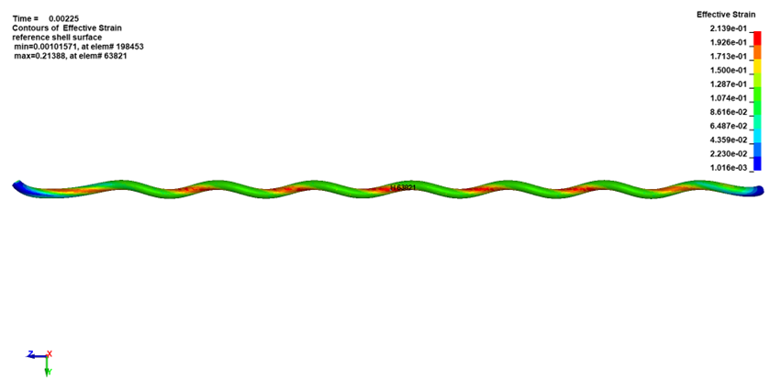
Consequently, the second prototyping stage focused on structures with already recognized auxetic behaviour.
Figure 3. Elongated helical coil. Colormap indicates effective strain with surface reference.
4.1.2 Auxetic structures
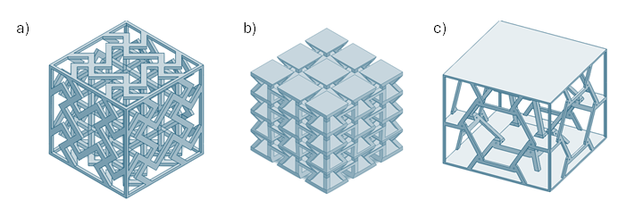
Three auxetic lattice topologies were selected for fabrication and experimental testing, all sourced from GrabCAD [23]. The geometries were chosen to represent distinct auxetic mechanisms, one based on flexural rib behaviour, one on re-entrant angular geometry, and one on chiral rotation, providing a broad coverage of the structural strategies by which a negative Poisson's ratio can be achieved. Three cases of cellular auxetic structures were studied (Figure 4): the missing rib structure, in which selected ribs are systematically removed from an otherwise regular lattice; the re-entrant honeycomb, in which the internal cell angles are inverted relative to a conventional hexagonal honeycomb; and the hexachiral lattice, a member of the chiral auxetic family in which circular nodes are connected by tangential ligaments arranged with six-fold rotational symmetry.
Figure 4: Auxetic lattice structures: a) missing-rib, b) re-entrant honeycomb, c) hexachiral.
The experimental results obtained from the three auxetic topologies were informative but ultimately inconclusive (see the details in [13]). The most immediate limitation was the brittleness of the VeroWhite™ photopolymer: rather than undergoing progressive deformation, the specimens failed by brittle fracture of the structural elements before the auxetic response could fully develop. Some evidence of lateral behavior consistent with a negative Poisson's ratio was nonetheless observed.
Moreover, VeroWhite is not representative of the bioabsorbable polymers or shape-memory alloys envisaged for the final device.
Beyond the material and geometric issues, the cubic form factor of these specimens is fundamentally misaligned with the cylindrical geometry required for an intravascular embolization coil. A structure arranged in a Cartesian lattice does not translate directly into a tubular device without significant topological redesign, and the fabrication complexity of these three-dimensional lattices, adds further practical barriers to clinical translation.
Summarizing what we have just shown, conventional coil geometries are inherently non-auxetic and therefore undergo significant axial elongation during crimping. Conversely, existing auxetic architectures are typically based on complex cubic structures that are difficult to manufacture at the scale required for endovascular devices and are not ideally suited to cylindrical deployment configurations. To overcome these limitations, this work proposes an auxetic structure with cylindrical symmetry, specifically conceived for embolization applications. The proposed concept is described in the following subsections.
4.2 Cylindrical sinusoidal lattice
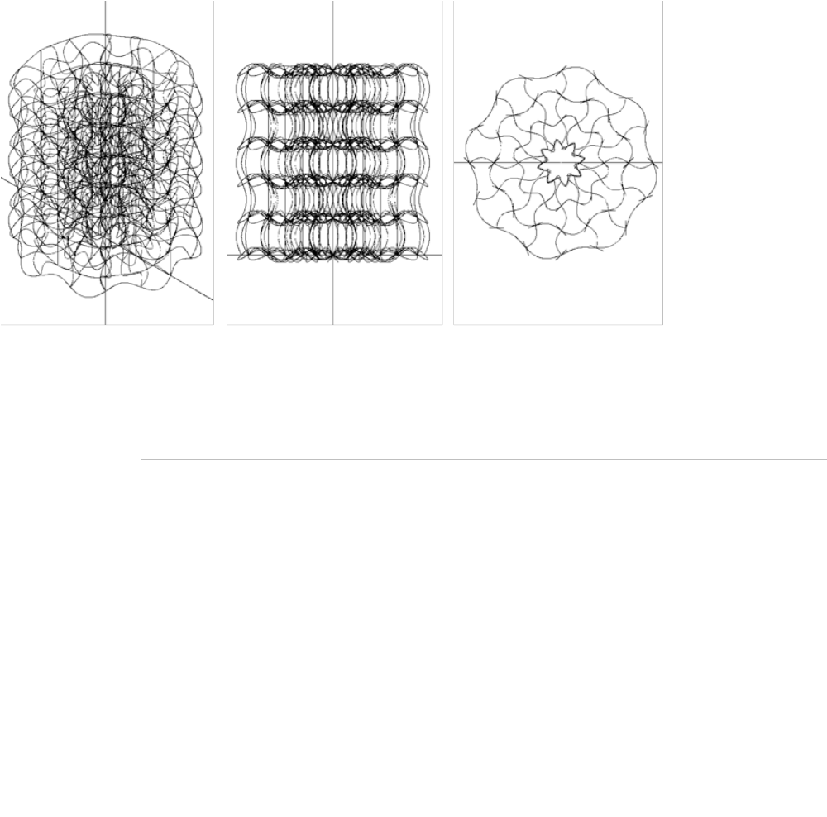
The geometry examined in this subsection is a complex sinusoidal auxetic structure derived from the three-dimensional axisymmetric chiral structure (ACS) proposed by Novak et al. [24]. The original ACS is constructed by mapping the conventional tetra-chiral auxetic unit cell into an axisymmetric (cylindrical) configuration: the horizontal struts of the planar tetra-chiral cell are replaced by sinusoidal curves arranged circumferentially around a central axis, and these are interconnected radially and axially to form a periodic three-dimensional lattice. The resulting structure inherits the auxetic mechanism of the tetra-chiral cell, namely, the rotation of nodes induced by load-carrying ligaments, while presenting an intrinsically cylindrical, radially periodic geometry. This is a fundamental advantage over the cubic specimens: the topology is directly compatible with a tubular embolization device, and radial confinement during crimping engages the auxetic mechanism through the same coordinate axis along which axial contraction is desired.
Figure 5. Three views of the sinusoidal cylindrical auxetic lattice.
The geometry presented in [24] is described primarily through figures and qualitative descriptions rather than explicit parametric equations. The equations and Python implementation used to reconstruct the structure in this work were therefore developed independently from those visual descriptions, taking the ACS as the reference target. The full geometry was implemented as a parametric CadQuery script, defining the structure as a network of one-dimensional spline curves rather than as a solid swept body. The wireframe representation was enough for design exploration.
The structure consists of three families of sinusoidal curves, along the mean directions of a cylindrical coordinate system. The parametric equations of the three families are as follows.
The tangential family:
$\left\{\begin{aligned}x\left(s\right)=\left(R_{i}+A\sin\left(N_{c}s\right)\sin{θ}\right)\cos{s} \\ y\left(s\right)=\left(R_{i}+A\sin\left(N_{c}s\right)\sin{θ}\right)\sin{s} \\ z\left(s\right)=z_{j}+A\sin\left(N_{c}s\right)\cos{θ} \end{aligned} ,s∈\left[0,2π\right), θ={\left(-1\right)}^{i}θ_{0}\right.$; (1)
the radial family:
$\begin{matrix} \\ \left\{\begin{aligned}x\left(s\right)=\left(\left(1-s\right)R_{ext}+ sR_{int}\right)\cos{φ_{k}}- A\sin\left(N_{r}πs\right)\sin{θ} \sin{φ_{k}} \\ y\left(s\right)=\left(\left(1-s\right)R_{ext}+ sR_{int}\right)\sin{φ_{k}}+ A\sin\left(N_{r}πs\right)\sin{θ} \cos{φ_{k}} \\ z\left(s\right)=z_{j}+ A\sin\left(N_{r}πs\right)\cos{θ} \end{aligned}\right. , s∈\left[0,1\right], θ={\left(-1\right)}^{k}θ_{0} \\ \end{matrix}$; (2)
and the axial family:
$\left\{\begin{aligned}x\left(s\right)=R_{i}\cos{φ_{k}}+A\sin\left(\left(N_{z}-1\right)πs\right)\cos{(φ_{k}+​θ_{eff​})} \\ y\left(s\right)=R_{i}\sin{φ_{k}}+A\sin\left(\left(N_{z}-1\right)πs\right)\sin{(φ_{k}+​θ_{eff​})} \\ z\left(s\right)=sH \end{aligned}\right. , s∈\left[0,1\right] , θ_{eff}={\left(-1\right)}^{i+k}θ_{0}$; (3)
with the coupling equations:
$\left\{\begin{aligned}R_{i}=R_{int}+\frac{i-1}{N_{r}-1}\left(R_{ext}-R_{int}\right) , i=1,2,…N_{r} \\ z_{j}=\frac{j-1}{N_{z}-1}H , j=1,2,…N_{z} \\ φ_{k}=k·\frac{π}{N_{c}} , k=1,2,…2N_{c} \end{aligned}\right.$ (4)
The complete geometry is parametrized by the outer and inner radii of the structure (R_{ext}, R_{int}), the sinusoidal amplitude (A), the number of circumferential periods (N_{c}), the number of concentric radial rings per layer (N_{r}), the number of transversal layers (N_{z}), the inclination angle of the sinusoids (θ₀), the total axial height (H), and the wire cross-section radius (r) used in the optional solid sweep. This parametric formulation allows the structure to be regenerated in seconds for any combination of geometric parameters, supporting rapid design exploration. Figure 5 shows the resulting wireframe geometry for a representative set of parameters.
The sinusoidal auxetic structure is intrinsically periodic in the radial direction, and its cylindrical topology is directly compatible with the form factor of an intravascular embolization device. The auxetic mechanism inherited from the underlying tetra-chiral unit cell is well aligned with radial compression, producing the coupled radial–axial deformation behavior sought for the intended application. From a design perspective, the geometry satisfies several of the functional requirements identified for embolization devices. Nevertheless, it must be ruled out on grounds of manufacturability.
The first limitation concerns fabrication. Producing this geometry by additive manufacturing at the scale relevant to the embolization device would require extremely slender structural elements, which at such resolutions are highly susceptible to fracture during support removal. This issue is exacerbated by the substantial volume of internal support material that would be required by the dense wire network.
The second limitation arises from a coupling between fabricability and crimpability. The structure is densely packed, with the sinusoidal wires occupying a significant fraction of the available volume even at the design parameters used here. To make the geometry more amenable to fabrication, the natural mitigation is to increase the wire thickness; this, however, further reduces the free volume within the structure and compromises its ability to undergo the large radial compression required during catheter delivery. The two requirements, printability and crimpability, therefore pull the wire dimensions in opposite directions, leaving a narrow and uncertain feasibility window.
These considerations led to a deliberate simplification of the design: rather than attempting to fabricate the full three-dimensional axisymmetric structure, the geometry was reduced to a much simpler single sinusoidal ring extracted from one circumferential element.
4.3 Sinusoidal ring with an occluding membrane (SROM)
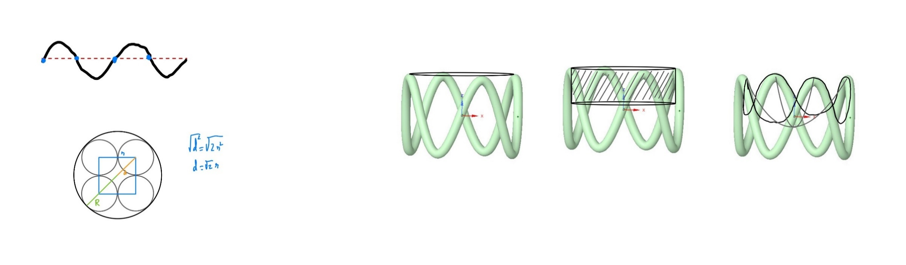
The design consists of a design using a single sinusoidal ring, consisting of a closed sinusoidal curve on a cylindrical surface (Figure 6). This geometry provides theoretical crimpability with only a small degree of elongation. It is not truly an auxetic structure (ν < 0), but it does exhibit limited elongation. This behaviour may nevertheless be sufficient for the intended application.
Figure 6. SROM concept with three alternative occluding-membrane designs.
Since it is an annular structure, it is not expected to have a significant effect on venous flow. Instead, the occlusive effect would be provided by some kind of membrane, for which the ring serves as a supporting framework.
The membrane itself is envisaged to be fabricated from a bioabsorbable polymer by electrospinning, with attachment to the sinusoidal wire most likely realised through suture. The specific material selection, fabrication parameters, and attachment validation, however, fall outside the scope of this work, which focuses exclusively on the design, simulation, and crimping characterisation of the sinusoidal wire structure.
The parametric equation of the sinusoidal centerline of amplitude A, with N periods on a cylindrical surface of radius R is
$r\left(s\right)=\left\{\begin{aligned}x\left(s\right)=R\cos{s} \\ y\left(s\right)=R\sin{s} \\ z\left(s\right)=A\sin{(Ns)}\end{aligned} , s∈[0,2π)\right.$ (5)
The 3D model is achieved by sweeping a circle of a given diameter $d_{wire}$ along this centerline.
Not every combination of these four parameters yields a physically valid geometry. Because the wire has a finite thickness, the sinusoidal centreline cannot bend more sharply than the wire cross-section allows: if the local radius of curvature of the centreline falls below the wire radius, the swept solid self-intersects and the geometry becomes invalid. The binding constraint occurs at the points of maximum curvature of the sinusoid, the crests and troughs of the wave, where the centreline bends most sharply. The maximum admissible wire diameter is therefore set by twice the minimum radius of curvature along the curve, which was evaluated analytically from the Frenet–Serret equation [25,26]:
$d_{\text{max}}=\frac{2}{\max{κ\left(s\right)}}$ (6)
with
$κ\left(s\right)=\frac{\left|r^{'}\left(s\right)×r^{''}\left(s\right)\right|}{{\left|r^{'}\left(s\right)\right|}^{3}}$ (7)
Where $r(s)$ is the parametric centreline.
On the other hand, when the ring is fully compressed, the sinusoidal lobes close upon themselves and the limiting diameter is set by the wire segments coming into mutual contact. Approximating the fully crimped configuration as a regular arrangement of $N$ wire segments around a circle, the minimum outer diameter achievable can be calculated with
$D_{\text{crimp}}=d_{\text{wire}}\left(1+\frac{1}{\sin\left(π/N\right)}\right)$ (8)
Two variants of the ring were considered, differing only in the number of sinusoidal periods. The first variant uses $N=3$, the minimum number of periods compatible with anchoring the occluding membrane to the wire at distinct points. This configuration minimises the amount of structural material around the circumference, which in turn maximises the achievable crimping ratio: less material in the cross-section means more free volume available to accommodate the radial compression imposed by the catheter. The second variant uses $N=4$, providing an additional anchoring point for the membrane at the cost of slightly increased material density and therefore reduced crimping margin. Since the membrane design has not yet been finalised, the relative merits of these two variants depend on the final attachment scheme; both will therefore be evaluated in the simulation phase. Other period counts were discarded on geometric grounds. For the fixed ring radius and amplitude used in this work (R = 6 mm, A = 4 mm, see below), equation (6) gives a maximum admissible wire diameter of 1.97 mm for N = 3 and 1.12 mm for N = 4, but only 0.72 mm for N = 5 and 0.50 mm for N = 6, so the 1 mm wire becomes geometrically invalid for N ≥ 5 and higher period counts would also concentrate bending at increasingly sharp crests. Conversely, N = 2 offers only two anchoring points for the membrane.
Simulation of the crimping.
The parametric workflow was applied to four configurations of primary interest, combining two period counts ($N=3$ and $N=4$) with two wire diameters (0.5 mm and 1 mm). The ring radius and sinusoidal amplitude were held fixed at $R=6$ mm and $A=4$ mm respectively across all simulations. To obtain comparable results across all configurations, every design point was crimped to the same final diameter of 5.67 mm. This value was not chosen arbitrarily: it corresponds to the minimum crimped diameter actually achievable in simulation by the most restrictive configuration ($N=4$, $d_{wire}=1 mm$), which the geometric analysis already identified as the variant with the least crimping margin. It is worth noting that this simulated limit (5.67 mm) is appreciably larger than the value predicted by the theoretical relationship (8) (2.41 mm for this configuration).
This difference has both geometric and numerical origins. Equation (8) is an idealised lower bound: it treats the wire as N rigid straight segments, parallel to the axis and in line contact along their whole length. Equation (8) should therefore be interpreted as a geometric lower bound rather than an achievable design target. In the simulated ring, the crests and troughs retain a finite radius of curvature and the lobes remain inclined with respect to the axis, so the three-dimensional wire of circular cross-section occupies a larger effective section and adjacent lobes come into contact at a much larger diameter. Further compression would require increasingly sharp bending at the crests. In addition, once self-contact between adjacent lobes developed, the explicit analysis could not be progressed further in a stable manner. The value of 5.67 mm should therefore be regarded as the practical crimping limit reached in simulation for the configurations studied, whereas equation (8) provides a theoretical bound that is not attainable with the present geometry.
Table 2 shows the resulting axial elongation that is significant but acceptable for the intended purpose.
Table 2. Results of FEA simulation of crimping SROM.
Design point | N | $d_{wire}$ [mm] | External diameter [mm] | Max. effective strain [–] | Axial elongation [mm]
dp0 | 3 | 0.5 | 12.5 | 0.041 | 1.70
dp1 | 3 | 1.0 | 13.0 | 0.116 | 1.96
dp2 | 4 | 0.5 | 12.5 | 0.041 | 0.93
dp3 | 4 | 1.0 | 13.0 | 0.129 | 0.99

In all cases the strain concentrates, as expected, at the crests and troughs of the sinusoid where the wire bends most sharply, while the straighter segments between lobes remain at low strain (see Figure 7). Within the limits discussed in Section 3.2, these strain results can be used as a preliminary screening criterion in the material selection process.
Between the two period configurations considered, the N = 4 configuration shows a slight advantage in terms of axial behaviour, as it exhibits less elongation during crimping and therefore comes closer to the desired response of an almost constant length. However, this aspect alone is not decisive: the difference is modest, and the N = 4 configuration exhibits a slightly higher maximum deformation and a narrower crimping margin (Table 2: axial elongation of 0.93–0.99 mm for N = 4 versus 1.70–1.96 mm for N = 3; maximum effective strain of 0.129 versus 0.116 with the 1 mm wire; theoretical crimped diameter from equation (8) of 2.41 mm versus 2.15 mm with the 1 mm wire). Manufacturability did not discriminate between the two period counts, since experimental failures depended only on the wire diameter, as shown below. The final choice between the two variants will ultimately be determined by the membrane’s fixing scheme rather than by the mechanics of the wire alone, since the number of anchor points available for the occlusive membrane depends directly on the number of periods. Consequently, both variants remain viable options until the membrane design is finalised.
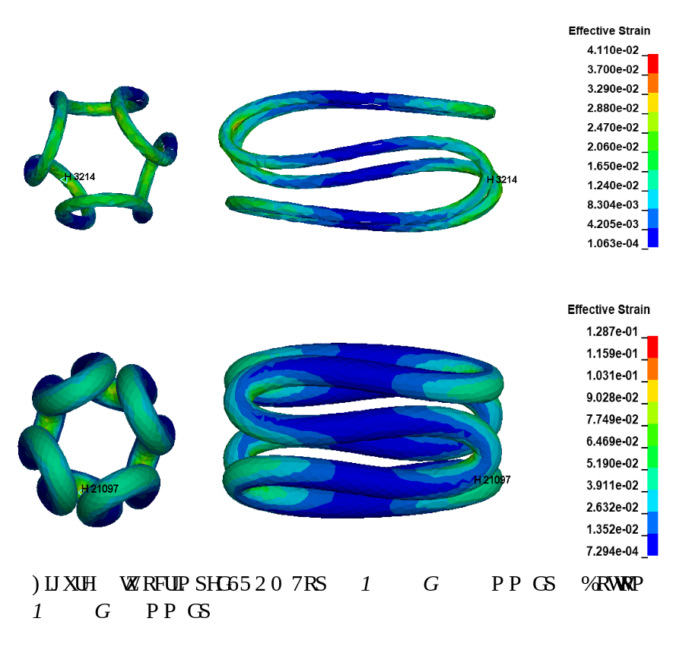
Figure 7. Two crimped SROM. Top: N = 3; d = 0.5 mm (dp0). Bottom: N = 4; d = 1 mm (dp3).
Experimental results.
The experimental work showed deformation modes consistent with those predicted by simulation (Figure 8), providing qualitative support for the modelling approach for this geometry. All 0.5 mm specimens were crimped without fracture (0/3 for both N = 3 and N = 4), whereas two of the three 1 mm specimens fractured in each configuration (2/3, i.e. a 67% failure rate for both N = 3 and N = 4). The principal discrepancy, the fracture of two of the three 1 mm specimens in both configurations, against the failure-free 0.5 mm specimens, is consistent with the strain trends from simulation, since the 1 mm configurations are precisely those predicted to experience the highest strains. This correspondence between the most highly strained configurations and those that failed experimentally reinforces the value of the strain field as a screening criterion, even though the test material itself is not representative of the final device. A quantitative comparison between simulation and experiment was limited by the test set-up: since the funnel imposes the same final diameter as the simulation, radial deformation is prescribed rather than predicted and does not constitute an independent validation metric, and axial elongation was not measured during the tests. The comparison is therefore restricted to deformation modes, and quantitative measurement of the crimped length is left to future work.
Validation of the geometry using a representative bioabsorbable material remains a necessary step that falls outside the scope of this study. However, as long as the candidate material remains in the linear elastic regime, the strain magnitudes reported here remain useful as a preliminary screening tool during material selection, thereby enabling the current results to contribute directly to the material selection process.
This work presents a preliminary geometric investigation of crimpable embolization devices. Several limitations should be acknowledged. The simulations employed a surrogate linear-elastic material, and the definitive bioabsorbable material has not yet been selected. Experimental validation was therefore restricted to geometric deformation behaviour rather than device-level performance. Furthermore, the occluding membrane was not fabricated or evaluated, and embolization efficacy was not assessed. Future work will address material selection, membrane integration, deployment testing, and in-vitro vascular evaluation. Moreover, the number of specimens was small (three to four per configuration), which precludes a statistical assessment of variability. The conclusions of this work should therefore be regarded as preliminary.
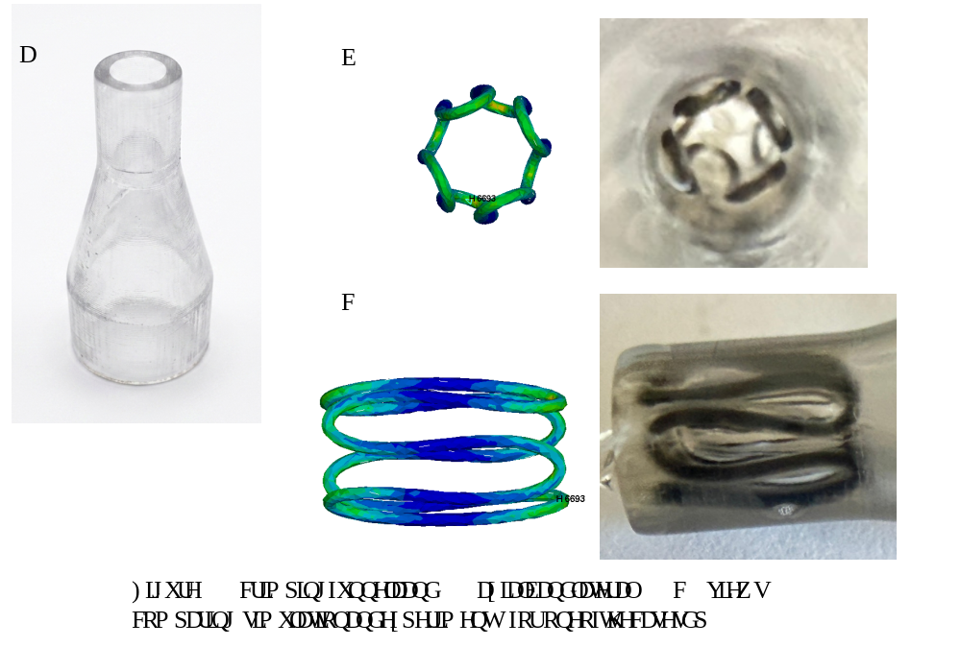Figure 8. Crimping funnel (a) and axial (b) and lateral (c) views comparing simulation and experiment for one of the cases (dp2).
5. Conclusions and further work
The conventional helical coil served as the baseline against which the simulation methodology was developed and confirmed the expected non-auxetic response, axial elongation under radial compression. The preliminary auxetic structures demonstrated auxetic behaviour to varying degrees but exposed two decisive limitations for the present application: their cubic, Cartesian form factor is fundamentally incompatible with the radially periodic geometry required of a tubular intravascular device, and their fabrication at the target scale proved difficult, with the slenderest features unable to survive support removal. These findings motivated the move towards radially periodic and progressively simpler geometries.
The complex sinusoidal auxetic structure, adapted from the axisymmetric chiral structure of Novak et al., resolved the radial-periodicity requirement and was implemented as a fully parametric geometry. However, it presented an intrinsic conflict between fabricability and crimpability thicker wires ease manufacture but reduce the free volume needed for crimping. These considerations led to its deliberate simplification into a single sinusoidal ring.
A sinusoidal ring with occluding membrane, which is not strictly auxetic but shows limited axial elongation, emerged as a promising candidate. Parametric crimping simulations revealed that wire diameter primarily governs peak strain, whereas the number of sinusoidal periods predominantly influences axial elongation. Experimental crimping tests reproduced the deformation modes predicted numerically, providing qualitative validation of the computational model. Unlike the previously evaluated lattice topologies, the proposed design combines radial periodicity, manufacturability, and acceptable crimping performance, making it a suitable platform for future development of bioabsorbable embolization devices. The SROM geometry exhibited axial elongations between 0.93 and 1.96 mm and maximum effective strains between 0.041 and 0.129 under the investigated crimping conditions, while remaining manufacturable at a wire diameter of 0.5 mm. Compared with the reference helical coil, which elongated by 321% during crimping, the SROM reduced axial elongation to below 2 mm for all configurations analysed.
Two immediate issues remain to be thoroughly investigated. First, the selection of bioabsorbable material exhibiting elastic behaviour over the strain range revealed by the simulations. Second, the occluding membrane, whose design, material, and attachment remain to be resolved. These conclusions are preliminary, as they rely on a linear elastic surrogate material and a small number of specimens, and do not yet include membrane, deployment or embolization tests.
The results indicate that radial periodicity and geometric simplicity are more important for practical embolization-device development than maximising auxetic behaviour. While strongly auxetic lattice topologies exhibited significant manufacturing challenges, the simplified sinusoidal-ring concept achieved a more favourable balance between crimpability, manufacturability, and structural integrity.
Acknowledgements
This project is funded by the Spanish AEI 2024 Call – “Proyectos de Generación de Conocimiento”, Ref. PID2024-161387OB-C21.
References
[1] Kashef E, Evans E, Patel N, Agrawal D and Hemingway AP 2023 Pelvic venous congestion syndrome: female venous congestive syndromes and endovascular treatment options. CVIR Endovasc. 6, 25. https://doi.org/10.1186/s42155-023-00365-y
[2] Bałabuszek K, Toborek M and Pietura R 2022 Comprehensive overview of the venous disorder known as pelvic congestion syndrome. Ann. Med. 54, 22–36. https://doi.org/10.1080/07853890.2021.2014556
[3] Alsannan B, Alzeeny A, Etrusco A, Laganà AS, D’Amato A and Tulandi T 2024 Diagnosis and management of pelvic congestion syndrome: comprehensive review. Gynecol. Obstet. Invest. 89, 437–44. https://doi.org/10.1159/000539931
[4] Daniels JP, Champaneria R, Shah L, Gupta JK, Birch J and Moss JG 2016 Effectiveness of embolization or sclerotherapy of pelvic veins for reducing chronic pelvic pain: a systematic review. J. Vasc. Interv. Radiol. 27, 1478–1486.e8. https://doi.org/10.1016/j.jvir.2016.04.016
[5] Hanna J, Bruinsma J, Temperley HC, Fernando D, O’Sullivan N, Hanna M et al 2024 Efficacy of embolotherapy for the treatment of pelvic congestion syndrome: a systematic review. Ir. J. Med. Sci. 193, 1441–51. https://doi.org/10.1007/s11845-024-03608-6
[6] Siqueira-Campos VM, de Deus MSC, Poli-Neto OB, Rosa-e-Silva JC, de Deus JM and Conde DM 2022 Current challenges in the management of chronic pelvic pain in women: from bench to bedside. Int. J. Womens Health 14, 225–44. https://doi.org/10.2147/IJWH.S224891
[7] Senechal Q, Echegut P, Bravetti M, Florin M, Jarboui L, Bouaboua M et al 2021 Endovascular treatment of pelvic congestion syndrome: visual analog scale follow-up. Front. Cardiovasc. Med. 8, 751178. https://doi.org/10.3389/fcvm.2021.751178
[8] Lopez AJ 2015 Female pelvic vein embolization: indications, techniques, and outcomes. Cardiovasc. Intervent. Radiol. 38, 806–20. https://doi.org/10.1007/s00270-015-1074-7
[9] Mausner EV, Yitta S, Slywotzky CM and Bennett GL 2011 Commonly encountered foreign bodies and devices in the female pelvis: MDCT appearances. Am. J. Roentgenol. 196, W461–70. https://doi.org/10.2214/AJR.10.5119
[10] Canalejo-Codina F, Pegueroles M, García-Granada AA, Martorell J, Edelman ER and Balcells M 2025 Integrating stent design and microstructural characterization to improve clinical outcomes of bioresorbable stents. Mater. Des. 260, 115013. https://doi.org/10.1016/j.matdes.2025.115013
[11] U.S. Food and Drug Administration 2023 Assessing the credibility of computational modeling and simulation in medical device submissions. Guidance for industry and Food and Drug Administration staff (Silver Spring, MD: FDA Center for Devices and Radiological Health).
[12] Garcia-Granada AA, Catafal-Pedragosa J and Lemu HG 2019 Topology optimization through stiffness/weight ratio analysis for a three-point bending test of additive manufactured parts. IOP Conf. Ser.: Mater. Sci. Eng. 700, 012012. https://doi.org/10.1088/1757-899X/700/1/012012
[13] Perquel-Zamudio G 2026 Geometric design and experimental–numerical assessment of novel embolization devices for pelvic congestion syndrome. Final degree project (Barcelona: IQS – Universitat Ramon Llull).
[14] Rozenblit AM, Ricci ZJ, Tuvia J and Amis ES 2001 Incompetent and dilated ovarian veins: a common CT finding in asymptomatic parous women. Am. J. Roentgenol. 176, 119–22. https://doi.org/10.2214/ajr.176.1.1760119
[15] Valero I, Garcia-Jimenez R, Valdevieso P, Garcia-Mejido JA, Gonzalez-Herráez JV, Pelayo-Delgado I et al 2022 Identification of pelvic congestion syndrome using transvaginal ultrasonography. A useful tool. Tomography 8, 89–99. https://doi.org/10.3390/tomography8010008
[16] Knuttinen M-G, Xie K, Jani A, Palumbo A, Carrillo T and Mar W 2015 Pelvic venous insufficiency: imaging diagnosis, treatment approaches, and therapeutic issues. Am. J. Roentgenol. 204, 448–58. https://doi.org/10.2214/AJR.14.12709
[17] Tartière D, Seguin P, Juhel C, Laviolle B and Mallédant Y 2009 Estimation of the diameter and cross-sectional area of the internal jugular veins in adult patients. Crit. Care 13, R197. https://doi.org/10.1186/cc8200
[18] Satyapal KS, Rambiritch V and Pillai G 1995 Morphometric analysis of the renal veins. Anat. Rec. 241, 268–72. https://doi.org/10.1002/ar.1092410213
[19] Tünay A, Acıkgoz A and Atesal Ö 2025 Internal jugular vein size and thrombosis risk in central venous catheterization. Med. Sci. Monit. 31, e948228. https://doi.org/10.12659/MSM.948228
[20] Scherer KL and Winokur RS 2023 Techniques for embolization of the ovarian vein and pelvic reservoir. Tech. Vasc. Interv. Radiol. 26, 100899. https://doi.org/10.1016/j.tvir.2023.100899
[21] Xiao N and Lewandowski RJ 2022 Embolic agents: coils. Semin. Intervent. Radiol. 39, 113–8. https://doi.org/10.1055/s-0041-1740939
[22] Tsauo J 2025 Embolization coils: materials, designs, and future directions. Int. J. Gastrointest. Interv. 14, 93–7. https://doi.org/10.18528/ijgii250044
[23] GrabCAD Community Library 3D CAD model collection. Available at: https://grabcad.com/library
[24] Novak N, Nowak M, Vesenjak M and Ren Z 2022 Structural optimization of the novel 3D graded axisymmetric chiral auxetic structure. Phys. Status Solidi B 259, 2200409. https://doi.org/10.1002/pssb.202200409
[25] Frenet F 1852 Sur les courbes à double courbure. J. Math. Pures Appl. 17, 437–47.
[26] Serret J-A 1851 Sur quelques formules relatives à la théorie des courbes à double courbure. J. Math. Pures Appl. 16, 193–207.

