Surface Roughness as a Critical Factor in Hydrogen-Assisted Cracking of API 5L X52 Pipeline Steel
Markus Rønning Danielsen¹, Erange Guruge¹, Nirosha D Adasooriya¹
¹ University of Stavanger, Mailbox 8600, 4036 Stavanger, Norway

*pasindu.e.yaddehiguruge@uis.no
Abstract. The transportation of hydrogen has been a heated topic among industries and researchers for a long time due to its low carbon footprint across the value chain. However, challenging the use of pipelines for hydrogen transportation, hydrogen-assisted cracking (HAC) has been identified and explored by researchers as one of the leading degradation mechanisms of C-Mn pipeline materials. Although minimum surface roughness (SR) requirements have been specified in various standards for different applications, the influence of SR on the performance and integrity of hydrogen transport pipelines has received limited attention in the literature. the relationship between HAC susceptibility and surface roughness has not been studied for widely used C-Mn pipelines such as API 5L X52. Therefore, this study investigates the effect of surface roughness on the HAC susceptibility of API 5L X52 pipeline steel under slow strain rate tensile (SSRT) testing with in-situ electrochemical hydrogen charging.(Revised as per Reviewer #2 Comment #1.a) Hydrogen-exposed specimens showed a significant reduction in ductility, with the lowest area reduction observed in the as-machined specimens due to higher surface defects. Significant surface cracking was also observed in microscopic images in hydrogen-exposed specimens compared to uncharged specimens. Also, it is observed that the intensity of the surface cracking is reduced with decreasing SR (smoothing) of the specimen. However, further polishing beyond an average SR of 0.2 µm did not result in a reduction in the I_{HAC}. Instead, I_{HAC} increased, indicating that the highest resistance to HAC was achieved at an SR of 0.20 µm, identifying a distinct characteristic for HAC of API 5L X52 pipeline steel.
- Introduction
Extensive experimental research is underway to examine the effects of hydrogen on pipeline steels, driven primarily by the urgent need to transition away from non-renewable energy sources such as fossil fuels and coal. Hydrogen has emerged as a promising alternative energy carrier, since it generates very low carbon emissions (near-zero carbon emissions when it is blue hydrogen). Elaborate more: the hydrogen value chain consists of three main phases: production, transportation & storage and end-use applications. Among those, distribution plays a major role, where distribution through pipelines is even more interesting, as it enables the transportation of gaseous hydrogen at a lower cost for short and medium distances [1]. However, its distribution through steel pipelines is threatened by the risk of hydrogen-assisted cracking (HAC) [2-5]. Consequently, both industry and academia have devoted significant effort to studying HAC in the context of dedicated hydrogen pipelines as well as the repurposing of existing natural gas networks [3, 6].
Generally, pipelines transport hydrogen in high-pressure conditions. Hydrogen atoms are adsorbed into the pipeline material and further absorbed into the bulk material, creating favourable conditions for HAC [7]. HAC can be defined as the cracking of the vulnerable material in contact with hydrogen gas or other hydrogen sources under applied stresses [1, 8, 9]. HAC affects the structural performance of the material by reducing ductility, fracture toughness and fatigue properties [1, 7, 8]. There are different factors affecting HAC, which can be mainly divided into three categories: Metallurgical, Environmental and Structural [10-14]. Metallurgical factors include chemical composition, material microstructure, steel grade, heat treatment condition, and surface roughness, all of which affect hydrogen uptake, diffusion, trapping, and crack propagation behaviour [4]. Environmental factors such as hydrogen concentration and purity, pressure, temperature, pH, and the surrounding environment govern the availability and transport of hydrogen into the material [15]. Structural factors, including cathodic protection, coating degradation, applied and residual stresses, pressure fluctuations, and geometric discontinuities, determine the stress state and potential crack initiation sites [13, 16]. Among the critical parameters influencing hydrogen permeation in steels, surface roughness has been identified as a governing factor because it directly influences the condition of the steel surface where hydrogen ingress occurs [17]. Rougher surfaces contain a higher density of microscopic asperities, machining marks, and localised stress concentration sites that can promote hydrogen accumulation and facilitate crack initiation. Despite the recognition of surface roughness requirements in a few industry standards, its specific influence on the susceptibility of pipeline steels to hydrogen-assisted cracking has received limited attention, specially for electrochemical hydrogen charging, highlighting the need for further investigation. The existing standards, such as ASTM E 466 [18], specify SR for the fatigue specimens, and ASTM G 142 [19] recommends SR for hydrogen embrittlement of gaseous charging. However, the effect of SR on electrochemical hydrogen charging has not been investigated. Also, the behaviour of HAC susceptibility with SR has not been investigated for common pipelines such as API 5L X52, even though it is important to understand the effect of SR on HAC for hydrogen transport pipelines.(Revised as per Reviewer #2 Comment #1.b)
Electrochemical hydrogen charging is popular technique (Revised as per Reviewer #2 Comment #4) widely used for introducing hydrogen into the system via the hydrogen evolution reaction (HER), in which atomic hydrogen is generated on the steel surface as a result of cathodic reactions. In acidic solutions, hydrogen is produced from hydronium ions, whereas in alkaline solutions it is generated from water molecules. Once formed, the adsorbed hydrogen atoms can either recombine to form molecular hydrogen and leave the surface (desorption) or be absorbed into the steel lattice, where they may diffuse through the material and contribute to hydrogen-assisted cracking [4, 8, 20]. This process consists of three steps. The first step is called the Volmer step, where hydrogen atoms are electrochemically adsorbed into the metal surface. The second step is the Tafel step, where adsorbed hydrogen atoms recombine into hydrogen molecules inside the metal lattice. This same process can occur electrochemically as well, which is referred to as the Heyrovsky step [21].
API 5L X52 pipeline material has been widely utilised for both natural gas (NG) and H₂ gas transportation and therefore investigated during this study [22]. Therefore, API 5L X52 material is investigated during this study. (Revised as per Reviewer #2 Comment #4) This material typically exhibits a ferritic-pearlitic microstructure [4]. Ferrite is associated with higher diffusivity and lower hydrogen trapping capacity, while pearlite and harder phases contribute to strength and can promote localised hydrogen accumulation. The relationship between phase hardness and embrittlement is not, however, straightforward. Harder phases increase trap density but may simultaneously reduce hydrogen mobility depending on trap binding energy, which has produced conflicting observations in the literature [23]. In the absence of hydrogen, crack initiation in steels occurs at sites of stress concentration, internal defects, inclusions, or regions of localised plastic deformation, where local stress exceeds the material's fracture resistance, driving microvoid or microcrack nucleation [24]. However, Surfacesurface (Revised as per Reviewer #2 Comment #4) irregularities such as machining marks or roughness features act as stress concentrators by locally amplifying the applied stress field. These elevations in local stress facilitate plastic deformation and raise the probability of microcrack formation, making the surface a primary site for crack initiation under tensile loading [25]. Hydrogen changes this picture by accumulating at dislocation structures and grain boundaries, regions of high stress and plastic deformation, where it either promotes localised plasticity (via hydrogen-enhanced localised plasticity/HELP) (Revised as per Reviewer #2 Comment #4) or reduces atomic cohesion (via hydrogen-enhanced decohesion mechanism/HEDE), (Revised as per Reviewer #2 Comment #4) or both simultaneously [26, 27]. The net effect is a reduction in the stress required to initiate cracking relative to uncharged conditions [28]. In 2024, Du and the team [25] quantified this effect in X52 (Revised as per Reviewer #2 Comment #4) specimens with different microstructures, finding that hydrogen-charged specimens consistently showed earlier crack initiation and lower fracture elongation across all conditions tested, with the degree of degradation correlating with diffusible hydrogen content rather than total hydrogen content, highlighting that it is the mobile fraction, not the total absorbed hydrogen, that drives embrittlement Onceonce (Revised as per Reviewer #2 Comment #4) initiated, crack propagation is governed by the stress intensity at the crack tip, where plastic deformation is highly localised and hydrogen transport is enhanced by both stress driven diffusion and increased trap density [28].
Therefore, investigating the effect of surface roughness on hydrogen transport pipelines is vital for mitigating HAC since it directly governs how hydrogen atoms enter and interact with the metal lattice. Further, it helps engineers to identify the optimum most suitable (Revised as per Reviewer #2 Comment #4) surface finish and avoid over-polishing, standardising the surface preparation procedures, standardising the test methods by increasing the repeatability and allowing engineers to balance the material's resistance to HAC with surface conditions to improve the coating bond strength. However, the influence of surface roughness on the performance and integrity of hydrogen transport pipelines has received limited attention in the literature. In particular, there is limited information regarding the optimum surface (Revised as per Reviewer #2 Comment #4) roughness for hydrogen transport pipeline materials in industry and for experimental test specimens in academia. Therefore, the Moreover, the effect of surface roughness as a metallurgical factor influencing HAC needs to be investigated to identify the most resistant surface conditions of pipeline materials against HAC has not yet been systematically evaluated for API 5L X52, a widely used pipeline steel for hydrogen transport. (Revised as per Reviewer #2 Comment #1.c)
To address these knowledge gaps, this study investigated the effect of surface roughness on hydrogen-assisted cracking susceptibility in API 5L X52 pipeline steel using slow strain rate tensile testing with in-situ electrochemical hydrogen charging. The objectives were to establish the relationship between surface roughness and HAC susceptibility and to identify the surface finish most effective in reducing susceptibility under the investigated conditions in hydrogen transport pipelines. To address the above knowledge gaps, the effect of surface roughness on HAC was investigated using SSRT testing with in-situ electrochemical charging for API 5L X52 pipeline steel in this study. Hence, the relationship/trend of HAC susceptibility and surface roughness, and the optimum most effective surface roughness to control the effect of HAC for hydrogen transport pipelines. (Revised as per Reviewer #2 Comment #4) Initially, the paper discusses the specific details of surface roughness as a critical factor for HAC of pipelines. Then it presents the details of the materials and methods used for the study, and the results are presented in the latter part with detailed discussion. Finally, the major conclusions drawn from the study are presented.
- Surface roughness as a critical factor
Surface roughness quantifies the small-scale topographic variations of a material surface and is typically expressed through statistical parameters derived from measured profiles. The arithmetic mean-roughness R_{a}, the average absolute deviation of the profile from its mean line over a defined evaluation length, is the most widely used parameter because of its practical simplicity and reproducibility [17]. Additional parameters such as R_{z} (average maximum height) can provide complementary information about peak-to-valley extremes and localised surface features, which R_{a} alone does not capture. These parameters are reported inconsistently across studies, and their interpretation varies with measurement method, which limits direct comparisons between published datasets [17]. In 2006, Kentish [29] (Revised as per Reviewer #2 Comment #4) observed that surfaces with similar R_{a} can differ significantly in their stress corrosion cracking behaviour depending on peak sharpness and valley geometry, features not captured by R_{a} alone, which underscores the importance of interpreting R_{a} results within the context of the specific surface preparation method used [29]. Manufacturing and preparation processes, machining, grinding, and polishing, determine both the geometric characteristics of the surface and its near-surface microstructure and residual stress state. Machining can introduce near-surface plastic deformation and residual stresses that alter local hydrogen diffusion and trapping behaviour independently of the roughness value measured [17, 30]. In 2023, Leng and the team [17] demonstrated this (Revised as per Reviewer #2 Comment #4) in reactor-grade high-strength low-alloy steel, (Revised as per Reviewer #2 Comment #4) showing that grinding with coarser abrasives introduced a deformed near-surface layer with elevated dislocation density, which increased hydrogen-trapping capacity and reduced hydrogen permeation flux. This effect persisted even after the surface profile was polished to a lower Ra, indicating that prior preparation history can independently influence hydrogen uptake behaviour. Surface roughness (R_{a}) (Revised as per Reviewer #2 Comment #4) is therefore an incomplete descriptor of surface condition. A more complete picture requires considering topography, residual stress, and near-surface microstructure together, which is broadly referred to as surface integrity. The connection between surface preparation and hydrogen behaviour has been noted in pipeline steel studies, where identical R_{a} values produced different crack initiation responses depending on preparation method [30, 31].
Hydrogen uptake begins at the material surface, where atomic hydrogen adsorbs before being absorbed and diffusing into the bulk. Surface condition therefore directly affects both the rate of hydrogen entry and its spatial distribution within the material [17, 32]. Increased surface roughness raises the effective area available for hydrogen adsorption and introduces micro-asperities that can act as local stress concentrations, promoting near-surface plastic deformation. Both effects tend to enhance hydrogen entry: the former by increasing the number of active adsorption sites, the latter by increasing trap density in the near-surface region [17]. In 2022, Wang and the team [30] (Revised as per Reviewer #2 Comment #4) investigated X65 pipeline steel under different surface preparation conditions and found that electrochemically charged specimens with rougher surfaces accumulated higher diffusible hydrogen concentrations as measured by thermal desorption spectroscopy, confirming the direct link between surface topography and hydrogen uptake at the subsurface level. The relationship between roughness and hydrogen uptake is not, however, simply proportional. Rougher surfaces can also carry oxide films, surface damage layers, or compressive residual stresses from abrasive preparation, all of which can inhibit hydrogen entry [30]. Studies on pipeline steels [30, 31] show (Revised as per Reviewer #2 Comment #4) that near-surface microstructure and residual stress, both consequences of surface preparation, affect hydrogen uptake independently of topography. Surface preparation methods therefore have a dual character: they set the roughness but simultaneously modify dislocation density, residual stress, and trap site density in the near-surface layer. Whether the net effect promotes or inhibits hydrogen uptake depends on the balance between increased adsorption area and the presence of traps that restrict hydrogen mobility [17, 23]. However, hydrogen-assisted crack initiation frequently originates at or near the surface; local stress concentrations arising from surface topography can significantly influence the onset of failure [25]. Surface roughness is therefore not only a geometric variable but a mechanical one, relevant to both the initiation and early propagation of hydrogen-assisted cracks [29].
Kentish [29] (Revised as per Reviewer #2 Comment #4) examined stress corrosion cracking in gas pipeline steels and found that time to failure decreased with increasing R_{a}, attributing this primarily to the enhanced stress concentration at surface asperities that facilitates localised plastic deformation and crack nucleation. Increasing roughness also affects crack distribution: while more initiation sites might be expected, Kentish [29] (Revised as per Reviewer #2 Comment #4) observed a reduction in crack density with increasing R_{a}, with those cracks that did form being more likely to propagate. This suggests that asperity spacing influences whether adjacent cracks interact and mutually arrest or grow independently [29]. Rough surfaces also present greater area to corrosive or hydrogen-generating environments, raising localised electrochemical activity and hydrogen uptake. Surface integrity studies confirm that machining-induced features alter hydrogen absorption and trapping behaviour in the near-surface layer, contributing to the overall embrittlement response [17]. Wang and the team [30] (Revised as per Reviewer #2 Comment #4) found in X65 pipeline steel that specimens prepared by grinding retained a compressive residual stress layer near the surface that partially resisted hydrogen-driven crack initiation, whereas electropolished specimens lacking this layer showed earlier crack formation despite having lower R_{a} values, a result that confirms the importance of near-surface residual stress as a variable independent of roughness.
During an investigation by Zhiyi Leng and team in 2023 [17], (Revised as per Reviewer #2 Comment #4) it was found that an R_{a} of 0.17µm has the best performance against hydrogen permeation resistance for electrochemical hydrogen charging for low-alloy carbon steel material used for hydrogen production reactors. Also, R_{a} of 0.17µm has shown the maximum elongation and tensile strength and the lowest hydrogen embrittlement index. However, they also observed decreased resistance when the surface roughness was reduced to less than 0.17 µm. Another study on low-alloy ferritic steel reported that a smoother surface condition enhances hydrogen uptake efficiency and leads to higher measured hydrogen diffusivity, whereas increased surface roughness suppresses hydrogen entry due to enhanced surface recombination of hydrogen atoms [21]. Further, a study by Alessandro Campari [33] compares (Revised as per Reviewer #2 Comment #4) vintage and modern API 5L X65 pipeline steels under high-pressure hydrogen conditions using a hollow specimen technique. The study found that specimens with higher inner surface roughness (drilled) showed greater susceptibility to hydrogen embrittlement, with more significant ductility loss and higher scatter in results compared to reamed specimens.
- Material and Methods

Material
In this study, API 5L X52 pipeline steel, a commonly used grade in the European natural gas transmission system, was investigated. The material was supplied by Vallourec Deutschland GmbH as a hot-rolled, normalised seamless pipe with an outer diameter of 114.3 mm and a wall thickness of 11.1 mm. The heat chemical composition provided by the manufacturer is given in Table 1. (Revised as per Reviewer #2 Comment #4) The material exhibited a ferrite–pearlite microstructure.
Table 1. Chemical composition of API 5L X52 material
C  % | Si  % | Mn  % | P  % | S  % | Al  % | Cu  % | Cr  % | Ni  % | Mo  % | V  % | As  % | Sn  % | Ti  % | Nb  % | N  % | Pb  % | B  % | Ca  % | Bi  % | Fe  %
0.120 | 0.295 | 1.45 | 0.014 | 0.0018 | 0.037 | 0.023 | 0.053 | 0.127 | 0.003 | 0.048 | 0.0017 | 0.001 | 0.002 | 0.031 | 0.007 | 0.001 | 0.0001 | 0.002 | 0.001 | Balance

Specimen preparation
The longitudinal samples were sectioned from the API 5L X52 steel pipe parallel to the pipe axis to ensure that the specimens were oriented along the rolling direction. Then, cylindrical tensile specimens for slow strain rate testing (SSRT) were machined and prepared in accordance with BS ISO 16573-2:2022 and ASTM E8/E8M, as shown in Figure 1 (ISO 16573-2:2022, 2022).
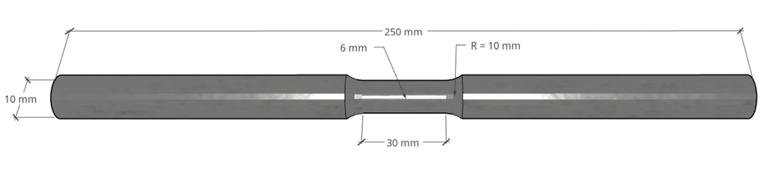
Figure 1. Specimen dimensions of tensile specimen
Controlled modification of surface roughness was performed to systematically investigate the relationship between surface topography and HAC susceptibility. Surface roughness (R_{a}) was measured using a contact stylus profilometer. The model of the profilometer is INSIZE ISR-C300, Portable Surface Roughness Tester. (Revised as per Reviewer #2 Comment #4) Six surface conditions were considered: the as-machined condition and target surface roughness values of R_{a} ≈ 1.00 µm, 0.50 µm, 0.20 µm, 0.10 µm and 0.05 µm. The desired surface finishes were obtained through sequential grinding and mechanical polishing. Progressive grinding using abrasive papers of increasing grit size was employed to gradually reduce machining-induced surface irregularities and deformation. At each stage, grinding was continued until the scratches produced during the preceding step were completely removed, following standard metallographic specimen preparation practices [34]. Depending on the required surface roughness conditions, the specimens were progressively ground using abrasive silicon carbide papers (SiC) with increasing grit sizes. A typical grinding sequence consists of polishing using 240-grit, 400-grit, and 2000-grit SiC papers, followed by 4000-grit SiC paper. Further reduction in surface roughness was achieved by extending the grinding duration using the finest abrasive papers, thereby promoting continued material removal and progressive smoothing of the surface asperities.
The surface texture of the target groups is given in the Figure 2. In the Figure 2 (a) machining marks from the CNC are clearly visible. The surface has significant roughness, normally around 1-3 µm. However, as the target roughness was reduced, the smoothness and the shine of the specimen surface have increased. The specimen identification (Specimen ID) and surface roughness of each specimen and other details are provided in the Table 2. Specimen ID AIR is the specimen tested in air, and AM means As Machinedas-machined (Revised as per Reviewer #2 Comment #4) specimens. Ra-0.5 means specimens with target surface roughness of 0.5 µm. The number at the end of each specimen ID distinguishes the specimens of the same condition.

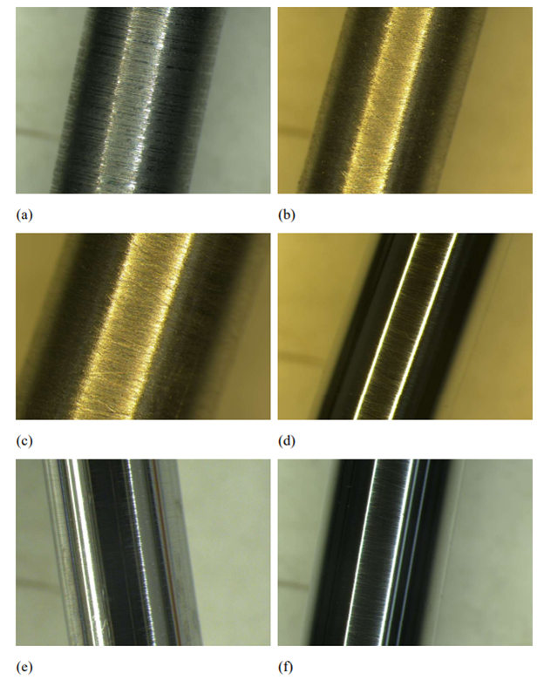
Figure 2. Representative macroscopic images of the target surface roughness (R_{a}) in µm after polishing, before the hydrogen charging: (a) As-machined (b) 1.00 (c) 0.50 (d) 0.20 (e) 0.10 (f) 0.05 µm
Table 2. Specimen details used for the study
Specimen ID | Target Ra [µm] | Test Condition | Actual Ra [µm]
AIR-1 | <0,2 | Air | 0.181
AIR-2 | <0,2 | Air | 0.174
AM-1 | As machined | H2 | 1.380
AM-2 | As machined | H2 | 1.838
AM-3 | As machined | H2 | 2.269
Ra-1-1 | 1.00 | H2 | 0.898
Ra-1-2 | 1.00 | H2 | 1.020
Ra-1-3 | 1.00 | H2 | 1.067
Ra-0.5-1 | 0.50 | H2 | 0.506
Ra-0.5-2 | 0.50 | H2 | 0.480
Ra-0.2-1 | 0.20 | H2 | 0.211
Ra-0.2-2 | 0.20 | H2 | 0.205
Ra-0.2-3 | 0.20 | H2 | 0.207
Ra-0.1-1 | 0.10 | H2 | 0.111
Ra-0.1-2 | 0.10 | H2 | 0.107
Ra-0.05-1 | 0.05 | H2 | 0.052
Ra-0.05-2 | 0.05 | H2 | 0.045

Electrochemical hydrogen charging
Electrochemical hydrogen charging was performed to introduce diffusible hydrogen into the API 5L X52 pipeline steel specimens before SSRT testing. The electrolyte consisted of a 3.5 wt% sodium chloride (NaCl) solution with 2 g/L thiourea (CH₄N₂S) added as a hydrogen recombination poison. Thiourea was added to suppress the recombination of hydrogen into molecular hydrogen, thereby enhancing atomic hydrogen absorption in the steel [35]. The pH of the solution started as approximately neutral and was checked with pH strips. Charging was conducted at room temperature (21 ± 1 °C). A constant cathodic potential of -1225mV was applied to simulate electrochemical conditions equivalent to hydrogen gas exposure [35]. A pre-charging duration of 24 h was selected based on the findings reported in the authors’ previous publication (Revised as per Reviewer #2 Comment #4) [36]. A three-electrode electrochemical cell was used. The specimen, platinum electrode, and Ag/AgCl worked as the working electrode, counter electrode, and reference electrode, respectively, as illustrated in Figure 3.
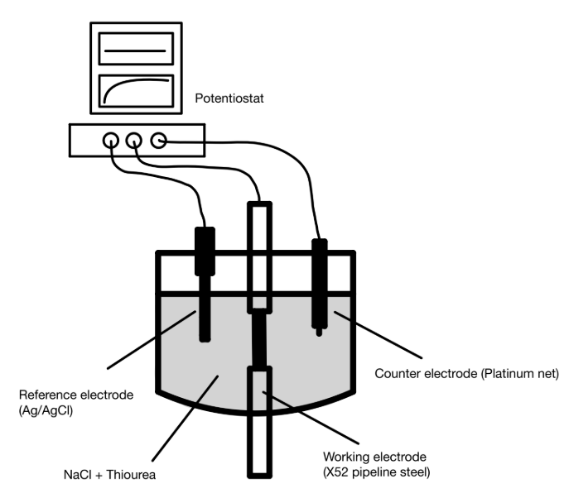
Figure 3. Schematic illustration of the three-electrode electrochemical cell used for hydrogen charging

Due to the high diffusivity of hydrogen in steel, the specimens were not exposed outside the charging environment for more than 10-15 minutes to minimise hydrogen loss from the material.

SSRT testing
SSRT was employed to assess the susceptibility of the material to hydrogen-assisted cracking (HAC). The tests were performed in accordance with ASTM E8/E8M-13a using a constant strain rate of 10⁻⁵ s⁻¹ (Revised as per Reviewer #2 Comment #4) [37]. This relatively low strain rate provides sufficient time for hydrogen to diffuse and redistribute towards regions of high local stress, such as crack tips, thereby promoting conditions favourable for HAC [4, 38]. Mechanical testing was conducted using an Instron 5985 dual-column universal testing machine equipped with a 250 kN load cell. All SSRT tests were carried out under in situ electrochemical hydrogen charging, as illustrated in Figure 4. Hydrogen charging was maintained throughout the SSRT test to ensure a continuous supply of hydrogen to the specimen during deformation. The specimens were exposed to the same electrochemical charging conditions used during the pre-charging stage described above. Three replicate specimens were tested for each surface roughness condition to assess the repeatability and reliability of the mechanical test results.
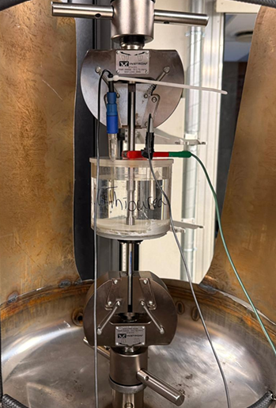
Figure 4. SSRT test setup with in-situ electrochemical hydrogen charging
The hydrogen-assisted cracking susceptibility index (I_{HAC}) was calculated to quantify the loss of ductility resulting from hydrogen exposure. In the present study, it was determined based on the reduction in area (RA), as RA provides a direct measure of localised ductility at the fracture region, where hydrogen-assisted degradation and damage mechanisms are most pronounced [17, 31]. The I_{HAC} is calculated by comparing the reduction in area of the hydrogen-charged specimens with uncharged reference specimens tested in air, as given in Equation (1):
$I_{HAC}=\frac{{RA}_{ref}-{RA}_{H}}{{RA}_{ref}}×100$ (1)
where RA_{ref} represents the average reduction in area of the uncharged reference specimens, while RA_{H} denotes the average reduction in area of the hydrogen-charged specimens for each surface roughness condition. A higher value corresponds to a greater hydrogen-induced loss of ductility and, consequently, a higher susceptibility to HAC.

Microscopic analysis of specimen surface
A light microscope (Leica MZ 12.5) was used to examine the macroscopic appearance and surface cracking of the specimens after mechanical testing. The examination focused on visible necking, overall fracture appearance, and the presence and extent of surface cracks. The obtained images were used to qualitatively compare the specimens with different surface roughness conditions.
- Results & Discussion

Tensile behaviour and effect of surface roughness
The mechanical response of the specimens was evaluated using SSRT test results to assess how different surface conditions influenced the tensile behaviour under hydrogen charging. Compared to air samples, all the hydrogen-charged samples show reduced ductility (strain to failure), demonstrating the effect of HAC as illustrated in Figure 5. As-machined specimens, which have the highest surface roughness and undulations, show the greatest impact from hydrogen-assisted degradation. However, a proper trend of HAC behaviour against surface roughness cannot be observed by analysing the stress-strain curves for the rest of the specimens. Therefore, area reduction of the gauge section was used to define the susceptibility index and compare the effect of HAC.
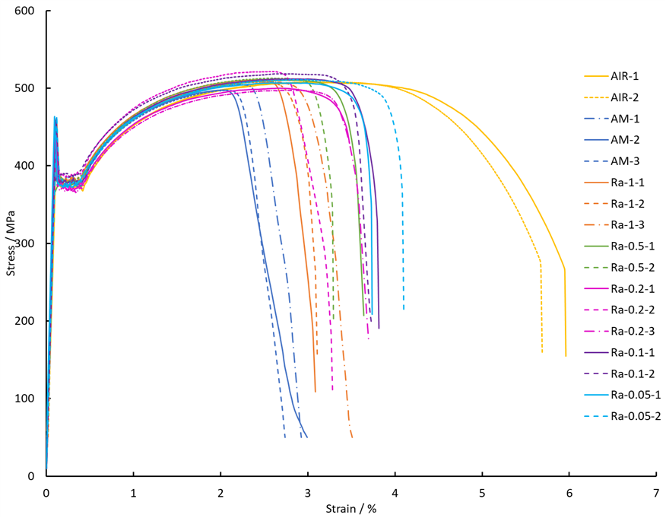
Figure 5. Stress-strain graphs of tested specimens
Further, as visible from Figure 5, the impact on the yield strength and the tensile strength of the material by hydrogen charging is insignificant compared to the impact on the ductility. The yield strength values range from approximately 369 to 382 MPa across all conditions. The mean tensile strength values range between approximately 506 and 514 MPa for the hydrogen-charged specimens and approximately 507 MPa for the air-tested reference baseline.
The I_{HAC} were calculated using area reductions due to the SSRT testing as defined in Section 3.4. Air-tested specimens were used as reference values for the I_{HAC} calculations. Resultant I_{HAC} calculations along with the standard deviations (SD) are given in the Table 3. Since the as-machined samples showed a wide range of surface roughness, those values are not compared in the Table 3 and the Figure 6.
Table 3 shows that the average (Revised as per Reviewer #2 Comment #4) area reduction of air-tested specimens is 78.74%, showing a significant necking at the fracture area. However, all hydrogen-charged specimens showed decreased area reduction values lower than 30%. Therefore, a significant impact on the API 5L X52 material is observed due to the HAC. To identify the behaviour of the material for hydrogen degradation, I_{HAC} values have been graphed against target surface roughness values as given in the Figure 6.

Table 3.Susceptibility index for each target surface roughness value
Target R_{a} [µm] | Mean area reduction [%] | SD area reduction | I_{HAC} [%] | SD I_{HAC}
AIR | 78.74 | 0.36 | - | -
0.05 | 28.91 | 0.73 | 63.29 | 0.92
0.10 | 27.73 | 3.63 | 64.78 | 4.61
0.20 | 29.70 | 3.27 | 62.28 | 4.15
0.50 | 27.74 | 1.03 | 64.77 | 1.31
1.00 | 23.66 | 1.86 | 69.95 | 2.37

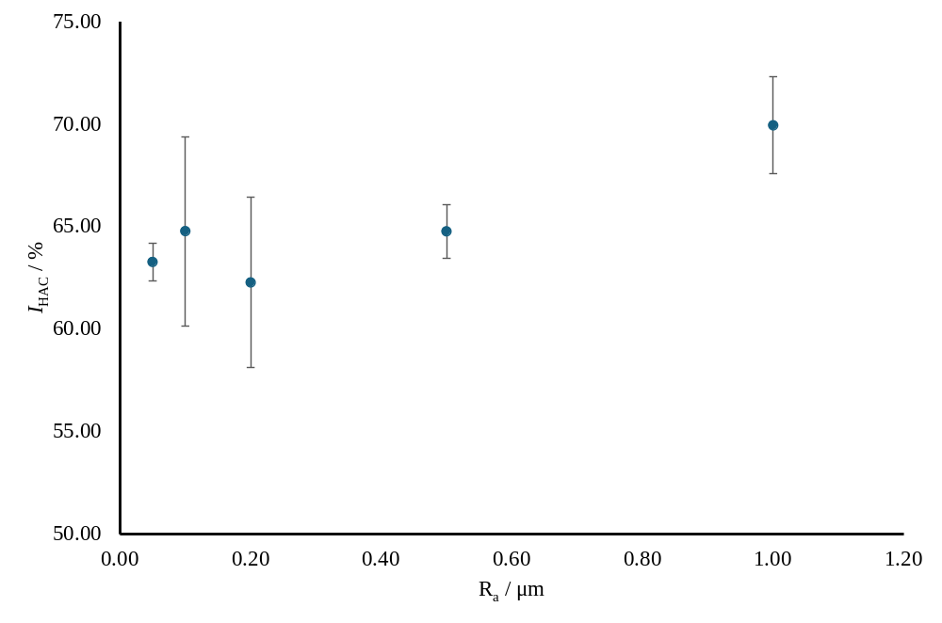
Figure 6.Variation of HAC susceptibility index with material surface roughness(Revised as per Reviewer #2 Comment #2)
As-machined samples showed the maximum average susceptibility for HAC around 72.83%, which is even higher than the target R_{a} of 1µm shown in the Figure 6. There is a clear trend of decreasing the susceptibility index with reducing the surface roughness as observed in the Figure 6. It has reached a minimum I_{HAC} around 0.2 µm, giving the highest resistance to the hydrogen-assisted cracking for API 5L X52 materials. However, with a further reduction in surface roughness, increases, indicating that the susceptibility to HAC begins to increase beyond a certain point despite the continued reduction in surface roughness.

Microscopic observations of the specimen surface
Macroscopic side view analysis was carried out to compare the overall hydrogen-assisted cracking appearance of the reference specimen and the hydrogen-charged specimen with different surface roughness conditions. The observations focused on necking, intensity of surface cracking and the shape of the fracture. Representative micrographs from each surface condition are shown in Figure 7.

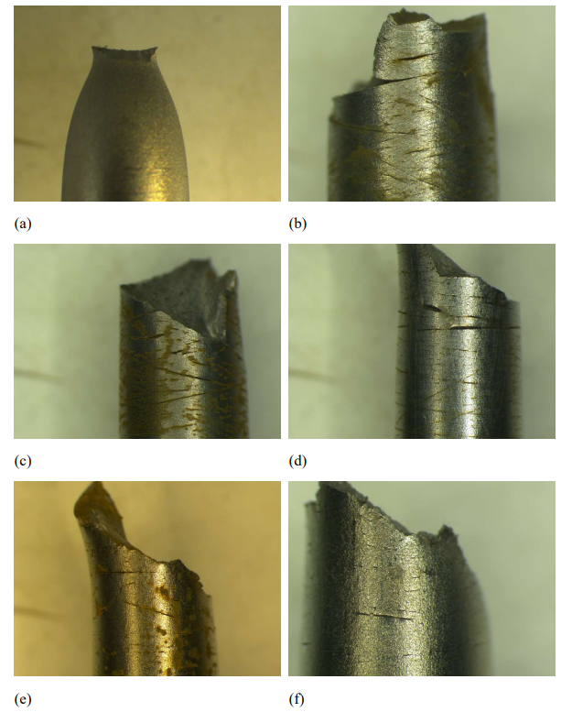
Figure 7. Representative macroscopic fracture images after SSRT testing: (a) Reference (in-air) (b) 1,00 (c) 0.50 (d) 0.20 (e) 0.10 (f) 0.05
The reference specimen tested in air showed a clearly ductile macroscopic fracture appearance with cup and cone mode, characterised by pronounced necking. The visible plastic deformation around the fracture region, as shown in Figure 7 (a) indicates substantial deformation before failure. In comparison, the hydrogen-charged specimens shown in Figure 7 (b-f) exhibited reduced visible necking compared with the reference specimen in Figure 7 (a). The fracture profiles of the hydrogen-charged specimens appeared more abrupt, inclined, and irregular at the macroscopic scale, showing more brittle behaviour. Although minor variations were observed among individual specimens, all hydrogen-charged specimens exhibited an inclined/angled fracture mode, regardless of their surface roughness.
There were no any surface cracks or crack initiation sites were visible in the uncharged specimens. But after introducing hydrogen to the system, several subcritical surface cracks were observed in the region near the main fracture. Even though several factors such as applied cathodic potential, electrolyte, pH, charging duration and machining methods also affect the surface cracking, during this study we kept everything the same while changing only the surface roughness. The maximum surface cracking density was observed in as-machined samples, as shown in Figure 8.
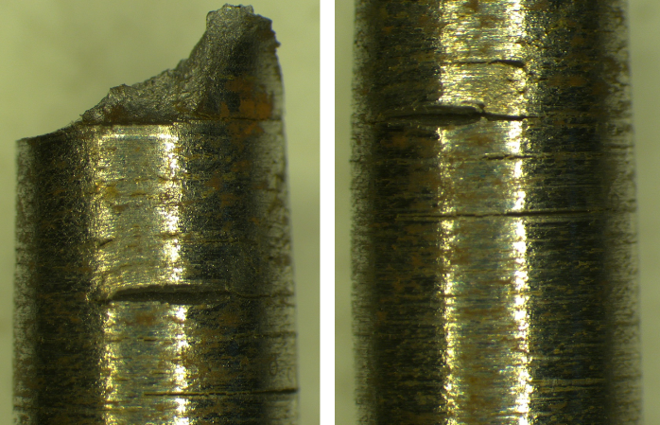
Figure 8. Micrographs of surface cracks in as-machined specimens
A large number of surface cracks have initiated and propagated along the circumferential machining marks. Those irregularities may act as localised stress concentration locations and promote the hydrogen-assisted crack initiation. Further, the extent of visible surface cracking appeared to decrease with decreasing measured R_{a}. After as-machined specimens, R_{a} of 1 µm and 0.5 µm specimens showed higher density of surface cracks, as shown in the Figure 7 (b) and (c). The density of circumferential surface cracks of specimens with R_{a} of 0.2 µm and 0.1 µm is lower than the higher-rough specimens, and the lowest surface crack density was observed in the smoothest specimen, which is R_{a} of 0.05 µm. Therefore, increased HAC susceptibility and decreased surface crack density show contradictory observations and may be explained as follows.
Researchers have observed two favourable conditions for increased hydrogen degradation in rough surfaces. Firstly, irregularities of the metal surface act as stress concentration sites and more hydrogen atoms accumulate around them and develop localised triaxial stresses to promote cracking [4, 31, 33]. Secondly, a rougher surface provides a larger specific surface area and higher specific surface energy, leading to greater hydrogen penetration [17, 33, 39]. When the surface is smooth, there are fewer defects on the surface. Therefore, relatively low hydrogen penetration is observed [33]. Also, another argument is that recombination of hydrogen atoms to molecules is higher on smooth surfaces than rough surfaces, which can be a favourable condition for hydrogen adsorption [40, 41]. However, once the small microcrack propagates due to the applied stresses, because the rest of the surface is flawless, this single new crack becomes an extreme, singular point of stress concentration [33]. Then, penetrated hydrogen atoms accumulate around fewer specific points and rapidly degrade the atomic bonds at the crack tip and propagate, creating several cleavage planes [17].

- Conclusions
During this study, the effect of material surface roughness on the susceptibility of hydrogen-assisted cracking was investigated for API 5L X52 pipeline steel. Slow strain rate tensile tests were performed with in-situ electrochemical hydrogen charging, and the following conclusions were observed during the study.
- Material ductility has been reduced significantly while yield strength and tensile strength remain in the same range. Despite surface roughness adjustments aimed at improving resistance to hydrogen-assisted cracking, the mean reduction of area remained below 30% for all hydrogen-charged conditions, corresponding to a relative ductility loss of more than 62.28% compared with the uncharged condition. These findings indicate that surface roughness control alone is not effective in preventing substantial hydrogen-induced ductility degradation under the investigated conditions. (Revised as per Reviewer #2 Comment #3)
- Once the surface roughness decreased, the susceptibility of the material to HAC also reduced up to a 0.2 µm R_{a} value and started to increase again despite decreasing the surface roughness, providing the highest resistance against HAC at a surface roughness of 0.2µm (R_{a}). Further testing with a larger sample set is needed to validate this observation and refine the estimated surface roughness R_{a} value. Once validated, these findings could inform surface-finish requirements for hydrogen transport pipeline manufacturing, support the standardisation of specimens for hydrogen-assisted cracking tests, and guide coating selection based on substrate surface conditions.(Revised as per Reviewer #2 Comment #3)
- The density of surface cracks near the gauge area is reduced with the reduction in surface roughness, even though the susceptibility of HAC increased after 0.2µm (R_{a}). These findings highlight the complexity of hydrogen-assisted cracking and suggest that its underlying mechanisms vary with environmental and material conditions, underscoring the need for further investigation to elucidate the mechanisms governing cracking under specific conditions.(Revised as per Reviewer #2 Comment #3)
This study (Revised as per Reviewer #2 Comment #4) can be extended in future to investigate the effects of surface roughness on the fracture mechanism and fracture surface using SEM analysis. In particular, changes in the fracture mode associated with different levels of surface roughness may be identified

Acknowledgment
The authors would like to acknowledge the support received from the University of Stavanger lab engineers Johan Andreas, Mats Ingdal and Espen Undheim. Also, the authors would like to appreciate the workshop staff, Emil Mannes Surnevik, Caroline Einvik and Are Molund, for their support for this work.

References
- DNV. Hydrogen pipeline systems. DNV; 2026
- Chatzidouros EV, Papazoglou VJ, Tsiourva TE, Pantelis DI. Hydrogen effect on fracture toughness of pipeline steel welds, with in situ hydrogen charging. International Journal of Hydrogen Energy. 2011;36:12626–43.10.1016/j.ijhydene.2011.06.140
- Catalano F, Palombo M, De Marco M, Mortello M, Recanzone FA, Baricco M, et al. Development of an experimental setup for testing X52 steel SENT specimens in electrolytic hydrogen to explore repurposing potential of pipelines. International Journal of Pressure Vessels and Piping. 2025;216.10.1016/j.ijpvp.2025.105527
- Hoschke J, Chowdhury MFW, Venezuela J, Atrens A. A review of hydrogen embrittlement in gas transmission pipeline steels. Corrosion Reviews. 2023;41:277–317.10.1515/corrrev-2022-0052
- Guruge E, Adasooriya ND. Environment-Assisted Cracking of Pipeline Steel in Hydrogen-Prone Environment. In: Pavlou D, Adeli H, Correia J, editors. Advances in Computational and Experimental Methods in Engineering. Springer Nature Switzerland; 2026. p. 41–73
- Kovács J, Lukács J. Systematic review of factors influencing the integrity of pipeline girth welds exposed to hydrogen. Welding in the World. 2025.10.1007/s40194-025-02034-1
- Lars Magne Haldorsen XS, Jørund Fonneland. Perspectives and Investigations on Re-purposing of Large Diameter Offshore Pipelines for H2 transport. Proceedings of the Thirty-fourth (2024) International Ocean and Polar Engineering Conference. Rhodes, Greece: International Society of Offshore and Polar Engineers (ISOPE); 2024
- Hagen AB, Alvaro A. Hydrogen Influence on Mechanical Properties in Pipeline Steel. SINTEF; 2020
- EIGA EIGA. Hydrogen Pipelines Systems. IGC Doc 121/14: EIGA; 2014
- Pourazizi R, Mohtadi-Bonab MA, Szpunar JA. Investigation of different failure modes in oil and natural gas pipeline steels. Engineering Failure Analysis. 2020;109:104400.https://doi.org/10.1016/j.engfailanal.2020.104400
- Ohaeri EG, Qin W, Szpunar J. A critical perspective on pipeline processing and failure risks in hydrogen service conditions. Journal of Alloys and Compounds. 2021;857.10.1016/j.jallcom.2020.158240
- Li D, Liu M, Li G, Wang H, Jiao L, Li W, et al. Effect of H on Mechanical Properties and Corrosion Resistance of Ferritic/Martensitic Steels with Different Si Contents. Journal of Materials Engineering and Performance. 2024.10.1007/s11665-024-10325-9
- Bolzoni F, Paterlini L, Casanova L, Ormellese M. Hydrogen charging of carbon and low alloy steel by electrochemical methods. Journal of Applied Electrochemistry. 2023;54:103–14.10.1007/s10800-023-01942-8
- Mohtadi-Bonab MA. Effects of Different Parameters on Initiation and Propagation of Stress Corrosion Cracks in Pipeline Steels: A Review. Metals. 2019;9:590
- Abubakar SA, Mori S, Sumner J. A Review of Factors Affecting SCC Initiation and Propagation in Pipeline Carbon Steels. Metals. 2022;12.10.3390/met12081397
- Ohaeri E, Eduok U, Szpunar J. Hydrogen related degradation in pipeline steel: A review. International Journal of Hydrogen Energy. 2018;43:14584–617.https://doi.org/10.1016/j.ijhydene.2018.06.064
- Leng Z, Zhang S, Wang W, Gu H, Yin J, Wang Z, et al. Study on the Influence of Surface Integrity on Hydrogen Permeation Resistance of Hydrogen Production Reactor Materials. Applied Sciences. 2023;13.10.3390/app131810461
- ASTM. Standard Practice for Conducting Force Controlled Constant Amplitude Axial Fatigue Tests of Metallic Materials. ASTM; 2021
- ASTM. Standard Test Method for Determination of Susceptibility of Metals to Embrittlement in Hydrogen Containing Environments at High Pressure, High Temperature, or Both (G142-98). 2022.10.1520/G0142-98R22
- Venezuela J, Tapia-Bastidas C, Zhou Q, Depover T, Verbeken K, Gray E, et al. Determination of the equivalent hydrogen fugacity during electrochemical charging of 3.5NiCrMoV steel. Corrosion Science. 2018;132:90–106.10.1016/j.corsci.2017.12.018
- Peral LB, Díaz A, Alegre JM, Cuesta II. Hydrogen uptake and diffusion kinetics in a quenched and tempered low carbon steel: experimental and numerical study. International Journal of Hydrogen Energy. 2023;48:35347–65.10.1016/j.ijhydene.2023.05.286
- Zhao W, Yang M, Zhang T, Deng Q, Jiang W, Jiang W. Study on hydrogen enrichment in X80 steel spiral welded pipe. Corrosion Science. 2018;133:251–60.10.1016/j.corsci.2018.01.011
- Chen Y-S, Huang C, Liu P-Y, Yen H-W, Niu R, Burr P, et al. Hydrogen trapping and embrittlement in metals – A review. International Journal of Hydrogen Energy. 2025;136:789–821.https://doi.org/10.1016/j.ijhydene.2024.04.076
- Bai Q, Bai Y. Subsea Pipeline Design, Analysis, and Installation: Gulf Professional Publishing; 2014.https://doi.org/10.1016/C2010-0-67706-6
- Du Y, Lv L, Chen K, Dang G, Xu H, Zheng S. Investigating variations in hydrogen-assisted crack propagation of X52 pipeline steel with different microstructural characteristics. Corrosion Science. 2024;239:112417.https://doi.org/10.1016/j.corsci.2024.112417
- Lynch S. Hydrogen embrittlement phenomena and mechanisms. Corrosion Reviews. 2012;30:105–23.doi:10.1515/corrrev-2012-0502
- Koyama M, Akiyama E, Lee Y-K, Raabe D, Tsuzaki K. Overview of hydrogen embrittlement in high-Mn steels. International Journal of Hydrogen Energy. 2017;42:12706–23.https://doi.org/10.1016/j.ijhydene.2017.02.214
- Di Leo CV, Anand L. Hydrogen in metals: A coupled theory for species diffusion and large elastic–plastic deformations. International Journal of Plasticity. 2013;43:42–69.https://doi.org/10.1016/j.ijplas.2012.11.005
- Kentish P. Stress corrosion cracking of gas pipelines – Effect of surface roughness, orientations and flattening. Corrosion Science. 2007;49:2521–33.10.1016/j.corsci.2006.12.014
- Wang D, Hagen AB, Fathi PU, Lin M, Johnsen R, Lu X. Investigation of hydrogen embrittlement behavior in X65 pipeline steel under different hydrogen charging conditions. Materials Science and Engineering: A. 2022;860.10.1016/j.msea.2022.144262
- Nanninga NE, Levy YS, Drexler ES, Condon RT, Stevenson AE, Slifka AJ. Comparison of hydrogen embrittlement in three pipeline steels in high pressure gaseous hydrogen environments. Corrosion Science. 2012;59:1–9.10.1016/j.corsci.2012.01.028
- Yu H, Díaz A, Lu X, Sun B, Ding Y, Koyama M, et al. Hydrogen Embrittlement as a Conspicuous Material Challenge─Comprehensive Review and Future Directions. Chemical Reviews. 2024;124:6271–392.10.1021/acs.chemrev.3c00624
- Campari A, Konert F, Sobol O, Alvaro A. A comparison of vintage and modern X65 pipeline steel using hollow specimen technique for in-situ hydrogen testing. Engineering Failure Analysis. 2024;163.10.1016/j.engfailanal.2024.108530
- ASTM. Standard Guide for Preparation of Metallographic Specimens. ASTM; 2011.10.1520/e0003-11r17
- Koren E, Hagen CMH, Wang D, Lu X, Johnsen R. Investigating electrochemical charging conditions equivalent to hydrogen gas exposure of X65 pipeline steel. Materials and Corrosion. 2023;75:315–21.10.1002/maco.202313931
- Guruge E, Adasooriya ND, Pavlou D. Hydrogen-Induced Degradation of Tensile, Impact and Hardness Properties of API 5L X52 Pipeline Steel. The 36th International Ocean and Polar Engineering Conference2026. Orlando, Florida, USA: ISOPE; 2026 (Revised as per Reviewer #1 Comment #1)
- ASTM. Standard Test Methods for Tension Testing of Metallic Materials. E8/E8M-13: ASTM; 2013.10.1520/E0008_E0008M-13
- ASTM. Standard Practice for Slow Strain Rate Testing to Evaluate the Susceptibility of Metallic Materials to Environmentally Assisted Cracking. ASTM G129 − 21: ASTM; 2021
- Jubica, Claeys L, Laureys A, De Waele W, Schweicher J, Depover T, et al. Gaseous inhibitors: A comprehensive overview on mitigating hydrogen embrittlement in pipeline steels. International Journal of Hydrogen Energy. 2025;136:630–42.10.1016/j.ijhydene.2024.08.018
- Kim J, Hall D, Yan H, Shi Y, Joseph S, Fearn S, et al. Roughening improves hydrogen embrittlement resistance of Ti-6Al-4V. Acta Materialia. 2021;220.10.1016/j.actamat.2021.117304
- Li X, Wang Y, Huang W, Zhang J, Wu X. Effect of Surface Roughness on Hydrogen-Induced Blister Behavior in Pure Iron. Metals. 2020;10.10.3390/met10060745

