Repurposing Natural Gas Pipeline Infrastructure for Hydrogen Transport: A Structural Integrity Perspective
A Khodabakhsh^{1,2}, E Guruge² and N D Adasooriya^{2,*}
¹Aker Solutions, Oslo, Norway.
²Department of Mechanical and Structural Engineering and Material Science, Faculty of Science and Technology, University of Stavanger, Stavanger, Norway

* Contact Author: mudiyan.n.adasooriya@uis.no
Abstract. The repurposing of existing subsea natural gas pipelines for hydrogen transport may reduce infrastructure costs in the low-carbon energy transition, but hydrogen exposure can degrade pipeline steels through embrittlement and reduced fatigue resistance. This study assesses the structural integrity and remaining fatigue life of a representative subsea pipeline converted to hydrogen service, focusing on free-spanning sections subjected to cyclic hydrodynamic loading. A two-stage numerical framework was applied. A global OrcaFlex model of a 29 km route identified 43 free spans, with a maximum unsupported length of 30 m. This critical span was then analysed in ANSYS Mechanical using static, modal and harmonic response analyses. At an estimated vortex-shedding frequency of 0.46 Hz, the nominal axial stress range was 15.52 MPa. Fatigue assessment using the stress-life approach showed a reduction in life from 309 years for the natural gas baseline to 94 years using DNV-RP-C203 Curve F and 26 years using a modified BS7608:2015 F-curve. After 30 years of prior operation and applying a design fatigue factor of 6, remaining hydrogen service life decreased to 14 and 4 years, respectively. Pressure derating and free-span correction significantly improved fatigue life, supporting hydrogen repurposing under controlled integrity-management conditions.

Introduction
Hydrogen is increasingly considered as an energy carrier for decarbonizing industrial feedstocks, heavy transport and power systems, and the growth of offshore renewable energy in the North Sea has increased interest in large-scale hydrogen transport. Constructing a new offshore transmission network would require substantial capital investment, permitting and installation effort. Repurposing parts of the existing natural gas pipeline network can therefore provide a potentially attractive alternative when the condition and technical suitability of the existing assets are demonstrated [1,2].
A change from methane-dominated natural gas to hydrogen is, however, not only an operational change. Hydrogen can diffuse into ferritic pipeline steels and interact with grain boundaries, dislocations, inclusions and weld heat-affected zones. The resulting hydrogen embrittlement mechanisms can reduce ductility and fracture toughness and may accelerate fatigue crack growth [3-6]. Welded regions are particularly important because residual stress, local heterogeneity and geometric discontinuities already make girth welds fatigue-sensitive locations. Consequently, the fatigue resistance used for conventional gas services cannot automatically be assumed to remain applicable after conversion to hydrogen [2].
Fatigue is also influenced by the external configuration of the pipeline. Uneven seabed conditions, scour and sediment transport can create unsupported free spans. Under waves and currents, these spans are exposed to cyclic drag, inertia and lift forces and may experience vortex-induced vibration (VIV). Longer unsupported spans have lower structural stiffness and can develop larger cyclic bending stresses, making free-span fatigue an important integrity concern for exposed subsea pipelines [7,8]. A free span that is acceptable during natural gas service may therefore become more critical after hydrogen conversion if the effective fatigue resistance of the welded detail is reduced.
Technical guidance for repurposing pipelines for hydrogen service emphasizes the importance of material characterization and verification of fracture toughness prior to conversion [9]. However, for offshore pipelines whose fatigue performance is primarily assessed using S-N methods, reassessment should also account for possible degradation of fatigue-strength parameters under hydrogen exposure. This is particularly important for welded regions, where hydrogen-assisted fatigue crack growth and reduced fatigue resistance may significantly decrease the remaining fatigue-life margin.
Although a limited number of case studies have investigated the structural integrity and remaining fatigue life of pipelines considered for hydrogen repurposing, systematic parametric evaluations of the changes associated with such conversion remain very rare in the published literature. In particular, remedial measures and life-extension strategies for repurposed hydrogen pipelines, together with quantitative evaluations of their effectiveness, have received relatively limited attention.
To address this research gap, the main objective of this paper is to investigate remedial measures and life-extension strategies for increasing the remaining fatigue life of an existing subsea natural gas pipeline considered for repurposing to hydrogen transport. Particular attention is given to potential fatigue degradation in hydrogen service and to the influence of free-span-induced cyclic loading on the remaining fatigue life.
Therefore, this paper investigates a representative subsea pipeline case from a structural-integrity perspective using a two-stage numerical framework. First, global pipeline-seabed screening is performed in OrcaFlex to identify critical free spans. A selected critical span is then assessed in ANSYS Mechanical using finite element analysis. The resulting nominal axial stress range is subsequently used in a stress-life assessment employing a baseline natural gas S-N curve together with two more conservative fatigue-resistance cases representing hydrogen service. The effects of previous natural gas service, the design fatigue factor (DFF), pressure derating and free-span correction are then incorporated into a parametric remaining-life assessment. The effectiveness of the proposed remedial and life-extension measures is quantitatively evaluated by comparing their influence on the remaining fatigue-life margin. The objective is not to provide a fit-for-purpose assessment of a specific operating pipeline, but rather to demonstrate how hydrogen-related fatigue degradation may influence the remaining-life margin of an existing offshore pipeline and to assess the extent to which structural and operational mitigation measures can recover part of that margin.
Accordingly, the paper first presents the structural-integrity considerations relevant to pipelines repurposed for hydrogen transport. It then describes the structural-integrity assessment of the representative case-study pipeline, followed by a parametric evaluation of remedial measures and life-extension strategies aimed at increasing the remaining fatigue life of repurposed subsea pipelines.

Structural integrity basis for hydrogen repurposing

Hydrogen-assisted fatigue and welded pipeline details
Hydrogen-assisted fatigue occurs when cyclic loading acts on a material exposed to hydrogen. Experimental and review studies reported for pipeline steels show that hydrogen can increase fatigue crack-growth rates and lower the threshold for crack propagation relative to air or methane-dominant environments [4-6]. The extent of degradation depends on factors such as material grade, weld condition, hydrogen pressure and concentration. For repurposing studies, this is one of key modelling decisions for estimating fatigue resistance associated structural integrity.
For welded offshore pipelines, the stress-life approach remains a practical design framework because classified S-N curves represent the fatigue performance of welded details and incorporate the effects of environment and detail category. In the present study, DNV-RP-C203 Curve D is used for the baseline as-welded girth-weld condition in seawater with cathodic protection [10]. Two lower fatigue-resistance assumptions are then used for hydrogen service. DNV-RP-C203 Curve F is included as a comparative fatigue class within the same DNV framework, while a modified BS 7608:2015 F-curve proposed from hydrogen testing of large-diameter offshore pipeline girth welds is used as the more conservative hydrogen-degraded case [11,12]. Importantly, DNV Curve F is not treated as a hydrogen-specific material law; it is used to demonstrate the sensitivity of life prediction to a reduction in fatigue class.

Free spans, VIV and integrity management
A free span is a pipeline segment that loses continuous seabed support. Alternating vortices generated by flow around the circular pipe produce fluctuating cross-flow and in-line forces. The vortex-shedding frequency may be represented in simplified form by the Strouhal relationship as in Eq (1),
$f_{s}=S_{t}\frac{U}{D}$ (1)
where $f_{s}$ is the vortex-shedding frequency, S_{t} is the Strouhal number, U is the flow velocity normal to the pipe and D is the outside diameter. If the excitation approaches a structural natural frequency, vibration amplification and lock-in may occur. In the case study, a representative excitation frequency, $f_{s}$, 0.46 Hz was adopted for the harmonic response analysis, while the detailed hydrodynamic interaction was not modelled through a coupled fluid-structure simulation.
Repurposing therefore requires more than a one-time fatigue calculation. DNV guidance for hydrogen pipeline systems and repurpose guidance emphasize reassessment of material compatibility, weld integrity, historical defects, pressure limits, inspection capability and future monitoring [3,9]. For free-spanning pipelines, the structural assessment should be integrated with free-span/VIV monitoring, inspection planning and mitigation measures such as seabed support or span correction. The numerical study presented here focuses on the fatigue life assessment of that broader integrity-management process.

Structural integrity assessment of reproposed hydrogen transport pipelines: A Case study

Pipeline, seabed and environmental inputs
The case study considers a 29 km subsea gas export pipeline laid over an uneven seabed and assessed for potential hydrogen service. The pipe is a 36 inches API 5L X60 carbon-steel pipeline with a 914 mm outside diameter and 23.83 mm wall thickness. A 4.2 mm three-layer polyethylene coating is included. The design pressure is 99 bars, the specified minimum yield strength is 415 MPa, specified minimum tensile strength is 520 MPa and Young's modulus is 207 GPa. Representative soil, wave and current inputs were used in the global model. The main structural and environmental parameters used for the integrity assessment are summarized in Table 1.

Global OrcaFlex screening and free-span identification
The full route was represented in OrcaFlex using the imported seabed elevation profile (Figure 1), pipe and coating properties, soil-pipe interaction parameters (Table 2), JONSWAP wave input and current loading (Table 3 and 4 respectively). The principal purpose of the global model was to determine pipeline-seabed contact and identify unsupported regions rather than to obtain the local fatigue stress directly. Vertical clearance was extracted along the route. Continuous regions with positive clearance were treated as potential free spans, and the span length was defined by the nearest contact points on either side of each unsupported region.

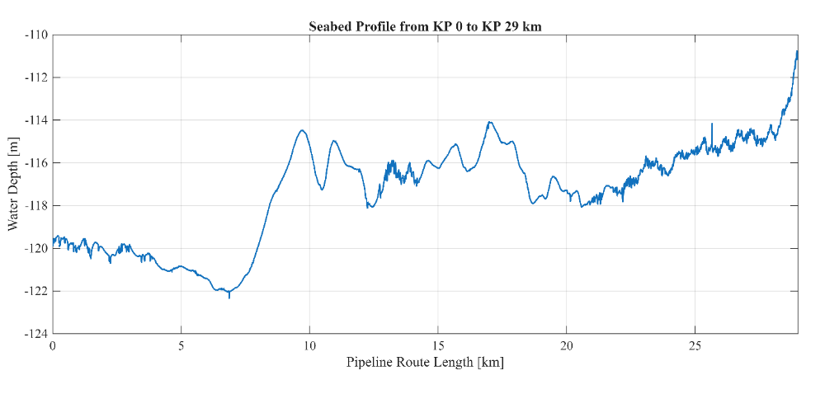
Table 1. Selected pipeline and environmental parameters used in the case study
Parameter | Value
Pipeline route length | 29 km
Nominal / outside diameter | 36 in / 914 mm
Wall thickness | 23.83 mm
Material | API 5L X60 carbon steel
SMYS / SMTS | 415 / 520 MPa
Young's modulus / Poisson ratio | 207 GPa / 0.30
External coating | 3LPE, 4.2 mm
Design pressure | 99 barg
Design temperature range | -20 to 70 C
Seawater density | 1026 kg/m3
Axial soil friction coefficient | 0.45-0.55
Current velocity at 3 m above seabed | 0.60, 0.65, 0.68 m/s (1-, 10-, 100-year)
Figure 1. Generated seabed profile from KP0 to KP 29km

The screening identified a maximum unsupported length of 30 m. Forty-three spans reached this maximum length. Because all these spans shared the same unsupported length, a representative 30 m span was selected for detailed local analysis. Figure 2 summarizes the overall analysis chain from route screening to the life-extension study, while Figure 3 shows the dense sequence of positive-clearance regions obtained from the OrcaFlex route model.

Table 2. Soil pipe interaction parameters
Soil description | Axial soil friction coefficient
Soil description | Lower bound | Upper bound
Sand | 0.45 | 0.55

Table 3. JONSWAP wave input data
Wave type | 1 year |  | 10 years |  | 100 years
Wave type | Hs (m) | Tp (s) | Hs (m) | Tp (s) | Hs (m) | Tp (s)
JONSWAP | 10.9 | 14.2 | 13.1 | 15.3 | 15.3 | 16.4

Table 4. JONSWAP current data
Reference height | Current velocity (m/s)
Reference height | 1 year | 10 years | 100 years
3m above the seabed | 0.60 | 0.65 | 0.68

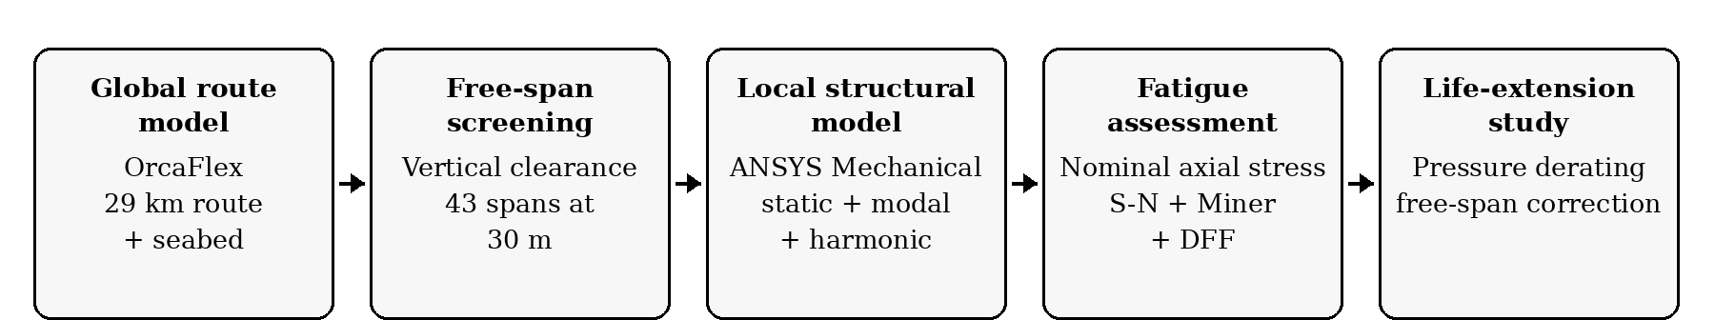
Figure 2. Assessment framework used for global screening, local structural analysis, fatigue assessment and life-extension evaluation

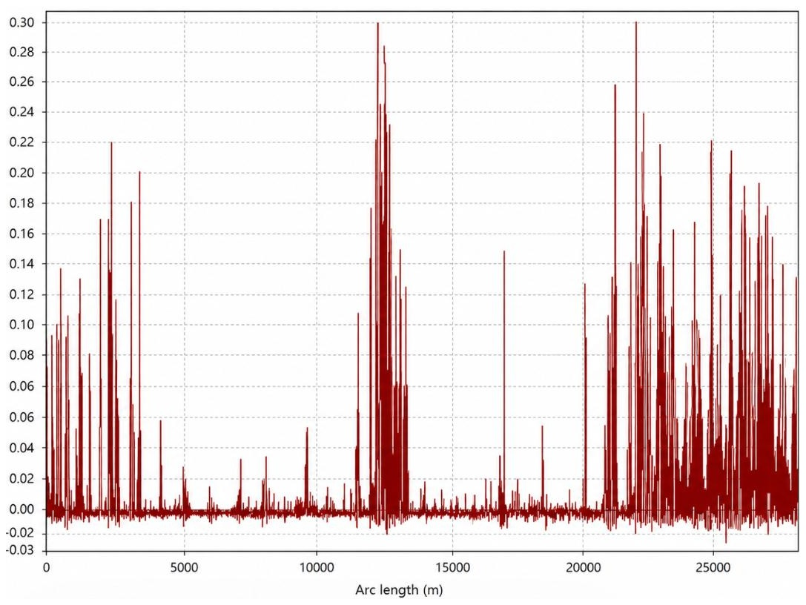
Figure 3. Vertical seabed clearance obtained along the OrcaFlex pipeline route. Continuous positive-clearance regions were screened as potential free spans.
  - Local finite element analysis in ANSYS Mechanical
The boundary conditions and applied loads were defined in ANSYS Mechanical to represent the simplified support conditions and operating load environment of the selected 30 m free span. The free span was idealized as an unsupported pipe segment extending between two seabed contact points, with the two ends of the model constrained to represent the support provided at the span shoulders.
A straight 30 m pipe segment was created in ANSYS SpaceClaim as concentric steel and coating bodies. The steel inner diameter was 0.86634 m, the outer diameter 0.914 m and the coated outer diameter 0.9224 m. Bonded contact was assumed between the pipe and coating. The longitudinal pipeline axis was aligned with the global x-axis so that the x-direction normal stress could be extracted as the nominal axial stress for the fatigue calculation.
The finite element mesh used a global element size of 0.25 m and contained 12,450 elements and 74,480 nodes. No local refinement was introduced at the span shoulders or through the wall because the assessment was based on nominal axial stress rather than a local weld-toe or notch-stress method. The same geometry, mesh and material definition were maintained for the static, modal and harmonic analyses.
The ends of the free span were idealized using remote displacement constraints. Translation in x, y and z and rotation about the pipe axis were restrained, while bending rotations about the transverse axes remained free. Applied loads included internal pressure, external hydrostatic pressure, temperature and equivalent accelerations representing the hydrodynamic force components. The design internal pressure was 9.9 MPa, the thermal condition was 50 ⁰C, seawater density was 1026 kg/m3 and the hydrostatic free-surface location was set at z = -120 m. Equivalent accelerations of 1.94 m/s² in the y-direction and -10.33 m/s2 in the z-direction were applied to represent the selected drag, inertia and lift effects.
The analysis sequence comprised: (i) static structural analysis to establish the pre-stress and deformation state; (ii) modal analysis to obtain natural frequencies and mode shapes; and (iii) harmonic response analysis at 0.46 Hz to obtain the steady-state cyclic stress response. Figure 4 shows the representative static deformation and equivalent von Mises stress distributions.
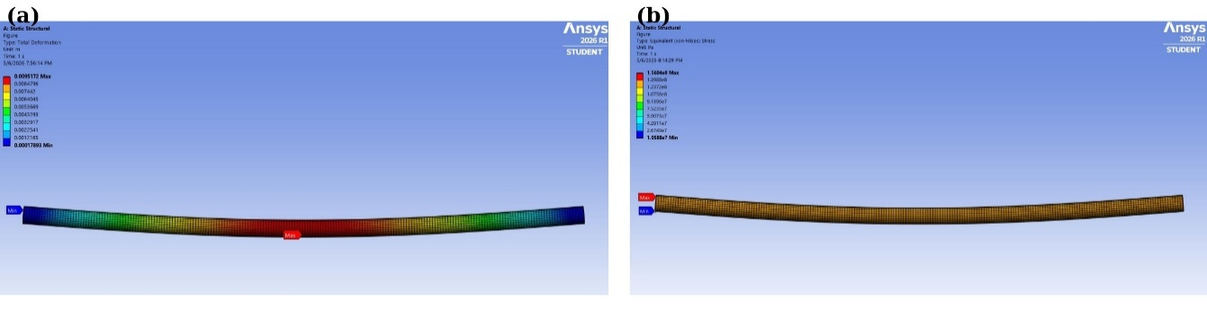
Figure 4. Static response of the representative 30 m free span: (a) total deformation and (b) equivalent von Mises stress distribution.
(a)
(b)

Figure 5 (a) shows the total deformation obtained from the harmonic response analysis. Figure 5 (b) presents the equivalent von Mises stress distribution, while Figure 5 (c) shows the axial normal stress distribution in the global x-direction. The harmonic axial normal stress alternated between +7.8023 MPa and -7.7172 MPa at the critical cross-section. The corresponding nominal axial stress range was therefore calculated as 15.5195 MPa.

Remaining fatigue-life assessment
For stress-life assessment, the nominal axial stress range from the harmonic response was used with the selected S-N curves. In this study, fatigue life in cycles was obtained from,
$\log{N}=\log{\overline{a}}-mlog ∆σ$ (2)

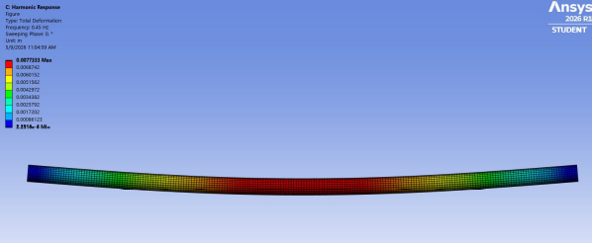
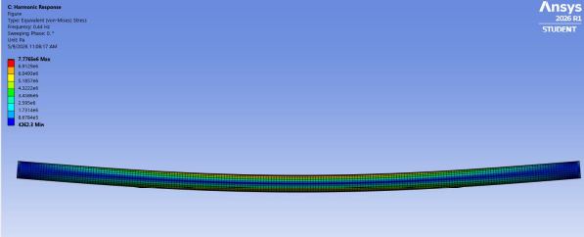
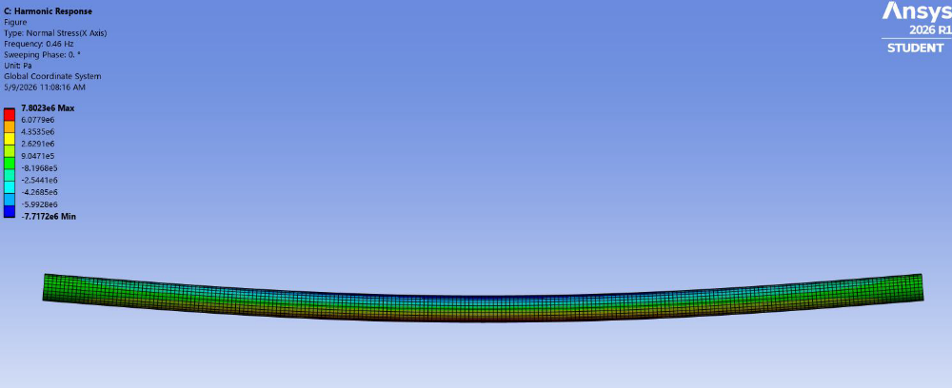
where N is cycles to failure, $\overline{a}$is the S-N intercept parameter, m is the inverse slope and $∆σ$ is the nominal stress range. The number of cycles was converted to years using selected excitation frequency, f_{s} (i.e. in this study f_{s} = 0.46 Hz). The total fatigue life in years can be calculated by converting the number of cycles to failure using the selected excitation frequency as shown below Eq (3).
Figure 5. Harmonic excitation of the representative 30 m free span at 0.46 Hz: (a) total deformation (b) equivalent von Mises stress distribution, and (c) axial normal stress distribution
(c)
(a)
(b)
$T_{fatigu life}=\frac{\overline{a}{∆σ}^{-m}}{f_{s}365×24×60×60}$ (3)
Since the extracted stress range in the above section is below the stress range corresponding to the knee point of the selected S-N curves at N = 10⁶, the second slope of the S-N curves should be used for the fatigue life assessment. Therefore, m = 5 was applied for the baseline natural gas case, and the DNV Curve F case and the modified BS7608:2015 F-curve case [11]. Table 5 lists the values for $\log{\overline{a}}$ of the relevant S-N curves. The structural stress response was intentionally kept unchanged between the baseline and hydrogen cases so that the difference in calculated life was caused only by the assumed fatigue resistance.

Table 5. S-N curve parameters used for the baseline and hydrogen fatigue cases
Assessment case | S-N curve | m | $$\log{\overline{a}}$$ | Environment
Natural gas baseline | DNV Curve D | 5.0 | 15.606 | Seawater + CP
Hydrogen comparative | DNV Curve F | 5.0 | 15.091 | Seawater + CP
Hydrogen degraded | Modified BS7608 F | 5.0 | 14.535 | Seawater + CP

Accumulated fatigue damage from previous natural gas operation was evaluated using Miner's linear damage rule [13]. With a single representative fatigue process, the fraction of capacity consumed during the previous service period can be written as $D_{used}=T_{service}/T_{life,NG}$. The remaining damage capacity, $1-D_{used}$ , was used to calculate the hydrogen case fatigue lives. A DFF of 6 was then applied to the remaining hydrogen life to obtain a conservative design-adjusted service life, consistent with the selected integrity category in the case study and the design-factor framework used for submarine pipelines [14].

Comparison of case study results and discussion

Static, modal and harmonic response
The static structural analysis produced a maximum total deformation of 9.52 mm at the centre of the unsupported span. The maximum equivalent von Mises stress was 156.04 MPa, approximately 37.6% of the 415 MPa SMYS of the X60 steel. The peak occurred near a constrained end and is influenced by the idealized support definition, but the calculated static response remained within the elastic range of the material.
The first two natural frequencies of the pre-stressed 30m model were 2.7622 and 2.7627 Hz. Similar frequency pairing was observed for higher modes because the circular pipe has nearly identical stiffness in the two transverse directions. The lower modes exhibited the expected global bending response of an unsupported span. The harmonic analysis was subsequently performed at the prescribed vortex-shedding-related frequency of f_{s} equal to 0.46 Hz as mentioned in section 3.3. The model therefore represents a simplified frequency-domain response rather than a coupled VIV lock-in simulation.
As described in Section 3.3, the harmonic analysis yielded a nominal axial stress range of 15.5195 MPa, which was rounded to 15.52 MPa for the fatigue calculations. This stress range was applied consistently to all three fatigue-resistance cases.

Comparison of natural gas and hydrogen fatigue life
Using Eqs. (1) and (2), together with the input data and methodology described in Section 3.4, the fatigue lives were calculated for all three cases as shown in Table 6. For the natural gas baseline, using DNV Curve D, the calculated fatigue life was 309.01 years. Applying the same nominal stress range of 15.52 MPa with the lower-resistance DNV Curve F reduced the calculated fatigue life to 94.40 years. The modified BS 7608 F-curve further reduced the fatigue life to 26.26 years.
Relative to the natural gas baseline, these values represent reductions in fatigue life of approximately 69.6% and 91.5%, respectively. This comparison demonstrates that S-N curve selection can have a dominant influence on the predicted fatigue life in a screening-level assessment of pipeline repurposing for hydrogen when the structural loading and applied stress range are kept unchanged.

Table 6. Fatigue-life and remaining-life results for the representative 30 m free span
Case | Fatigue life (years) | Remaining fatigue life after 30 yrs of natural gas service (years) | Remaining fatigue life after 30 yrs of natural gas service when DFF=6 used (years)
Natural gas - DNV D | 309.01 | - | -
Hydrogen - DNV F | 94.40 | 85.24 | 14.21
Hydrogen - modified BS7608 F | 26.26 | 23.71 | 3.95

For the assumed 30 years of prior natural gas operation, the baseline DNV Curve D result implies a consumed fatigue fraction of 30/309 = 0.097. Thus, approximately 9.7% of the fatigue capacity is assigned to the previous service and 90.3% remains at the time of repurposing. Applying this remaining fraction to the hydrogen cases gives 85.24 years of calculated hydrogen fatigue life for DNV Curve F and 23.71 years for the modified BS7608 F-curve before application of DFF. With DFF = 6, the corresponding design-adjusted remaining service lives are 14.21 and 3.95 years.
The difference between 14.21 and 3.95 years is important from an integrity-management standpoint. It does not arise from a change in the finite element stress response, but solely from the fatigue-resistance assumption. A repurposing decision based only on a single generic S-N curve could therefore overestimate or underestimate the available life. Hydrogen-specific material and weld data, inspection history and defect information should be used to narrow this uncertainty whenever available.

Proposed remedial measures and life-extension strategies: a parametric study
Two mitigation strategies were investigated parametrically: pressure derating and free-span correction. For pressure derating, the 30 m geometry, mesh, supports, excitation frequency and fatigue procedure were retained while internal pressure was reduced from 99 bar to 80, 60, 45 and 30 bar. The DFF adjusted remaining fatigue life of the hydrogen transport pipeline is increased progressively as shown in Figure 6 (a). At 30 bar, it reached 23.87 years using DNV Curve F and 6.64 years using the modified BS7608 F-curve, compared with 14.21 and 3.95 years at the original pressure. The increase is approximately 68% for both fatigue-resistance assumptions. Pressure derating therefore improves the fatigue margin, although it also reduces transport capacity and does not directly remove the VIV source of cyclic bending.
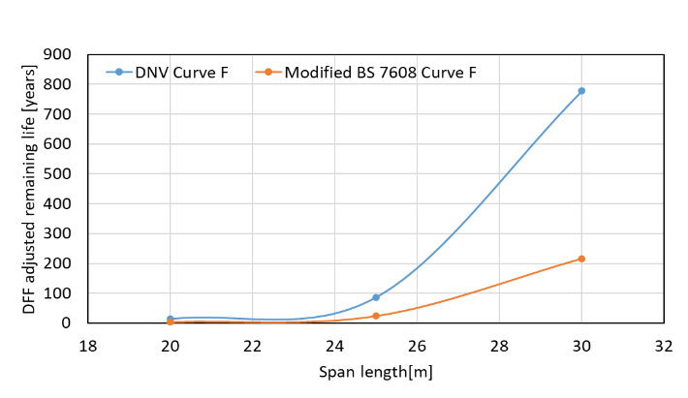
Free-span length reduction produced a much stronger effect in the present model. Reducing the unsupported length from 30 to 25 m decreased the nominal axial stress range from 15.52 to 10.81 MPa, a reduction of about 30%. The DFF-adjusted remaining life increased to approximately 87 years for DNV Curve F and 24.1 years for the modified BS7608 F-curve a shown in Figure 6 (b). A further reduction to 20 m gave a stress range of 6.97 MPa and very large, calculated lives of approximately 778 and 216 years. These values should be interpreted as a sensitivity study rather than real operational predictions, because the S-N relationship magnifies relatively small changes in stress range into large changes in fatigue life.
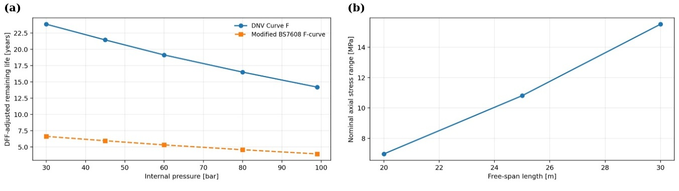
(a)
(b)

Figure 6. Parametric life-extension results: (a) influence of internal-pressure derating on DFF-adjusted remaining life of hydrogen transport case/pipelines; (b) influence of free-span length on nominal axial stress range.

From a structural-integrity perspective, the comparison indicates that span correction is more directly targeted at the governing fatigue mechanism in this case because it increases the effective stiffness of the unsupported pipe and reduces VIV-related bending. Practical span-remediation options discussed in the thesis include seabed support, rock dumping, grout bags and mechanical support. Pressure derating can complement these measures, particularly when an immediate operational reduction in fatigue demand is required, but the acceptable derated pressure must also be evaluated against hydrogen throughput requirements.

Limitations and integrity-management implications
The calculated service lives are representative case-study results and should not be transferred directly to an operating pipeline. The global route, environmental loading, material properties and seabed profile are representative inputs and the local 30 m span is an idealized straight segment. Real span shoulders can involve partial embedment, nonlinear soil stiffness, axial friction, local seabed irregularity and varying restraint. The idealized pinned-end representation therefore provides a controlled comparison rather than a complete model of pipe-soil interaction.
Hydrogen degradation is represented indirectly by reduced S-N fatigue resistance. Hydrogen diffusion, microstructural embrittlement, crack initiation and hydrogen-accelerated crack growth are not explicitly simulated. Likewise, the nominal-stress method does not model local girth-weld geometry, residual stress or pre-existing weld defects. These limitations are important because the most critical hydrogen effects may occur at precisely these local regions. A fracture-mechanics assessment based on inspection-informed initial flaw sizes and hydrogen crack-growth data would provide a stronger basis for pipeline-specific remaining-life prediction.
The hydrodynamic model is also simplified. Equivalent accelerations and a single representative harmonic frequency are used in the local finite element analysis; fully coupled fluid-structure interaction, stochastic VIV response and lock-in are outside the scope. Future work should therefore combine detailed weld modelling, fracture mechanics, improved VIV/CFD-FEA analysis and realistic operational pressure-time histories. The original thesis also identifies the need to compare emerging hydrogen pipeline standards and to incorporate inspection and monitoring data as hydrogen-specific guidance develops.
Despite these limitations, the study illustrates a useful integrity-management principle. Repurposing should be treated as a reassessment of the whole remaining life margin rather than as a simple change of transported medium. The decision process should combine material verification, weld condition, inspection history, defect data, free-span condition, fatigue reanalysis, pressure limits, DFF selection and a future inspection schedule [3,9]. Where the available margin is insufficient, structural mitigation and operating changes can be evaluated quantitatively before conversion.

Conclusions
A structural-integrity assessment was developed for a representative 29 km subsea natural gas pipeline considered for hydrogen repurposing. Global OrcaFlex screening identified 43 free spans at the maximum unsupported length of 30 m. A representative 30 m span was then assessed in ANSYS Mechanical using static, modal and harmonic response analyses. The static response remained elastic, with a maximum deformation of 9.52 mm and maximum von Mises stress of 156.04 MPa. Harmonic analysis at 0.46 Hz produced a nominal axial stress range of 15.52 MPa.
Using this stress range, the calculated fatigue life decreased from 309 years for the DNV Curve D natural gas baseline to 94 years for the DNV Curve F comparative hydrogen case and 26 years for the modified BS7608 hydrogen-degraded case. After accounting for 30 years of prior natural gas operation and applying a design fatigue factor (DFF) of 6, the design-adjusted remaining hydrogen lives were approximately 14.2 and 4.0 years, respectively. The substantial difference between the two hydrogen cases demonstrates the sensitivity of remaining-life predictions to the assumed fatigue-resistance curve.
Pressure derating from 99 to 30 bar increased the design-adjusted remaining life to approximately 23.9 and 6.6 years for the two hydrogen fatigue cases, respectively. Free-span correction was more effective in the present VIV-dominated model: reducing the span length from 30 to 25 m lowered the nominal stress range by approximately 30% and increased the design-adjusted remaining life by approximately sixfold. The results therefore indicate that hydrogen repurposing may be feasible under controlled conditions, provided that hydrogen-related fatigue degradation, accumulated damage from previous service, conservative design margins, critical free spans, and appropriate inspection and mitigation measures are incorporated into the integrity-management plan.
To further confirm the effectiveness of the proposed remedial measures and life-extension strategies, future research should consider detailed modelling of welded details using a hot-spot stress approach, fracture-mechanics-based remaining-life assessment and advanced hydrodynamic and fluid-structure interaction modelling using coupled CFD-FEA analyses.

Acknowledgements
The authors would like to express their sincere gratitude to Prof. Sudath C. Siriwardane for his valuable technical support during this study. This paper is based on the results of the first author’s master’s thesis, submitted in 2026. The authors also acknowledge the use of ChatGPT for assistance with English proofreading of portions of the master’s thesis that had already been written.
References
- International Energy Agency 2025 Global Hydrogen Review 2025 (Paris: IEA).
- NOGAT 2023 Hydrogen Transport Feasibility Executive Summary.
- DNV 2026 DNV-RP-F123: Hydrogen Pipeline Systems (Høvik: DNV).
- Nanninga N, Slifka A, Levy Y and White C 2010 A review of fatigue crack growth for pipeline steels exposed to hydrogen, J. Res. Natl. Inst. Stand. Technol. 115(6) 437, doi:10.6028/jres.115.030.
- Jia G et al. 2023 Hydrogen embrittlement in hydrogen-blended natural gas transportation systems: A review, Int. J. Hydrogen Energy 48(82) 32137–32157, doi:10.1016/j.ijhydene.2023.04.266.
- Drexler E S et al. 2019 Fatigue testing of pipeline welds and heat-affected zones in pressurized hydrogen gas, J. Res. Natl. Inst. Stand. Technol. 124 124008, doi:10.6028/jres.124.008.
- DNV 2017 DNV-RP-F105: Free Spanning Pipelines (Høvik: DNV).
- Bai Q and Bai Y 2014 Subsea Pipeline Design, Analysis, and Installation (Amsterdam: Elsevier).
- European Pipeline Research Group 2024 Hydrogen Pipelines Integrity Management and Repurposing Guideline.
- DNV 2023 DNV-RP-C203: Fatigue Design of Offshore Steel Structures (Høvik: DNV).
- British Standards Institution 2015 Guide to Fatigue Design and Assessment of Steel Products, BS 7608:2014+A1:2015 (London: BSI).
- Haldorsen L M, Sun X and Fonneland J 2024 Perspectives and investigations on re-purposing of large diameter offshore pipelines for H₂ transport, Proc. 34th Int. Ocean and Polar Engineering Conf. (Rhodes, Greece: ISOPE) pp 1390–1382.
- Miner M A 1945 Cumulative damage in fatigue, J. Appl. Mech.
- DNV 2021 DNV-ST-F101: Submarine Pipeline Systems (Høvik: DNV)

