Techno-economical analysis of a solar-assisted multi-zone residential heat pump with storage under fixed price tariffs
A Karimi^{1, *}, A Safari² and M Mansouri^{1, 3}
¹ Department of Energy and Petroleum Engineering, University of Stavanger, Stavanger, Norway
² Department of Science and Industry Systems, University of South-Eastern Norway, Kongsberg, Norway
³ NORCE Research, Stavanger, Norway

* ali.karimi@uis.no
Abstract. Residential space heating and domestic hot water are key targets for decarbonization in cold climates. This paper presents an hourly digital twin of a solar-assisted heat pump system (SHPS) for a multi-zone Norwegian residence. The system integrates an R32 heat pump, a 10 kWp photovoltaic (PV) array, a 10 kWh battery energy storage system (BESS), a 262 L thermal buffer tank and a 203 L domestic hot water (DHW) tank. A thermodynamic R32 cycle model with a compressor efficiency correlation fitted to manufacturer data represents the heat pump. A six-zone three-resistance, two-capacitance thermal network calibrated to the Norwegian TEK87 standard represents the building. With a rule-based energy management strategy, the system delivers 24,307 kWh of heat at a seasonal performance factor of 3.79. Compared with direct electric heating, the SHPS reduces 25-year lifecycle emissions by 82.1% and saves 9,523 NOK per year. Under the fixed Norgespris electricity price, high capital costs give a payback period of 47.6 years and a negative net present value at a 6% discount rate. Under hourly 2024 spot prices, the payback period falls to 21.4 years, but the net present value remains negative. The results highlight the importance of public incentives and carbon pricing.
- Introduction
Space heating and domestic hot water (DHW) account for most residential energy demand in cold climates. Electrifying this demand with heat pumps is a key decarbonization lever for the building sector [1]. Norwegian electricity generation is largely decarbonized through hydropower. However, interconnectors couple the Norwegian grid to the European electricity market [22,23]. Additional winter demand may therefore be met partly by imported or fossil-based marginal generation. Heat pumps also add load at the winter peak, when distribution grids are most constrained. Combining heat pumps with on-site renewable generation and storage may help manage that load [2]. In Nordic climates, however, PV output is lowest when heating demand peaks [27].
Solar-assisted heat pump (SAHP) systems couple a heat pump with photovoltaic (PV) or photovoltaic-thermal (PVT) generation. Many designs add battery energy storage (BESS). PV or PVT generation offsets part of the heat pump's electricity demand. Batteries shift that offset into the evening and morning heating peaks. Thermal storage decouples heat delivery from instantaneous heat-pump operation [3,4]. Studies of PVT-SAHP systems report improved self-consumption and seasonal performance relative to unassisted air-source heat pumps. Most techno-economic evaluations of these systems target southern European or district-scale public housing, with a favourable solar resource and a gas-boiler baseline [5,6]. Evidence for a single-family, multi-zone building in a Nordic maritime climate remains limited. This gap matters because Norway now offers households an optional fixed, government-set electricity price and has a low-carbon average grid mix.
Two modelling choices affect the credibility of a residential heat-pump digital twin. First, low-order lumped-parameter building models trade some accuracy for the speed needed in year-long, hourly control-loop simulation. Validated second order and self-adjusting RC-network models reproduce multi-zone thermal behaviour accurately at low computational cost [7,8]. Second, air-source heat-pump performance falls in cold climates as evaporating pressure drops and compression ratio rises. Air-source heat pumps, including R32 units, are particularly sensitive to frosting near 0 °C and at high humidity, where compressor and evaporator loading are already severe [12,13]. A digital twin that represents this only through a temperature-only coefficient of performance (COP) curve risks over-predicting cold-climate performance. Resolving the underlying thermodynamic cycle avoids this risk.
This paper presents an hourly digital twin of a solar-assisted heat pump system (SHPS) for a multi-zone Norwegian residence. It adds a techno-economic and lifecycle-emissions assessment against a direct electric heating (DEH) baseline. The paper makes four contributions. First, it builds a first-principles R32 vapour-compression cycle model in TESPy. A compressor isentropic-efficiency correlation, fitted to manufacturer data, captures the COP penalty of low-ambient, high-pressure-ratio operation, without an empirical COP curve. Second, it calibrates a six-zone, second-order thermal network to the Norwegian TEK87 building-code vintage. TEK87 is representative of a large share of the existing Norwegian housing stock [9,10,11]. Third, it couples the heat pump, a 262 L thermal buffer tank, a 203 L DHW tank, a 10 kWp PV array and a 10 kWh BESS through a hysteresis-based rule-based energy management strategy (EMS). This EMS follows established approaches for maximizing PV self-consumption around a heat-pump load [14,15]. Fourth, it computes the levelized cost of heat (LCOH), net present value (NPV), payback period and 25-year lifecycle CO₂eq emissions under the fixed Norgespris electricity price and the hourly average Norwegian grid mix. This assessment follows established LCOH and life-cycle-assessment methods [16,17,18,19]. The results indicate that the SHPS performs well technically and recovers its embodied carbon almost immediately relative to DEH. However, it remains financially unattractive under current Norwegian capital costs and the Norgespris tariff. This tension suggests a need for targeted policy support.
- Methodology

System overview and simulation approach
The SHPS is modelled as a single multi-zone Norwegian residence in Stavanger, Norway. Hourly ambient temperature ranges from –9.1 °C to 26.1 °C over the simulated year, with a mean of 9.0 °C. The simulation runs at hourly resolution over one full year (8760 h), using 2024 Open-Meteo reanalysis weather data for the site. Figure 1 shows the simulation workflow.
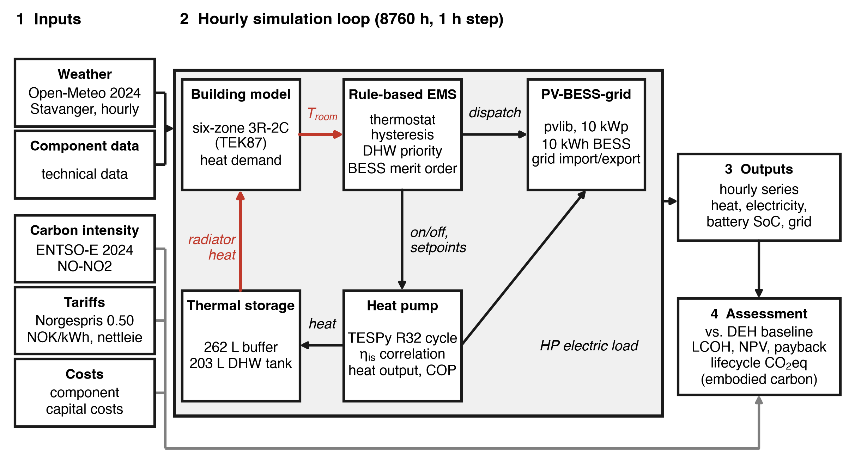
Figure 1. The methodology couples weather, carbon intensity, tariff and component inputs to an hourly simulation of the building, controller, heat pump, storage and PV-battery models. The hourly results feed the techno-economic and carbon assessment against the DEH baseline.
The building has a gross floor area of 130 m². Five zones are heated, living room/kitchen (45 m²), master bedroom (18 m²), two further bedrooms (15 m² and 12 m²), and a bathroom/utility room (15 m², held at a constant 22 °C). A 25 m² unheated buffer zone (garage/crawl space) completes the envelope. A shared, buffer-tank-fed hydronic radiator loop serves all heated zones.
The supply system comprises an R32 air-to-water heat pump (NORD MB 9.0 F, 9.0 kW rated capacity), a 262 L thermal buffer tank (NORD EcoHeat Storage 15/250), a 203 L domestic hot water tank (NORD EcoFresh Tank 220), a 10 kWp roof-mounted PV array (35° tilt, 180° azimuth, EcoMaster 3P 10.0 hybrid inverter), and a 10 kWh lithium-ion BESS. The BESS operates between 10% and 90% state of charge (SoC), giving 8 kWh of usable capacity, to preserve cycle life. The heat pump uses a twin-rotary DC-inverter compressor with economizer injection. The unit modulates between 4 and 12.5 kW and has a rated electrical input of 4 kW. Its rated water flow is 1.5 m³/h, and its maximum water temperature is 55 °C. R32 is a synthetic hydrofluorocarbon refrigerant. Its global warming potential (GWP) is 675 on the AR4 basis [28]. This is lower than that of R410A, which it replaces in many residential units. However, its GWP remains far higher than that of natural refrigerants such as R290, R744 and R717. A life-cycle assessment for 18 European countries found lower climate-change impacts for R290 than for R32 [26]. The refrigerant follows from the selected commercial unit and is not an environmental design choice of this study.

Building thermal model
Each of the six zones i is represented by a second-order, three-resistance, two-capacitance (3R-2C) network. Two temperature states describe each zone: an air node T_{air,i} (the thermostat reference) and a structural mass node T_{str,i}. A fast window/infiltration path (UA_{win,i}) and a slower envelope-conduction path (UA_{wall,i}, UA_{surf,i}) couple each zone to ambient. Explicit air-to-air and structure-to-structure terms couple each zone to its neighbours j. The governing energy balances follow.
$C_{\text{air,i}}\frac{dT_{\text{air,i}}}{dt} = {UA}_{\text{surf,i}}\left(T_{\text{str,i}} - T_{\text{air,i}}\right) + {UA}_{\text{win,i}}\left(T_{\text{amb}} - T_{\text{air,i}}\right)$
$+ \sum_{\text{j}}{{UA}_{\text{air,ij}}\left(T_{\text{air,j}} - T_{\text{air,i}}\right)} + f_{\text{i}}Q_{\text{rad}} + Q_{\text{int,i}}$ (1)
$C_{\text{str,i}}\frac{dT_{\text{str,i}}}{dt} = {UA}_{\text{wall,i}}\left(T_{\text{amb}} - T_{\text{str,i}}\right) - {UA}_{\text{surf,i}}\left(T_{\text{str,i}} - T_{\text{air,i}}\right)$
$+ \sum_{\text{j}}{{UA}_{\text{str,ij}}\left(T_{\text{str,j}} - T_{\text{str,i}}\right)} + A_{\text{sol,i}}G$ (2)
C_{air,i} and C_{str,i} are the air and structural thermal capacitances. UA_{air,ij} and UA_{str,ij} are the inter-zone air and structural conductances, and T_{amb} is the ambient temperature. Q_{rad} is the total radiator output and f_{i} is the fraction delivered to zone i. Q_{int,i} is the internal heat gain, A_{sol,i} is the effective solar aperture and G is the global horizontal irradiance. Two relations fix the thermal capacitances from the floor area A_{i} of each zone.
The conductance split derives from the target steady-state envelope conductance UA_{eff,i} of each zone.
UA_{eff,i} is 0.110, 0.050, 0.042, 0.033 and 0.030 kW/K for the living room, master bedroom, bedroom 2, bedroom 3 and bathroom respectively. This calibration reproduces a TEK87-consistent total heated-zone conductance of approximately 289 W/K. Radiators are sized at 75 W/m² for the living-room and bedroom zones and 130 W/m² for the bathroom, which sets f_{i} in equation (1). Each zone follows a seasonal, occupancy-dependent setpoint schedule under EN 15251 Category II comfort criteria. The simulated living-room temperature averages 19.8 °C over the year. An implicit (backward) Euler scheme integrates the resulting 12-state linear system at a one-hour timestep. This scheme is unconditionally stable, despite the short (approximately 0.2 to 0.3 h) time constant of the air node.

Heat pump model
The heat pump is represented as a full R32 vapour-compression cycle, not as an empirical, temperature-only COP curve. The cycle model is built and solved in TESPy. It comprises an evaporator, a compressor, a condenser and an expansion valve on the refrigerant side, coupled to a pump, condenser and load loop on the water side. Fixed approach temperatures set the refrigerant-side saturation temperatures from the ambient and required supply temperature.
$T_{\text{evap,sat}} = T_{\text{amb}} - ΔT , T_{\text{cond,sat}} = T_{\text{supply}} + ΔT'$ (3)
T_{evap,sat} and T_{cond,sat} are the evaporator and condenser saturation temperatures, and T_{supply} is the supply water temperature. The approach temperatures ΔT and ΔT' are fixed values.
These values represent nominal-load operation of the finned-tube air-side evaporator and the water-side condenser. Fixed approaches neglect the smaller temperature differences at part load and the larger differences under frosting and at low ambient temperature. The model may therefore underestimate COP at part load and overestimate it during frosting. A linear fit to NORD EcoHeat manufacturer performance data then correlates compressor isentropic efficiency η_{is} to the instantaneous pressure ratio PR.
$PR = \frac{p_{\text{cond,sat}}}{p_{\text{evap,sat}}} , η_{\text{is}} = clip\left(0.88 - 0.032·PR, 0.55, 0.80\right)$ (4)
Here, p_{cond,sat} and p_{evap,sat} are the condenser and evaporator saturation pressures. COP therefore degrades as ambient temperature falls and pressure ratio rises, without an ad-hoc penalty factor. A three-way valve routes the water side to the buffer tank for space heating, or to the DHW coil for domestic hot water. The buffer path targets a design temperature rise of approximately 5.2 K at the rated water flow. The DHW path holds a fixed 55 °C supply, the maximum water temperature of the unit, and overrides space heating whenever DHW charging is required. The water-side energy balance gives the heat-pump thermal output. COP follows from the electrical input.
$Q_{\text{hp}} = ṁ_{\text{w}}c_{\text{p}}\left(T_{\text{supply}} - T_{\text{return}}\right) , COP = \frac{Q_{\text{hp}}}{P_{\text{elec}}}$ (5)
Q_{hp} is the heat-pump thermal output and P_{elec} is the heat-pump electrical input. ṁ_{w} is the water mass flow rate, c_{p} is the specific heat capacity of water and T_{return} is the return water temperature. The design water flow rate is fixed.
At the design point (7 °C ambient, 40 °C supply, 34.8 °C return), the model solves to a rated capacity of 9.0 kW and a COP of 4.10. This result matches the manufacturer's nominal rating for this operating point. Figure 3 marks a design-point reference COP of 4.05 for comparison. At a colder validation point (–15 °C ambient, 55 °C supply), the same cycle solves to a COP near 1.9. This drop reflects the combined effect of a larger temperature lift and a falling isentropic efficiency at high pressure ratio. This mechanism captures the temperature-lift effect only. The model does not include frosting or the defrost cycles of the commercial unit, and no humidity correction is applied. Ambient temperature lies between –5 °C and 5 °C in 2,021 h of the simulated year. Frost formation is most likely in this range, and frosting and defrost cycles reduce capacity and raise electricity demand in cold climates [24,25]. These hours account for 49% of the annual heat-pump electricity use. The reported COP values may therefore be optimistic for these hours. Over the full year, the ratio of heat-pump thermal output from equation (5) to electricity input gives a seasonal COP of 3.89. The ratio of delivered useful heat to electricity input gives a seasonal performance factor (SPF) of 3.79. The SPF is lower because it includes buffer and DHW tank standing losses. The arithmetic mean of the instantaneous COP across all heat-pump-on hours (Figure 3) is 3.96. The cycle solution fixes the water-side mass flow and the supply and return temperatures. The water side therefore sets the heat duty, and the refrigerant mass flow follows from the condenser energy balance. The model uses no compressor displacement, volumetric efficiency or speed map. In heating mode, the supply temperature equals the buffer temperature plus 5.2 K, with a 30 °C minimum, so the unit delivers its rated 9.0 kW unless the supply setpoint limits the rise. Below the 4 kW minimum modulation, the unit runs at 4 kW for the corresponding fraction of the hour. Output is capped at the 12.5 kW maximum modulation, which binds only in four start-up hours after summer standstill. Capacity is not derated with ambient temperature. Output reaches 9.0 kW in 90% of heat-pump-on hours below –5 °C and in 57% of hours between 0 and 5 °C. The living room temperature falls more than 1 K below its setpoint in 304 of the 553 hours below 0 °C.

Thermal storage
The buffer and DHW tanks are each modelled as a single, well-mixed thermal mass. Each balance combines a heat input, a load-side draw and a standing loss.
$M_{\text{buf}}c_{\text{p}}\frac{dT_{\text{buf}}}{dt} = ṁ_{\text{hp}}c_{\text{p}}\left(T_{\text{hp,out}} - T_{\text{buf}}\right) - {UA}_{\text{rad}}\left(T_{\text{buf}} - T_{\text{room}}\right)$
$- {UA}_{\text{loss,buf}}\left(T_{\text{buf}} - T_{\text{amb}}\right)$ (6)
$M_{\text{dhw}}c_{\text{p}}\frac{dT_{\text{dhw}}}{dt} = {UA}_{\text{coil}}\left(T_{\text{hp,sup}} - T_{\text{dhw}}\right) - ṁ_{\text{draw}}c_{\text{p}}\left(T_{\text{dhw}} - T_{\text{cold}}\right)$
$- {UA}_{\text{loss,dhw}}\left(T_{\text{dhw}} - T_{\text{env}}\right)$ (7)
M_{buf} and M_{dhw} are the tank water masses, and T_{buf} and T_{dhw} are the tank temperatures. ṁ_{hp} and T_{hp,out} (T_{hp,sup}) are the heat-pump water flow rate and supply temperature, and T_{room} is the room temperature. UA_{rad}, UA_{coil} and UA_{loss} are the radiator, DHW-coil and standing-loss conductances. ṁ_{draw} is the DHW draw mass flow rate, T_{cold} is the cold-water inlet temperature and T_{env} is the temperature around the tank. The buffer tank holds 262 kg of water. Its standing-loss and radiator conductance follow from the manufacturer's rated loss and the heat pump's design point.
The DHW tank holds 203 kg of water. The heat pump recharges it whenever its temperature falls below 50 °C. Its coil and standing-loss conductance are fixed values.

PV-BESS subsystem and grid interface
The 10 kWp array is modelled in pvlib. Solar position and the Erbs decomposition give plane-of-array irradiance under an isotropic sky model. The Faiman model gives cell temperature. PVWatts gives DC power, capped by the inverter.
$T_{\text{cell}} = T_{\text{amb}} + \frac{G_{\text{POA}}}{U_{\text{0}} + U_{\text{1}}v_{\text{wind}}}$ (8)
$P_{\text{dc}} = \frac{G_{\text{POA}}}{1000}P_{\text{dc0}}\left(1 + γ\left(T_{\text{cell}} - 25\right)\right) , P_{\text{ac}} = min\left(η_{\text{inv}}P_{\text{dc}}, P_{\text{ac,nom}}\right)$ (9)
T_{cell} is the PV cell temperature, G_{POA} is the plane-of-array irradiance and v_{wind} is the wind speed. U₀ and U₁ are the Faiman heat-loss coefficients, γ is the power temperature coefficient and η_{inv} is the inverter efficiency. P_{dc0} is the rated DC power and P_{ac,nom} is the inverter AC rating. The Faiman and module coefficients are fixed values.
The 10 kWh BESS follows a merit-order dispatch. It charges from PV surplus and discharges to cover unmet heat-pump demand, subject to its state-of-charge bounds.
$SoC\left(t+1\right) = SoC\left(t\right) + \frac{\left(η_{\text{ch}}P_{\text{ch}} - P_{\text{dis}}/η_{\text{dis}}\right)·Δt}{E_{\text{nom}}} ,$
$SoC ∈ [0.10, 0.90]$ (10)
P_{ch} and P_{dis} are the battery charge and discharge power, and η_{ch} and η_{dis} are the corresponding efficiencies. Δt is the timestep and E_{nom} is the nominal battery capacity. The battery efficiency and capacity are fixed values.
Any PV surplus remaining once the battery reaches its 90% SoC ceiling is exported to the grid. Any heat-pump demand remaining once the battery reaches its 10% SoC floor is imported from the grid. The electricity commodity price is held at the Norgespris rate of 0.50 NOK/kWh, including VAT, throughout the simulated year. Norgespris is an optional fixed household price offered by the Norwegian government from 1 October 2025. This study applies it to the 2024 weather and grid carbon-intensity year. Only the hourly grid carbon intensity is allowed to vary. This intensity ranges from 20.7 to 115.9 gCO₂/kWh over the year, with a mean of 33.0 gCO₂/kWh, taken from ENTSO-E lifecycle data for the NO-NO2 bidding zone.

Rule-based energy management strategy
Thermal dispatch follows a three-rule hysteresis controller. A space-heating thermostat acts on living-room temperature with a ±0.5 K dead-band. A buffer-tank thermostat applies a 5 K differential, which gates whether the heat pump may charge the buffer even when space heating is called for. DHW charging takes absolute priority over space heating whenever the DHW tank needs recharging. Electrical dispatch follows the BESS merit-order rule of equation (10). PV surplus charges the battery before any export. Heat-pump demand not covered by concurrent PV is met from the battery before any grid import. This logic follows rule-based control approaches shown in the literature to raise PV self-consumption around a heat-pump load, without forecast-dependent optimization [14,15].

Techno-economic and environmental assessment
The SHPS is compared against a DEH counterfactual. The DEH system delivers the identical annual thermal energy Q_{total} through resistive heating at an assumed conversion efficiency (COP) of 0.95. Capital expenditure (CAPEX), including VAT, is 510,000 NOK for the SHPS and 56,250 NOK for the DEH baseline, an additional investment ΔCAPEX of 453,750 NOK for the SHPS. The SHPS CAPEX comprises the heat pump (135,000 NOK), the PV array (118,000 NOK), the battery (58,000 NOK), tanks and hydraulics (42,000 NOK), the inverter and balance of system (37,000 NOK), and commissioning (18,000 NOK). The DEH CAPEX comprises the boiler and controls (28,000 NOK), hydraulic integration (12,000 NOK), and commissioning (5,000 NOK).
Annual operating expenditure (OPEX) combines the fixed electricity commodity price with the Norwegian network tariff, known as nettleie, and annual operation and maintenance (O&M). The nettleie tariff has three parts: a fixed monthly capacity charge, a time-of-day energy charge, and state levies.
O&M is set at 2% of CAPEX per year for the SHPS and 1.5% of CAPEX per year for the DEH baseline. The levelized cost of heat follows a standard capital-recovery formulation.
$LCOH = \frac{CAPEX·CRF + OPEX}{Q_{\text{total}}} , CRF = \frac{r·{\left(1+r\right)}^{\text{n}}}{{\left(1+r\right)}^{\text{n}} - 1}$ (11)
Here, CRF is the capital recovery factor, r is the discount rate and n is the system lifetime in years. These values are fixed assumptions.
Net present value over the same horizon sums the discounted annual saving against the additional upfront cost.
$NPV = -ΔCAPEX + \sum_{y=1}^{n}{\frac{ΔOPEX}{{\left(1+r\right)}^{\text{y}}}}$ (12)
ΔOPEX is the DEH-minus-SHPS annual operating-cost saving, and y is the year index. Simple payback period is ΔCAPEX divided by ΔOPEX. Lifecycle greenhouse-gas emissions apply the hourly NO-NO2 grid carbon intensity to each configuration's hourly grid electricity draw, integrated over the 25-year horizon. An embodied-carbon allowance is added for each system.
This allowance follows life-cycle-assessment practice for domestic heat pumps and comparable electrified-heating pathways [18,19]. The carbon payback period is the additional SHPS embodied carbon divided by the annual avoided grid emissions, DEH minus SHPS.
Two sensitivity analyses address the fixed tariff and the battery size. The spot-price scenario replaces the commodity price with hourly 2024 NO2 spot prices [29]. Imports pay the spot price plus 25% VAT, and exports earn the spot price excluding VAT. The network tariff and levies stay unchanged. The EMS does not respond to price, so the hourly dispatch is identical in both tariff cases. The battery sensitivity repeats the dispatch of equation (10) for capacities from 0 to 30 kWh. It uses the PV and heat-pump electricity series of the base case and the same 5 kW power limit. Flat emission factors of 100, 300 and 500 gCO₂/kWh illustrate the effect of a higher marginal carbon intensity.
Table 1. Key SHPS component specifications used in the digital twin.
Component | Model / specification | Role | Notes
Heat pump | NORD MB 9.0 F, R32 | Space heating + DHW | 9.0 kW / COP 4.10 at A7/W40
PV array | 10 kWp, 35° tilt, 180° az. | On-site generation | 10,910 kWh/yr simulated
Inverter | EcoMaster 3P 10.0 | DC/AC conversion | 10 kW AC, 98% efficiency
Battery (BESS) | 10 kWh Li-ion, 10–90% SoC | Load shifting | 8 kWh usable, ~90% round-trip efficiency
Thermal buffer tank | EcoHeat Storage 15/250, 262 L | Space-heating buffer | 61 W standing loss
DHW tank | EcoFresh Tank 220, 203 L | Domestic hot water | 50 °C recharge threshold, 52 W loss
Building envelope | 6-zone 3R-2C, TEK87 | Thermal demand | 130 m² gross, UA≈289 W/K
Site / weather | Stavanger, Norway (2024) | Digital twin input | 58.9455°N, 5.6502°E

- Results and Discussion

Thermal and electrical performance
Over the simulated year, the SHPS delivers 24,307.3 kWh of useful thermal energy. Space heating accounts for 20,297.0 kWh and DHW for 4,010.3 kWh. The DHW demand corresponds to an average hot-water draw of about 194 L/day. Total heat-pump electricity consumption is 6,417.6 kWh, giving an SPF of 3.79 (Section 2.3). The heat pump runs for 3,392 h over the year, or 38.7% of all hours. Figure 2 shows radiator heat delivery, which is non-zero in 3,774 h. The difference arises because the buffer tank continues to supply the radiators after the heat pump switches off. Hourly on/off cycling is also not visible at the annual scale of Figure 2, so the electricity trace appears continuous. Radiator heat demand and heat-pump electrical draw both concentrate in the October to April heating season. They peak at 11.1 kW thermal and 3.8 kW electrical respectively (Figure 2). From June to August, heat-pump electricity covers DHW reheating almost exclusively. Space heating in May and September accounts for 89 h and 143 kWh of heat-pump electricity.
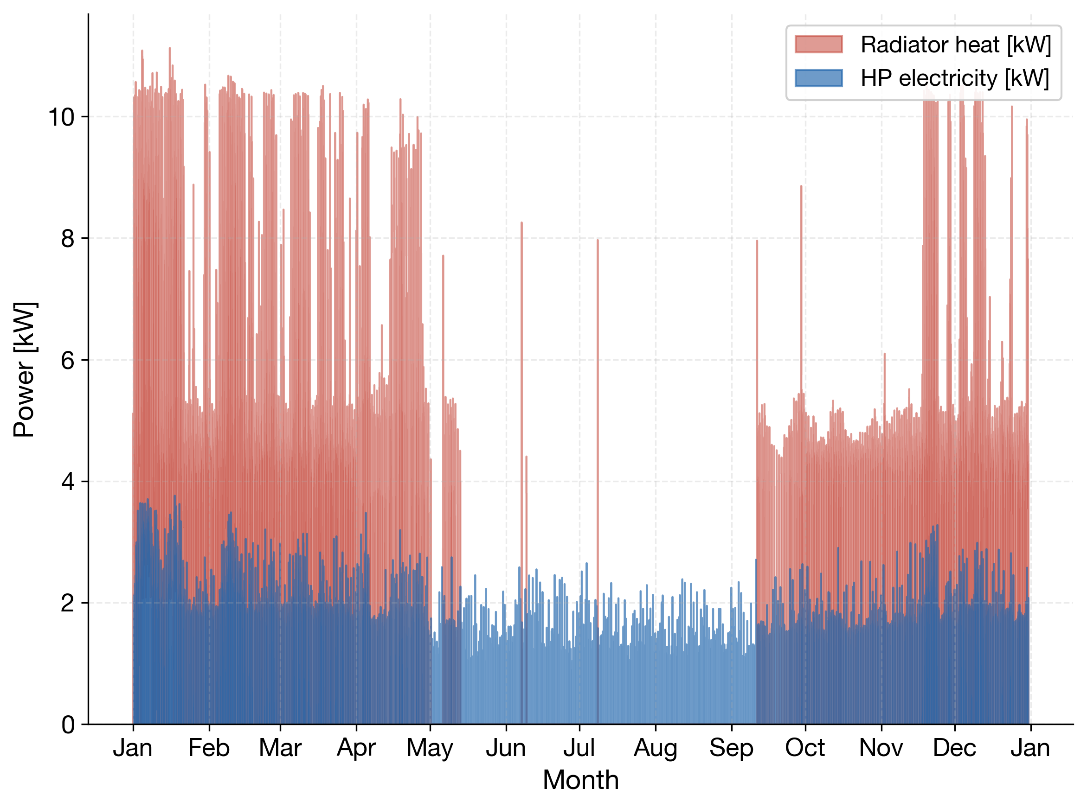
Figure 2. Annual radiator heat delivery and heat-pump electricity draw.
The instantaneous COP (Figure 3) tracks ambient temperature and pressure ratio closely, per equations (3) to (5). It falls to about 2.0 during the coldest hours, when ambient temperature reaches its annual minimum of –9.1 °C. This value is consistent with the standalone TESPy validation, which solves to a COP near 1.9 at –15 °C ambient and 55 °C supply. COP rises above 5.5 during the shoulder seasons, when ambient temperatures are mild and the compression ratio is low. The gap between the instantaneous mean (3.96) and the design-point reference (4.05) reflects low-ambient, high-pressure-ratio operation and off-design supply temperature.
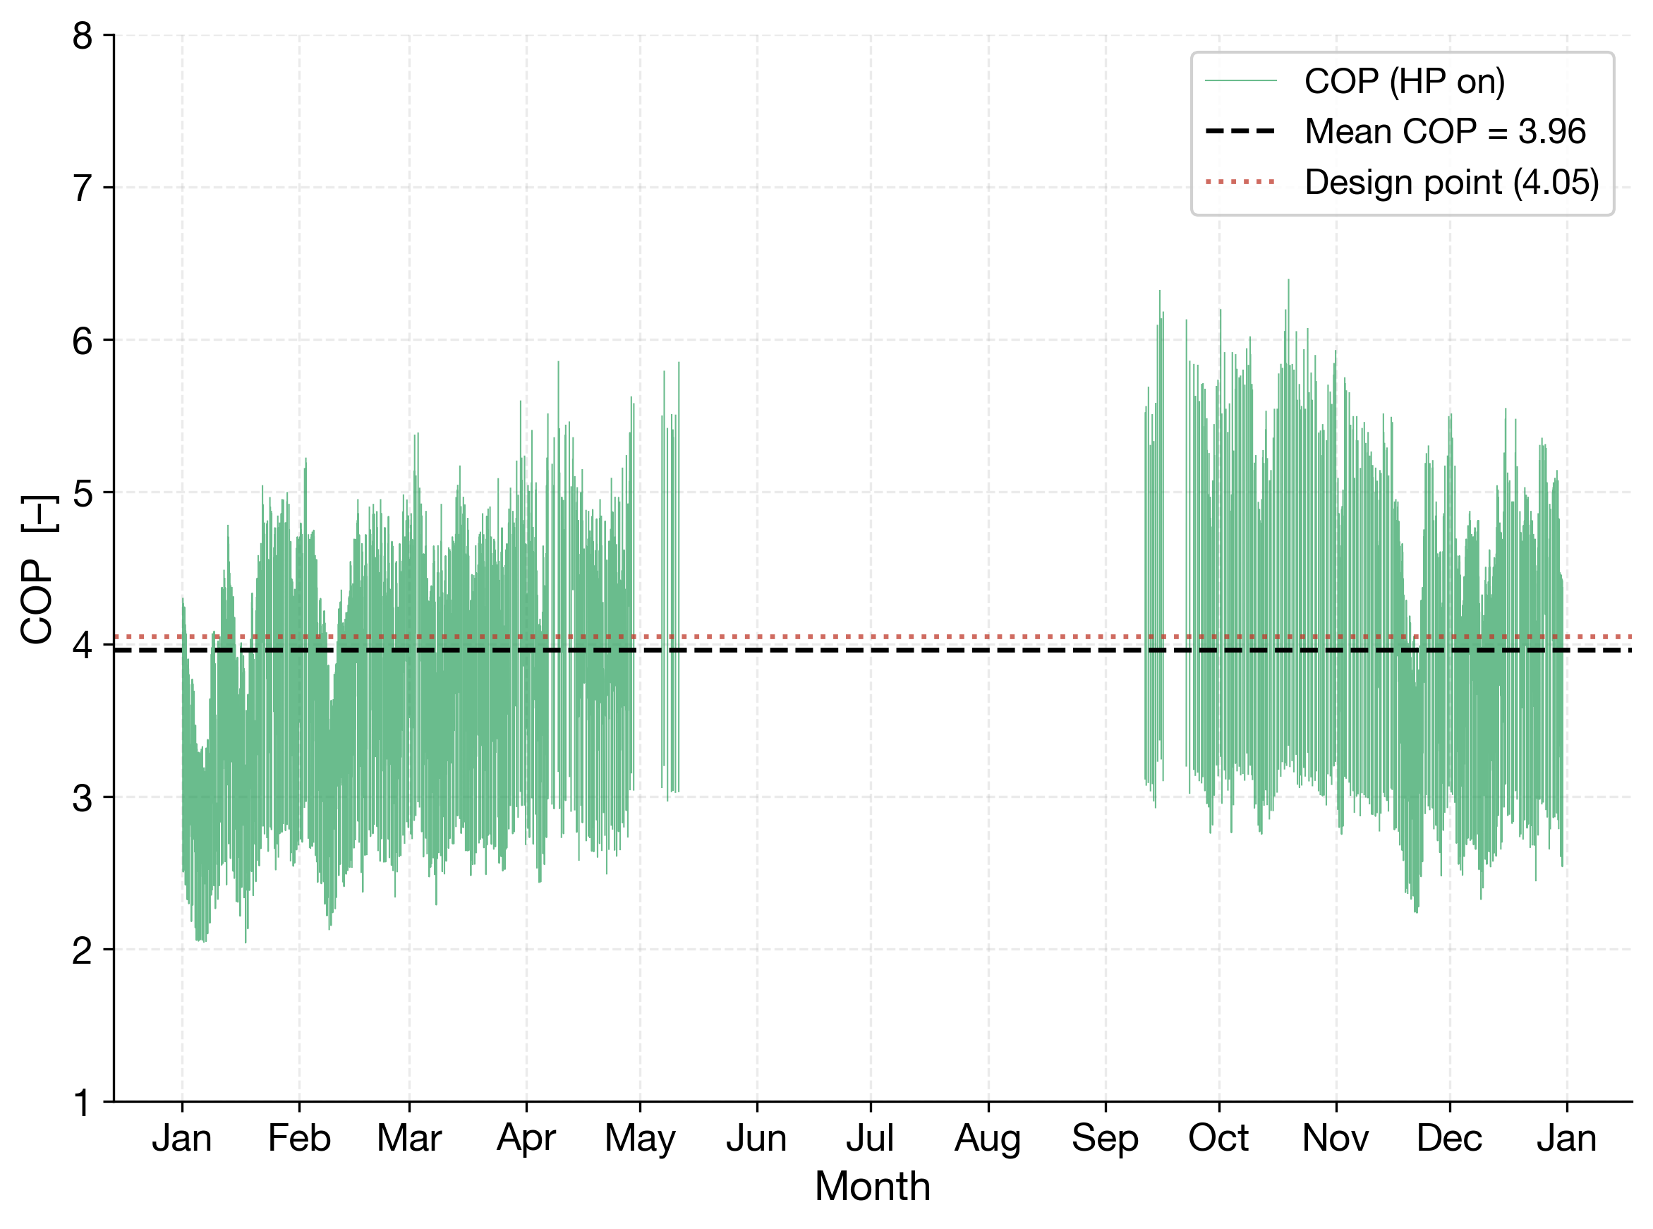
Figure 3. Annual instantaneous COP during heat-pump operation, with the mean over heat-pump-on hours and the design-point reference.

PV-BESS-grid interaction
The 10 kWp PV array generates 10,910.2 kWh over the year, per equation (9). Output concentrates in April to September and is negligible in the December to January heating peak (Figure 4). On-site generation, from the BESS and direct PV use together, covers 42.3% of total annual heat-pump electricity demand. The remaining 3,704.7 kWh is imported from the grid. As a share of PV generation itself, 24.9% of PV output is self-used to meet heat-pump demand, or 2,712.9 kWh of the 10,910.2 kWh generated. The remainder is exported.
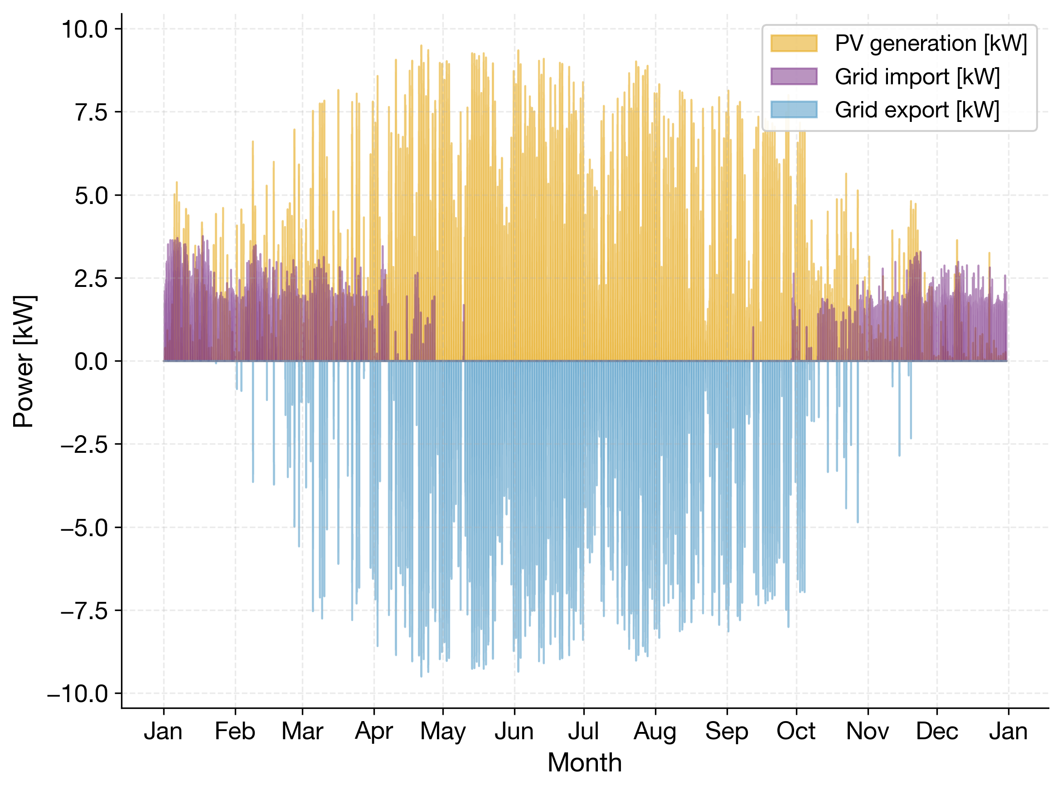
Figure 4. Annual PV generation, grid import and grid export.
The BESS's role is strongly seasonal. In a representative winter week (Figure 5, left), state of charge (equation (10)) stays near its 10% floor for most of the week. Winter PV surplus is rarely sufficient to charge the battery meaningfully, so the heat pump depends on grid import for most of its demand. In a representative summer week (Figure 5, right), the battery cycles between roughly 70% and 90% SoC. It covers the smaller summer heat-pump and DHW load without any grid import. This seasonal asymmetry suggests that winter battery use is limited by the low PV surplus rather than by battery capacity. Under the adopted EMS, the battery charges only from PV surplus. A capacity sensitivity analysis supports this interpretation (Table 2). Raising capacity from 10 to 30 kWh reduces December to February grid import by only 66 kWh, or 2.6%. The battery stays at its SoC floor in 80 to 86% of winter hours for every capacity from 5 to 30 kWh. In summer, grid import is already zero at 5 kWh, and the battery is full in about 57% of summer hours at every capacity. Most of the additional annual benefit of a larger battery therefore occurs outside December to February. A larger battery cannot compensate for the winter PV deficit. A similar sizing question has been reported for combined solar-thermal and PV-battery district heating systems, where the relative sizing of thermal versus electrical storage depends strongly on climate and electricity-price context [4].
Table 2. Sensitivity of grid import and PV use to battery capacity with the rule-based EMS.
Capacity (kWh) | Annual import (kWh) | Dec–Feb import (kWh) | PV used for HP (%) | HP demand covered (%)
0 | 4,886 | 2,756 | 14.0 | 23.9
5 | 4,065 | 2,609 | 21.6 | 36.7
10 | 3,705 | 2,537 | 24.9 | 42.3
15 | 3,539 | 2,504 | 26.4 | 44.9
20 | 3,450 | 2,484 | 27.2 | 46.2
30 | 3,340 | 2,471 | 28.2 | 48.0

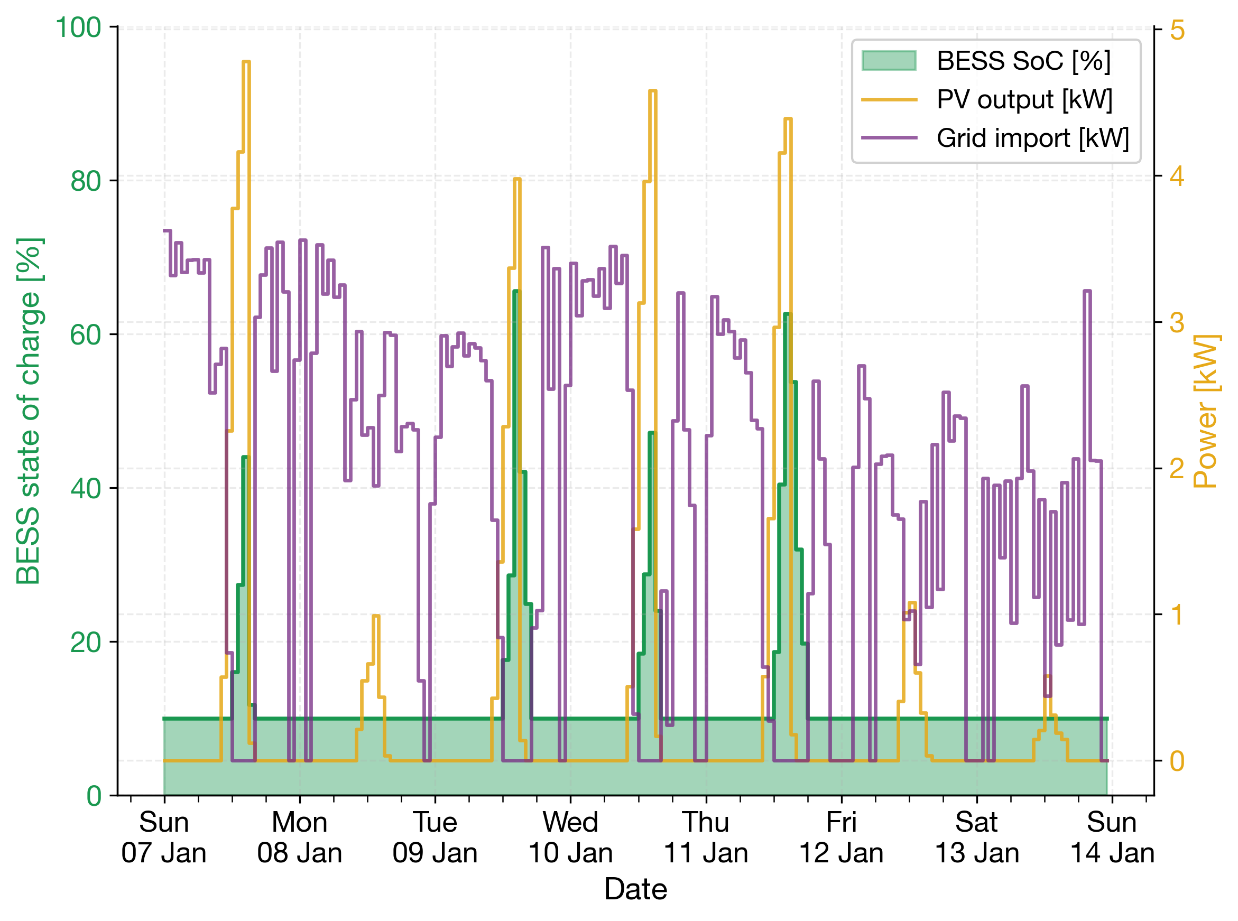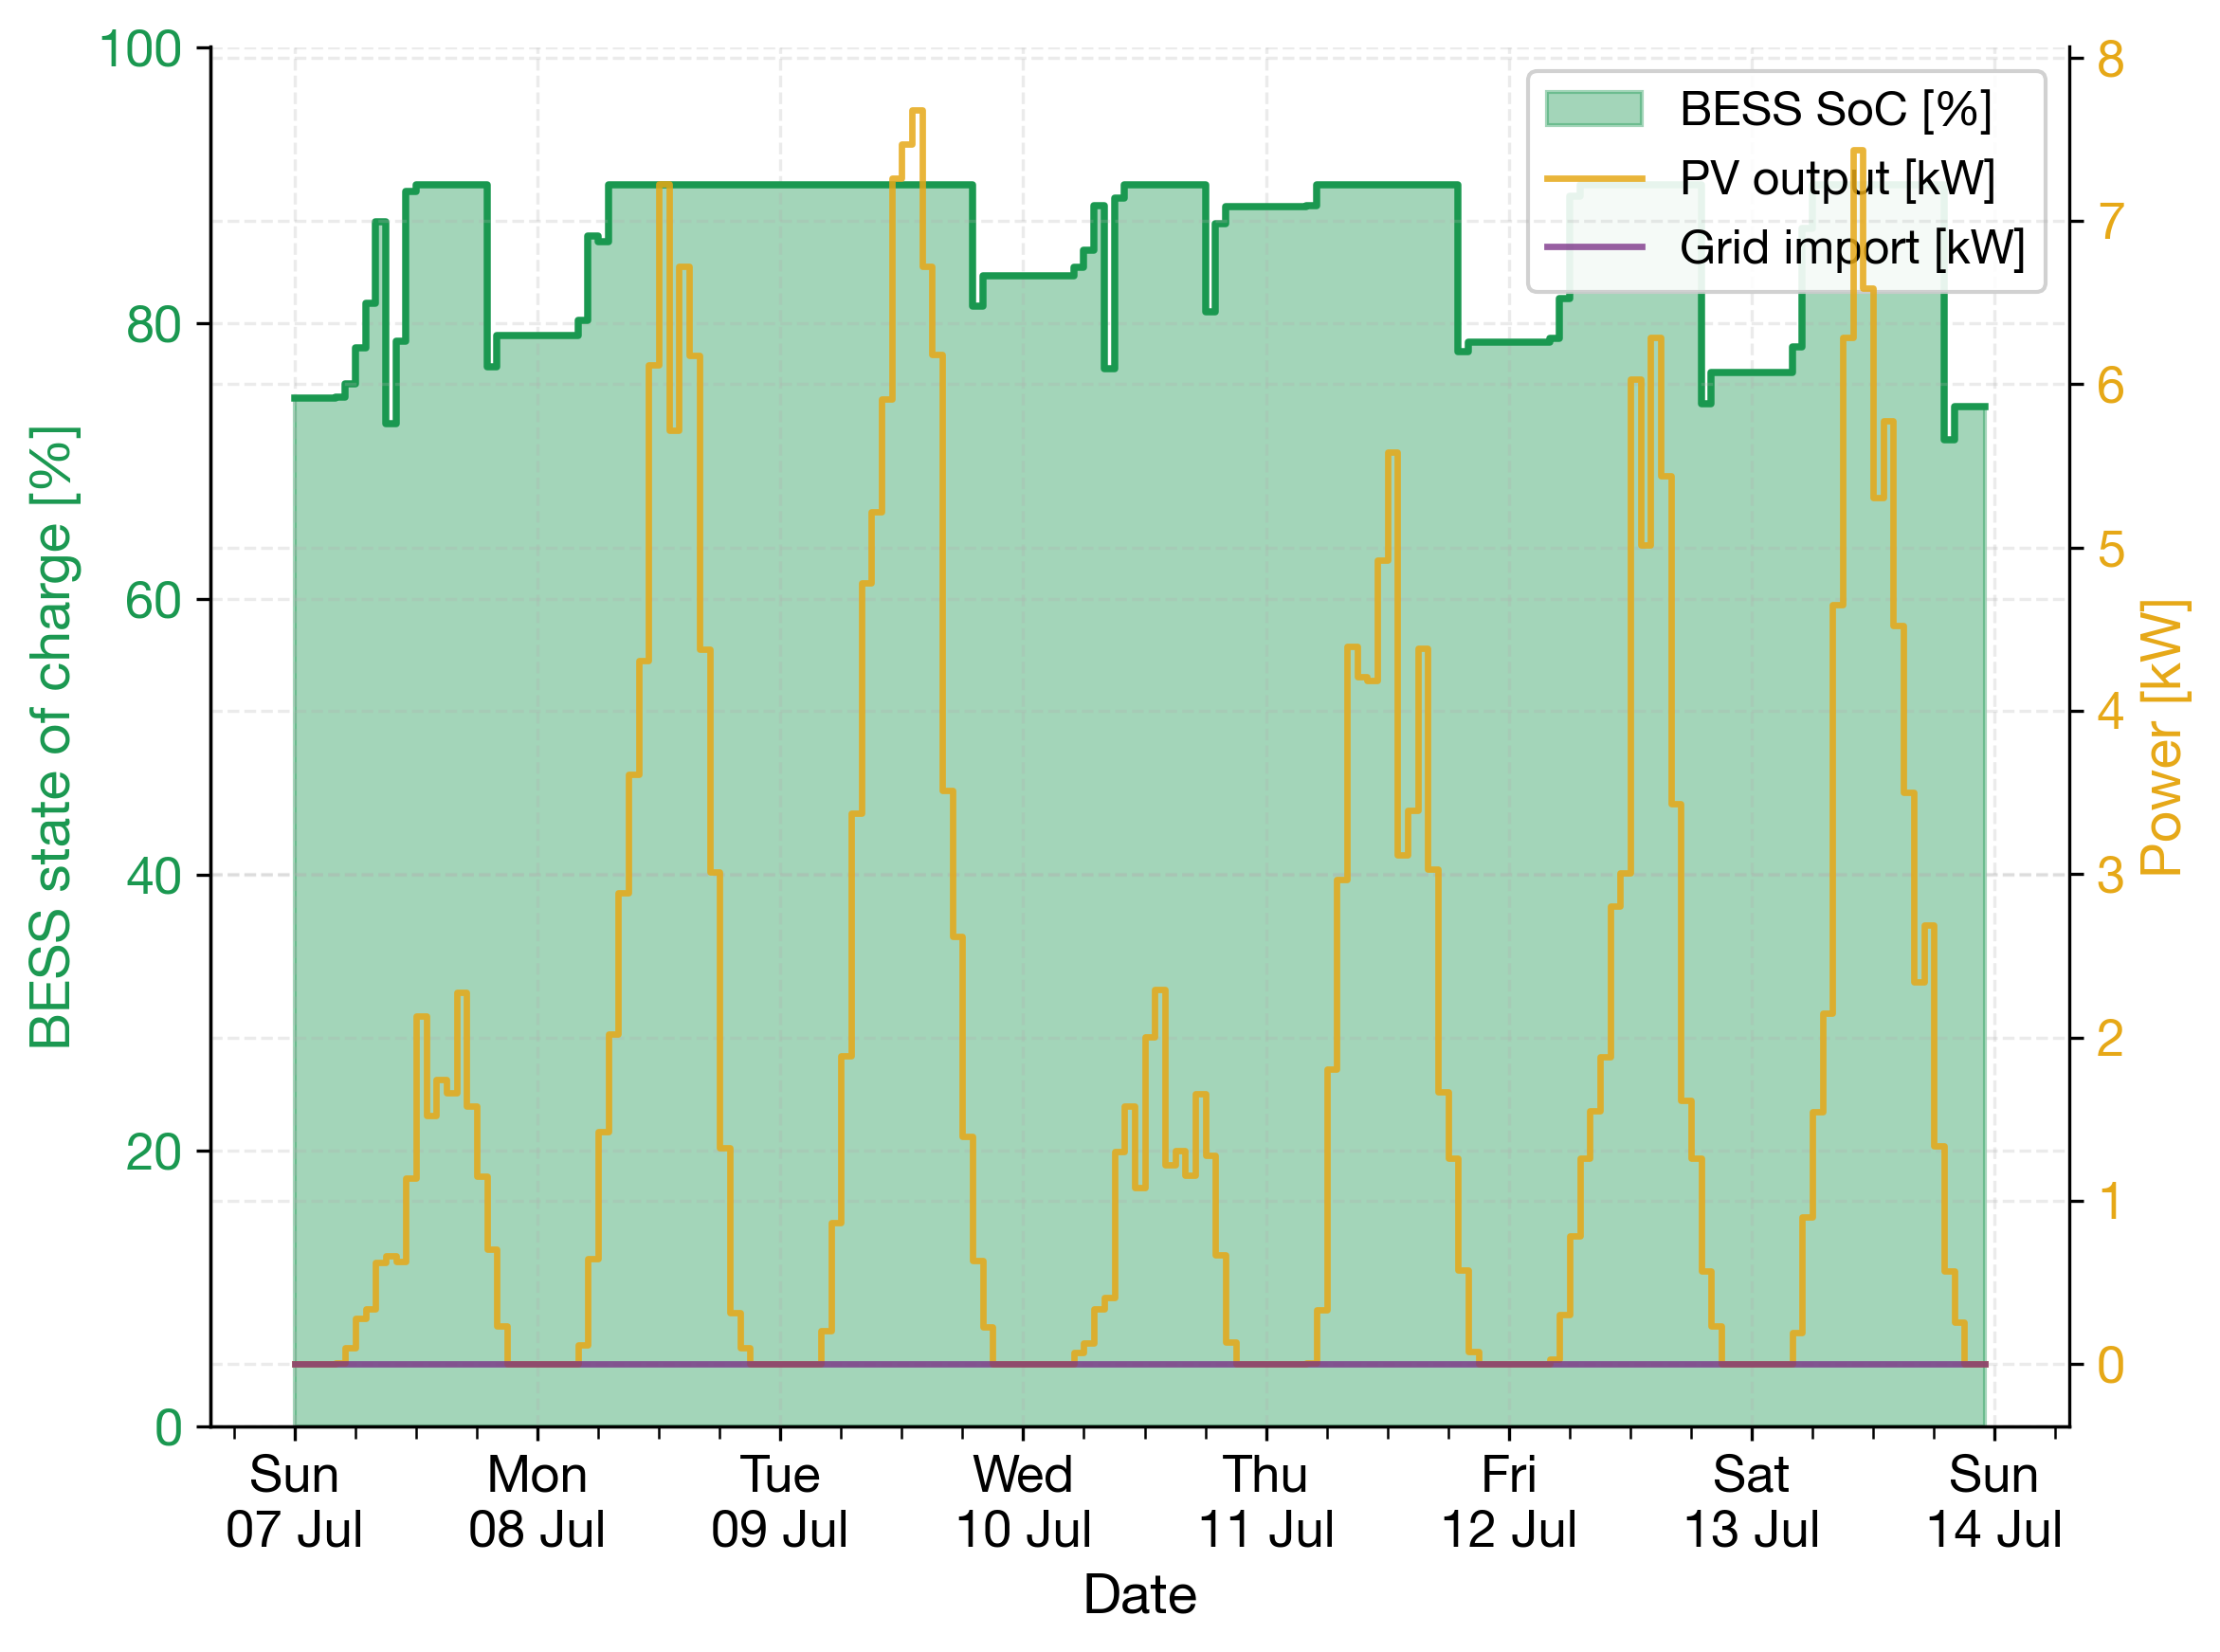
Figure 5. BESS state of charge, PV output and grid import over a representative winter week (7–14 Jan, left) and summer week (7–14 Jul, right).

Techno-economic and environmental assessment
The SHPS shows a favourable OPEX profile. Its total annual OPEX is 16,352 NOK/yr, split between 6,152 NOK/yr grid electricity and 10,200 NOK/yr O&M. DEH's total annual OPEX is 25,875 NOK/yr, split between 25,031 NOK/yr grid electricity and 844 NOK/yr O&M (Figure 6, left). Despite this, the SHPS's much larger CAPEX, 510,000 NOK against 56,250 NOK including VAT, pushes its levelized cost of heat (equation (11)) to 2.31 NOK/kWh. This is nearly double the DEH baseline's 1.25 NOK/kWh (Figure 6, right).
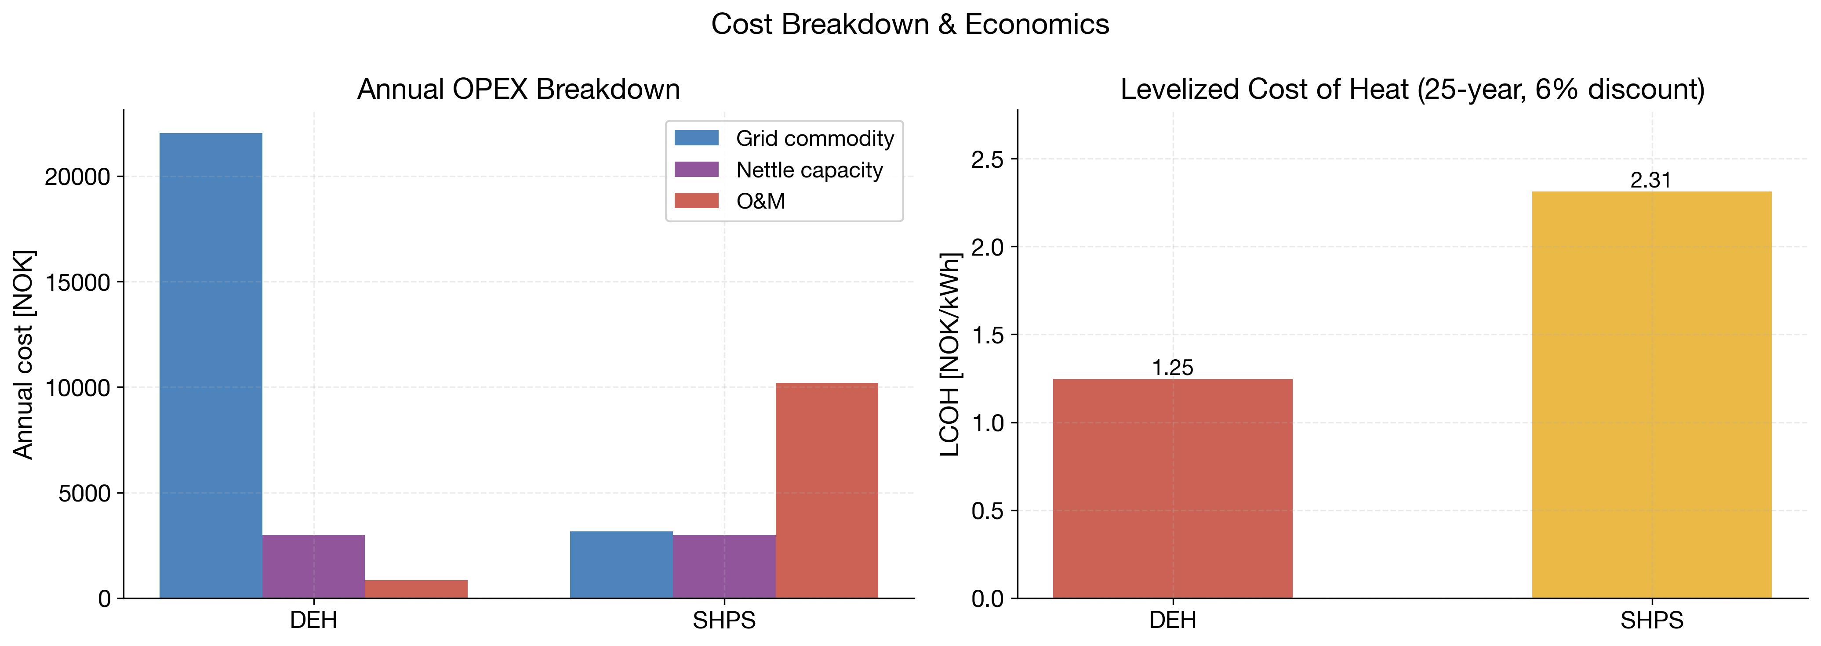
Figure 6. Annual OPEX breakdown and 25-year, 6%-discount levelized cost of heat (LCOH) for DEH and SHPS.
The SHPS's cumulative NPV (equation (12), Figure 7) starts at –453,750 NOK at commissioning, the additional CAPEX over DEH. It improves only gradually, reaching –332,015 NOK after 25 years, and never crosses zero. Under the fixed 0.50 NOK/kWh commodity price, the Norwegian nettleie tariff and a 6% discount rate, the simple payback period is 47.6 years, almost twice the 25-year system lifetime. This result holds despite genuine annual operational savings of 9,523 NOK relative to DEH. The sizeable upfront capital cost of the heat pump, PV, BESS and dual thermal storage, not the running cost, is therefore the binding constraint on financial viability. The fixed Norgespris price removes most of the value of shifting heat-pump or battery operation in time. Only the time-of-day network energy charge varies. The rule-based EMS does not respond to price in either case. Under an hourly spot-price contract, a price-responsive EMS could shift grid imports to low-price hours. PV self-consumption would then avoid a variable rather than a fixed price. The economic results should therefore be read as specific to the Norgespris tariff. A comparable pattern has been reported for combined solar-thermal, PV and battery district heating systems, where electricity price and PV remuneration structure govern which architecture is cost-optimal [4].
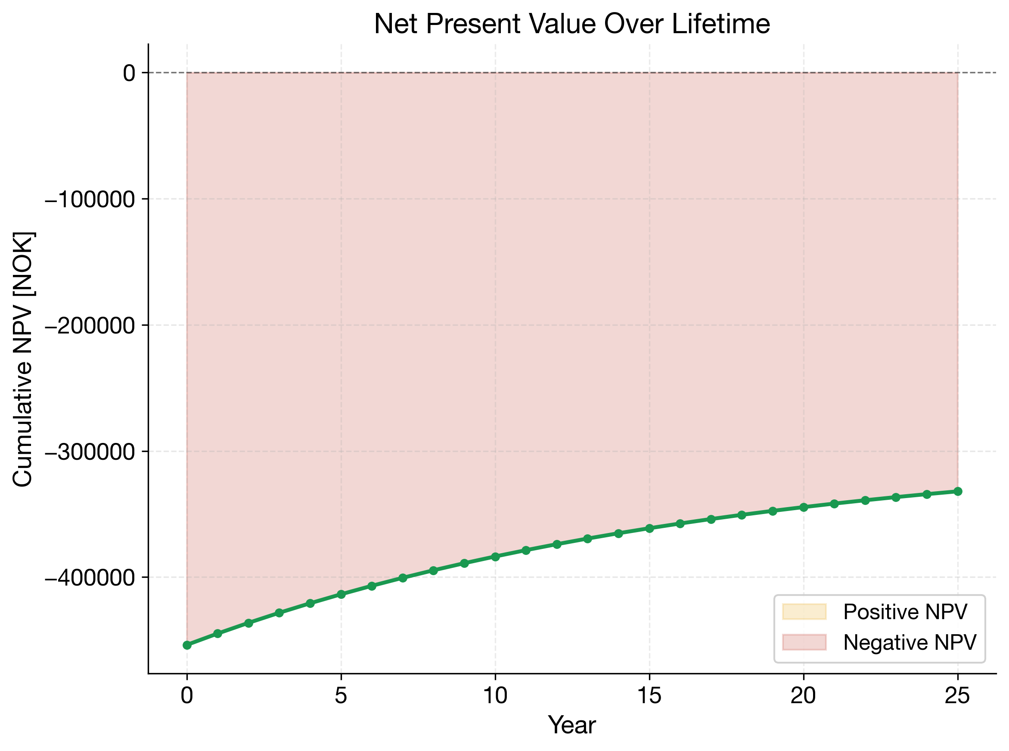
Figure 7. Cumulative net present value of the SHPS relative to the DEH baseline over the 25-year system lifetime (6% discount rate).
A second scenario replaces Norgespris with hourly 2024 NO2 spot prices (Table 3). The mean spot price was 0.58 NOK/kWh excluding VAT, with a maximum of 10.5 NOK/kWh and 206 negative-price hours. DEH grid cost rises from 25,031 to 35,606 NOK/yr because its demand concentrates in the expensive winter months. SHPS grid cost falls from 6,152 to 5,033 NOK/yr because export revenue outweighs the higher import price. The annual saving rises to 21,216 NOK, and the simple payback period falls to 21.4 years. About 90% of this gain comes from the higher DEH cost. The NPV remains negative at –182,541 NOK, and the SHPS LCOH remains above that of DEH. Break-even at a 6% discount rate would require a saving about 1.7 times larger, or an about 40% lower additional capital cost. The result rests on one price year and on export remuneration at the spot price. Without export remuneration, the saving falls by about 3,100 NOK/yr. The tariff therefore explains a large share of the unfavourable economics, but not the sign of the NPV.
Table 3. Economic results under the fixed Norgespris price and hourly 2024 NO2 spot prices.
Quantity | Norgespris | NO2 spot 2024
SHPS grid electricity cost (NOK/yr) | 6,152 | 5,033
DEH grid electricity cost (NOK/yr) | 25,031 | 35,606
Annual operating saving (NOK/yr) | 9,523 | 21,216
LCOH, SHPS / DEH (NOK/kWh) | 2.31 / 1.25 | 2.27 / 1.68
Simple payback period (years) | 47.6 | 21.4
25-year NPV (NOK) | –332,015 | –182,541

The environmental picture runs opposite to the economic one. Annual grid-related emissions fall from 942 kgCO₂eq/yr for DEH to 149 kgCO₂eq/yr for the SHPS (Figure 8, left). Over the 25-year horizon, including embodied carbon of 500 kgCO₂eq for the SHPS's additional components and 50 kgCO₂eq for DEH, this compounds to a reduction from 23.61 tCO₂eq to 4.22 tCO₂eq, an 82.1% cut in lifecycle emissions (Figure 8, right). This reduction is consistent with the scale reported for other electrified, PV-coupled heating retrofits relative to resistive or fossil baselines [18,19]. The additional embodied carbon of the SHPS is recovered by an annual avoided-emissions saving of 794 kgCO₂eq/yr, giving a carbon payback period of 0.57 years. This period is roughly two orders of magnitude shorter than the 47.6-year financial payback period. The Norwegian grid's low average carbon intensity in this simulation, 33.0 gCO₂/kWh, means the DEH baseline is already a relatively low-carbon heating option in absolute terms. The SHPS's advantage over DEH is therefore an incremental, but almost immediately realised, environmental gain rather than a transformation of an otherwise carbon-intensive baseline. These emission results use the hourly average NO-NO2 carbon intensity. Because Norway is coupled to the European market, additional winter demand may be met partly by fossil-based marginal generation [20,21]. A marginal emission factor would raise the emissions of both systems. It would likely widen the absolute gap in favour of the SHPS. The SHPS imports about 3,705 kWh of grid electricity per year, against about 25,590 kWh for DEH. About 97% of SHPS grid imports occur from October to March, when PV output is low and system demand peaks. Flat emission factors of 100, 300 and 500 gCO₂/kWh illustrate a higher marginal intensity. They give annual savings of 2,188, 6,565 and 10,941 kgCO₂eq and carbon payback periods of 0.21, 0.07 and 0.04 years. The SHPS advantage over DEH therefore does not depend on the low average carbon intensity.
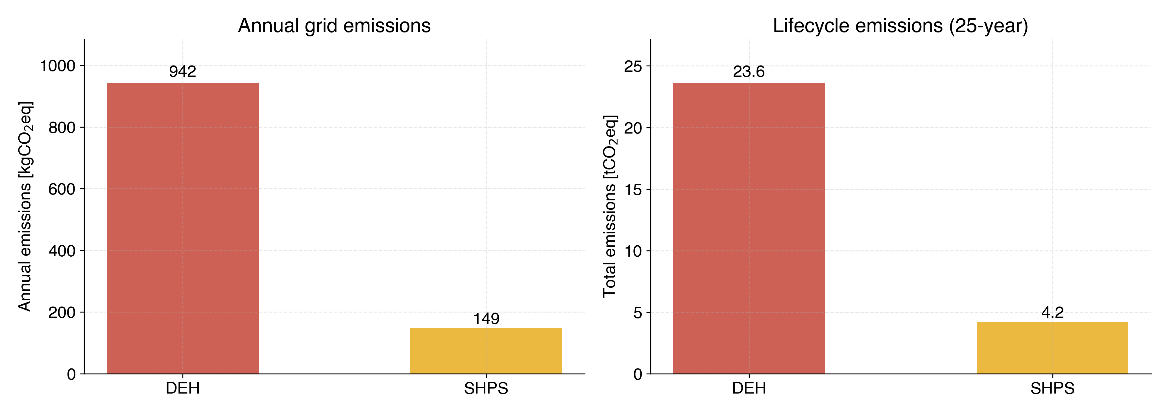
Figure 8. Annual and 25-year lifecycle CO₂eq emissions for DEH and SHPS.
Taken together, these results reproduce a tension increasingly reported for solar-assisted heat pump systems in general. The systems appear technically mature and environmentally favourable relative to resistive heating, yet financially unattractive at prevailing capital costs, tariffs and discount rates. Comparable techno-economic assessments of solar-assisted heat pump architectures suggest that profitability depends strongly on retail electricity prices, PV export remuneration and available capital subsidies, rather than on technical performance [5,6]. In the Norwegian context modelled here, where the electricity commodity price is fixed and comparatively low and grid electricity is already low-carbon, public support for residential SHPS deployment appears justified mainly by future decarbonization headroom and reduced exposure to future carbon pricing or tariff volatility, rather than by near-term private financial return.
- Conclusion
This paper presented an hourly digital twin of a solar-assisted, multi-zone residential heat pump system in a Norwegian maritime climate. The model combines a first-principles R32 vapour-compression cycle with a manufacturer-fitted compressor efficiency correlation, a six-zone 3R-2C building thermal network calibrated to the TEK87 building-code vintage, a 10 kWp PV array with 10 kWh battery storage, and a rule-based energy management strategy. The simulation covers a full year under the fixed Norgespris electricity price. The system delivers 24,307.3 kWh of thermal energy at a seasonal performance factor of 3.79. The PV-BESS subsystem covers 42.3% of heat-pump electricity demand overall, though this coverage is highly seasonal. Coverage falls to near zero in the coldest winter weeks, and the system needs no grid import in summer weeks.
Relative to a direct electric heating baseline delivering the same thermal output, the system cuts 25-year lifecycle emissions by 82.1%, from 23.61 to 4.22 tCO₂eq, and recovers its embodied carbon in 0.57 years. Its levelized cost of heat, 2.31 against 1.25 NOK/kWh, and its 25-year NPV of –332,015 NOK remain unfavourable under current capital costs, 510,000 against 56,250 NOK CAPEX, the fixed commodity tariff, and a 6% discount rate. The simple payback period is 47.6 years, almost twice the system lifetime. Under hourly 2024 spot prices, the payback period falls to 21.4 years, but the NPV remains negative at –182,541 NOK.
These findings suggest that, in low-carbon-grid, fixed-tariff contexts such as Norway, the SHPS offers a clear emissions reduction relative to direct electric heating. This study did not assess alternative heat-pump configurations, natural refrigerants or storage designs. The environmental conclusions are therefore limited to the comparison with DEH. Systems of this kind likely require targeted capital subsidies, more favourable PV export remuneration, or explicit carbon pricing to become financially competitive with direct electric heating. Such policy levers would not change the technology's environmental performance, but they would materially change its adoption economics. Future work should extend the rule-based EMS evaluated here to model-predictive or price-responsive control strategies, since this study isolated the effect of storage sizing and heat-pump thermodynamics from tariff-driven optimization. Future work should also test sensitivity to reduced component capital costs and alternative discount rates. It should also represent frosting and defrost losses and assess natural refrigerants such as R290.
Acknowledgment
The authors would like to acknowledge the Nor-Can Geo-Exchange project (UTF-2024/10209) that has received funding from the Utforsk program of the Norwegian Directorate for Higher Education and Skills (HK-dir). Authors are also highly grateful to Equinor ASA for funding provided to the University of Stavanger through the Equinor-UiS Academia Agreement. This publication reflects only the authors’ views, and the granting authorities are not liable for any use that may be made of the information contained therein.
References
- Thomaßen G, Kavvadias K and Jiménez Navarro J P 2021, Energy Policy 148, 111929.
- Javanshir N, Syri S and Hiltunen P 2024, Renew. Sustain. Energy Rev. 202, 114652.
- Rengaowa W and Arauzo T 2026, Appl. Therm. Eng. 298, 130860.
- Braimakis K 2025, Appl. Therm. Eng. 281, 128723.
- Miglioli A, Aste N, Del Pero C and Leonforte F 2023, Energy Built Environ. 4(1), 39-56.
- Namdar H, Rossi di Schio E, Semprini G and Valdiserri P 2025, Energy Build. 334, 115516.
- Wang J, Jiang Y, Tang C Y and Song L 2022, Appl. Energy 306, 118124.
- Rodríguez Jara E Á, Sánchez de la Flor F J, Álvarez Domínguez S, Molina Félix J L and Salmerón Lissén J M 2016, Energy Build. 130, 85-97.
- Nord N, Ding Y, Skrautvol O and Eliassen S F 2021, Energies 14, 934.
- Amini S, Rousseau L S A and Hertwich E G 2025, J. Ind. Ecol. 29(4), 1121-34.
- Mohseni Pahlavan H and Nord N 2026, Energies 19, 604.
- Wang S, Wei W, Wang W, Sun Y, Li Z, Dai C, Huang C, Tang R and Deng S 2025, Appl. Therm. Eng. 262, 125189.
- Sezen K and Gungor A 2022, Energy Convers. Manag. 263, 115702.
- Pinamonti M, Prada A and Baggio P 2020, Energies 13, 6282.
- Salpakari J and Lund P 2016, Appl. Energy 161, 425-36.
- Schreurs T, Madani H, Zottl A, Sommerfeldt N and Zucker G 2021, Energy Strategy Rev. 36, 100666.
- Gilbert T, Menon A K, Dames C and Prasher R 2023, Joule 7(1), 128-49.
- Aridi M, Pannier M-L, Aridi R and Lemenand T 2025, Energy Build. 336, 115605.
- Pistochini T, Dichter M, Chakraborty S, Dichter N and Aboud A 2022, Energy Policy 163, 112813.
- Seckinger N and Radgen P 2021, Energies 14, 2527.
- Fleschutz M, Bohlayer M, Braun M, Henze G and Murphy M D 2021, Appl. Energy 295, 117040.
- Schrader S E and Benth F E 2022, Energy Econ. 114, 106300.
- Zhu L, Zhang L, Liu J, Zhang H, Zhang W, Bian Y and Yan J 2024, iScience 27, 109924.
- Song M, Deng S, Dang C, Mao N and Wang Z 2018, Appl. Energy 211, 1150-70.
- Milev G, Al-Habaibeh A, Fanshawe S and Siena F L 2023, Energy Build. 300, 113656.
- Masternak C, Meunier S, Reinbold V, Saelens D, Marchand C and Leroy Y 2024, Energy 292, 130487.
- Ahrens Kayayan V, Cabral D, Gustafsson M and Johari F 2025, Buildings 15, 3112.
- European Parliament and Council 2024 Regulation (EU) 2024/573 on fluorinated greenhouse gases Off. J. Eur. Union L 2024/573.
- Hva koster strømmen? 2024 Hourly electricity prices for bidding zone NO2, www.hvakosterstrommen.no (accessed 6 October 2026).

