Reusable novel energy dissipation concept for bridges and offshore structures
B M Staavi¹ and Y Sha¹
¹ Department of Mechanical and Structural Engineering and Materials Science, University of Stavanger, Norway

*E-mail: bs.staavi@stud.uis.no
*E-mail: yanyan.sha@uis.no

Abstract. This article presents the development and evaluation of a novel reusable passive energy dissipation system designed to protect bridge piers and offshore structures from ship collisions. Growing maritime traffic, increasing vessel sizes, and recent bridge allision incidents have highlighted the need for more effective, sustainable, and cost-efficient protection systems. Existing solutions, such as dolphins and artificial islands, are often expensive, non-reusable, and limited in their ability to provide comprehensive protection. The proposed concept combines pneumatic fenders, solid rubber fenders, and a structural containment barrier to absorb and dissipate impact energy while also reducing peak collision forces. The system utilizes controlled deformation and increased stopping distance to minimize structural damage and distribute loads over a larger area. A modular design approach enables adaptation to various bridge geometries and impact scenarios. This concept is evaluated through theoretical analyses, a case study, and scaled experimental impact testing using a pendulum setup. Results demonstrated a significant reduction in peak impact forces compared to direct impacts, confirming the effectiveness of combining pneumatic and solid rubber components. The findings indicate that the proposed system has strong potential as a reusable and sustainable alternative to conventional collision protection methods.

1. Introduction
The maritime industry is facing increasing challenges as vessel sizes and traffic densities continue to grow while coastal and offshore infrastructure becomes increasingly developed. These changes increase the potential consequences of failures that cause vessels to deviate from their intended course and collide with fixed infrastructure. Although major ship–bridge collisions remain relatively rare, their consequences can be severe, with historical incidents demonstrating that vessel impacts have resulted in the collapse of bridges and significant loss of life [1]. The 2024 Francis Scott Key Bridge collapse further demonstrated how a single vessel failure can have catastrophic consequences for both infrastructure and society [2].
Loss of propulsion and steering of a ship is an important contributor to this risk. A blackout can result in a sudden loss of electrical power and consequently propulsion, creating a potentially critical situation when a vessel is operating near bridges, ports or other infrastructure [3]. Such failures can originate from mechanical or electrical faults as well as failures in complex integrated ship systems. Machinery failure has also been identified as one of the leading causes of shipping incidents, with increasing vessel size contributing to greater consequences when failures occur [4]. In addition, recent studies of ship–bridge allisions indicate that active navigational errors and technical failures can both result in abnormal vessel trajectories and subsequent collision risk [5].
The risk is particularly relevant in confined and highly trafficked waterways. European maritime casualty data show that a large proportion of reported casualties occur in internal waters, where vessels operate in close proximity to bridges, ports and other coastal infrastructure [6]. At the same time, increasing vessel dimensions and traffic volumes mean that existing infrastructure may be exposed to impact conditions that differ considerably from those considered during its original design. Recent research into ship–bridge allision risk in Scandinavia has demonstrated substantial variation in navigational failure probabilities between different locations and highlighted the importance of considering actual vessel behaviour when assessing collision risk [5]. The reliability of ship systems is also affected by maintenance and operational conditions. Poor or delayed maintenance has been linked to technical failures, while limited crew resources, operational demands and difficulties obtaining spare parts can further increase the likelihood of equipment failure [7]. These challenges are becoming increasingly relevant as vessels grow larger and their systems become more complex.
The combination of denser maritime traffic, larger vessels, and new coastal infrastructure creates an increasing need for effective protection against vessel impacts. While improvements in navigation, vessel reliability and operational procedures can reduce the probability of an accident, they cannot eliminate the possibility of a collision. Passive protection systems consequently provide an additional layer of safety by absorbing and dissipating a portion of the vessel's kinetic energy before it is transferred to the primary structure. This creates a need for energy-absorption systems that can withstand large impact loads while limiting transmitted forces and maintaining structural integrity. The development and optimization of such systems is therefore important for improving the resilience of coastal and offshore infrastructure against vessel collisions.
2. Overview of current passive energy absorption system
A good solution to protect bridge piers from being damaged is to build piers on land or in shallow waters. Through good placement, we can reduce damage from allisions by a significant amount by making it almost impossible to hit. But not all water crossings allow for this solution and may force the engineer to place one or more piers in or close to the shipping channel. To protect the bridge piers placed in a perilous location, different protective solutions have been designed
Dolphins are structures placed around a bridge pier to protect it from impact damage from ships. They are generally made of steel or concrete in different shapes and sizes. The purpose is to sacrifice the dolphin and absorb energy from the ship through plastic deformation of the dolphin. It is usually required a large dolphin or multiple small dolphins for sufficient protection of a bridge foundation. Piles are driven into the ocean floor and are usually used as the foundation of the dolphins, but floating dolphins have also been made. Strategic placement and number of dolphins are key to good protection of a bridge pier [8,9,10].
To protect bridge piers from potential damage, artificial islands can be constructed to provide protection as if the pier were built on land. This is an effective way of making the bridge pier unreachable from potential allisions. The artificial island must be big enough to safely run a ship aground without it ever hitting the bridge. When a ship hits shallow waters, the bow of the ship gets forced upwards by the sea floor of the artificial island and the bow gets pushed above the water line. Gravity and the friction between the ship hull and the ground are the forces stopping the ship [11]. Other adaptations of the artificial island also include faux pier island or low pier island if built separately from the bridge foundation. Generally, large concrete structures are built around a bridge foundation representing a second foundation to the bridge [12].
A buoy system consisting of wires, a complex anchorage system to the seafloor and a catch net has also been developed. While potentially reusable, it is highly complex and requires extensive maintenance and large space. Of all defined solutions, the buoy system has the highest potential in reducing damage to both the striking and the struck structures. But since it typically requires several ship lengths to effectively stop a ship, it requires more space than what is available in most cases [12].
3. Introduction to the proposed concept
Structural protection from a high-energy impact requires a solid and well-engineered solution. Under the severe loading condition associated with an allision, developing a reusable solution places significant demands on both the material properties and the mechanism responsible for energy absorption and dissipation. Allowing for controlled large deformation of a structure increases the available deformation distance over which the kinetic energy can be absorbed, thereby reducing the rate of deceleration and limiting the resulting impact force. However, the magnitude of deformation alone is not sufficient to reduce peak forces. Efficient energy dissipation requires deformation to occur in a controlled and progressive manner. The system must provide sufficient resistance throughout the entire deformation range, delivering the appropriate level of force at the appropriate stage of the impact to maximize energy absorption while limiting peak loads.
Designing an impact energy absorber capable of dissipating large amounts of kinetic energy represents a significant engineering challenge. Dissipating energy while limiting peak forces transmitted to the protected structure and aiming for reusability amplify that challenge. While absorbed energy equals the area under the force-deflection curve, and increasing the deflection provides a means of reducing force levels, this solution requires structural mechanics and material behaviour working synergistic. The structural geometry and mechanics of the solution must allow for large and predictable controlled deformation without failure. Requiring material behaviours like ductility to sustain plastic deformation without failure, while also delivering sufficient strength. Meaning the solution cannot be solved by a material or geometry alone, but requires a seamless interaction between material properties, structural geometry and deformation mechanics at impact velocity. The design therefore represents a multi-objective optimization problem in which energy absorption, peak force, deformation capacity, structural mass and geometrical constraints must be considered simultaneously.
An ideal shock absorber requires high stiffness with high yields of energy absorption after an impact while keeping its structural integrity. The absorber should also be scalable for industrial production, but so far, no structure can meet all the requirements.[13] Different material-based approaches can be used to achieve energy absorption, including CFRP, honeycomb or cellular structures, foams, rubber where energy is dissipated through material deformation or controlled failure. At the mechanism level, pneumatic, hydraulic, friction-based mechanisms, mechanical dampers, buckling mechanisms and hybrid systems offer alternative approaches to energy dissipation, but each introduces its own potential failure modes and design challenges.
Looking at reusability, several of these approaches have failure points or limitations that become more significant when the impact energy gets larger. The main desired mechanism for several of the approaches focuses on progressive plastic deformation of a material. This can be plastic folding, buckling, crushing/delamination, cell collapse or compression. While this is an efficient way of dissipating energy, it is difficult to find a reusable material which suits these approaches.

4. Proposed concept
In this article, we will introduce a novel concept of dissipating and absorbing the kinetic energy from a ship during an allision in this article, the concept is mainly proposed for the protection of a bridge pier, but it can also be adopted for other coastal or offshore infrastructures.
Ship collisions are complex events involving multiple stages of energy transfer and rapidly varying force levels. According to NORSOK N-004:2022 and DNV-RP-C204 [14,15], collision loads can reach the order of tens of meganewtons, with the specific force–deformation response depending on factors such as vessel displacement, bow geometry, and impact locations. The kinetic energy is strongly dependent on the mass and velocity of the striking vessel and can therefore become substantial even when the impact force is limited. Given the magnitude and variability of the energy involved, relying on a single energy-absorption mechanism can place significant demands on the system.

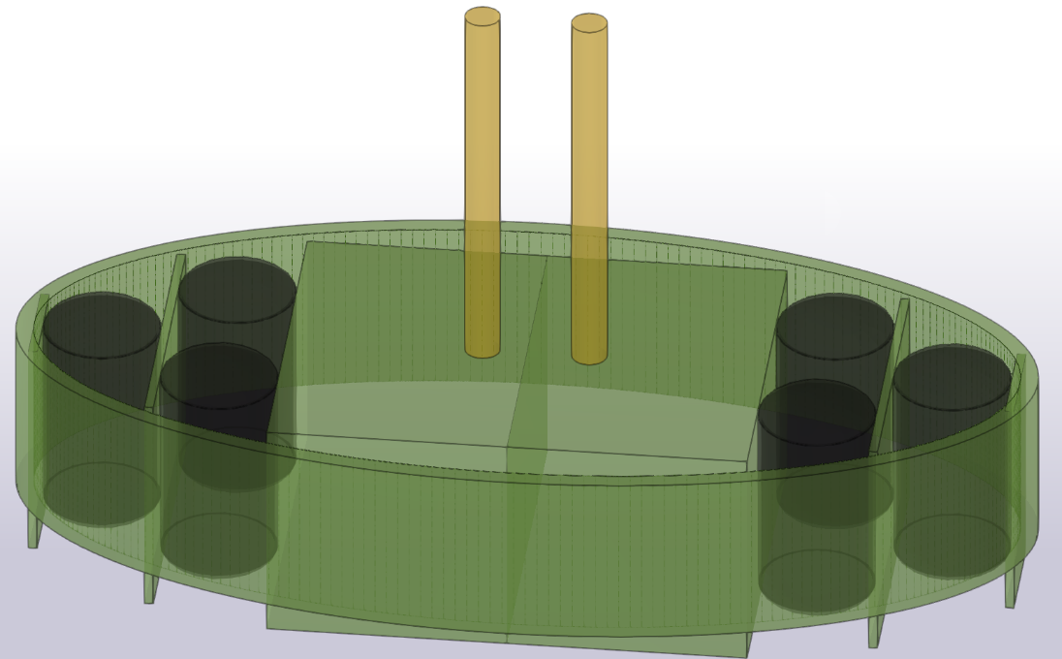
Figure 1. Simplified illustrative model of the concept.
The proposed concept as shown in Figure 1 combines energy absorption and energy dissipation through multiple mechanisms. By combining different non-conservative mechanisms within a single mechanical system, the energy can be distributed across several deformation and dissipation processes rather than being concentrated in one mechanism. This allows the system to control the force–deformation response and provide resistance at different stages of the collision.
With the proposed concept, we aim to reduce the peak force in phase b as shown in Figure 2 (d). By utilizing the pneumatic fender’s ability to absorb energy, the possibility of high local pressure on the bridge foundation will be reduced. As a pneumatic fender uses compressed air for energy absorption, the thermodynamic effects occurring under load shall be properly designed. A general limitation for pneumatic fenders is the adiabatic air compression when a fender is compressed too rapidly. If the pressure builds rapidly and uncontrollably, over-compression is likely to occur and can cause permanent damage. To address this limitation, the proposed concept combines the pneumatic fender with solid fenders. The solid fender in this system will support the pneumatic fender to establish controlled progressive deformation by controlling the deformation speed. This will allow for the application of the proposed system for large and uncontrolled impacts. Based on ISO 17357-1:2014 recommendations, the maximum deformation for an air-filled shipping fender is 60% with a 5% tolerance. At the represented fender size, in ISO 17357-1:2014, we are given a guaranteed energy absorption value (GEA), at a given deformation and an expected reaction force based on the internal pressure of the fender [17].

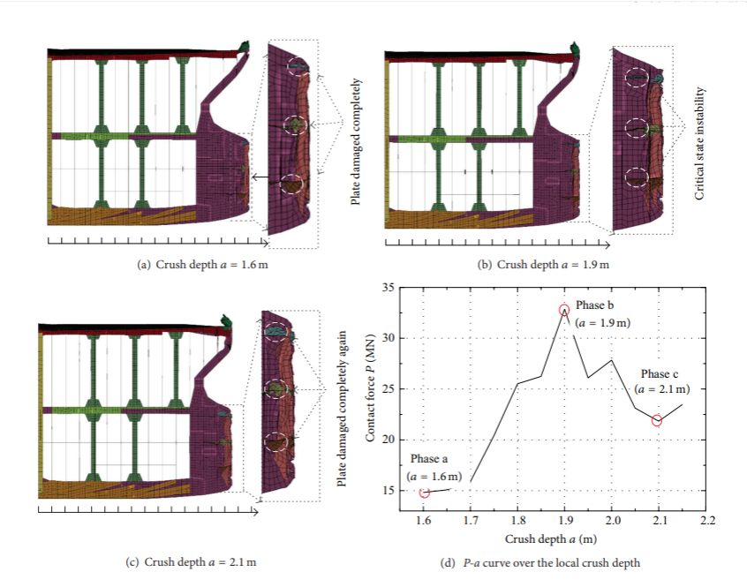
Figure 2. Crushed ship bow with corresponding force-crush graph [16].

The concept is designed to facilitate multiple fenders in a system to increase total energy absorption, load capacity and deformation range. The ability to control total deformation also enables multiple rows with a divider pressure plate between each row. The controlled deformation ensures a maximum utilisation of each fender, and the purpose-designed pressure plate enables multiple rows, making a flexible design for new and existing and new structures, with the ability to adapt to expected force and energy levels.
5. Testing concept with a scaled model
To test the proposed hybrid system concept, lab experiment with readily available materials was conducted to check the performance. The experimental setup consisted of an impact pendulum, a pneumatic fender representing pneumatic energy absorption and a solid rubber fender representing elastic energy absorption. By combining these energy-absorption mechanisms within the same mechanical system the probability of the previously identified failure modes will be reduced.
The test consisted of a simple setup made from euro pallets, concrete blocks and a makeshift pneumatic fender and a solid rubber fender made from go-kart tyres as shown in Figure 3. The euro pallets made a structure to hold and mount the fenders so the interaction between pneumatic and solid fenders could be measured.

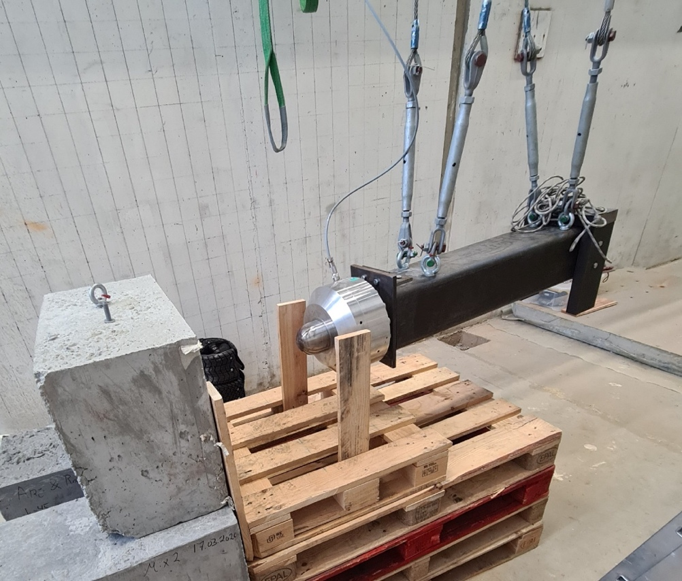
Figure 3. Experimental setup.
The test procedure was done in three series as shown in Table 1. Test series One with high pressure in the pneumatic fender is denoted H. The second test series with low pressure in the pneumatic fender is denoted L. The third test series direct impact with concrete without the fender is denoted C. The weight of the pendulum impactor was the same through all tests.

Table 1. Impact test setup
Name | Weight (kg) | Height (cm) | Initial pressure (kPa)
H10 | 187 | 10 | 50
H20 | 187 | 20 | 50
H30 | 187 | 30 | 50
L5 | 187 | 5 | 25
L10 | 187 | 10 | 25
L20 | 187 | 20 | 25
C10 | 187 | 10
C20 | 187 | 20

6. Results and discussions
The experimental results demonstrate the relationship between high and low pressure compared to direct impact are listed in Table 2. The force- time histories graphs in Figures 4-6 show the impact force time histories for different impact scenarios.

Table 2. Results of each impact test
Name | Weight (kg) | Height (cm) | Energy (kJ) | Peak force (kN) | Pressure plate deformation (mm)
H10 | 187 | 10 | 0.18 | 0.50 | 100
H20 | 187 | 20 | 0.36 | 1.77 | 120
H30 | 187 | 30 | 0.55 | 2.45 | 125
L5 | 187 | 5 | 0.09 | 0.51 | 40
L10 | 187 | 10 | 0.18 | 1.00 | 120
L20 | 187 | 20 | 0.36 | 2.40 | 127
C10 | 187 | 10 | 0.18 | 8.00
C20 | 187 | 20 | 0.36 | 14,82

Figures 4-6 illustrate how the different parts of the system behave through the impact process. For all the impact cases, a distinct high force was first captured when the pendulum contacts the pressure plate. A second peak was observed at the maximum deformation of the fenders. From the graphs, we can also find that the force increases and drops at a higher rate when the impact speed, i.e. the lifting height, increases. Meanwhile, the initial fender pressure also affects the force development. Figures 7 and 8 show the status of the device before impact and at the maximum displacement, respectively.

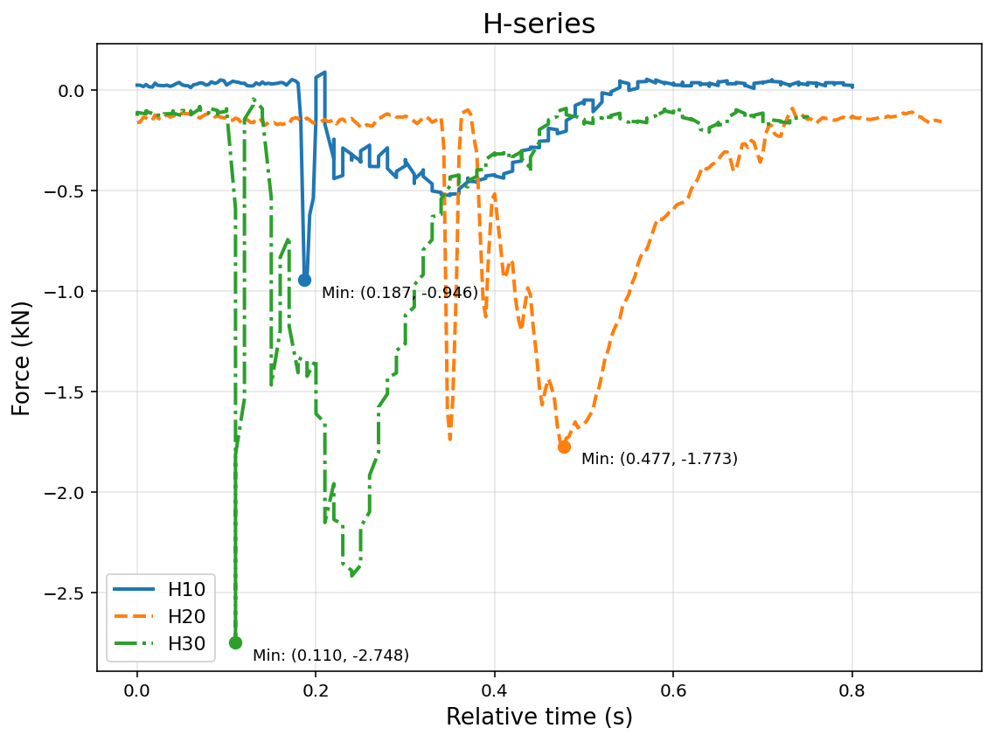
Figure 4. Force time histories for the H-series.
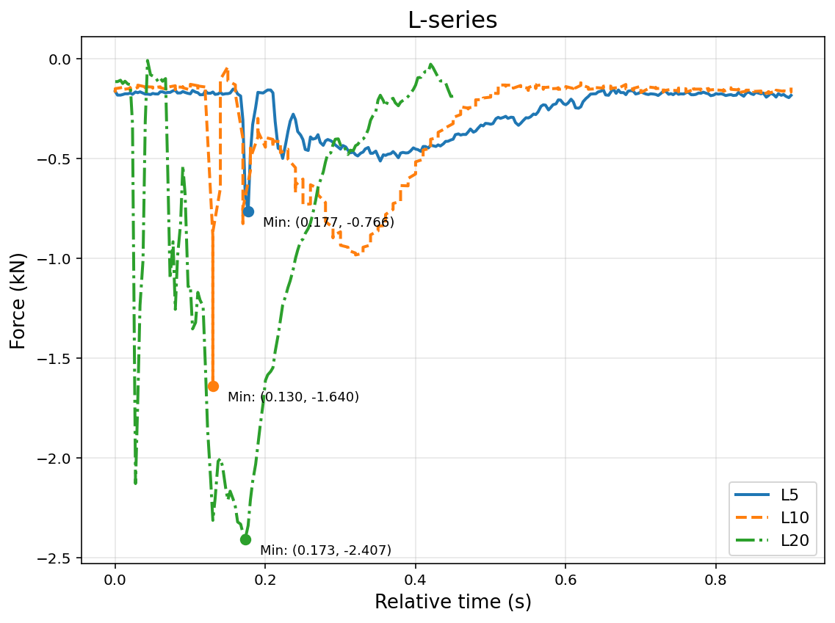
Figure 5. Force time histories for the L-series.
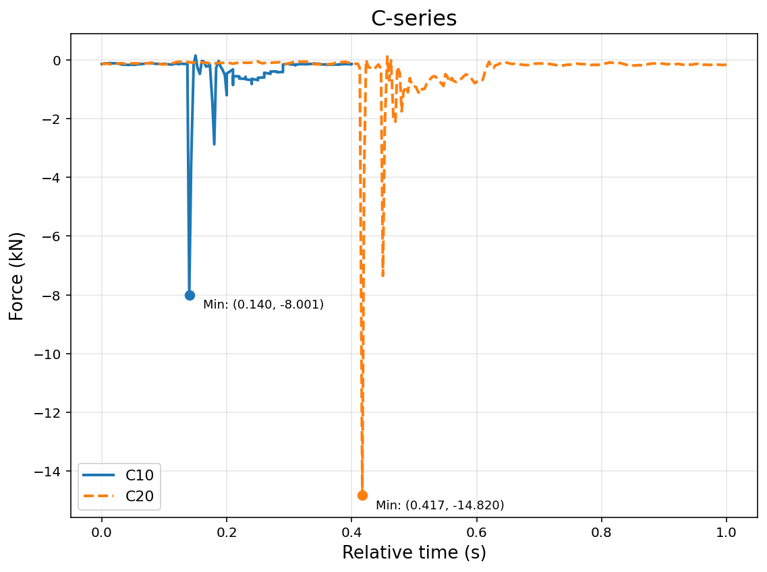
Figure 6. Force time histories for the C-series.

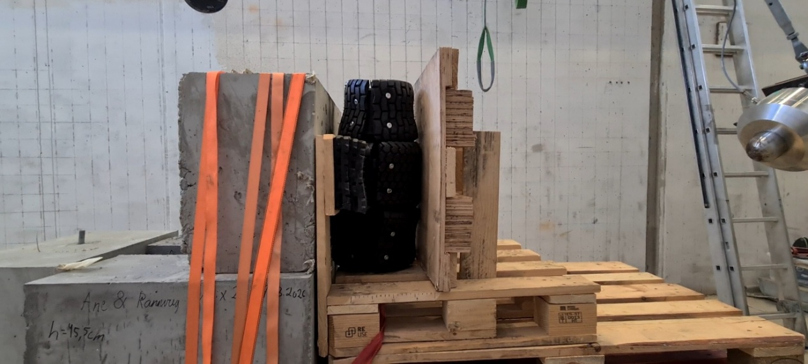
Figure 7. Device before impact.
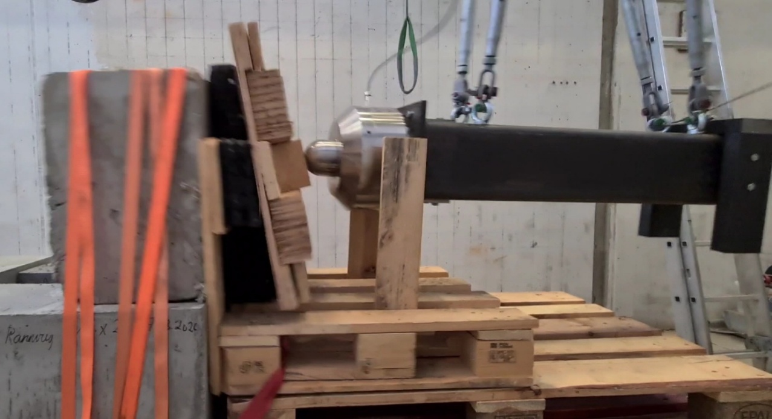
Figure 8. Device at maximum displacement.

The objective of the experimental investigation is to evaluate the interaction between pneumatic and solid rubber fenders and to investigate whether combining the two mechanisms could provide a more controlled energy-absorption response. The results show that both the initial pressure and the impact energy have a significant influence on the force–deformation behavior of the system. More importantly, reducing initial fender pressure to maximize the deformation distance of the fender does not necessarily result in a lower peak force.
When comparing the tests performed at 10 cm and 20 cm drop heights, the lower-pressure configuration generally allowed a greater deformation of the pressure plate. However, this did not necessarily result in lower peak forces. At the higher impact energies, the low-pressure configuration produced peak forces comparable to, or greater than, those measured with the higher-pressure configuration. This indicates that the deformation capacity of the system must be considered together with its resistance during the different stages of impact. A system that provides insufficient resistance during the initial stage of an impact may allow excessive deformation before sufficient energy absorption takes place.
The influence of impact velocity is particularly important for the pneumatic component. As the mass of the pendulum remained constant while the drop height was increased. The pneumatic fender therefore experienced increasingly rapid compression at higher drop heights. Under these conditions, the compression of the enclosed air becomes increasingly important to the force response. The results show a sharper increase in force as deformation progresses, indicating that the pneumatic fender has a larger resistance at high compression rates. This observation shows one of the limitations of using a pneumatic fender as the only energy-absorption mechanism. For relatively low impact energy, the pneumatic fender can provide an effective and controllable resistance. However, as the compression rate increases, the pressure response becomes increasingly pronounced. If the available deformation is limited, this can result in a rapid increase in reaction force before the available impact energy has been sufficiently dissipated.
The addition of the solid rubber fender changes this response by introducing a second energy-absorption mechanism. Instead of requiring the pneumatic fender to accommodate the entire impact, part of the deformation and energy absorption is transferred to the solid rubber component. This provides the possibility of controlling the rate at which the pneumatic fender is compressed. The results therefore support the basic concept of combining the two mechanisms rather than relying on a single energy absorber.
An important observation is that the higher-pressure configuration provided greater resistance during the initial stages of compression. This can be beneficial as the system begins energy absorption immediately upon contact. However, a higher initial pressure also reduces the available deformation before the pneumatic fender reaches its maximum allowable compression. Conversely, the lower-pressure configuration provides greater deformation capacity but may initially provide insufficient resistance. The results therefore indicate that there is a balance between initial pressure, available deformation, and impact energy.
The results also indicate that the force–deformation response of the protective system could potentially be adjusted to better correspond with the deformation behavior of a ship bow. By changing the initial pneumatic pressure, the geometry and stiffness of the solid rubber component, and the arrangement of multiple fenders, the force response could be tailored to different impact conditions. This provides an important advantage of the proposed modular concept. Instead of designing one fixed absorber for a single impact condition, the system could potentially be configured according to the expected vessel size, impact energy and available deformation distance.
7. Conclusions
This study proposed a hybrid energy-absorption concept combining pneumatic and solid rubber fenders for protection against ship collisions. Scaled lab tests were conducted to evaluate the effectiveness of the proposed concept against impact loads.
The experimental results demonstrated that the initial pneumatic pressure, impact energy and deformation capacity have a significant influence on the resulting peak force. The tests showed that increased deformation does not necessarily lead to lower peak forces. Alternatively, the resistance of the system should be controlled throughout the deformation process. Combining pneumatic and solid rubber components provides a means of distributing the energy absorption between different mechanisms and modifying the force–deformation response.
Overall, the experimental investigation supports the underlying concept of using multiple complementary energy-absorption mechanisms. The results suggest that the main potential of the system is not only providing additional deformation from the fenders but also introduce the ability to control the force–deformation response by combining mechanisms with different characteristics. This approach may provide a basis for developing a scalable and potentially reusable protection system for bridge piers and other coastal or offshore structures.
It should be noted that the experiment was performed using a relatively small pendulum and simplified components, including a makeshift pneumatic fender and solid rubber elements. The direct-impact tests only provide a reference for the magnitude of force reduction by introducing the fender system. The tests, however, cannot reproduce the full complexity of a ship–bridge collision. In a full-scale collision, the vessel bow, protective system, supporting structure and foundation would all contribute to the overall energy absorption and deformation. The experimental results can also be used for validation of numerical models before investigating larger and more complex configurations.
References
[1] Gary Dixon 2024 ‘Thankfully rare’: Ship collisions have collapsed 35 bridges over last 60 years TradeWinds, 27
March.
[2] USA TODAY 2024 Baltimore bridge collapse: ship blackout incidents USA TODAY, 11 April.
[3] DNV n.d. Managing the risk of blackouts: Reasons for concern DNV.
[4] SAFETY4SEA 2019 Machinery failure the top cause of shipping incidents in last decade SAFETY4SEA, 13 June.
[5] Hörteborn A and Eidem M E 2025 Probability of active navigational failures: incident analyses for use in ship–
bridge allision risk assessments J. Navig. 78 171–189.
[6] European Maritime Safety Agency 2025 Annual Overview of Marine Casualties and Incidents 2025 (Lisbon:
EMSA), 15 July.
[7] Skuld 2025 The shipshape struggle in shipboard maintenance Skuld, 21 August.
[8] Krivokapic A and Sjöstedt H 2016 Design of protective dolphins in difficult geotechnical conditions
Proceedings of the 17th Nordic Geotechnical Meeting (NGM 2016) (Reykjavik, Iceland, 25–28 May).
[9] Sjöstedt J n.d. Collision Protection Dolphins on Piles: Experience from Recent Projects in Denmark.
[10] Parsons J 2024 Structural dolphins too small and too few to protect bridges against big ships Engineering.com,
5 April. Available at:
[11] New University Studies n.d. Bridge pier protections: preventing ship allisions of bridges New University
Studies. Available at:
[12] Zhang W Z, Pan J Y and Xu M C 2024 Review on the protective technologies of bridge against vessel collision
Thin-Walled Structures 201 112013.
[13] Liu W, Janbaz S, Dykstra D, Ennis B and Coulais C 2023 Leveraging yield buckling to achieve ideal shock
absorbers arXiv arXiv:2310.04748.
[14] Standards Norway 2022 NORSOK Standard N-004: Design of Steel Structures, 4th ed. (Lysaker: Standards
Norway).
[15] DNV 2019 DNV-RP-C204: Structural Design Against Accidental Loads. Edition 2019-09, amended 2021-09.
[16] Fan W and Yuan W 2014 Ship bow force-deformation curves for ship-impact demand of bridges considering
effect of pile-cap depth, Shock and Vibration 2014, 201425.

