Optimization and Minimization of Surface Roughness and Temperature during the Milling of Aluminium LM26 Reinforced MWCNT Using RSM and DFA.
Endalkachew Mosisa Gutema¹, Mahesh Gopal¹ and Hirpa G. Lemu^{2,*}

¹Department of Mechanical Engineering, College of Engineering and Technology, Wollega University, Nekemte P.O. Box 395, Ethiopia

²Faculty of Science and Technology, University of Stavanger, N-4036 Stavanger, Norway
* Correspondence: hirpa.g.lemu@uis.no

Abstract. Castable aluminum-silicon alloy LM26 is widely used in applications requiring high wear resistance, low thermal expansion, and excellent high-temperature strength. This study investigates the sustainable machining performance of LM26 reinforced with multi-walled carbon nanotubes (MWCNTs) at weight fractions of 0.25%, 0.5%, and 0.75%. We fabricated the composites by stir casting at 700°C and 650 RPM. We used a Central Composite Design (CCD) and generated quadratic models in Design-Expert V13. We evaluated surface roughness (Ra) and machining temperature (T) during milling by varying spindle speed, feed rate, depth of cut, and MWCNT content. The performance characteristics using ANOVA. These results show that MWCNT wt.% is an influential factor in minimizing Ra and temperature. Based on the results, adding 0.25% wt. MWCNTs improved machinability; however, increasing MWCNT content increased Ra and temperature. Multi-response desirability analysis identified the optimum machining conditions as 2500 RPM spindle speed, 0.04 mm/rev feed rate, 0.5 mm depth of cut, and 0.25 wt.% MWCNT. Under these conditions, Ra and temperature were 1.35 µm and 30.29°C, respectively, achieving a desirability value of 1.0.

Keywords: LM26 Aluminium alloy, Multi-walled Carbon Nanotube (MWCNT), Spindle speed, Feed rate, depth of cut, Response Surface Methodology, Desirability Function Analysis.
- Introduction

LM26 is commonly used as the base material for Metal Matrix Composites (MMC) in modern manufacturing. To enhance tensile strength, reduce the friction coefficient, and improve wear resistance, researchers reinforce LM26 with materials such as SiC, graphite, or ceramics [1].
[2] established the mathematical relationship between machining parameters and responses using multiple regression analysis and ANOVA. A milling operation is performed on the Al6061 alloy reinforced with aluminium oxide and graphite. Both surface roughness and cutting force depend strongly on spindle speed and feed rate, whereas higher spindle speed improves surface finish by reducing chip load and promoting smoother cutting. Using S/N ratios and ANOVA in the Taguchi experimental design, the experiment identified the optimal machining parameters for end-milling a glass fiber-reinforced polymeric composite. In this regard, depth of cut and cutting speed were identified as the two most significant parameters affecting machining quality. According to ANOVA results, cutting speed accounted for about 26.84% of the variance in surface roughness, while depth of cut accounted for about 40.44% of the variance in delamination damage [3]. Karabu [4] conducted a meticulous investigation of manufacturing AA7039/Al₂O₃ MMC through powder metallurgy techniques. For the experimental design, the authors used an L18 orthogonal array of the Taguchi method to analyze the effects of cutting speed, feed rate, depth of cut, and microstructure on cutting force and surface roughness. Compared with the base material (AA7039), surface roughness improved by 196%-312%.
The authors [5] analyzed the influence of intensification pressure, shot velocity, and pouring temperature on micro-hardness, surface roughness, and porosity in LM 26 alloy. The authors developed prediction models using RSM and optimized parameters using MOGA. The statistical analysis indicated that intensification pressure contributed the greatest percentage (58.12%) to micro-hardness, surface roughness (48.9%), and porosity (39.39%). This study aimed to design composite materials based on LM26 aluminum alloy with varying amounts of SiC while keeping the nickel-coated graphite weight constant. We studied the effects of process variables on wear loss and coefficient of friction using DOE analysis, the Taguchi method, and ANOVA. The composite material made of LM26 and 20 wt% SiC with 2 wt% Ni-Gr showed the highest wear resistance and the lowest COF in the experimental results [6]. The influence of Ni-Gr on the mechanical properties of the LM26 alloy has been investigated [7], which reported an optimal Ni-Gr content of 2 wt. % Ni-Gr addition improved the material's impact energy absorption capacity, ductility, and tensile strength. However, beyond this optimum range, porosity and particle agglomeration reduced mechanical properties. The mechanical behavior research focused on tensile strength, hardness, impact strength, elongation, and porosity of LM26/SiC/TiO2/Ni-Gr. Because hard ceramic particles inhibit dislocation motion and make plastic deformation more difficult, the presence of both SiC and TiO₂ resulted in high tensile strength and hardness [8]. The primary goal of the research was to use the WEDM process to measure machinability parameters, including MRR, surface roughness, dimensional tolerance, circularity error, and perpendicularity error, for stir-cast LM26 hybrid composites reinforced with fly ash and graphite. The results showed that pulse-off time and servo voltage played an important role in determining surface finish and dimensional tolerance, while pulse-on time strongly influenced the material removal rate [9]. The composition of 85% LM26 alloy, 7.5% fly ash, and 7.5% graphite had better mechanical characteristics, micro-hardness around 163.3 VHN, and tensile strength of 238 N/mm², and the author [10] states that graphite in lubrication was established; meanwhile, fly ash improved mechanical strength owing to its grain refinement and load distribution properties. As reported by [11] in their study on AA2024-MWCNT nanocomposites produced via powder metallurgy, hot pressing yielded higher density, hardness, and compressive strength than conventional compaction methods. The researchers observed property degradation and agglomeration when reinforcement levels exceeded 2 wt.%.
The mechanical and functional properties of aluminum-based composites improve greatly with the addition of MWCNTs, which have remarkable tensile strength, a high elastic modulus, and an excellent aspect ratio. However, processing methods, dispersion quality, interfacial bonding, and microstructural integrity all significantly impact the overall performance of Al–MWCNT composites [12]. The authors [13] investigated how milling process parameters affect Al/MWCNT composites. Because of agglomeration and degradation during consolidation, CNTs mainly remain on the surface of Al particles at low milling intensity, leading to poor bonding and mechanical properties. At higher milling intensities, CNTs are incorporated into Al particles through plastic deformation. We experimentally investigated AA7075 reinforcement with MWCNTs via hot extrusion following powder metallurgy. The results revealed that high-energy ball milling enabled uniform distribution of MWCNTs in the aluminum matrix and concluded that AA7075/MWCNT composites with improved mechanical and tribological properties can be fabricated via powder metallurgy followed by hot extrusion [14]. The researchers [15] studied mechanical alloying for Al-MWCNT composite powders and found that high-energy ball milling can disperse CNTs within the aluminum matrix, improving powder-mixture uniformity. In general, studies have shown that mechanical alloying effectively produces Al-MWCNT composite powders. Nonetheless, to enhance the mechanical properties of the final composite powder, the balance between CNT distribution and structure must be optimized. Al₂O₃-MWCNT hybrid nanofluids, in turn, simultaneously improve energy efficiency, reduce tool wear, and enhance surface quality under difficult machining conditions, thereby offering an efficient and sustainable option for milling Ti–6Al–4V [16]. Since load transfer and grain refinement enhance strength and hardness, both increase with increasing MWCNT content in AA7075. However, as the CNT proportion increases further, they tend to form clusters, leading to stress concentration and reduced ductility. Thus, an optimal CNT proportion needs to be considered [17]. In a SQL environment, Al₂O₃ and MWCNTs are excellent nanofluids that enhance grinding operations. MWCNTs' high aspect ratio and ability to form a tribofilm at the wheel-workpiece contact area make them better lubricants, while Al₂O₃ nanoparticles enhance thermal conductivity [18].
Erosion behavior will change further when MWCNT, carbon fillers, and other reinforcements are introduced into the E-glass epoxy matrix system. Poor interfacial bonding may lead to fiber pull-out and increased wear; however, carbon fillers can increase hardness while reducing plasticity [19]. The authors [20] predicted the mechanical performance of woven fabrics reinforced with MWCNTs through FEA. MWCNT secondary reinforcement improves load distribution across different fibers. It has been experimentally proven that low concentrations of 0.1-0.2 wt% MWCNTs can lead to a significant enhancement in mechanical properties. However, higher MWCNT content can reduce effectiveness because bonding strength decreases and stress-concentration areas form. The phase-inversion technique was used to fabricate pure PES membranes, which were then filled with CNTs at different wt. % to fabricate PES/2.5 wt. % of CNT, PES/5 wt. % CNT, PES/7.5 wt. % CNT, and PES/10 wt. % CNT membranes. PES/CNT membranes have been used to experimentally demonstrate the synergistic effect between CNT weight percentage and applied pressure. An optimum CNT weight percentage of around 5% is reported to offer the best combination of flux enhancement and rejection efficiency [21].
Existing studies identify the machinability of LM26 aluminum metal matrix composites reinforced with MWCNTs as an important research gap. An innovative approach to fabricating, evaluating, nano-reinforcing, machining, and optimizing the process through an evolutionary framework can improve machining performance for LM26 MWCNT nanocomposites and develop a complete framework that enhances the material's properties. The mechanical and thermal properties of the resulting nanocomposites will be evaluated to enable optimal material design.
Composites were created in controlled environments to test certain results. CCD is an RSM method that examines the effects and interactions among factors to develop, analyze, and improve the process through a limited number of experiments. ANOVA is a statistical test that assesses the validity and reliability of regression models. By concurrently controlling reinforcement amounts and machining parameters via DFA, the built-in conflicts within the machining performance attributes have been addressed. DFA has proven useful for determining the best machining parameters.

2. Methodology and selection of process parameters

The LM26 aluminum ingot was obtained from M/S Jaikrishna Metals, Coimbatore, India, and the MWCNT was sourced from AdNano Technologies Pvt. Ltd., Karnataka, India. The properties of the Multi-Walled Carbon Nanotube include a length of 10 µm, a diameter of 5-20 nm, and a purity of 99%. Table 1 presents the chemical composition of LM26. We prepared the composites using different weight percentages of MWCNTs (0.25%, 0.5%, and 0.75%) and reinforced LM26 aluminum, following [19], [21], and [22]. The stir casting process involves melting Aluminum LM26 in a crucible at 700 °C with different wt.% of MWCNT (0.25%, 0.5%, and 0.75%), then stirring at 650 RPM to achieve even dispersion. After 5 minutes of mixing, the metal was formed into plates as illustrated in Figure 1(a). We conducted all experiments in a dry environment using a TiAIN-coated carbide end mill cutter (Model Name: ZLY-Tools, Manufacturer: China) and a semi-automatic milling machine (Model Name: Esteam 4S Dro, Manufacturer: India), as shown in Figure 1(b). We set process parameters such as spindle speed, feed rate, depth of cut, and MWCNT concentration.
To measure surface roughness, the SURFTEST SJ-201 surface roughness tester from Mitutoyo America Corporation (Aurora, IL, USA). measuring device was used to test the machined specimens' surface roughness in compliance with ASTM D4417 to compute the arithmetic average roughness (Ra) from recorded measurements taken at several points on each machined surface under uniform measurement conditions. A calibrated infrared (IR) thermometer (Model Name: SKOLE, Manufacturer: India) was used to measure the cutting temperature in compliance with the manufacturer's suggested measurement procedure. For each experimental trial, we measured the temperature during machining under the same conditions and determined the cutting temperature.

Table 1. Chemical composition of LM26
LM26 | Si | Mg | Fe | Cu | Mn | Aluminium (Al)
Weight % | 8.4– 10.6 | 0.6–1.4 | 1.3 | 2.3– 4.7 | ≤ 0.5 | Balance

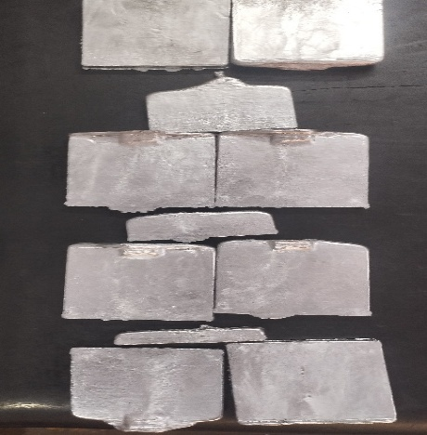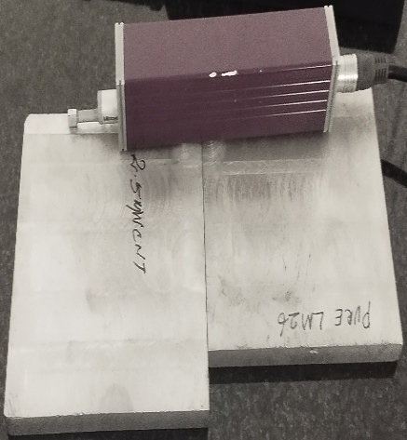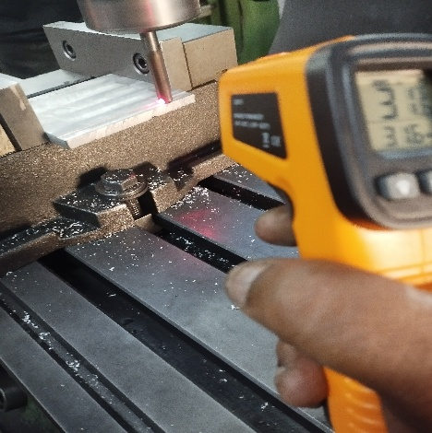
(c)
(b)
(a)
Figure 1. Experimentation of the LM26/MWCNT specimen: (a) Cast specimen; (b) Milling Experiment.

2.1. Process parameter identification, selection of parameter levels and Development of design matrix

This paper employs RSM along with CCD to develop and optimize the machining behavior of LM 26 aluminum alloy reinforced with MWCNTs. The RSM approach is widely recognized as a mathematical and statistical methodology for developing empirical models and optimizing engineering processes with various interactive parameters [23], [24]. As per the suggestions made by [25], four essential parameters, namely, spindle speed (N), feed rate (f), depth of cut (a_{p}), and percentage of MWCNTs, have been considered here due to their significant impact on machining operations. We selected the input parameters based on the recommendations of [26] and [27]. The experimental domain is based on the restrictions imposed by actual machining, as shown in Table 1. Each factor was varied across three levels (−1, 0, +1). We selected a Face-Centered Central Composite Design (α = 1) because it efficiently captures second-order effects and uses a limited number of experimental points. To ensure adequate curvature and efficient estimation of experimental error, the design matrix includes 16 factorial points, 8 axial points, and 6 center-point replications. We executed 30 experiments using the design matrix. Based on preliminary machining trials, machine-tool limits, cutting-tool/workpiece concerns, and ranges stated in pertinent prior research, we determined the operating ranges of the chosen machining parameters. Early testing identified a stable machining region, and we avoided conditions linked to high vibration, early tool wear, unstable cutting, or unsatisfactory machining responses. As a result, we chose the final lower and upper levels to provide enough variation in each factor to examine its primary, quadratic, and interaction effects within the empirically possible operating range. We also checked the chosen ranges against the cutting tool's recommended operating conditions and the trial machine's capabilities. As a result, the face-centered central composite design factor values were set to ensure practical viability and sufficient statistical coverage of the machining domain, rather than chosen at random.
Ra: Minimize (µm) = c (Nk₁ f k₂ a_{p} k₃ % k₄) (1) T: Minimize (°C) = ε (Nk₁ f k₂ a_{p} k₃ % k₄) (2)

Where,
Ra- Surface Roughness
T: Temperature
N: Spindle speed
F: Feed rate
a_{p}: Depth of cut
%: Wt. percentage of MWCNT
K₁, k₂, k₃, k₄, k₅: Model terms (to be estimated from experimental data)
c: Response error for Ra, ε: Response error for temperature

The input variables and responses were related using a second-order polynomial regression model. The second-order polynomial model is frequently used in optimization research because it offers a good compromise between model accuracy and computational simplicity.

Table 2. Factor and their levels
Parameter (input variables) | Units | Units Factor level
Parameter (input variables) | Units | -1 | 0 | +1
Spindle speed (N) | RPM | 1500 | 2000 | 2500
Feed rate (f) | mm/rev | 0.04 | 0.06 | 0.08
Depth of cut (a_{p}) | mm | 0.5 | 0.6 | 0.7
Weight Percentage of MWCNT | % | 0.25 | 0.5 | 0.75

Table 3. Design matrix and its responses
Std | Run | Factors |  |  |  | Response
Std | Run | Spindle speed (N) | Feed Rate (f) | Depth of cut (a_{p}) | Wt. Percentage of MWCNT (%) | Ra_{Exp} | Temperature (T)_{Exp} | Ra RSM _{Pred} | Temperature (T) °C  RSM_{Pred}
24 | 1 | 2000 | 0.06 | 0.6 | 0.75 | 1.51 | 30.6 | 1.51 | 30.70
17 | 2 | 1500 | 0.06 | 0.6 | 0.5 | 1.50 | 31.8 | 1.48 | 31.99
23 | 3 | 2000 | 0.06 | 0.6 | 0.25 | 1.39 | 29.9 | 1.38 | 29.76
8 | 4 | 2500 | 0.08 | 0.7 | 0.25 | 1.42 | 31.7 | 1.42 | 31.66
30 | 5 | 2000 | 0.06 | 0.6 | 0.5 | 1.52 | 31.3 | 1.49 | 31.50
14 | 6 | 2500 | 0.04 | 0.7 | 0.75 | 1.53 | 32.3 | 1.53 | 32.22
21 | 7 | 2000 | 0.06 | 0.5 | 0.5 | 1.50 | 32.1 | 1.49 | 31.93
5 | 8 | 1500 | 0.04 | 0.7 | 0.25 | 1.41 | 30.6 | 1.41 | 30.45
29 | 9 | 2000 | 0.06 | 0.6 | 0.5 | 1.48 | 31.3 | 1.49 | 31.50
2 | 10 | 2500 | 0.04 | 0.5 | 0.25 | 1.36 | 30.3 | 1.36 | 30.24
9 | 11 | 1500 | 0.04 | 0.5 | 0.75 | 1.55 | 32.1 | 1.55 | 32.08
28 | 12 | 2000 | 0.06 | 0.6 | 0.5 | 1.48 | 31.6 | 1.49 | 31.50
16 | 13 | 2500 | 0.08 | 0.7 | 0.75 | 1.57 | 32.8 | 1.57 | 32.81
22 | 14 | 2000 | 0.06 | 0.7 | 0.5 | 1.51 | 31.9 | 1.51 | 32.03
19 | 15 | 2000 | 0.04 | 0.6 | 0.5 | 1.52 | 31.5 | 1.51 | 31.62
12 | 16 | 2500 | 0.08 | 0.5 | 0.75 | 1.53 | 31.6 | 1.53 | 31.69
15 | 17 | 1500 | 0.08 | 0.7 | 0.75 | 1.54 | 31.9 | 1.54 | 31.90
25 | 18 | 2000 | 0.06 | 0.6 | 0.5 | 1.47 | 31.7 | 1.49 | 31.50
13 | 19 | 1500 | 0.04 | 0.7 | 0.75 | 1.53 | 31.5 | 1.54 | 31.44
3 | 20 | 1500 | 0.08 | 0.5 | 0.25 | 1.42 | 31.8 | 1.42 | 31.82
11 | 21 | 1500 | 0.08 | 0.5 | 0.75 | 1.52 | 31.8 | 1.52 | 31.72
1 | 22 | 1500 | 0.04 | 0.5 | 0.25 | 1.42 | 31.3 | 1.43 | 31.36
7 | 23 | 1500 | 0.08 | 0.7 | 0.25 | 1.44 | 31.7 | 1.44 | 31.73
27 | 24 | 2000 | 0.06 | 0.6 | 0.5 | 1.47 | 31.8 | 1.49 | 31.50
6 | 25 | 2500 | 0.04 | 0.7 | 0.25 | 1.37 | 30.1 | 1.37 | 30.25
10 | 26 | 2500 | 0.04 | 0.5 | 0.75 | 1.51 | 31.9 | 1.51 | 31.93
20 | 27 | 2000 | 0.08 | 0.6 | 0.5 | 1.53 | 32.3 | 1.53 | 32.14
4 | 28 | 2500 | 0.08 | 0.5 | 0.25 | 1.39 | 30.7 | 1.39 | 30.82
18 | 29 | 2500 | 0.06 | 0.6 | 0.5 | 1.45 | 32.1 | 1.46 | 31.87
26 | 30 | 2000 | 0.06 | 0.6 | 0.5 | 1.47 | 31.2 | 1.49 | 31.50

3. Prediction of surface roughness using ANOVA

We used Design-Expert V13 for experimental analysis and statistical analysis. We developed a second-order quadratic equation to predict Ra. We assessed model appropriateness using analysis of variance (ANOVA).
Table 4 shows the ANOVA results for predicting Ra. From the table, the signal-to-noise ratio is approximately 0.01% of the observed value. The model is statistically significant (F = 32.50). P-values less than 0.0500 indicate that the terms N, f, %, Nf, N%, f², and %² are statistically significant. The lack-of-fit F-value is 0.31, indicating a 94.48% probability that the observed effect is due to noise.

Table 4. ANOVA table to predict Ra
Source | Sum of Squares | df | Mean Square | F-value | p-value
Model | 0.0928 | 14 | 0.0066 | 32.50 | < 0.0001 |  | significant
A-Spindle speed (N) | 0.0022 | 1 | 0.0022 | 10.90 | 0.0048
B-Feed rate (f) | 0.0014 | 1 | 0.0014 | 6.98 | 0.0185
C-Depth of cut (a_{p}) | 0.0008 | 1 | 0.0008 | 3.92 | 0.0663
D- Wt. Percentage of MWCNT (%) | 0.0761 | 1 | 0.0761 | 372.99 | < 0.0001
AB | 0.0011 | 1 | 0.0011 | 3.52 | 0.0801
AC | 0.0033 | 1 | 0.0033 | 11.03 | 0.0047
AD | 0.0023 | 1 | 0.0023 | 7.53 | 0.0151
BC | 0.0005 | 1 | 0.0005 | 1.69 | 0.2134
BD | 0.0003 | 1 | 0.0003 | 1.02 | 0.3282
CD | 0.0002 | 1 | 0.0002 | 0.5212 | 0.4814
A² | 0.0000 | 1 | 0.0000 | 0.1347 | 0.7188
B² | 0.0007 | 1 | 0.0007 | 2.23 | 0.1564
C² | 0.0001 | 1 | 0.0001 | 0.3166 | 0.5820
D² | 0.0062 | 1 | 0.0062 | 20.71 | 0.0004
Residual | 0.0031 | 15 | 0.0002
Lack of Fit | 0.0012 | 10 | 0.0001 | 0.3120 | 0.9448 |  | not significant
Pure Error | 0.0019 | 5 | 0.0004 | R² |  | 0.9681
Cor Total | 0.0958 | 29 |  | Adjusted R² | 0.9383
 |  |  |  | Predicted R² | 0.9224

The regression equation from Design Expert software, based on fundamental factors, is presented below.

Ra =+2.00308+0.000113*N-12.38450*f-1.80866*a_{p}+0.836623* %+0.000812*N*f+0.000113*N*a_{p}+0.000075*N*%+3.43750*f*a_{p}-0.875000*f*%+0.025000*a_{p}*%-7.22807E-08*N²+79.82456*f²+1.19298*a_{p}²-0.689123*%² (3)

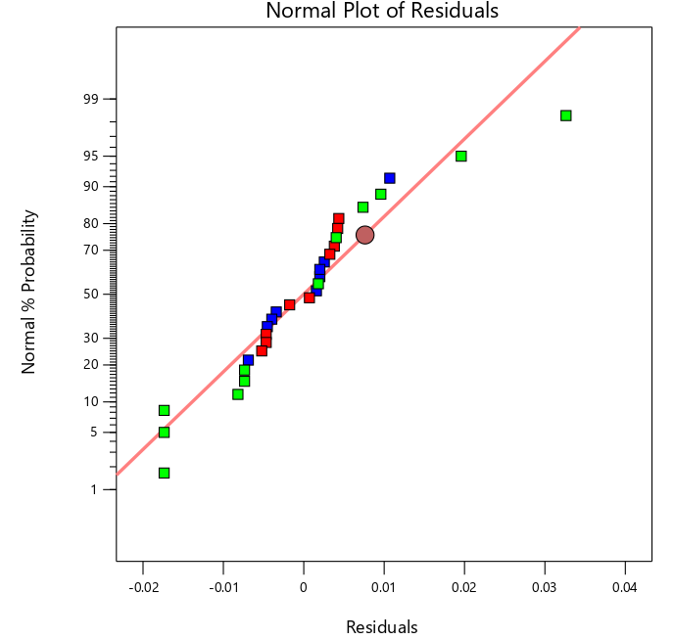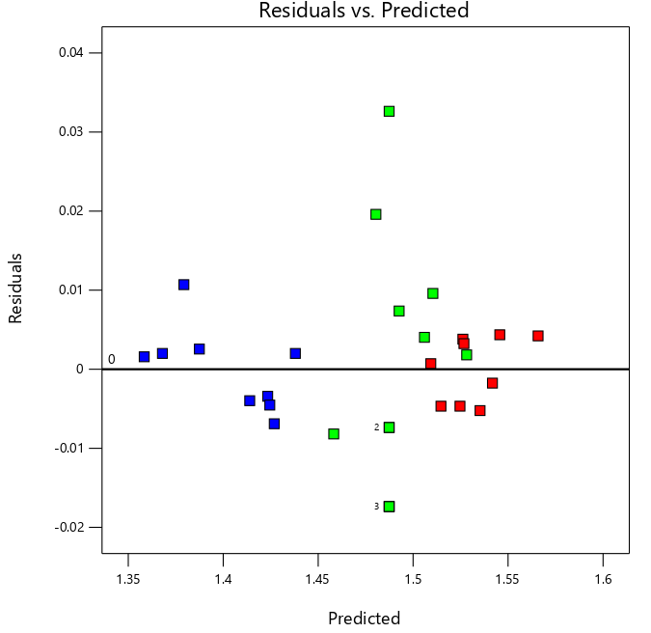

Figure 2. Normal plot of Residuals Figure 3. Residuals vs. Predicted of Ra

Figure 2 shows the normal plot of residuals. The errors appear normally distributed, as they cluster around a straight line. Figure 3 assesses whether residuals are randomly distributed around zero. Residuals stand for the differences between experimental and predicted values. The residual points on the chart are randomly distributed above and below the reference line, without forming any systematic shape, such as funneling or curvature.

4. Prediction of temperature (T) using ANOVA

Table 5 shows the ANOVA results used to predict temperature. The signal showed a noise level of 0.01%, and the table indicates that the model is significant (F = 22.69). Model terms with p-values below 0.0500, and thus considered significant, include f, %, Nap, N%, f a_{p}, f %, N², f a_{p}, and %. Although the term lacks significance given the lack-of-fit F-value of 0.48, the possibility that noise accounts for it is 84.59%.
Table 5. ANOVA table to predict Temperature (T)
Source | Sum of Squares | df | Mean Square | F-value | p-value
Model | 12.85 | 14 | 0.9180 | 22.69 | < 0.0001 | significant
A-Spindle speed (N) | 0.0556 | 1 | 0.0556 | 1.37 | 0.2596
B-Feed rate (f) | 1.23 | 1 | 1.23 | 30.33 | < 0.0001
C-Depth of cut (a_{p}) | 0.0450 | 1 | 0.0450 | 1.11 | 0.3083
D- Wt. Percentage of MWCNT (%) | 3.92 | 1 | 3.92 | 96.87 | < 0.0001
AB | 0.0225 | 1 | 0.0225 | 0.7536 | 0.3990
AC | 0.8100 | 1 | 0.8100 | 27.13 | 0.0001
AD | 0.6400 | 1 | 0.6400 | 21.44 | 0.0003
BC | 0.4225 | 1 | 0.4225 | 14.15 | 0.0019
BD | 0.7225 | 1 | 0.7225 | 24.20 | 0.0002
CD | 0.0900 | 1 | 0.0900 | 3.01 | 0.1030
A² | 0.2387 | 1 | 0.2387 | 7.99 | 0.0127
B² | 0.6569 | 1 | 0.6569 | 22.00 | 0.0003
C² | 0.9437 | 1 | 0.9437 | 31.61 | < 0.0001
D² | 4.36 | 1 | 4.36 | 145.87 | < 0.0001
Residual | 0.6070 | 15 | 0.0405
Lack of Fit | 0.2986 | 10 | 0.0299 | 0.4843 | 0.8459 | not significant
Pure Error | 0.3083 | 5 | 0.0617 | R² | 0.9549
Cor Total | 13.46 | 29 |  | Adjusted R² | 0.9128
 |  |  |  | Predicted R² | 0.8538

The regression equation from Design-Expert, based on the actual factors, is shown below.

Temperature (T) = +63.14459-0.010870*N-147.33918*f-73.47039*a_{p}+19.17061*%+0.003125*Nf+0.004625*Na_{p}+0.001950*N%+103.12500*fa_{p}-41.25000*f%+2.75000*a_{p}%+1.70526E-06*N²+940.78947*f²+47.63158*a_{p}²-20.37895*%² (4)

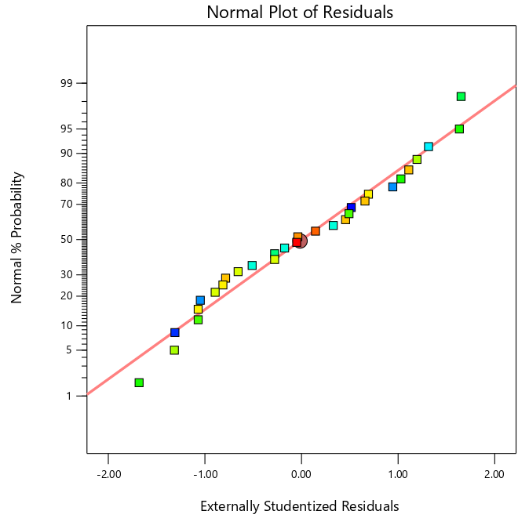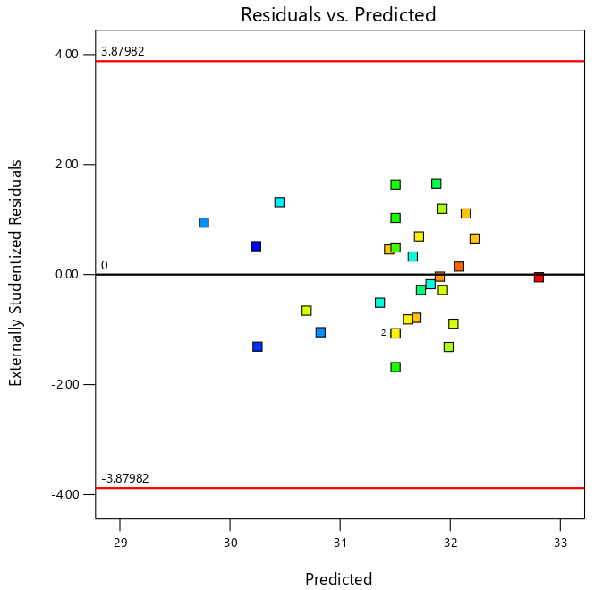

Figure 4. Normal plot of Residuals Figure 5. Residuals vs Predicted of

Temperature

The externally studentized residuals show no outliers and are well distributed on the normal probability plot, as shown in Figure 4. All the studentized residuals lie within the control limits; therefore, the model's assumptions are satisfied. In Figure 5, no obvious systematic pattern of curvature or funnel shape is observed. At the same time, the residuals appear randomly scattered around the zero reference line.

5. Microstructure analysis using SEM

The microstructure of WMCNT-reinforced LM26 composites has been investigated using a scanning electron microscope (FESEM) (MAKE: CARL ZEISS (USA), MODEL: SIGMA WITH GEMINI COLUMN, RESOLUTION: 1.5 nm), as seen in Figure 6a–d. Figure 6a depicts the microstructure of the aluminum alloy LM26. Machining response is significantly affected by changes in the material's basic properties. The figure shows the unreinforced matrix, with long, continuous grooves and severe plowing marks from direct metal-to-metal contact during sliding. Figure 6b depicts the microstructure of the 0.25% reinforced LM26 aluminum alloy. By reducing groove depth and smoothing the surface, MWCNTs improve the worn-surface morphology. A 0.5% MWCNT composite on LM26 is strengthened in several ways, including an extraordinarily high aspect ratio and effective load transfer between the LM26 matrix and the reinforcement material, as shown in Figure 6c. At this reinforcement level, Figure 6d shows that the LM26/0.75% MWCNT composite becomes more noticeable. Tensile and yield strengths are increased and metal strain is decreased by the LM26's effective load transfer and dispersion of applied stresses.

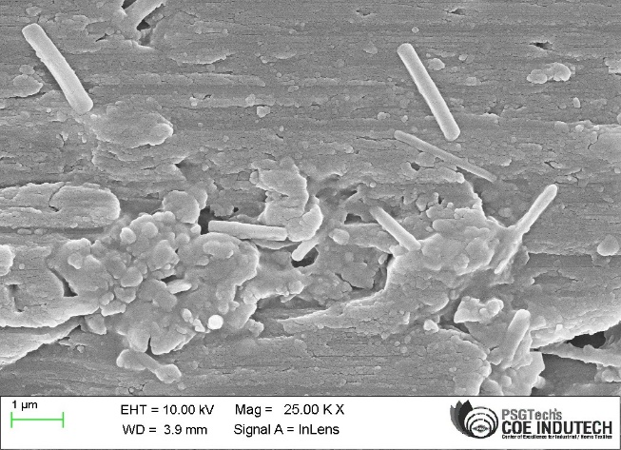
(b)
(a)

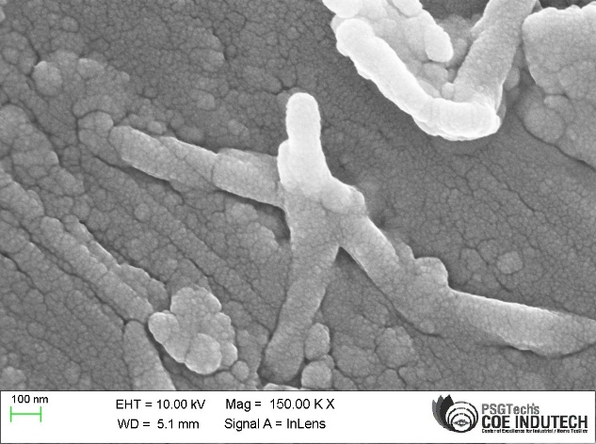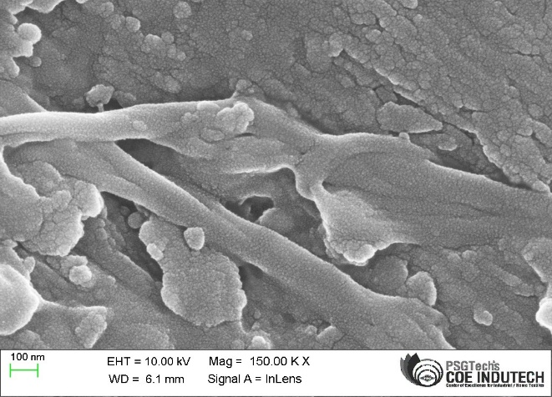
(d)
(c)
Figure 6. Microstructure: (a) Pure LM26 image; (b) 0.25% MWCNT image; (c) 0.5% MWCNT image; (d) 0.75% MWCNT image.

6. Interaction effect of surface roughness

As discussed below, the 3D response surface plots in Figures 7(a)–(f) show how different machining parameters interact to affect the surface roughness of LM26 reinforced with MWCNTs.
Figure 7(a) displays the interaction plot of spindle speed and surface roughness with respect to feed rate. From the graph, the surface is relatively flat, showing that spindle speed and feed rate do not affect the
.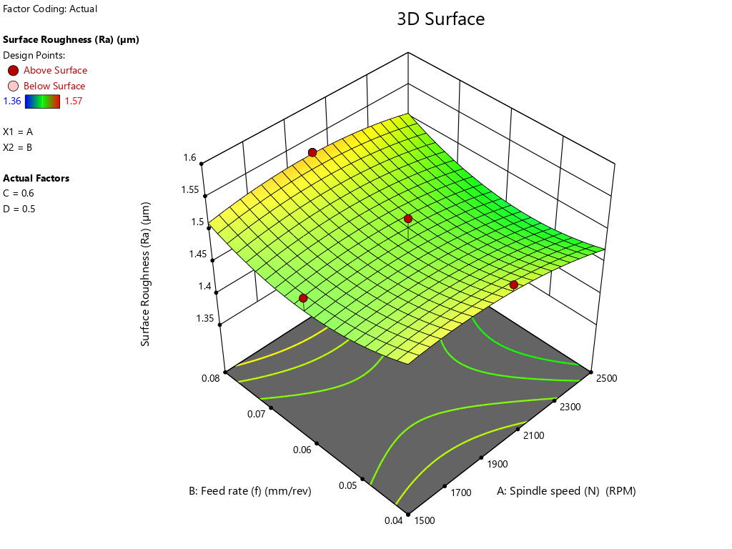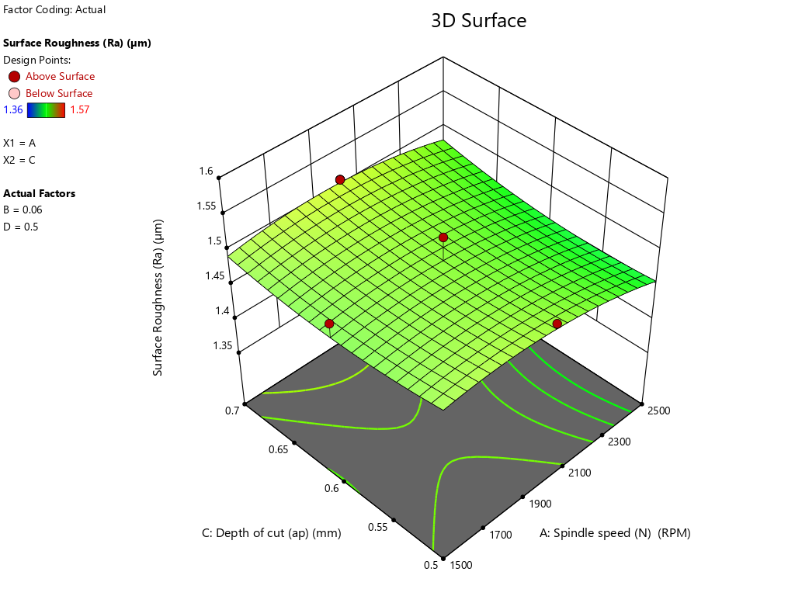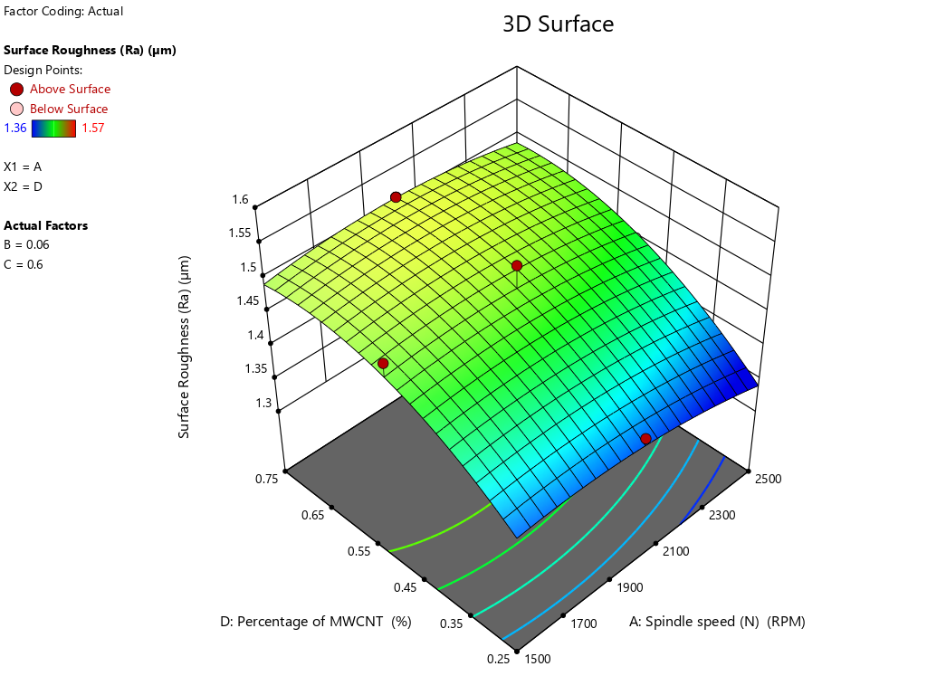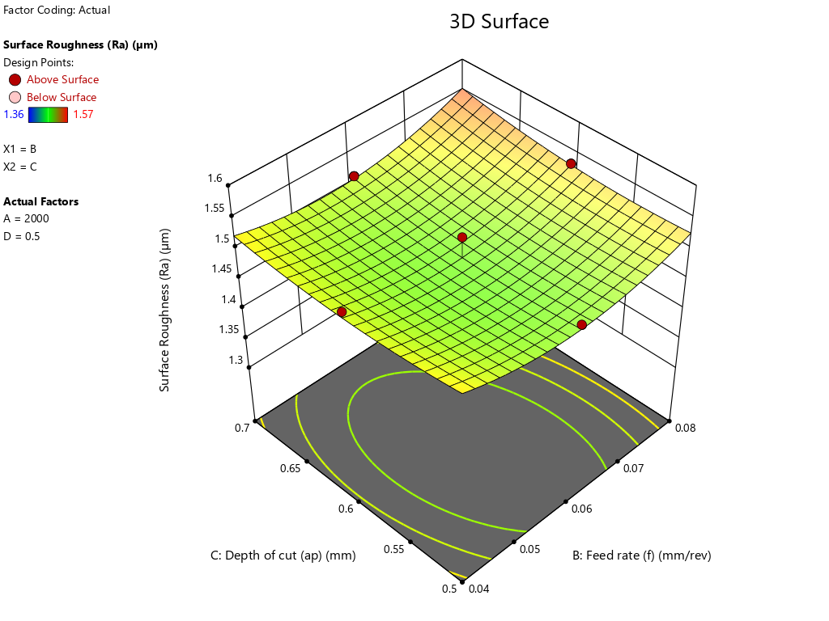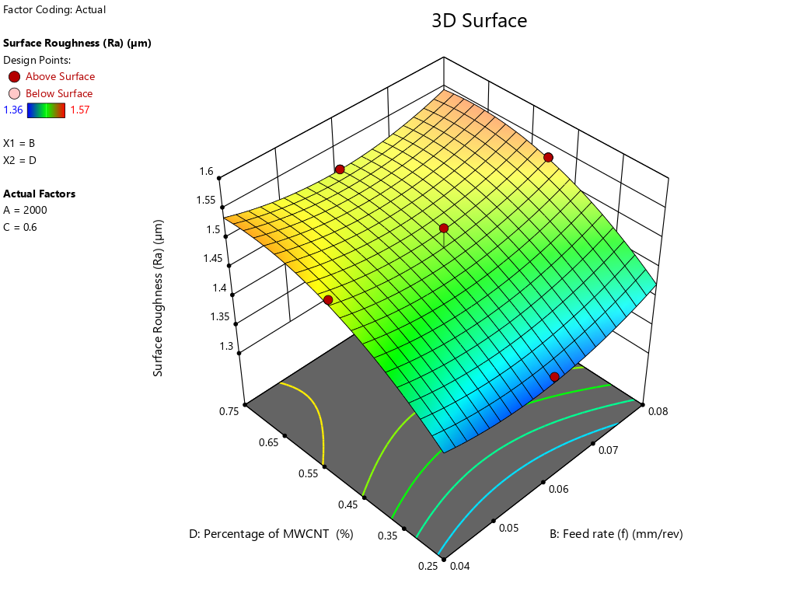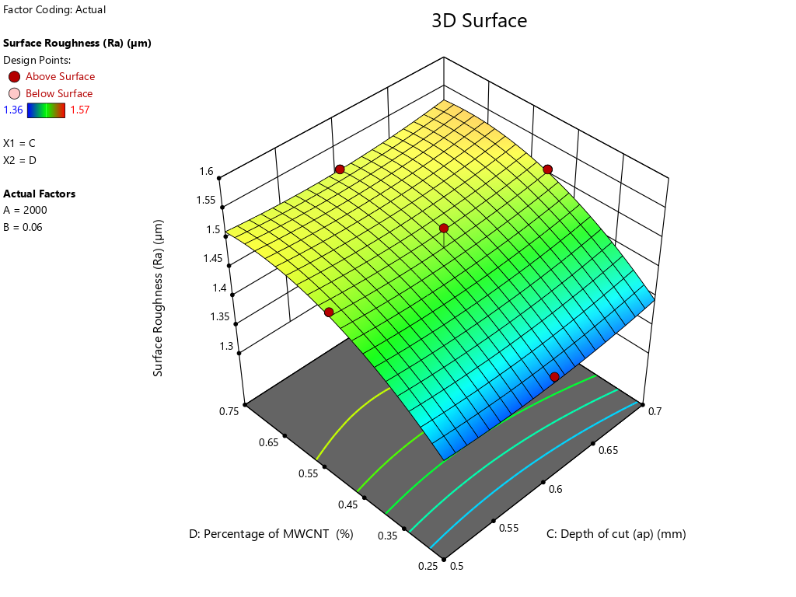
(e)
(b)
(a)
(c)
(d)
(f)
Figure 7. Interaction effect of surface roughness on LM26/MWCNT
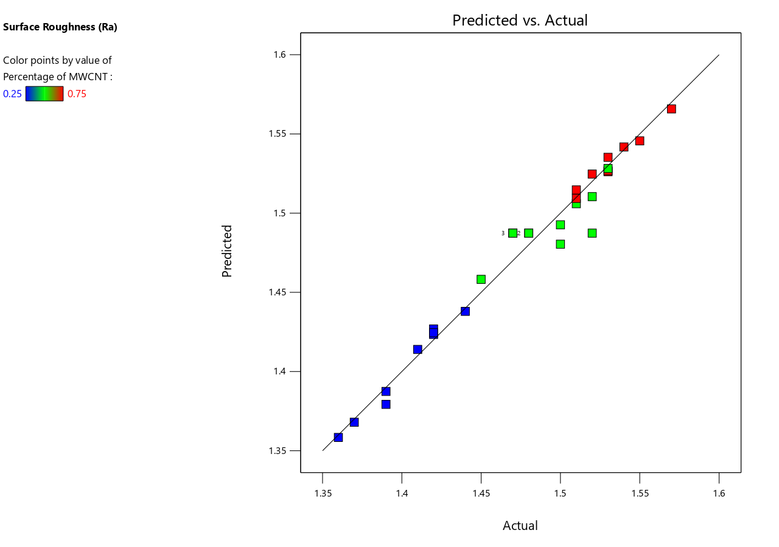
Figure 8. Plot of predicted vs. actual.
roughness in the given range. As spindle speed increases, surface roughness decreases slowly, indicating a slight reduction in roughness with increasing spindle speed. Surface roughness also marginally increases with increasing feed rate. The wide spacing and smooth surface pattern indicate little interaction between the two parameters [28]. Figure 7 (b) presents the effect of spindle speed on surface roughness with respect to depth of cut. With optimal dispersion and concentration of MWCNTs forming a tribofilm that acts as a micro-barrier, surface roughness is low at a depth of cut of 0.6 mm. As suggested by [29], this reduces friction and plastic deformation at a depth of cut of 0.6 mm. Figure 7(c) shows the relationship between spindle speed and MWCNT concentration on LM26 in terms of surface roughness. The best surface roughness can be obtained by combining an optimum low-to-moderate MWCNT concentration with a moderate-to-high spindle speed. Very high spindle speed can cause tool vibration, while very high nanoparticle loadings can cause agglomeration [30]. Figure 7(d) shows the effect of Feed Rate versus depth on surface roughness. The graph shows that surface roughness in this region is unaffected by feed rate or depth. Although roughness increases slightly with feed rate, it is not sensitive to either parameter. The effect is close to the horizontal axis, but not on the depth parameter. Figure 7(e) presents the plot of feed rate, fraction of MWCNTs, and surface roughness. The 3D graph shows a clear curved shape along the MWCNT axis. Since lower percentages lead to smoother surfaces, surface roughness appears highly dependent on the reinforcement percentage. Figure 7(f) shows the relationship between MWCNT percentage, cutting depth, and surface roughness. As the MWCNT percentage decreases, the surface area decreases, indicating that surface roughness is strongly affected by the reinforcement percentage. The gentle slope indicates lower roughness at low cutting depth; however, cutting depth has no significant effect. Figure 8 depicts that both the predicted and observed results from Design-Expert are close to the centerline.

7. Interaction effect of temperature

The graph below shows the effect of the MWCNT-reinforced LM26 process parameter on temperature.
Figure 9(a) illustrates the association between temperature and spindle speed with respect to feed rate. The three-dimensional graph illustrates how temperature increases with spindle speed and feed rate. Temperature depends on the spindle speed and feed rate, which have the lowest values of 2000 RPM and 0.06 mm/rev, respectively. The non-linear increase in the slope of your axis emphasizes the effect of frictional heat. Mechanical load and friction between the tool and workpiece increase exponentially as spindle speed and cutting rate increase, resulting in significant localized heat [31]. The chart below shows how temperature depends on spindle speed and depth of cut. Similar events occur as shown in Fig. 9(b). Depth of cut causes greater mechanical heating but also produces larger, thicker chips that may absorb more heat. However, spindle speed remains the most critical parameter for temperature [32]. Fig. 9(c) shows spindle speed versus MWCNT percentage in the LM26 sample at different temperatures.
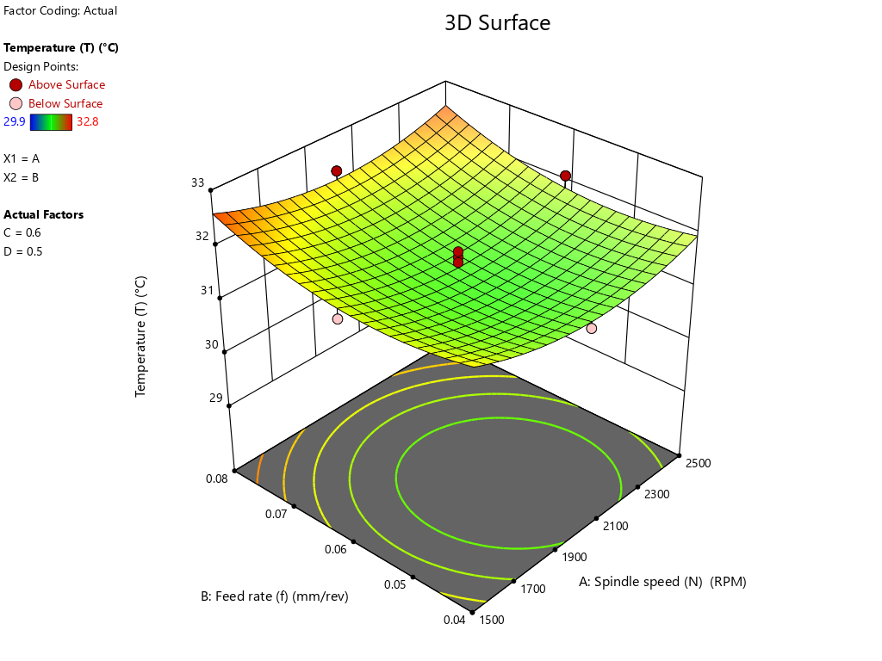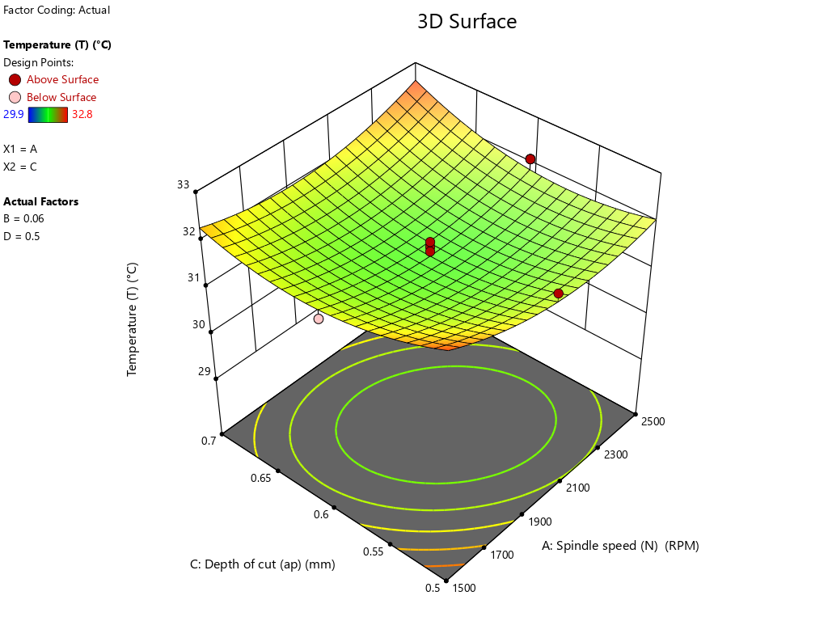
(a)
(b)
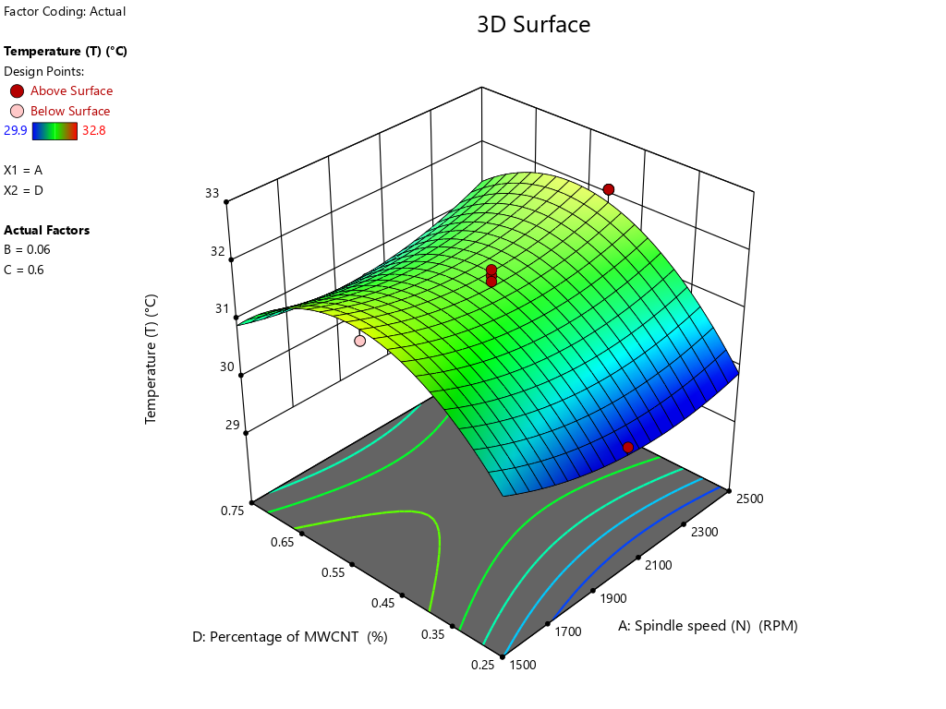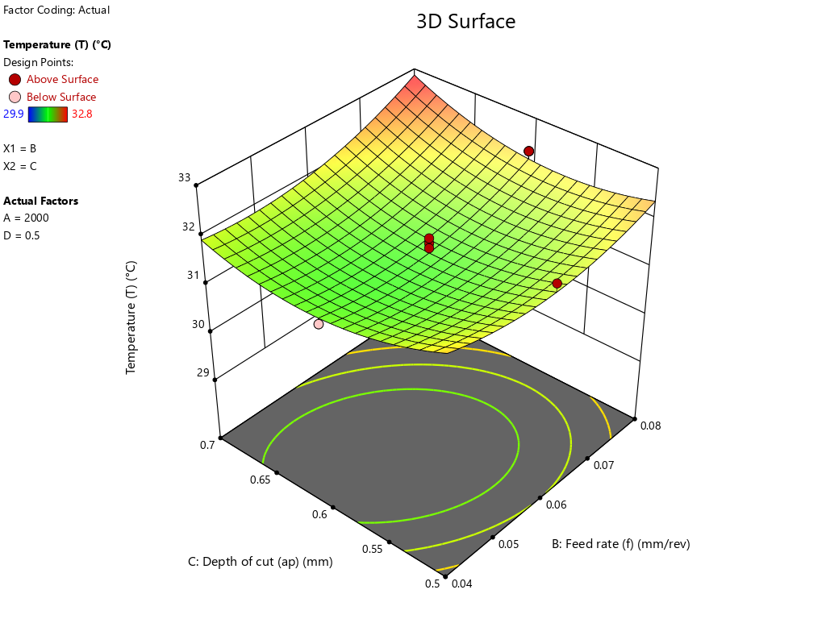
(e)
(f)
(d)
(c)
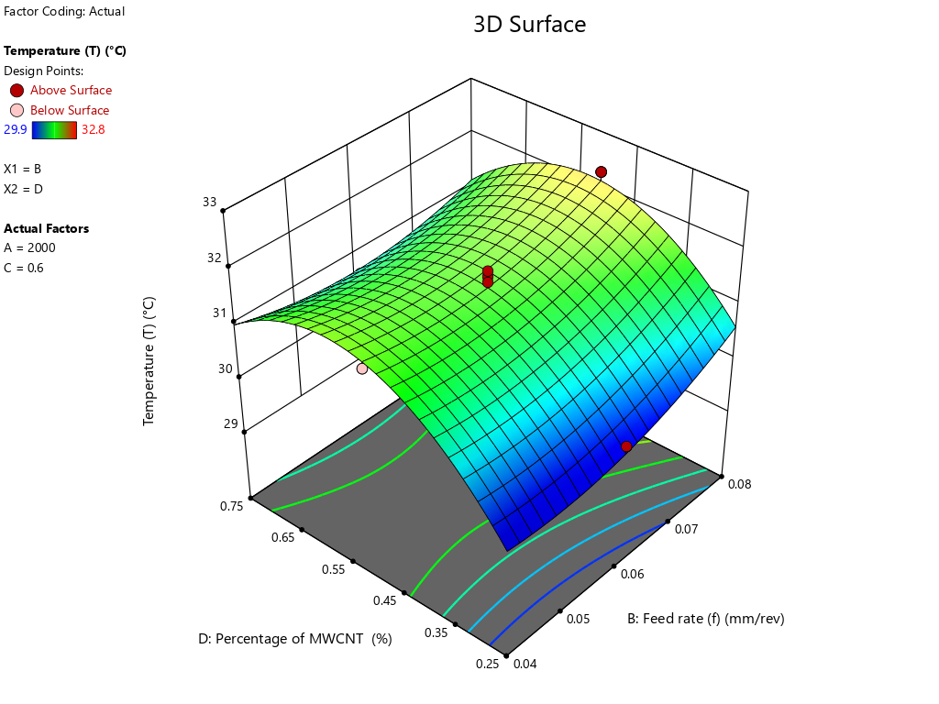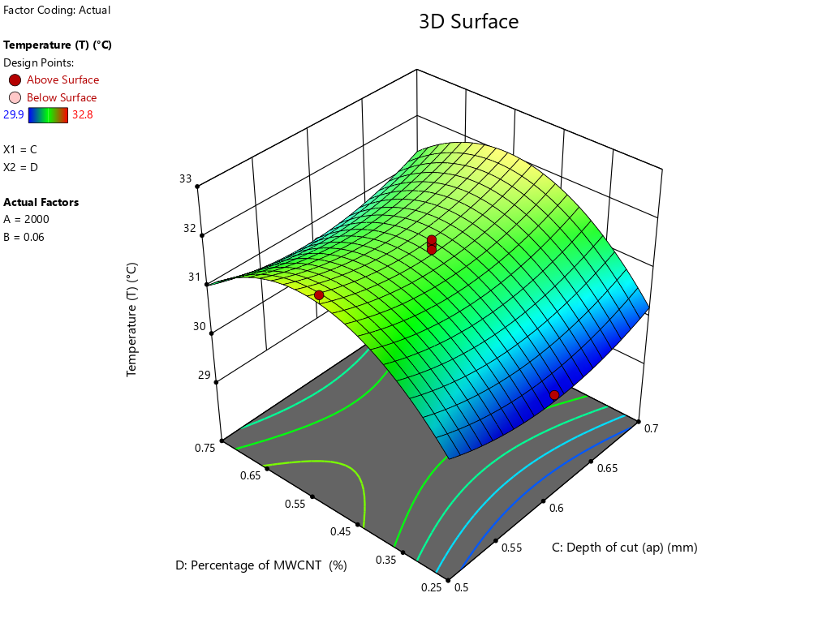
Figure 9. Interaction effect of Surface roughness on LM26/MWCNT
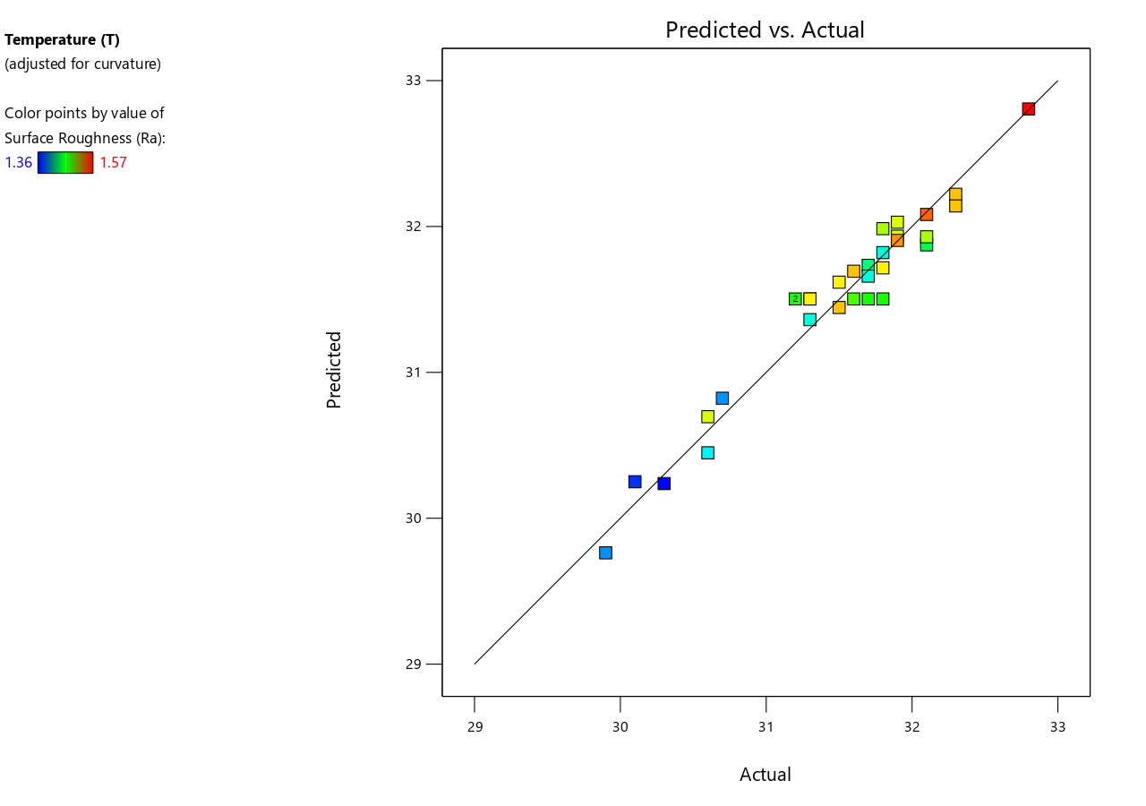
Figure 10. Plot of predicted vs. actual.

The surface shows pronounced curvature in the reinforcement direction, indicating that MWCNT content strongly affects temperature. Lower MWCNT content can improve conductivity and reduce friction in the sample [33]. Nevertheless, the temperature slightly increases with increasing spindle speed. Figure 9(d) graphically represents the relationships among temperature, feed rate, and depth of cut. Temperature increases with feed rate because cutting at higher feed rates requires greater material removal per revolution. As indicated above, the temperature increases with cut depth. Therefore, temperature depends strongly on these two parameters. Figure 9(e) graphically represents the relationship between feed rate and MWCNT % at different temperatures. This graph shows that reinforcement percentage strongly affects heat generation. Temperature drops sharply because there is less MWCNT. Temperature increases because chips and cutting forces generate more heat. Figure 9(f) below shows the relationship between temperature, reinforcement percentage, and depth of cut. From the figure above, temperature increases with increasing depth of cut because the high force applied requires more energy. Figure 10 shows the predicted and actual outputs from Design-Expert software, both near the centerline.
8. Desirability function analysis

The statistical approach known as Desirability Function Analysis (DFA) is widely used for multi-objective optimization. The challenging problem of multiple performance criteria, often in conflict, can be represented mathematically as a single objective value ranging from 0 to 1 [34].
- Optimal parameters are therefore selected as those that yield the highest desirability index, which is the summation of all desirability values.

A. Individual desirability functions
Larger-the-Better Response
When the objective is to maximize a response
$d_{i }= \left\{\begin{aligned}0 \\ 1\end{aligned}\right. {\left(\frac{y_{i}- L_{i}}{T_{i}- L_{i}}\right)}^{s}$ $y_{i} < L_{i}$ : $L_{i} ≤ y_{i}$ $≤ T_{i}$ : $y_{i} < T_{i}$ (5)

Where,
$y_{i}$ = predicted response value
$L_{i}$​ = lower acceptable limit
$T_{i}$ = target (maximum desired value)
$s$ = weight determining the importance of the response
B. Smaller-the-Better Response
When the objective is to minimize a response (e.g., surface roughness, temperature)
$d_{i }= \left\{\begin{aligned}1 \\ 0\end{aligned}\right. {\left(\frac{U_{i}- y_{i}}{U_{i}- T_{i}}\right)}^{t}$ $L_{i} ≤ y_{i}$ $≤ T_{i}$ : $T_{i} ≤ y_{i}$ $≤ U_{i}$ : $y_{i} < U_{i}$ (6)

Where,
$U_{i}$​ = upper acceptable limit
$T_{i}$​ = target minimum value
$t$ = weighting factor

Target-is-best response

When a specific target value is desired
$d_{i }= \left\{\begin{aligned}{\left(\frac{y_{i}- L_{i}}{T_{i}- L_{i}}\right)}^{s} \\ {\left(\frac{U_{i}- y_{i}}{U_{i}- T_{i}}\right)}^{t}\end{aligned}\right.$ $L_{i} ≤ y_{i}$ $≤ T_{i}$ : $T_{i} ≤ y_{i}$ $≤ U_{i}$ : $y_{i} < L_{i} or y_{i} < U_{i}$ (7)
Where,
$T_{i}$​ = target value
$L_{i}$ and $U_{i}$= lower and upper limits

C. Composite (overall) desirability function

Once the individual desirability values ($d_{1}d_{2}d_{3}$,…,$d_{n}$​) are obtained, combine them using the geometric mean.
$D={(d_{1}d_{2}d_{3}……..d_{n})}^{\frac{1}{n}}$ (8)
More generally, when different responses have different importance weights $r_{i}$
$D={(\prod_{i=1}^{n}{d_{i}^{r_{i}}})}^{\frac{1}{\sum{r_{i}}}}$ (9)

Where
D = overall desirability
n = number of responses
$r_{i}$​ = importance weight of response i
The optimal parameter combination corresponds to the maximum D value.

8.1. Process parameter multi-response optimization for lowest surface roughness and temperature

Analysis of the Desirability Function (DFA) transforms multiple conflicting quality measures into one integrated multi-response measure, the Overall Desirability Index (D), which seeks to minimize both surface roughness and temperature. Surface roughness (Ra) and cutting temperature (T) are both “smaller-the-better” quality characteristics in machining processes. To minimize both, the optimal spindle speed, feed rate, depth of cut, and % of MWCNT need to be determined through mathematical transformation of the experimentally obtained values (Response Surface Methodology), as reported by [35]. Using Design-Expert V11, a multi-response optimization analysis of the process parameters (Table 6) was carried out to reduce temperature and surface roughness.

Table 6. Parameter ranges and responses for desirability.
Sl.No | Input Parameter | Goal | Lower Limit | Upper Limit
1 | Spindle speed (N) | In range | 1500 | 2500
2 | Feed rate (f) | In range | 0.04 | 0.08
3 | Depth of cut (a_{p}) | In range | 0.5 | 0.7
4 | Weight Percentage of MWCNT | In range | 0.25 | 0.75
5 | Surface roughness observed (Ra) (µm) | Minimize | 1.36 | 1.57
6 | Temperature rise observed (T) (°) | Minimize | 29.7 | 32.8

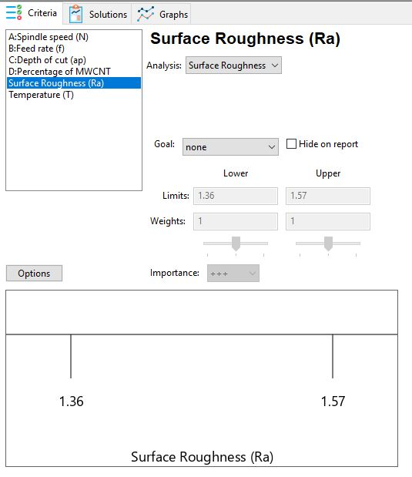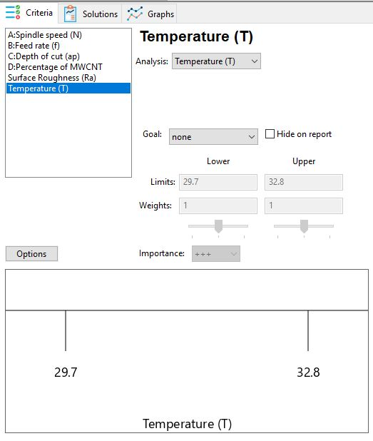
Figure 11. Criteria to (a) minimize surface roughness (µm) and (b) minimize temperature (°).

Table 6 and Figures 11a and 11b depict the objectives of the two optimization approaches: minimizing temperature and surface roughness. For each objective in each solution for instantaneous optimization, lower and upper bounds must be defined. Goals are assigned to variables and responses to perform the optimization. “Minimize” was the goal for the responses. Weighting of the desirability function is possible. However, the solution ranking remains unchanged, with the best solutions listed first. Both methods aim to reduce temperature and surface roughness. The idea behind deposition is to produce high-quality finished machined parts by reducing temperatures. Smaller-is-better surface roughness and temperature were the major concerns in these research studies. The optimization method yielded 100 optimal solutions; however, the desirability function identified multiple optimal solutions. The investigation considered only five higher-desirability choices, as shown in Table 7, with one having outstanding desirability (D = 1.00). The optimal values were a spindle speed of 2500 RPM, a feed rate of 0.40 mm/rev, a depth of cut of 0.50 mm, and an MWCNT percentage of 0.25. The optimal temperature and surface roughness are 30.29°C and 1.35 µm, respectively. A smaller value was considered better.

Table 7. Best solution for optimization.
Sl.No | Spindle speed (N) | Feed rate (f) | Depth of cut (a_{p}) | Percentage of MWCNT | Surface Roughness (Ra) | Temperature (T) | Desirability
1 | 2500.00 | 0.04 | 0.50 | 0.25 | 1.35 | 30.29 | 1.000 | Selected
2 | 2066.51 | 0.05 | 0.51 | 0.26 | 1.38 | 30.35 | 1.000
3 | 1500.00 | 0.08 | 0.50 | 0.25 | 1.42 | 31.91 | 1.000
4 | 1500.00 | 0.04 | 0.70 | 0.25 | 1.41 | 30.42 | 1.000
5 | 2500.00 | 0.08 | 0.70 | 0.25 | 1.42 | 31.71 | 1.000

Figures 12(a-c). The contour plot shows the relationship among the three variables. In this plot, one dependent variable is shown along the z-axis, while two independent variables are plotted along the x and y axes. Contour plots make it easy to find combinations that yield acceptable results. The optimum reaction was obtained with higher spindle speed, lower feed rate, lower cutting depth, and a smaller percentage of MWCNTs.

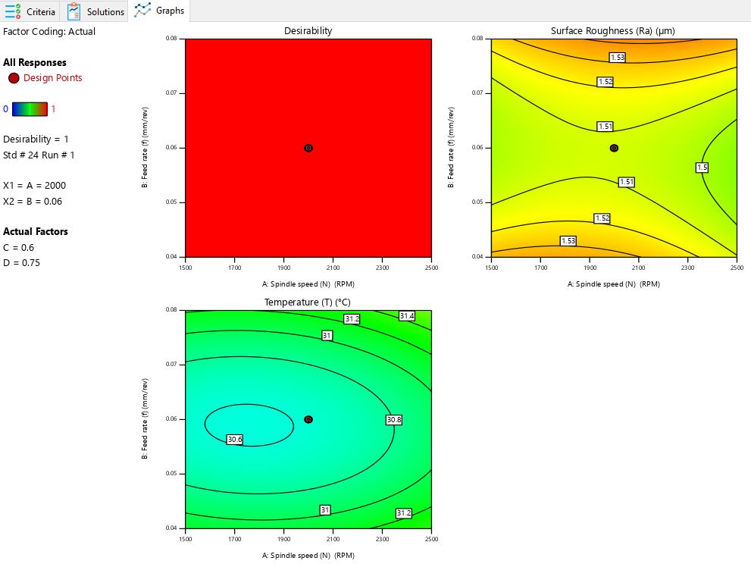

Figure 12. Contour plot on desirability for (a) Vc vs. Fz, (b) Vc vs. Dc and (c) Vc vs. Rn. Plots

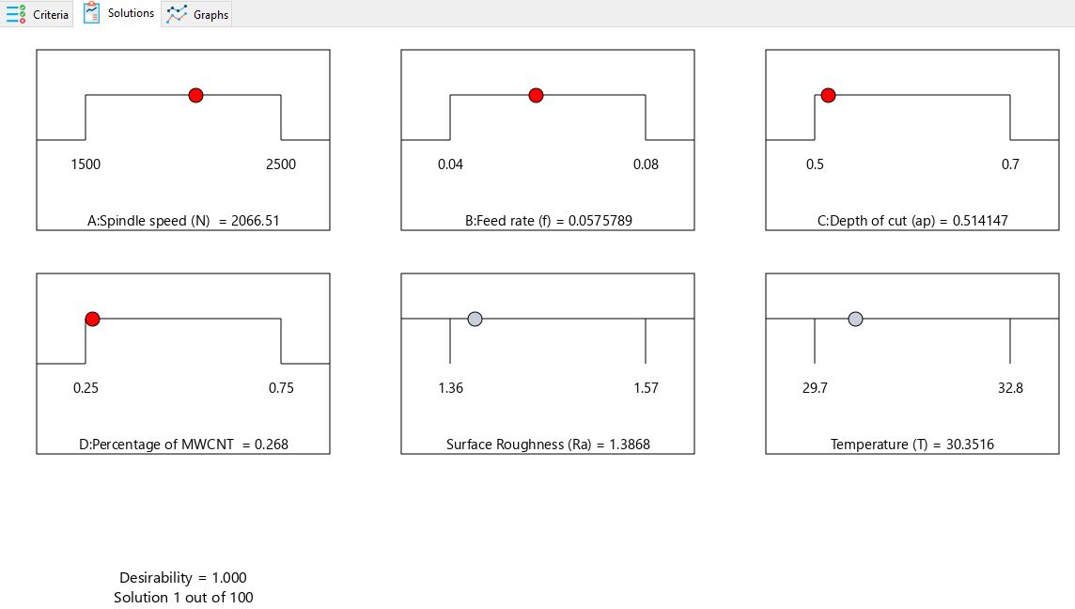
Figure 13. Optimal parameter ramps function graphs and combined optimization.
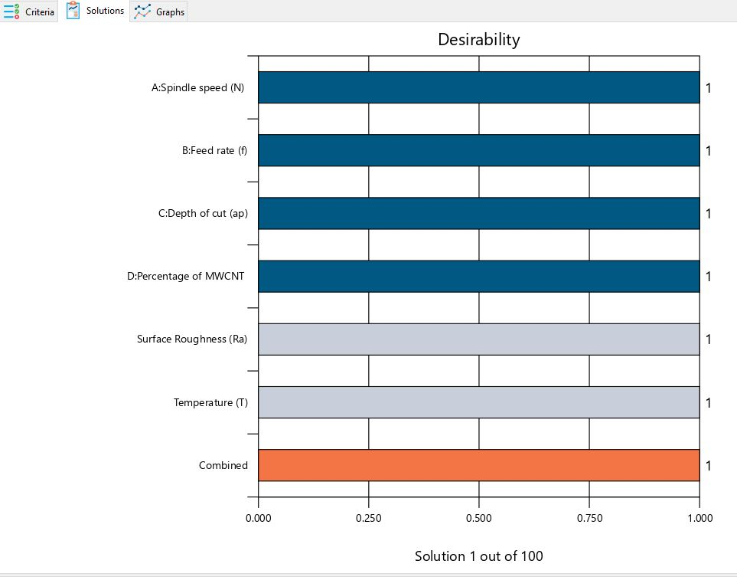
Figure 14. Desirability bar graph for combined optimization
Figure 13 shows the ramps of the optimization result. Red dots indicate the exact component values, and black dots indicate objective satisfaction. It is better if the ramp appears higher. Figure 14 presents the corresponding desirability bar graph for the given cutting conditions, responses, and a total desirability of 1.00. The brown bottom bar indicates the desirability of all the parameters and responses. However, the goal of the optimization procedure is not to obtain a D value of 1, but to find the appropriate combination of conditions. Thus, the best approach to ensure attractiveness is to use a shallow cutting depth when operating at high speeds and low feed rates. Table 9 provides the optimal values for milling MWCNT-reinforced LM26.

Table 9. Optimum values during the milling of aluminum.
Sl.No | Input Parameter | Goal | Optimum Value
1 | Spindle speed (N) | In range | 2500.00
2 | Feed rate (f) | In range | 0.04
3 | Depth of cut (a_{p}) | In range | 0.50
4 | Weight Percentage of MWCNT | In range | 0.25
5 | Surface Roughness (Ra) | In range | 1.35
6 | Temperature (T) | Minimize | 30.29
7 | Overall Desirability | Minimize | 1.000

9. Model validation

The optimum conditions are derived from the desirability function analysis and then verified using physical observation data. Any error margin below ±2% ensures the model's accuracy. As shown in Table 10, surface roughness and temperature test results indicate that the model agrees well with the ideal cutting settings (as predicted by DFA).

Table 9. Optimized process parameter—validation model.

Sl.No | Spindle speed (N) | Feed Rate (f) | Depth of cut (a_{p}) | Wt. Percentage of MWCNT (%) | Observations | Confirmatory Test
 |  |  |  |  |  | DFA (Opti. Value) | Exp. Value | % Error
1 | 2500.00 | 0.04 | 0.50 | 0.25 | Ra | 1.35 | 1.34 | 0.74
 |  |  |  |  | T | 30.29 | 30.27 | 0.06
2 | 1500.00 | 0.08 | 0.50 | 0.25 | Ra | 1.42 | 1.44 | -1.41
 |  |  |  |  | T | 31.91 | 31.88 | 0.09

Conclusion

Design-Expert software was used to analyze the experimental results obtained using a central composite design (CCD) on a milling machine with MWCNT-reinforced LM26. ANOVA was used to examine the Ra and temperature performance characteristics. The study investigated interaction effects among the cutting parameters. To achieve the optimized values, desirability function analysis was also carried out. This study has led to the following conclusions:

- In accordance with the ANOVA results, the most significant factor influencing Ra and temperature is the percentage of MWCNT, followed by feed rate on temperature and spindle speed on Ra.
- The findings show that adding 0.25% wt. MWCNTs enhanced machinability; nevertheless, increasing the MWCNT content increased temperature and Ra values.
- The best machining settings were determined by multi-response desirability analysis to be 2500 RPM spindle speed, 0.04 mm/rev feed rate, 0.5 mm depth of cut, and 0.25 weight percent MWCNT.
- Ra and temperature were 1.35 µm and 30.29°C, respectively, under these circumstances, resulting in a desirability value of 1.0.
- The confirmatory test was carried out, and the measured values and the percentage error agree well.

Reference

- Satishkumar, P., Gokila Krishnan, G., Seenivasan, S., & Rajarathnam, P. 2023. A study on tribological evaluation of hybrid aluminium metal matrix for thermal application. Mater. Today: Proc., 81(Part 2), 1097–1104.
- Premnath, A. A., Alwarsamy, T., & Rajmohan, T. 2012. Experimental investigation and optimization of process parameters in milling of hybrid metal matrix composites. Mater. Manuf. Process., 27(10), 1035-1044.
- Sreenivasulu, R. 2013. Optimization of surface roughness and delamination damage of GFRP composite material in end milling using Taguchi design method and artificial neural network. Procedia Eng, 64, 785-794.
- Karabulut, Ş. 2015. Optimization of surface roughness and cutting force during milling of AA7039/Al2O3 metal matrix composites using neural networks and the Taguchi method. Measurement, 66, 139-149.
- Zeelanbasha, N., Senthil, V., Sharon Sylvester, B., & Balamurugan, N. 2017. Modeling and experimental investigation of LM26 pressure die cast process parameters using multi-objective genetic algorithm (MOGA). Metalurgija, 56(3-4), 307-310.
- Pawar, S. Y., & Kharde, Y. R 2021. Tribological characterization of LM26/SiC/Ni.-Gr. Hybrid aluminium matrix composites (HAMCs) for high-temperature applications. Mater. Today: Proc., 37, 793-800.
- Pawar, S. Y., Haider, J., Pintaude, G., Sekar, S. M., Kolhe, V., Chandratre, K., ... & Ritapure, P 2023. Mechanical and tribological behavior of LM26/SiC/Ni-Gr hybrid composites—J. Compos. Sci, 7(4), 159.
- Kumaravel, P., Raja, K. V., & Suresh, P. 2023. Mechanical behavior of LM26/SiC/TiO2/Ni-Gr reinforced hybrid metal matrix composites–An experimental investigation. J. Ceram. Process. Res., 24(3), 569-577.
- Prakash, C., Senthil, P., Manikandan, N., & Palanisamy, D. 2022. Investigations on machinability characteristics of cast aluminum alloy-based (LM 26+ Graphite+ Fly ash) hybrid metal matrix composites for automobile components. Mater. Manuf. Process, 37(7), 748-763.
- Prakash, C., Selvakumar, S., Manikandan, D., & Ramaswamy, K. 2025. Machinability analysis of LM26 aluminium metal matrix composites reinforced with graphite and fly Ash using the AWJM process. Sci. Rep, 15(1), 23613.
- Jafari, M., Abbasi, M. H., Enayati, M. H., & Karimzadeh, F. 2012. Mechanical properties of nanostructured Al2024–MWCNT composite prepared by optimized mechanical milling and hot pressing methods. Adv. Powder Technol., 23(2), 205-210.
- Sridhar, I., & Narayanan, K. R. 2009. Processing and characterization of MWCNT-reinforced aluminum matrix composites. J. Mater. Sci., 44(7), 1750-1756.
- Choi, H. J., Shin, J. H., & Bae, D. H. 2012. The effect of milling conditions on microstructures and mechanical properties of Al/MWCNT composites. Compos. Part A: Appl. Sci. Manuf., 43(7), 1061-1072.
- Jagannatham, M., Senthil Saravanan, M. S., Sivaprasad, K., & Kumaresh Babu, S. P. 2018. Mechanical and tribological behavior of multi-walled carbon nanotube-reinforced AA7075 composites prepared by powder metallurgy and hot extrusion. J. Mater. Eng. Perform, 27(11), 5675-5688.
- Peng, T., & Chang, I. 2014. Mechanical alloying of multi-walled carbon nanotubes reinforced aluminum composite powder. Powder Technol., 266, 7-15.
- Jamil, M., Khan, A. M., Hegab, H., Gupta, M. K., Mia, M., He, N., ... & Liu, Z. 2020. Milling of Ti–6Al–4V under hybrid Al2O3-MWCNT nanofluids considering energy consumption, surface quality, and tool wear: a sustainable machining. The Int. J. of Adv. Manu.Tech, 107(9), 4141-4157.
- Feijoo, I., Pena, G., Cristóbal, M. J., Cabeza, M., & Rey, P. 2022. Effect of carbon nanotube content and mechanical milling conditions on the manufacture of AA7075/MWCNT composites. Metals, 12(6), 1020.
- Paul, S., Singh, A. K., & Ghosh, A. 2017. Grinding of Ti-6Al-4V under a small-quantity cooling lubrication environment using alumina and MWCNT nanofluids. Mater. Manuf. Process, 32(6), 608-615.
- Sravanthi, K., Mahesh, V., Rao, B. N., Fernandez, G., & Haiter, L. A. 2022. Carbon‐Filled E‐Glass Fiber-Reinforced Epoxy Composite: Erosive Wear Properties at an Angle of Impingement—Adv. Mater. Sci. Eng, (1), 8725305.
- Uthale, S., Shinde, D., Shahapure, N., Kulkarni, S., & Nikam, M. 2024. Effect of MWCNTS on mechanical properties of woven fabric hybrid polymeric nanocomposites and finite element analysis of nanocomposite. Int. J. Interact. Des. Manuf., 18(10), 7477-7494.
- Ngoma, M. M., Mathaba, M., & Moothi, K. 2021. Effect of carbon nanotube loading and pressure on the performance of a polyethersulfone (PES)/carbon nanotubes (CNT) membrane. Sci. Rep, 11(1), 23805.
- Chen L, Hou Z, Liu Y, Luan C, Zhu L, Li W 2020. High strength and high ductility copper matrix composite reinforced by graded distribution of carbon nanotubes. Compos. Part A Appl. Sci. Manuf, 138:106063. Available from: https://doi.org/10.1016/j.compositesa.2020.106063
- Santhosh, A. J., Tura, A. D., Jiregna, I. T., Gemechu, W. F., Ashok, N., & Ponnusamy, M. 2021. Optimization of CNC turning parameters using face-centered CCD approach in RSM and ANN-genetic algorithm for AISI 4340 alloy steel. Results Eng., 11, 100251.
- Farouk, W. M., Ahmed, A. G., Gamil, M., Nasser, F. T., Abu-Okail, M., & Elamy, M. I. 2026. Hybrid intelligent RSM–ANN modeling and optimization of precision turning of CK45 steel for calibration devices. Sci. Rep
- Muthusamy Subramanian AV, Nachimuthu MDG, Cinnasamy V 2017. Assessment of cutting force and surface roughness in LM6/SiCp using response surface methodology. J Appl Res Technol. 15(3):283–96. Available from: http://dx.doi.org/10.1016/j.jart.2017.01.013
- Pasha, A., & Rajaprakash, B. M. (2022). Effect of CNT content on microstructure and hardness of AlSi/MWCNT nano composite. Mater. Today: Proc, 49, 1345-1350.
- Sharma R, Sasikumar C, Baral J 2024. Wear behavior of Al-MWCNT composites by varying MWCNT concentration. J Alloy Metall Syst. Sep;7:100104. Available from: https://linkinghub.elsevier.com/retrieve/pii/S2949917824000518
- Akiyama, Y., Iwaki, M., Komagamine, Y., Minakuchi, S., & Kanazawa, M. (2023). Effect of spindle speed and feed rate on surface roughness and milling duration in the fabrication of milled complete dentures: an in vitro study. Appl. Sci, 13(24), 13338.
- Öndin, O., Kıvak, T., Sarıkaya, M., & Yıldırım, Ç. V. 2020. Investigation of the influence of MWCNT-mixed nanofluid on the machinability characteristics of PH 13-8 Mo stainless steel. Tribol. Int, 148, 106323.
- Bilen, K., Kızılkaya, H. Z., & Güldaş, A. 2026. Experimental investigation of effects of nano-fluid usage on cooling in machining. J. Therm. Sci. Technol, 46(1), 79-89.
- Sulaiman, S., Roshan, A., & Borazjani, S. 2014. Effect of cutting parameters on tool-chip interface temperature in an orthogonal turning process. Adv. Mater. Res, 903, 21-26.
- Sivarajan, S., & Padmanabhan, R. 2014. Green machining and forming using surface-coated tools. Procedia Eng, 97, 15-21.
- Kumanek, B., & Janas, D. 2019. Thermal conductivity of carbon nanotube networks: A review. J. Mater. Sci.. 54(10), 7397–427.
- Perec, A. 2022. Desirability function analysis (DFA) in multiple responses optimization of abrasive water jet cutting process. Rep. Mech. Eng, 3(1), 11-19.
- Das, R., Ball, A. K., & Roy, S. S. 2017. Optimization of E-jet-based micro-manufacturing process using desirability function analysis. In Industry Inter. Inno. in Sci., Eng and Techno: Proc. of the Inter. Conf., I3SET 2016 (477-484). Singapore: Springer Singapore.

