Towards self-diagnosing FFF components: Relating conductivity loss to mechanical degradation under accelerated environmental aging
V Gribniak*, A Rimkus, R Kovalenkovas, and S Rajendran
Vilnius Gediminas Technical University, Lithuania

* viktor.gribniak@vilniustech.lt
Abstract. Fused filament fabrication (FFF) enables low-cost manufacturing of customized polymer components with integrated sensing capabilities, creating opportunities for flexible structural health monitoring systems. Polylactic acid modified with carbon black (PLA/CB) is particularly attractive for these applications because it allows direct incorporation of electrical conductivity during printing with commercial desktop printers. However, PLA aging may affect the self-sensing functionality. This study investigates the effect of accelerated aging on the mechanical and electrical characteristics of FFF PLA/CB components, and employs commercially available PLA and conductive PLA/CB filaments. The accelerated aging tests, combining UV irradiation at 50 °C and condensation, lasted up to 28 days; control specimens were stored under laboratory conditions. Mechanical characteristics and electrical resistance were monitored periodically. Non-conductive PLA specimens served as mechanical references, while conductive specimens were tested using clamped electrical contacts and heat-set threaded inserts. The results showed minor changes in the mechanical response and no evidence of substantial degradation of the conductive PLA/CB network. In contrast, specimens with heat-set threaded inserts showed a substantial increase in electrical resistance, indicating that degradation at the metal-polymer interface predominantly governed the measured electrical response. These findings demonstrate that contact durability controls the long-term self-sensing functionality of FFF PLA/CB components.
- Introduction
Structural health monitoring systems increasingly require sensing elements tailored to specific geometries, deformation modes, and service conditions [1]. This need is especially relevant for offshore and petroleum infrastructure, where monitoring solutions must often adapt to complex structural details and demanding environmental conditions [2]. Fused filament fabrication (FFF) offers a low-cost and accessible manufacturing route for producing such customized components using widely available desktop 3D printers [3]. Among FFF materials, polylactic acid (PLA) is attractive because of its printability, dimensional stability, and bio-based origin. Furthermore, PLA-based sensing devices can provide an environmentally favorable solution for temporary monitoring applications because they biodegrade after their service life ends [4]. However, neat PLA is electrically insulating and cannot self-sense. Incorporating conductive fillers such as carbon black (CB) creates electrically conductive pathways within the polymer matrix, enabling self-sensing PLA/CB components for electrodes, strain sensors, electromagnetic shielding, and resistive heating applications [5–8]. The electrical response of printed components depends not only on material composition but also on the printing process, conductive network morphology, and contact-interface quality [8].
Electrical transport in polymer/CB composites occurs through direct contacts between conductive particles and electron tunneling across small polymer gaps [9, 10]. Consequently, changes in particle spacing caused by mechanical deformation or temperature can substantially alter electrical resistance [9–11]. This coupling between the mechanical state and electrical response provides the basis for using conductive polymer composites as self-sensing materials.
Environmental durability remains a major limitation for long-term PLA-based applications. UV radiation, moisture, and elevated temperature promote PLA chain scission and structural changes, resulting in progressive embrittlement and loss of mechanical strength [12–14]. Although environmental degradation of PLA has been extensively investigated from mechanical, thermal, and chemical perspectives [12–14], far less is known about the corresponding evolution of the electrical properties of FFF-manufactured PLA/CB. Moreover, measured resistance may be affected not only by conductive-polymer degradation but also by the electrical contact between the printed component and metal terminals [15, 16].
This study aims to evaluate the effect of accelerated aging, combining UV irradiation at 50 °C and condensation, on the mechanical and electrical resistances of FFF-manufactured PLA/CB samples. It examines whether aging-induced changes in electrical resistance can indicate mechanical degradation and how the electrical contact configuration influences the measured resistance changes during aging. For this purpose, PLA/CB specimens with two contact configurations, namely clamped contacts and heat-set threaded inserts, were subjected to accelerated aging for up to 28 days and compared with counterparts stored under laboratory conditions. Ordinary PLA specimens were included as a benchmark for the aging response of unfilled FFF PLA. The test program employs commercially available PLA and conductive PLA/CB filaments.
- Materials and methods
The experimental program was designed to evaluate the effect of environmental aging on the mechanical and electrical performance of FFF-PLA components. Two polymeric materials were considered: conventional non-conductive PLA as a reference and electrically conductive PLA/CB, the primary focus of this investigation. The test program combined controlled environmental exposure, uniaxial tensile testing, mass-loss monitoring, and, for the conductive specimens, simultaneous electrical resistance measurements. The specimens were tested immediately after fabrication and after 7, 14, 21, and 28 days of exposure.

Materials and specimen preparation
Two commercially available filaments with a nominal diameter of 1.75 mm were used without further modification of the material content. The ordinary (non-conductive) specimens were fabricated from High Speed Pro PLA (colorFabb, Belfeld, The Netherlands) [17]. The conductive specimens were fabricated from ProtoPasta Conductive PLA (Protoplant, Vancouver, WA, USA), a commercial compound of NatureWorks Ingeo 4043D PLA, a dispersant, and conductive CB at a content below 21.4 wt.% [18]. In this program, ordinary PLA served as the benchmark response for the same aging protocol, ensuring only qualitative comparisons between PLA and PLA/CB specimens.
The manufacturer [17] specified the following mechanical characteristics of PLA: a density of 1.24 g/cm³, a tensile modulus of 2.63 GPa, a tensile strength of 43.7 MPa, and an elongation at break of 5.7%. Its glass-transition and melting temperatures are approximately 60 °C and 165 °C, respectively.
For the PLA/CB filament, the manufacturer did not report mechanical characteristics; qualitatively, the printed PLA/CB is described as less stiff than neat PLA, with weaker interlayer adhesion and failure along layer lines [18]. Its heat resistance is similar to that of ordinary PLA, with a recommended service temperature below 50 °C [18], and its glass-transition temperature is 62 °C [19]. The electrical resistance of printed parts depends on geometry and printing parameters. The specified [18] resistance ranges from 2.0 to 3.5 kΩ for a 100 mm long filament segment, corresponding to a volume resistivity of 4.8–8.4 Ω·cm, and a volume resistivity of 15 Ω·cm for the molded compound, 30 Ω·cm for printed parts along the layers (in-plane), and 115 Ω·cm perpendicular to the layers.
All specimens were fabricated using a Bambu Lab P1S printer (Bambu Lab, Shenzhen, China; Figure 1a) with a 0.4 mm nozzle and prepared in Bambu Studio software (version 2.7.1.57, Bambu Lab, Shenzhen, China). The specimens were produced with 100% infill density, a 0.20 mm layer height, and two outer wall loops. The extrusion temperature was 220 °C, and the build plate temperature was 55 °C. The extrusion temperature of 220 °C falls within the recommended range for conductive PLA (215-230 °C) [18] and for the reference PLA [17]. The printing speeds were 200 mm/s for the outer walls and 230 mm/s for the infill. The same fabrication parameters were maintained for all specimen groups to minimize manufacturing variability and reduce its influence on the subsequent comparison of mechanical and electrical characteristics.
The tensile specimens followed the dumbbell-shaped Type I geometry specified in ASTM D638 [20]. The nominal specimen geometry comprised an overall length of 165 mm, a 57 mm long reduced section, a width of 13 mm within the reduced section, and a thickness of 3.2 mm (Figure 1b). The specimens were printed flat, with their longitudinal axis corresponding to the tensile loading direction. The internal raster was arranged at ±45° relative to the loading direction, with the orientation alternating between consecutive layers.
Three specimen configurations were investigated, as shown in Figure 1b. The P-type specimens were fabricated from reference PLA and determined the baseline for evaluating the mechanical response. The remaining two configurations were fabricated from PLA/CB and differed in the electrical contact arrangement. In the C-type specimens, the electrical connection was established directly on the printed conductive material by mechanically clamping the measurement leads on the specimen. In the I-type specimens, brass heat-set threaded inserts (M3, 5.7 mm long) were installed at the contact locations using a soldering iron at 180 °C, as shown in Figure 1c. These inserts were installed before aging and were exposed to the aging cycles, whereas the clamps of the C-type specimens were attached just before testing. For both configurations, the distance between the electrical contacts was 50 mm. The alternative contact configurations were introduced to evaluate the influence of the electrical interface on the measured resistance, which includes both the intrinsic resistance of the printed conductive material and the contribution of the contact characteristics.

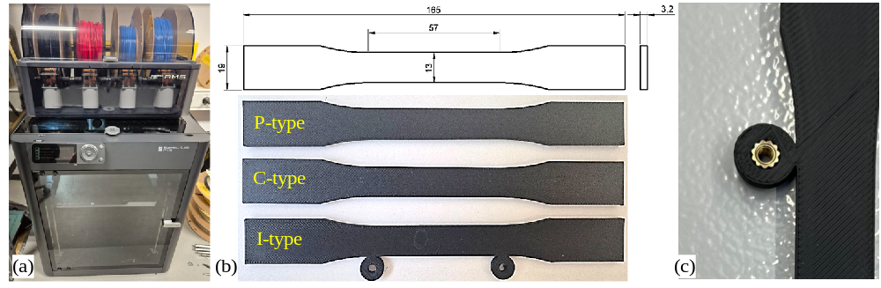
Figure 1. Specimen preparation and configurations: (a) Bambu Lab P1S printer used for specimen fabrication; (b) ASTM D638 Type I specimen geometry and P-, C-, and I-type specimens; (c) heat-set threaded insert of the I-type specimen.

Environmental exposure and test program
The experimental program included 112 specimens. The accelerated-aging series comprised 75 specimens, with five specimens of each P, C, and I configuration tested just after fabrication and after 7, 14, 21, and 28 days of exposure, for a total of 25 specimens per configuration. The laboratory-conditioned reference series comprised 37 specimens (13 NAP, 13 NAC, and 11 NAI) tested after 21 days of storage at 23 ± 2 °C and 50 ± 10% relative humidity, and tested just after fabrication and after 7, 14, and 21 days. The prefix NA identifies specimens stored under laboratory conditions; the third letter indicates the specimen type. The number following the specimen type identifies the individual specimen, while the number after the hyphen indicates the conditioning period in days. For example, C12-14 denotes C-type specimen No. 12 tested after 14 days of accelerated aging, whereas NAC10-21 denotes C-type specimen No. 10 stored under laboratory conditions for 21 days. Because the tests were destructive, each time point comprised an independent set of specimens.
The accelerated UV-aging procedure was adapted from ASTM G154 Cycle 1 [21], which specifies repeated 12 h cycles comprising 8 h of UV irradiation at 0.89 W/(m²·nm) at 340 nm and a black-panel temperature of 60 ± 3 °C, followed by 4 h of condensation under saturated humid conditions. The standard temperature was reduced to 50 ± 3 °C, following the manufacturer’s recommendations [18]. At the same time, the applied 50 °C corresponds to the upper limit of the recommended service range, so thermal effects (e.g., physical aging or annealing) may have contributed to the observed changes. The condensation stage was maintained at 50 ± 3 °C under saturated humid conditions (RH = 100%). Therefore, the 28-day exposure comprised 56 cycles, corresponding to 448 h of UV irradiation and a cumulative radiant exposure of approximately 1.44 MJ/(m²·nm) at 340 nm.
Aging was accelerated in a UV weathering chamber LR-B002-B (Dongguan Lonroy Equipment Co., Ltd., Dongguan, China) equipped with UVA-340 fluorescent lamps (Figure 2a). The specimens were placed within the uniform irradiation zone with their side surfaces facing the lamps at a distance of 80 mm (Figure 2b) and were not repositioned during exposure. The specimens tested just after fabrication represented the initial material condition. For conditioning periods up to 21 days, the aged specimens were compared with the corresponding specimens stored under laboratory conditions.

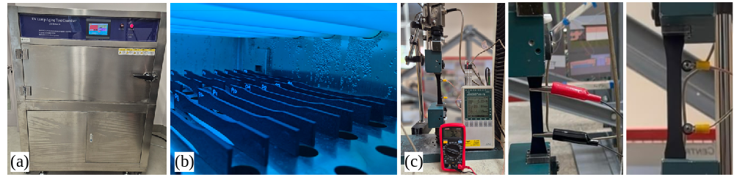
Figure 2. Experimental setup: (a) UV weathering chamber; (b) positioning of specimens during accelerated aging; (c) uniaxial tensile test setup with simultaneous force, displacement, and electrical resistance measurements of different configuration contacts.

Mechanical loading and electrical resistance measurements
Before mechanical testing, each specimen was weighed to evaluate possible mass changes associated with environmental conditioning. After removal from the chamber, the specimens were stored at 23 ± 2 °C and 50 ± 10% RH for 2 h before weighing. The relative mass change was calculated with respect to the mass recorded after fabrication; for I-type specimens, the mass included the heat-set inserts, which were installed before the initial weighing.
Uniaxial tensile tests were performed using a 75 kN capacity universal testing machine (Tinius Olsen, Redhill, UK), as shown in Figure 2c. It has a position measurement accuracy of ±0.01%. A 10 kN load cell recorded the tensile force with a measurement precision of 0.5%. Two linear variable displacement transducers (LVDTs, Ahlborn, Holzkirchen, Germany), with a 0.02% accuracy, monitored the relative vertical displacement of the grips; the average of the two measurements was used in the subsequent analysis. The mechanical loading and displacement signals were acquired using an Almemo 2890-9 data acquisition system (Ahlborn, Holzkirchen, Germany). The specimens were loaded monotonically in tension until failure at a crosshead displacement rate of 1 mm/min. The load-displacement response was used to evaluate changes in mechanical stiffness, load-bearing capacity, and deformation capacity with aging.
For the C- and I-type specimens, electrical resistance was monitored during tensile loading using a UT131B digital multimeter (Uni-Trend Technology Co., Ltd., Dongguan, China; Figure 2c). Resistance values were recorded in 0.05 kN increments of applied tensile load. In the approximately linear portion of the load-displacement response, this corresponded to a displacement interval of approximately 0.15 mm, or about 10 s at the applied crosshead rate of 1 mm/min. For the C-type specimens, the multimeter leads were connected directly to the printed PLA/CB material using crocodile clips. For the I-type specimens, heat-set threaded inserts were embedded at the contact locations, and a screw was threaded into each insert to connect the multimeter leads. Because a two-terminal measurement arrangement was employed, the recorded resistance included both the resistance of the printed conductive path and the contribution of the electrical contact interface. Figure 2c shows both contact configurations and the corresponding resistance measurement arrangements. The initial resistance R₀ was recorded after mounting the specimen in the grips and before loading, and the resistance change was calculated as ΔR = R − R₀. The multimeter’s measurement current was negligibly low; therefore, Joule heating, which affects this material’s response under higher electric fields [19], was disregarded.
Because electrical resistance was measured through mechanical contacts, some records were affected by interrupted contact, data-acquisition dropouts, or other irregularities. Records were excluded from further consideration if the multimeter displayed an open circuit (overload) or zero resistance before specimen failure, if the resistance changed by more than 15% between consecutive readings without a corresponding change in load, or if the loading history was incomplete, i.e., resistance readings were missing for more than two consecutive load increments or were not available up to at least 90% of the peak load.
- Results and discussion

Mass changes due to aging
No systematic change in specimen mass was observed during accelerated aging and laboratory storage. Across all specimen configurations, the mean relative mass change remained within approximately ±0.6% throughout the 28-day exposure period. It fluctuated around zero rather than following a consistent trend, indicating neither measurable material loss nor persistent moisture uptake. This result agrees with the experimental findings from references [12–14], where UV-induced chain scission, changes in crystallinity, and embrittlement of PLA preceded measurable mass loss. Therefore, the absence of mass change does not exclude changes in the mechanical or electrical characteristics examined in the following sections.

The effect of contact configuration on the electrical resistance
A substantial difference was observed between the two electrical contact configurations (specimen types C and I; Figure 1b) even under initial conditions. The I-type specimens exhibited an initial resistance of 353 ± 7 Ω, whereas the directly contacted C-type specimens showed a considerably higher and more scattered value of 896 ± 222 Ω. Thus, the heat-set threaded inserts provided a lower and substantially more reproducible initial electrical connection. This difference stems from the contact conditions: the insert, embedded in the locally melted PLA/CB, forms a large, geometrically robust contact area, whereas the local contact quality of the clamps depends on surface roughness and clamping force, which were beyond control. Moreover, the measured resistances cannot be compared with values provided by the manufacturer because the reported resistivity ranges from about 5 Ω·cm (filament) to 30 Ω·cm (printed parts) and depends on printing parameters [18]; therefore, the contribution of the contact configuration was assessed by comparing the C- and I-type specimens printed with identical parameters.
Accelerated aging affected these configurations differently. For I-type specimens, the mean resistance increased from 353 ± 7 Ω at Day 0 to 703 ± 96 Ω after 7 days and 929 ± 160 Ω after 14 days. The maximum mean value of 1205 ± 243 Ω was reached after 21 days, about 3.4 times the initial resistance. After 28 days, resistance decreased to 932 ± 188 Ω but remained about 2.6 times higher than the initial value.
In contrast, the directly contacted C-type specimens did not exhibit a corresponding increase with aging. Their mean resistance decreased from 896 ± 222 Ω at Day 0 to 658 ± 86 Ω, 594 ± 69 Ω, and 555 ± 34 Ω after 7, 14, and 21 days, respectively, and reached 700 ± 152 Ω after 28 days. Thus, this contact configuration showed no progressive loss of electrical conductivity during the investigated exposure period.
The laboratory-conditioned I-type specimens also remained comparatively stable, with mean resistance values of 343 ± 3 Ω, 333 ± 5 Ω, 315 ± 53 Ω, and 343 ± 8 Ω at 0, 7, 14, and 21 days, respectively. The resistance of the laboratory-conditioned C-type specimens showed greater scatter, which is consistent with the lower reproducibility of direct mechanical contact, but no sustained time-dependent increase was observed.

Interpreting the electrical resistance trends
The key difference between the two contact configurations is that the insert-PLA/CB interface was exposed to the aging cycles. In contrast, the clamp contacts of the C-type specimens were formed on the aged surface just before testing. The contrasting responses of the I- and C-type specimens strongly suggest that the pronounced increase in resistance observed for the UV-aged I-type specimens is primarily associated with changes at the heat-set insert-PLA/CB interface, rather than with uniform deterioration of the conductive CB network within the polymer bulk. A bulk degradation mechanism would be expected to affect both conductive specimen configurations exposed to the same environmental conditions, whereas the resistance increase was observed only when the heat-set threaded insert was present. Moreover, corresponding I-type specimens stored under laboratory conditions retained essentially unchanged resistance. The progressive increase in scatter of the UV-aged I-type results provides additional evidence of an interface-controlled process. The standard deviation increased from 7 Ω after fabrication to 243 Ω at day 21, indicating increasing specimen-to-specimen variability as environmental exposure progressed. Such behavior is consistent with electrical contact resistance being controlled by local contact conditions rather than by a homogeneous change throughout the specimen volume [15, 16]. Possible mechanisms include changes in the effective contact area, formation of interfacial films, and loss or redistribution of contact pressure due to environmental and thermally induced dimensional changes. These mechanisms cannot be distinguished individually from the present measurements and should therefore be regarded as possible explanations rather than directly observed degradation processes.
The decrease in the mean resistance of the aged C-type specimens, from 896 ± 222 Ω to 555 ± 34 Ω after 21 days, requires a separate explanation. Because the exposure temperature (50 °C) matches the upper service limit of PLA/CB [18], this decrease may reflect thermally induced rearrangement of the CB network in the PLA matrix; the reduced scatter indicates it is not a contact artifact. Moreover, substantial degradation of the conductive network was not expected under the applied conditions. In particular, Crespo-Miguel et al. [19] reported degradation of the same PLA material associated with mesostructural pore growth after heating above the glass-transition temperature. However, the aging temperature was approximately 12 °C below the glass-transition temperature in this study.
Each measurement time represents an independent dataset of several specimens. Therefore, the lower mean resistance after 28 days (932 ± 188 Ω) than after 21 days (1205 ± 243 Ω) is not treated as a physical process since it lies within the specimen-to-specimen scatter of the results. After 28 days, the resistance remained about 2.6 times higher than the initial value. Consequently, assessment of the durability of conductive PLA/CB components should distinguish changes in the conductive polymer from changes introduced by the electrical termination.

Mechanical response vs. electrical resistance changes
The electrical resistance was measured through mechanical contacts. Therefore, some individual records were compromised by unstable or interrupted contact at the clamped leads or the heat-set threaded insert, by data-acquisition dropouts, or by irregularities in specimen mounting. Figures 3 and 4 show results from selected specimens with valid records, as described in Section 2.

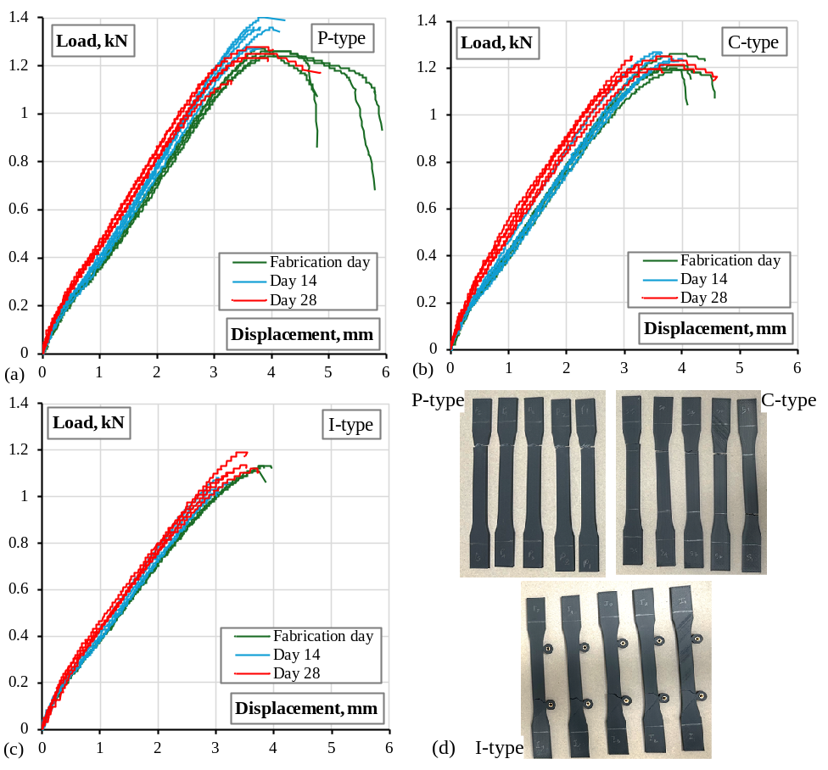
Figure 3. Experimental characterization of the investigated specimens: (a)–(c) load-displacement response of P-type, C-type, and I-type specimens, respectively; (d) representative failure modes of all specimen types.

Figure 3 shows the load-displacement diagrams, and Figure 4 relates the electrical resistance changes to measured displacement. All specimen types showed comparable mechanical stiffness and load-bearing capacity, with minimal changes due to aging. Modest aging reduced the deformation capacity of the neat P-type specimens, consistent with UV-induced embrittlement of PLA reported in [12–14]. The I-type specimens carried slightly lower loads and, as shown in Figure 3d, consistently fractured near the heat-set insert, which represents the mechanically critical region of these specimens.
The electrical resistance increased with mechanical tension in both specimen configurations (Figure 4), confirming the piezoresistive coupling that underlies self-sensing [9–11]; the I-type specimens with heat-set threaded inserts produced a smoother diagram than the C-type specimens with clamped electrodes. This mechanical behavior contrasts with the up to 3.4-fold increase in initial resistance of the aged I-type specimens (Sections 3.2 and 3.3). Under the applied exposure, the mechanical response changed only marginally, and the largest resistance changes occurred in specimens with an aged PLA-metal contact interface, primarily reflecting the electrical termination condition. Therefore, the measured resistance cannot be considered an indicator of mechanical aging. Further research should focus on smoothing contact degradation at the boundaries of heat-set threaded inserts or developing alternative contact technologies resistant to mechanical load and aging.

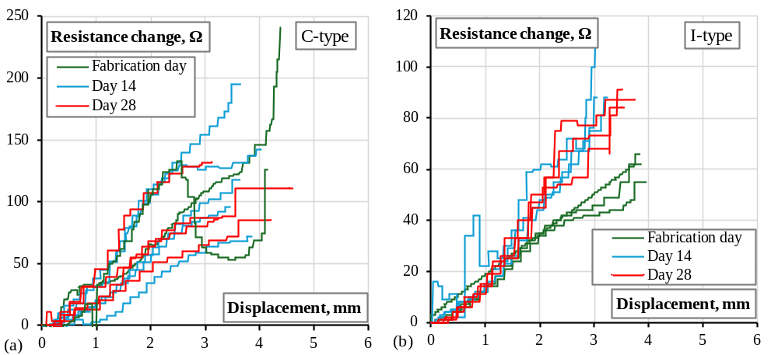
Figure 4. Electrical resistance change-displacement response of conductive specimens: (a) C-type specimens; (b) I-type specimens.

- Conclusions
Structural health monitoring often requires sensing elements tailored to specific geometries and service conditions. Fused filament fabrication (FFF) provides an accessible manufacturing route for producing such customized self-monitoring components using conductive polymeric composites. To assess the durability of these systems, this study investigated the mechanical and electrical characteristics of FFF-manufactured polylactic acid modified with carbon black (PLA/CB) specimens subjected to accelerated aging. The experimental results lead to the following conclusions:
- Contrary to the initial expectation that aging-induced deterioration of the conductive network could be tracked through electrical resistance changes, the results indicate that the PLA/CB material retained electrical conductivity during accelerated aging, whereas substantial resistance increases originated primarily at the metal-polymer interface of the heat-set threaded inserts.
- Tension tests showed that the stiffness and load-bearing capacity changed marginally with aging, with only a minor reduction in the ductility of the neat PLA. Specimens with heat-set threaded inserts consistently failed at the insert installation site, identifying it as the mechanically critical region. The measured electrical resistance confirmed the piezoresistive self-sensing capability of the conductive PLA/CB material.
- No systematic mass change was observed during the 28-day accelerated aging period. The mean relative mass variation remained within approximately ±0.6% for all investigated specimen configurations, indicating that the applied environmental exposure did not cause measurable bulk material loss or persistent moisture uptake.
- The electrical response strongly depended on the contact configuration. Heat-set threaded inserts provided substantially lower and more reproducible initial resistance than clamped electrodes but exhibited significantly greater sensitivity to accelerated aging. Future research should focus on improving the environmental resistance of heat-set insert connections or developing alternative contact technologies suitable for long-term service.
Acknowledgments
The Authors appreciate financial support from the Research Council of Lithuania (LMTLT) under the project “Developing electrically conductive polymer (nano)composites for additive manufacturing of mechanically resilient objects with self-sensing abilities,” Grant No. S-MIP-25-74.
References
- Ogunleye R O, Rusnáková S, Javořík J, Žaludek M and Kotlánová B 2024 Advanced sensors and sensing systems for structural health monitoring in aerospace composites, Adv. Eng. Mater. 26(22), 2401745. https://doi.org/10.1002/adem.202401745
- Mardanshahi A, Sreekumar A, Yang X, Barman S K, and Chronopoulos D 2025 Sensing techniques for structural health monitoring: A state-of-the-art review on performance criteria and new-generation technologies, Sensors 25(5), 1424. https://doi.org/10.3390/s25051424
- Masiuchok O, Iurzhenko M, Kolisnyk R, Mamunya Y, Godzierz M, Demchenko V, Yermolenko D and Shadrin A 2022 Polylactide/carbon black segregated composites for 3D printing of conductive products, Polymers 14(19), 4022. https://doi.org/10.3390/polym14194022
- Farh M M, Rimkus A, Meškėnas A and Gribniak V 2026 Recent advancements in the additive manufacturing of fiber-reinforced polymeric composites, Rev. Adv. Mater. Sci. 65(1), 20250228. https://doi.org/10.1515/rams-2025-0228
- Leigh S J, Bradley R J, Purssell C P, Billson D R and Hutchins D A 2012 A simple, low-cost conductive composite material for 3D printing of electronic sensors, PLOS One 7(11), e49365. https://doi.org/10.1371/journal.pone.0049365
- Sathies T, Senthil P and Prakash C 2019 Application of 3D printed PLA-carbon black conductive polymer composite in solvent sensing, Mater. Res. Express 6(11), 115349. https://doi.org/10.1088/2053-1591/ab5040
- Vaneckova E, Bouša M, Lachmanová Š N, Rathouský J, Gál M, Sebechlebská T and Kolivoška V 2020 3D printed polylactic acid/carbon black electrodes with nearly ideal electrochemical behaviour, J. Electroanal. Chem. 857, 113745. https://doi.org/10.1016/j.jelechem.2019.113745
- Delbart R, Noble T, Roumy L, Fernandez Toribio J C, Robert C, Truong Hoang T Q and Martinez-Hergueta F 2023 Multiscale characterisation of the electrical response of 3D printed carbon black polylactic acid, J. Mater. Sci. 58, 13118-35. https://doi.org/10.1007/s10853-023-08840-6
- Tirado-Garcia I, Garcia-Gonzalez D, Garzon-Hernandez S, Rusinek A, Robles G, Martinez-Tarifa J M and Arias A 2021 Conductive 3D printed PLA composites: on the interplay of mechanical, electrical and thermal behaviours, Compos. Struct. 265, 113744. https://doi.org/10.1016/j.compstruct.2021.113744
- Berzina A, Klemenoks I and Knite M 2023 The influence of DC voltage on the conductivity of chloroprene rubber–carbon black composites for flexible resistive heating elements, RSC Adv. 13(26), 17678-84. https://doi.org/10.1039/d3ra01558k
- Meyer J 1973 Glass transition temperature as a guide to selection of polymers suitable for PTC materials, Polym. Eng. Sci. 13(6), 462-8. https://doi.org/10.1002/pen.760130611
- González-López M E, Martín del Campo A S, Robledo-Ortíz J R, Arellano M and Pérez-Fonseca A A 2020 Accelerated weathering of poly(lactic acid) and its biocomposites: a review, Polym. Degrad. Stab. 179, 109290. https://doi.org/10.1016/j.polymdegradstab.2020.109290
- Antunes A, Popelka A, Aljarod O, Hassan M K and Luyt A S 2020 Effects of rutile–TiO₂ nanoparticles on accelerated weathering degradation of poly(lactic acid), Polymers 12(5), 1096. https://doi.org/10.3390/polym12051096
- Faizaan M, Shenoy Baloor S, Nunna S, Nayak S Y, Shenoy R N, Kini C R and Creighton C 2026 Temporal evolution of structure–property relationship for UV+RH artificially weathered material extrusion additive manufactured PLA, Sci. Rep. 16, 11562. https://doi.org/10.1038/s41598-026-41192-0
- Sunguray C, Ürgün S, Fidan S and Bora M Ö 2026 Geometry-driven deformation and degradation behavior of crimped electrical connections under coupled environmental and chemical loading, Materials 19(11), 2342. https://doi.org/10.3390/ma19112342
- Braunovic M, Konchits V V and Myshkin N K 2006 Electrical Contacts: Fundamentals, Applications and Technology (Boca Raton, FL: CRC Press) p 670.
- colorFabb BV 2024 Technical Datasheet: colorFabb PLA High Speed PRO. Version 1.0 (Belfeld: colorFabb B.V.) p 2.
- Protoplant 2024 ProtoPasta Conductive PLA Technical Data Sheet (Vancouver, WA: Protoplant INC) p 2.
- Crespo-Miguel J, Garcia-Gonzalez D, Robles G, Hossain M, Martinez-Tarifa J M and Arias A 2023 Thermo-electro-mechanical aging and degradation of conductive 3D printed PLA/CB composite, Compos. Struct. 316, 116992. https://doi.org/10.1016/j.compstruct.2023.116992
- ASTM International 2015 Standard Test Method for Tensile Properties of Plastics, ASTM D638-14 (West Conshohocken, PA: ASTM International) p 17. https://doi.org/10.1520/D0638-14
- ASTM International 2023 Standard Practice for Operating Fluorescent Ultraviolet (UV) Lamp Apparatus for Exposure of Materials, ASTM G154-23 (West Conshohocken, PA: ASTM International) p 12. https://doi.org/10.1520/G0154-23

