Compressive Response of Gyroid Infill Structures at Different Relative Densities
A A Garcia-Granada^{1, *}, H Rostro-Gonzalez¹, I Selgar-Agramunt¹, G Gómez-Gras¹ and M.M. Aghdam ²
¹ IQS, University Ramon Llull, Spain
² Amirkabir University of Technology, Iran

* andres.garcia@iqs.url.edu
Abstract. Additive manufacturing enables significant weight reduction through controlled variation of infill density, yet reliable material data across densities is essential for accurate simulation. In this study, specimens were fabricated from standard PLA using consumer-grade printers with gyroid infill structures of varying relative densities. Experimental compression tests were performed to determine key mechanical properties, including Young's modulus, stress at 20% strain, and stored energy. These results are used to develop correlation-based fits that relate infill density to material response, providing a practical parameterization for simulation-driven design and optimization of lightweight parts. The derived material model facilitates more accurate predictions of structural behaviour in additively manufactured components. The results are compared with existing theoretical models and published data. Attention is given to elastic deformation, plastic yielding, buckling, and densification during compression. This work contributes to improved understanding and modelling of infill-dependent material behaviour, supporting more efficient and reliable design workflows in additive manufacturing applications.
- Introduction
Additive manufacturing (AM) enables significant weight reduction while maintaining acceptable mechanical performance through the use of cellular infill structures. Previous work by Garcia-Granada [1] focused on compression testing of fully solid PLA specimens, whereas Rostro-Gonzalez et al. [2] extended the analysis to gyroid structures and demonstrated that their mechanical response can be described using the power-law model proposed by Gibson and Ashby [3]. However, Rostro-Gonzalez et al. [2] showed that the mechanical response is affected by geometric scaling due to variations in the number of deposited layers forming the cell walls, highlighting a key limitation in current approaches.
Subsequent studies have explored the mechanical behaviour of gyroid lattices across different materials and configurations. Maconachie et al. [4] performed quasi-static compression tests on ABS gyroid structures and established power-law relationships for both Young's modulus and strength. Their regression models incorporated parameters such as the number of unit cells and wall thickness, yielding coefficients of 1.14 (R² = 0.965) for stiffness and 1.37 (R² = 0.955) for strength. Similarly, Kladovasilakis et al. [5] investigated PLA specimens with relative densities between 10% and 30% using gyroid, Schwarz-Diamond, and Schwarz-Primitive geometries. Both experimental tests and finite-element simulations were performed. Mechanical properties increased consistently with density; however, no general power-law relationship was proposed. Comparable observations were reported by Sankineni and Kumar [6].
Other works have focused on high-porosity structures. Alizadeh-Osgouei et al. [7] examined lattices with relative densities between 10% and 14%, proposing power-law fits based on limited experimental data, with exponents ranging widely from 1 to 4. Wallat et al. [8] studied the relationship between porosity and cell size in single gyroid cells through a computational approach, though without establishing a corresponding scaling law. Overall, most studies report power-law exponents for stiffness and strength typically ranging between 1.5 and 2.5. However, in nearly all cases, density variation is achieved by modifying wall thickness. This approach introduces manufacturing inconsistencies, particularly when thick walls require multiple deposited layers compared to single-layer thin walls at low densities, leading to unreliable and non-scalable results [2].
From a design perspective, reliable material models are essential for topology optimization. These models must account for process-dependent factors such as slicing strategy, printer configuration, and fabrication parameters [9], [10]. Recent advances in topology optimization and AI-assisted design have demonstrated the potential of graded infill structures. For example, Wang et al. [11] generated non-uniform infill distributions that minimize stress, while Khan et al. [12] achieved mass reductions up to 70% by mapping stress fields to lattice parameters. However, these approaches rely heavily on numerical validation, often without experimental verification using physically fabricated samples. This is a critical limitation, as Catafal et al. [9] showed that material behaviour strongly depends on manufacturing conditions.
Although recent developments in generative AI and machine learning, such as those reviewed by Su et al. [13], enable inverse design of lattice structures, most proposed geometries remain experimentally unvalidated. Mohseni & Khodaygan [14] used deep-learning CNN and GAN models to improve topology optimization defining better infill. Stollberg et al. [15] used neural networks embedded in topology optimization to simultaneously improve structure topology and relative density grading. They used a cantilever beam and a support bracket optimization. In all these studies, AI-generated geometries were primarily validated numerically. Physical manufacturing and experimental verification were generally not performed.
Even when experimental data are available, as in Maszybrocka et al. [16], non-standard modelling approaches (e.g., linear regression instead of power-law relationships) limit their general applicability. Other efforts, such as Liu et al. [17] and Kędziora et al.[18], demonstrated the effectiveness of graded infill strategies through physical testing, confirming improvements in strength and stiffness-to-weight ratios.
Modern slicing software allows the generation of gyroid infill structures with varying relative densities by adjusting the unit cell size rather than wall thickness. This approach enables the fabrication of structures with a consistent number of layers, improving reliability and reducing manufacturing variability and time. Despite this capability, comprehensive experimental characterization remains limited for gyroid infill generated through this method.
Therefore, the objective of this study is to systematically characterize gyroid infill structures across a range of relative densities using compression tests, while maintaining a constant wall thickness (i.e., a single-layer constraint). The goal is to establish a unique, scalable material law that accurately captures the mechanical response of gyroid infill. Unlike previous studies that focus on isolated stress or stiffness values, this work evaluates the full stress-strain behaviour, enabling accurate modelling of energy absorption and storage. This is particularly relevant for applications where energy dissipation and thermal effects are significant, as the stored energy can be directly related to temperature increases within the structure.

- Materials and methods

Additive manufacturing of gyroid infill
A Bambu Lab P2S desktop printer (Shenzhen Tuozhu Technology, Shenzhen, China) was used. The material was PLA with a nominal density of 1.24 g/cm³) Young's Modulus of 2580 ± 220 MPa in X and Y and 2060 ± 170 MPa in Z direction and a tensile strength of 35 ± 4 MPa in X and Y and 31 ± 3 MPa in Z direction.
A cube with a side length of L=20 mm was designed and exported as STL file. A 3 x 3 matrix was created to enable simultaneous fabrication with different infills. The same file was scaled to obtain cubes of side L=30 mm to reach the maximum force of compression machine calculated as tensile strength by area:
$F_{max}=σA=35·\left(30·30\right)=31500 N$ (1)
Bambu Studio v02.07.01.57 was used to generate the toolpaths. All specimens were printed with no outer walls (perimeters), no top layers, and no bottom layers, such that the printed structure consisted exclusively of the gyroid infill pattern. Therefore, the mechanical response measured in the compression tests corresponds solely to the behaviour of the gyroid infill and is not influenced by external shell layers. The target relative density was varied from 20% to 100%. Figure 1 shows that for a target relative density of 20%, only approximately 1.7 unit cells were required. For 30% the slicer used 5 unit cells, for 40% infill used 7 unit cells, for 50% used 9 unit cells… and finally for 100% slicer can not use gyroid and used straight lines to achieve the maximum density. This is summarised in Table 1 for both lengths of 20 and 30 mm.

Table 1. Unit cells as a function of density.
ρ | Unit cells L=20 | Unit cells L=30
0.2 | 1.7 | 2.5
0.3 | 5 | 7.5
0.4 | 7 | 10.5
0.5 | 9 | 13.5
0.6 | 11 | 16.5
0.7 | 13 | 19.5
0.8 | 15 | 22.5
0.9 | 17 | 25.5

Figure 1 shows on the left the slicing software snapshot of all infills and the real parts obtained on the right. A red mark was added on real parts near the top left corner (minimum x, maximum y and maximum z coordinate) to identify printing direction prior to testing. Parts were tested in compression later in z direction and in x direction. Analysing Figure 1 it is possible to count the number of unit cells used for both 20 and 30 mm scale. As expected, the specimens with a side length of 30 mm exhibited larger dimensions and greater mass than the corresponding 20 mm specimens. The weight of each part is also documented in Figure 1.

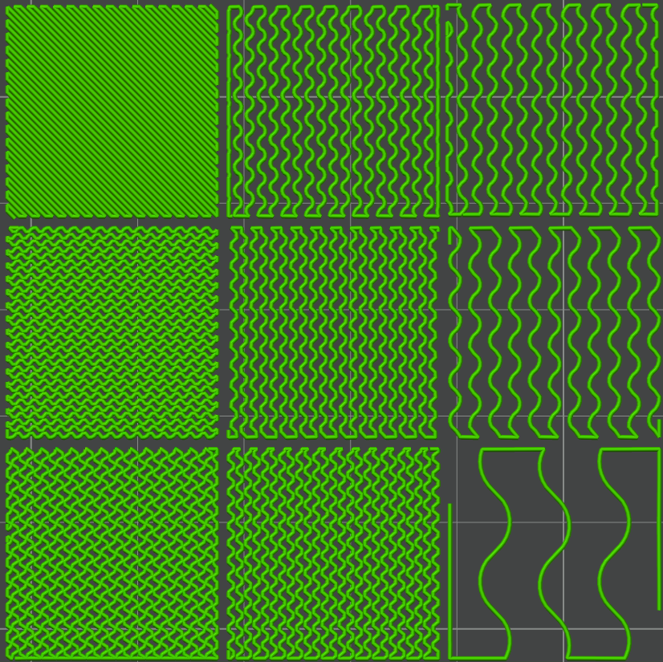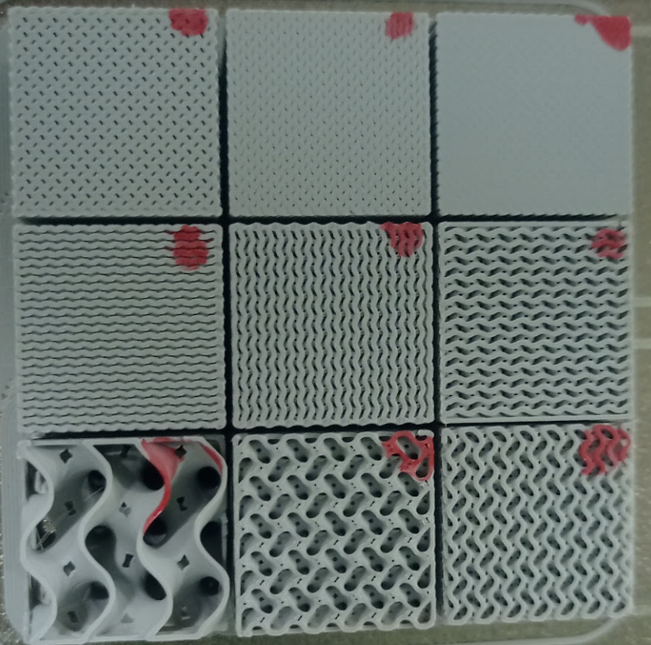
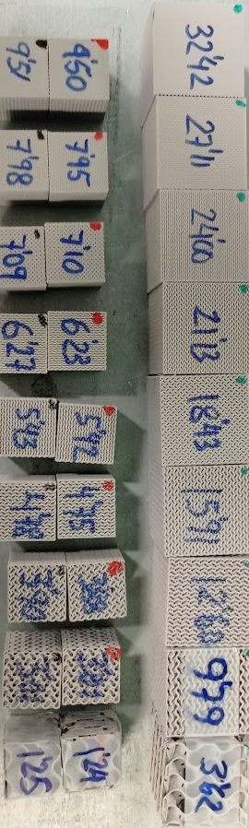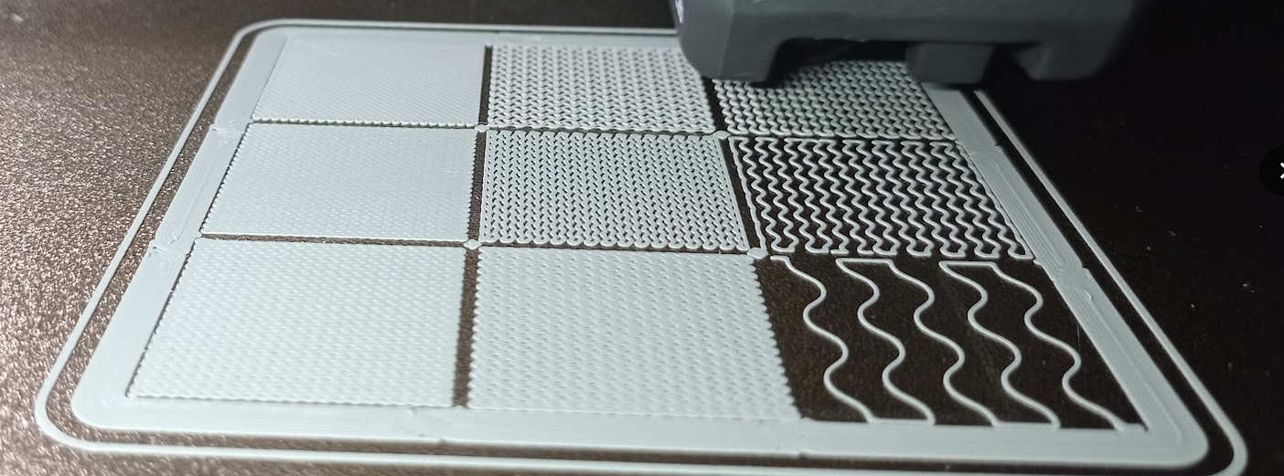
x
y
z
Figure 1. Slicing of solid 20 mm cubes using only gyroid infill with theoretical relative density from 20 to 90% and lines for 100% infill. Comparison of real 20 and 30 mm side with weights in grams and first layer fabrication for L=30.

Compression of gyroid structures
Compression tests were conducted using an Instron 5985 testing machine (Instron, Norwood, MA USA) with load capacity up to 100 kN was used with parallel plates as shown in Figure 2.
Speed was set to 12 mm/min for length 20 mm and 18 mm/min for length 30mm which resulted in the same strain rate of 12/(20·60)= 18/(30·60)=0.01 s⁻¹. In order to obtain a strain of 0.8=80% we required 0.8/0.01=80 seconds. Data recording was performed every 0.01 s (100 Hz) obtaining 80/0.01=8000 data points of time, force and displacement. Each configuration was tested with three samples for statistical purposes.

Thermal camera measurements
A thermal camera Flir i7 (Flir Systems, Wilsonville, Oregon, USA) was used as in previous research [2]. The specimens were observed to be warm after testing. The aim of using the thermal camera was to evaluate the conversion of mechanical energy into heat within the component.
Figure 2 shows the output of this camera providing a scale colour image with temperature in parallel with the real testing image.
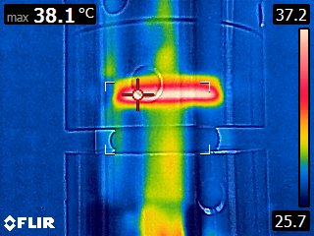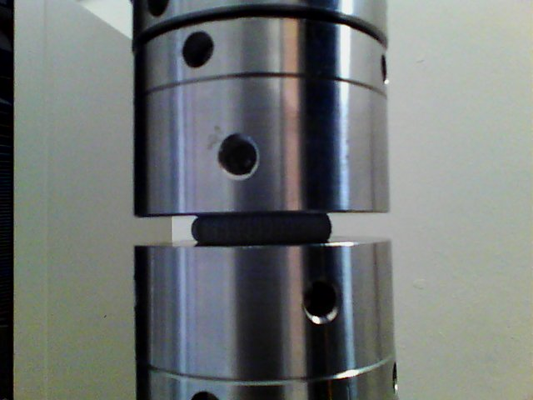
Figure 2. Temperature measurement for high compression of gyroid structures.

Theory to relate cross section, stiffness and energy to relative density
When we compress a hollow cube we need to divide the force by the real cross section and not just by cross section of a 100% filled cube. If we name for a hollow cube the side L and wall thickness t, then the relative density is calculated as follow:
$ρ=1-{(1-\frac{2t}{L})}^{3}$ (2)
When t=0 we have a relative density ρ=0, and when t=L/2 we have ρ=1.
For gyroid structures it is well accepted that material properties are dominated by density as reported by Wallat et al. [8]. Jin et al. [19] and Li et al. [20] proposed a linear relation between density and thickness. The best model was proposed by Gibson and Ashby [3] with the following equation:
$ρ_{gyroid}≈1-{\left(1-\frac{2t}{L}\right)}^{n}$ (3)
Where n is a parameter between 2.5 and 3 depending on researchers.
As it can be seen gyroid and hollow cubes follow the same pattern for relative density. It should be noted that t is half thickness of gyroid. From the minimal surface you can construct your solid by offsetting t to one side and t to the other side, ending in a gyroid for slicing of thickness 2t.
Cross section for a hollow cube can be expressed as function of relative density as follows:
$\frac{A}{L^{2}}=1-{(1-ρ)}^{2/3}$ (4)
Where A is dashed cross section, L is cube side length and ρ is relative density.

Figure 3 shows three different thickness configurations for hollow cubes summarised in Table 2.

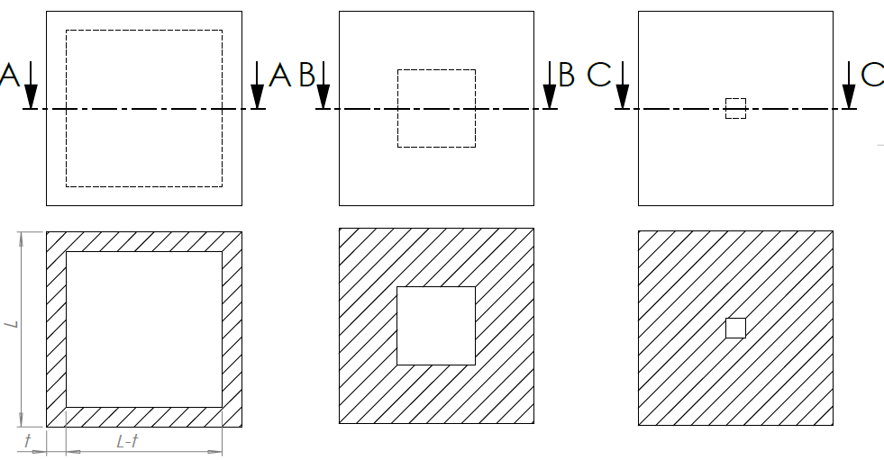
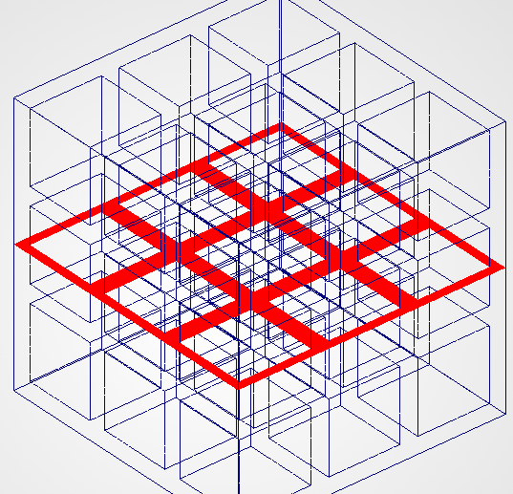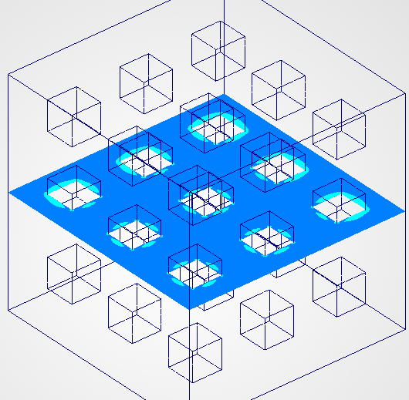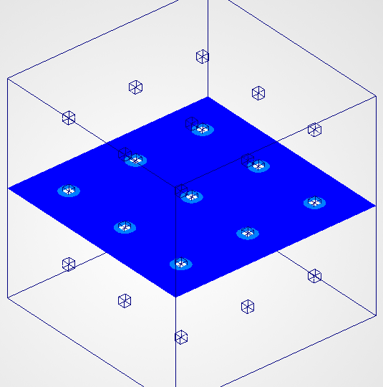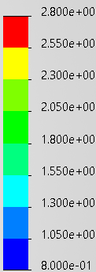
Figure 3. Hollow cube representation for different densities.

Table 2. Relative density for theoretical cross section.
 | t/L | ρ | A/L² | σ_{ρ}/σ₁ | σ₁/σ_{ρ} | δ_{ρ}/δ₁ | δ₁/δ_{ρ}
A | 0.100 | 0.488 | 0.360 | 2.78 | 0.3597 | 2.567 | 0.3896
B | 0.300 | 0.936 | 0.840 | 1.12 | 0.8929 | 1.108 | 0.9025
C | 0.450 | 0.999 | 0.990 | 1.01 | 0.9901 | 1.005 | 0.9954

Table 2 shows how for high densities above 50% we can relate stress and displacement to cross section ratios. The stress and displacement values reported in Table 2 were obtained from finite-element simulations and are included only to illustrate the nonlinear relationship between cross-sectional area, relative density and mechanical response. However, the main focus of this research is on more complex gyroid structures where we have less stress concentrations and we can approximate stress to cross section even better than for hollow cubes.

In order to obtain a model to normalize stress and energy for any porous structure we can obtain a power fit of cross section as function of relative density with power exponent. This exponent is 1.1361 using densities from 0.1 to 1. The exponent grows to 1.3899 if using only 6 data points for relative densities from 0.5 to 1 (named in Figure 4 as A-gt0.5). These exponents should be compared to exponent 2.2 for Gyroid used in Rostro-Gonzalez et al. [2] for just one relative density of 0.2 comparing relative errors for some densities as shown in Figure 4.
In Figure 4 we plot some properties against relative density showing nonlinearity. Even if a hollow cube is not the same as a gyroid. Although hollow cubes do not fully represent gyroid geometries, the model provides useful insight into the effect of cross-sectional reduction on mechanical response.

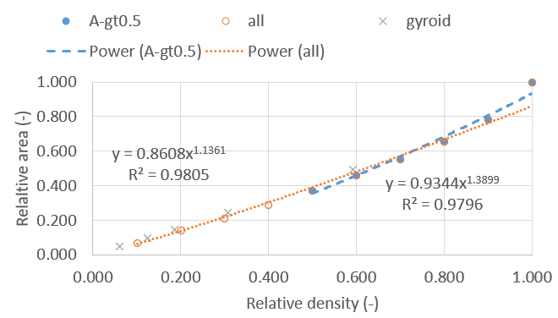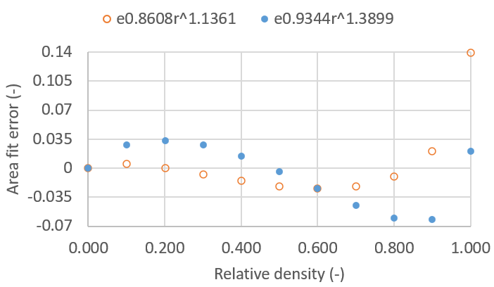
Figure 4. Area to relative density correlation for theoretical model with errors.

Once we have that area is fitted to a power-law function of relative density we can obtain a normalized stress as follows:
$σ_{ρ}=σ_{1}*ρ^{n}$ (5)
Where $σ_{ρ}$ is stress for a given relative density ρ, $σ_{1}$ is stress for 100% infill cube and n is our fitted exponent.
We can repeat the same process for the integration of stress strain curve to obtain stored energy within the component as follows:
$W_{ρ}=σ_{ρ}*V*ϵ={σ_{1}*ρ^{n}*V*ϵ=W}_{1}*ρ^{n}$ (6)
Where $W_{ρ}$ is stored work/energy for a given relative density ρ, $W_{1}$ is stored work for 100% infill cube and n is our fitted exponent.

Theory for thermal heating during compression
When we compress a structure we have a mass which is function of relative density, a specific heat $c_{p}$ and stored work/energy. This energy is partially converted into heating of the component by the following relation
${∆T}_{ρ}=\frac{W_{ρ}}{m_{ρ}*c_{p}}=\frac{W_{1}*ρ^{n}}{m_{1}*ρ*c_{p}}={∆T}_{1}*ρ^{n-1}$ (7)
Assuming a mass of $m_{1}$=0.008 kg, $c_{p}$=2000 J/kg·K and $W_{1}$=320 J we could measure a maximum temperature increase of ${∆T}_{ρ}$=20 K. Assuming n=1.3899 we can create a table with expected temperature increase values.

Table 3. Expected temperature increase
ρ | 0.1 | 0.2 | 0.3 | 0.4 | 0.5 | 0.6 | 0.7 | 0.8 | 0.9 | 1
ΔT | 8.15 | 10.68 | 12.51 | 13.99 | 15.26 | 16.39 | 17.40 | 18.33 | 19.20 | 20.00

All these assumptions should be tested in this research for the real energy to check that temperatures are not so different for low relative density with low energy but all low mass compared to high relative density.

- Results and discussion

Fabrication of parts
All parts were fabricated and weighed to check real relative densities. Each theoretical relative density was fabricated and tested for 30 mm side length and using two orientations for 20 mm side length. Samples 20p correspond to 20 mm side length to be tested in compression in direction perpendicular to fabrication. Figure 5 and Table 4 show errors in relative densities. The measured relative density was consistently lower than the target relative density for high-density specimens. For example, samples designed with 90% infill exhibited measured relative densities between 83.6% and 83.9%, corresponding to errors of approximately 7%. The largest deviations were observed for specimens designed with 20% infill, where the measured relative density ranged from 11.2% to 13.1%.

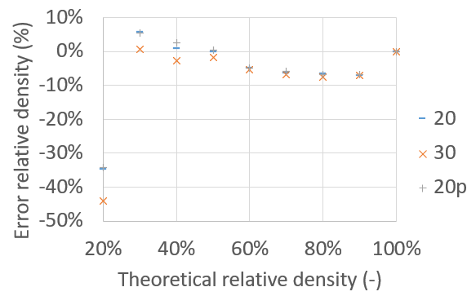
Figure 5. Error in fabricated densities with respect to theoretical relative densities.

Table 4. Measured relative densities.
Theory relative density | 100% | 90% | 80% | 70% | 60% | 50% | 40% |  | 30% | 20%
30 mass (g) | 32.42 | 27.11 | 24.00 | 21.13 | 18.43 | 15.91 | 12.60 |  | 9.79 | 3.62
density (g/cm³) | 1.201 | 1.004 | 0.889 | 0.783 | 0.683 | 0.589 | 0.467 |  | 0.363 | 0.134
Rel.density (-) | 100.0% | 83.6% | 74.0% | 65.2% | 56.8% | 49.1% | 38.9% |  | 30.2% | 11.2%
error-density (%) | 0.0% | -7.1% | -7.5% | -6.9% | -5.3% | -1.9% | -2.8% |  | 0.7% | -44.2%
20 mass (g) | 9.50 | 7.95 | 7.10 | 6.23 | 5.42 | 4.75 | 3.83 |  | 3.01 | 1.24
Rel.density (-) | 100.0% | 83.7% | 74.7% | 65.6% | 57.1% | 50.0% | 40.3% |  | 31.7% | 13.1%
density (g/cm³) | 1.188 | 0.994 | 0.888 | 0.779 | 0.678 | 0.594 | 0.479 |  | 0.376 | 0.155
error-density (%) | 0.0% | -7.0% | -6.6% | -6.3% | -4.9% | 0.0% | 0.8% |  | 5.6% | -34.7%
20p mass (g) | 9.51 | 7.98 | 7.09 | 6.27 | 5.43 | 4.78 | 3.90 |  | 3.01 | 1.25
Rel.density (-) | 100.0% | 83.9% | 74.6% | 65.9% | 57.1% | 50.3% | 41.0% |  | 31.7% | 13.1%
density (g/cm³) | 1.189 | 0.998 | 0.886 | 0.784 | 0.679 | 0.598 | 0.488 |  | 0.376 | 0.156
error-density (%) | 0.0% | -6.8% | -6.8% | -5.8% | -4.8% | 0.5% | 2.5% |  | 5.5% | -34.3%

All parts were tested in compression and stress-strain curves were analyzed to report some parameters such as Young's Modulus or stress at 20% compression for different densities. Figure 6 shows such values in scatter plot as function of relative density. Curve fitting was performed to determine the most appropriate exponent to create a useful model for topology optimization simulations. In order to minimize errors for high densities exponent n=1.94 (1.9407 if we choose 4 significant digits) was chosen using Excel power fit regression. The regression was performed using nine experimental data points and two fitting parameters, providing seven degrees of freedom and a coefficient of determination of R² = 0.988. If we use only 8 data points for high densities, we obtain slightly different regression coefficients (1.9399) with an improved correlation R² = 0.9974. Regressions based only on low-density specimens were not considered because they resulted in larger prediction errors for the higher-stress, high-density region that is most relevant to engineering applications such as topology optimization. Decision to avoid using 20% density for regression is later justified after Figure 7.

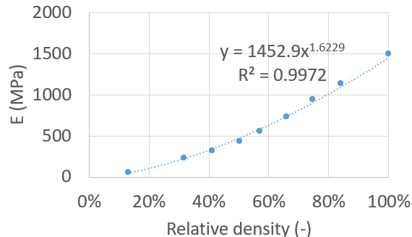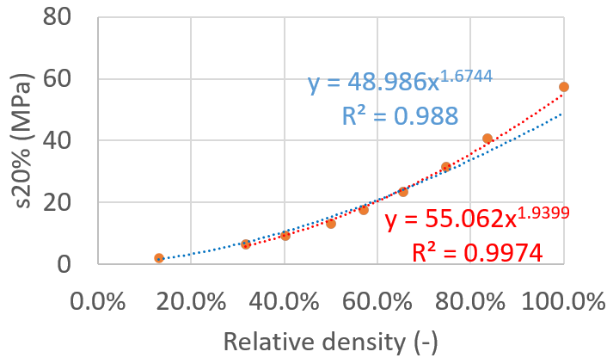
Figure 6. Correlation fit of Young's Modulus and stress at 20% compression.

The complete stress-strain curves are now shown in Figure 7 in original state and normalised by relative density power n=1.94 from previous curve fitting. The largest normalization error was observed for specimens with a nominal relative density of 20%. Their actual relative density was substantially lower than intended, and the small number of unit cells promoted buckling of the thin gyroid walls of just 2 unit cells. The buckling of thin walls of density 20% shown in Figure 7 lead to a different stress strain behaviour which difficulted to decide the point to use for regression coefficient fit. This is the major reason to avoid using this density in regression fit. Stress at 20% deformation used for regression fit seems too low for density 20% leading to wrong regression coefficients for high densities.

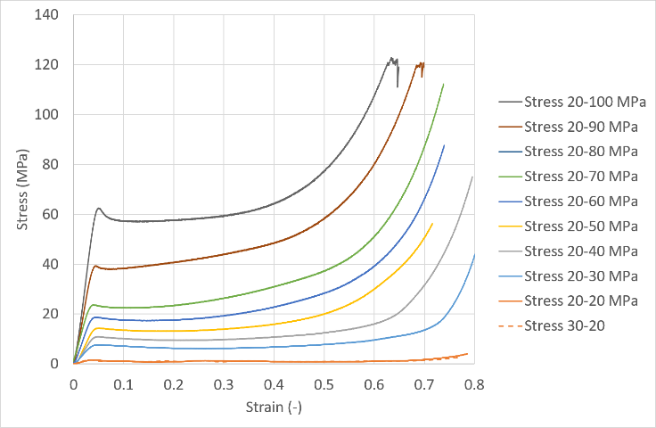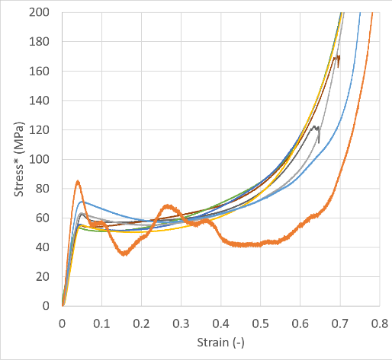

Figure 7. Original and normalised* stress-strain curves for n=1.94.

The same procedure is repeated for the stored energy during compression. Figure 8 shows how the stored energy of W₁=320 J for a compression of 62% for relative density of 1.0 is normalised to obtained unique curve for any density.

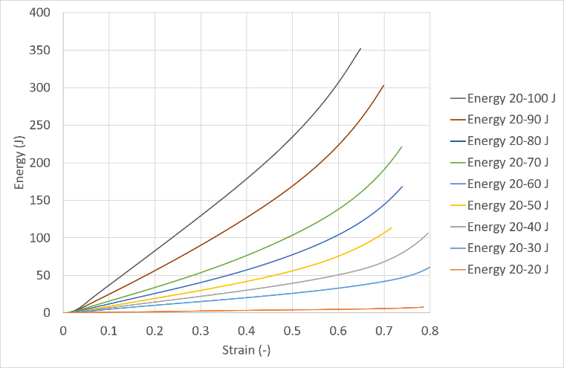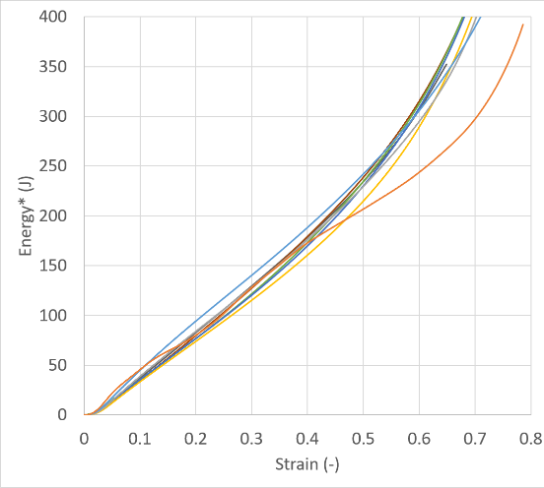
Figure 8. Original and normalised* energy-strain curves for n=1.94.

To better understand the influence of very thin walls that may buckle we plot 3 different tests performed for low relative density in Figure 9. The difference between the Stress 20-20 and Stress 30-20 curves is attributed to specimen size. For bigger cubes we have more unit cells to stabilize buckling. Test curve 20p-20 is the low relative density cube of size 20 tested in perpendicular direction (x direction from Figure 1). In this case as reported previously by Rostro-Gonzalez et al. [2] filaments detach during compression obtaining a lower stress-strain curve behaviour. The variability observed among repeated tests of the same configuration was significantly smaller than the effects associated with specimen size and printing orientation shown in Figure 9.

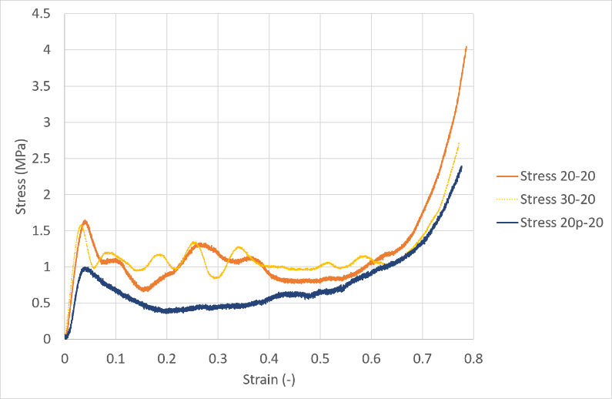
Figure 9. Effect of low number of unit cells on low relative density and printing direction.

Finally, temperature measurements were taken at 62% compression which corresponds to W₁=320 J for relative density of 1.0 for comparison to theoretical Table 4 and shown in Figure 10. During compression it was possible to check that temperatures were even more stable in the range of ΔT≈ 12ºC (37-25 from room temperature). All specimens felt warm after testing but it was very difficult to spot real differences between densities. This could be related to the way heat is transferred to compression rigs and convection to the surrounding air with multiple surfaces.

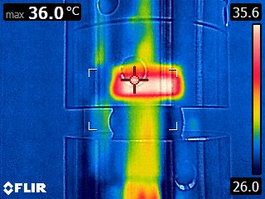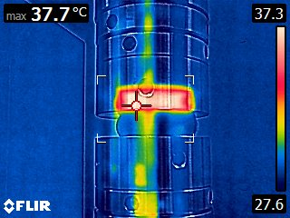
Figure 10. Temperature measurements for different gyroid structures at 62% compression corresponding to W₁=320 J for relative density of 1.0.

- Conclusions
Gyroid structures were manufactured at nine different relative densities using a simple cube geometry with slicing only using infill without external walls, nor top nor bottom skin and using a common desktop printer with commercial PLA. Unlike most previous studies, relative density was varied by changing the gyroid cell size generated by the slicer rather than by modifying wall thickness. Consequently, the wall thickness remained approximately constant and was produced using a single deposited filament path across all specimens.
The measured densities were generally close to the target values with a large error for the lowest relative density of 20% which uses only 1.7 unit cells for L=20 and 2.5 unit cells for L=30 mm. Theory of hollow cubes is quite similar to gyroids in terms of cross section area to carry the compression load. With this theory cross section area can be fit to a power-law of exponent 1.3899 to focus on densities above 50% for future topology optimization purposes. With this theory we could expect temperature increase in the range 8-20ºC for compression based on a 62% compression of a solid cube requesting 320 J.
Compression tests with plasticity showed that the best power coefficient to normalise both stress-strain and energy-strain curves is n=1.94 instead of theoretical elastic 1.3899. With this new exponent only one reference compression curve is required to obtain reliable material properties in areas designed with lower densities. This can be checked for the complete strain range and not just one single value.
Specimens do store heat during compression. However, the difference in measurable temperature between different densities was not easy to measure. All components showed a similar small temperature increase.
This research provides a practical material model that can be readily incorporated into numerical simulations and data-driven design methodologies, including neural-network-based optimisation tools. This will allow weight reduction using different infill densities with gyroid structures manufactured using an approximately constant wall thickness corresponding to a single deposited filament path. Although larger deviations were observed at very low relative densities, these densities are generally of limited importance in topology optimization because such regions are often removed from the final design. With our approach we do not define empty volumes but low relative density which might work as internal support during part manufacturing.

References
[1] A.-A. Garcia-Granada, “High-Compression Crash Simulations and Tests of PLA Cubes Fabricated Using Additive Manufacturing FDM with a Scaling Strategy,” Computation, vol. 12, no. 3, 2024, doi: 10.3390/computation12030040.
[2] H. Rostro-González, G. Reyes-Pozo, J. M. Puigoriol-Forcada, F.-J. López-Valdés, S. S. Sundarram, and A.-A. Garcia-Granada, “Additive Manufacturing Gyroid Structures Used as Crash Energy Management,” Computation, vol. 12, no. 12, 2024, doi: 10.3390/computation12120248.
[3] L. J. Gibson and M. F. Ashby, “Cellular solids: Structure and properties,” Solids Struct. Prop, pp. 1–510, 2014, doi: doi.org/10.1557/mrs2003.79.
[4] T. Maconachie et al., “The compressive behaviour of ABS gyroid lattice structures manufactured by fused deposition modelling,” Int. J. Adv. Manuf. Technol., vol. 107, no. 11, pp. 4449–4467, 2020, doi: 10.1007/s00170-020-05239-4.
[5] N. Kladovasilakis, K. Tsongas, and D. Tzetzis, “Mechanical and FEA-Assisted Characterization of Fused Filament Fabricated Triply Periodic Minimal Surface Structures,” J. Compos. Sci., vol. 5, no. 2, 2021, doi: 10.3390/jcs5020058.
[6] R. Sankineni., “Evaluation of energy absorption capabilities and mechanical properties in FDM printed PLA TPMS structures,” Proc. Inst. Mech. Eng. C J. Mech. Eng. Sci., vol. 236, no. 7, pp. 3558–3577, Apr. 2022, doi: 10.1177/09544062211039530.
[7] M. Alizadeh-Osgouei, Y. Li, A. Vahid, A. Ataee, and C. Wen, “High strength porous PLA gyroid scaffolds manufactured via fused deposition modeling for tissue-engineering applications,” Smart Mater. Med., vol. 2, pp. 15–25, 2021, doi: 10.1016/j.smaim.2020.10.003.
[8] L. Wallat, P. Altschuh, M. Reder, B. Nestler, and F. Poehler, “Computational Design and Characterisation of Gyroid Structures with Different Gradient Functions for Porosity Adjustment.,” Mater. (Basel, Switzerland), vol. 15, no. 10, May 2022, doi: 10.3390/ma15103730.
[9] A. A. Garcia-Granada, J. Catafal-Pedragosa, and H. G. Lemu, “Topology optimization through stiffness/weight ratio analysis for a three-point bending test of additive manufactured parts,” in IOP Conference Series: Materials Science and Engineering, 2019. doi: 10.1088/1757-899X/700/1/012012.
[10] A. A. Garcia-Granada, H. Rostro-González, J. M. Puigoriol-Forcada, and G. Reyes-Pozo, “Open material database for tensile test properties of additive manufacturing materials,” in IOP Conference Series: Materials Science and Engineering, 2023, p. 12043. doi: 10.1088/1757-899X/1294/1/012043.
[11] L. I. U. Y. WANG Chen LU Yufan, LAI Zhanglong, ZHOU Mingdong, “Topology Optimization of Infill Structures for Additive Manufacturing Considering Structural Strength,” Journal of Shanghai Jiaotong University, vol. 58, no. 3. pp. 333–341. [Online]. Available: https://xuebao.sjtu.edu.cn
[12] N. Khan, F. G. Alabtah, and M. Khraisheh, “Integrating Topology Optimization and Lattice Infilling for Lightweight Aircraft Bracket Design via Additive Manufacturing,” Key Eng. Mater., vol. 1047, pp. 139–149, 2026, doi: 10.4028/p-mQS6IQ.
[13] J. Su, Y. Mo, and S. L. Sing, “Generative artificial intelligence in lattice structure design for additive manufacturing: A critical review,” Eng. Sci. Addit. Manuf., vol. 1, no. 1, p. 25110006, 2025, doi: 10.36922/ESAM025110006.
[14] M. Mohseni and S. Khodaygan, “Design for additive manufacturing of topology-optimized structures based on deep learning and transfer learning,” Rapid Prototyp. J., vol. 30, no. 7, pp. 1411–1433, 2024, doi: 10.1108/RPJ-02-2024-0102.
[15] J. Stollberg, T. Gangwar, O. Weeger, and D. Schillinger, “Multiscale topology optimization of functionally graded lattice structures based on physics-augmented neural network material models,” Comput. Methods Appl. Mech. Eng., vol. 438, p. 117808, 2025, doi: 10.1016/j.cma.2025.117808.
[16] J. Maszybrocka, M. Dworak, G. Nowakowska, P. Osak, and B. Łosiewicz, “The Influence of the Gradient Infill of PLA Samples Produced with the FDM Technique on Their Mechanical Properties.,” Mater. (Basel, Switzerland), vol. 15, no. 4, Feb. 2022, doi: 10.3390/ma15041304.
[17] J. Liu, Z. Su, C. Wang, and Z. Xu, “Effect of an Adaptive-Density Filling Structure on the Mechanical Properties of FDM Parts with a Variable Cross-Section,” Mater. (Basel, Switzerland), vol. 15, no. 24, 2022, doi: 10.3390/ma15248746.
[18] S. Kedziora, T. Decker, and E. Museyibov, “Application of Functionally Graded Shell Lattice as Infill in Additive Manufacturing.,” Mater. (Basel, Switzerland), vol. 16, no. 12, Jun. 2023, doi: 10.3390/ma16124401.
[19] Y. Jin, H. Kong, X. Zhou, G. Li, and J. Du, “Design and characterization of sheet-based gyroid porous structures with bioinspired functional gradients,” Materials (Basel)., vol. 13, no. 17, p. 3844, 2020.
[20] D. Li, W. Liao, N. Dai, and Y. M. Xie, “Comparison of mechanical properties and energy absorption of sheet-based and strut-based gyroid cellular structures with graded densities,” Materials (Basel)., vol. 12, no. 13, p. 2183, 2019.

